|  |  |  |
| --- | --- | --- |
| **哈哈，我是原始样式**  **lu** |  |  |
|  |  |  |

**我是带样式的段落**

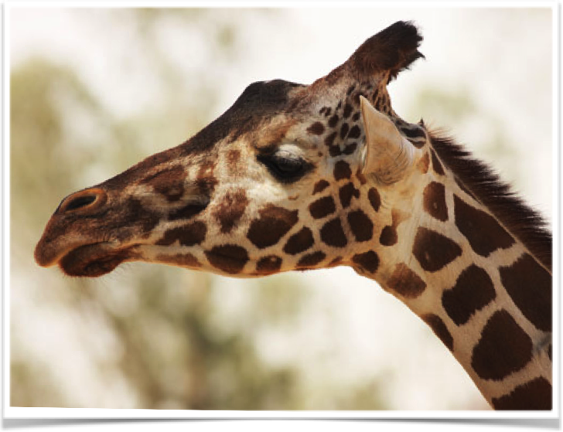

|  |  |  |
| --- | --- | --- |
|  |  | 我是第二个表 |
|  |  |  |