1. Two possible use cases

**As a user, I want to add a new product “iPhone” into the system with ProdcutID.**

Case1 User Add product

ProductID Name Price Quantity

(1234) (iPhone) (780) (2019)

Product added successfully!

**As a user, I want to add a new product “iPhone” into the system without ProdcutID.**

Case2 User Add product

ProductID Name Price Quantity

( ) (iPhone) (780) (2019)

ProductID cannot be null!

**As a user, I want to add a new customer “Tommy” into the system with CustomerID.**

Case1 User Add customer

CustomerID Name Address Phone

(5678) (Tommy) (427 E Magnolia ave) (3342741243)

Customer added successfully!

**As a user, I want to add a new customer “Tommy” into the system without CustomerID.**

Case2 User Add customer

CustomerID Name Address Phone

( ) (Tommy) (427 E Magnolia ave) (3342741243)

CustomerID cannot be null!

**As a user, I want to add a purchase from a customer into the system with PurchaseID.**

Case1 User Add purchase

PurchaseID CustomerID ProductID Quantity

(9101) (5678) (1234) (1)

Purchase added successfully!

**As a user, I want to add a purchase from a customer into the system without PurchaseID.**

Case2 User Add purchase

PurchaseID CustomerID ProductID Quantity

( ) (5678) (1234) (1)

PurchaseID cannot be null!

1. Design the screens (UI windows and widgets) the system should display in each use case.
2. Product

Case 1

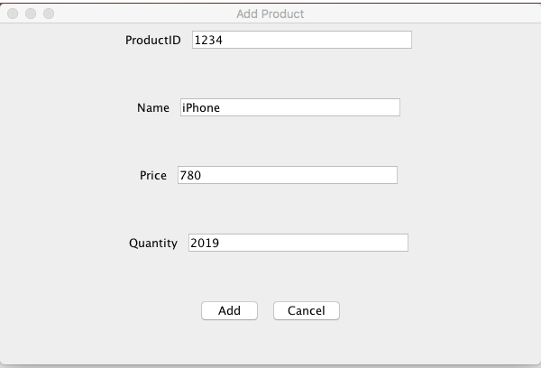 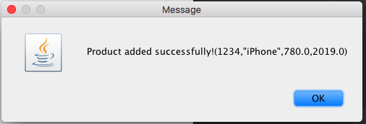

Case 2

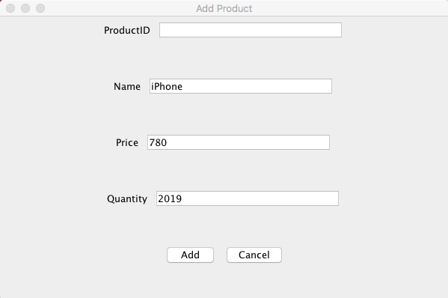 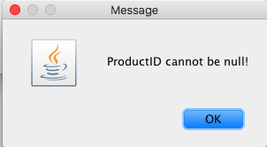

1. Customer

Case 1

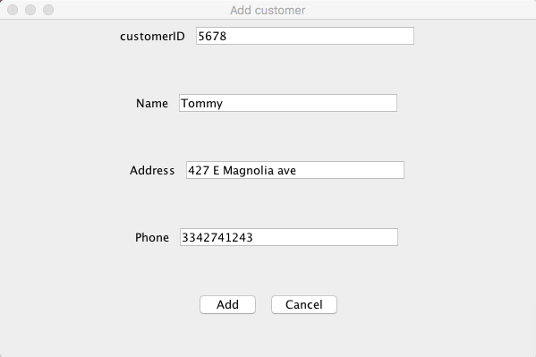 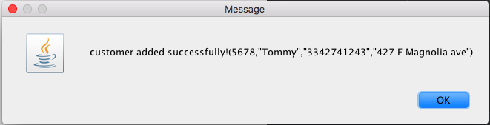

Case 2

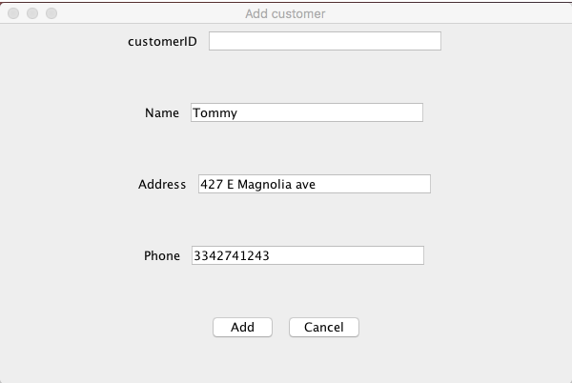 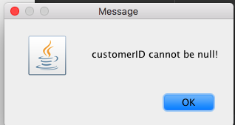

1. Purchase

Case 1

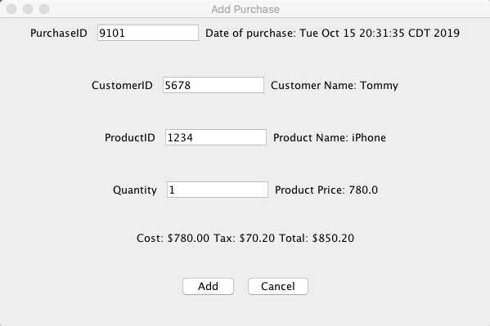

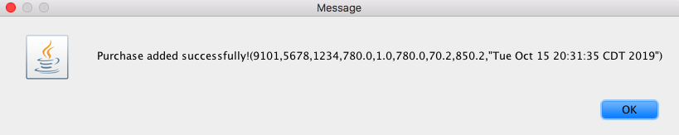

Case 2

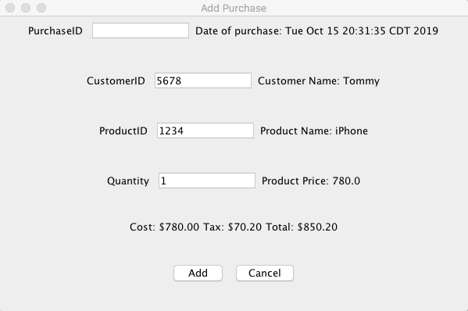 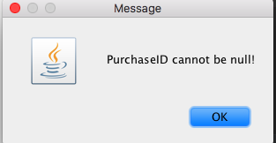

1. Design the database physically and prepare data for the tables, with at least 5 products, 5 customers, and 10 purchases.

﻿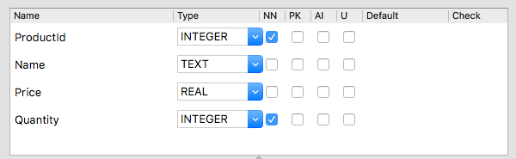

CREATE TABLE "Products" (

"ProductId" INTEGER NOT NULL,

"Name" TEXT,

"Price" REAL,

"Quantity" INTEGER NOT NULL

);

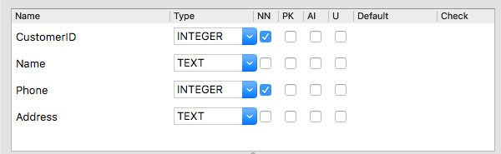

CREATE TABLE "Customers" (

"CustomerID" INTEGER NOT NULL,

"Name" TEXT,

"Phone" INTEGER NOT NULL,

"Address" TEXT

);

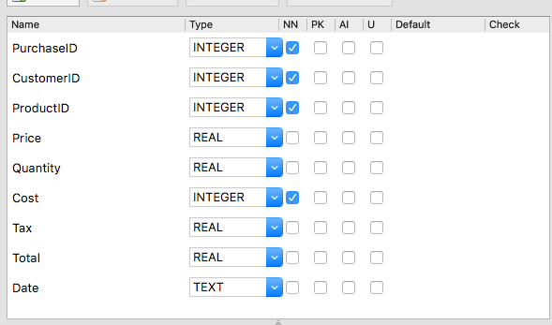

﻿CREATE TABLE "Purchases" (

"PurchaseID" INTEGER NOT NULL,

"CustomerID" INTEGER NOT NULL,

"ProductID" INTEGER NOT NULL,

"Price" REAL,

"Quantity" INTEGER NOT NULL,

"Cost" REAL,

"Tax" REAL,

"Total" REAL,

"Date" TEXT

);

|  |  |  |  |
| --- | --- | --- | --- |
| ProductID | Name | Price | Quantity |
| 1234 | iPhone | 780 | 2019 |
| 2134 | apple | 3 | 2018 |
| 3124 | clock | 15 | 2017 |
| 4123 | chair | 30 | 2016 |
| 4321 | window | 50 | 2015 |

|  |  |  |  |
| --- | --- | --- | --- |
| CustomerID | Name | Address | Phone |
| 5678 | Tommy | 427 E Magnolia ave | 3342741243 |
| 6578 | Jenny | 300 E Longleaf Dr | 3345671234 |
| 7568 | Jay | 202 W Longleaf Dr | 3345782134 |
| 8567 | Bob | 201 W Longleaf Dr | 3345632098 |
| 8765 | Rob | 575 Shelton Road | 3346531927 |

|  |  |  |  |
| --- | --- | --- | --- |
| PurchaseID | CustomerID | ProductID | Quantity |
| 9101 | 5678 | 1234 | 1 |
| 9111 | 6578 | 2134 | 20 |
| 9222 | 7568 | 3124 | 2 |
| 9333 | 8567 | 4123 | 50 |
| 9444 | 8765 | 4321 | 60 |
| 9555 | 1111 | 6666 | 12 |
| 9666 | 2222 | 7777 | 34 |
| 9777 | 3333 | 8888 | 12 |
| 9888 | 4444 | 9999 | 1 |
| 9998 | 5555 | 0000 | 6 |

1. Implement the use cases.

