FTC Web Developer logo

FTC Web Developer

**By:**

Sergejs Ivcenko

Oleksandr Gerasymenko

Hasibullah Darwish

Georgiana Bulgaru

Table of Contents

Table of Contents 1

Website name and URL 6

Objectives 7

Target Audience 8

Price Plan – Domain/Hosting cost 9

Hosting 9

SSL Certificate 10

Price Plan Table 12

Flowchart 14

Wireframes 15

Home Page 15

Mobile 15

Tablet 16

Desktop 17

Traineeship Page 17

Mobile 18

Tablet 19

Desktop 20

About Course Page 21

Mobile 21

Tablet 22

Desktop 23

Testimonials Page 24

Mobile 24

Tablet 25

Desktop 26

Certifications and Further Education Options 27

Mobile 27

Tablet 28

Desktop 29

Contact us Page 30

Mobile 30

Tablet 31

Desktop 32

About FTC Page 33

Mobile 33

Tablet 34

Desktop 35

Our Partners Page 36

Mobile 36

Tablet 37

Desktop 38

Colours 39

Font 40

Font Sizes 41

Content 42

Header 42

Footer 42

Home Page 44

Traineeship Page 45

About Course Page 46

Testimonials Page 50

Certifications and Further Education Options Page 52

Work Practice 6N1947 52

Project Management 6N4090 52

Web Authoring 6N2532 53

Web Development 6N1277 53

Interactive Scripting 6N20494 53

Further Education Options 54

Contact Us Page 55

About FTC Page 57

About Us 57

Car park 57

Canteen 58

Classrooms and Workshops 58

Our Partners Page 59

SOLAS 59

The European Social Fund (ESF) 59

Images 61

Header/Footer 61

Home and Traineeship Pages 62

About Course Page 63

Testimonials Page 64

Certifications and Further Education Page 65

Contact Us Page 65

About FTC Page 66

Our Partners Page 66

Copyright 67

Search Engine Optimization 71

SEO Strategy 71

Titles and Descriptions 72

Home page 72

Traineeship page 72

About Course Page 73

Certifications and Further Education Options Page 73

Testimonials Page 74

Contact Us Page 74

About FTC Page 75

Our Partners Page 75

Keywords 77

Accessibility 78

Semantic markup 78

Image 78

Colours 78

Search Engine Optimisation 79

Speed 79

Timetable 80

# Website name and URL

Website name – FTC Web Developer

Website URL - https://www.ftcwebdeveloper.com

# Objectives

1. Provide an overview of the traineeship program – explain the purpose, duration, requirements, and benefits.
2. Attract potential trainees and encourage them to apply for the traineeship program.
3. Demonstrate the value of the traineeship program and how it can help the trainee develop his skills and start his career as a front-end web developer.
4. Share success stories – include success stories from previous – current trainees and highlight the impact of their career after completing the program.
5. Attract potential employers by showcasing the skills and experience trainees have gained through the program.
6. Provide an overview of the training centre – car parking, classrooms, and facilities.

# Target Audience

The targeted audience of a front-end web developer traineeship website includes individuals who are interested in front-end web development, this can include:

1. Individuals who are looking to start a career in web development and are interested in learning front-end web development skills.
2. Job seekers looking to enhance their abilities by acquiring front-end web development skills to qualify for web development positions.
3. Individuals with a passion for web development, interested in front-end web development looking to learn or enhance their skills.
4. Individuals with varying levels of experience in web development, ranging from beginners with no prior experience to advanced developers looking to acquire or improve their skills, or have an interest in staying up to date with the web development industry trends.
5. Individuals interested in changing their careers and transitioning into the field of web development.
6. Individuals who are interested in starting their own business as a front-end web developer.
7. Individuals who are seeking a comprehensive traineeship that is necessary to acquire the skills for front-end web development, enabling them to start their careers in this field.

# Price Plan – Domain/Hosting cost

We have selected an Irish hosting provider called letshost based in Galway for this project due to offering 24/7 local support and storing our data in Irish-owned servers, which is very important. However, their prices are a bit high, which is sensible as they offer high-quality services and value their customers.

### Hosting

The hosting plan we chose is called Starter Hosting Package. This plan costs €5.99 for the first month and €11.99 per month afterwards or €107.99 per annum excluding VAT. As we want to have a stable and consistent hosting service, we wanted to go with an annual plan instead of making payments every month. Furthermore, we saved some coins as well hence, good for the business. The screenshot below is from the letshost’s checkout for the Starter Hosting Package we selected for ftcwebdeveloper.ie

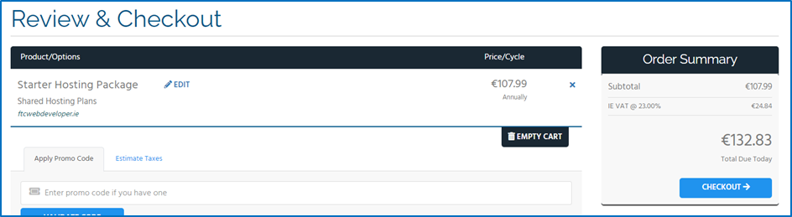

The package consists of a huge amount of storage, MySQL Database, unlimited email addresses, hosting up to 3 websites, and 24/7 technical local support, which is awesome. In addition, they are offering Irish Dedicated Servers if needed in case of business expansion and growth at affordable and flexible prices. The following screenshot shows details of Starter Hosting Package of letshost, which we are going to have for hosting our website.

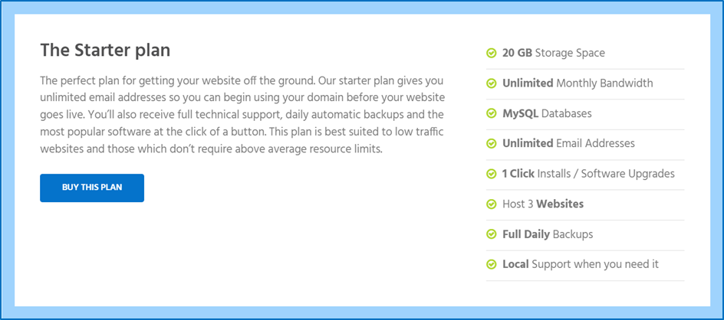

Since our hosting package does not include SSL Certificate, which is particularly important for our website and customers, we are going to have an SSL Certificate package separately.

### SSL Certificate

When it comes to going live online, having Secure Socket Layer Certificated installed on your website is crucial. As its name suggests, it secures the connection between your website and your clients, who are interacting with your website, through encryption.

There is a need for SSL especially if you have some sort of form on your website like a contact form that allows your client to provide their personal details for you. Without SSL, your client’s details will be transferred over the network into a plain text format that is readable whereas, with SSL installed, it is turned into a meaningless format first; passed through the network; and then turned back into a meaningful format once it reached your server. In this case, if someone intercepted the connection between your client and your web server, they would not have access to your client details since it is in a format that does not make sense.

Hence, we need to have SSL Certificate installed on our website. We have selected the basic SSL Certificate of letshost which costs €139.99 per annum excluding VAT. It is a bit expensive in comparison to SSL certificates offered by other hosting providers, but it covers domain validation; www and none-www version of website; has strong encryption of 2048 bit; installed by the letshost staff. The screenshot below shows the Basic SSL package plan we are going to have for our website.

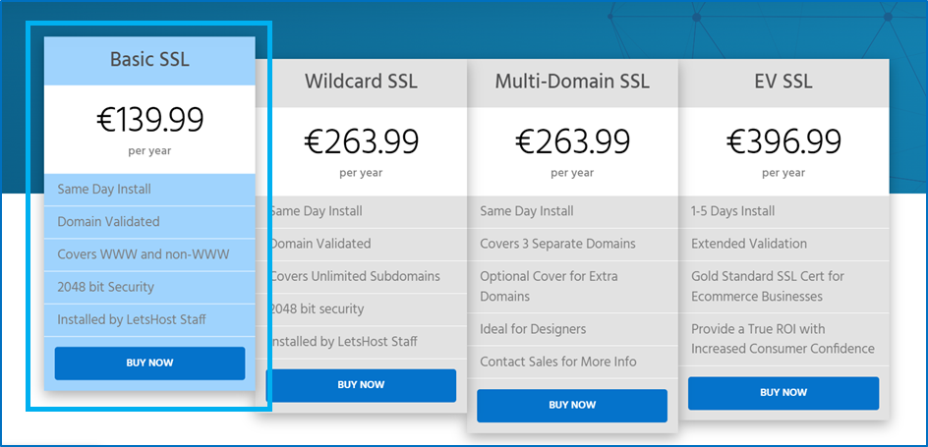

In general, it builds customer trust and enhances our website security since nowadays, every browser marks a website as not secure and warns not to provide any data if that website’s SSL certificate is expired or doesn’t have one when someone visits it. If a website has SSL Certificate installed, the browser puts a green/grey lock mark on the left side of the URL to indicate the website is secure and you are safe.

The following screenshot is from Google website URL section showing that it has SSL Certificate installed.



The screenshot below is from an unknown website that does not have SSL Certificate installed.

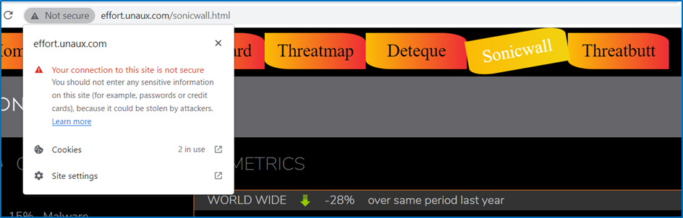

Even though our SSL Certificate is expensive, it is important to have it as we are collecting and processing the personal data of people who are applying for the course through our contact form, which by law, we are required to make sure is safe and secure.

The following screenshot shows the total cost for the domain, hosting and SSL certificate in the letshost checkout section.

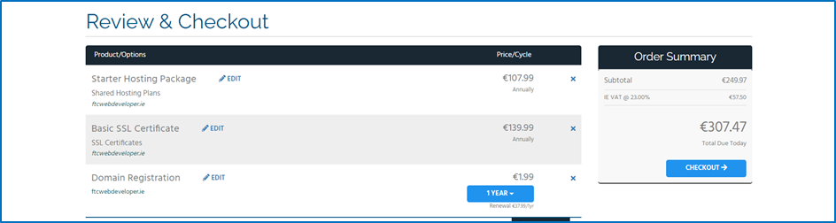

### Price Plan Table

|  |  |  |
| --- | --- | --- |
| Product Name | Feature | Price |
| Starter Hosting Package | 25GB Storage, MySQL Database, Unlimited email addresses, fully daily backups, hosting up to 3 websites, 24/7 local support | €107.99 per annum  excluding VAT |
| SSL Certificate | Same day installation, Domain Validation, Covers WWW, and none-www websites, 2048-bit Security, installed by Letshost staff | €139.99 per annum excluding VAT |
| Total |  | €247.98  per annum |

# Flowchart

# Wireframes

## Home Page

### Mobile

420px



### Tablet

820px

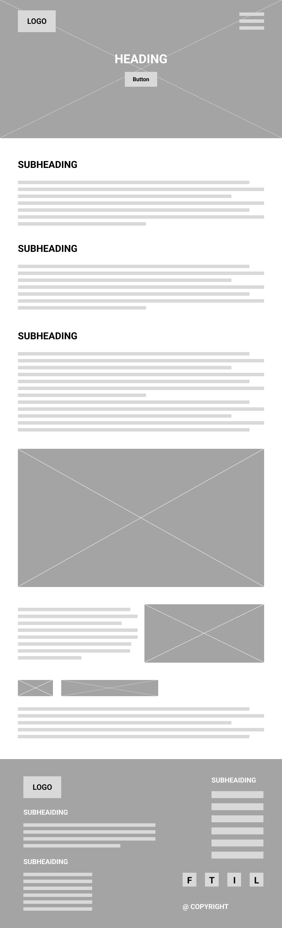

### Desktop

1920px

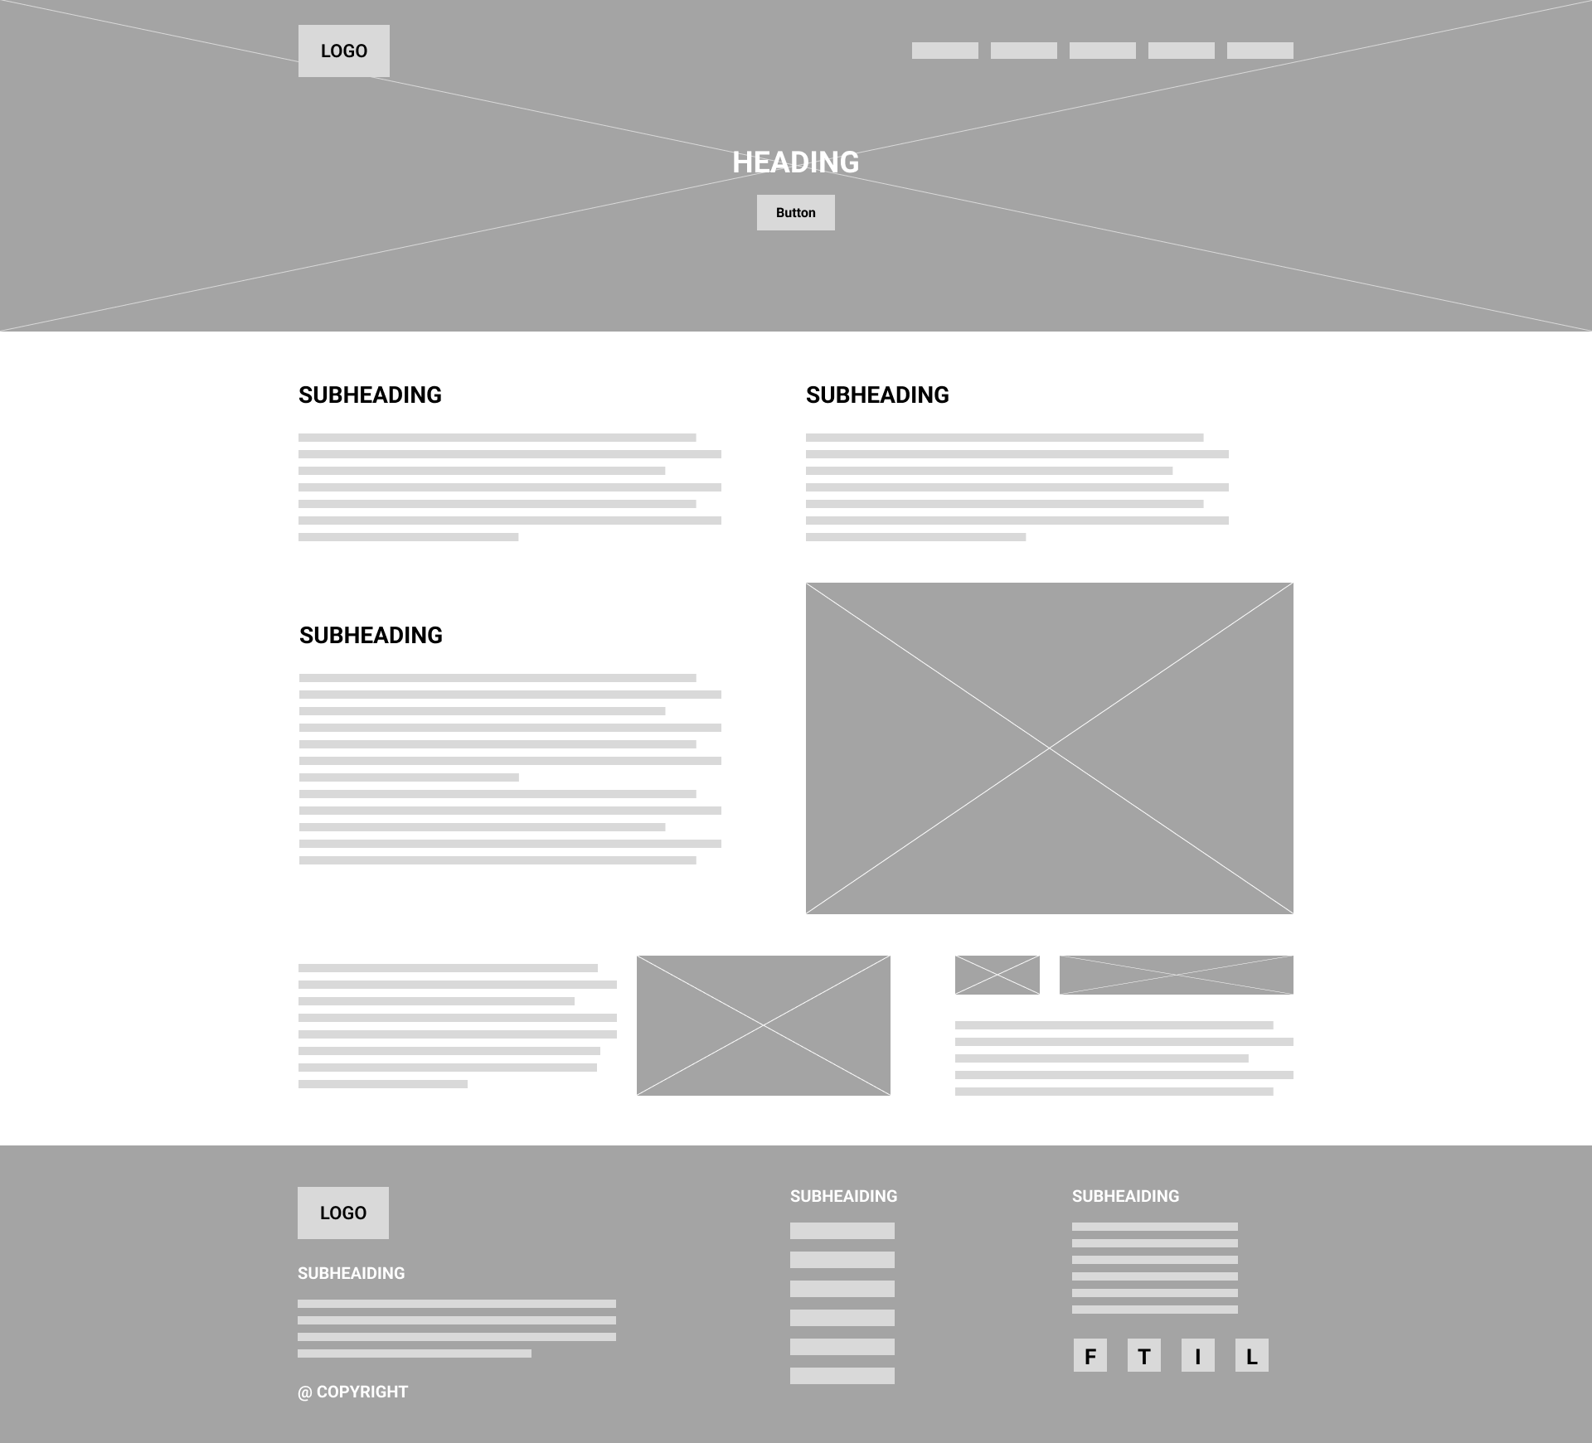

## Traineeship Page

### Mobile

420px



### Tablet

820px

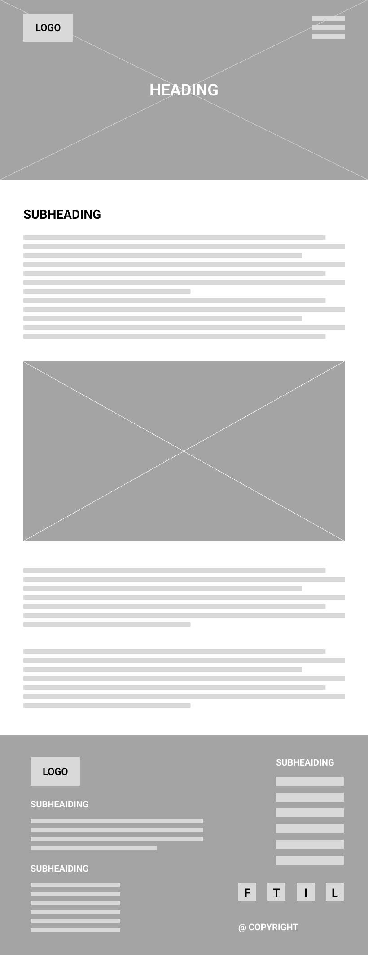

### Desktop

1920px

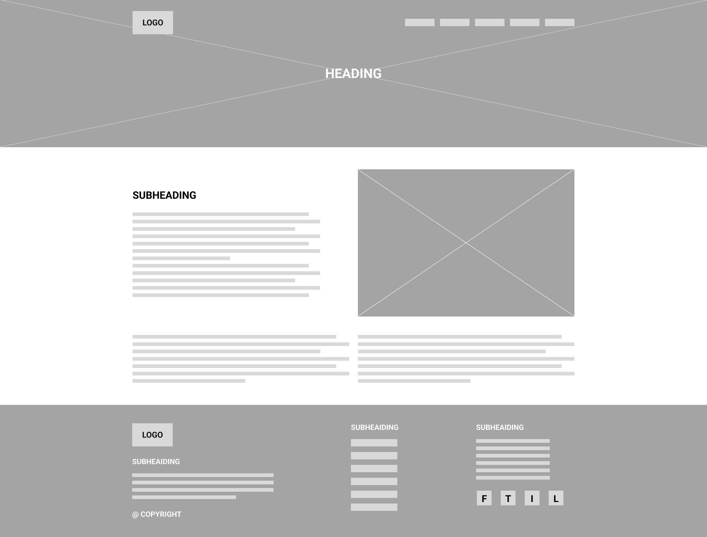

## About Course Page

### Mobile

420px



### Tablet

820px

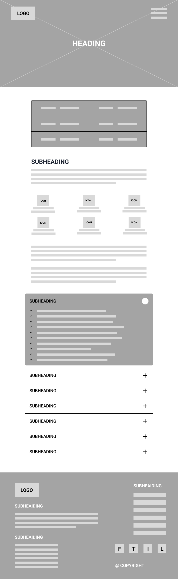

### Desktop

1920px

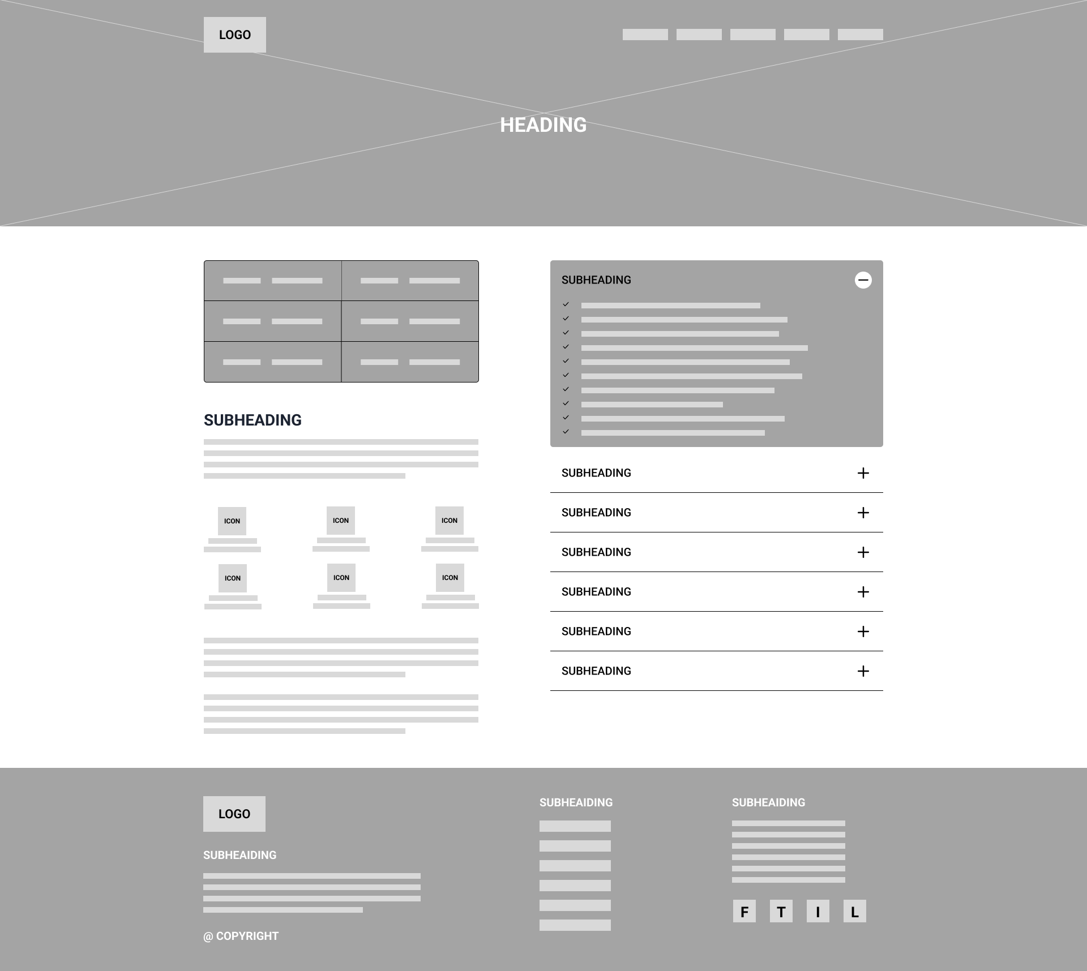

## Testimonials Page

### Mobile

420px



### Tablet

820px

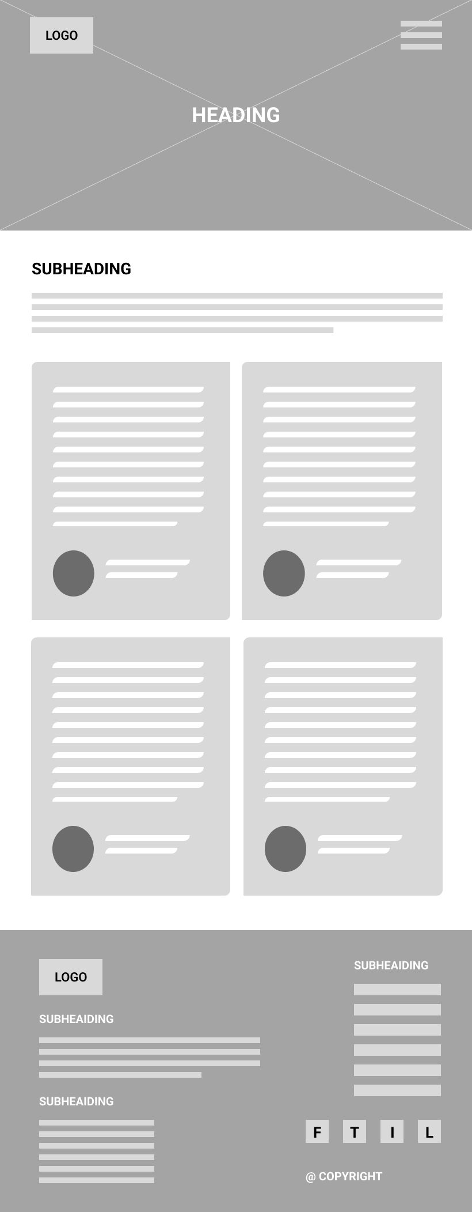

### Desktop

1920px

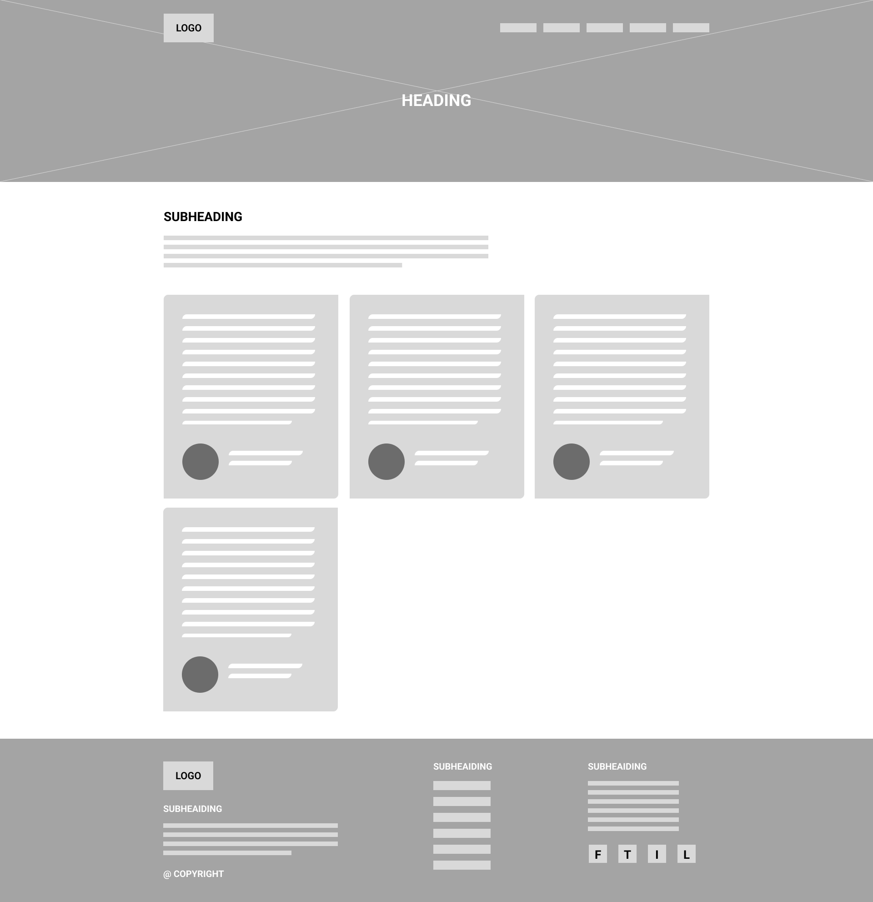

## Certifications and Further Education Options

### Mobile

420px



### **Tablet**

820px

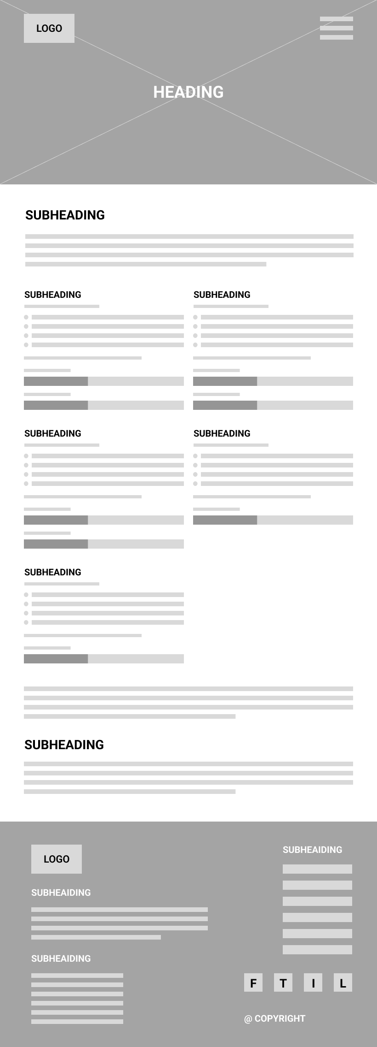

### Desktop

1920px

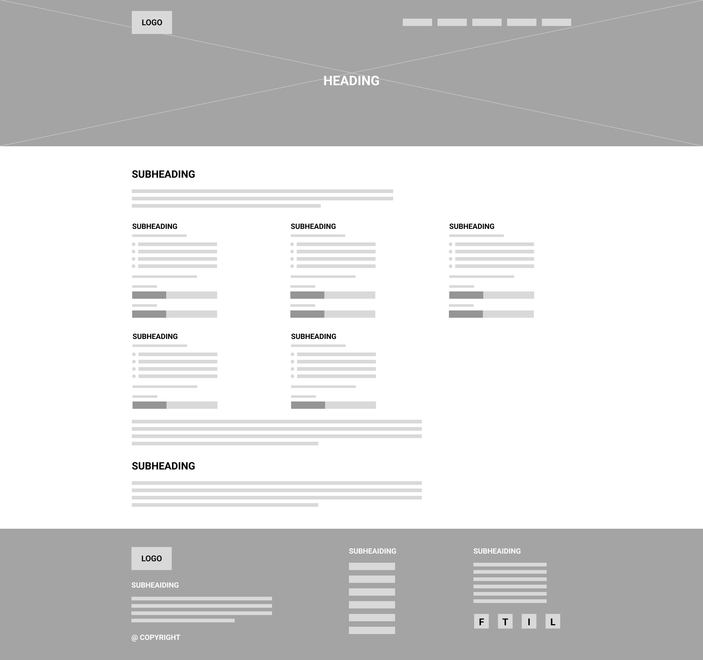

## Contact us Page

### Mobile

420px



### Tablet

820px

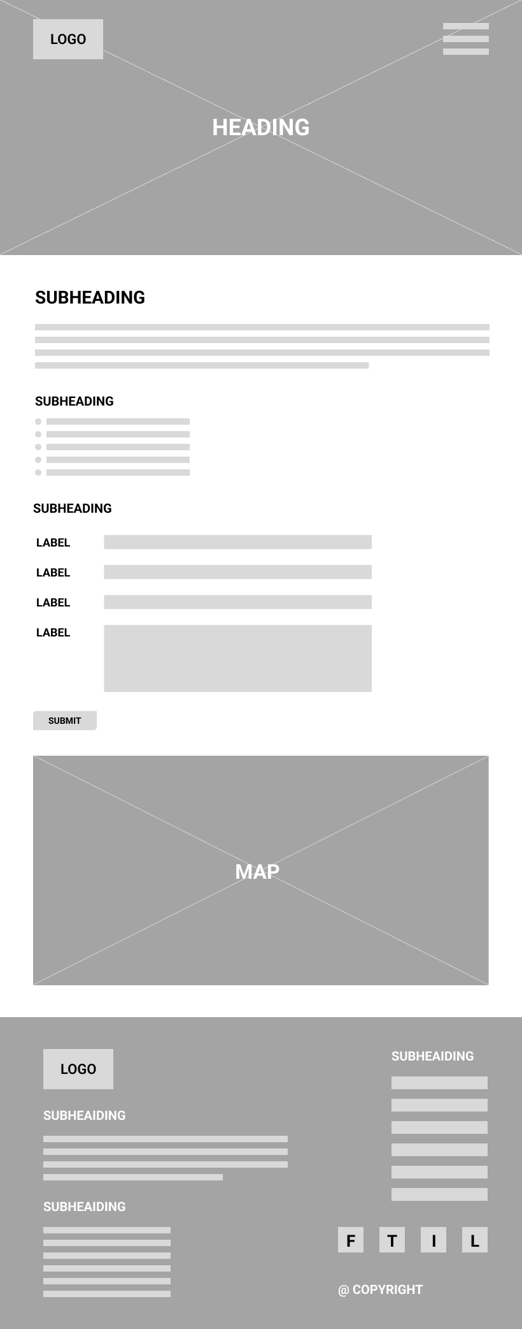

### Desktop

1920px

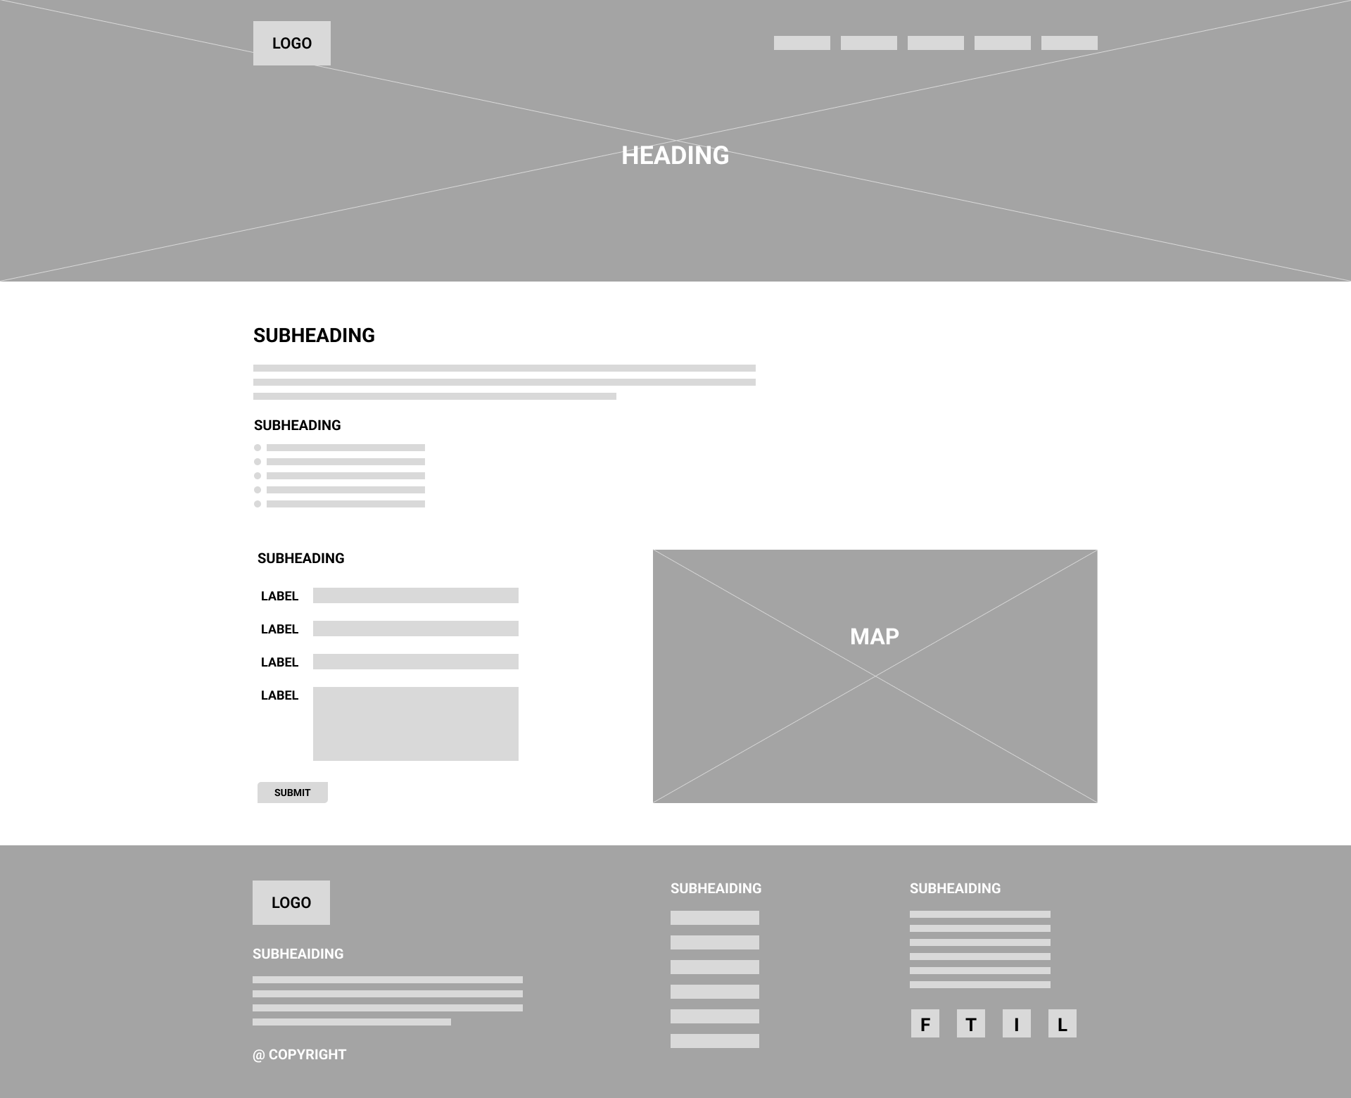

## About FTC Page

### Mobile

420px



### Tablet

820px

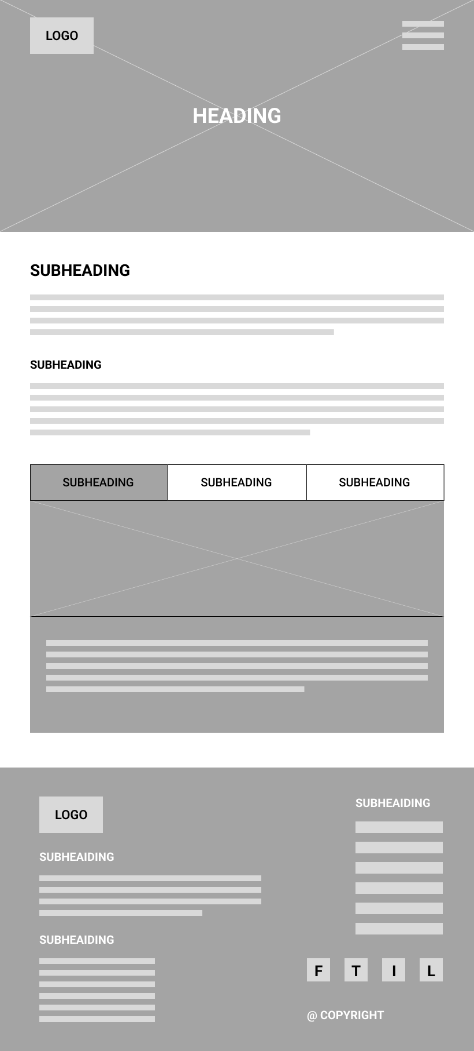

### Desktop

1920px

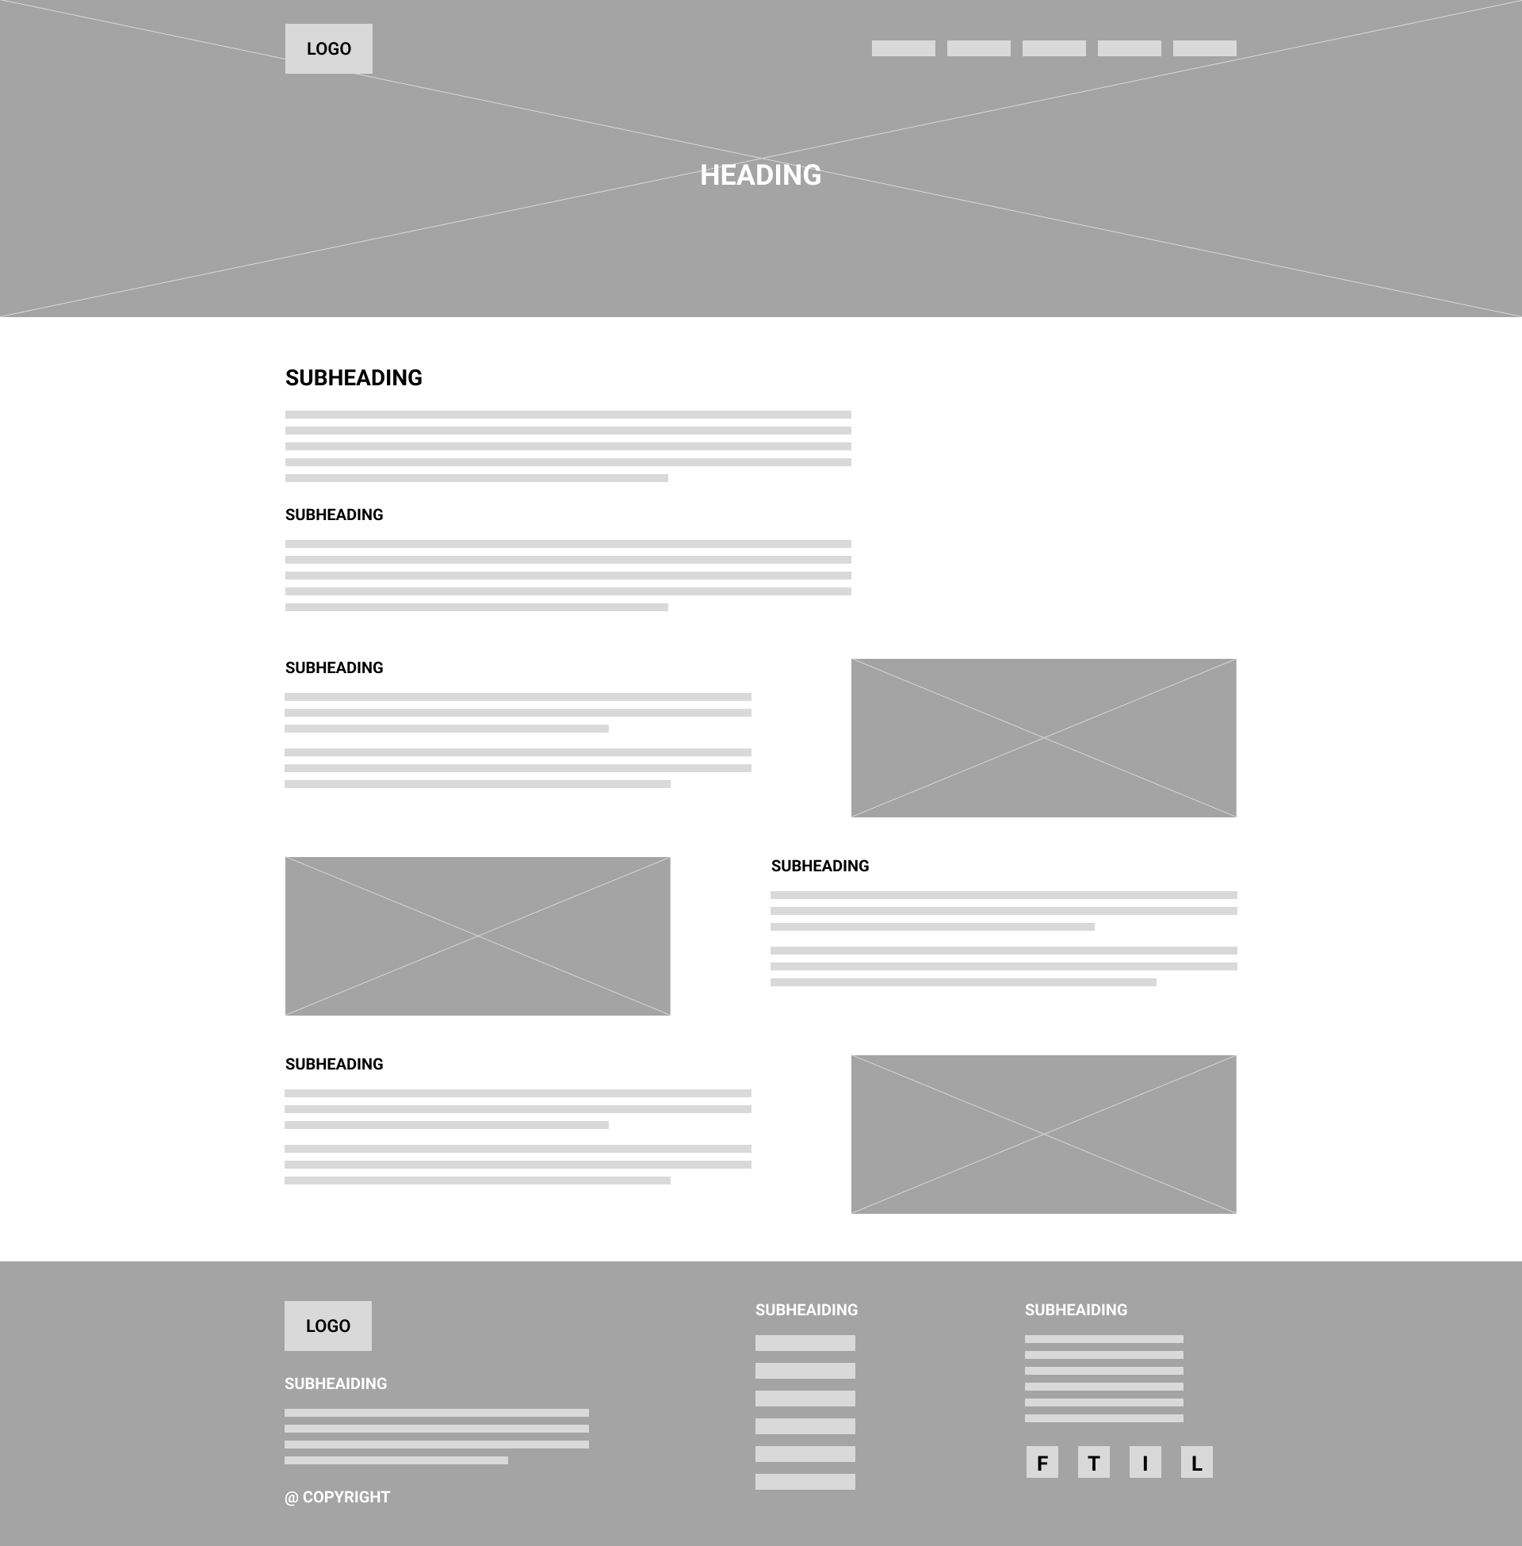

## Our Partners Page

### Mobile

420px



### Tablet

820px

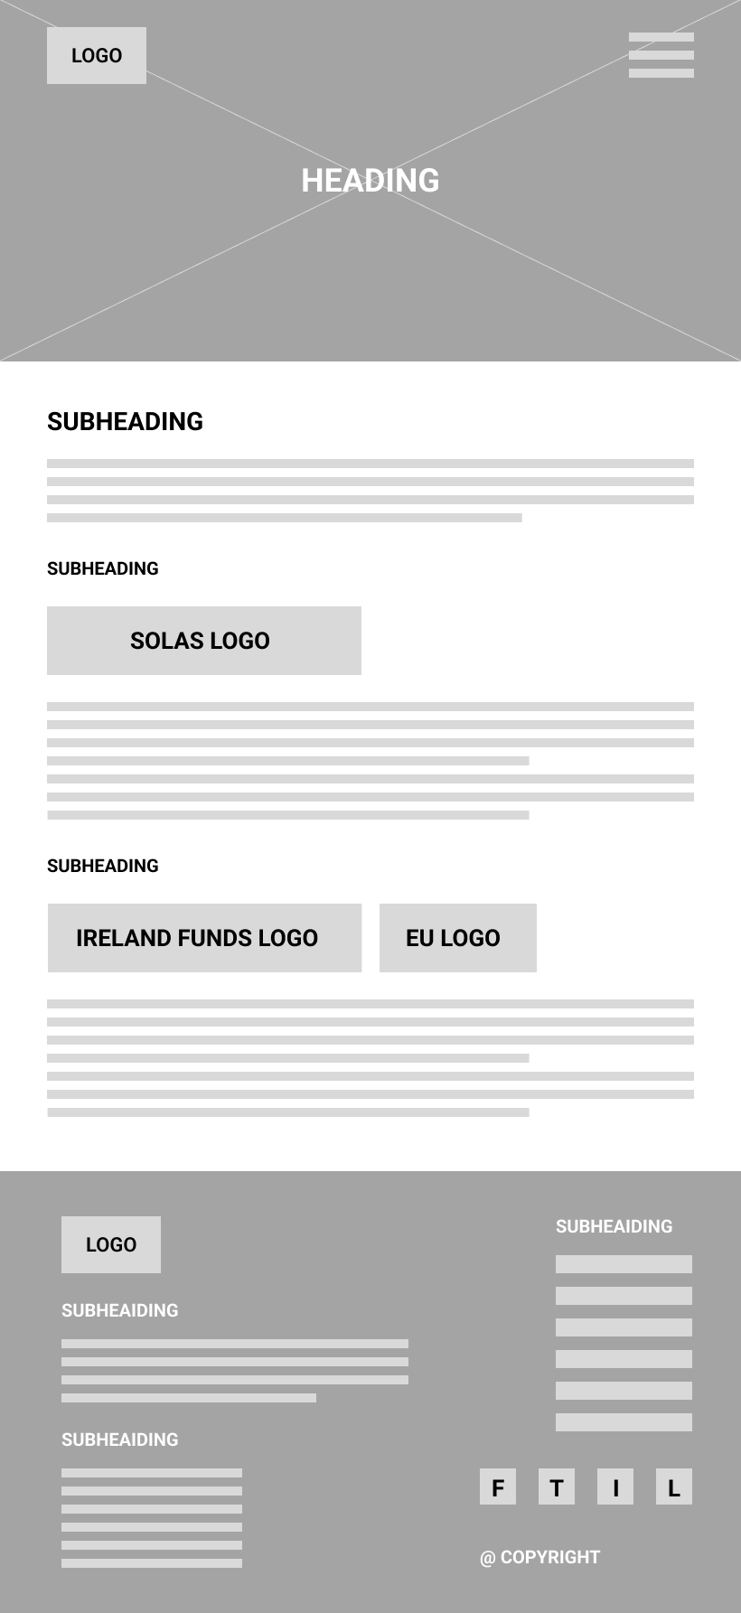

### Desktop

1920px

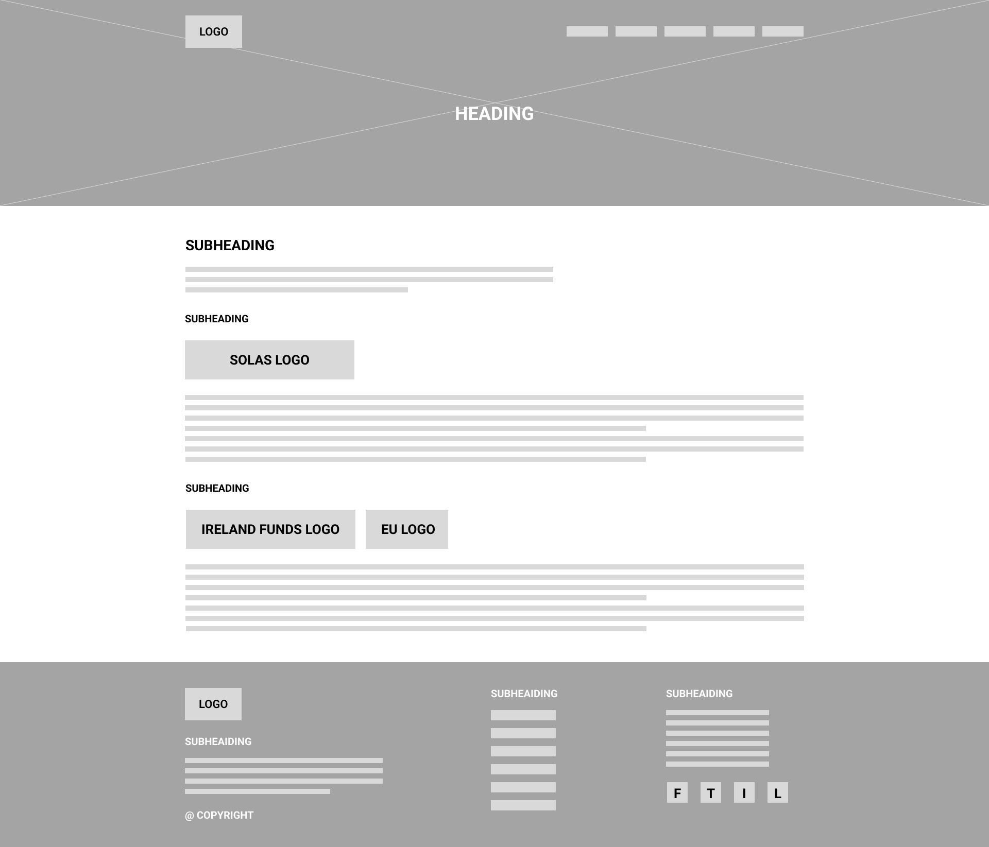

# Colours

For website colours will be used the following colours palette.

#1C2331 – Very Dark Blue

This very dark blue color is good for text color and background color for footer. This color makes text softer and not harsh on the eyes.

#1F439E – Blue

The dark blue color is a main color associated with web development and web technologies.

**#FF816B** – Orange Red Light

Orange Red light version will be used for the hover effects of the content Orange Red colour and for testimonial card.

**#F05941** – Orange Red

This color is an accent color and will be used to highlight some content. As well will be used for buttons and links.

**#FFFFFF** – White

White color will be used as a background and for text color on the dark background.

**#B4D9E7** – Coral Blue

This color will be used for some testimonials cards background and for hide and show active state.

#626262 – Black Color 60% lighter. This color will be used for banner images overlay.

# Font

The font will be used is Roboto, there are many reasons why to use this font:

1. Roboto makes content readable and accessible to all website users. It has a clean and simple appearance.
2. Roboto is flexible font. It can be used for different purposes, for headings, subheadings, and body text.
3. Roboto has great web optimization features. Easy to read on a digital screen and optimized for file size.
4. Robot is a widely used font and was developed by Google. Using Roboto font can increase brand recognition.





# Font Sizes

**Heading 1**: 36px

**Heading 2**: 28px

**Heading 3**: 20px

Paragraph: 18px

The following image shows how the heading is going to look like in our chosen colour for it. The heading is 700 bold 36px whereas the first paragraph is 20px and the second paragraph is 18px.

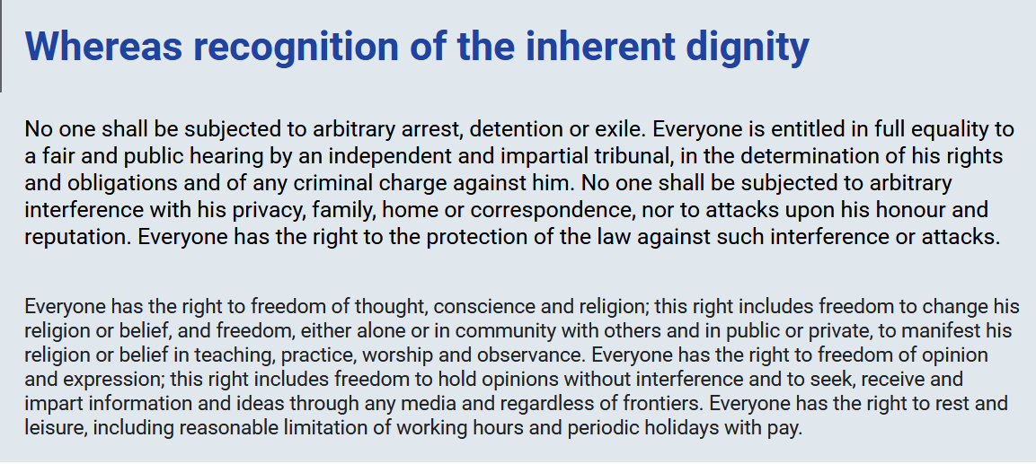

# Content

## Header

Navigation links

* Home
* About Course
* Traineeship
* Testimonials
* Contact Us

Download Brochure

## Footer

**About Us**

Our front-end web developer training program is designed to equip developers with the skills and knowledge they need to succeed in the industry. With a strong emphasis on hands-on experience and real-world projects, our program prepares our trainees for the demands of the job market.

**Browse**

* Home
* Traineeship
* About Course
* Testimonials
* About FTC
* Our Partners
* Certifications and Further Education

**Contact Us**

* CDETB Finglas Training Centre,
* Poppintree Industrial Estate,
* Jamestown Road,
* Finglas, Dublin 11.
* D11KW18
* Tel: 018140200
* Email: finglasday@ftc.cdetb.ie

## Home Page

**Front-End Web Developer: The Path to Success** - page heading

**Our Traineeship!**

Are you looking for a hands-on approach to learning front end web development and gaining practical industry experience? Our traineeship course provides you with the opportunity to develop your skills, work on real-world projects and gain experience through working alongside professional developers in the industry.

**What we cover?**

Our comprehensive program covers everything from HTML and CSS basics to advanced JavaScript. Our experienced instructors will guide you through every step of the process, providing personalised feedback to help you succeed. You'll work on projects for real clients under the guidance of experienced mentors, allowing you to build your portfolio and gain valuable experience.

**What you get?**

By the end of the course, you will have built a portfolio of projects that demonstrate your abilities as a front-end web developer. Whether you're a recent graduate or a career changer or enhancing your current skills, our traineeship course is the perfect way to gain the skills and experience needed to launch your career in web development. Enrol today to take the first step towards a rewarding career and becoming a skilled and successful front-end web developer through our traineeship.

This course is a part of Finglas Training Centre programmes. The Centre provides full, part-time, evening, apprenticeship, and community-based courses. Centre has ample car parking space, a large modern canteen and fully equipped training facilities in spacious classrooms. You can read more about Centre in About FTC page.

Course is co-funded by the Ireland’s Further Education and Training Authority (SOLAS), Irish Government and the European Social Fund (ESF) as part of the Programme for Employability. You can find more information in Our Partners page.

## Traineeship Page

**What you get from this program?**

This is the final step of your journey towards becoming a professional front-end developer where you will be working on real-world projects under the guidance of experienced developers. This is your chance to apply all the skills you have learned in the previous part of the course and gain valuable practical experience.

You will be working closely with a team of developers on various projects in our partners company and will be responsible for contributing to the development of web applications, websites, and other digital products. Your team will provide you with guidance and support as you work on your projects, giving you the opportunity to learn from their experience.

During this time, you will have the opportunity to learn new skills, refine your existing skills, and gain valuable industry experience. You will also have the chance to network with other developers, build your portfolio, and establish yourself as a professional in the field of web development.

At the end of your traineeship, you will have the skills and experience necessary to pursue a career as a front-end developer since you will have a strong portfolio of work that demonstrates your skills, as well as the confidence and knowledge necessary to succeed in the industry.

So, roll up your sleeves and get ready to start your journey as a professional front-end developer!

## About Course Page

Front End Web Developer Traineeship – page heading

Table with course information

* **Course Name:** Front End Web Developer Traineeship
* **Course Code:** 296449
* **Attendance:** Day
* **Duration:** 49 weeks
* **Start Date:** 16/01/2023
* **End Date:** 2024

**Course Description**

This course will provide the web development IT sectors with learners skilled in all basic aspects of front-end development using:

* Hypertext Mark-up Language (XHTML/HTML5)
* Cascading Style Sheets (CSS)
* Responsive Web Design (RWD)
* Content Management Systems (CMS)
* JavaScript (JS)
* React

Learners will be able to take designs/mock-ups and create modern, clean, mobile first responsive, functional, and beautiful interfaces using HTML, CSS, and JavaScript.

Learners will also gain experience in project management, working to deadlines, take and give direction and contribute to projects, along with creating their own online portfolio.

**Course Content**

* Induction
* Extensible HyperText Markup Language XHTML
* Cascading Style Sheets CSS
* JavaScript
* Cross Browser Development
* Testing and debugging
* Content Management Systemx
* Project Management
* Job Seeking Skills and creation of a curriculum vitae
* Work Practice

**Entry Requirements**

Candidates should be passionate about building web sites

Education:  
Leaving Certificate Standard or equivalent or progression from a relevant related course.

Aptitude:  
Applicants should have flair for troubleshooting and a keen desire to work in this sector  
Applicants should be capable of working under their own initiative and as part of a team as during the course participants will be required to meet deadlines in the completion of individual and group projects

Previous Experience:  
File Management and Word Processing skills. (Essential) Familiarity with Web Terminology and Internet Navigation. (Essential) Learners should be able to communicate fluently and professionally in both written and spoken English.

For more information and how to apply for this course – see: <https://www.fetchcourses.ie/course/finder?sfcw-courseId=296449>

**Course Fees**

Fees apply only to attendance on Evening Courses. These courses are generally free to the unemployed. You should discuss your eligibility in advance of application with your local Department of Social Protection office, or Finglas Training Centre.

**Certification**

* QQI Work Practice (6N1947)
* QQI Project Management (6N4090)
* QQI Web Authoring (6N2532)
* QQI Web Development (6N1277)
* QQI Interactive Scripting (6N20494)
* QQI Major Award Level 6 Digital Media Production 6M20496
* Read More link

**How to apply for a course**

You may now apply online for Day, Evening and Local Training Initiative courses using the website of the Further Education and Training Course Hub [www.fetchcourses.ie](http://www.fetchcourses.ie). Those wishing to pursue application for a Community Programme (i.e., Specialist Training Provider and Community Training Centre), should contact the relevant provider directly.

**Employment Opportunities**

Junior Front End Web Developer in an internet webpage design consultancy.

Further Education Options

Progression to a Third Level course in Web Development or Multimedia Development.

Read More Link

## Testimonials Page

**Testimonials - Trainee in Real Company Program –** page heading

**Learner Stories**

Hear from our trainees and see what they say about their experiences with the Front-End Web Developer Traineeship

**Story 1**

Before joining the Front-End Web Developer Traineeship this February, I had no background in coding. I have always been fascinated by what computer technology has to offer. Our dedicated instructor plays an essential role in my learning journey, ensuring that I understand and learn all the concepts regardless my initial lack of experience. As I look forward to completing the traineeship next year, I am confident that the opportunity I was given to participate in this course will contribute to a personal and professional growth that will set the foundation for a successful career in front-end web development!

Georgiana Bulgaru – Current Student

**Story 2**

As a current student of the Front-End Web Developer Traineeship course, I can say that this program has exceeded my expectations. I have experience coding and building website previously, but this course gives me to improve my soft skills, like communication and working with team members. We are building group projects. Not just writing code for the website, but we build websites from scratch it’s include documented project plan, copywrite and wireframes. The instructor is great. She always response to our questions and always help to us. I would highly recommend this course to anyone who is interested in a career in web development.

Sergejs Ivcenko – Current Student

**Story 3**

Before this course, I only had experience with simple website development and did it myself. Now I am glad that I got into this course "Front End Web Developer Traineeship", where all training takes place in a team, which gives me the opportunity to acquire and consolidate knowledge in this field and to gain experience working in a company that I have not had before. Special thanks to our instructor, who supports and helps at any time, even outside working hours. I recommend this course for people who want to get into the world "Front End Web Developer".

Oleksandr Gerasymenko – Current Student

**Story 4**

I found the course to be quite easy and even boring sometimes because I am already familiar with the web development industry and the technology and tools we are covering as part of this course. What brought me here is working alongside senior developers within the Finglas Training Centre Partners company. As part of the course, we will be working on real-world projects for 3-months under the supervision of experienced developers. It helps to build a decent portfolio of projects that have real-life impacts.

Hasibullah Darwish – Current Student

## Certifications and Further Education Options Page

**“Improve Your Skills!”** -Page heading

As part of our comprehensive training program, we offer industry relevant QQI Certifications that will equip you with the skills and knowledge needed to excel in the field of front-end web development. The QQI Certifications merge classroom learning with practical experience providing to the trainees the necessary tools that are needed in this field. (Finglas Training Centre website, 2023)

### Work Practice 6N1947

Learning outcomes:

1. Research an organisation within their chosen industry and the factors which impact on that industry
2. Prepare to undertake a work practice placement
3. Undertake work placement within the chosen career
4. Reflect on their experience on work practice placement

Assessment Type/Percentage:

Collection of work: 40%

Skills Demonstration: 60% (in web company)

### Project Management 6N4090

Learning outcomes:

1. Apply the key principles of project management to a project
2. Understand the essential elements of a project proposal
3. Manage the life cycle of a project
4. Assess the outcome of the project

Assessment Type/Percentage:

Assignment: 30%

Project: 70%

### Web Authoring 6N2532

Learning outcomes:

1. Critically analyse the essential concepts needed to develop a website
2. Produce a full project plan for a website
3. Create an interactive website, using the latest web development languages
4. Determine best practice in developing a website

Assessment Type/Percentage:

Portfolio/Collection of Work: 100%

### Web Development 6N1277

Learning outcomes:

1. Appraise the development lifecycle of a website
2. Design and develop an interactive website using an advanced IDE editor
3. Design and develop an interactive website using a content management system
4. Host, maintain and update a variety of websites

Assessment Type/Percentage:

Skills Demonstration: 100%

### Interactive Scripting 6N20494

Learning outcomes:

1. Evaluate the basic programming techniques needed for scripting to a chosen environment
2. Use testing and debugging of scripting in a programme
3. Demonstrate best practice in the use of scripting language
4. Utilise a scripting solution for a chosen environment

Assessment Type/Percentage:

Assignment: 30%

Project:70%

By completing the listed modules results in receiving a major award: Digital Media Production 6M20496, which delivers the essential skills for creating, managing, and sustaining digital media content on diverse platforms, while working independently or as part of a team. With a focus on project management this award prepares learners for career opportunities or further education. Read more about the major award here: <https://qsearch.qqi.ie/WebPart/AwardDetails?awardCode=6M20496>

### Further Education Options

After successfully completing the Front-End Web Developer Traineeship, learners can progress to a Third Level course in Web Development or Multimedia Development. Many institutions offer courses that build upon the skills and knowledge gained during this traineeship, enabling learners to continue their professional development. (Finglas Training Centre, 2023)

## Contact Us Page

**“Get in Touch”** -page heading

If you have any questions or need more information about our front-end web developer traineeship program, please do not hesitate to contact us. We are here to help you start your career in web development!

Telephone: 01 8140200

Email: [finglasday@ftc.cdetb.ie](mailto:finglasday@ftc.cdetb.ie)

[finglasnight@ftc.cdetb.ie](mailto:finglasnight@ftc.cdetb.ie)

Finglas Training Centre CDETB (City of Dublin Education and Training Board)

Poppintree Industrial Estate,

Jamestown Rd,

Finglas, Dublin 11

**Enquiry Form**

Please fill out the form below to send us your questions or enquiries about the front-end web developer traineeship.

We will get back to you as soon as possible.

_____________________________________________

There will be a form on the website that will have:

* Full Name
* Email Address
* Phone Number
* Comment/ Message
* Submit Button

## About FTC Page

Programmes provide the knowledge and skills required to offer students the opportunity for employment and/or further or higher education. Every student receives expert instruction and support from a team of committed staff. Instructors are industry specialists and continue to keep up to date with current trends and latest technologies in their relevant sectors.

### About Us

Finglas Training Centre, CDETB is located off the Jamestown Road in Finglas, Dublin 11. The Centre provides full, part-time, evening, apprenticeship, and community-based courses for up to 500+ students in areas such as Information Communication Technology, Design, Renewable Energy, Aircraft Maintenance, Software Development, Engineering and Business.

Courses offered provide training to those who are entering the labour market for the first time and those who wish to upskill or change their career path. Courses are designed to equip learners with the skills necessary both to progress to further training and ultimately to employment.

All full-time courses offer certification leading to a range of awards as certified by awarding bodies including QQI, City & Guilds, CompTIA, Oracle, Microsoft etc.

### Car park

Finglas Training Centre has ample car parking space for students.  
– 200+ large parking spaces  
– 3 disability parking spaces  
– disability set-down and standard set down area  
– large bicycle area  
– motor bike area

### Canteen

The training centre has a large modern canteen. A varied menu is offered for both morning and lunch breaks. Refreshments and vending machine facilities are also available. The canteen is closed outside of break times.

### Classrooms and Workshops

The Centre provides fully equipped training facilities in spacious classrooms and workshops. Small class sizes (14-20 learners) and expert instruction ensures learners receive quality tuition and support when required, throughout their course of study.

## Our Partners Page

**Courses provided by Finglas Training Centre are co-funded by the Irish Government and the European Social Fund (ESF) as part of the Programme for Employability, Inclusion and Learning (PEIL) 2014-2020.**

### SOLAS

SOLAS is Ireland’s Further Education and Training Authority. Established in 2013 under the Further Education and Training Act,​​​ SOLAS is an agency of the Department of Education and Skills and is governed by a Board​.

SOLAS funded through the Department of Education and Skills and is the State organisation with responsibility for funding, planning and co-ordinating Further Education and Training (FET) in Ireland, and the designated Intermediate Body for the European Social Fund Programme for Employment, Inclusion and Learning (PEIL) 2014 – 2020. Eligible further education and training programmes are co-funded by the Irish Government and the European Social Fund (ESF). Co-funded programmes include ETB Training for the Unemployed, Adult Literacy, Back to Education Initiative, Community Training Centres and Youthreach.

SOLAS has been tasked with building the identity and values of a world-class, integrated FET sector that is responsive to the needs of learners and the requirements of a changed and changing economy. SOLAS also manages the National Apprenticeship system, European Globalisation Adjustment Fund (EGF), eCollege, Safe Pass a​nd the Construction Skills Certification Scheme.

### The European Social Fund (ESF)

The European Social Fund (ESF) is the European Union’s main financial instrument for helping people seeking employment through investment in education, skills, and employment support. It does this by investing in Europe’s people and their skills – employed and jobless, young, and old.

The ESF channels money into helping Member States meet the goals they have agreed together for educating and training people throughout Europe through the Europe 2020 strategy. Its mission is, to help prevent and fight unemployment, to make Europe’s workforce better equipped to face new challenges and to prevent people losing touch with the labour market.

The Programme for Employability, Inclusion and Learning, PEIL for short, is the only ESF programme in Ireland for the 2014 to 2020 period. It was formally approved by the European Commission in February 2015 and was launched in April of that year. The Programme involves a total investment of €1.157 billion; over €544 million each from the ESF and the Irish Government and a special allocation of just over €68 million from the EU’s Youth Employment Initiative.

The European Social Fund along with the Irish Government provides co-funding for eligible further education and training programmes. Since Ireland joined the EU, the ESF has invested over €7 billion in education, training, and employment creation in Ireland.

# Images

### Header/Footer

|  |  |  |
| --- | --- | --- |
| *Logo* | Logo | Sergejs Ivcenko (2023) |
| *LinkedIn Logo Icon* | LinkedIn log | By Uxwing (2023) Available at: <https://uxwing.com/linkedin-icon/> (Accessed 12 April 2023). |
| *Facebook Logo Icon* | Facebook logo | By Uxwing (2023) Available at: <https://uxwing.com/facebook-icon/> (Accessed 12 April 2023). |
| *Twitter Logo Icon* | Twitter logo | By Uxwing (2023) Available at: <https://uxwing.com/twitter-icon/> (Accessed 12 April 2023). |
| *Instagram Logo Icon* | Instagram logo | By Uxwing (2023) Available at: <https://uxwing.com/black-instagram-icon/> (Accessed 12 April 2023). |

### Home and Traineeship Pages

|  |  |  |
| --- | --- | --- |
| Home | Banner for home page | By Annie Spratt (2018) Available at:  <https://unsplash.com/photos/QckxruozjRg>  (Accessed 17 April 2023) |
| Home |  | By Mohammad Rahmani (2020) Available at:  <https://unsplash.com/photos/oXlXu2qukGE>  (Accessed 17 April 2023) |
| Home | Main entrance into the Finglas Training Centre. | Finglas Training Centre About Us (2023). Available at:  [https://finglastrainingcentre.ie/about/](%20https://finglastrainingcentre.ie/about/) (Accessed 17 April 2023) |
| Home | Solas logo | Finglas Training Centre About Us (2023). Available at:  [https://finglastrainingcentre.ie/funders/](%20https://finglastrainingcentre.ie/about/) (Accessed 17 April 2023) |
| Home | The European Social Fund (ESF) logo | Finglas Training Centre About Us (2023). Available at: <https://finglastrainingcentre.ie/funders/> (Accessed 17 April 2023) |
| Traineeship | Banner for Traineeship page | By Kobu Agency (2018) Available at:  <https://unsplash.com/photos/7okkFhxrxNw>  (Accessed 17 April 2023) |
| Traineeship |  | By Alex Kotliarskyi (2017) Available at:  <https://unsplash.com/photos/QBpZGqEMsKg>  (Accessed 17 April 2023) |

### About Course Page

|  |  |  |
| --- | --- | --- |
| About Course | Banner Image for About Course Page | By Daniel Korapi (2019) Available at: <https://unsplash.com/photos/pKRNxEguRgM> (Accessed 10 April 2023). |
| HTML Logo Icon | HTML logo | By Uxwing (2023) Available at: <https://uxwing.com/html5-line-icon/> (Accessed 12 April 2023). |
| CSS Logo Icon | CSS Logo | By Uxwing (2023) Available at: <https://uxwing.com/css3-icon/> (Accessed 12 April 2023). |
| Responsive Icon | Responsive icon | By Uxwing (2023) Available at: <https://uxwing.com/mobile-and-tablet-icon/> (Accessed 12 April 2023). |
| WordPress Logo Icon | WordPress Logo | By Uxwing (2023) Available at: <https://uxwing.com/wordpress-icon/> (Accessed 12 April 2023). |
| JavaScript Logo Icon | JavaScript Logo | By Uxwing (2023) Available at: <https://uxwing.com/javascript-programming-language-icon/> (Accessed 12 April 2023). |
| React Logo Icon | React Logo | By Uxwing (2023) Available at: <https://uxwing.com/react-js-icon/> (Accessed 12 April 2023). |
| Check Icon | Check  mark icon | By Uxwing (2023) Available at: <https://uxwing.com/check-mark-icon/> (Accessed 12 April 2023). |
| Plus Icon | Plus icon | By Uxwing (2023) Available at: <https://uxwing.com/plus-line-icon/> (Accessed 12 April 2023). |
| Minus Icon | Minus icon | By Uxwing (2023) Available at: <https://uxwing.com/minus-line-icon/> (Accessed 12 April 2023). |

### Testimonials Page

|  |  |  |
| --- | --- | --- |
| Testimonials | Person typing on a laptop, working or studying. | Christin Hume (2018) Available at: [https://unsplash.com/photos/mfB1B1s4sMc](https://unsplash.com/photos/mfB1B1s4sMc%20%20)  (Accessed 10 April 2023). |
| Testimonials | Oleksandr Gerasymenko, the person providing the testimonial.  To be displayed on the website's testimonial section. | Oleksandr Gerasymenko (2023) |
| Testimonials | Georgiana Bulgaru, the person providing the testimonial.  To be displayed on the website's testimonial section. | Georgiana Bulgaru (2023) |
| Testimonials | Sergejs Ivcenko, the person providing the testimonial.  To be displayed on the website's testimonial section. | Sergejs Ivcenko (2023) |
| Testimonials | Hassibullah Darwish, the person providing the testimonial.  To be displayed on the website's testimonial section. | Hasibullah Darwish |

### Certifications and Further Education Page

|  |  |  |
| --- | --- | --- |
| Library | Interior view of a library | Susan Q Yin (2018). Available at: <https://unsplash.com/photos/2JIvboGLeho> (Accessed 13 April 2023) |

### Contact Us Page

|  |  |  |
| --- | --- | --- |
| Contact | *Contact image* | Michal Biernat (2021). Available at: <https://unsplash.com/photos/h0xEUQXzU38> (Accessed 14 April 2023) |
| Map | Map image | Finglas Training Centre Map location (2023). Available at: <https://finglastrainingcentre.ie/contact/>(Accessed 14 April 2023) |

### About FTC Page

|  |  |  |
| --- | --- | --- |
| *About Us* | Main entrance into the Finglas Training Centre. | Finglas Training Centre About Us (2023). Available at:  [https://finglastrainingcentre.ie/about/](%20https://finglastrainingcentre.ie/about/) (Accessed 12 April 2023) |
| *Car Park* | Road to the Finglas Training Centre Car Park. | Finglas Training Centre About Us (2023). Available at:  [https://finglastrainingcentre.ie/about/](%20https://finglastrainingcentre.ie/about/) (Accessed 12 April 2023) |
| *Canteen* | Finglas Training Center Canteen | Finglas Training Centre About Us (2023). Available at:  [https://finglastrainingcentre.ie/about/](%20https://finglastrainingcentre.ie/about/) (Accessed 12 April 2023) |
| *Classrooms and Workshops* | Finglas Training Center Classroom | Finglas Training Centre About Us (2023). Available at:  [https://finglastrainingcentre.ie/about/](%20https://finglastrainingcentre.ie/about/) (Accessed 12 April 2023) |

### Our Partners Page

|  |  |  |
| --- | --- | --- |
| SOLAS | Solas logo | Finglas Training Centre About Us (2023). Available at:  [https://finglastrainingcentre.ie/funders/](%20https://finglastrainingcentre.ie/about/) (Accessed 13 April 2023) |
| *The European Social Fund (ESF)* | The European Social Fund (ESF) logo | Finglas Training Centre About Us (2023). Available at: <https://finglastrainingcentre.ie/funders/> (Accessed 13 April 2023) |

# Copyright

|  |  |  |  |  |
| --- | --- | --- | --- | --- |
| **Picture** | **Author** | **Original** | **Desktop** | **Copy link** |
| A group of people working on their computers. | Annie Spratt | 7952X5304  9.83mb | 1920X1280  374kb | <https://unsplash.com/photos/QckxruozjRg> |
|  | Mohammad Rahmani | 6720X4480  1.65mb | 1920X1280  212kb | <https://unsplash.com/photos/oXlXu2qukGE> |
| Reviewing work at a computer. | Kobu Agency | 6702X4468  3.60mb | 1920X1280  310kb | <https://unsplash.com/photos/7okkFhxrxNw> |
|  | Kobu Agency | 5472X3648  3.28mb | 1920X1280  447kb | <https://unsplash.com/photos/7okkFhxrxNw> |
| Interior of a library. This image will be used on Certifications and Further Education Options page | Susan Q Yin | 4395x2933  2.17 mb | 1920x1280  440kb | <https://unsplash.com/photos/2JIvboGLeho> |
| Person typing on a laptop, working or studying. | Christin Hume | 5616X3744  3.5mb | 1920X1280  310kb | <https://unsplash.com/photos/mfB1B1s4sMc> |
| Map location. This image will be used on the Contact Us page. | Finglas Training Centre  Map location |  | 750x450 | <https://finglastrainingcentre.ie/contact/> |
| Contact image. This image will be used on the Contact Us page. | Michal Biernat | 2624x3936  1.84mb | 1920x1280  300kb | <https://unsplash.com/photos/h0xEUQXzU38> |
| Main entrance into Finglas Training Centre. | Finglas Training Centre About | 300x200  0.52mb | 300x200  0.52mb | <https://finglastrainingcentre.ie/wp-content/uploads/2015/08/ftc_entrance1.jpg> |
| Finglas Training Centre Car Parking | Finglas Training Centre About | 300x200  0.36mb | 300x200  0.36mb | <https://finglastrainingcentre.ie/wp-content/uploads/2015/08/carpark.jpg> |
| Finglas Training Centre Canteen | Finglas Training Centre About | 300x193  0.36mb | 300x193  0.36mb | <https://finglastrainingcentre.ie/wp-content/uploads/2015/08/ftc_canteen.jpg> |
| Finglas Training Centre Classroom | Finglas Training Centre About | 300x200  0.44mb | 300x200  0.44mb | <https://finglastrainingcentre.ie/wp-content/uploads/2015/08/classroom.gif> |
| Solas logo | Finglas Training Centre Funders | 523x200  0.24mb | 523x200  0.24mb | <https://finglastrainingcentre.ie/wp-content/uploads/2019/11/SOLAS_LOGO-1.jpg> |
| The European Social Fund (ESF) logo | Finglas Training Centre Funders | 850x124  0.32mb | 850x124  0.32mb | <https://finglastrainingcentre.ie/wp-content/uploads/2019/11/eu-logos-2.png> |
| Computer | Daniel Korpai | 3908X4885  1.7mb | 1920X2400  617kb | <https://unsplash.com/photos/pKRNxEguRgM> |
| Instagram logo | Uxwing | 1.52kb | 1.52kb | <https://uxwing.com/black-instagram-icon/> |
| Twitter logo | Uxwing | 1.01kb | 1.01kb | <https://uxwing.com/twitter-icon/> |
| Facebook logo | Uxwing | 440b | 440b | <https://uxwing.com/facebook-icon/> |
| LinkedIn logo | Uxwing | 698b | 698b | <https://uxwing.com/linkedin-icon/> |
| Minus icon | Uxwing | 1.05kb | 1.05kb | <https://uxwing.com/minus-line-icon/> |
| Plus icon | Uxwing | 1.69kb | 1.69kb | <https://uxwing.com/plus-line-icon/> |
| Check icon | Uxwing | 914b | 914b | <https://uxwing.com/check-mark-icon/> |
| React logo | Uxwing | 3.57kb | 3.57kb | <https://uxwing.com/react-js-icon/> |
| JavaScript icon | Uxwing | 1.16kb | 1.16kb | <https://uxwing.com/javascript-programming-language-icon/> |
| WordPress icon | Uxwing | 2.18kb | 2.18kb | <https://uxwing.com/wordpress-icon/> |
| CSS icon | Uxwing | 572b | 572b | <https://uxwing.com/css3-icon/> |
| HTML icon | Uxwing | 734b | 734b | <https://uxwing.com/html5-line-icon/> |
| Responsive icon | Uxwing | 654b | 654b | <https://uxwing.com/mobile-and-tablet-icon/> |

The content for “Certifications and Further Education Options”, “About FTC” and “Our Partners” pages has been obtained from the Finglas Training Centre website and the modules content has been supplied by client.

Please access the following links for the original content sources:

[Finglas Training Centre Front End Web Developer Traineeship](https://finglastrainingcentre.ie/day-courses/web-design-with-adobe-dreamweaver/)

The content for “Contact Us”, “About FTC”, “Our Partners” pages has been obtained from the Finglas Training Centre website. Please access the following links for the original content source:

[Contact Finglas Training Centre](https://finglastrainingcentre.ie/contact/)

[About Finglas Training Centre](https://finglastrainingcentre.ie/about/)

[Funders Finglas Training Centre](https://finglastrainingcentre.ie/funders/)

The content for “About Course” page has been obtained from the Finglas Training Centre website. Please access the following links for the original content source:

[Front End Web Developer Traineeship](https://finglastrainingcentre.ie/day-courses/web-design-with-adobe-dreamweaver/)

# Search Engine Optimization

## SEO Strategy

* Keyword research
* Website pages descriptions, titles, and content optimization
* Images and font optimization
* Matching images alt text
* Mobile friendly
* Best practices folder structure
* Best practices HTML structure semantic tags
* Create short and descriptive URLs.

## Titles and Descriptions

### Home page

*Tittle Tag:*

Front-End Web Developer Traineeship | Finglas Training Centre | Dublin

*Meta Tag description:*

“Launch your career in tech with our Front-End Web Developer Traineeship at Finglas Training Centre, Dublin. Master the skills you need to succeed in the rapidly evolving world of web development such as HTML, CSS and JavaScript, and Gain industry experience through working alongside senior developers on real-world projects. Apply now! “

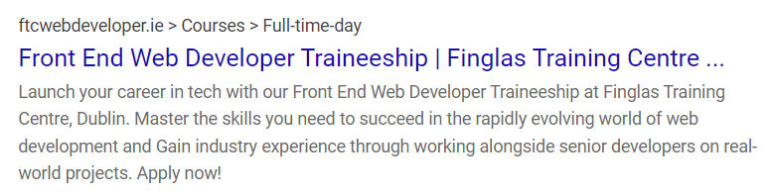

### Traineeship page

*Tittle Tag:*

Finglas Traineeship | Work alongside senior developers on real-world projects

*Meta Tag description:*

“Join our comprehensive front-end web developer traineeship program with hands-on training and mentorship from experienced professionals. By the end of the course, you'll have an impressive portfolio to work as a Junior Front End Developer. Apply now to take the first step towards your dream career: web development!

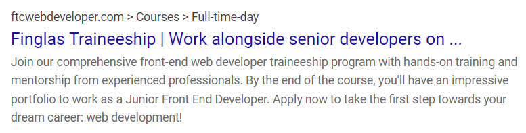

### About Course Page

*Tittle Tag:*

About Course | FTC Web Developer Traineeship – The Path to Success - Dublin



*Meta Tag description:*

“The Front-End Web Development Traineeship course at Finglas Training Centre is your key to a successful career in web development. Our program covers HTML, CSS, JavaScript, React and provides you with hands-on experience to build your skills and portfolio.”

### Certifications and Further Education Options Page

*Title Tag:*

Certifications | FTC Web Developer Traineeship – Boost Your Career - Dublin



*Meta Tag description:*

“Join our Front-End Web Developer Traineeship to gain industry relevant QQI certifications, hands-on work practice, and explore further education options to advance your career in web development.”

### Testimonials Page

*Title Tag:*

Front-End Web Development Traineeship Testimonials | Finglas Training Centre



*Meta Tag description:*

“Find out what our Front-End Web Developer Traineeship students have to say about their experiences with our program. Read our testimonials now.”

### Contact Us Page

*Title Tag:*

Contact Us | Get in Touch for Front-End Web Developer Traineeship | Finglas Training Centre, Web Development Career

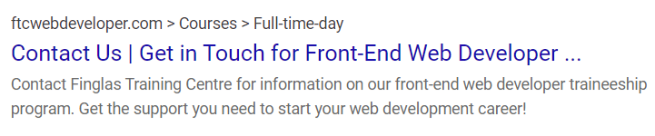

*Meta Tag description:*

“Contact Finglas Training Centre for information on our front-end web developer traineeship program. Get the support you need to start your web development career!”

### About FTC Page

*Tittle Tag:*

About FTC | Front End Web Developer Traineeship - Finglas Training Centre – Dublin



*Meta Tag description:*

“Programmes provide the knowledge and skills required to offer students the opportunity for employment and/or further or higher education.”

### Our Partners Page

*Tittle Tag:*

Our Partners | Front End Web Developer Traineeship - Finglas Training Centre – Dublin



*Meta Tag description:*

“**Courses provided by Finglas Training Centre are co-funded by the Irish Government and the European Social Fund (ESF).**”

## Keywords

**Primary Keywords**

|  |  |  |  |  |
| --- | --- | --- | --- | --- |
| **Front-End** | **Web Developer** | **Traineeship** | **Course** | **Certification** |

**Expand on primary keywords:**

|  |  |  |  |  |
| --- | --- | --- | --- | --- |
| HTML | Content Management  System | Professional  development | Free Course | QQI |
| CSS | Functional  Interface | Skill development | Online learning | Industry standard |
| JavaScript | Mock-ups | Learning opportunities | Coursework | Professional development |
| React | Portfolio | Work practice | Blended learning | Qualification |
| Frameworks |  | Mentorship | Educational program | Career advancement |
| Mobile-first Design |  | Practical training | Course material | Certified training |
| Responsive Web Design |  | Graduate program | Course program |  |
| Accessibility |  | Soft Skills | Course program |  |
|  |  | Work Practise | Course duration |  |
|  |  |  | Course in Dublin |  |

# Accessibility

We are building the FTC Web Developer website in accordance with the guidance of the National Disability Authority and European Union Regulation 2020 for the mutual benefit of its audience.

### Semantic markup

We will be using consistent semantic markup throughout the website like nav for navigation, main for the main section of the page where the content goes, footer for content of the footer, h1-h6 for heading and subheadings, and so on. This outlines a clear navigation structure for assistive technology like navigating around the page content through keyboard or mouse or other plugins that are designed for specific user use such as text-to-speech for users who have difficulty reading.

### Image

We will be providing descriptive text that describes the image for each image within the website. If the text is more than 100 characters, we will be using the longest attribute to provide a lengthy description of the image. This ensures the screen reader users have access to the descriptive text of the image instead of the image. In addition, if an image link is broken for some reason, the alternative text is displayed instead, which means there is always content in there: image or descriptive text.

### Colours

We have already picked suitable foreground and background colour for the website that is above the accessibility requirements. This contributes to the accessibility and presentation of the website by helping colour-blind users and in general all users since a good contrast ratio stands out the content like text from the background and makes it more readable.

### Search Engine Optimisation

We will optimize a website to make it accessible for search engines.

* Use descriptive page titles and headings. This will help search engine understand what each page about.
* Provide descriptive text for links. This will help search engine to understand where the link goes.
* Use descriptive URLs. This will help search engine to understand what each page is about.

### Speed

We will make sure our website is fast. Website speed is important for SEO and accessibility. We will make sure our website optimized for speed by compressing images and minimizing code.

# Timetable

The website will be built over the course of 5 days. Each person will build 2 pages that they provided contents for and layout during the project plan. We are going to have three meetings during the day to ensure we are accomplishing our daily tasks and a team member is not lifting behind.

|  |  |  |  |
| --- | --- | --- | --- |
| Date | Meeting | Meeting Duration | Tasks |
| Monday | 10:00AM  1:00PM  3:00PM | 15 minutes stand up  15 minutes check up  15 minutes check up | HTML of the website |
| Tuesday | 10:00AM  1:00PM  3:00PM | 15 minutes stand up  15 minutes check up  15 minutes check up | CSS of the website for mobile break point |
| Wednesday | 10:00AM  1:00PM  3:00PM | 15 minutes stand up  15 minutes check up  15 minutes check up | CSS of the website for tablet break point |
| Thursday | 10:00AM  1:00PM  3:00PM | 15 minutes stand up  15 minutes check up  15 minutes check up | CSS of the website for desktop break point |
| Friday | 10:00AM  1:00PM  3:00PM | 15 minutes stand up  15 minutes check up  15 minutes check up | Testing/debugging of the website |