FTC WEB DEVELOPER

https://www.ftcwebdeveloper.com

KSENIA PEDAKSOO

SIMONE SUSINO

LASZLO VARGA

MICHAL KRAWCZYK

NOEMIE HUSEMANN

April 17, 2023

Table of Contents

Table of figures 4

Website Name and Website URL 6

Objective of the website 7

Target Audience 8

Price plan 9

Site Structure and Flow Chart 12

Wireframes 14

Mobile - Wireframe 15

Homepage 15

404 16

About 17

Course Information 18

Entry Requirements 19

Certifications 20

How to Apply 21

Employment Opportunity 22

FAQ 23

Contact 24

Tablet – Wireframe 25

Homepage 25

404 26

About 27

Course Information 28

Entry Requirements 29

Certifications 30

How to Apply 31

Employment Opportunity 32

FAQ 32

Contact 33

Desktop – Wireframe 34

Homepage 34

404 35

About 36

Course Information 37

Entry requirements 38

Certifications 39

How to Apply 40

Employment Opportunity 41

FAQ 42

Contact 43

Website Design 44

Colors 44

Font 46

Text sizes 49

Content used on the website 50

Header 50

Footer 50

Homepage 51

404 53

About 54

Course Information 56

Entry Requirements 60

Certifications 61

How To Apply 64

Employment Opportunity 66

FAQ 67

Contact 69

Images used on the website 70

Footer 70

Homepage 70

404 73

About 74

Course Information 75

Entry Requirements 78

Certifications 79

How To Apply 80

Employment Opportunity 81

FAQ 82

Contact 83

Copyrights 84

Initial SEO 86

URLs: 86

Titles and Meta 87

Homepage 87

404 87

About 87

Course Information 88

Entry Requirements 88

Certifications 88

How To Apply 89

Employment Opportunity 89

FAQ 89

Contact 90

Keywords 90

Initial Accessibility 92

Timetable to Complete 94

# Table of figures

Figure 1 - Hostinger Plan 9

Figure 2 - Hostingireland Plan 10

Figure 3 - FLOW Chart 12

Figure 4 - Index Page – Mobile Wireframe 15

Figure 5 - 404 Page – Mobile Wireframe 16

Figure 6 - About Page – Mobile Wireframe 17

Figure 7 - Course Information Page – Mobile Wireframe 18

Figure 8 - Entry Requirements Page – Mobile Wireframe 19

Figure 9 - Certifications Page - Mobile Wireframe 20

Figure 10 - How To Apply Page - Mobile Wireframe 21

Figure 11 - Employment Opportunity Page - Mobile Wireframe 22

Figure 12 - FAQ Page - Mobile Wireframe 23

Figure 13 - Contact Page - Mobile Wireframe 24

Figure 14 - Index Page - Tablet Wireframe 25

Figure 15 - 404 Page - Tablet Wireframe 26

Figure 16 - About Page - Tablet Wireframe 27

Figure 17 - Course Information Page - Tablet Wireframe 28

Figure 18 - Entry Requirements Page - Tablet Wireframe 29

Figure 19 - Certifications Page - Tablet Wireframe 30

Figure 20 - How To Apply Page - Tablet Wireframe 31

Figure 21 - Employment Opportunity Page - Tablet Wireframe 32

Figure 22 - FAQ Page - Tablet Wireframe 32

Figure 23 - Contact page - Tablet Wireframe 33

Figure 24 - Index Page - Desktop Wireframe 34

Figure 25 - 404 Page - Desktop Wireframe 35

Figure 26 - About Page - Desktop Wireframe 36

Figure 27 - Course Information Page - Desktop Wireframe 37

Figure 28 - Entry Requirements Page - Desktop Wireframe 38

Figure 29 - Certifications Page - Desktop Wireframe 39

Figure 30 - How To Apply Page - Desktop Wireframe 40

Figure 31 - Employment Opportunity Page - Desktop Wireframe 41

Figure 32 - FAQ Page - Desktop Wireframe 42

Figure 33 - Contact Page - Desktop Wireframe 43

Figure 34 - Color Palette Option 1 44

Figure 35 - Color Blind Safe Checker Option 1 44

Figure 36 - Color Palette Option 2 45

Figure 37 - Color Gradient 45

Figure 38 – Color Blind Safe Checker Option 2 45

Figure 39 - Lato vs Helvetica 47

Figure 40 - Lato vs Roboto 47

Figure 41 - Helvetica vs Roboto 48

# Website Name and Website URL

**Name:** FTC WEB DEVELOPER

**URL/Domain:** https://www.ftcwebdeveloper.com

Team Members:

* KSENIA PEDAKSOO (Team leader)
* SIMONE SUSINO
* LASZLO VARGA
* MICHAL KRAWCZYK
* NOEMIE HUSEMANN

# Objective of the website

The website’s objective is to equip potential trainees with plenty of information on the Frontend Web Development course if they choose to enrol while offering information on the Finglas Training Centre.

# Target Audience

The target audience is anyone who is dedicated and has an interest in frontend web development. Whether they have much or limited experience or want a foot in the door of the tech world or wish to add new skills to their resume, the target audience is a broad one.

# Price plan

The Domain is supplied by the Client. Our task was to find a suitable Hosting plan.

After careful research and analysis of your domain requirements, we are excited to present two outstanding hosting plan options tailored to meet your needs. Our recommendations come from two reputable providers: Hostinger and HostingIreland. We have compared their offerings to ensure that you receive the best value and features for your website.

**Option A: Hostinger - Affordable and Feature-Rich Hosting**

Hostinger offers two exceptional plans perfect for personal websites or small to medium-sized businesses. To learn more about their offerings, visit their website at https://www.hostinger.com/.

Premium Web Hosting: Designed for personal websites, this plan costs just $2.99/month and offers impressive features such as unlimited bandwidth and a free SSL certificate to ensure a seamless browsing experience for your visitors.

Business Web Hosting: Catering to small and medium-sized businesses, this plan is priced at an affordable $3.99/month and offers additional features to support your growing business needs.

For reference, you can visit Hostinger's website at <https://www.hostinger.com/>.

Figure 1 - Hostinger Plan

**Option B: HostingIreland - Reliable and Scalable Hosting Solutions**

HostingIreland provides two versatile hosting plans, perfect for personal sites, blogs, or those looking to optimize their WordPress experience. Explore their offerings at https://www.hostingireland.ie/hosting.php.

Lite Hosting Plan: Ideal for personal websites and blogs, this plan starts at €4.48 for the first month, followed by €8.95/month. The first-year cost is €40.48, with an annual renewal rate of €80.95, ensuring you receive consistent and reliable service.

WordPress Hosting Plan: Specifically optimized for WordPress websites, this plan costs €60.98 for the first year and €121.95 annually thereafter. This option is perfect for those seeking to enhance their WordPress experience and future-proof their website.

For more information, you can visit HOSTINGIRELAND's website at <https://www.hostingireland.ie/hosting.php>.

Figure 2 - Hostingireland Plan

Our Recommendation

After evaluating both providers, we believe Hostinger's plans offer superior value due to their competitive pricing, unlimited bandwidth, and free SSL certificates. These features ensure that your website remains attractive and professional, providing a smooth experience for your visitors.

Whichever option you choose, rest assured that both Hostinger and HostingIreland deliver reliable and high-quality hosting services to support your website's growth and success.

# Site Structure and Flow Chart

The website consists of a total of ten pages, organized into three levels.

The first level includes the Homepage and the 404 page.

The second level includes the following pages: About, Course Information, How to Apply, Employment Opportunity, FAQ, and Contact.

Finally, the third level includes the pages for Entry Requirements and Certifications. To access the pages for Entry Requirements and Certifications, visitors must first navigate to the Course Information page.

Figure 3 - FLOW Chart

The folder structure for the project will consist of a main folder named after the project, with subfolders for html, css, js, and images. The css folder will contain a style.css file for the CSS code, while the js folder will contain app.js file for the JavaScript code.

The file naming convention for the project will follow a lowercase, hyphen-separated format:

* Homepage: index.html
* 404: 404.html
* About: about.html
* Course Information: course-information.html
* Entry Requirements: entry-requirements.html
* Certifications: certifications.html
* How to Apply: how-to-apply.html
* Employment Opportunity: employment-opportunity.html
* FAQ: faq.html
* Contact: contact.html

# Wireframes

Based on statistics for screen resolutions, we can identify the typical sizes for mobile devices, tablets, and desktops.

Mobile devices have a screen resolution of around 360 pixels[1], while tablets have a resolution of 768 pixels[2], and desktops have a resolution of 1366 pixels[3]. Therefore, to optimize website performance, we can provide three different sizes of images based on screen resolution.

These sizes would be:

1. For screen resolutions below 640 pixels, optimized for mobile devices.
2. For screen resolutions between 640 pixels and 1024 pixels, optimized for tablets.
3. For screen resolutions over 1024 pixels, optimized for desktops.

## Mobile - Wireframe

### Homepage

Figure 4 - Index Page – Mobile Wireframe

### 404

Figure 5 - 404 Page – Mobile Wireframe

### About

Figure 6 - About Page – Mobile Wireframe

### Course Information

Figure 7 - Course Information Page – Mobile Wireframe

### Entry Requirements

Figure 8 - Entry Requirements Page – Mobile Wireframe

### Certifications

Figure 9 - Certifications Page - Mobile Wireframe

### How to Apply

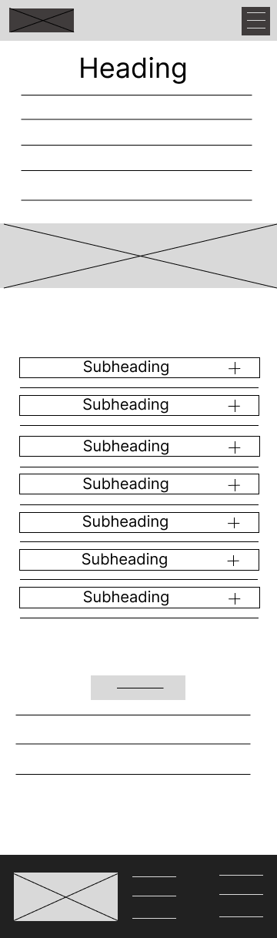

Figure 10 - How To Apply Page - Mobile Wireframe

### Employment Opportunity

Figure 11 - Employment Opportunity Page - Mobile Wireframe

### FAQ

Figure 12 - FAQ Page - Mobile Wireframe

### Contact

Figure 13 - Contact Page - Mobile Wireframe

## Tablet – Wireframe

### Homepage

Figure 14 - Index Page - Tablet Wireframe

### 404

Figure 15 - 404 Page - Tablet Wireframe

### About

Figure 16 - About Page - Tablet Wireframe

### Course Information

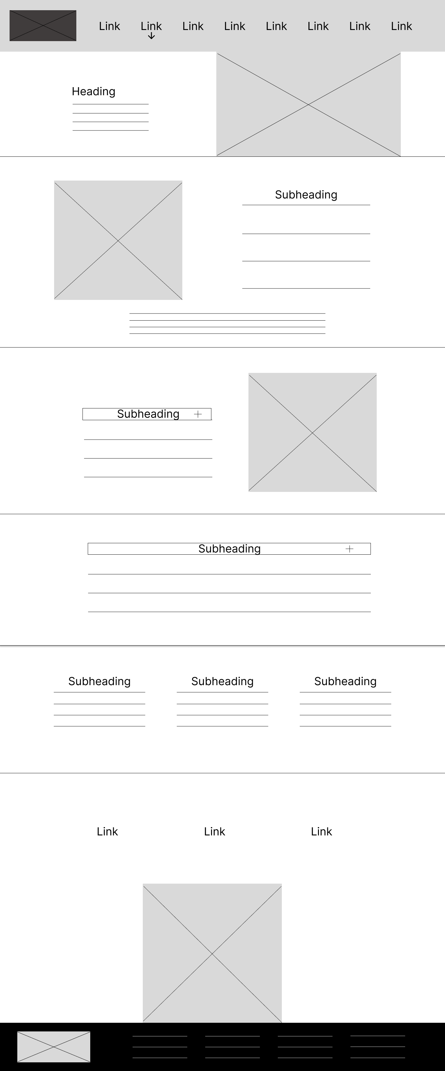

Figure 17 - Course Information Page - Tablet Wireframe

### Entry Requirements

Figure 18 - Entry Requirements Page - Tablet Wireframe

### Certifications

Figure 19 - Certifications Page - Tablet Wireframe

### How to Apply

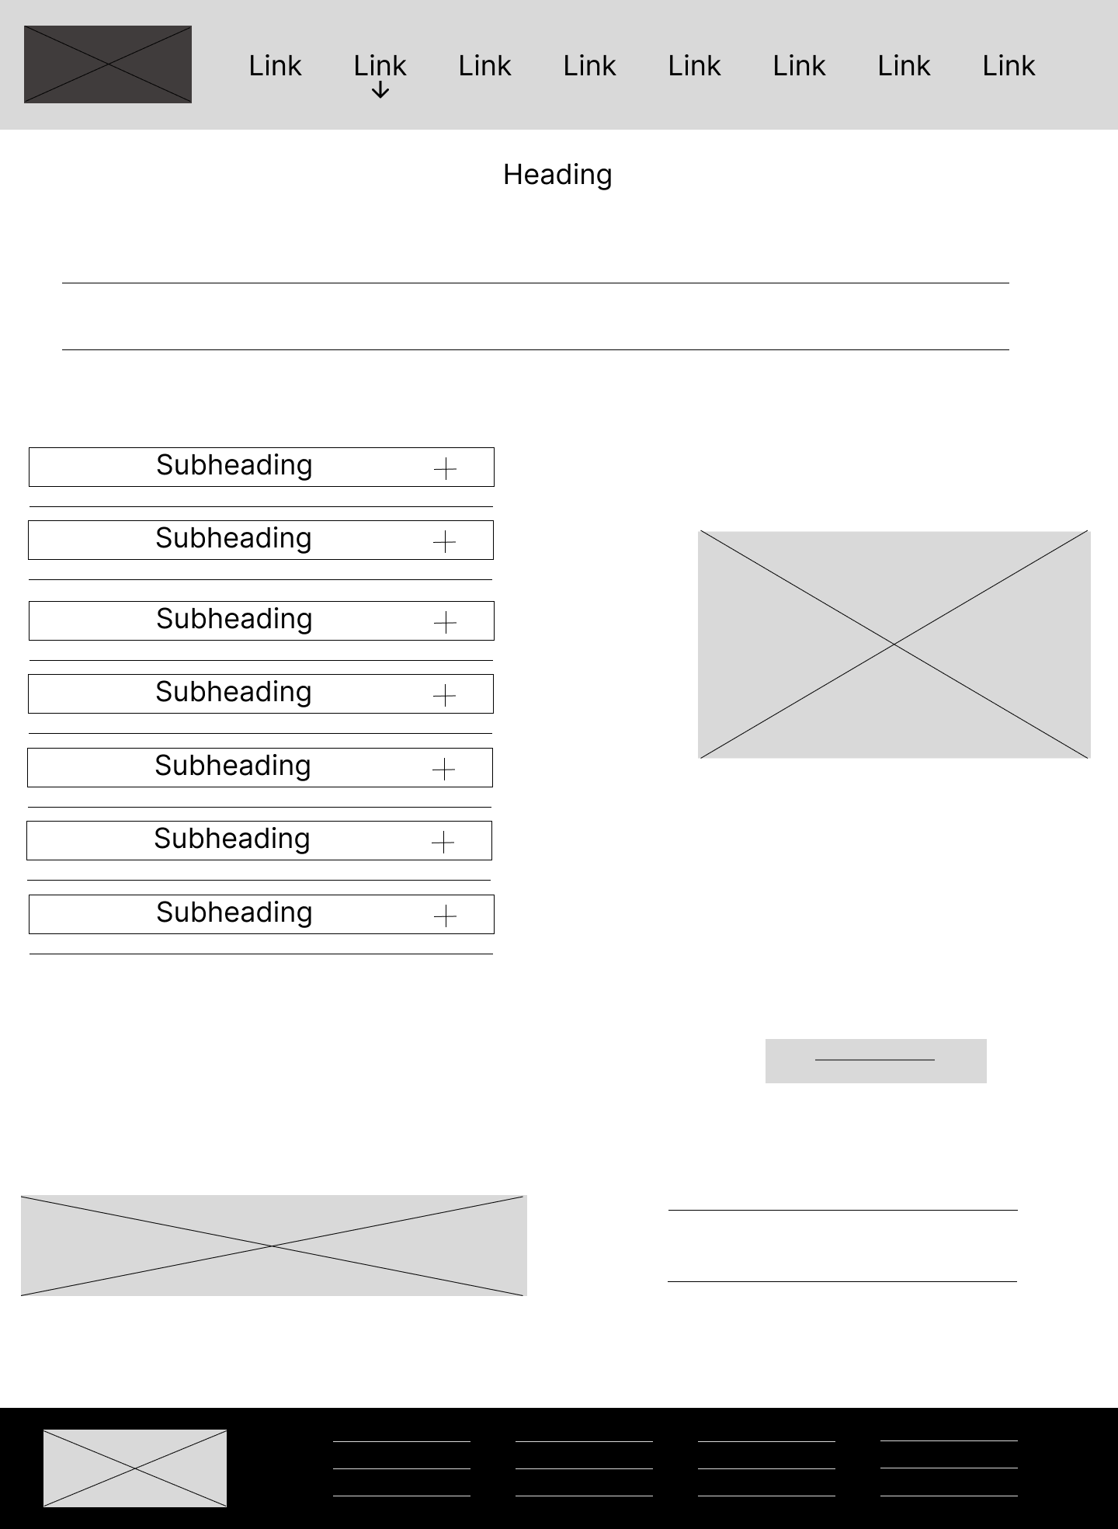

Figure 20 - How To Apply Page - Tablet Wireframe

### Employment Opportunity

Figure 21 - Employment Opportunity Page - Tablet Wireframe

### FAQ

Figure 22 - FAQ Page - Tablet Wireframe

### Contact

Figure 23 - Contact page - Tablet Wireframe

## Desktop – Wireframe

### Homepage

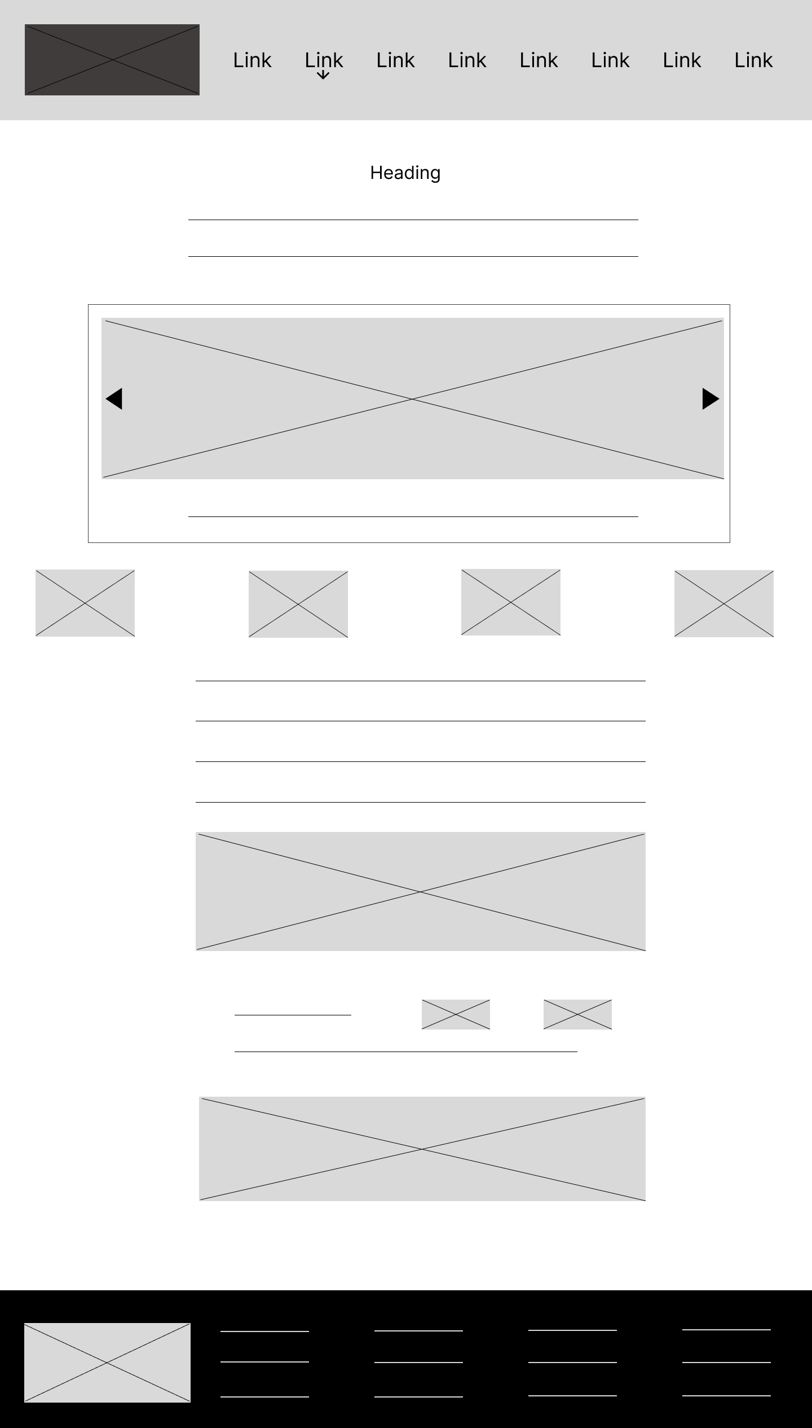

Figure 24 - Index Page - Desktop Wireframe

### 404

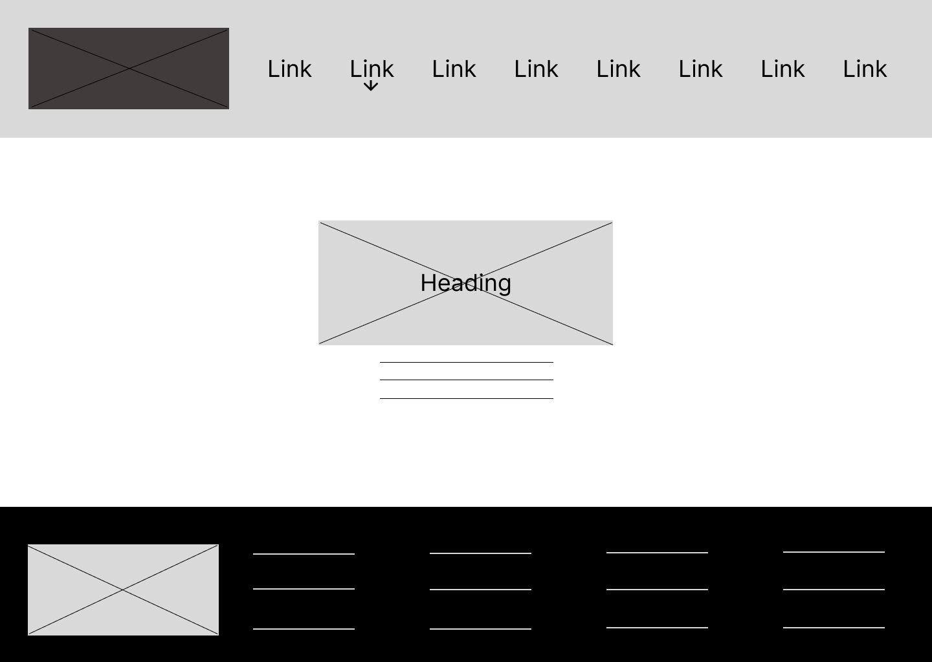

Figure 25 - 404 Page - Desktop Wireframe

### About

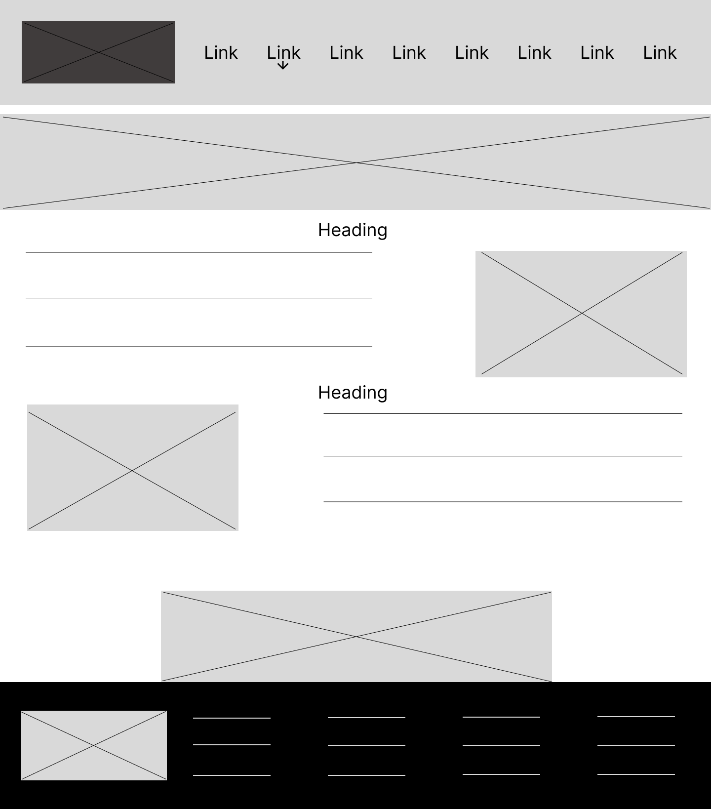

Figure 26 - About Page - Desktop Wireframe

### Course Information

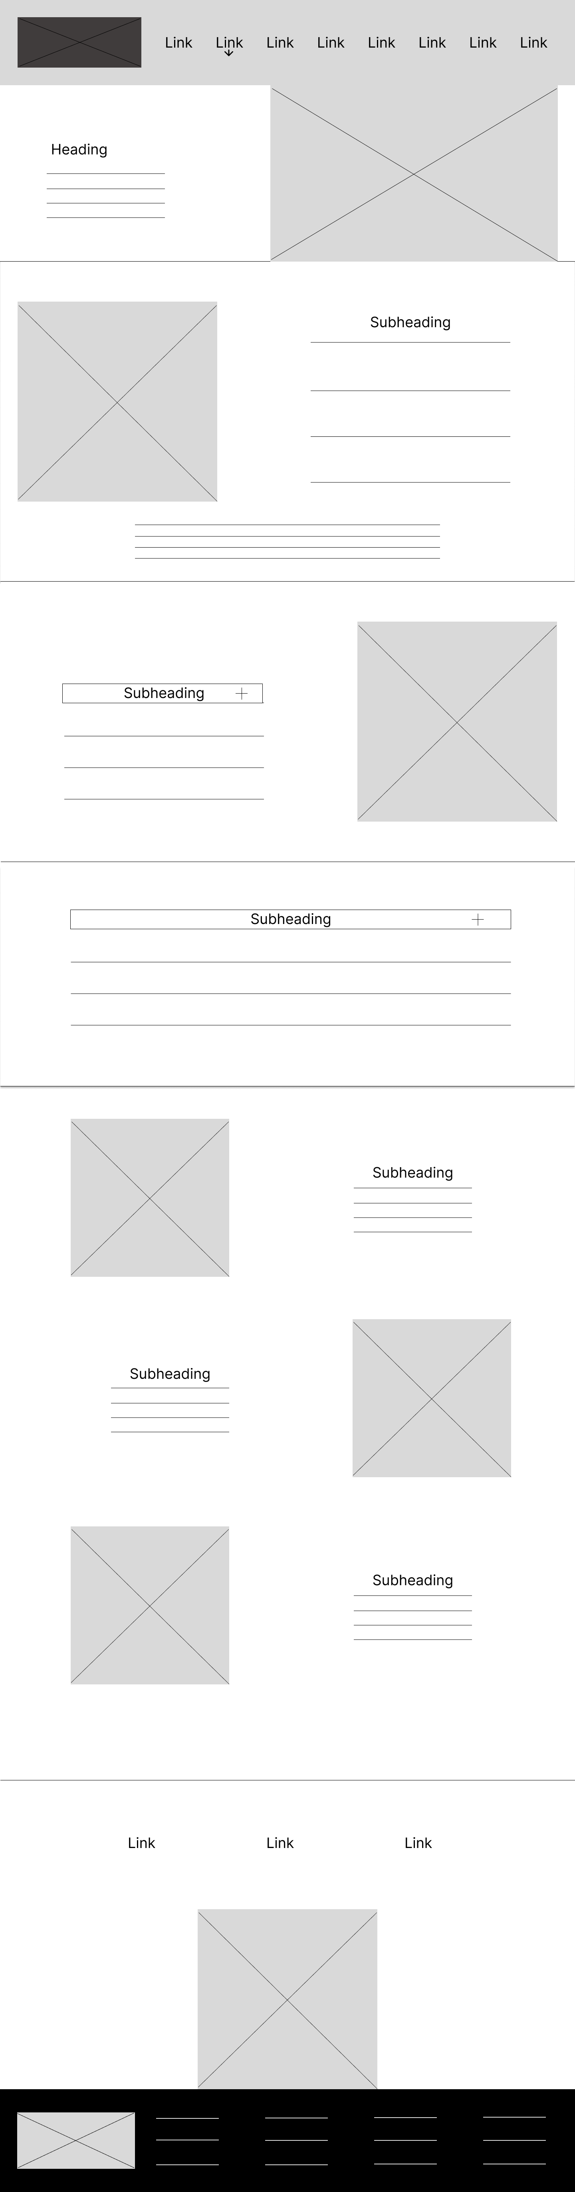

Figure 27 - Course Information Page - Desktop Wireframe

### Entry requirements

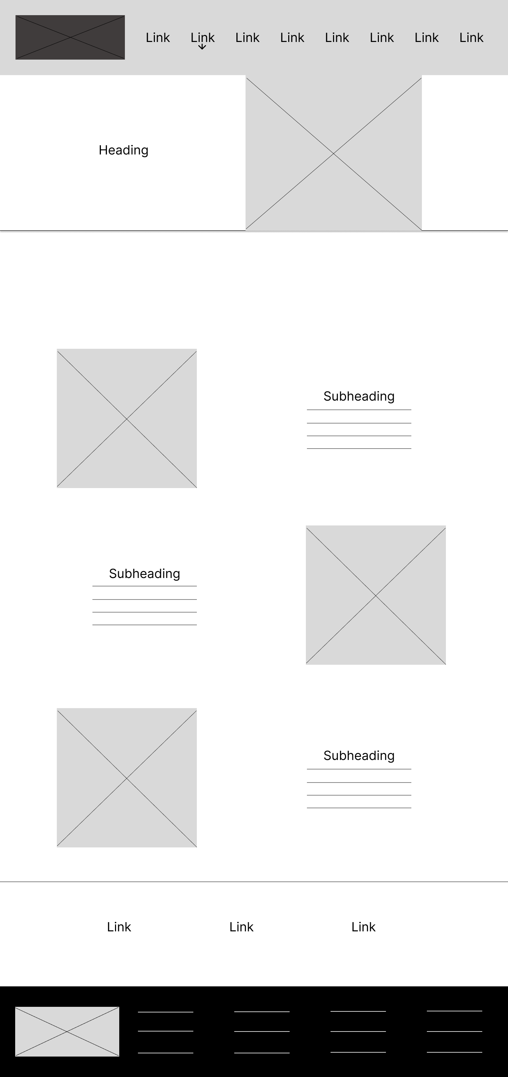

Figure 28 - Entry Requirements Page - Desktop Wireframe

### Certifications

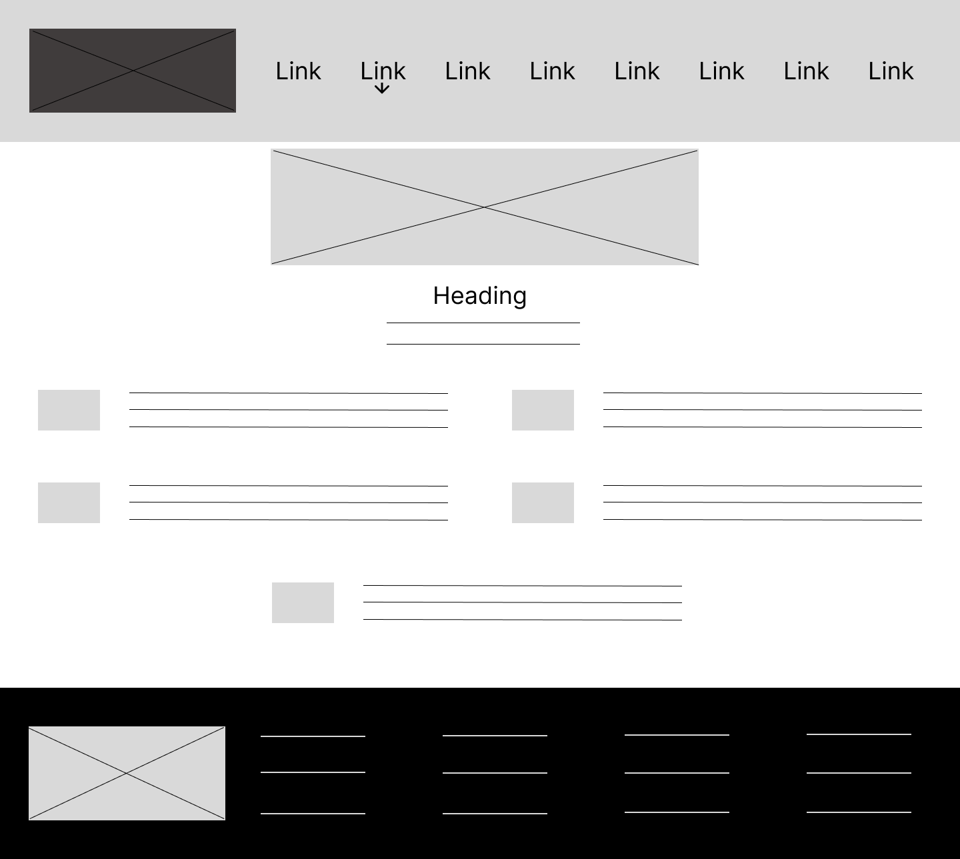

Figure 29 - Certifications Page - Desktop Wireframe

### How to Apply

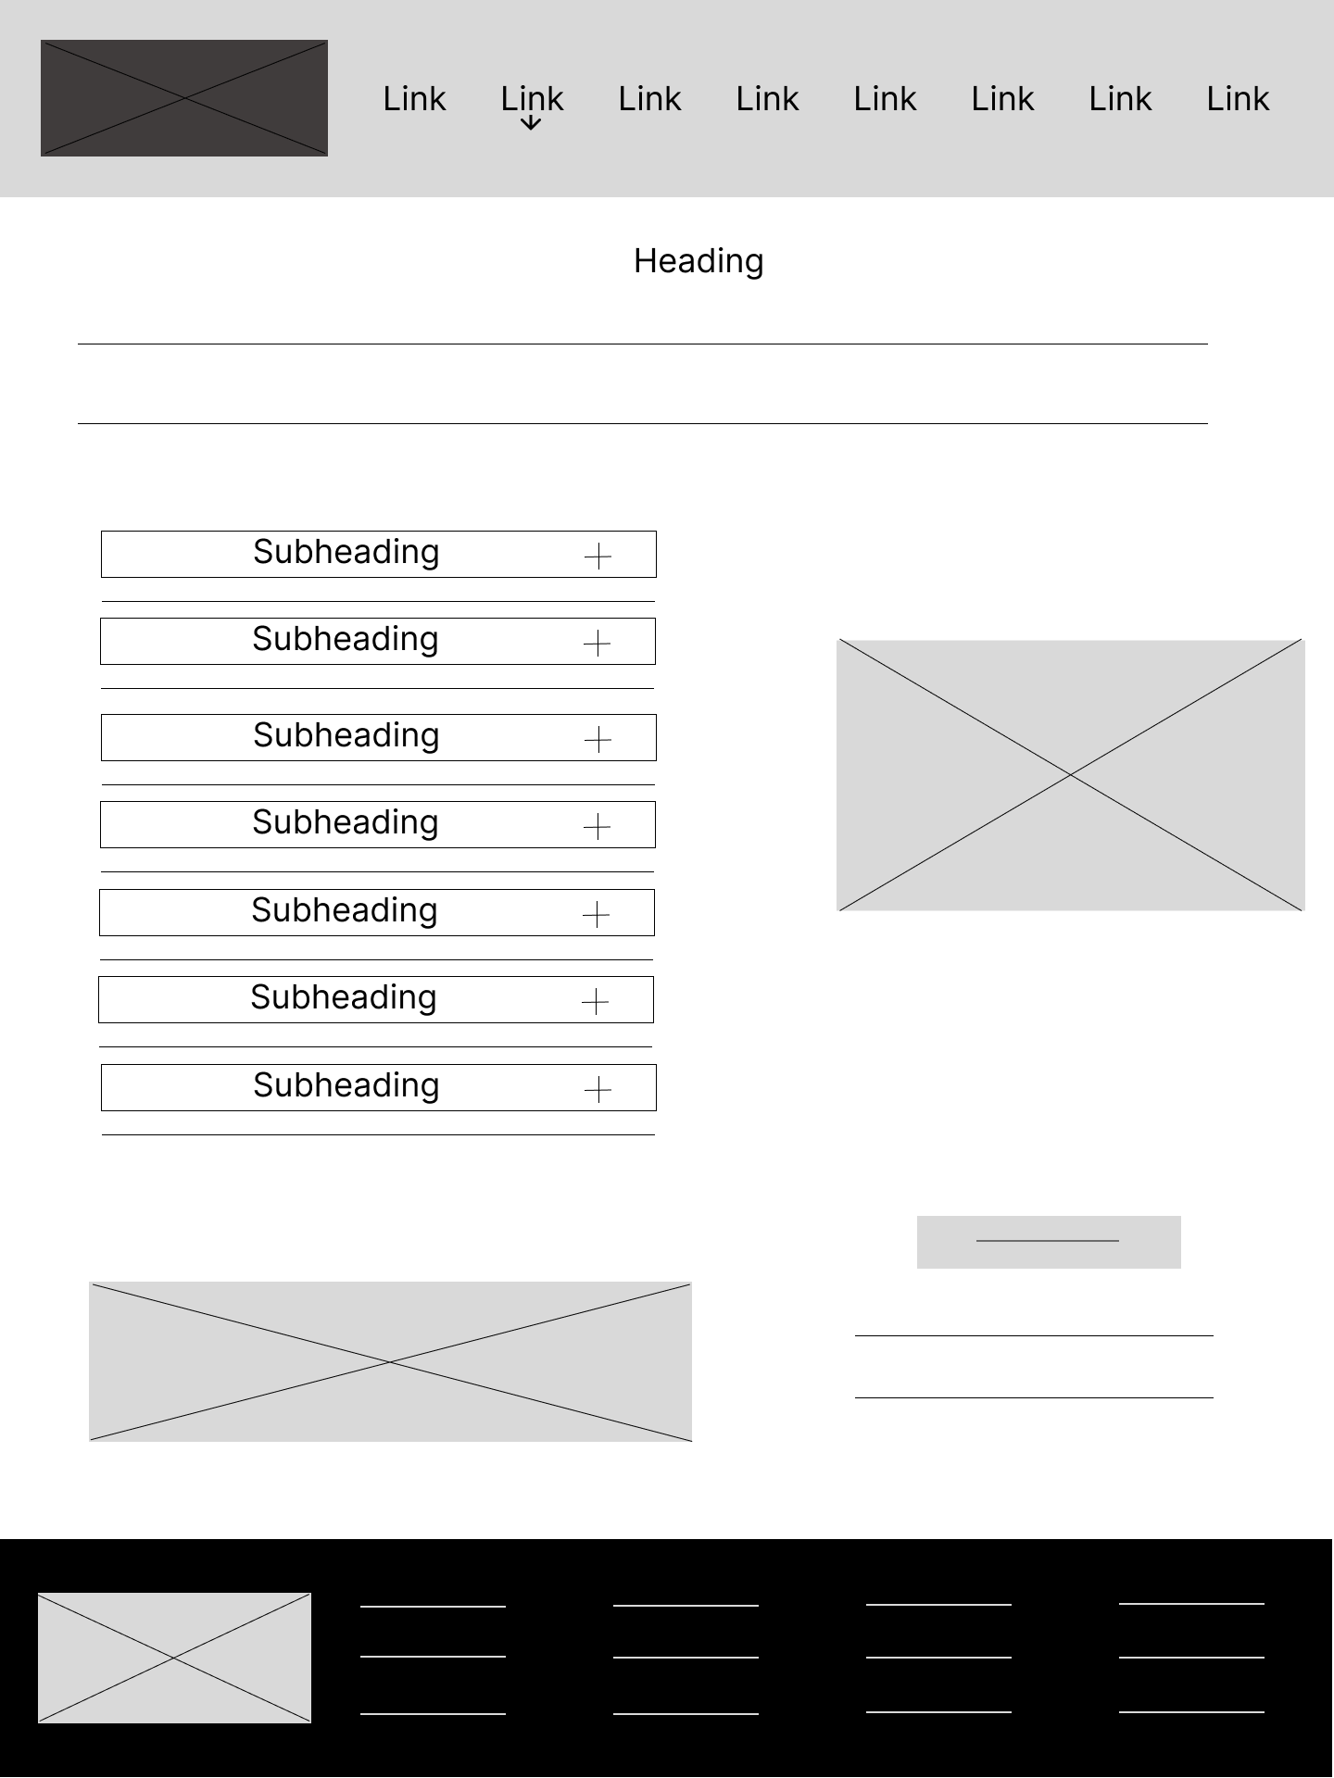

Figure 30 - How To Apply Page - Desktop Wireframe

### Employment Opportunity

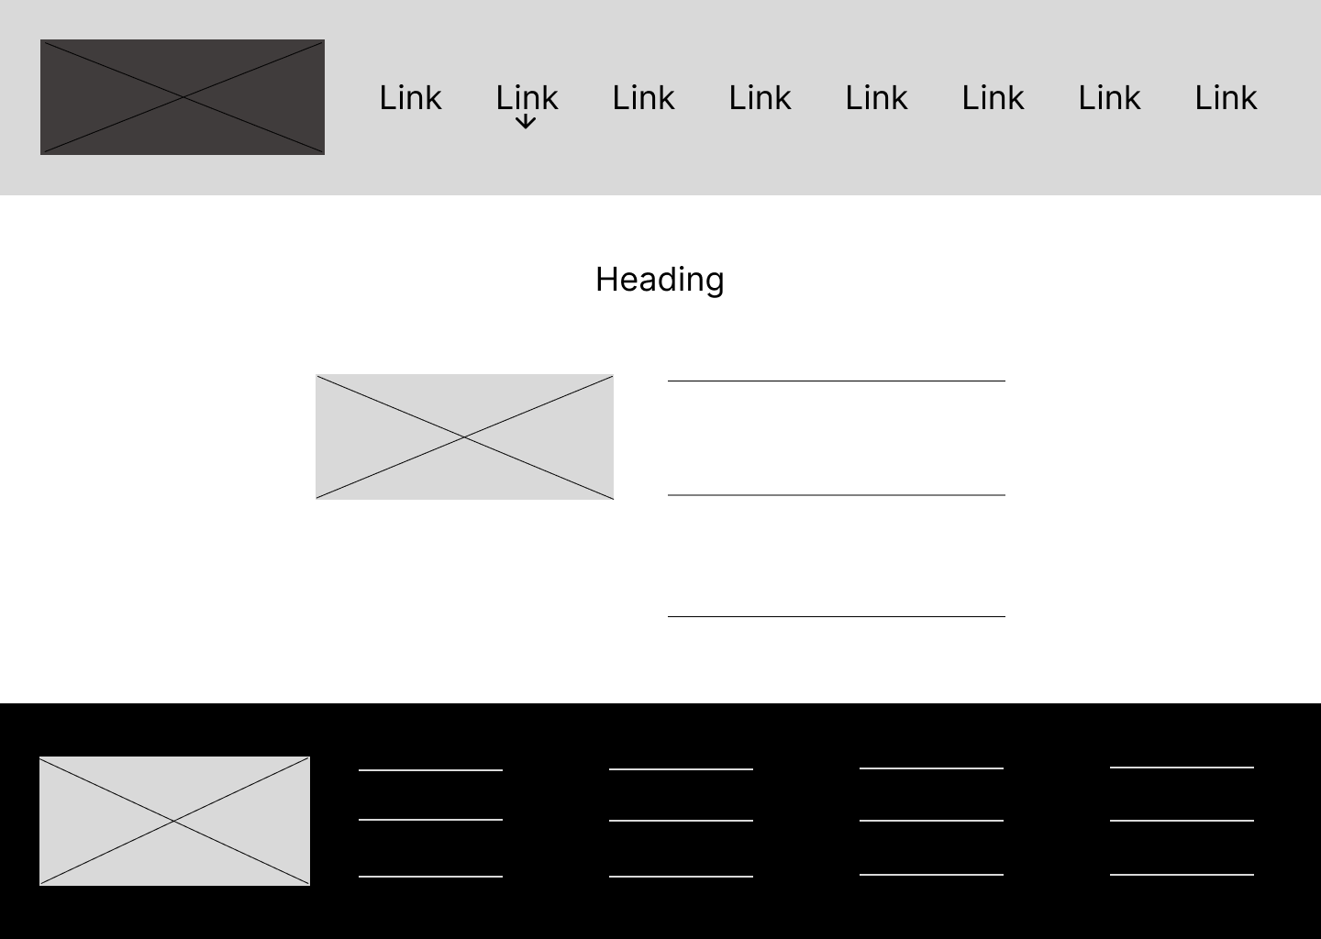

Figure 31 - Employment Opportunity Page - Desktop Wireframe

### FAQ

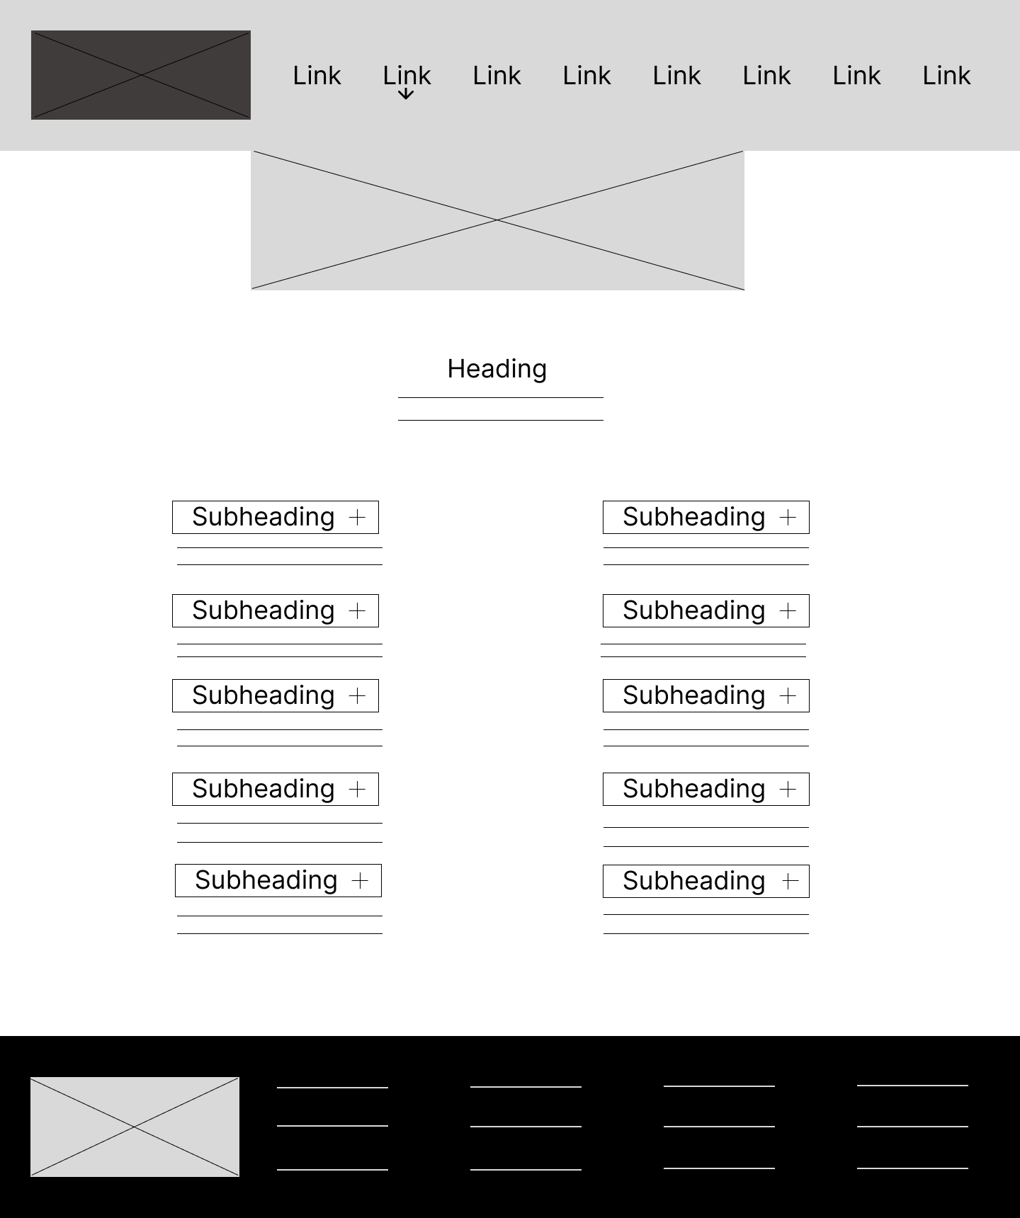

Figure 32 - FAQ Page - Desktop Wireframe

### Contact

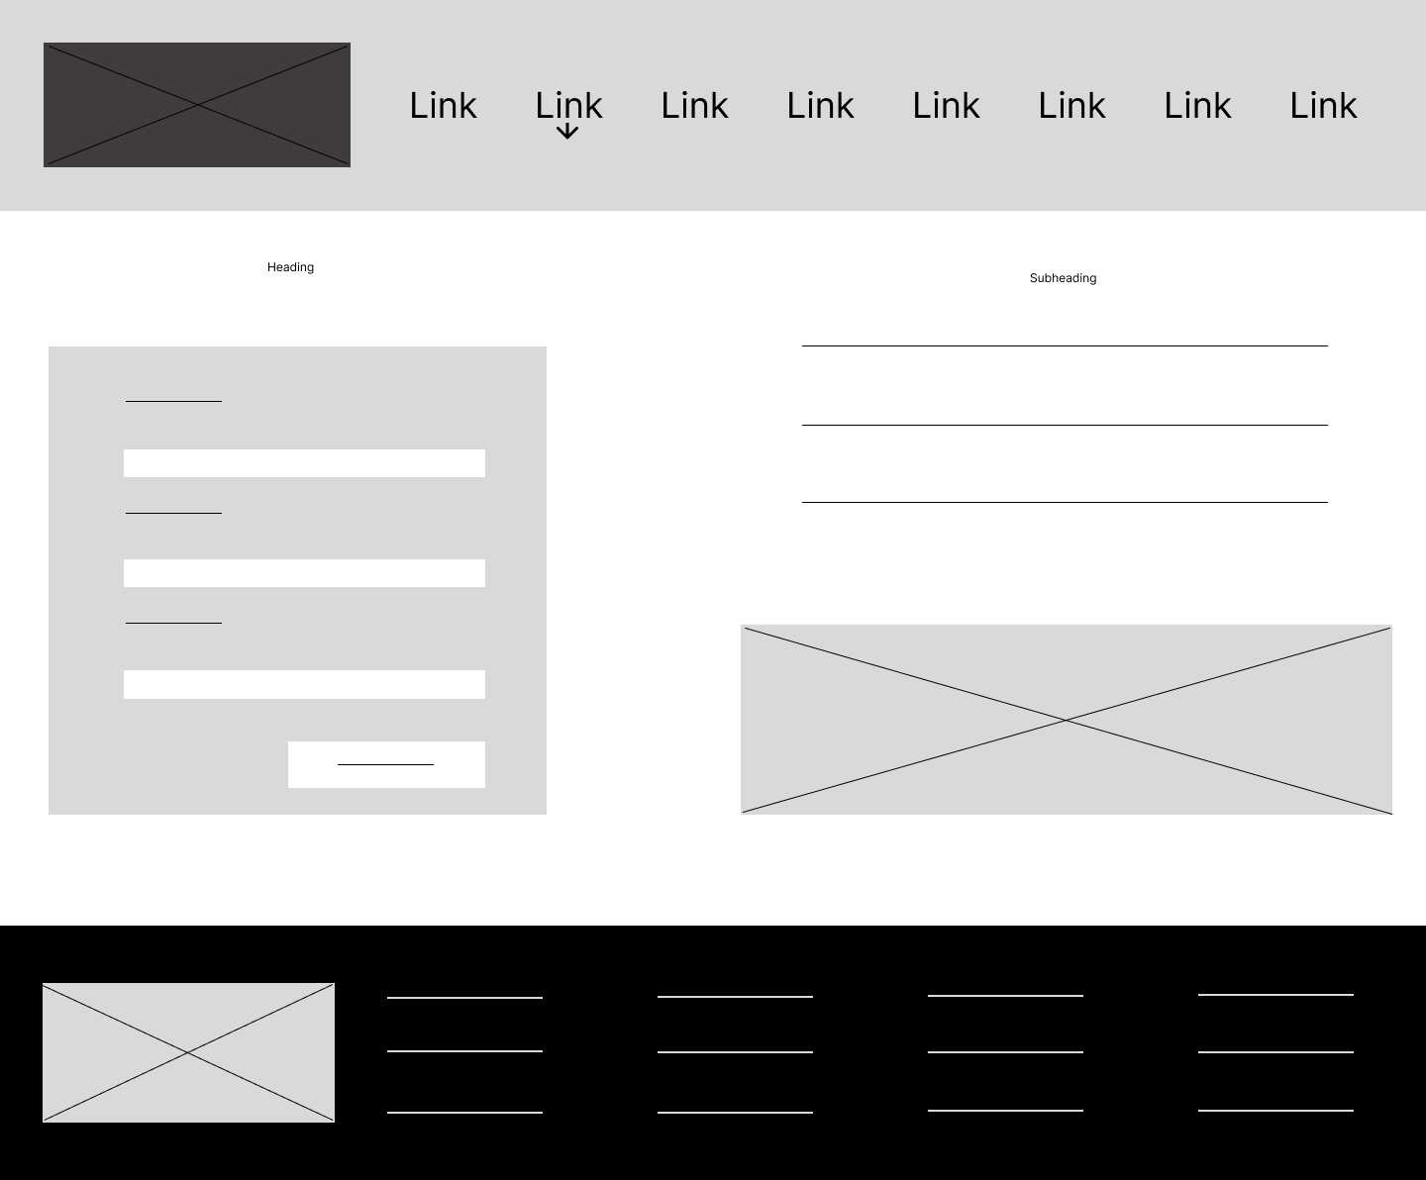

Figure 33 - Contact Page - Desktop Wireframe

# Website Design

## Colors

We are proposing two Color Schemes. They both Color Blind Safe and pass the minimum requirements of Web Content Accessibility Guidelines (**WCAG**) **2.1 Level** **AA.**

The first option for the color scheme:

The Color Palette for the FTC Web Developer Traineeship website has a White Smoke (#F5F5F5) background, dark gray primary color for text (Nero #212121), Gray (#757575) secondary color, deep purple (Daisy Bush #512DA8) links and buttons (slightly darker purple hover states), bright orange (Outrageous Orange #FF5722) accent color, and dark orange for error or warning messages.

The Color Scheme strikes a balance between aesthetic appeal and functional design, creating a positive user experience.

Figure 34 - Color Palette Option 1

Color Blind Safe checker:

Figure 35 - Color Blind Safe Checker Option 1

The second option for the color scheme:

The Color Palette for the FTC Web Developer Traineeship website has a White Smoke (#F5F5F5) background, dark gray primary color for text (Nero #212121) when Dodger Blue (#2196F3) and Daisy Bush (#512DA8) colors act as an accent, error messages, and emphasizing links.

The Blue Color Scheme creates a user-friendly experience and matches the general FTC logos’ colors. Apart from this, the Palette symbolizes professionalism and responsibility.

Figure 36 - Color Palette Option 2

 + Gradient (mix of #2196F3 and #512DAB):

Figure 37 - Color Gradient

Color Blind Safe checker:

Figure 38 – Color Blind Safe Checker Option 2

## Font

We have selected a font combination of Lato, Roboto, Helvetica, and Sans-serif for our website design. This selection is based on several factors, including readability, versatility, modern aesthetics, compatibility with web use, and being open-source fonts.

Helvetica – Body font;

Lato, Roboto – Headings;

Readability:

Clean, simple letterforms and generous spacing between characters. This makes them easy to read on screens of various sizes and resolutions, improving the user experience.

Versatility:

Both fonts come with multiple weights and styles, from thin to bold and italic, allowing for a wide range of typographic options to suit different design needs. This versatility enables you to create a consistent and harmonious visual hierarchy in content.

Modern Aesthetics:

Minimalist appearance, making them suitable for contemporary web design. They convey a sense of professionalism and sophistication, which can enhance the overall look and feel of a website.

Compatibility:

Available through Google Fonts, which means they are optimized for web use and compatible with most browsers and devices. This ensures a consistent viewing experience for users across different platforms.

Open-Source:

Both are open-source fonts which means they are free to use, modify, and distribute without restrictions. This makes them a cost-effective choice for website design projects, especially for small businesses or individuals on a tight budget.

Figure 39 - Lato vs Helvetica

Figure 40 - Lato vs Roboto

Figure 41 - Helvetica vs Roboto

## Text sizes

To ensure accessibility and responsiveness in our website design, we have decided our preferred text sizes for the headings and body text.

* H1 – for main headings or page titles in range from 2rem (32px) – 3rem (48px)
* H2 – for subheadings or section titles 1.5rem (24px) – 2.2rem (34px)
* H3 - for smaller subheadings or subsections titles 1.1rem -1.5(rem)
* Body text in range from .8rem - 1.1rem

To achieve consistent font sizes and responsive design on our website, we use relative measurements such as rem and maintain the same font sizes across all pages. This approach ensures that users can easily adjust the font size in their browser, and the website will adapt the font size automatically to fit different screen sizes and resolutions. Additionally, rem values are taken from the root element, providing a consistent size reference throughout the website.

# Content used on the website

## Header

FTC Web Developer Traineeship

* About
* Course Information
* How To Apply
* Employment Opportunity
* FAQ
* Entry Requirements
* Certifications
* Contact

## Footer

Tel: 01 8140200

Fax: 01 8346336

Email: [finglasday@ftc.cdetb.ie](mailto:finglasday@ftc.cdetb.ie)

CDETB Finglas Training Centre,

Poppintree Industrial Estate,

Jamestown Road,

Finglas, Dublin 11

D11KW18

Data Protection (GDPR)

Facebook

Twitter

Instagram

Ftcwebdeveloper.com

<https://finglastrainingcentre.ie/>

© 2023 FTC Web Developer Traineeship. All Rights Reserved.

## Homepage

Welcome to the Web Developer Course

This course will provide the web development IT sectors with learners skilled in all basic aspects of front end development using:

* Hypertext Mark-up Language (XHTML/HTML5)
* Cascading Style Sheets (CSS)
* Responsive Web Design (RWD)
* Content Management Systems (CMS)
* JavaScript, jQuery, React

Learners will be able to take designs/mock-ups and create modern, clean, mobile first responsive, functional, and beautiful interfaces using HTML, CSS and JavaScript.

Learners will also gain experience in project management, working to deadlines, take and give direction and contribute to projects, along with creating their own online portfolio.

**HTML** (Hypertext Markup Language) is the most basic building block of the Web. It defines the meaning and structure of web content (MDN, 2023).

**Cascading Style Sheets** (**CSS**) is stylesheet language used to describe the presentation of a document written in HTML or XML. (MDN, 2023)

**JavaScript** (**JS**) is a lightweight, interpreted, or just-in-time compiled programming language with first-class function (MDN, 2023).

React (MDN, 2023) is a library for building user interfaces. React is not a framework – it's not even exclusive to the web. It's used with other libraries to render to certain environments.

A wireframe (Assistant Secretary for Public Affairs, 2013) is a two-dimensional illustration of a page’s interface that specifically focuses on space allocation and prioritization of content, functionalities available, and intended behaviors. For these reasons, wireframes typically do not include any styling, color, or graphics. Wireframes also help establish relationships between a website’s various templates.

**SEO** (Search Engine Optimization) is the process of making a website more visible in search results, also termed improving search rankings (MDN, 2023).   
**The importance of prototyping.**

Website prototypes are interactive demos of a website. These are often used to gather feedback from project stakeholders early in the project lifecycle before the project goes into final development (Rees, 2023).

Our web development course is designed to equip learners with recognized qualifications and employment relevant skills. All modules are certified leading to QQI (FETAC) Awards at level 6 or to industry accepted accreditation and include a work placement element. The duration of training can vary ranging from two weeks to one year and run all year round.

## 404

We're sorry, but it looks like the page you're trying to access doesn't exist. This could be because of a few reasons:

* The URL may be incorrect or outdated.
* The page may have been moved or deleted.
* There may be a technical issue with our website.

## About

Empower Your Future with Front End Web Developer Traineeship Program

Welcome to our Front-End Web Developer Traineeship Program - your gateway to a rewarding career in web development. This year long program has been meticulously designed to equip you with the essential skills and knowledge required to excel in the dynamic world of front-end development.

Our comprehensive curriculum covers everything from the fundamentals of XHTML/HTML5 and Cascading Style Sheets (CSS) to more advanced concepts like Responsive Web Design (RWD), Content Management Systems (CMS), JavaScript, jQuery, and React. You'll learn how to transform design mock-ups into modern, clean, and responsive web interfaces using HTML, CSS, and JavaScript.

Throughout the traineeship, you'll gain hands-on experience in project management, working with deadlines, and collaborating on projects, ensuring you're prepared for real-world challenges. Plus, you'll have the opportunity to create your very own online portfolio, showcasing your skills and accomplishments to potential employers.

Our entry requirements are designed to welcome passionate individuals who are eager to build websites and make a mark in the web development industry. You'll need a Leaving Certificate Standard or equivalent, or progression from a relevant related course, along with a flair for troubleshooting, a keen desire to work in this sector, and the ability to work both independently and as part of a team.

Upon completing the traineeship, you'll be awarded a QQI Minor Award Level 6 in Digital Media Production, along with certifications in Work Experience, Project Management, Web Authoring, Web Development, and Interactive Scripting. These qualifications will open doors to employment opportunities as a Junior Front End Web Developer or pave the way for further education in Web Development or Multimedia Development.

Join our Front-End Web Developer Traineeship Program today and take your first step towards a successful career in web development. Visit the "How to Apply" page for more information and application guidelines. Empower your future with us and make your mark on the digital landscape!

About Finglas Training Centre

Finglas Training Centre, CDETB is located off the Jamestown Road in Finglas, Dublin 11. The Centre provides full, part-time, evening, apprenticeship, and community-based courses for up to 500+ students in areas such as Information Communication Technology, Design, Renewable Energy, Aircraft Maintenance, Software Development, Engineering and Business.

Courses offered provide training to those who are entering the labour market for the first time and those who wish to upskill or change their career path. Courses are designed to equip learners with the skills necessary both to progress to further training and ultimately to employment.

All full-time courses offer certification leading to a range of awards as certified by awarding bodies including QQI, City & Guilds, CompTIA, Oracle, Microsoft etc. Details of all courses offered may be accessed either using the search facility, or alternatively, the full course listings for Day, Night, and Community.

## Course Information

Course Title: Front End Web Development Traineeship QQI Level 6 Minor Award

Course Code: 296449

Course Aim

This course is designed to provide trainees with the knowledge and practical skills necessary to build effective, engaging, and user-friendly websites. Trainees will learn key programming languages such as HTML, CSS, and JavaScript, and will become proficient in the use of web development tools and frameworks. The program is highly practical, with a focus on real-world projects and hands-on experience. Successful completion can provide trainees with the knowledge and skills needed to pursue a career in web development or related fields.

Further education options include progressing to a third-level course in web development or multimedia development.

 Course content

Induction   
Extensible Hyper Text Markup Language XHTML   
Cascading Style Sheets CSS   
JavaScript   
Cross Browser Development   
Testing and debugging   
Content Management Systems   
Project Management   
Job Seeking Skills and creation of a curriculum vitae   
Work Practice

On the course

**Web Authoring** and **Web Development** modules focus on developing websites using different tools and techniques, including wire-framing, content management systems, and programming languages.

**Interactive Scripting** module will go over the basics of programming for scripting and the most effective use of scripting languages.

**Work Practice** module will have you looking into an organisation in the industry of your choice, completing a work practice placement, and reflecting on what you have learned from the experience.

**Project Management** module covers fundamental principles, the essential pieces of a project plan, managing the development of a project, and analysing the conclusion of the project.

Each module has its own assessment types, ranging from portfolio/collection of work to skills demonstration, assignments, and projects.

Learning outcomes will be:

* Appraise the contents of a project plan for a website:
* The chosen domain name
* Scope/aim of the website
* Site structure of the website
* A rationale for the design choices, including layout, colour scheme, sample text, and sample font
* Wireframes for desktop/mobile/iPad in low or high-fidelity,
* Initial SEO plan
* Initial accessibility plan
* Copyright information for images used
* Understand the web development lifecycle
* Understand the purpose of wire-framing and the use of design techniques
* Be aware of various Wire-framing tools such as Power Mock-up and Balsamiq Mock-up, to create conceptual layouts for websites
* Choose the appropriate use of colours in relation to colour theory
* Describe the difference between Responsive, Adaptive and Mobile websites
* Appraise the use of Integrated Development Environment (IDE) and Content Management Systems (CMS), and when to use an IDE and when to use a CMS
* Develop an initial Search Engine Optimization (SEO) and Initial Accessibility plan for a webpage
* Be able to understand HTML Browser Support, add HTML elements to a page, understand what Semantic Elements are, and be able to validate their HTML markup using HTML validators
* Have a strong understanding of Cascading Style Sheets (CSS), including understanding CSS selectors, properties, and values to style HTML elements
* Use JavaScript to create interactivity and dynamic functionality on a webpage
* Be aware of browser compatibility issues and use appropriate techniques to ensure that CSS and JavaScript are compatible with different browsers

Schedule

This is a Full-time course. The duration of this course is one year, using online and offline study methods.

The final schedule you will know closer to the beginning of the course.

Fees

You must meet the Entry Requirements. This course is generally free to the unemployed. You should discuss your eligibility in advance of application with your local Department of Social Protection office, or Finglas Training Centre.

Entitlement to Allowances

In the case of persons with an established DSP entitlement and attending full time day courses, a training allowance is payable. Payment is issued to learners on the basis of a back-week.

A travel allowance, as a contribution towards travel costs, may be payable where the learner lives five kilometres or more from the training location.

(Finglas Training Centre, 2023)

Entry Requirements

How to Apply

Your career opportunities

## Entry Requirements

Eligibility:

* Applicants must be 18 years or older
* Leaving Certificate or equivalent or progression from a relevant related course

Applicants must be or hold:

* Irish/UK/EU/EEA Citizens
* GNIB Stamp 4
* Have a Letter of Permission to work & TRC Card
* Temporary Protection Order (Ukraine)

All genders and disabled candidates are warmly encouraged to apply.

(Ballyfermot Training Centre, 2023)

Previous Experience are required:

* File Management and Word Processing skills
* Familiarity with Web Terminology and Internet Navigation
* Whether writing or speaking, you must have the ability to communicate fluently and professionally in English

Aptitude

This position requires a flair for troubleshooting and a powerful desire to work in this field. The course will require participants to meet deadlines when completing individual and group projects. Therefore, be capable of working independently as well as part of a team.

Course Information

How to Apply

Your career opportunities

## Certifications

The Frontend Web Development Traineeship course awards successful trainees with a QQI Major Award Level 6 Digital Media Production 6M20496 certification.

This course is split into 5 web modules which upon full completion will qualify the trainee as a junior frontend developer and further progression paths are available. For more information on prospects and progression, please visit our job opportunities page.

The course is split into 5 modules :

1. QQI Work Experience (6N1946)

This module offers the trainees an essential opportunity for a foot in the tech job market. Trainees will be placed with a company and therefore learn the skills necessary to be an asset to a business and team.

Learning Outcomes

1. Research an organisation within their chosen industry and the factors which impact on that industry.

2. Prepare to undertake a work practice placement.

3. Undertake work placement within the chosen career.

4. Reflect on their experience on work practice placement.

Assessment Type/Percentage

Collection of Work: 40%

Skills Demonstration : 60% ( in web company)

2. QQI Project Management (6N4090)

The trainee will be taught how to manage projects well. Whether that be working with a team or alone, the trainees will be equipped with how to deliver the best project plans and in turn deliver quality in their assigned projects.

Learning Outcomes

1.Apply the key principles of project management to a project.

2.Understand the essential elements of a project proposal.

3. Manage the life cycle of a project.

4. Assess the outcome of the project.

Assessment Type/Percentage

Assignment: 30%

Project: 70%

3. QQI Web Authoring (6N2532)

This module will teach the trainee on the entire website developing process with best practices, before ever producing code. The trainee will learn how to plan for and host a public website for real- life clientele.

Learning Outcomes

1. Critically analyse the essential concepts needed to develop a website.

2. Produce a full project plan for a website.

3. Create an interactive website, using the latest web development languages.

4. Determine best practices in developing a website**.**

Assessment Type/Percentage

Portfolio/Collection of Work: 100%

4. QQI Web Development (6N1277)

The trainee will be taught all the best practices for when it comes to actual coding of websites and their life cycles. The systems that go into websites and their management. The coding languages in detail. All the best practices, industry standards, laws and regulations for code, trouble shooting and debugging.

Learning Outcomes

1. Appraise the development lifecycle of a website.

2. Design and develop an interactive website using an advanced IDE editor.

3. Design and develop an interactive website using a content management system.

4. Host, maintain and update a variety of websites.

Assessment Type/Percentage

Skills Demonstration : 100%

5. QQI Interactive Scripting (6N20494)

The trainee will be taught web coding languages to entry level job standard.   All the best practices, industry standards, laws and regulations for code, trouble shooting and debugging and scripting languages.

Learning Outcomes

1. Evaluate the basic programming techniques needed for scripting to a chosen environment.

2**.** Use testing and debugging of scripting in a programme.

3. Demonstrate best practice in the use of scripting languages.

4. Utilise a scripting solution for a chosen environment.

Assessment Type/Percentage

Assignment: 30%

Project: 70%

## How To Apply

Join the Front-End Web Developer Traineeship: Apply Today!

Ready to kickstart your career in web development? Applying for our Front-End Web Developer Traineeship Program is easy and straightforward. Follow the steps below to embark on an exciting journey towards becoming a skilled web developer.

Step 1: Assess Your Eligibility

Before applying, make sure you meet our entry requirements, including education, aptitude, and previous experience. Passion for building websites and the ability to work both independently and as part of a team are essential.

Step 2: Prepare Your Application

Gather all required documents, such as transcripts, certificates, and a current resume. Take the time to update your resume, highlighting any relevant skills, experiences, or achievements that demonstrate your enthusiasm for web development.

Step 3: Write a Compelling Cover Letter

Craft a persuasive cover letter, expressing your interest in the traineeship program and explaining why you would be a great fit. Showcase your passion for web development and your eagerness to learn and grow in the field.

Step 4: Visit the Application Portal

To apply for the course, visit the application portal at Link to apply!! Here, you'll find detailed information on the application process and any additional requirements.

Step 5: Submit Your Application

Carefully follow the instructions on the application portal to submit your application, along with your supporting documents and cover letter. Double-check your information to ensure accuracy and completeness before submitting.

Step 6: Await Our Response

Once your application is submitted, our team will review it and contact you with the outcome. Be patient during this process, as it may take some time for our team to thoroughly evaluate each application.

Step 7: Secure Your Spot

If you are accepted into the traineeship program, congratulations! Follow the instructions provided in the acceptance communication to secure your spot and complete any necessary enrolment procedures.

We're excited to have you join our Front-End Web Developer Traineeship Program and can't wait to help you shape a successful career in web development. Apply today and take the first step towards transforming your future!

## Employment Opportunity

Over the years, Finglas Training Centre has established strong partnerships with companies in Dublin, allowing them to provide opportunities to individuals who have completed training programs.

The training centre offers a diverse range of courses, including a Front-End Web Development traineeship that includes a 12-week internship within a company.

Upon completing the program, graduates are equipped with the necessary skills and knowledge to become eligible candidates for job opportunities in the field of web development. One such opportunity is a Junior Front End Web Developer role in an internet webpage design consultancy.

In this role, the Junior Front End Web Developer will work closely with a team of experienced professionals to create high-quality, responsive, and visually appealing web pages. The position requires proficiency in HTML, CSS, and JavaScript, along with experience in web development framework such as React.

The consultancy is dedicated for providing its employees with continuous training and development opportunities to help them enhance their skills and knowledge, stay up to date with the latest trends and technologies in the industry, and advance their career prospects.

## FAQ

This page includes our most frequently asked questions regarding the Frontend Web Development Traineeship Course. Please read each question and answer carefully to ensure you are fully equipped with the information you may need.

1. How much does the course cost?

The Frontend Web Development Traineeship course is free. These courses are generally free to the unemployed. You should discuss your eligibility in advance of application with your local Department of Social Protection office, or Finglas Training Centre.

2. What will we learn on this course?

For full information, please visit theCourse Informationpage.

3 How long does the course run for?

49 weeks.

4. What are my job / progression opportunities? (Ballyfermot Training Centre, 2023)

* Entry Junior Frontend Web Developer
* Opportunity to progress to third level education.
* For full information, please visit our employment opportunities page.

5. How will I learn? What is the learning environment?

* + The course is hybrid, with both online and offline classes.
  + There are no end of year assessments but the trainees are assessed through continuous self- projects and team projects.
  + While this course aims in preparing the trainees with necessary tools for the job market, self- initiative is very important, and you should take your learning into your own hands.

6 .  What level certifications/ qualifications will I be awarded with on completion of the course? (Ballyfermot Training Centre, 2023)

QQI Minor Award Level 6 Digital Media Production 6M20496

For full certifications please go to the certifications page.

7. What are the course entry requirements?

For full course requirements please go to the Certification page.

8. Is the course fulltime or part-time?

 The course is a fulltime day course.

9. Are there opportunities for work experience?

It is required that trainees are placed in a Frontend Wed developer work environment for 12 weeks.

This is a part of the Work Practice 6N1947 certification and module.

10. What is a traineeship?

* + A traineeship is a programme of structured training which combines learning in an education and training setting and in the workplace aiming to improve employment outcomes for participants and increase retention productivity within industry.
  + Traineeships enable learners to develop innovative skills and knowledge on-the-job, making them more skilled, more employable and enhancing their career options.

If you feel you need more information, please contact us through email or phone

Email: [finglasday@ftc.cdetb.ie](mailto:finglasday@ftc.cdetb.ie)

Telephone: 01 8140200

Course lecturer: Martina Stewart and Carmel Lenon

## Contact

Contact Us

Tel: 01 8140200

Fax: 01 8346336

Email:   [finglasday@ftc.cdetb.ie](mailto:finglasday@ftc.cdetb.ie)

Address: Finglas, D11

Contact form

Full Name

Enter your full name

Your Email

Enter your email

Your Message

Enter your message

Submit

Google map

How to Find Us (optional)

Arriving by Bus: 140, 9, N6, 220D

<https://www.dublinpublictransport.ie/dublin-buses>

# Images used on the website

## Footer

|  |  |
| --- | --- |
|  | Size: 554x500 Filename: Email Signature Logo.png  URL: Provided by the client  Attribution: Provided by the client |
|  |  |

## Homepage

|  |  |
| --- | --- |
|  | Size: 1000x500 Filename: html.jpg  URL: <https://www.freepik.com/free-photo/design-html-web-design-template-concept_16444436.htm#query=html&position=2&from_view=search&track=sph>  Attribution: "image: Freepik.com". This document has been designed using assets from Freepik.com |
|  |  |

|  |  |
| --- | --- |
|  | Size: 1000x667 Filename: css.jpg  URL: https://www.freepik.com/free-photo/programming-background-collage_34089179.htm#query=css&position=3&from_view=search&track=sph  Attribution: "image: Freepik.com". This document has been designed using assets from Freepik.com |
|  | Size: 1000x667 Filename: javascript.jpg  URL: https://www.freepik.com/free-photo/programming-background-with-person-working-with-codes-computer_38669466.htm#query=javascript&position=2&from_view=search&track=sph  Attribution: "image: Freepik.com". This document has been designed using assets from Freepik.com |
|  | Size: 1000x443 Filename: wireframing.jpg  URL: https://www.freepik.com/free-photo/create-website-layout-blank-banner_18044175.htm#query=wireframing&position=2&from_view=search&track=sph  Attribution: "image: Freepik.com". This document has been designed using assets from Freepik.com |
|  | Size: 1200x630 Filename: react.png  URL:https://commons.wikimedia.org/wiki/File:React_Native_Logo.png  Attribution: Mostafiz93, CC BY-SA 4.0 <https://creativecommons.org/licenses/by-sa/4.0> , via Wikimedia Commons |
|  | Size: 1000x667 Filename: seo.jpg  URL: <https://www.freepik.com/free-photo/top-view-cloud-with-word-seo_902783.htm#query=seo&position=0&from_view=search&track=sph>  Attribution: "image: Freepik.com". This document has been designed using assets from Freepik.com |
|  |  |

## 404

|  |  |
| --- | --- |
|  | Size: 2000x2000  Filename: 404-cat.jpg  URL: <https://storyset.com/illustration/404-error-with-a-cute-animal/bro#utm_source=freepik&utm_medium=referall&utm_campaign=storiesdetail&utm_content=edit-button&utm_term=edit>  Attribution: Web illustrations by Storyset |
|  | Size: 2000 × 2000 Filename: 404-dog.png URL: <https://storyset.com/illustration/404-error-lost-in-space/amico>  Attribution: Online illustrations by Storyset |

## About

|  |  |
| --- | --- |
|  | Size: 5000 × 3333 Filename: about.png URL: <https://www.freepik.com/free-vector/web-development-programmer-engineering-coding-website-augmented-reality-interface-screens-developer-project-engineer-programming-software-application-design-cartoon-illustration_10798281.htm>  Attribution: "image: Freepik.com". This document has been designed using assets from Freepik.com |
|  | Size: 7730x7730 Filename: training-center.png URL: <https://www.freepik.com/free-vector/computer-lab-abstract-concept-illustration_12291226.htm#query=training%20center&position=18&from_view=search&track=ais>  Attribution: "image: Freepik.com". This document has been designed using assets from Freepik.com |

## Course Information

|  |  |
| --- | --- |
|  | Size: 2000 × 2000  Filename: course-info-main.png  URL: <https://storyset.com/illustration/product-tour/cuate>  Attribution: Online illustrations by Storyset |
|  | Size: 2000 × 2000  Filename: course-aim.png  URL: <https://storyset.com/illustration/scope/pana>  Attribution: Online illustrations by Storyset |
|  | Size: 2000 × 2000  Filename: course-content.png  URL: <https://storyset.com/illustration/wireframing/cuate>  Attribution: Online illustrations by Storyset |
|  | Size: 2000 × 2000  Filename: on-the-course.png  URL: <https://storyset.com/illustration/static-assets/cuate>  Attribution: Online illustrations by Storyset |
|  | Size: 2000 × 2000  Filename: schedule.png  URL: <https://storyset.com/illustration/time-management/cuate>  Attribution: Online illustrations by Storyset |
|  | Size: 2000 × 2000  Filename: fees.png  URL:<https://storyset.com/illustration/investing/cuate>  Attribution: Online illustrations by Storyset |
|  | Size: 2000 × 2000  Filename: allowances.png  URL: <https://storyset.com/illustration/reading-list/cuate>  Attribution: Online illustrations by Storyset |
|  | Size: 2000 × 2000  Filename: bottom-picture.png  URL: <https://storyset.com/illustration/code-typing/cuate>  Attribution: Online illustrations by Storyset |

## Entry Requirements

|  |  |
| --- | --- |
|  | Size: 2000 × 2000  Filename: enrty-req-main.png  URL: <https://storyset.com/illustration/search/rafiki>  Attribution: Online illustrations by Storyset |
|  | Size: 2000 × 2000  Filename: eligibility.png  URL: <https://storyset.com/illustration/certification/rafiki>  Attribution: Online illustrations by Storyset |
|  | Size: 2000 × 2000  Filename: aptitude.png  URL: <https://storyset.com/illustration/superhero/rafiki>Attribution: Online illustrations by Storyset |
|  | Size: 2000 × 2000  Filename: previous-experience.png  URL: <https://storyset.com/illustration/experts/rafiki>  Attribution: Online illustrations by Storyset |

## Certifications

|  |  |
| --- | --- |
| Inserting image... | Size: 2000 × 2000 Filename: certification.png URL: <https://www.freepik.com/free-vector/online-certification_8600851.htm>  Attribution: "image: Freepik.com". This document has been designed using assets from Freepik.com |

## How To Apply

|  |  |
| --- | --- |
|  | Size: 2000 × 2000 Filename: apply.jpg URL: <https://www.freepik.com/free-vector/flat-design-apply-now-label-collection_29137937.htm#query=apply&position=0&from_view=search&track=sph>  Attribution: "image: Freepik.com". This document has been designed using assets from Freepik.com |
|  | Size: 5157 × 3438 Filename: side1.jpg URL: <https://www.freepik.com/free-vector/engineer-developer-with-laptop-tablet-code-cross-platform-development-cross-platform-operating-systems-software-environments-concept-pinkish-coral-bluevector-isolated-illustration_11669400.htm#page=3&query=coding&position=5&from_view=search&track=sph>  Attribution: "image: Freepik.com". This document has been designed using assets from Freepik.com |
|  | Size: 7730 × 7730 Filename: side2.jpg URL: <https://www.freepik.com/free-vector/single-page-application-abstract-concept-illustration_12291170.htm#query=apply%20coding&position=3&from_view=search&track=ais>  Attribution: "image: Freepik.com". This document has been designed using assets from Freepik.com |

## Employment Opportunity

|  |  |
| --- | --- |
|  | Size: 7500 × 5000 Filename: employment-opportunity.png URL: https://www.freepik.com/free-vector/cartoon-tiny-young-programmers-coders-working-with-computers-flat-illustration_14623773.htm  Attribution: "image: Freepik.com". This document has been designed using assets from Freepik.com |

## FAQ

|  |  |
| --- | --- |
|  | Size: 2000 × 2000 Filename: faq.png URL: <https://www.freepik.com/free-vector/faqs-concept-illustration_12781055.htm#query=faq&position=1&from_view=search&track=sph>  Attribution: "image: Freepik.com". This document has been designed using assets from Freepik.com |

## Contact

|  |  |
| --- | --- |
|  | Size: 1400 × 503 Filename: finglas-tc.webp URL: Provided by the client  Attribution: Provided by the client |
|  | Size: 964x328 Filename: ftc-map.jpg URL:<https://www.google.com/maps/place/Finglas+Training+Centre+CDETB/@53.3988459,-6.2921868,17z/data=!3m1!4b1!4m6!3m5!1s0x48670dc475e5c117:0x7baa038425845b41!8m2!3d53.3988459!4d-6.2896119!16s%2Fg%2F1hd_62yjw>  Attribution: Provided by Google Maps |

# Copyrights

Assistant Secretary for Public Affairs, 2013. *Wireframing.* [Online]   
Available at: https://www.usability.gov/how-to-and-tools/methods/wireframing.html  
[Accessed 10 April 2023].

Ballyfermot Training Centre, 2023. *FAQ.* [Online]   
Available at: https://www.ballyfermottrainingcentre.ie/  
[Accessed 14 04 2023].

Finglas Training Centre, 2023. *Front end web developer Traineeship.* [Online]   
Available at: https://finglastrainingcentre.ie/day-courses/web-design-with-adobe-dreamweaver/  
[Accessed 13 April 2023].

MDN, 2023. *Getting started with react - learn web development: MDN.* [Online]   
Available at: https://developer.mozilla.org/en-US/docs/Learn/Tools_and_testing/Client-side_JavaScript_frameworks/React_getting_started   
[Accessed 14 April 2023].

MDN, 2023. *HTML.* [Online]   
Available at: https://developer.mozilla.org/en-US/docs/Web/HTML   
[Accessed 2023 April 14].

MDN, 2023. *https://developer.mozilla.org/en-US/docs/Web/CSS.* [Online]   
Available at: CSS  
[Accessed 12 April 2023].

MDN, 2023. *JavaScript.* [Online]   
Available at: https://developer.mozilla.org/en-US/docs/Web/JavaScript   
[Accessed 14 April 2023].

MDN, 2023. *MDN Web Docs Glossary: Definitions of Web-related terms | MDN.* [Online]   
Available at: https://developer.mozilla.org/en-US/docs/Glossary/SEO  
[Accessed 11 April 2023].

Rees, D., 2023. *What is a website prototype.* [Online]   
Available at: https://www.experienceux.co.uk/faqs/what-is-a-website-prototype/   
[Accessed 12 April 2023].

Some of the information in the Footer, Certification and Course pages content information have been provided by the client.

# Initial SEO

Site map in XML for the entire website will be generated and uploaded.

Three different sizes of images will be provided for the different devices, mobile, tablet and desktop.

All the images will be compressed using the format .webp

### URLs:

https://[www.ftcwebdeveloper.com/index.html](http://www.ftcwebdeveloper.com/index.html)

https://[www.ftcwebdeveloper.com/404.html](http://www.ftcwebdeveloper.com/404.html)

https://[www.ftcwebdeveloper.com/about.html](http://www.ftcwebdeveloper.com/about.html)

https://[www.ftcwebdeveloper.com/course-information.html](http://www.ftcwebdeveloper.com/course-information.html)

https://[www.ftcwebdeveloper.com/entry-requirements.html](http://www.ftcwebdeveloper.com/entry-requirements.html)

https://[www.ftcwebdeveloper.com/certifications.html](http://www.ftcwebdeveloper.com/certifications.html)

https://[www.ftcwebdeveloper.com/how-to-apply.html](http://www.ftcwebdeveloper.com/how-to-apply.html)

https://[www.ftcwebdeveloper.com/employment-opportunity.html](http://www.ftcwebdeveloper.com/employment-opportunity.html)

https://[www.ftcwebdeveloper.com/faq.html](http://www.ftcwebdeveloper.com/faq.html)

https://[www.ftcwebdeveloper.com/contact.html](http://www.ftcwebdeveloper.com/contact.html)

## Titles and Meta

### Homepage

Title:  
FTC Web Development Traineeship | FTC Web Developer

Description:

We offer a comprehensive free web development traineeship with work placement for the unemployed in Finglas, Dublin. Give us a call on 01 8140200.

### 404

Title:

404 Error | FTC Web Developer

Description:

Oops! It looks like the page you were looking for is not available. We apologize for the inconvenience. Please try searching for what you need or check out our homepage for more information. Thank you for visiting our website.

### About

Title:

About the Front End Developer Traineeship: Transform Your Career | FTC Web Developer

Description:

Discover our comprehensive Front End Developer Traineeship program, designed to equip you with essential web development skills in HTML, CSS, JavaScript, and more. Transform your career today!

### Course Information

Title:

Get Job-Ready with Front End Web Development Traineeship | QQI Level 6 | FTC Web Developer

Description:

Gain practical skills and knowledge in web development with our one-year full-time Front End Web Development Traineeship. Learn HTML, CSS, JavaScript, and more.

### Entry Requirements

Title:

Application Requirements | What You Need to Know Before Applying | FTC Web Developer

Description:

Ready to take your first step into the world of web development? This page outlines the skills and experience you'll need to apply for our traineeship. Start building your future in TECH today.

### Certifications

Title:

Certifications and Awards | FTC Web Developer

Description:

Certifications and qualifications awarded to those upon completing the FTC Web Developer Traineeship Program

### How To Apply

Title:

Your Path to Success: How to Apply for the Front End Developer Traineeship | FTC Web Developer

Description:

Learn how to apply for our Front End Developer Traineeship and embark on a rewarding career in web development. Find admission requirements, application guidelines, and more.

### Employment Opportunity

Title:

Employment Opportunity | FTC Web Developer

Description:

Join our team as a frontend web developer! We are seeking a talented individual with experience in HTML, CSS, JavaScript, and responsive design. You will have the opportunity to work on exciting projects and collaborate with our creative team. Apply now to take your career to the next level.

### FAQ

Title:

FAQ Page | FTC Web Developer

Description:

Enter here to view answers to the most frequently asked questions about the FTC Web Developer Traineeship Program Dublin.

### Contact

Title:

Contact Us | FTC Web Developer

Description:

Get in touch with us to learn more about the course and other opportunities. Give us a call on 01 8140200 .

## Keywords

1. Dublin
2. Web developer
3. Free courses
4. Front-end courses
5. Traineeship
6. HTML
7. CSS
8. JavaScript
9. SEO
10. Project management
11. Wireframing
12. Day courses
13. React course
14. Responsive web development
15. Mobile-first approach
16. Finglas Training Centre
17. User interface
18. User experience
19. QQI certification
20. Employment opportunities
21. Web scripting
22. Design principles
23. Coding
24. Junior web developer
25. Hybrid courses
26. Remote courses
27. Certifications
28. QQI levels
29. Job progression
30. Course duration

# Initial Accessibility

DOCTYPE

We are going to have an HTML5 DOCTYPE declaration on every page including the lang attribute for the html tag i.e. “en”.

<!DOCTYPE html>

<html lang="en">

Structural and Semantic Mark-up

Headings from <h1> through to <h6> will be properly organized and structured i.e. only one <h1> will be used on any one page followed by <h2>s and <h3>s wherever necessary in the correct order. The mark-up will be improved by using HTML tags that describe the words in them e.g. <address> wherever possible. We will use relative units instead of pixels (px) throughout the entire document, this way, users can quickly adjust the size of the text displayed in their browser.

Links and Navigation

Both internal and external links will be accessible to facilitate site navigation. Links will be descriptive other than “Click here” text. If we use images, they will have an alt attribute and a title attribute. We will ensure that links will not open in a new window/tab (within website navigation).

Images and Multimedia

Alt or longdesc attributes will precisely describe what the image is about for those who use assistive technologies. For video or audio track a text-based transcript will be provided. ￼

For any animated content, we will ensure that there is an easy way for the visitor to pause or stop that content.

We are providing captions and transcripts for videos and audio content on our website. This will make it easier for people who are deaf or hard of hearing to access your content.

Color

Background and foreground colors will be tested to provide the best contrast possible.

We ensure the colors we use for our website have sufficient contrast and are not too bright or too dark. This will make it easier for people with visual impairments to read the text on your website.

Forms

We will use the <label> element to indicate the label for each form element. When a user makes an error, we will provide an error message next to the appropriate form field and give that form element focus. This way, users will be able to correct their mistakes. We will use the <fieldset> and <legend> elements to group related form controls to improve the organization and functionality of the form.

Style Sheets

We will organize all pages to remain readable even without style sheets. Also, we will provide enough contrast between colors, so any text will be read easily. We will use CSS to provide alternative style sheets for different devices that can improve the usability of website design.

Skip Links

A link at the top of the HTML document will be provided to skip all the navigation links, so the user can jump to the main content with one click.

We will make the website keyboard accessible. We will ensure that our website can be navigated using a keyboard alone, without requiring the use of a mouse or other pointing device. This will make it easier for people with mobility impairments to access your content.

# Timetable to Complete

Number of group members working on the website: 5

**Group members’ responsibilities:** Each group member writes 2 pages. The FTC WEB DEVELOPER TRAINEESHIP website has 10 pages overall, which include a PDF document to download/print, a contact form, sliders and show-hide features, and a different menu for mobile.

The website will be created with a mobile-first approach.

During the building phase, we will be testing two Color Schemes and picking the Final version for the website design.

KSENIA PEDAKSOO:

* Course Information Page
* Entry Requirements Page

SIMONE SUSINO:

* Employment Opportunity Page
* 404 Page

LASZLO VARGA:

* Home Page
* Contact Page

MICHAL KRAWCZYK:

* About Page
* How to Apply Page

NOEMIE HUSEMANN:

* FAQ Page
* Certification Page

|  |  |  |  |  |  |
| --- | --- | --- | --- | --- | --- |
| Time | Day 1 | Day 2 | Day 3 | Day 4 | Day 5 |
| 10:00 AM – 11:00 PM | Meeting  (On discussing the consistent base for HTML including the layout, header, navigation menu, content sections, footer;    Design, and layout of the website, including the font, color, size, and positioning of each element and CSS +  File structure +  Naming conventions for IDs and Classes in CSS +  Good comments) | Meeting  (Check on the building HTML base + defining the style in CSS code) | Meeting  (On the building CSS + JavaScript) | Meeting  (On the creating responsive part + how we will put together as one) | Meeting  (Check how the responsive part did go and putting together as one  +  How we will test the website before it goes life) |
| 11:00 AM – 12:00 PM | Building a consistent HTML including headings, paragraphs, images, links, and other elements,  and CSS base;    Ensure that the code is clean, valid, and easy to read; | Work on creating a responsive part;    Ensure that the code is clean, valid, and easy to read; |
| 12:00 PM – 13:00 PM | Lunch | Lunch | Lunch | Lunch | Lunch |
| 13:00 PM – 14:30 PM | Creating a Main folder with a good structure for a Website with all the documents for building the website, which includes creating separate HTML and CSS files for each page of the website, ensuring that each file has a clear naming convention and follows a consistent file structure; | Building a consistent HTML and CSS base;    Ensure that the code is clean, valid, and easy to read; | Building a consistent HTML and CSS + JavaScript base;    Ensure that the code is clean, valid, and easy to read; | Work on creating a responsive part;    Ensure that the code is clean, valid, and easy to read; | The Final test before the website will go life – testing on different devices and browsers to ensure that it is responsive and functional +  Identifying and fixing any bugs or issues;    Deploy the website to a web server, and test it again to ensure that it is functional and accessible;    Check the Main folder before the submission; |
| 14:30 PM – 15:00 PM | Meeting  (On the building HTML base + defining the style in CSS code) |
| 15:00 PM – 16:30 PM | Start building a consistent HTML and CSS base;    Ensure that the code is clean, valid, and easy to read; |
| 16:30 PM -  17:00 PM | Validate and test HTML through the W3C validator; | Validate and test HTML and CSS through the W3C validator; | Validate and test CSS through the W3C validator; |

## **Outline for duties**

|  |  |
| --- | --- |
| **Members** | **Our Duties** |
| **Noemie** | Group:  2 pages (Find all the text and images for these pages + copyright for the text and images that you find/use);  Wireframes for 2 pages (3 versions);  SEO keywords for website;  SEO 2 pages - Title, meta descriptions;  Colors, Fonts;  Initial Accessibility;  The content of the Flowchart;  Putting the actual project plan together  ____________________________________  Individual:  Target audience;  Aim/ Objective;  Company cover sheet; |
| **Ksenia** | Keep everything running smoothly, and make a final decision in case of a conflict;  Group:  2 pages (Find all the text and images for these pages + copyright for the text and images that you find/use);  Wireframes for 2 pages (3 versions);  SEO keywords for website;  SEO 2 pages - Title, meta descriptions;  Colors, Fonts;  Initial Accessibility;  The content of the Flowchart;  Putting the actual project plan together  ____________________________________  Individual:  Timetable for build; |
| **Laszlo** | Group:  2 pages (Find all the text and images for these pages + copyright for the text and images that you find/use);  Wireframes for 2 pages (3 versions);  SEO keywords for website;  SEO 2 pages - Title, meta descriptions;  Colors, Fonts;  Initial Accessibility;  The content of the Flowchart;  Putting the actual project plan together  ____________________________________  Individual:  Domain (supplied by client) – Hosting info – price plan;  Wireframe for the header and footer – mobile, tablet and desktop; |
| **Michal** | Group:  2 pages (Find all the text and images for these pages + copyright for the text and images that you find/use);  Wireframes for 2 pages (3 versions);  SEO keywords for website;  SEO 2 pages - Title, meta descriptions;  Colors, Fonts;  Initial Accessibility;  The content of the Flowchart;  Putting the actual project plan together  ____________________________________  Individual:  PDF;  Font sizes for titles, headings, subheadings + text etc; |
| **Simone** | Group:  2 pages (Find all the text and images for these pages + copyright for the text and images that you find/use);  Wireframes for 2 pages (3 versions);  SEO keywords for website;  SEO 2 pages - Title, meta descriptions;  Initial Accessibility;  Colors, Fonts;  The content of the Flowchart;  Putting the actual project plan together  ____________________________________  Individual:  In charge of Project Plan;  Creating a Flow Chart; |

PDF

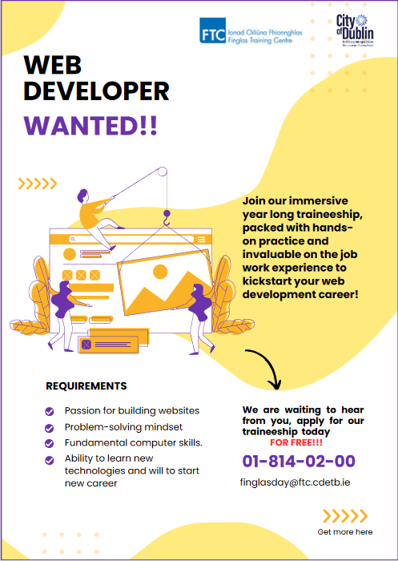

**WEB DEVELOPER WANTED!!**

Join our immersive year long traineeship, packed with hands on practice and invaluable on the job work experience to kick start your web development career!

**REQUIREMENTS**

* Passion for building websites
* Fundamental computer skills.
* Ability to learn new
* technologies and will to start
* new career
* Problem-solving mind set

We are waiting to hear from you, apply for our traineeship today FOR FREE!!!

finglasday@ftc.cdetb.ie

01-814-02-00

1. https://gs.statcounter.com/screen-resolution-stats/mobile/worldwide/#yearly-2019-2022-bar
2. https://gs.statcounter.com/screen-resolution-stats/tablet/worldwide/#yearly-2019-2022-bar
3. https://gs.statcounter.com/screen-resolution-stats/desktop/worldwide/#yearly-2019-2022-bar