Council district 1: 31

Data Operations Unit

August 8, 2019

# 311 complaints

## Opened Complaints

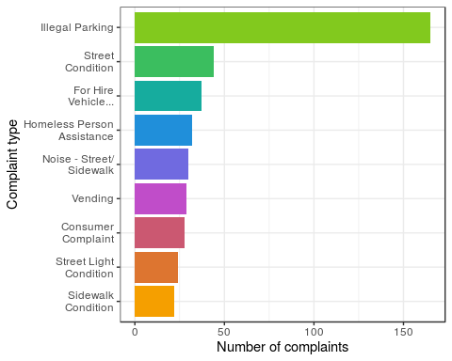

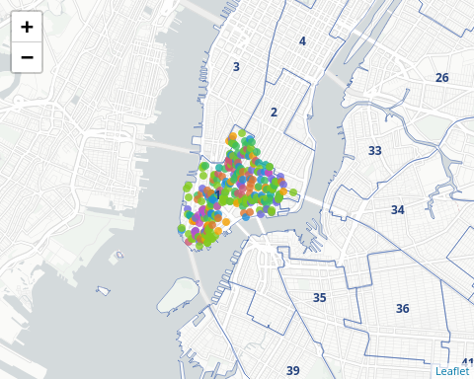

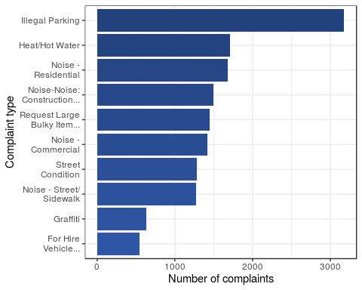

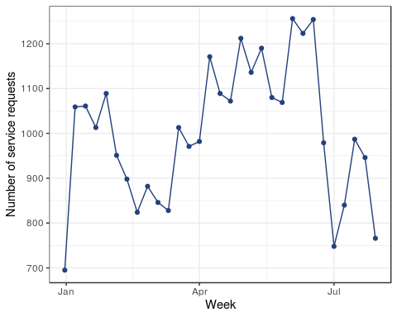

## Closed complaints

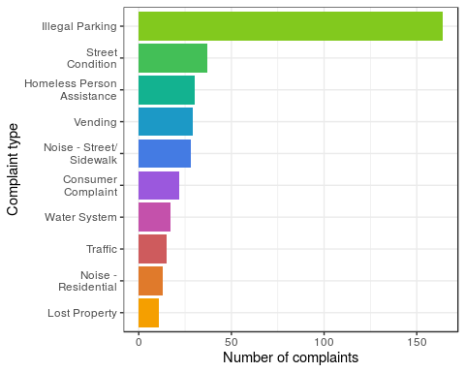

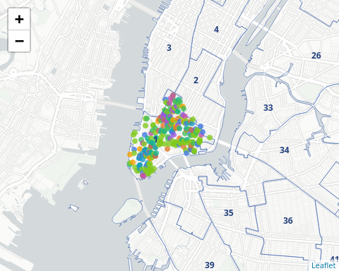

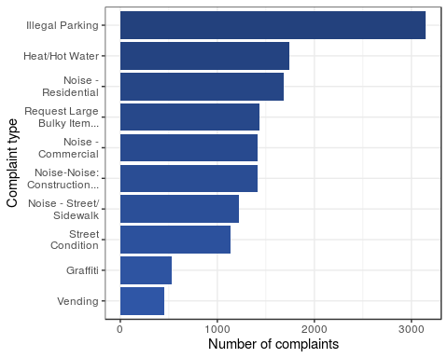

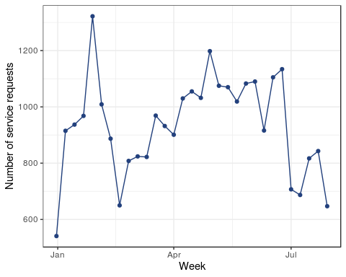

# OEM incidents

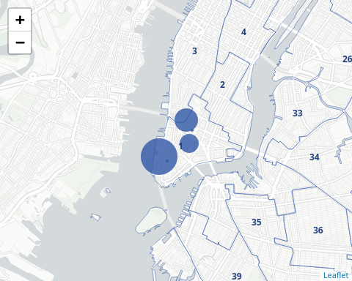

|  |  |  |  |
| --- | --- | --- | --- |
| incident_type | location | creation_date | closed_date |
| Fire-3rd Alarm | 68 Thompson Street | 2011-08-05 02:16:02 | 2011-08-09 11:26:44 |
| Fire-Explosion | 127 Grand St | 2012-08-01 07:53:29 | 2012-08-01 09:56:42 |
| Structural-Construction Accident | Church Street & Liberty Street | 2013-07-30 16:31:01 | 2013-07-30 18:14:32 |
| Law Enforcement-Suspicious Package | 200 Liberty St | 2014-08-01 20:42:02 | 2014-08-12 10:06:20 |
| Fire-Other | 100 Centre Street | 2016-08-05 12:37:23 | 2016-08-08 09:31:35 |

# HPD vacate orders

## Issued vacate orders

No issued vacate orders.

## Rescinded vacate orders

## type is 36

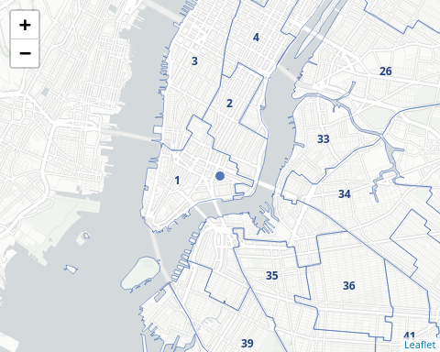

|  |  |  |  |  |
| --- | --- | --- | --- | --- |
| address | primary_vacate_reason | vacate_type | vacate_effective_date | number_of_vacated_units |
| 43 ESSEX STREET | Habitability | Partial | 2015-06-04 | 1 |