Early Childhood Education: Neighborhood Demographics and Access
Brook Frye
Overview
This one-pager examines whether access to Department of Education early childhood education (ECE) seats differs across New York City neighborhoods with different racial and ethnic compositions. The outcome is measured at the PUMA level as ECE seats per preschool-age child ages 3-4 and occupied ECE seats per preschool-age child.
The racial and ethnic categories match the ECE analysis files: White non-Hispanic, Hispanic/Latino, Black non-Hispanic, Asian/API non-Hispanic, and Other/Multiracial non-Hispanic. The adjusted regression models use White non-Hispanic as the reference composition and estimate changes associated with 10 percentage-point increases in Hispanic/Latino, Black non-Hispanic, and Asian/API non-Hispanic population shares.
What We Found
Neighborhoods with larger Asian/API non-Hispanic population shares have the strongest positive adjusted association with ECE access. In the occupied-seat model, a 10 percentage-point increase in Asian/API non-Hispanic population share is associated with 22.9% more occupied seats per preschool-age child after accounting for median household income.
Black non-Hispanic population share is also positively associated with seats per child, but the adjusted estimates are smaller and less precise. Hispanic/Latino population share is not meaningfully associated with higher seat access after adjustment in these models.
What disparities do we observe?
Descriptively, ECE access varies sharply across PUMAs. The citywide mean is 0.58 occupied seats per preschool-age child, but the PUMA-level range runs from 0.23 to 2.10.
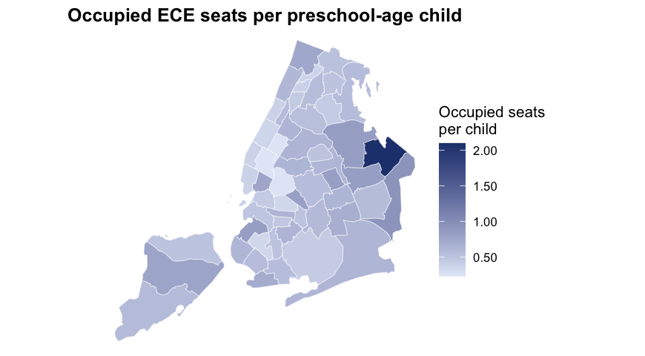
Areas with different racial and ethnic plurality groups show different average levels of access, but these descriptive comparisons combine demographics, income, geography, enrollment preferences, and the historical location of ECE providers.
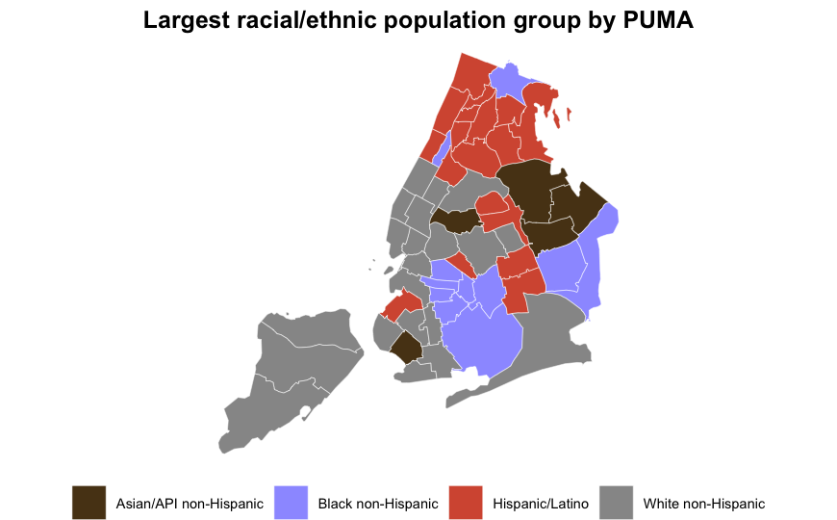
Largest group | PUMAs | Mean total seats per child | Mean occupied seats per child
White non-Hispanic | 21 | 0.67 | 0.51
Hispanic/Latino | 18 | 0.75 | 0.57
Black non-Hispanic | 11 | 0.81 | 0.56
Asian/API non-Hispanic | 5 | 1.20 | 0.99
Other/Multiracial non-Hispanic | 0 | n/a | n/a
Do those disparities persist after accounting for relevant factors?
The adjusted models estimate log seats per child as a function of race/ethnicity composition and median household income. Coefficients are converted to percent changes, so each estimate represents the modeled change associated with a 10 percentage-point increase in the population share.
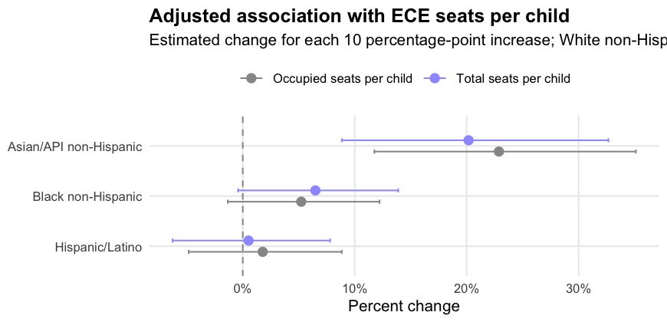
Outcome | Race/ethnicity share | Percent change | 95% CI | P-value
Total seats per child | Hispanic/Latino | 0.5 | -6.3% to 7.8% | 0.883
Total seats per child | Black non-Hispanic | 6.5 | -0.4% to 13.9% | 0.066
Total seats per child | Asian/API non-Hispanic | 20.2 | 8.8% to 32.7% | <0.001
Occupied seats per child | Hispanic/Latino | 1.8 | -4.8% to 8.8% | 0.600
Occupied seats per child | Black non-Hispanic | 5.2 | -1.3% to 12.2% | 0.119
Occupied seats per child | Asian/API non-Hispanic | 22.9 | 11.8% to 35.1% | <0.001
The adjusted results suggest that the descriptive differences are not explained entirely by median household income. However, the model is ecological: it estimates associations across neighborhoods, not individual child participation or household-level access.
Data Snapshot
Metric | Value
PUMAs | 55
Preschool-age children | 173,474
Total ECE seats | 122,827
Occupied ECE seats | 92,970
Mean total seats per child | 0.77
Mean occupied seats per child | 0.58
Median household income | $72,000
Data sources: DOE ECE seat and vacancy data aggregated to PUMA, preschool-age child counts, and 2024 PUMA demographic and income measures in 2026/ECE/data/lm_model_data.csv; PUMA geography in 2026/ECE/data/puma_nyc.geojson.
Policy Implications
Policy responses should focus on both capacity and use. Neighborhoods with low occupied seats per preschool-age child may need additional seats, outreach to families, language access, transportation support, or schedule models that better match caregiver needs. Areas where seats exist but occupancy is lower may require different interventions than areas with low total capacity.
Equity monitoring should track access by geography and racial/ethnic composition together, because citywide averages can obscure neighborhood-level mismatches between child population, available seats, and actual enrollment.
Limitations
The analysis is PUMA-level and should not be interpreted as individual-level evidence. The regression models adjust for median household income but do not account for all relevant factors, including parental work schedules, program quality, language access, disability access, commute patterns, provider type, eligibility rules, or family preferences. Seat counts and occupied seats are point-in-time administrative measures, and PUMAs can hide important variation within neighborhoods.

