AUTH0:-
🔹 Auth0 kya hai
👉 Identity-as-a-Service (IDaaS) platform hai
- Login, signup, MFA, SSO handle karta hai
- Aapko auth code likhne ki zarurat nahi
👉 Simple: “Auth0 = ready-made authentication + authorization system”
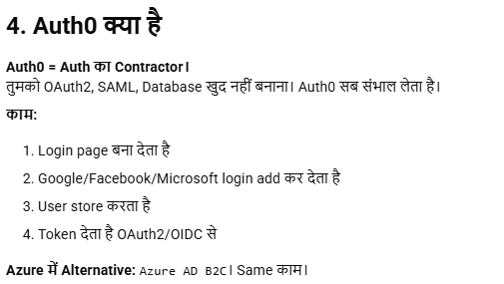

🔹 Auth0 kya provide karta hai
- User login (email/password, social login)
- SSO (Single Sign-On)
- MFA (OTP, authenticator)
- Token-based security (JWT)
- RBAC / roles

🔹 Authentication ke types (important 🔥)
1. Basic Authentication
- Username + password (base64 encoded)
- ❌ insecure (rarely used)

2. Session-based Authentication
- Login ke baad session create (cookie)
- Server session manage karta hai
👉 Traditional web apps

3. Token-based Authentication (JWT) ⭐
- Login → token milta hai
- Har request me token send
- Stateless (no server session)
👉 Modern apps / APIs

4. OAuth 2.0 ⭐
- Third-party login (Google, Facebook)
- User password share nahi hota
👉 “Login with Google”
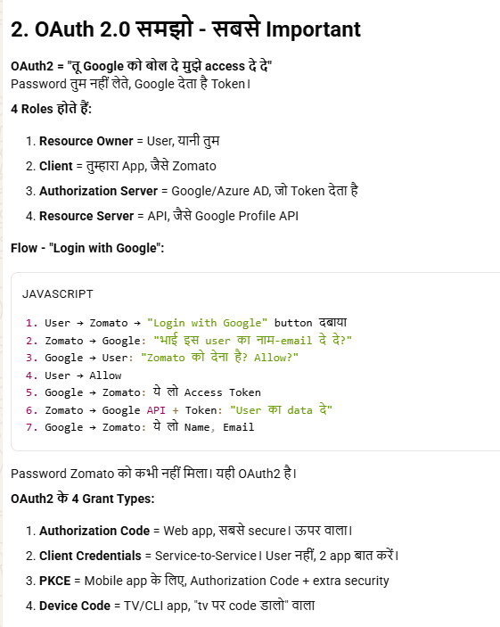

5. OpenID Connect (OIDC)
- OAuth ka extension (identity layer)
- User info (email, profile) deta hai
👉 Auth0 heavily use karta hai
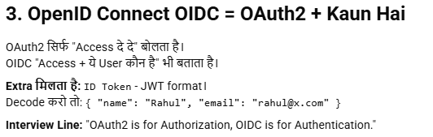

6. SAML
- Enterprise SSO (corporate login)
- XML based
👉 Office / enterprise apps

7. Multi-Factor Authentication (MFA)
- Password + OTP / device
👉 Extra security layer

🔹 Auth vs Authorization
- Authentication → “User kaun hai?”
- Authorization → “User kya kar sakta hai?”

🔥 Real flow (Auth0)
User → Auth0 login → token (JWT) → app verify → access

🔥 Interview one-liner
👉 “Auth0 is an identity platform that provides authentication and authorization using standards like OAuth2, OIDC, and JWT, supporting SSO and MFA.”

