🔥 DR का Goal
- Region down हो जाए तब भी app चलती रहे
- Minimum downtime (RTO) + minimum data loss (RPO)

We maintain a DR runbook and trigger it manually or via approval-based automation to avoid false failovers. Critical components like database and storage require controlled failover, while traffic routing is handled automatically.”
-------------------------------------

----------------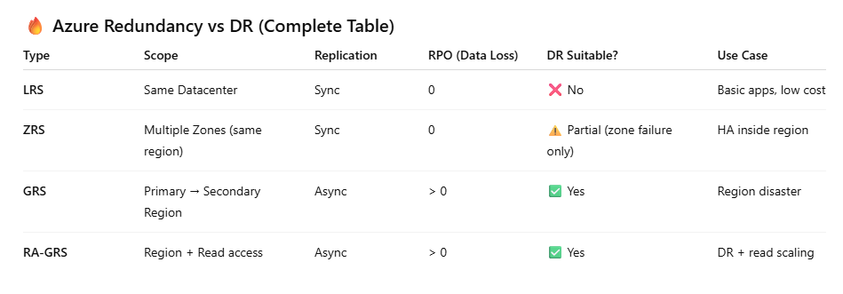
ठीक है—मैं तुम्हें Warm DR और Hot DR दोनों का complete interview-ready setup दे रहा हूँ (same stack: AFD + NGINX + AKS + PostgreSQL + KV) 👇

🔥 1. WARM DR (Active–Passive, cost balanced)
🧱 Architecture
- Azure Front Door
- Primary: Azure Kubernetes Service (running) + NGINX
- Secondary AKS: pre-created, minimal nodes (1 or small VM)
- Azure Database for PostgreSQL: Primary + geo-replica (async)
- Azure Key Vault: dual region (synced)

⚙️ Setup (resource-wise)
- AFD: health probes + priority routing
- AKS (DR): cluster ready, node=1, images pre-pulled (optional)
- PostgreSQL: read replica in DR region
- Storage: GRS
- KV: pipeline-based sync / dual access

🔁 Failover Flow
- AFD detects failure
- Traffic → DR AKS
- AKS scale-up (1 → N nodes)
- PostgreSQL replica → promote
- App connects to new DB

⏱️ RTO / RPO
- RTO: 5–15 min
- RPO: seconds–minutes (async replication)

💰 Cost
- Medium (minimal infra running)

🧠 Interview line
“In warm DR, secondary AKS is pre-provisioned with minimal capacity and database is geo-replicated. On failure, traffic is redirected and resources are scaled up, reducing recovery time.”

🚀 2. HOT DR (Active–Active, zero/min downtime)
🧱 Architecture
- Azure Front Door (latency/priority routing)
- Both regions active with Azure Kubernetes Service
- NGINX ingress दोनों में
- Azure Database for PostgreSQL:
  - Either:
    - Primary + replica (read traffic split)
    - OR multi-master (rare/complex)
- KV: globally accessible / dual synced

⚙️ Setup (resource-wise)
- AFD: both regions in backend pool
- AKS: both clusters running full capacity
- App: stateless (important)
- DB: read replicas / partitioning strategy
- Storage: RA-GRS (read from both)

🔁 Failover Flow
- One region fails
- AFD automatically routes all traffic to healthy region
- No infra spin-up needed

⏱️ RTO / RPO
- RTO: seconds ⚡
- RPO:
  - Near zero (if sync / well-architected)
  - Else minimal

💰 Cost
- High (duplicate infra always running)

🧠 Interview line
“In hot DR, both regions are active and serving traffic. Azure Front Door handles failover instantly, ensuring near-zero downtime and minimal data loss.”

⚖️ Final Comparison (quick recall)
Type | Infra | RTO | RPO | Cost
Warm DR | Pre-created, low capacity | 5–15 min | Low | Medium
Hot DR | Fully active दोनों side | Seconds | Very Low | High

🎯 Final Tip (interview killer)
👉 हमेशा ये line add करो:
“Choice of DR strategy depends on business SLA—critical apps prefer hot DR, while cost-sensitive workloads use warm DR.”

❄️ 1. COLD DR (Cost Optimized / Backup-based)
🧱 Architecture
- Azure Front Door (configured but DR backend disabled / low priority)
- Primary: Azure Kubernetes Service + NGINX
- DR Region:
  - ❌ AKS running नहीं
  - ❌ DB running नहीं
  - सिर्फ backup + IaC (Terraform / pipeline)
- Azure Database for PostgreSQL → backups enabled
- Azure Storage → GRS for backup storage
- Azure Key Vault → backup/export or pipeline sync

⚙️ Setup (resource-wise)
- Infra as Code (Terraform) ready
- Backup strategy:
  - DB → periodic backup
  - Storage → GRS
- Pipeline:
  - AKS create
  - DB restore
  - App deploy

🔁 Failover Flow (important 🔥)
- Region down ❌
- Run DR pipeline manually
- AKS cluster create (DR region)
- PostgreSQL restore from backup
- Key Vault restore / sync
- App deploy (Helm / pipeline)
- AFD → DR backend enable

⏱️ RTO / RPO
- RTO: 30 min – hours ❌
- RPO: backup frequency based (high) ❌

💰 Cost
- ✅ Very Low (almost no running infra)
🧠 Interview line
“In cold DR, infrastructure is recreated on demand using IaC and data is restored from backups. This minimizes cost but results in higher RTO and RPO.”

⚖️ Final 3-Tier DR Strategy (तुम्हारा answer 🔥)
👉 ऐसे बोलो:
“We follow a tiered DR strategy based on business SLA:
- Cold DR for non-critical workloads (low cost, higher RTO/RPO)
- Warm DR for moderate critical systems (balanced cost and recovery)
- Hot DR for mission-critical applications (near-zero downtime)”

🎯 Pro Tip (extra impress करने के लिए)
👉 ये line add करना:
“DR drills are regularly performed to validate recovery procedures and ensure RTO/RPO targets are met.”
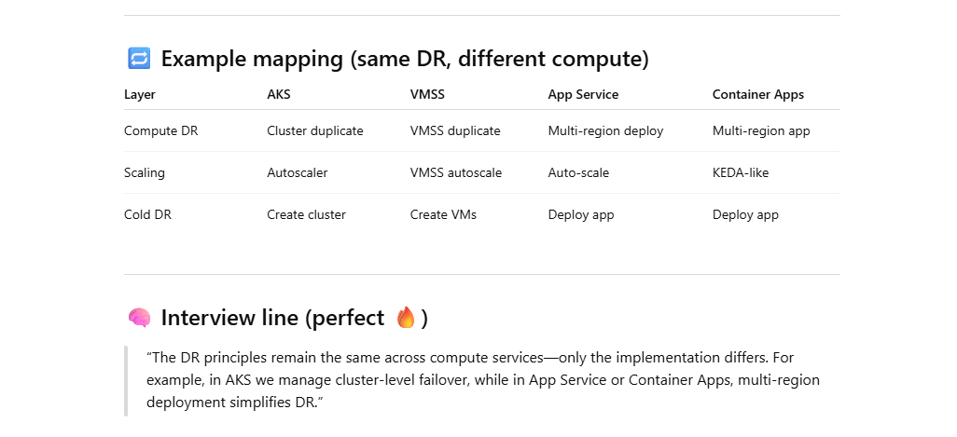

Normally we can say this :-
🔥 1. Architecture (1–2 lines)
- Global entry: Azure Front Door
- Inside cluster: Ingress → Azure Kubernetes Service
- DB: Azure Database for PostgreSQL (Geo-replication)

🔹 2. DR Strategy (बताने का सही तरीका)
👉 “I designed active-passive DR across regions”
- Primary region → AKS (active) + PostgreSQL primary
- Secondary region → AKS (warm standby) + PostgreSQL replica
- Storage/config → GRS / synced
- AFD → health probe based routing

🔁 3. Failover Flow (सबसे important)
Step 1: Normal
- AFD → Primary AKS → Ingress → App
- DB writes → Primary PostgreSQL → replicate to secondary

Step 2: Disaster (Region down ❌)
- AFD health probe fails

Step 3: Automatic Traffic Switch
- AFD routes traffic → Secondary AKS ✅

Step 4: DB Failover
- PostgreSQL replica → promote as primary
- App connection string updated (or via DNS/endpoint)

Step 5: App resumes
- Users hit DR region without manual change

🔹 4. Key Interview Points (must बोलना)
- DB replication = async → small data loss possible (RPO > 0)
- AFD = global failover in seconds (low RTO)
- AKS DR cluster = pre-provisioned / scaled when needed
- Secrets/config → synced (Key Vault)

🧠 Final 4-line Answer (perfect wrap)
- AFD handles global routing with health probes
- Secondary AKS + PostgreSQL replica maintained in another region
- On failure → AFD shifts traffic + DB promoted
- Ensures low downtime with minimal data loss
ठीक है—मैं तुम्हें end-to-end DR setup (business continuity view) ऐसा दे रहा हूँ जो तुम interview में confidently बोल सको 👇
(Flow + resource-wise + RTO/RPO focus)

🔥 1. Architecture Overview (start ऐसे करो)
👉
- Global entry via Azure Front Door
- App on Azure Kubernetes Service with NGINX Ingress
- DB: Azure Database for PostgreSQL Flexible Server
- Secrets: Azure Key Vault
👉 “I designed a multi-region DR architecture with active-passive strategy”

🔹 2. Region Design
Primary Region (Active)
- AKS cluster (running)
- NGINX Ingress
- PostgreSQL (primary, zone redundant)
- Key Vault
- VNet + Subnets

Secondary Region (DR)
- AKS cluster (pre-provisioned, min node = 0)
- PostgreSQL (geo-replica)
- Key Vault (same or replicated)
- Same VNet structure
👉 Infra deployed via Terraform (same config both regions)

🔁 3. Resource-wise DR Setup
🌐 AFD (Traffic Layer)
- Health probe configured
- Backend pools = Primary + Secondary AKS
👉 Failure → auto traffic switch
👉 RTO = seconds

⚙️ AKS + NGINX
- Secondary AKS → autoscaler (min=0)
- Failover → nodes spin up → pods deployed
👉 RTO impact = few minutes (cold start)

🛢️ PostgreSQL
- Zone redundant HA (within region)
- Cross-region read replica (async)
👉 Failover:
- Replica → promote as primary
👉 RPO = few seconds/minutes
👉 RTO = 1–2 min

🔐 Key Vault
👉 Option used:
- Same Key Vault (global access via private endpoint)
OR
- Separate KV → synced via pipeline
👉 Access via Managed Identity (AKS)

🌐 VNet / Networking
- Same CIDR in both regions
- Private endpoints (DB, KV)
- NSG rules replicated
👉 Ensures seamless failover

🔥 4. Failover Flow (must बोलना)
- Region down ❌
- AFD health probe fails
- Traffic → Secondary AKS
- AKS scales up nodes
- PostgreSQL replica promoted
- App connects to new DB
- System resumes ✅

🔹 5. RTO / RPO Optimization (important part)
🟢 RTO (downtime कम कैसे किया)
- AFD auto failover (seconds)
- Pre-provisioned AKS (no infra creation time)
- Minimal node or fast autoscaler

🟢 RPO (data loss कम कैसे किया)
- PostgreSQL geo-replication
- Critical data → frequent sync
- Async limitation explained

⚠️ Tradeoff (must बोलना)
- Scale-to-zero → cost ↓ but RTO ↑
- Warm standby → cost ↑ but faster recovery

🧠 Final Interview Answer (perfect wrap 🔥)
👉 ऐसे बोलो:
“I designed a multi-region DR using Azure Front Door for global routing, AKS clusters in active-passive mode, and PostgreSQL with geo-replication. In case of failure, AFD shifts traffic automatically, AKS scales up in DR region, and database replica is promoted. This ensures low RTO (few minutes) and minimal RPO (seconds), while optimizing cost using autoscaler-based standby clusters.”

*Azure में Cluster Failover / Redundancy = "एक जगह खराब हो जाए तो दूसरी जगह से चलता रहे"*
Downtime zero करने का तरीका। 3 Level पर होता है।
### *Level 1: Node Level Failover - AKS के अंदर*
सबसे basic। एक VM मर गई तो Pod दूसरी VM पर चल जाए।

*कैसे होता है:*
1. *Availability Set / VMSS:* AKS node pool VMSS use करता है। Azure खुद VM को अलग-अलग rack, power में बांटता है।
2. *Node Auto-Repair:* AKS देखता है `NotReady` 10 min से। Node cordon + drain करके नया बना देता है।
3. *Pod Disruption Budget:* `minAvailable: 2` बोल दो। AKS एक साथ सारे pod नहीं मारेगा।
apiVersion: policy/v1
kind: PodDisruptionBudget
metadata:
name: backend-pdb
spec:
minAvailable: 2
selector:
matchLabels:
app: backend
*फायदा:* 1 Node गया, App नहीं।
*Limit:* पूरा DataCenter गया तो सब गया।

### *Level 2: Zone Level Failover - Availability Zones*

एक DataCenter = 1 Zone। Azure Region में 3 Zone होते हैं: `1, 2, 3`। हर Zone अलग building, अलग बिजली, अलग network।

*AKS Cluster को Zone Redundant बनाओ:*
az aks create \
--name myaks \
--node-count 3 \
--zones 1 2 3 \
--location centralindia
अब 3 node बनेंगे: 1 Zone-1 में, 1 Zone-2 में, 1 Zone-3 में।

*Pod Spread कैसे होगा:*
apiVersion: apps/v1
kind: Deployment
metadata:
name: backend
spec:
replicas: 6
template:
spec:
topologySpreadConstraints:
- maxSkew: 1
topologyKey: topology.kubernetes.io/zone
whenUnsatisfiable: DoNotSchedule
labelSelector:
matchLabels:
app: backend
K8s बोलेगा: 6 pod को 3 Zone में बराबर बांटो। 2-2-2।

*Failover कैसे होता है:*
Zone-2 में आग लग गई। Zone-2 के 2 pod मर गए।
K8s Scheduler देखेगा: Zone-1, Zone-3 में जगह है। 2 नए pod वहां बना देगा। 10-30 sec में app वापस 6 replica।
LoadBalancer भी Zone-Redundant है, IP नहीं बदलेगा।

*फायदा:* 1 Zone पूरा उड़ा, App फिर भी up। 99.99% SLA मिलता है।
*Limit:* पूरा Region गया तो सब गया। Mumbai flood, Central India Region down।

### *Level 3: Region Level Failover - Multi-Region AKS*

सबसे मजबूत। 2 अलग Region में 2 AKS Cluster।
Example: `aks-centralindia` + `aks-southindia`

*Traffic कैसे बांटते हैं:*

*Option 1: Azure Front Door / Traffic Manager*
User `myapp.com` hit करता है → Front Door
Front Door health check करता है: Central India AKS /healthz OK? भेज दो।
Down हुआ? South India भेज दो। Automatic, DNS based। 30-60 sec failover।
User → Front Door → Primary: AKS Central India ✅
↘ Secondary: AKS South India (Standby)

*Option 2: Active-Active*
दोनों Region में traffic भेजो 50-50। एक गया तो दूसरा 100% ले लेगा।
पर Data sync का issue आता है।

*Data का क्या - सबसे बड़ा Challenge:*
AKS Stateless है, पर Database?
1. *Azure SQL Geo-Replication:* Central India = Primary, South India = Read Replica। Failover पर Replica को Primary बना दो।
2. *Cosmos DB Multi-Region:* खुद ही sync रखता है। Latency low।
3. *Kafka MirrorMaker:* Topic replicate करो।

Stateless app failover 30 sec में। Stateful में DB failover 1-5 min।

### *तीनों Level का Comparison:*
| **Node Failover** | **Zone Failover** | **Region Failover**
**बचाता किससे** | VM Crash | DataCenter Fire/Power | Flood, पूरे Region Down
**Setup** | Default AKS में है | `--zones 1 2 3` दो | 2 AKS + Front Door + DB Replica
**RTO** | 30 sec | 1-2 min | 2-10 min
**RPO** | 0, Data नहीं जाता | 0 | 0-5 min, DB sync पे depend
**Cost** | 1x | 1x, same VM बस spread | 2x+, 2 cluster + Data egress
**SLA Azure देता** | 99.5% | 99.99% | 99.999% अगर सही किया
RTO = Recovery Time Objective, कितनी देर में up।
RPO = Recovery Point Objective, कितना data loss allowed।

### *AKS में Failover के लिए Checklist:*

*Zone Redundancy के लिए:*
1. Node pool बनाते time `--zones 1 2 3` देना।
2. PV use कर रहे तो `storageclass` ZRS लेना: `managed-csi-premium` ZRS support करता है।
3. `topologySpreadConstraints` लगाना Pod में।
4. Cluster Autoscaler हर zone में balance रखे।

*Region Failover के लिए:*
1. 2 AKS cluster, दोनों region में।
2. ACR Geo-Replication: Image दोनों region में push हो।
3. Azure Front Door + Health Probe `/healthz` पर।
4. Database Geo-Replica + Failover Group।
5. GitOps ArgoCD दोनों cluster में sync। एक जगह apply, दोनों जगह पहुंचे।
6. DNS TTL कम रखो 30 sec, failover fast।

### *सारांश आसान भाषा में:*

1. *Node Failover:* बिल्डिंग में 1 कमरा खराब, दूसरे कमरे में shift। 30 sec।
2. *Zone Failover:* पूरी बिल्डिंग में आग, बगल वाली बिल्डिंग में shift। 2 min।
3. *Region Failover:* पूरा शहर डूबा, दूसरे शहर वाली branch संभाले। 5 min।

*तुम्हारे AKS के लिए Best Practice:*
Prod में हमेशा `--zones 1 2 3` use करो। Cost same, SLA 99.5% से 99.99%।
Region failover चाहिए तो Front Door + SQL Geo Replica add करो।

कौन सा level implement करना है अभी? Central India में Zone Redundant चाहिए या Multi-Region? Command दे दूं।

