ETL:-
"ETL is a data integration process to move data from source to target after cleaning it, for reporting and analytics."
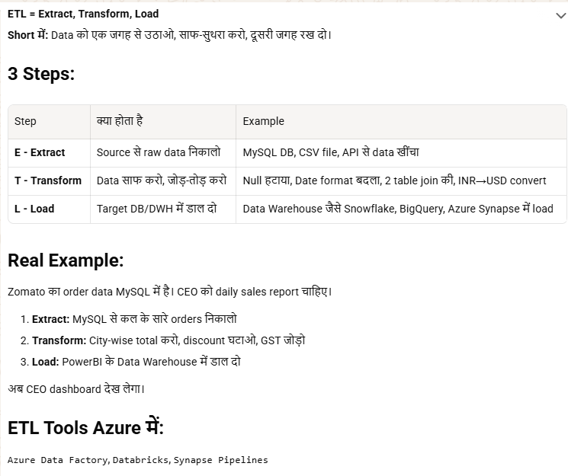
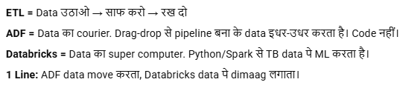
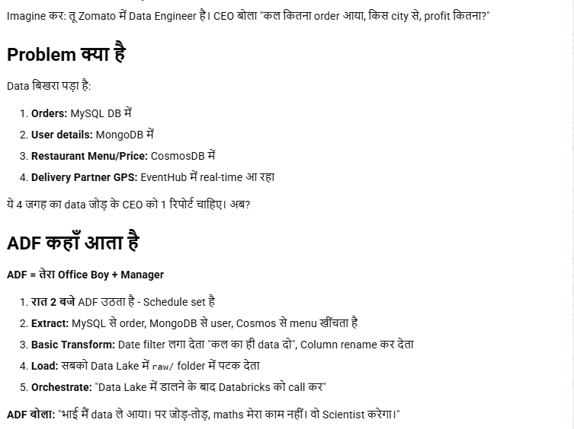
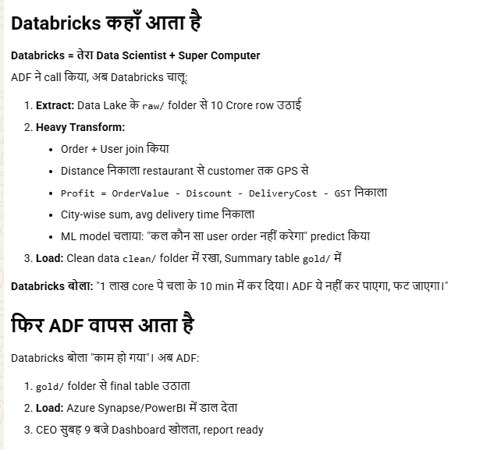
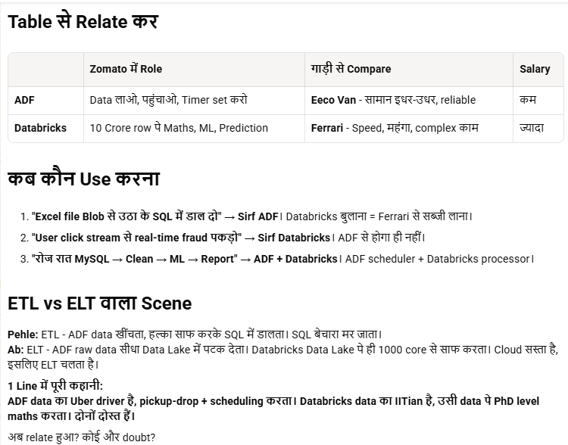
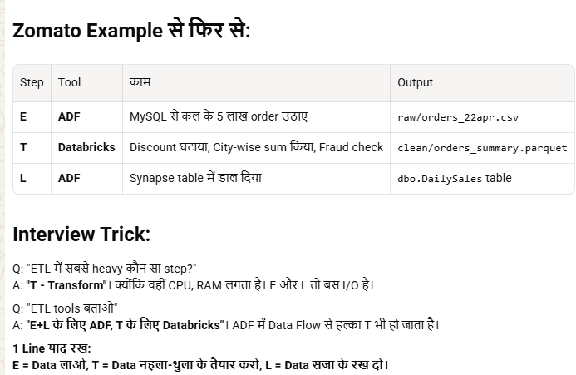
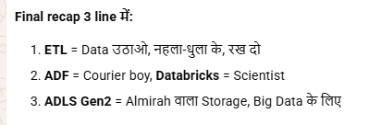

ADLS :- AZURE DATA LAKE STORAGE

🔹 ADLS kya hai
Azure Data Lake Storage ek big data optimized storage hai, mainly analytics ke liye.

🔹 Simple samajh
👉 “ADLS = storage account + big data features”

🔹 Storage Account kya hota hai
Azure Storage Account ek umbrella service hai jisme:
- Blob
- File
- Queue
- Table

🔹 Difference (important 🔥)
Feature | Storage Account | ADLS
Purpose | General storage | Big data analytics
Structure | Flat (folders virtual) | Hierarchical (real folders)
Performance | Normal | Optimized for huge data
Access control | Basic RBAC | Fine-grained (file/folder level ACL)

🔹 Key features of ADLS
- Hierarchical namespace ✅
- Hadoop/Spark compatible
- High throughput for analytics
- Fine-grained security (ACLs)

🔹 Real use case
- Data lake (TB–PB data)
- Logs, analytics, ML workloads

🔥 Interview one-liner
👉 “ADLS Gen2 is a big data optimized storage built on top of Azure Blob Storage with hierarchical namespace and fine-grained access control.”

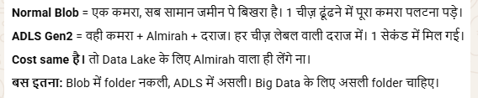

🔹 Power BI (PBI) kya hai?
- Microsoft ka Business Intelligence (BI) tool hai
- Data ko visualize (charts, dashboards) karne ke liye use hota hai
- Raw data → meaningful insights me convert karta hai
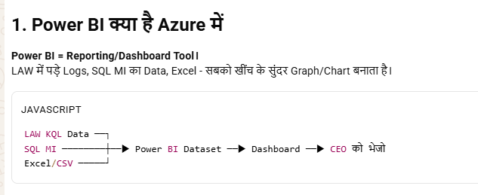

🔹 Kyu use karte hai?
- Multiple sources se data combine (Excel, DB, Azure, APIs)
- Real-time dashboards
- Decision making fast hota hai

🔹 Components
- Power BI Desktop → report create karne ke liye
- Power BI Service → cloud me publish/share
- Power BI Gateway → on-prem data connect

🔹 Kaise kaam karta hai (Flow)
- Data source connect
- Data transform (Power Query)
- Visualization create (charts, graphs)
- Publish to cloud
- Dashboard share

🔹 Use Cases
- Business reporting ,Sales analysis , DevOps metrics (pipeline, logs dashboards)
- Monitoring KPIs

🔹 Interview one-liner
👉 “Power BI ek Microsoft BI tool hai jo different data sources se data lekar interactive dashboards aur reports banata hai for business insights.”

🔹 Power BI Workspace kya hota hai?
- Workspace = collaboration space jaha reports, dashboards, datasets store & share hote hain
- Team ke log ek jagah milkar kaam karte hain

🔹 Types of Workspace
- My Workspace
  - Personal use
  - Sirf tum use karte ho
- App Workspace
  - Team/project ke liye
  - Multiple users + roles

🔹 Roles (Interview important)
- Admin → full control
- Member → edit + publish
- Contributor → edit only
- Viewer → sirf dekh sakta hai

🔹 Kaise kaam karta hai (Flow)
- Power BI Desktop me report banao
- Service me login karo
- Workspace create karo
- Report publish karo workspace me
- Users add karo (roles assign)
- Dashboard share / App publish
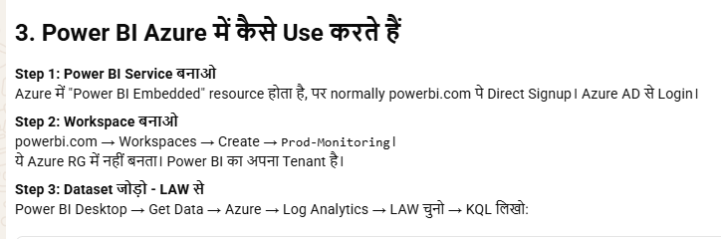

🔹 Features
- Access control (RBAC type)
- Version management
- App publish (end users ke liye)
- Data refresh scheduling

🔹 Real Use Case
👉 DevOps team:
- Pipeline metrics report create
- Workspace me publish
- Managers ko viewer access
- Team ko contributor access

🔹 Interview One-liner
👉 “Workspace Power BI me ek collaboration container hai jaha reports, dashboards aur datasets store hote hain aur role-based access ke sath share kiye jate hain.”

🔹 Azure Synapse Analytics
👉 Data warehouse + analytics engine (SQL based)

🔹 Tumhare flow me kaha fit hota hai
Updated flow 👇
- ADF → data ingest → ADLS (raw)
- Databricks → clean/transform → ADLS (curated)
- Synapse → curated data ko SQL tables / warehouse me load
- Power BI → Synapse se fast query + dashboard

🔹 Synapse kyu use karte hain
- ✅ SQL queries fast run karne ke liye
- ✅ Structured reporting (tables, joins)
- ✅ Large scale data warehouse
- ✅ Power BI integration best

🔹 Alternative bhi possible
- Power BI direct ADLS/Databricks se read kar sakta hai
👉 but:
- Performance slow ho sakti hai
- Complex queries me issue
👉 Isliye Synapse use karte hain as serving layer

🔹 Simple samajh
- ADLS → data store
- Databricks → processing
- Synapse → query + reporting optimized layer

🔥 Interview one-liner
👉 “Azure Synapse is used as a data warehouse layer to serve processed data from ADLS for fast SQL queries and reporting, especially for tools like Power BI.”

🔹 Final correct flow (interview ready)
- Azure Data Factory
👉 Different sources se data ingest karke
👉 Azure Data Lake Storage (Raw layer) me store karta hai

- Azure Databricks
👉 ADLS se data read
👉 Clean / transform
👉 Wapas ADLS me Curated layer me store

- Azure Synapse Analytics
👉 ADLS se curated data read karta hai
👉 (Optionally) SQL tables / warehouse me load karta hai
👉 Fast querying provide karta hai

- Power BI
👉 Mostly Synapse se data read karta hai (fast & optimized)
👉 Dashboard banata hai

🔹 Important correction ❗
👉 “Databricks → Synapse me data rakhta hai”
✔️ Kabhi-kabhi load hota hai
❗ But often Synapse direct ADLS se read bhi kar leta hai (serverless SQL)

🔹 Simple line
👉 ADLS = storage
👉 Databricks = processing
👉 Synapse = serving/query layer
👉 Power BI = visualization

🔥 Interview one-liner
👉 “ADF ingests data into ADLS, Databricks processes it, Synapse serves it for fast querying, and Power BI visualizes it.”
