What is Git?
A distributed version control system to track changes in source code and collaborate on projects.

What is a Git repository?
A .git directory that stores the complete history and version tracking of your project.

What is the difference between Git and GitHub?
Git is the tool for version control; GitHub is a cloud-based platform to host Git repositories.

How do you initialize a Git repository?
git init — sets up a new Git repo in your project directory.

What is a commit in Git?
A snapshot of your changes, recorded in the repo history using git commit.

How do you create a new branch in Git?
git branch <branch-name> — creates a new branch from the current commit.

How do you switch between branches in Git?
git checkout <branch-name> or git switch <branch-name>.

What is the purpose of the .gitignore file?
To exclude files/folders (like logs, temp files) from being tracked by Git.

What is the difference between git pull and git fetch?

git fetch: Gets changes from remote but doesn’t merge.

git pull: Fetches + auto merges into current branch.

How do you view the commit history in Git?
git log — shows commit history with hash, author, date, and message.
• git status → Current state of working directory/staging.
• git log → Commit history.
• git show → Details & changes of a specific commit.

What is a merge conflict in Git, and how do you resolve it?
When changes clash during merge; resolve manually, then git add + git commit.

What is the difference between git reset and git revert?

reset: Moves HEAD and deletes history (destructive).

revert: Creates a new commit that undoes changes (safe for shared repos).

What is the purpose of the git stash command?
Temporarily saves uncommitted changes so you can work on something else.

How do you undo the last commit in Git?

git reset --soft HEAD~1 (keep changes).

git reset --hard HEAD~1 (discard changes).

What is the difference between git merge and git rebase?

merge: Keeps commit history with a merge commit.

rebase: Rewrites history for cleaner linear commits.

What is a Git submodule, and how do you use it?
A sub-repo inside your main repo. Add with git submodule add <repo-url>.

How do you handle large files in Git?
Use Git LFS (Large File Storage) to manage large binaries efficiently.

What is the purpose of git cherry-pick?
To apply a specific commit from one branch to another.
How do you rename a branch in Git?

Current branch: git branch -m <new-name>

Remote: git push origin :old-name <new-name> + git push --set-upstream origin <new-name>

What is the difference between git pull --rebase and git pull?

git pull: Fetches + merges (adds merge commit).

git pull --rebase: Re-applies your changes over latest remote (linear history).
--
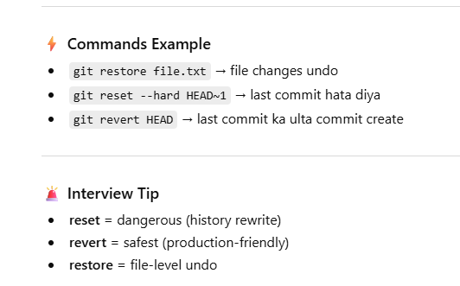
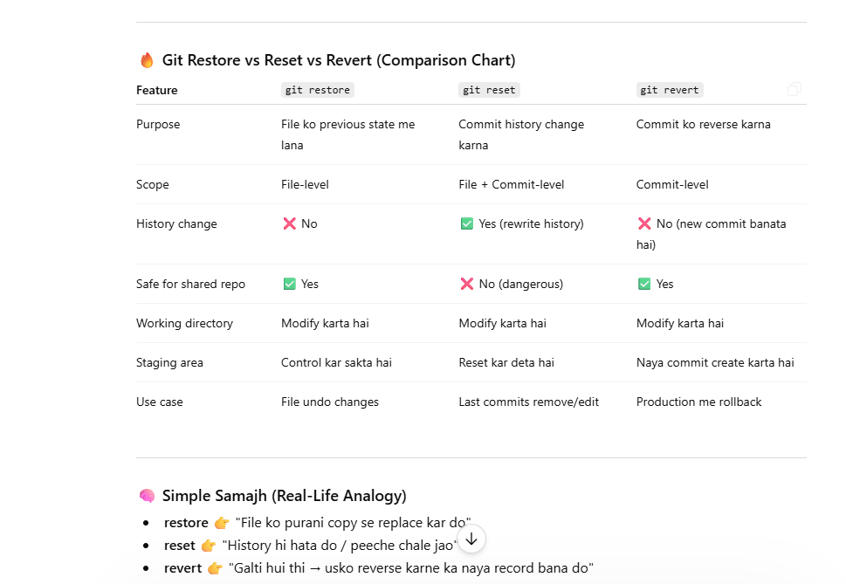
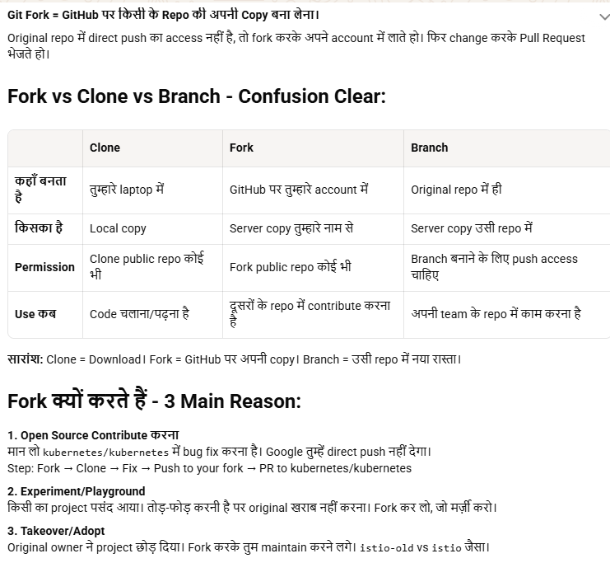

GITOPS:-
🔹 GitOps tool kya hota hai
👉 Git = single source of truth
👉 Infra / app configs Git repo me hote hain
👉 Tool automatically cluster ko Git ke state se sync karta hai
👉 Simple: “Jo Git me hai wahi cluster me hona chahiye”

🔹 Popular GitOps tools
- Argo CD ⭐
- Flux CD

🔹 Argo CD kya hai
👉 Kubernetes ka GitOps tool
- Git repo ko continuously watch karta hai
- Change detect → auto deploy / sync

🔹 Kaise kaam karta hai (flow)
Developer → Git push (YAML/Helm)
↓
Argo CD detect change
↓
Kubernetes cluster me deploy/update

🔹 Key features
- Auto sync / manual sync
- Rollback (Git version se)
- UI dashboard
- Drift detection (manual change detect)

🔹 Use case
- Kubernetes deployments automate
- CI/CD simplify
- Production consistency

🔥 Interview one-liner
👉 “GitOps tools like Argo CD use Git as the source of truth and automatically sync Kubernetes clusters with the desired state defined in the repository.”

INTEGRATION:-

🔹 1. Argo CD → Git se link
👉 Argo CD me repo add karte ho
argocd repo add https://github.com/user/repo.git \
--username xxx --password xxx
👉 Private repo ho to SSH key / PAT use

🔹 2. Argo CD → Cluster se link
👉 Default: jaha ArgoCD install hai wahi cluster connected hota hai
👉 Extra cluster add karna ho:
argocd cluster add <context-name>

🔹 3. Application create (MOST IMPORTANT ⭐)
👉 Haan, ArgoCD me “Application” banate ho
Ye define karta hai:
- Git repo path
- Target cluster
- Namespace
argocd app create my-app \
--repo https://github.com/user/repo.git \
--path k8s-manifests \
--dest-server https://kubernetes.default.svc \
--dest-namespace default

🔹 4. Sync (deploy)
argocd app sync my-app
👉 Auto-sync bhi enable kar sakte ho

🔹 Flow samajh lo
Git Repo → ArgoCD Application → Kubernetes Cluster

🔹 Project kya hota hai?
👉 Optional logical grouping
- Multiple apps ko group karne ke liye
- RBAC + restrictions

🔥 Interview one-liner
👉 “In ArgoCD, we connect Git as the source of truth, register the cluster, and create an Application resource that defines repo path, cluster, and namespace for deployment.”

