Without Helm NGINX deployment on AKS

- Write a deployment + service YAML for nginx.

apiVersion: apps/v1
kind: Deployment
metadata:
name: nginx-deployment
labels:
app: nginx
spec:
replicas: 3
selector:
matchLabels:
app: nginx
template:
metadata:
labels:
app: nginx
spec:
containers:
- name: nginx
image: nginx:latest
ports:
- containerPort: 80
resources:
requests:
memory: "64Mi"
cpu: "250m"
limits:
memory: "128Mi"
cpu: "500m"
---
apiVersion: v1
kind: Service
metadata:
name: nginx-service
spec:
selector:
app: nginx
ports:
- protocol: TCP
port: 80
targetPort: 80
type: LoadBalancer

- kubectl create ns dev-ns
- kubectl apply -f ds.yaml -n dev-ns
- kubectl get all -n dev-ns
- Open nginx using Loadbalancer services' external IP.

Now, if you want to rollback, it is not an easy task; you have to delete the deployment, then the services, and all one by one. So it time taking and complex.

So, we have Helm.

- Helm creates a new package,called a chart, and using this chart, we deploy our application.
- Chart is nothing , it is a folder which contains templates, value.yaml and chart.yaml etc
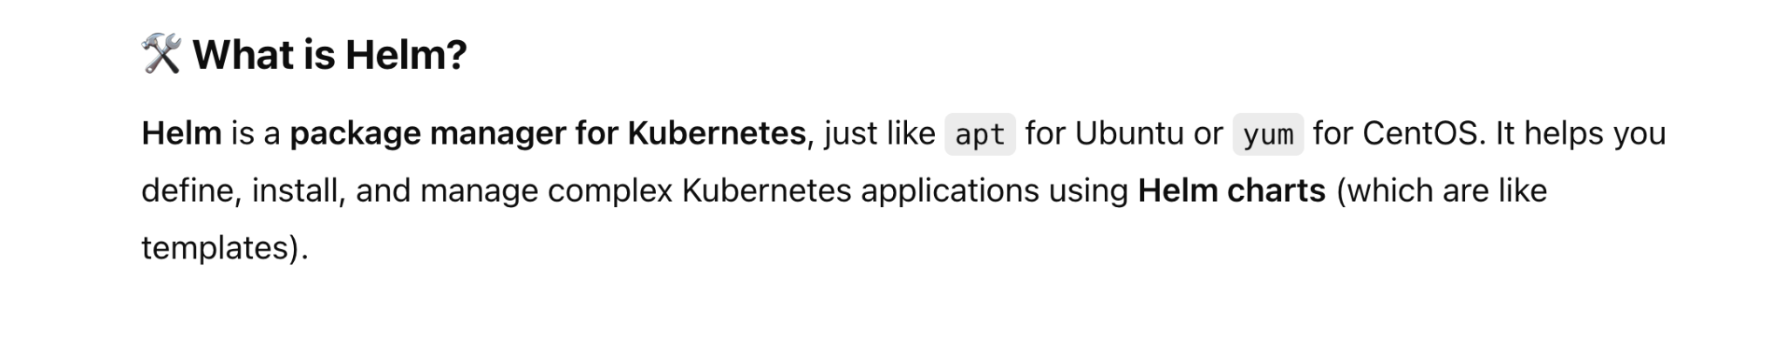
- Helm is a package manager for k8s which helps us to build and deploy application as well as manage the application very easly.
- Features:
- easily rollback
- Multi-environment deployment is very easy. Just create a separate value.yaml for each environment and modify it whenever is required. Rest file like chart.yaml and template folder will be common for all environments.

Step 1: Install Helm on your local pc. commands below are for a Linux pc.

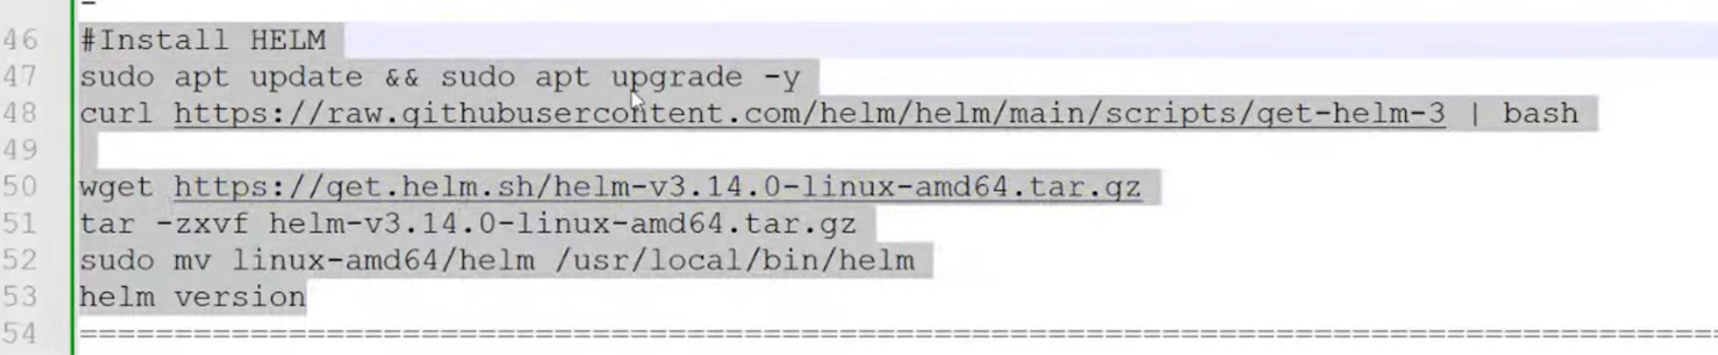

Step 2: create a chart [this command will create a folder that contains a chart, a template, a chart.yam,l and a value.yaml]
- helm create my-nginx
- cd my-nginx
- tree
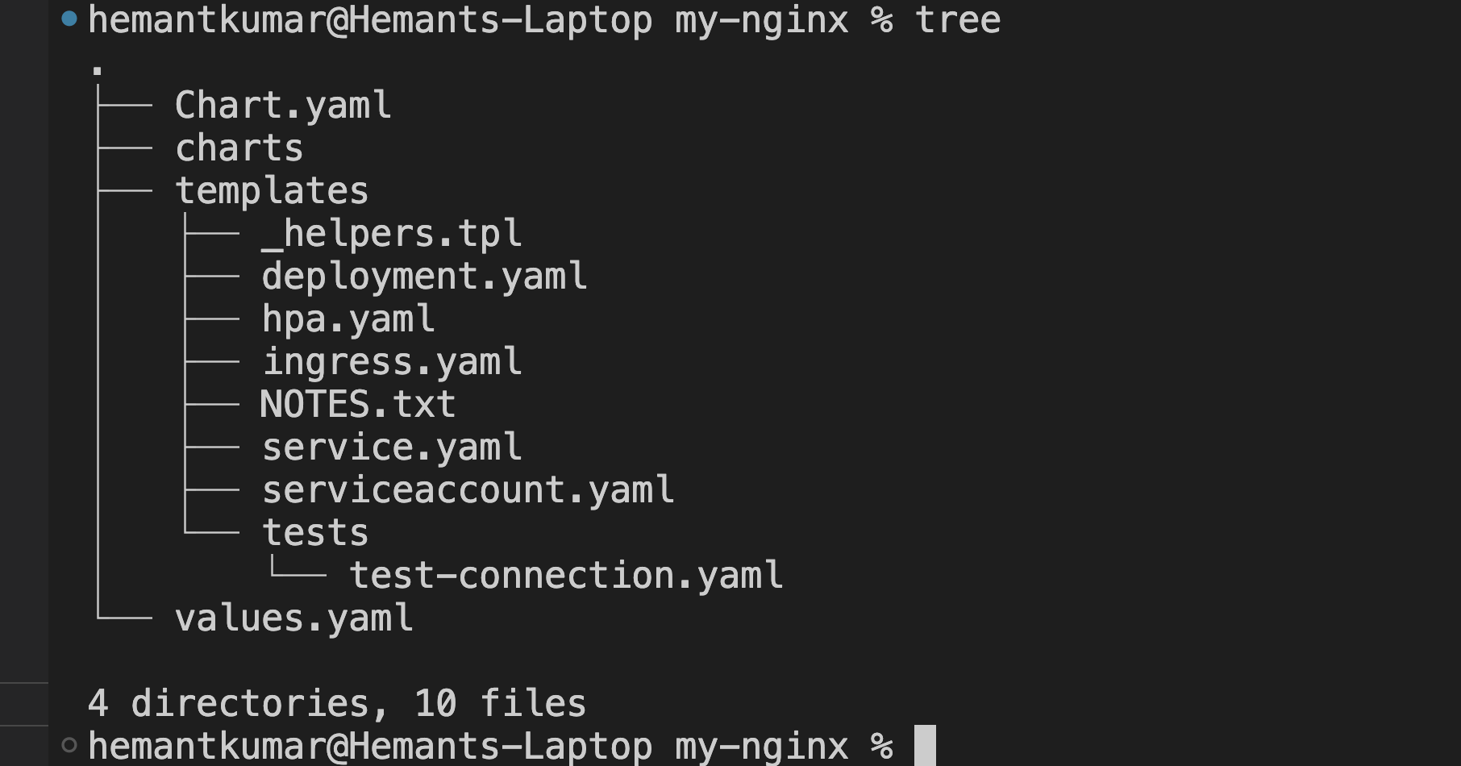

├── Chart.yaml
├── charts
├── templates
│ ├── _helpers.tpl
│ ├── deployment.yaml
│ ├── hpa.yaml
│ ├── ingress.yaml
│ ├── NOTES.txt
│ ├── service.yaml
│ ├── serviceaccount.yaml
│ └── tests
│ └── test-connection.yaml
└── values.yaml

- chart.yaml: a metadata file. Info about your project, like description of project
- Charts: This is a folder that contains information about the dependency.
- Templates: a folder…that contains files as shown above..
Inside this folder,
Deployment.yaml/service.yaml etc will be defined as a template, menas actual value will be not defined here…actual value will be defined in value.yaml and chart.yaml etc.. and from there only it will use the actual value.
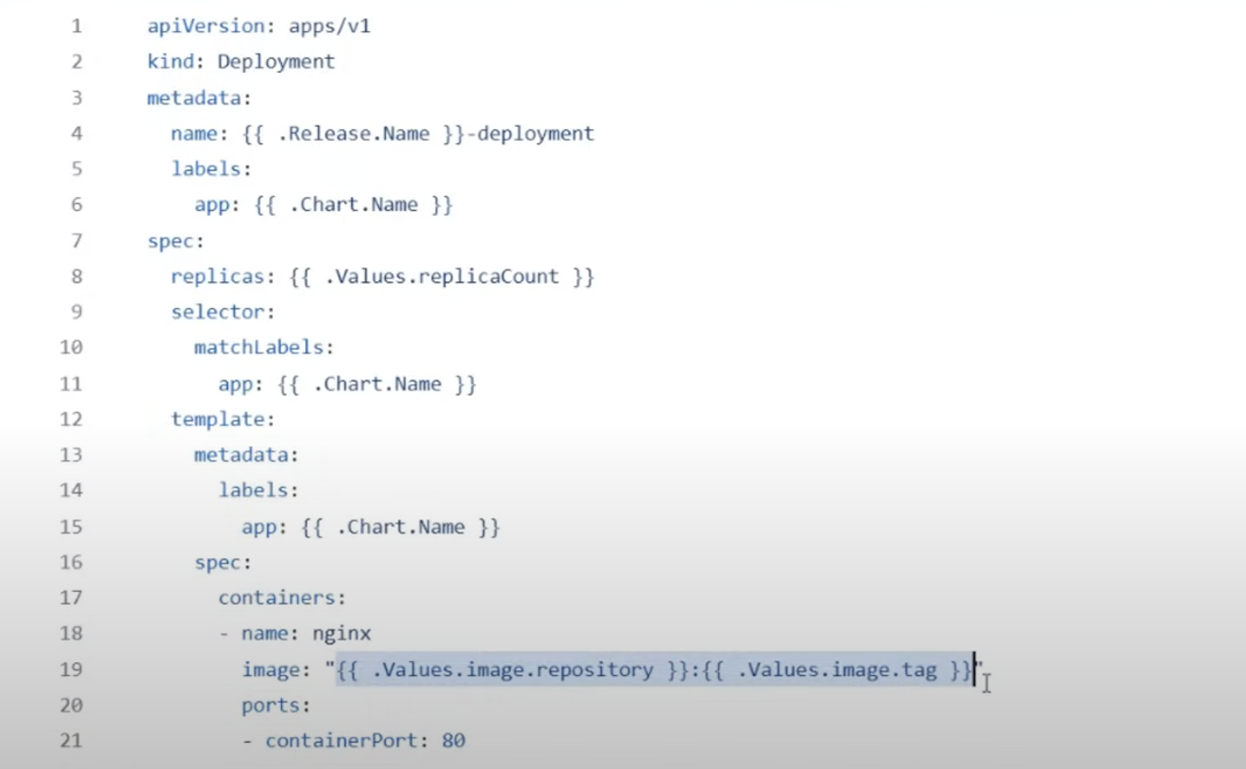

For example, these things will be defined as variable
Name
Image
Port
Replicas

There are three types of variables are defined here in deployment.yaml or service.yaml
Release: application release name
Chart: this variable value will be defined in chart.yaml
Value: values will be defined in value.yaml

- Notes.txt : some instructions which is to be followed after the deployementa are done.
For example : how to get application URL

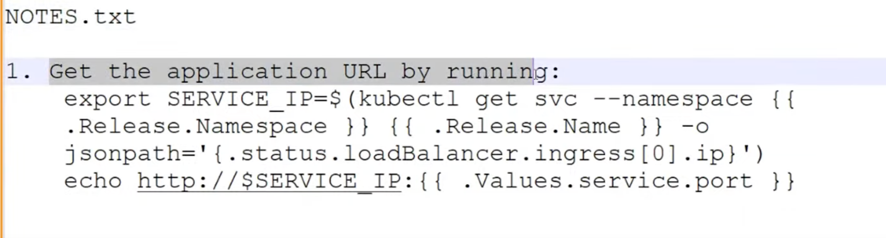

- _helpers.tpl: reusable functions ko define krte hain ham yahan par.

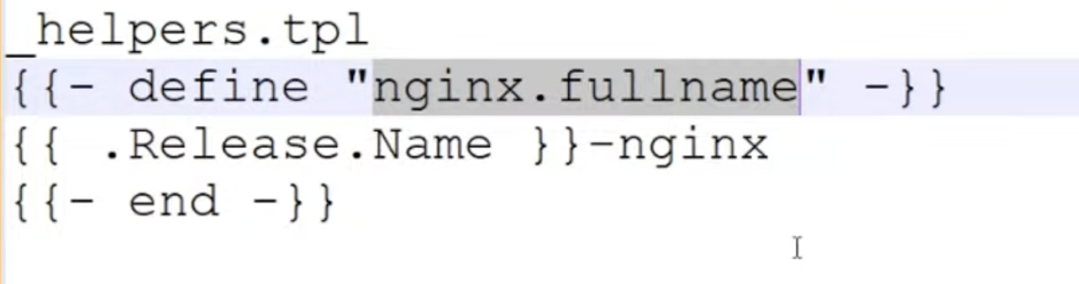

- Test folder : inside this folder we have separate kinds of yaml for testing purpose.

Just for now, basic learning purpose, we will remove charts folder, notes.txt and helpers.tpl

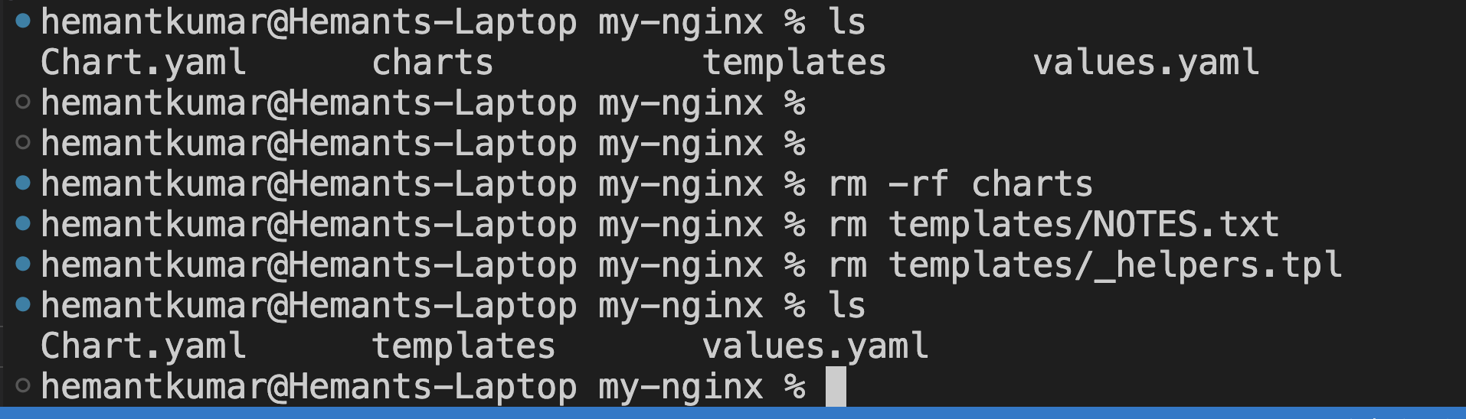

Also delete the all 4 yaml and test folder from template folder

rm deployment.yaml service.yaml serviceaccount.yaml ingress.yaml hpa.yaml
rm -rf tests

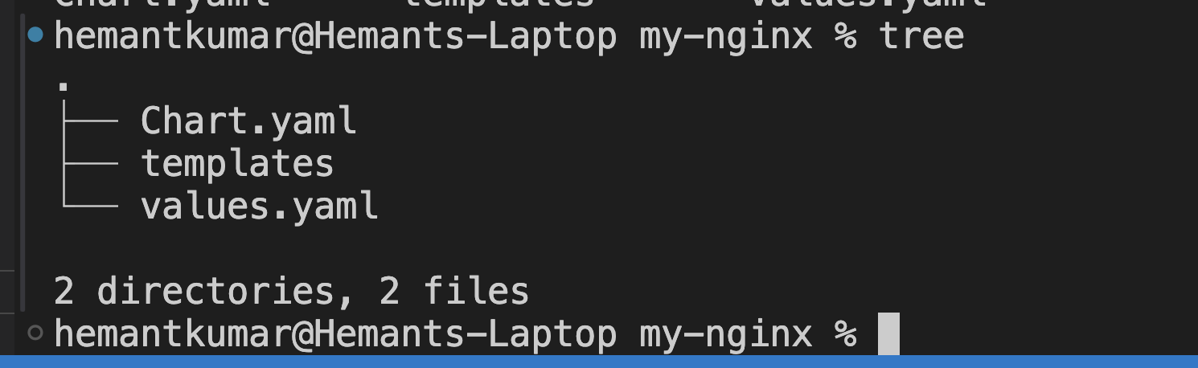

Now,

Create a deployment.yaml and service.yaml inside the template folder and define the value in value.yaml, chart.yaml and release

apiVersion: apps/v1
kind: Deployment
metadata:
name: {{ .Release.Name }}-deployment
labels:
app: {{ .Chart.Name }}
spec:
replicas: {{ .Values.replicasCount }}
selector:
matchLabels:
app: {{ .Chart.Name }}
template:
metadata:
labels:
app: {{ .Chart.Name }}
spec:
containers:
- name: nginx
image: {{ .Values.image.repository }}:{{ .Values.image.tag }}
ports:
- containerPort: 80
resources:
requests:
memory: {{ .Values.resources.requests.memory }}
cpu: {{ .Values.resources.requests.cpu }}
limits:
memory: {{ .Values.resources.limits.memory }}
cpu: {{ .Values.resources.limits.cpu }}

Service.yaml
apiVersion: v1
kind: Service
metadata:
name: {{ .Release.Name }}-service
spec:
selector:
app: {{ .Chart.Name }}
ports:
- protocol: TCP
port: 80
targetPort: 80
type: LoadBalancer

Value.yaml [Rules: indentation actual yaml file k jaise hona chahiye.]
replicaCount: 2

image:
repository: nginx
tag: stable
pullPolicy: IfNotPresent

resources:
limits:
cpu: 100m
memory: 128Mi
requests:
cpu: 100m
memory: 128Mi

service:
enabled: true
name: nginx
type: LoadBalancer
port: 80
targetPort: 80

hemantkumar@Hemants-Laptop helm_day1 % cd my-nginx
hemantkumar@Hemants-Laptop my-nginx %
hemantkumar@Hemants-Laptop my-nginx %
hemantkumar@Hemants-Laptop my-nginx %
hemantkumar@Hemants-Laptop my-nginx %
hemantkumar@Hemants-Laptop my-nginx % helm install abc-release . -n dev-ns
NAME: abc-release
LAST DEPLOYED: Wed May 7 23:02:05 2025
NAMESPACE: dev-ns
STATUS: deployed
REVISION: 1
TEST SUITE: None
hemantkumar@Hemants-Laptop my-nginx %

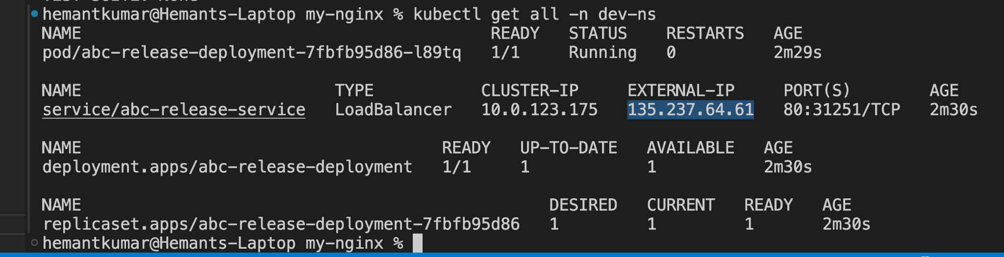

Now open NGINX in browser using external IP:port.

Helm upgrade
- Increase the replica count in value.yaml and then run the below command
hemantkumar@Hemants-Laptop my-nginx % helm upgrade abc-release . -n dev-ns
Release "abc-release" has been upgraded. Happy Helming!
NAME: abc-release
LAST DEPLOYED: Wed May 7 23:09:49 2025
NAMESPACE: dev-ns
STATUS: deployed
REVISION: 2
TEST SUITE: None
hemantkumar@Hemants-Laptop my-nginx %

Helm history[all revision of release.]

Helm rollback

hemantkumar@Hemants-Laptop my-nginx % helm rollback abc-release 1 -n dev-ns
Rollback was a success! Happy Helming!
hemantkumar@Hemants-Laptop my-nginx % kubectl get all -n dev-ns
NAME READY STATUS RESTARTS AGE
pod/abc-release-deployment-7fbfb95d86-m8nw6 1/1 Running 0 92s

NAME TYPE CLUSTER-IP EXTERNAL-IP PORT(S) AGE
service/abc-release-service LoadBalancer 10.0.123.175 135.237.64.61 80:31251/TCP 17m

NAME READY UP-TO-DATE AVAILABLE AGE
deployment.apps/abc-release-deployment 1/1 1 1 17m

NAME DESIRED CURRENT READY AGE
replicaset.apps/abc-release-deployment-7fbfb95d86 1 1 1 17m
hemantkumar@Hemants-Laptop my-nginx %

Now without updating the value.yaml still you can give the value at run time.

hemantkumar@Hemants-Laptop my-nginx % helm upgrade abc-release . --set replicasCount=4 -n dev-ns
Release "abc-release" has been upgraded. Happy Helming!
NAME: abc-release
LAST DEPLOYED: Wed May 7 23:31:34 2025
NAMESPACE: dev-ns
STATUS: deployed
REVISION: 12
TEST SUITE: None
hemantkumar@Hemants-Laptop my-nginx % kubectl get all -n dev-ns
NAME READY STATUS RESTARTS AGE
pod/abc-release-deployment-7fbfb95d86-2mqdj 1/1 Running 0 114s
pod/abc-release-deployment-7fbfb95d86-lfv5c 1/1 Running 0 114s
pod/abc-release-deployment-7fbfb95d86-m8nw6 1/1 Running 0 13m
pod/abc-release-deployment-7fbfb95d86-mdxmd 1/1 Running 0 5s

NAME TYPE CLUSTER-IP EXTERNAL-IP PORT(S) AGE
service/abc-release-service LoadBalancer 10.0.123.175 135.237.64.61 80:31251/TCP 29m

NAME READY UP-TO-DATE AVAILABLE AGE
deployment.apps/abc-release-deployment 4/4 4 4 29m

NAME DESIRED CURRENT READY AGE
replicaset.apps/abc-release-deployment-7fbfb95d86 4 4 4 29m
hemantkumar@Hemants-Laptop my-nginx %

Helm uninstall

emantkumar@Hemants-Laptop my-nginx % helm uninstall abc-release -n dev-ns
release "abc-release" uninstalled
hemantkumar@Hemants-Laptop my-nginx %

Now suppose we have 3 environments, dev, qa and prod.

So create 3 values.yaml for each environment, like dev-value.yaml, qu-value.yaml, prod-value.yaml

Then create 3 namespaces, dev-ns, qa-ns, and prod-ns.

Then deploy the application.
Suppose you want to deploy in dev-ns

helm install <chart name> . -f dev-value.yaml -n dev-ns

To deploy in QA

helm install <chart name> . -f qa-value.yaml -n qa-ns

Value.yaml

