Kubernetes

Kubernetes Architecture — Simple Overview
Kubernetes ek container orchestration system hai. Matlab, agar tu Docker containers chala raha hai aur unko manage karna mushkil ho raha hai (scale, restart, load balancing, etc.), to Kubernetes help karta hai.
🌐 1. Cluster
Kubernetes ka system ek Cluster hota hai. Ye cluster ke 2 main parts hote hain:
- Master Node (Control Plane)
- Worker Nodes

🧠 1. Master Node (Control Plane) — Decision Maker
Isme ye components hote hain:
Component | Kaam
API Server | Tu jitna bhi command dega (kubectl se ya UI se), sab iske paas aayega.(Master communicate with rest of cluster through API)
Scheduler | Decide karta hai ki kaunsa pod kis node pe chalega.
Controller Manager | Har cheez monitor karta hai (e.g., agar pod mar gaya to naya bana dega).
etcd | K8s ki sari info (state/config) yahan store hoti hai. (Think: database)  Is a distributed reliable key-value store used by k8s to store all data .

⚙️ 2. Worker Nodes — Jo Actual Kaam Karte Hain
Har worker node pe yeh chize hoti hain:
Component | Kaam
Kubelet | Master se instructions leta hai aur pods run karta hai.
Container Runtime | Docker ya containerd jo actual container chalata hai.
Kube Proxy | Networking + load balancing ke liye.

Step-by-Step Actual Flow of POD creation:
- kubectl → API Server
Tu command deta hai → API Server us request ko receive karta hai.
- API Server → Validate & Store in etcd
Sabse pehle, API server check karta hai YAML valid hai ya nahi.
Agar sab sahi hai, to etcd me "desired state" save kar deta hai.
🧠 Desired state matlab: "Mujhe ek nginx pod chahiye".
NOTE: - STARTING MEA NAI BOLNA HAI .
Controller Manager Activate Hota Hai.
🔹 Kaun involved hai? → Controller Manager (like ReplicationController)
- Controller Manager etcd ko continuously watch karta hai: "Kya desired state me kuch naya hai?"
- Usse pata chalta hai: "Aha! Ek new pod chahiye!"
- Fir wo dekhta hai: "Kya yeh pod exist karta hai? Nahi? To mujhe create karna hai."
📌 Controller ka kaam hota hai:
Desired state = Actual state banana.

- API Server → Scheduler ko batata hai
API Server notify karta hai Scheduler ko ki "Ek naya pod banana hai, le bhai schedule kar de."
API Server is the central hub — sab uske through hota hai.
- Scheduler → Best Node Choose karta hai
Scheduler dekhta hai: kaunsi node free hai, memory/cpu ka kya status hai, taaki best jagah chuni ja sake.
NOTE:-
• Kubelet → API Server ko Regularly Node ka Status deta hai
Har node ka kubelet apna status (CPU, RAM, disk, etc.) regularly API Server ko report karta hai.
• Scheduler → API Server se hi ye info uthata hai
Scheduler jab pod schedule karta hai, tab wo API Server se node ki sari info fetch karta hai.
Usko already updated data mil jata hai, kyunki API Server ke paas sab kubelets ka status hota hai.

- Scheduler → API Server ko node ka naam deta hai
Scheduler decide karta hai: "Chalo Node-2 pe ye pod chalega."
Ye info wapas API server ko bhejta hai.
- API Server → Node ke Kubelet ko Instruction deta hai
Ab API Server us node ke Kubelet ko bolta hai:
“Bhai, is pod ko tu run kar.”
- Kubelet → Container Runtime ko bolta hai
Kubelet use karta hai Docker ya containerd, jisse nginx container ko run kiya jaye.
- Pod Chal Jata Hai (Running State)
🔹 Kaun involved hai? → Container Runtime + Kubelet
- Container runtime nginx image pull karta hai.
- Container chalu karta hai.
- Kubelet status update karta hai:
“Bhai, pod chal gaya!” → API Server ko status bhejta hai.

9. Status Update → API Server → etcd
- Har step pe, kubelet pod ka status update karta hai (Pending → ContainerCreating → Running).
- Ye status API Server ko diya jata hai.
- API Server is status ko etcd me persist karta hai.

🔁 10. Controller Manager Watch Lagaye Rehta Hai
- Wo constantly check karta hai:
  - Desired state = Actual state?
  - Agar pod mar gaya, to naya bana deta hai.
  - Agar image nahi mila, to alert generate hota hai.

Kubernetes Internal Flow (Aur Thoda Deep)
🧭 Step 1: Kubelet → API Server (Status Report)
- Kubelet har pod ka status update karta hai:
  - e.g. Pending → Running → CrashLoopBackOff
- Ye updates API Server ko regularly bheje jaate hain
- Example:

🧠 Step 2: API Server → etcd (Persistent Store)
- API Server har update ko etcd me persist karta hai.
- etcd me:
  - Desired state (controller ne kya bola)
  - Actual state (kubelet ne kya diya) dono rehte hain.

👁️‍🗨️ Step 3: Controller Manager → API Server ko Watch Karta Hai
🚫 Controller directly etcd se nahi baat karta
✅ Wo API Server ke watch API ke through sab dekh raha hota hai.
- Jaise hi API Server ke paas koi update aata hai (e.g. pod delete/crash),
uska ek event generate hota hai (ADDED, MODIFIED, DELETED)
- Controller Manager ne watch=true lagaya hota hai, to usko real-time event mil jata hai.

🔧 Step 4: Controller Action Karta Hai
- Jaise hi Controller ko event mila (e.g. Pod DELETED ya status = Failed)
- Wo Desired ≠ Actual detect karta hai
- Fir API Server ko new request deta hai:
  - "Ek naya pod banao"
Aur ye cycle repeat hoti hai jab tak sab stable ho jaye.

Error scenario: -

4.1 PART 1: Pod Creation ke Time Aane Wale Real Errors (Interview Gold)
Yeh wo errors hain jo tu daily pod create karte time dekh sakta hai — aur interview me confidently bata sakta hai:

🔴 1. ImagePullBackOff / ErrImagePull
Reason:
- Image galat likhi hai
- Private registry se auth nahi mila
- DockerHub rate limit
📌 Example:
image: nginx123 # galat image
🛠️ Fix:
- Correct image name
- ImagePullSecrets for private registries
🗣️ Interview me bole:
"Kahi baar humne wrong image name ya auth issue ke kaaran ImagePullBackOff face kiya — toh hum kubectl describe pod karke reason trace karte hain."

🔴 2. CrashLoopBackOff
Reason:
- Container turant crash ho raha hai
- Health check fail ho rahi hai
- Application me bug hai
🛠️ Fix:
- Logs dekho: kubectl logs pod-name
- Readiness/liveness probe validate karo
🗣️ Interview line:
"CrashLoopBackOff detect karne ke liye hum logs aur probes pe focus karte hain — jaise wrong env var ya config map mismatch."

🔴 3. CreateContainerConfigError / CreateContainerError
Reason:
- Bad ConfigMap or Secret reference
- Volume mount galat hai
📌 Example:
envFrom:
- configMapRef:
name: my-missing-config
🛠️ Fix:
- ConfigMap exist karta hai ya nahi check karo
🗣️ Interview me:
"ConfigMap ya Secret missing hone pe container config error aata hai — isko hum usually describe pod se trace karte hain."

🔴 4. Pending State Me Pod Atka Rehta Hai
Reason:
- Koi node schedule nahi kar pa raha pod ko
- Resource request > available CPU/memory
- Node taint hai, no toleration diya
🛠️ Fix:
- kubectl describe pod → check scheduling events
- Node resources + taints check karo
🗣️ Interview:
"Pod pending state me tha kyunki resource limits zyada the aur nodes me space nahi tha — humne HPA configure karke fix kiya."

4.2 PART 2: AKS (Azure Kubernetes Service) Create Karte Time Common Errors

🔴 1. ProvisioningState=Failed – Cluster Create Failed at Resource Group Level
Reason:
- Incorrect network configuration (like subnet conflict)
- Insufficient permissions in service principal or managed identity
- Resource quota exceeded in Azure subscription
🛠️ Fix:
- Check Azure Resource Group deployment logs
- Use Azure CLI:
az aks show --resource-group my-rg --name my-cluster
- Validate subnet doesn't overlap with other VNets
🗣️ Interview bol:
"AKS creation failed because of overlapping subnets — we corrected VNet configuration using ARM templates."

🔴 2. Nodepool provisioning stuck or failed
Reason:
- Wrong VM size (not available in selected region)
- Insufficient quota for VM cores
🛠️ Fix:
- Check quota:
az vm list-usage -l eastus
- Change VM size in az aks create or via portal
🗣️ Interview line:
"In AKS we faced nodepool provisioning errors due to regional VM unavailability — we resolved it by switching SKU to an available one."

🔴 3. Cluster Created but kubectl Doesn’t Work (context not found)
Reason:
- az aks get-credentials not run
- Wrong kubeconfig context selected
🛠️ Fix:
az aks get-credentials --resource-group my-rg --name my-cluster
kubectl config get-contexts
kubectl config use-context aks-my-cluster
🗣️ Interview line:
"We often automate kubeconfig setup post-deployment using Azure CLI + GitHub Actions."

🔴 4. CoreDNS CrashLoopBackOff Right After AKS Creation
Reason:
- DNS not resolving inside pods
- Network policy conflict or custom DNS setup
🛠️ Fix:
kubectl -n kube-system logs -l k8s-app=kube-dns
- Check /etc/resolv.conf in pod
- Make sure Azure VNet DNS config is not blocking internal names
🗣️ Interview idea:
"After cluster setup, DNS resolution failed for internal services — we had to adjust custom DNS settings in VNet for pods to resolve names."

🔴 5. AAD Pod Identity Integration Fails
Reason:
- Wrong AzureIdentityBinding or AzureAssignedIdentity
- Pod MSI binding missing or not matching selectors
🛠️ Fix:
- Check pod labels + AzureIdentityBinding selector match
- Validate identity exists and has permission (RBAC)
🗣️ Interview gem:
"In one case, Azure Pod Identity failed to bind due to selector mismatch — debugging the binding and role assignment helped fix it."

🔴 6. Autoscaler Not Working
Reason:
- Not enabled in AKS node pool
- Wrong tags or taints on nodes
🛠️ Fix:
- Enable autoscaler via Azure CLI:
az aks nodepool update \
--resource-group my-rg \
--cluster-name my-cluster \
--name nodepool1 \
--enable-cluster-autoscaler \
--min-count 1 \
--max-count 5
🗣️ Interview:
"During AKS scaling test, autoscaler didn’t work — it was due to taints on system node pool. Moved workloads to user node pool to fix."

🔴 7. NetworkPolicy Not Working as Expected
Reason:
- NetworkPolicy not supported with default AKS plugin (kubenet)
- Calico not configured if using custom CNI
🛠️ Fix:
- Use azure CNI or Calico enabled AKS setup
- Validate policy with kubectl get netpol and pod labels

🧠 BONUS: AKS Cluster Diagnostics Command (for Interview Dhamaka 💥)
az aks browse --resource-group my-rg --name my-cluster
az aks diagnose --resource-group my-rg --name my-cluster
Use these to troubleshoot issues live.

🔥 TL;DR – Interview-Ready Error Scenarios in AKS:
Scenario | Reason | Fix
Provisioning failed | Subnet conflict / quota / permissions | Check logs / ARM templates
Nodepool failed | Wrong VM size / quota | Change size or request quota
kubectl not working | Kubeconfig missing or wrong context | az aks get-credentials
CoreDNS CrashLoop | DNS misconfig / VNet issue | Logs, /etc/resolv.conf, VNet settings
AAD Pod Identity not binding | Selector mismatch or RBAC missing | Check bindings, permissions
Autoscaler not scaling | Not enabled / taint conflict | Enable via CLI, use user nodepool

To create a Kubernetes cluster, gather the following info from the customer:
Business goal , what problem cst targeting to solve .primary use case , end user kon hai .koi compliance ya regulation follow krna hai .
- Cluster Name and Region (e.g., East US, West Europe).
- Node Count, VM Size (e.g., Standard_DS2_v2), and scaling requirements.
- Networking: VNet/Subnet details or whether to use Azure CNI or Kubenet.
- RBAC & Authentication: Azure AD integration or local accounts.
- Private/Public Cluster: Control plane access — private endpoint or public API.
- Add-ons: Monitoring (Azure Monitor), Ingress Controller, Container Registry integration.
Optional: Secrets management (Key Vault), Network policies, and Storage class preferences.

5.1 POD LIFECYCLE :-
  - Pending waiting/running/terminated(cont lifecycle)
  - Running
  - Succeeded
  - Failed
  - Unknown

5.2 TYPE OF CONTAINERS IN POD:-
Kubernetes mein Pod ke andar jo containers hote hain, unke roles ke hisaab se kuch specific types define kiye ja sakte hain — functionally.

🧱 1. Main Application Containers
- Ye primary container hota hai jo actual application run karta hai.
- Example: nginx, redis, java app, etc.
- Ek Pod mein 1 ya multiple app containers ho sakte hain (multi-container pod).

🔄 2. Sidecar Containers
- Ye containers main app ko support karte hain.
- Common use: logging, monitoring, config sync, proxy, etc.
- Example: Fluentd (logs), Envoy (proxy), Istio sidecar
✅ Sidecar container hamesha main container ke same Pod ke andar hi chalta hai, alag pod me nahi.
Aur yehi best practice hai.

⏳ 3. Init Containers
- Special containers jo pod ke main containers se pehle run hote hain.
- Use: Setup kaam, config download, wait-for-service.
- Ek baar run hoke complete hone ke baad hi main container start hota hai.
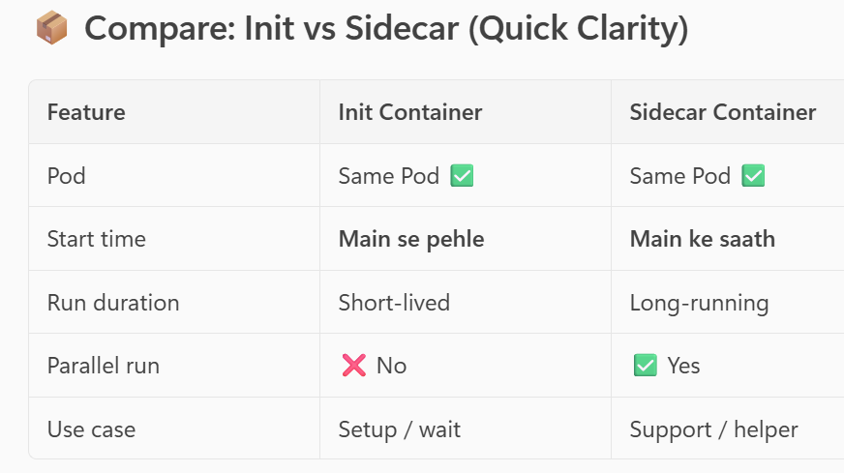
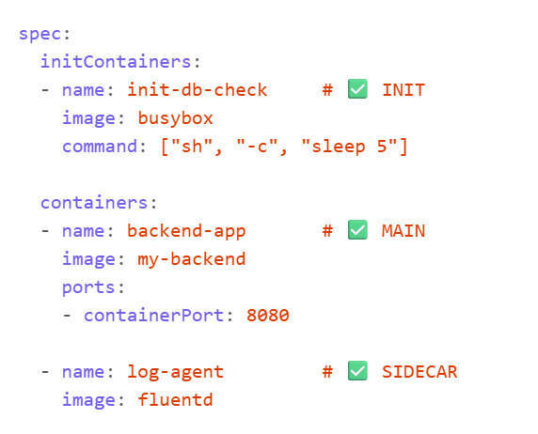

🧪 4. Ephemeral Containers (Advanced / Debugging)
- Runtime pe debugging ke liye inject kiye jaate hain.
- Ye normal pod lifecycle ka part nahi hote.
- Only available with kubectl debug (not in YAML).

🎯 Interview Ready Summary:
Q: Pod ke andar kya types ke containers ho sakte hain?
A:
- Main app containers (actual workload)
- Sidecar containers (support services like logging/proxy)
- Init containers (pre-start setup)
- Ephemeral containers (debugging purpose only)
📂 NS (Namespace) in Kubernetes kya hota hai?
Namespace = Logical isolation
Kubernetes mein Namespace (NS) ek tarah ka virtual cluster hota hai jo ek hi physical cluster ke andar alag-alag environment create karta hai.

🔑 Key Points:
Feature | Description
Isolation | Resources (Pods, Services, etc.) ko logically alag karta hai
Multi-tenancy | Alag teams/projects ek hi cluster mein kaam kar sakte hain
Resource Quota | Har namespace ka apna CPU/memory limit define kiya ja sakta hai
Access Control | RBAC ke through per-namespace permission control hota hai

🎯 Real Examples:
- default → Tumhara normal deployment yahi hota hai
- dev, qa, prod → Alag environments ke liye alag namespace bana sakte ho

🔧 Command:
kubectl get ns # List all namespaces
kubectl create ns dev # Create a new namespace
kubectl config set-context --current --namespace=dev # Switch namespace

📂 Default Namespaces:
Namespace | Purpose
default | User workloads ke liye default space (agar koi specify nahi kare)
kube-system | Kubernetes ke internal components (kube-dns, kube-proxy, etc.)
kube-public | Public data share karne ke liye (e.g., cluster-info, read-only)
kube-node-lease | Nodes ke heartbeat maintain karne ke liye (fast node status updates)

🔍 Difference between kubectl explain and kubectl describe:
Command | Purpose | Output
kubectl explain | Shows the structure/schema of a resource | Tells what fields exist and what they mean (used for writing YAML)
kubectl describe | Shows live detailed information about a resource in the cluster | Gives status, events, and configuration of running resources

📌 Example:
- kubectl explain pod.spec → Tells what containers field does in a Pod YAML.
- kubectl describe pod <pod-name> → Shows current status, events, restarts, etc. of that specific Pod.
👉 Use explain for learning how to define and describe for troubleshooting/debugging.

🔧 Difference between kubectl create vs kubectl apply:
Command | Purpose | Behavior
kubectl create | Creates a resource for the first time | Fails if the resource already exists
kubectl apply | Creates or updates resources | Idempotent – updates if exists, creates if not

📌 Example:
- kubectl create -f pod.yaml → One-time creation only
- kubectl apply -f pod.yaml → Safe for repeated use (e.g., CI/CD)
👉 Prefer apply in automation and GitOps workflows.

🔹 6. Pod – Definition & Concept
✅ What is a Pod?
- Smallest deployable unit in Kubernetes.
- Wraps one or more containers (usually Docker).
- All containers in a Pod share:
  - Network namespace (same IP, port space)
  - Storage volumes
✅ Use Case:
- Run tightly coupled app containers (e.g., app + log forwarder).
🔹 2. Pod Lifecycle Phases
- Pending → Running → Succeeded / Failed / CrashLoopBackOff
🔹 3. Single Container Pod – YAML Example
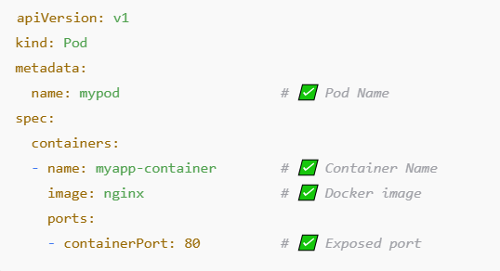
🔹 4. Multi-Container Pod (Sidecar Pattern)
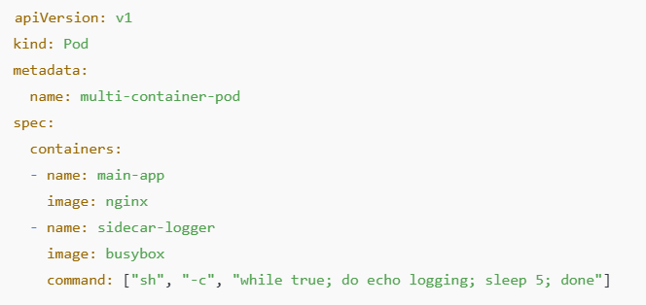
#### Introduction to Pod-to-Pod Communication in Kubernetes

In Kubernetes (K8s), a **Pod** is the smallest deployable unit, consisting of one or more containers that share the same network namespace. Each Pod in a K8s cluster gets its own IP address, which allows Pods to communicate with each other across the cluster. By default, **Pods can communicate with each other** across namespaces unless network policies are applied to restrict traffic.

#### Communication Flow:
1. **Pod-to-Pod communication** happens via internal cluster networking, where Pods can communicate using their IP addresses.
2. Kubernetes uses **CNI (Container Network Interface)** plugins to provide networking solutions, including network routing, load balancing, and DNS resolution.
3. Every Pod gets a unique IP address, so Pods can directly communicate without needing NAT (Network Address Translation).
4. Kubernetes Services, such as ClusterIP, NodePort, and LoadBalancer, can be used to expose Pods to each other and to the outside world.
✅ By default, yes — any Pod in a cluster (same Namespace or different) can talk to any other Pod.
🔹 Is kube-proxy involved?
Yes — but only in specific cases.
✅ *When kube-proxy is involved:
- When you’re accessing a Kubernetes Service (like curl http://my-service:8080).
- kube-proxy handles routing that request to the correct backend Pod(s).
- It watches Services and Endpoints via the Kubernetes API and configures iptables (or IPVS) rules to forward traffic.
❌ *When kube-proxy is not involved:
- When one Pod talks directly to another via Pod IP, kube-proxy is not used.
- This traffic goes directly over the CNI network plugin, which is responsible for Pod-to-Pod networking.

🔹 5. Probes (Health Checks)
Pod probes Kubernetes में ऐसे mechanisms हैं जो यह check करते हैं कि एक container ठीक से चल रहा है या नहीं, और क्या वह ready है request accept करने के लिए या नहीं।
👉 यानी: Probes = "Health Check" mechanism for containers

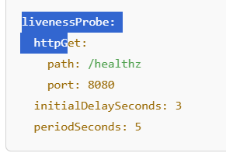
- livenessProbe: Restart container if failed
- readinessProbe: Controls service routing

🔸 6.1. Pod Probes – Health Checks
Probe Type | Purpose | Action
livenessProbe | Checks if container is alive | Restart if it fails
readinessProbe | Checks if container is ready | Add/remove from Service endpoint
startupProbe | Used during slow startup | Wait before applying other probes
🔹 Example – All Probes:
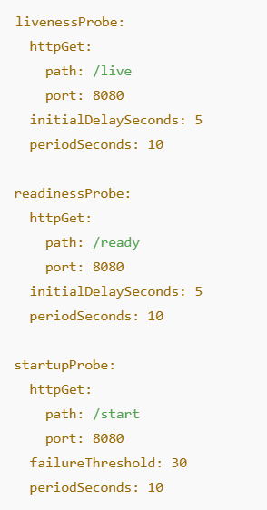
Controllers ensure desired state of Pods.
Liveness Probes ensure your application inside the container is actually alive.

🛡️ Why Use Pod Probes?
Benefit | Why it matters
🔄 Auto-recovery | Crash हो रहे containers auto-restart
⚖️ Load balancing | सिर्फ ready pods को traffic मिलता है
⏱️ Delayed start handling | Long boot-time apps को protect करता है
📊 Better monitoring & debugging | Pods के health logs मिलते हैं

6.2 🧬 What Are Container Lifecycle Hooks?
Kubernetes में Container Lifecycle Hooks ऐसे special actions हैं जो container के specific lifecycle events (जैसे start या stop) के समय trigger होते हैं।
ये hooks आपको allow करते हैं कि आप कुछ custom commands या scripts run कर सकें जब:
- Container start हो रहा हो (postStart)
- Container stop होने वाला हो (preStop)

🧰 दो Main Hooks होते हैं:
Hook | Triggered When | Typical Use
✅ postStart | Container start होने के तुरंत बाद | Initialization tasks (logs, sync, notify)
✅ preStop | Container को terminate करने से पहले | Graceful shutdown, save state, disconnect, notify

🔧 Hook Types:
Lifecycle hooks दो तरह के commands run कर सकते हैं:
- Exec → Container के अंदर एक command run करें
- HTTP GET → किसी endpoint को hit करें (e.g., local web server को notify करना)
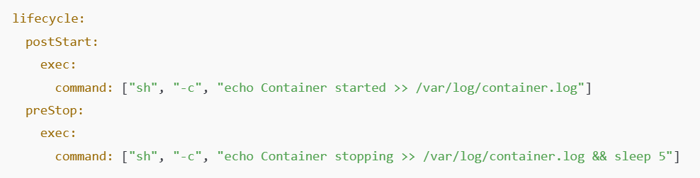
🚦 Hook Execution Flow
- postStart:
  - Container runtime container को start करता है
  - इसके तुरंत बाद postStart hook run होता है
  - Important: Hook complete नहीं होने तक container "running" state में नहीं आता
- preStop:
  - Pod को terminate करने का signal मिलता है (e.g., scale down या deployment update)
  - Kubernetes पहले SIGTERM signal भेजता है
  - फिर preStop hook run करता है
  - उसके बाद termination grace period खत्म होने पर SIGKILL आता है

🧪 Real-Life Use Cases:
Use Case | Hook | What It Does
Logging service start | postStart | Register service in log system
Send shutdown signal to DB | preStop | Close DB connections gracefully
Wait before terminating | preStop + sleep | Delay termination to let load balancer drain
Notify another system | HTTP preStop | Send API call on shutdown

⚠️ Things to Remember:
- Hook fail हो जाए तो भी container run होता है (especially postStart)
- preStop hook के लिए Pod को termination grace period देना जरूरी है (default 30s) — वरना hook complete नहीं हो पाएगा
- Hooks को asynchronous tasks के लिए carefully use करें, वरना termination delays हो सकते हैं

📘 Summary Table
Lifecycle Hook | Triggered | Purpose | Notes
postStart | After container starts | Initialize stuff | Runs once
preStop | Before container stops | Cleanup, notify | Must finish in grace period

6.3. Container States
✅ States:
State | Description
Waiting | Container is waiting to start
Running | Container is up and running
Terminated | Container has stopped (exit code, reason available)
- PODS->Pending → Running → Succeeded / Failed / CrashLoopBackOff

7 🔥 Kubernetes Volumes and Storage

📌 1. Background: Problem Without Volumes
Kubernetes ka basic kaam hai containers ko run karna and manage karna. Containers, jaise ki Docker containers, default tor par ephemeral hote hain — yaani:
- Jaise hi container delete ya crash hota hai, uska data chala jata hai.
- Container ke andar /tmp mein likha gaya file ya data sab wipe ho jata hai.
Problem:
Agar humare paas koi application hai jo:
- File system pe likhti hai (e.g., logs, uploads)
- Database jaisa persistent data store karti hai
Toh data bacha ke rakhna bahut zaroori hai. Yahi problem solve karta hai:
✅ Kubernetes Volumes.

📘 2. Kubernetes Volume Kya Hota Hai?
Definition:Kubernetes Volume ek storage directory hoti hai jo ek pod ke andar containers ke saath attach hoti hai taaki data survive kar sake:
Volume bnta hai Pod level pr aur mount hota hai container pr .
- Container crash ke baad bhi data delete na ho
- Multiple containers ek hi data ko access kar sake
Features:
- Pod level pe define hoti hai
- Pod ke andar jitne bhi containers hain, sab access kar sakte hain
- Kuch Volumes temporary hote hain (e.g. emptyDir)
- Kuch persistent hote hain (e.g. PersistentVolume, hostPath, NFS, EBS, etc.)

📦 3. Types of Volumes (Broad Categories)
🏗️ A. Ephemeral Volumes (Temporary)
- Data pod ke saath destroy ho jata hai
- Short-lived tasks ke liye use hota hai
Examples:
- emptyDir
- configMap
- secret
🏢 B. Persistent Volumes (Long-term / External Storage)
- Pod delete hone ke baad bhi data bacha rehta hai
- External disk/storage (like AWS EBS, GCP PD, NFS, etc.)
- Kubernetes automatically manage karta hai lifecycle
Key Concepts:
- PersistentVolume (PV) – actual physical storage
- PersistentVolumeClaim (PVC) – request from user/pod
- StorageClass – storage backend ka configuration (dynamic provisioning)

📂 4. Common Volume Types in Detail

🔹 7.1 emptyDir
- Jab pod start hota hai tab directory create hoti hai
- Sabhi containers isse share karte hain
- Jab tak pod hai volume rhega , Pod delete hone pe volume delete ho jata hai
- Magar agar container ko kill kr k naya bnayenge to uske paas volume ka data hoga
Use-case: temp files, cache sharing
volumes:
- name: temp-volume
emptyDir: {}
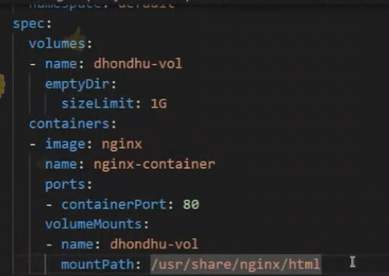

🔹 7.2 hostPath
- Node ka file path container ke saath mount hota hai
- Useful for debugging ya logs access ke liye
hostPath ek aisa volume type hai jo Kubernetes node ke host machine ka actual file system path container ke andar mount karta hai.
Yeh bahut useful hai jab:
- Aapko node-level data access karna ho (e.g., logs, binaries, Docker socket)
- Testing/debugging karna ho
- Aapko container ke andar ek specific host directory/file chahiye

Caution: Not recommended for production
volumes:
- name: host-volume
hostPath:
path: /data/logs
hostPath – क्या यह permanent है?
- डेटा persistence: Pod हट जाने (delete) के बाद भी hostPath पर लिखा गया data node पर बना रहता है। इसलिए यह emptyDir जैसा temporarily नहीं होता—यह कुछ हद तक persistent होता है।
- पर्यावरण का प्रतिबंध (Node-bound):
  - यह केवल उसी node का data शेयर करता है जहाँ Pod रन हो रहा था या था। अगर Pod फिरसे उसी node पर schedule होता है, तो data उपलब्ध रहता है।
  - लेकिन यदि Pod किसी दूसरे node पर चला जाए, तो उस नए node पर hostPath की उसी path पर मौजूद data अलग होगा (या हो सकता है बिलकुल खाली)—यानि पहले का data वहां उपलब्ध नहीं होगा।
- multi-node या production environment में limitations:
  - Pod को specific node से बाँध कर रखना पड़ता है जिससे scheduling flexibility खत्म हो जाती है।
  - इसलिए hostPath production workloads या stateful applications (जैसे डेटाबेस) के लिए recommended नहीं है।

Summary Table
Feature | hostPath Behavior
डेटा persistence | हाँ, Pod delete होने पर node पर data बना रहता है
Node-independent | नहीं — Pod अगर दूसरे node पर schedule होता है, तो data उपलब्ध नहीं होगा
Scheduling flexibility | कम — Pod को उसी node पर रोक कर रखना पड़ता है जहाँ data है
Production suitability | कम — data loss, security risks, और scheduling issues की वजह से unfit है

निष्कर्ष (Final Verdict)
- hostPath partial persistence प्रदान करता है — मतलब यदि Pod उसी node पर वापस आता है, फिर से data मिलेगा।
- लेकिन यह permanent volume नहीं होता यदि आपका मतलब data cluster-wide, node-independent persistence से है।
- Production-ready, highly available, scalable और secure storage के लिए आपको PersistentVolumes (PVs) जैसे विकल्प (CSI-based storage, cloud volumes, NFS आदि) चुनने चाहिए।

🔹 7.3 configMap / secret
- App configuration ya sensitive data inject karne ke liye
- It is not a storage , used to inject config or secret in pod

📘 1. Kya hai configMap aur secret?
✅ configMap:
- Non-sensitive data (like config files, environment variables) ko Kubernetes mein store karne ka tarika.
- YAML, JSON, .env jaise data store karne ke liye use hota hai.
- Plain-text format hota hai.
✅ secret:
- Sensitive data (like passwords, API keys, tokens) ko securely store karta hai.
- Data Base64 encoded hota hai.
- Automatically Kubernetes inhe secure handle karta hai.

📂 2. Use-case Example
- App ko run karne ke liye API key chahiye (Secret)
- App ko environment variable chahiye jaise ENV=production (ConfigMap)
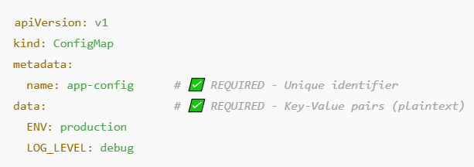
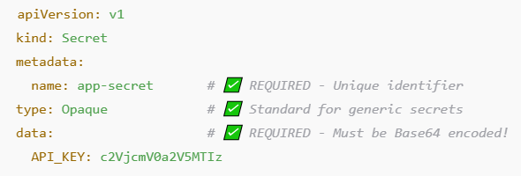
“ConfigMaps and Secrets can be consumed via volume mounts, environment variables (env/envFrom), container arguments, or directly through the Kubernetes API depending on use case.”
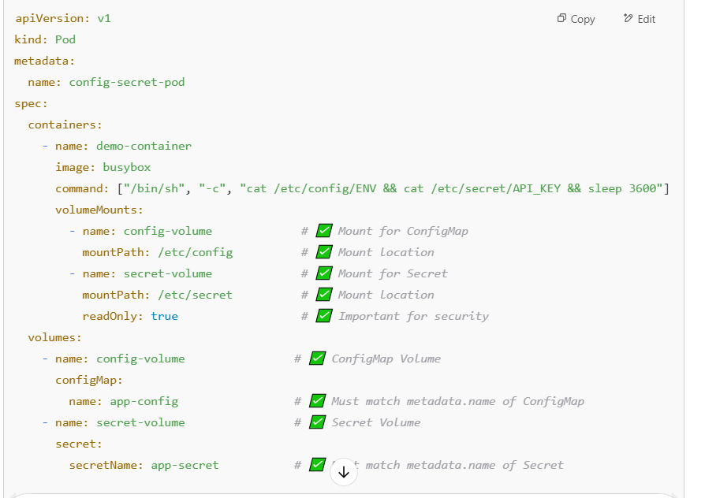
“Secrets and ConfigMaps are short-lived storage”
🔎 सच क्या है?
यह बात context पर निर्भर करती है — और यही जगह है जहाँ अक्सर confusion होता है।
चलिए इसको दो हिस्सों में समझते हैं:

🔹 1. ConfigMap / Secret as Kubernetes Resources (in etcd)
👉 ये जो आप kubectl create configmap या kubectl create secret से बनाते हो — ये Kubernetes के control plane पर store होते हैं (in etcd)
- जब तक आप manually delete नहीं करते या namespace delete नहीं करते,
ये बने रहते हैं
✅ यह long-lived है (relatively stable configuration source)

🔹 2. ConfigMap / Secret as Mounted Data Inside a Pod
जब कोई Pod इनको consume करता है (via volume mount या env variable):
- वो data Pod के filesystem या memory में mount होता है
- यह part होता है Pod के runtime environment का
- जैसे ही Pod मरता है — उसका ephemeral storage भी चला जाता है
⚠️ यही वह जगह है जहां लोग कहते हैं:
“ConfigMap/Secret is short-lived” — यानी Pod के अंदर उसका हिस्सा short-lived है, पर actual Kubernetes object नहीं।

🎯 इसलिए:
Concept | Short-lived? | Explanation
ConfigMap / Secret as K8s resource | ❌ No | Stable until deleted manually or namespace dies
ConfigMap / Secret inside Pod (mount/env) | ✅ Yes | Lives only as long as the Pod

🔹 7.4 PersistentVolume (PV) and PersistentVolumeClaim (PVC)
🧱 PersistentVolume (PV)
- Cluster-level resource
- Physical storage describes karta hai
✅ Solution: PVC + PV System
🤝 1. PersistentVolume (PV)
- Aapke cluster mein available physical/external storage (e.g., NFS, EBS, GlusterFS)
- Admin ne bana ke diya
- Note:- ek pv se ek hi pvc bnega . one to one mapping hoti hai .Jitna pvc chiyea utna ka hi pv bnao otherwise rest storage will be waste.
ek volume ko (pvc ko ) multiple pod access kr skte hai , if access mode is readwritemany.
🙋‍♂️ 2. PersistentVolumeClaim (PVC)
- Developer ne pod banate waqt kaha:
"Mujhe 1Gi storage chahiye, jo read/write ho sake"
PVC automatically bind ho jaata hai kisi matching PV se
NOTE:- PV kya krta hai k hume direct krta hai storage k taraf wo kuch bhi ho skta hai azure fileshare /gcp /aws . suppose humko azure fileshare pr pv bnanan hai to hum kubectl explain persistentVolume – recursive > pv.txt kr k uska data la kr fir bnayenge .eske liye azure pr storage account or file share bnana parega .uske baad ek secret banan parega apne cluster me ajis mea storage account ka naam or key hoga taki humusko access kr paye .
Kubectl create secret generic secretname –from-literal=azurestorageaccountname –from-literal=azurestorageaccountkey (kubectl get secret -kr k secret dekh skte hai )
Secret create kr k pv k yaml mea paas kr denge .
🧠 Analogy:
- PV = Room in a hotel
- PVC = Guest booking request
- StorageClass = Rules to create room on-demand

📌 Kab Use Karte Hai PVC + PV?
Scenario | Why Use PVC/PV?
Database (Postgres, MySQL) | Data loss nahi chahiye
WordPress/Media Apps | Uploads persist karne ke liye
Backup Jobs | Long-term storage required
StatefulSets | Each replica needs own persistent storage
CI/CD Pipelines | Build cache ya artifacts store karne ke liye
Logs aggregation | Logs container se bahar store karne ke liye

🔁 Volume Lifecycle
- Admin defines PV
- Dev defines PVC
- Kubernetes binds PVC to suitable PV
- Pod mounts PVC and writes to it
- Pod dies? Data safe
- PVC deleted? Depends on reclaimPolicy

🧾 Important Concepts
✅ Reclaim Policy (VERY IMPORTANT)
Policy | Behavior
Retain | PV stays even if PVC deleted (manual cleanup needed)
Delete | PV also deleted when PVC is deleted
Recycle | (Deprecated) Wipes data and reuses

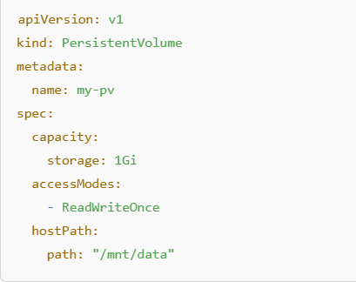

📥 PersistentVolumeClaim (PVC)
- User ya pod ki taraf se storage ka request
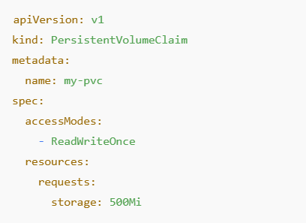
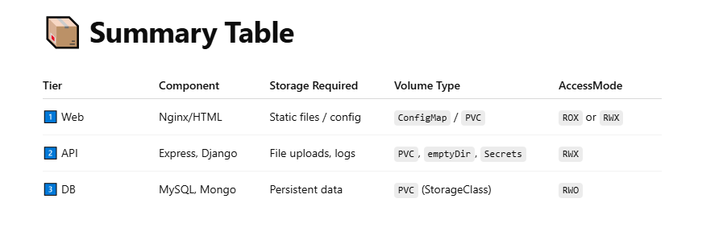

🧠 5. Access Modes (Kaun Kaise Access Kar Sakta Hai)
Mode | Description
ReadWriteOnce | 1 node can read/write
ReadOnlyMany | Many nodes can only read
ReadWriteMany | Many nodes can read/write (e.g. NFS)

🏗️ 6. Real World Examples
📁 Web App with File Uploads
Use PVC with dynamic provisioning. Agar user images upload kare toh wo data persistent rahe.
🧪 Logging System
Containers logs generate karte hain — hostPath ya emptyDir mein rakh sakte ho.
☁️ Cloud Environments
Use StorageClass with AWS EBS, Azure Disk, GCE PD, etc.

⚙️ 7. Volume Lifecycle
- Admin sets up PV or StorageClass
- Developer defines PVC
- PVC binds to PV automatically (or creates dynamically)
- Pod uses the PVC
- Pod deletes — PVC can stay
- PVC delete — then PV deleted (depends on reclaim policy)

🧾 8. Reclaim Policy (What Happens After PVC Deletion)
Reclaim Policy | Description
Retain | Data safe rahega manually cleanup
Recycle | Not used now
Delete | Volume also gets deleted automatically

📌 9. Summary Cheatsheet
Volume Type | Persistent? | Scope | Use-case
emptyDir | ❌ | Pod | Cache, temp files
hostPath | ❌ | Node | Logs, node diagnostics
configMap/secret | ❌ | Pod | Configuration, secrets
PV/PVC | ✅ | Cluster | Database, file storage
StorageClass | ✅ | Cluster | Dynamic provisioning

🔹 7.5 StorageClass (for Dynamic Provisioning)
- Har bar manually PV create karna boring hai
- StorageClass se Kubernetes khud se volume banata hai on-demand

🧠 What is StorageClass?
➤ Kubernetes ka built-in feature jo:
- PVC ke liye automatic PV create karta hai
- PVC banate hi storage provision ho jata hai
- Manual PersistentVolume banane ki zarurat nahi
🎯 Iska matlab: On-demand storage, just like cloud VMs.
Jaise tum PVC likho 10Gi, Kubernetes backend pe EBS / GCE disk khud create kar dega.

📦 Why Use StorageClass? (Benefits)
Feature | Benefit
✅ Dynamic provisioning | No manual PV creation
✅ Reduced waste | Storage created exactly per PVC
✅ Better scalability | Ideal for CI/CD, autoscaling
✅ Automation | Integrates with cloud provisioners
✅ Customization | You can set different IOPS, types, zones

🧱 How It Works (Flow)
[ PVC (10Gi) ] --> [ StorageClass "fast" ] --> [ Provisioner (EBS, NFS, etc.) ] --> [ Auto-created PV (10G)

• PVC references StorageClass
• StorageClass defines the provisioner and its parameters
• Kubernetes provisions a matching PV behind the scenes
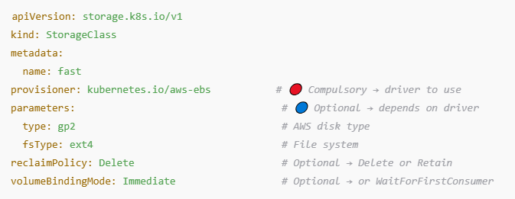
🔸 reclaimPolicy: What to do after PVC is deleted?
Value | Behavior
Delete | PV deleted automatically
Retain | PV remains; manual cleanup needed

Flow
- Pehle StorageClass YAML banao aur apply karo.
- Phir PVC YAML banao jo us StorageClass ka use kare.
- Jaise hi PVC apply karoge → Kubernetes dynamic provisioning se PV create karega

🔸 volumeBindingMode: Binding timing
Mode | Use When
Immediate | Volume created as soon as PVC is made
WaitForFirstConsumer | Volume created only when Pod is scheduled (best for multi-zone clusters)
ERROR SCENARIO:-
WHILE CREATEING STORAGECLASS, WE DID NOT PROVIDED RESOURCE GROUP NAME ONLY PROVIDED STORAGEACCOUNT NAME , SO PVC WITH STORAGECLASS FAILED .RG NAME NAI DENE SE PTA HI NAI CHALA K KIS RESOURCE GROUP K STORAGE MEA FILE SHARE BNANA HAI.
AUTH K BHI ISSUE HO SKTE HAI .
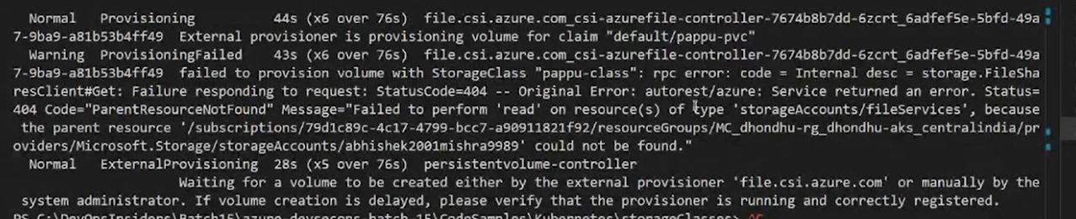
Access issue will be there as well. We need to use managed Identity to validate our AKS in storage account for this we can create a system assigned managed identity using cli (no portal option)
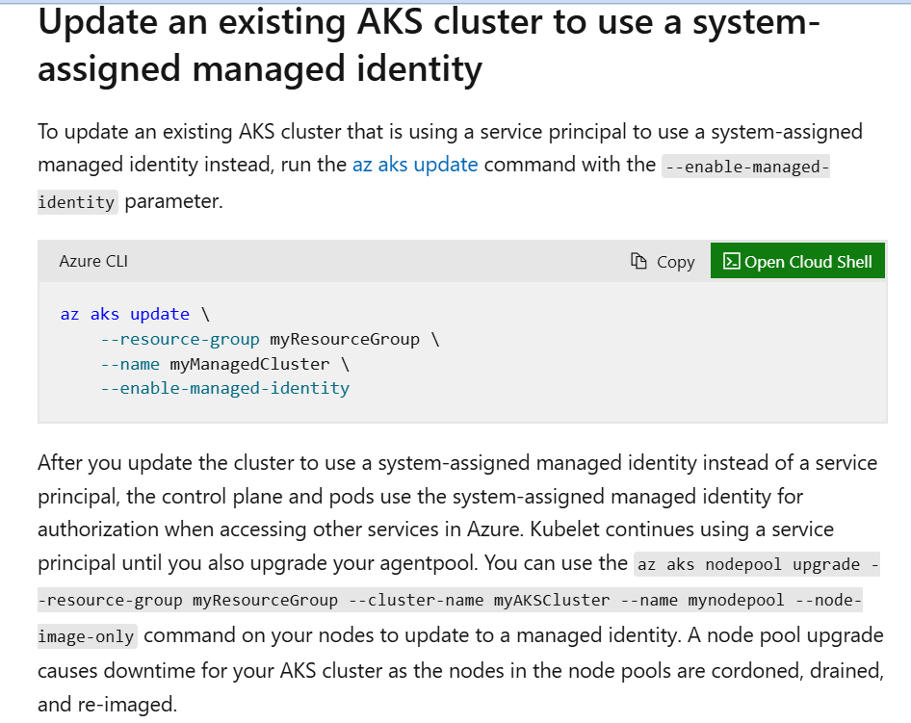

After creating system managed identity, go to storage IAM ADD ROLE ASSIGNMENT Privileged administrator rolescontributorManaged identity+select members select AKS CLUSTER NAME .
NOTE:- By default bht sare SC hote hai AKS mea . we can use them .

8.Scheduling’s: -
Basic type of scheduling is node name. directly mention node name in pod.
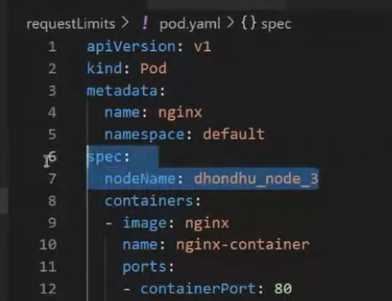

🔹 8.1 NodeSelector
➡️ Definition:
NodeSelector एक simple तरीका है Pod को किसी specific node पर चलाने का।
kubectl label nodes <node-name> <key>=<value> to set label of node.
➡️ कैसे काम करता है?
आप Node को एक label देते हो, फिर Pod में nodeSelector से वो label match करते हो।
# kubectl label
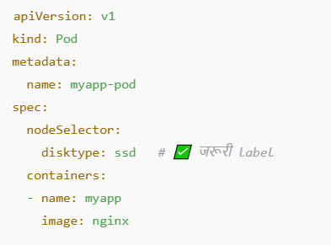

🔹 8.2 Affinity & Anti-Affinity
➡️ Definition:
यह advanced तरीका है pod placement control करने का। 3 प्रकार:
- Node Affinity (NodeSelector का advanced version)
- Pod Affinity (कुछ pods साथ में रखो)
- Pod Anti-Affinity (कुछ pods अलग रखो)
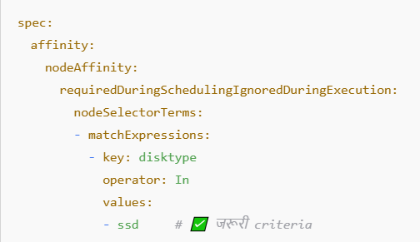
🔸 1. Node Affinity
🔹 Definition:
Node Affinity pod को किसी specific type के node पर शेड्यूल करने का तरीका है। यह nodeSelector का advanced version है।
🔹 दो प्रकार होते हैं:
- requiredDuringSchedulingIgnoredDuringExecution (जरूरी – वरना pod चलेगा ही नहीं)
- preferredDuringSchedulingIgnoredDuringExecution (preference – कोशिश करेगा)
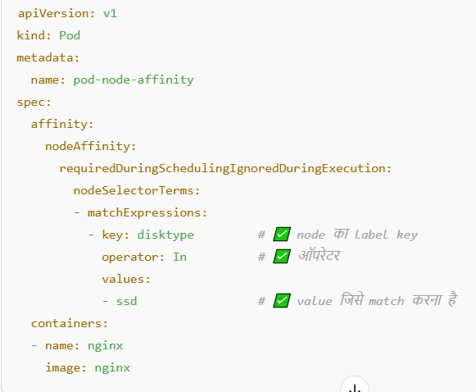
🎯 Use Case:
High performance pods को केवल SSD वाले nodes पर चलाना।

🔸 2. Pod Affinity
🔹 Definition:
Pod Affinity बताता है कि pod को किसी दूसरे pod के पास ही शेड्यूल करना है। यानी एक जैसे pod साथ में रहें।
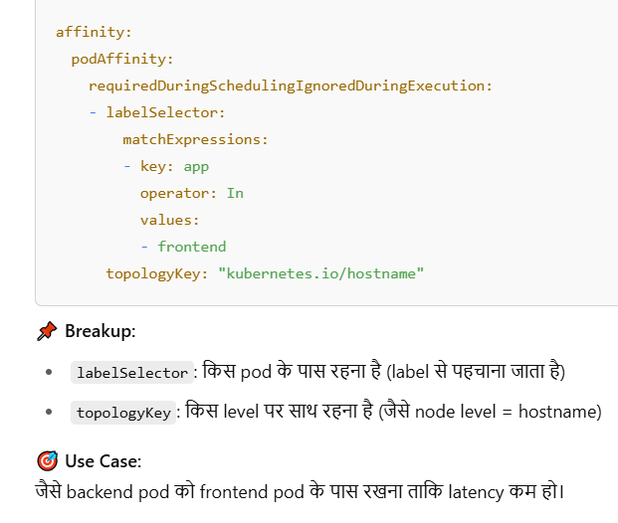
🔸 3. Pod Anti-Affinity
🔹 Definition:
Pod Anti-Affinity बताता है कि pod को किसी specific pod के पास नहीं रहना चाहिए। यानी, वे एक-दूसरे से अलग node पर रहें।
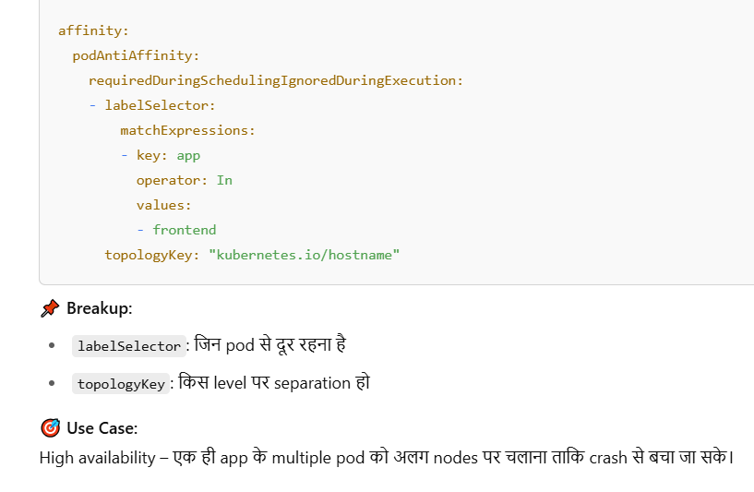

🔹 8.3 Taints & Tolerations
➡️ Definition:
Taints किसी node को "avoid" करने लायक बनाते हैं। Toleration बताता है कि कौनसा pod उस node पर चल सकता है।
- Taints: एक तरीका है जिससे हम Node पर restriction लगाते हैं कि केवल specific Pods ही उस Node पर चल सकें।
- Tolerations: यह Pod पर defined होता है जो बताता है कि वह Pod किस Taint को सह सकता है (tolerate कर सकता है)।
👉 मतलब: Taints को Node पर लगाया जाता है, और Toleration को Pod पर। अगर Pod में matching toleration है, तभी वह tainted node पर schedule होगा।

🧠 Use Case:
- Critical workloads को specific nodes पर run कराना।
- GPU वाले या licensed software वाले nodes को restrict करना।
- Test env के Pods को production node पर जाने से रोकना।
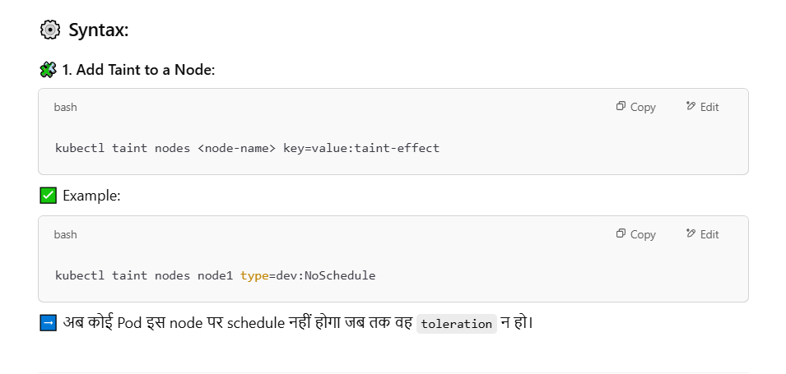
➡️ कैसे काम करता है?
- Taint node पर लगाया जाता है
- Toleration pod में add होता है
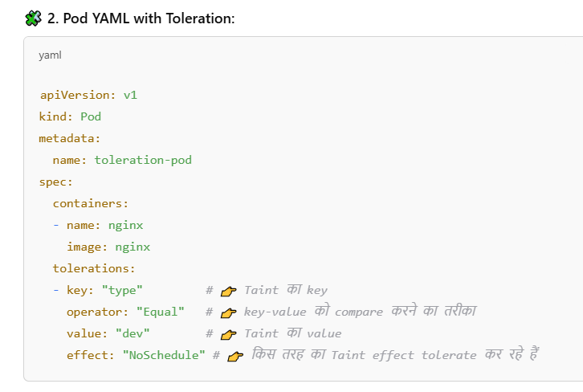
🔍 Taint Effects (3 प्रकार):
Effect | मतलब
NoSchedule | Pod schedule नहीं होगा unless it tolerates taint.
PreferNoSchedule | Avoid करता है scheduling को, but hard rule नहीं है.
NoExecute | Pod को तुरंत remove कर देता है अगर वो tolerate नहीं करता।
🤔 तो Taints की ज़रूरत क्यों पड़ी, जब Affinity था?
- Affinity सिर्फ suggest करता है (soft rule भी होता है):
  - NodeSelector/Affinity में आप required या preferred set कर सकते हो।
  - लेकिन taints में strict rule enforced होता है — अगर Pod tolerate नहीं करता, तो वो कभी schedule नहीं होगा।
- Taints node से enforce होते हैं:
  - Affinity में Pod अपने हिसाब से decide करता है कहाँ जाना है।
  - Taints में Node खुद कहता है कि "मैं सिर्फ उन Pods को चलाऊँगा जो मुझे tolerate करते हैं।"
- Use case isolation का difference:
  - Affinity का उपयोग workloads spread करने के लिए होता है (जैसे HA purpose)।
  - Taints/toleration isolation enforce करता है (जैसे test pods ना जाए prod node पर)।
- NoExecute behavior सिर्फ Taints में possible है:
  - अगर Pod tolerate नहीं करता, तो वो तुरंत उस node से निकाल दिया जाता है – ये Affinity में possible नहीं है।

📌 Conclusion (Notes Style):
- Affinity/Anti-Affinity → Pod कहता है उसे कहाँ जाना है
- Taints/Toleration → Node कहता है कौन उसके ऊपर आ सकता है
- Taints offer stronger, node-enforced restrictions
- दोनों मिलकर precise scheduling और isolation achieve करते हैं

🔹 8.4 Resource Requests & Limits
➡️ Definition:
Pod को कितनी CPU/Memory चाहिए (Request) और कितना maximum use कर सकता है (Limit) – ये define करता है।
In Kubernetes, **resource requests** and **limits** help manage resource allocation to containers and prevent overuse of system resources. They ensure that the pod has the necessary CPU and memory and help control the resources it can consume.
- **Resource Requests**:
- **Definition**: Minimum resources guaranteed to the container.
- **Purpose**: Kubernetes uses the requested resources to make scheduling decisions. A pod won’t be scheduled unless the node has enough capacity to meet its request.
- **Example**: A pod with a request of `0.5 CPU` and `256 Mi` of memory will be allocated at least this much on a node.
- **Resource Limits**:
- **Definition**: Maximum resources a container can use.
- **Purpose**: Protects against resource starvation by setting an upper bound on resource usage. If a pod exceeds its CPU limit, it is throttled; if it exceeds its memory limit, it may be terminated.
- **Example**: A pod with a limit of `1 CPU` and `512 Mi` memory can’t consume more than this, even if the node has additional capacity.

Setting requests and limits is crucial for optimal utilization of cluster resources, as it prevents a few containers from consuming all resources, leading to balanced performance across applications.
📘 क्यों ज़रूरी है?
- Fair resource sharing – Cluster में सबको बराबर chance मिले।
- Avoid overloading – कोई container ज़्यादा memory/CPU use ना कर ले।
- Scheduling decision – Scheduler उसी node पर pod भेजेगा जहाँ request fulfill हो सके।

📌 Use Case:
मान लीजिए आप एक backend API चला रहे हैं:
- आप जानते हो कि उसे कम से कम 100m CPU और 256Mi RAM चाहिए।
- लेकिन आप उसे 500m CPU और 512Mi RAM से ज़्यादा नहीं देना चाहते।
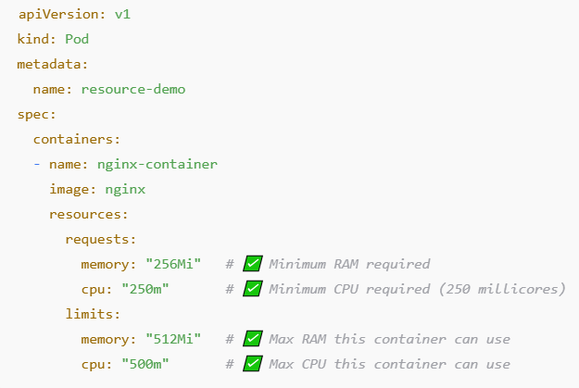
💡 Extra Concept:
- अगर Pod ने limit से ज़्यादा memory मांगी → Killed हो जाएगा (OOMKilled)
- अगर Pod ने CPU ज़्यादा use किया:
  - Limit set है → throttling होगा (CPU slow कर दिया जाएगा)
  - Limit नहीं है → जितना चाहे उतना use कर लेगा
- Stress cli tool se testing kr skte hai

🧠 Notes Summary:
- Request = Minimum resource for scheduling
- Limit = Maximum resource allowed during run
- अगर request नहीं दिया → default zero माना जाएगा (dangerous!)
- अगर limit नहीं दिया → container ज़्यादा resource ले सकता है
- Production में हमेशा दोनों set करना चाहिए

9. Namespaces & RBAC (Role-Based Access Control)

🔹 9.1 Namespaces
📘 Definition:
Namespace Kubernetes में logical isolation का तरीका है — आप एक ही cluster में multiple isolated environments बना सकते हैं जैसे: dev, test, prod, etc.
🔑 Key Points:
Feature | Details
Isolation | एक namespace के pod, दूसरे namespace के pod से isolate रहते हैं
Resource scoping | एक resource जैसे pod या service को एक specific namespace में create कर सकते हैं
Access control | RBAC के ज़रिए namespace-लीमत permissions दी जा सकती हैं

🧾 By Default Namespaces in K8s:
Namespace | Purpose
default | अगर कोई namespace न दो, तो resources यहीं बनते हैं
kube-system | Kubernetes internal components (जैसे kube-dns)
kube-public | Public readable data (जैसे cluster-info)
kube-node-lease | node health heartbeat info
kubectl config set-context --current --namespace=dev ns change krne ka cmd
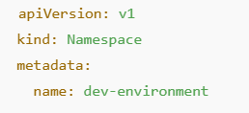

🔹 9.2 RBAC (Role-Based Access Control)
📘 Definition:
RBAC एक system है जो define करता है कि कौन (User/ServiceAccount) क्या कर सकता है (verbs like get, list, create, delete) और कहाँ (resource और namespace)।

🔑 Main Concepts:
RBAC Object | Description
Role | Specific namespace में permissions define करता है
RoleBinding | एक user/service को उस role से bind करता है
ClusterRole | Cluster-wide permissions देता है
ClusterRoleBinding | किसी user को ClusterRole assign करता है
ServiceAccount | Pod में चल रहे application को identify करता है

🔹 1. Role (भूमिका)
📖 परिभाषा:
Role Kubernetes में एक object है जो किसी एक namespace के अंदर resources पर क्या actions (verbs) allow हैं — ये define करता है।
✅ विशेषताएं:
- केवल एक namespace में लागू होता है
- verbs जैसे get, list, create, delete को control करता है
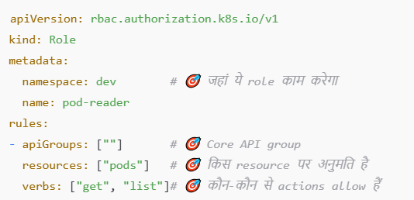

🔹 2. RoleBinding (भूमिका-बाइंडिंग)
📖 परिभाषा:
RoleBinding किसी user, group या service account को Role से bind करता है, ताकि वो user उस Role के अनुसार काम कर सके।
✅ विशेषताएं:
- एक namespace में लागू होता है (जहां Role defined है)
- subject में user/serviceaccount होता है
- roleRef में Role की details होती हैं
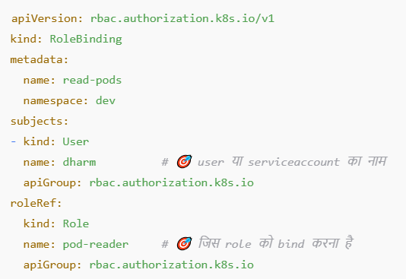
🔹 3. ClusterRole (क्लस्टर भूमिका)
📖 परिभाषा:
ClusterRole पूरे Kubernetes cluster में permission देता है।
यह Role से अलग है क्योंकि यह केवल एक namespace तक सीमित नहीं होता।
✅ विशेषताएं:
- Cluster-wide access देता है
- Namespace-specific और non-namespaced दोनों resources को control कर सकता है
- NetworkPolicy, nodes, persistentvolumes आदि पर भी काम करता है
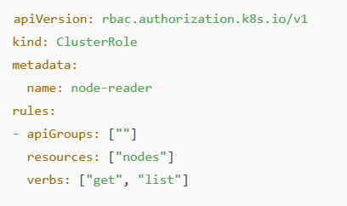
🔹 4. ClusterRoleBinding (क्लस्टर भूमिका-बाइंडिंग)
📖 परिभाषा:
ClusterRoleBinding एक user, group या service account को पूरे cluster में ClusterRole assign करता है।
✅ विशेषताएं:
- पूरे cluster में access देता है
- Mostly admin-level या cross-namespace access के लिए इस्तेमाल होता है
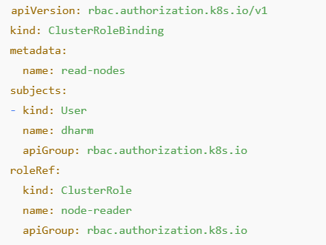
🔹 5. ServiceAccount
ServiceAccount एक Kubernetes object है जो किसी pod के अंदर चल रहे application को identity प्रदान करता है।
✅ विशेषताएं:
- Pod जब API server से बात करता है तो वो ServiceAccount के नाम से पहचानता है
- Default serviceAccount हर namespace में होता है
- आप custom serviceAccount बनाकर pods को assign कर सकते हैं
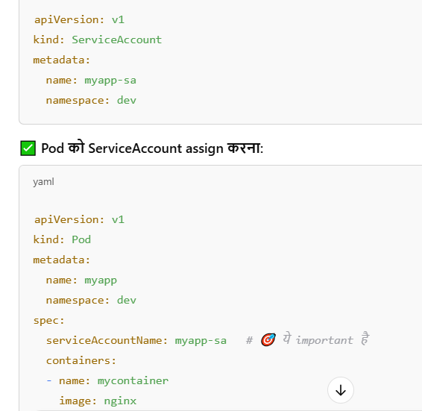
🧠 Real-Life Example (Use Case)
🎯 Use Case:
आपका pod एक monitoring app चला रहा है, जो cluster में चल रहे दूसरे pods की details देखना चाहता है।
लेकिन default service account को इतनी permission नहीं होती।
✅ Solution:
- आप एक custom ServiceAccount बनाइए।
- एक Role या ClusterRole बनाइए जिसमें pods को list करने की permission हो।
- फिर RoleBinding/ClusterRoleBinding के जरिए ServiceAccount को role assign कर दीजिए।
- Pod को वो ServiceAccount assign कर दीजिए।

10.Kubernetes Networking
A **Network Policy** in Kubernetes defines how Pods can communicate with each other and other network endpoints, controlling both **ingress** (incoming) and **egress** (outgoing) traffic. Network Policies are implemented through the **kube-proxy** and enforced by the network plugin.

By default, all traffic between Pods is allowed unless restricted by a Network Policy. Network Policies allow you to:
- Control which Pods can communicate with other Pods.
- Define restrictions based on labels, namespaces, or IP blocks.
- Enable security rules that are crucial for microservices architectures.

#### Key Concepts of Network Policies
1. **Pod Selector**: Specifies which Pods the Network Policy applies to, using label selectors. This can define a set of Pods that are allowed or denied.
2. **Ingress & Egress Rules**: Ingress defines what incoming traffic is allowed, while Egress defines what outgoing traffic is permitted from the selected Pods.
3. **Ports**: You can define specific ports that should be allowed or denied for ingress or egress.
4. **Policy Types**: You can define policies to only allow ingress traffic, egress traffic, or both.

### Network Policy Example

The following example demonstrates a Network Policy and a Pod configuration in Kubernetes.

#### 1. **NetworkPolicy Example**
This `NetworkPolicy` is named `nginx-network-policy` and controls traffic for Pods that have the label `papa: dhondhu`.

apiVersion: networking.k8s.io/v1
kind: NetworkPolicy
metadata:
name: nginx-network-policy
namespace: default
spec:
podSelector:
matchLabels:
papa: dhondhu
ingress:
- ports:
- port: 80
```

**Explanation:**
- `apiVersion: networking.k8s.io/v1`: Specifies the API version for networking resources.
- `kind: NetworkPolicy`: Declares this resource as a Network Policy.
- `metadata`: Includes metadata such as the name (`nginx-network-policy`) and the namespace (`default`).
- `spec`: Defines the rules for the Network Policy.
- `podSelector`: This selector ensures the policy applies only to Pods with the label `papa: dhondhu`.
- `ingress`: Specifies that incoming traffic to the selected Pods is allowed only on port 80.

This policy **limits incoming traffic** to Pods labeled `papa: dhondhu` on port 80, effectively allowing only HTTP traffic to these Pods and blocking other traffic.
#### 2. **Pod Definition (pod.yaml)**
Below is an example of a Pod configuration that would match the label `papa: dhondhu` and can be affected by the `nginx-network-policy`:

```yaml
apiVersion: v1
kind: Pod
metadata:
name: nginx-pod-with-label
namespace: default
labels:
papa: dhondhu
spec:
containers:
- image: nginx
name: nginx-container
ports:
- containerPort: 80
```

**Explanation:**
- `apiVersion: v1`: Specifies the Pod resource version.
- `kind: Pod`: Declares this resource as a Pod.
- `metadata`: Contains the name of the Pod (`nginx-pod-with-label`) and assigns it a label `papa: dhondhu`.
- `spec`: Defines the container configuration.
- `containers`: A list of containers to run in the Pod. In this case, it's running the `nginx` image, and the container is exposing port 80.

#### How the Network Policy Works:
- The **Pod `nginx-pod-with-label`** is assigned the label `papa: dhondhu`, which means the `nginx-network-policy` Network Policy will apply to this Pod.
- The **NetworkPolicy** allows incoming traffic only on **port 80** for Pods with the label `papa: dhondhu`. Any traffic trying to reach this Pod on other ports will be blocked.
- This provides a simple but powerful way to secure communication by restricting access to specific services or applications within a cluster.

---

### Understanding Network Policies

Network Policies can be used to manage communication between Pods in a Kubernetes cluster. Below are some important details about how they work:

1. **Default Behavior**: By default, if no Network Policies are defined, all traffic is allowed between Pods in a Kubernetes cluster.
2. **Ingress Rules**: These rules define what inbound traffic is allowed to reach the Pod. For example, you can define rules that only allow traffic from certain namespaces, IP blocks, or Pods with specific labels.
3. **Egress Rules**: These rules specify the allowed outbound traffic from a Pod. You can restrict egress traffic to certain services, hosts, or IP ranges.
4. **Policy Enforcement**: The Kubernetes network plugin (such as Calico, Cilium, or Weave) enforces the policies. Not all network plugins support Network Policies, so it's important to ensure the network plugin in use supports them.

---

### Common Use Cases for Network Policies

1. **Restricting Inter-Pod Communication**: Limit traffic between Pods of different applications or microservices.
2. **Isolation for Sensitive Pods**: Isolate Pods that handle sensitive data or are vulnerable to external threats.
3. **Whitelisting Traffic**: Only allow traffic from specific Pods, namespaces, or IP blocks, ensuring that only authorized services can communicate with each other.

---

### Conclusion

Pod-to-Pod communication in Kubernetes relies on the underlying network setup, where each Pod gets a unique IP address, and traffic is typically allowed between Pods unless restricted by network policies. Network Policies in Kubernetes provide an essential security mechanism for controlling how Pods can communicate with each other. By defining ingress and egress rules based on labels, namespaces, or IP addresses, you can fine-tune the security and networking behavior of your Kubernetes environment, ensuring that only authorized services can communicate with each other.
🔹 1. kube-proxy kya karta hai?
👉 Service networking handle karta hai (L4 level)
✔ Kaam:
- Service IP → Pod IP mapping
- Load balancing (iptables / IPVS)
- ClusterIP / NodePort routing
👉 Example:
my-service → 3 pods
➡ kube-proxy decide karega request kis pod pe jayegi

🔹 2. Calico kya karta hai?
👉 CNI plugin (networking + security)
✔ Kaam:
- Pod ko IP dena
- Pod-to-Pod networking
- NetworkPolicy enforce karna (firewall)
👉 Example:
- Pod A → Pod B allowed / blocked
➡ Calico decide karega

🔹 3. Azure CNI Overlay kya hai?
👉 Azure ka networking model (IP management)
✔ Kaam:
- Pod IP allocation (overlay network se)
- VNet IP bachana
- Encapsulation (VXLAN)
👉 Simple:
- Pod IP VNet se nahi aata, overlay se aata hai

🔹 4. Difference (Clear Table 🔥)
Component | Role
kube-proxy | Service routing & load balancing
Calico | Pod networking + NetworkPolicy
Azure CNI Overlay | Pod IP allocation + network model

🔹 5. Ek flow me samjho
👉 Pod A → Service call
- kube-proxy → service ko pod me route karega
- Calico → check karega allowed hai ya nahi
- Azure Overlay → underlying network provide karega

🔹 6. Important Interview Point 💡
- kube-proxy = L4 routing
- Calico = CNI + security (L3/L4 policy)
- Azure CNI overlay = IP allocation + infra networking

🔹 Final one-liner
“kube-proxy handles service routing, Calico manages pod networking and network policies, and Azure CNI Overlay provides the underlying IP allocation and networking model.”
🔹 Pod-to-Pod communication kaun karta hai?
👉 CNI plugin (like Calico / Azure CNI)
✔ Ye hi actual networking provide karta hai
✔ Pod ko IP deta hai
✔ Pod A → Pod B routing karta hai

🔹 Role breakdown
- CNI (Calico / Azure CNI) → ✅ Pod-to-Pod communication
- kube-proxy → ❌ (only Service routing)
- Overlay (Azure CNI overlay) → infra networking (IP + tunnel)

🔹 Simple samjho
👉 Pod A → Pod B direct call
➡ CNI handle karega
👉 Pod A → Service → Pod B
➡ kube-proxy + CNI dono ka role

🔹 Interview one-liner 💡
“Pod-to-pod communication is handled by the CNI plugin (like Calico or Azure CNI), while kube-proxy is only involved when traffic goes through a Service.”

🔹 10.1 CNI (Container Network Interface)
CNI Plugin Kubernetes में Pod-to-Pod communication को possible बनाता है।
Overlay n/w normally bnate hai so that pod can communicate .esko bnane k tool hai bht sare e.g-Calico
Azure CNI + CALICO enable krenge tbhi n/w policy and site to site connection kaam krega .
✅ Features:
- Pod को एक unique IP address देता है।
- Pod के बीच communication को possible बनाता है।
- कई तरह के plugins होते हैं (Flannel, Calico, Weave, Cilium etc.)
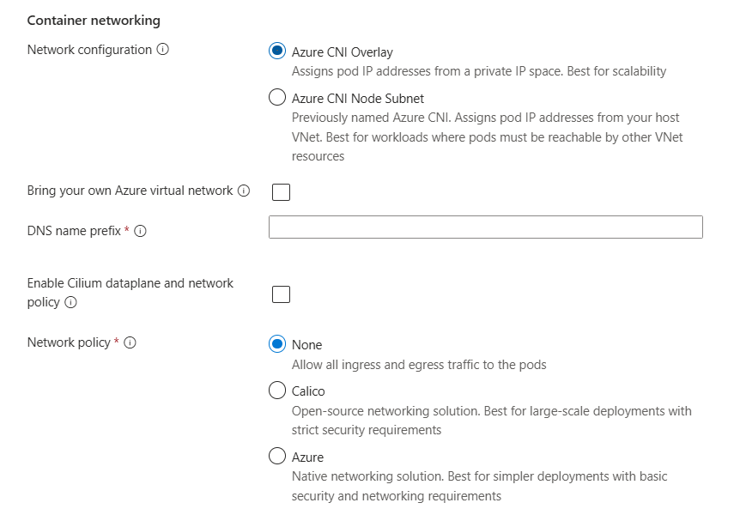
🔹 1. Azure CNI Overlay (selected)
- Pods ko separate private IP range milta hai
- VNet IP consume nahi hota
- Best for large scale (IP बचता hai)

🔹 2. Azure CNI Node Subnet
- Pods ko direct VNet IP milta hai
- Har pod ek real IP lega
- Best jab pod ko directly access karna ho (DB / on-prem)

# Network Plugins in Kubernetes
1. **Definition**:
- Network plugins (CNI - Container Network Interface) enable pod-to-pod communication within a Kubernetes cluster. (BY DEFAULT-KUBENET hota hai -n/w policy not supported) .
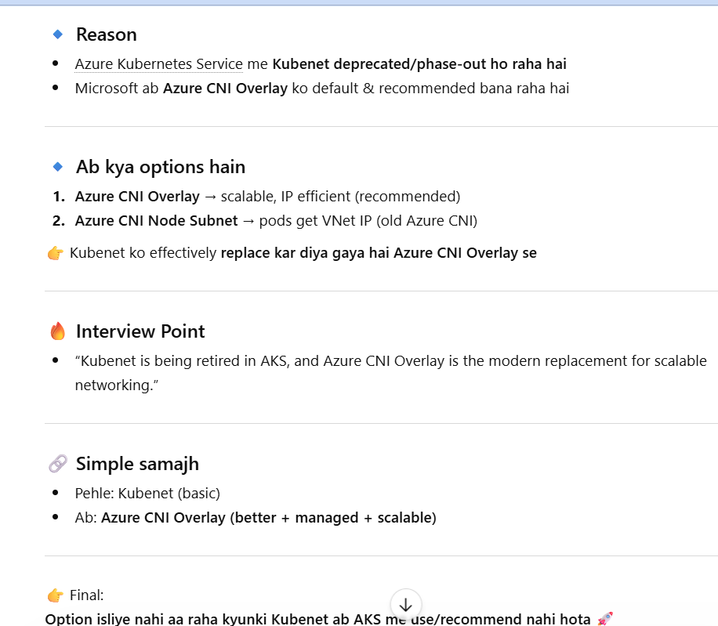
2. **Purpose**:
- Provide networking capabilities, including IP allocation, routing, and DNS.
- Ensure that pods can communicate with each other and external services.
3. **Common Network Plugins**:
- **Calico**: Offers high performance with network security features.
- **Flannel**: Simple overlay network primarily for flat networking.
- **Weave Net**: Focuses on simplicity and ease of use, with built-in encryption.
- **Cilium**: Uses eBPF for networking and security, providing fine-grained control.
- **Kube-router**: A network routing solution that integrates services and network policies.
4. **CNI Specifications**:
- Kubernetes uses CNI specifications to manage networking. Each plugin implements its own configuration, which typically includes IP address management, routing, and network policy enforcement.
5. **Installation**:
- Network plugins can be deployed via Helm charts, YAML manifests, or as part of Kubernetes installation tools (e.g., kubeadm).
🎯 Example:
आपके cluster में Calico CNI है → तो हर pod को Calico IP assign करेगा और policies भी लागू करेगा।

🔹 Pod-to-Pod Communication
Kubernetes में हर Pod एक दूसरे से IP के जरिए बात कर सकता है, चाहे वो किसी भी Node पर हो।
🔑 Rules:
- हर Pod को एक unique IP मिलती है (via CNI).
- Communication Flat Network पर होता है (no NAT).
- DNS के जरिए नाम से भी बात कर सकते हैं (via kube-dns/CoreDNS).

🔹 Service-to-Service Communication
जब pod scale होते हैं, तो उनका IP बदलता रहता है।
इसलिए communication के लिए हम Service abstraction का इस्तेमाल करते हैं।
🔑 Features:
- Stable DNS name देता है (ex: my-svc.default.svc.cluster.local)
- Service → Selector → Pod को request भेजता है
- Load balancing भी करता है

🔹 10.2 Network Policies
Kubernetes में by default सब pod एक-दूसरे से बात कर सकते हैं।
NetworkPolicy इसका control देता है → कौन pod किससे बात कर सकता है।
Jaise hi n/w policy apply krnege (bina igree/egress) k bhi to pod se kuch access nai hoga . communication bnd hoga .explicitly define krna parega kiskoane dena hai .
### Network Policies in Kubernetes

1. **Definition**:
- Network policies define how groups of pods can communicate with each other and with other network endpoints.

2. **Purpose**:
- Enhance security by controlling traffic flow at the IP address or port level.
3. **Key Concepts**:
- **Pod Selector**: Defines which pods the policy applies to.
- **Ingress**: Rules that specify what traffic is allowed to enter the pods.
- **Egress**: Rules that specify what traffic is allowed to leave the pods.
- **Namespaces**: Network policies can be applied across namespaces, allowing for more granular control.

4. **Example Use Cases**:
- Restricting traffic from external sources to specific services.
- Allowing communication only between certain pods within the cluster.
- Isolating workloads for compliance or security purposes.

5. **Implementation**:
- Network policies are defined in YAML manifests using `NetworkPolicy` resources.
- Requires a compatible CNI plugin that supports network policies (e.g., Calico, Cilium).

6. **Limitations**:
- Network policies are not enforced by default; a compatible CNI must be used.
- Policies are additive; there is no "deny all" by default, unless explicitly defined.

### Summary

- **Network plugins** are essential for establishing a functional network in Kubernetes, enabling communication and IP management among pods.
- **Network policies** enhance security by allowing users to define which pods can communicate, significantly improving the cluster's security posture.
✅ काम:
- Ingress control (कौन इस pod को access कर सकता है)
- Egress control (यह pod किसे access कर सकता है)
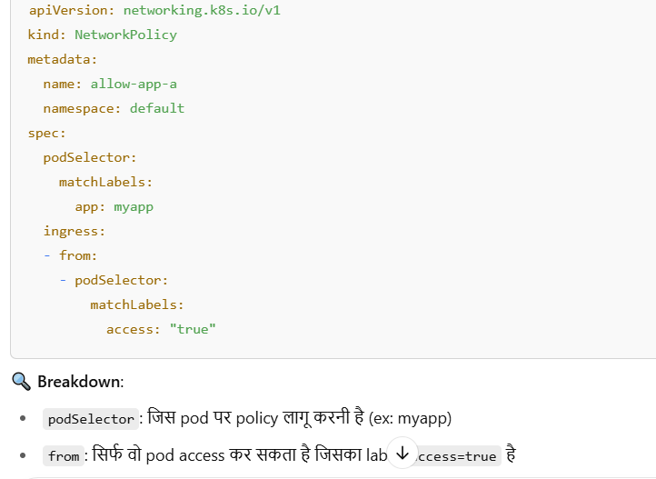
🎯 Use Case:
- आप चाहते हैं कि frontend pod सिर्फ backend pod से बात करे, किसी और से नहीं।
- या फिर कुछ pod इंटरनेट से data fetch कर सकें (egress), कुछ ना करें।

🔚 Summary (Quick Points):
Feature | Description
CNI Plugin | Network setup करता है, pod को IP देता है
Pod-to-Pod Communication | Flat network, हर pod एक-दूसरे से freely बात कर सकता है
Service Communication | Service DNS और Load Balancer के जरिए बात होती है
Network Policies | Security rules तय करते हैं (Ingress/Egress)

11. Controllers

📦 Kubernetes Controllers – Explained Simply
Controllers are control loops in Kubernetes that ensure the desired state (defined in YAML) matches the current state of the cluster.

🔧 Main Types of Controllers:
Controller | Purpose
ReplicationController | Legacy – ensures fixed number of Pod replicas
ReplicaSet | Modern version of ReplicationController
Deployment | Manages ReplicaSets, supports rolling updates/rollback
StatefulSet | For stateful apps – gives each Pod a stable identity
DaemonSet | Runs one Pod per node (e.g., log collectors, agents)
Job | Runs Pods once until completion (batch jobs)
CronJob | Runs Jobs on scheduled times (like cron)

🎯 Example:
- Deployment keeps 3 replicas of an app running.
- If 1 crashes, the controller creates a new Pod automatically.
Controllers are key to Kubernetes' self-healing behavior. ✅
--------------------------------------

11.1 ReplicationController (RC)
- Legacy controller (now replaced by ReplicaSet)
- Ensures a fixed number of identical Pods are running.
- If a Pod crashes, it creates a new one to match the desired count.
- Less used now; replaced by Deployment + ReplicaSet.

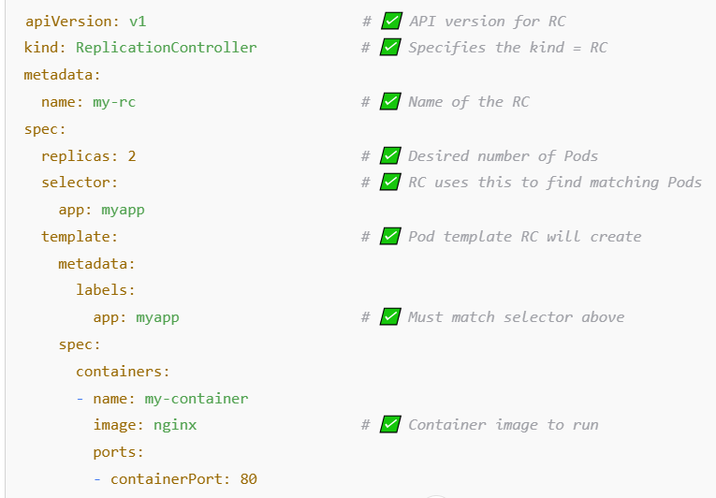
📌 Key Fields (Marked with ✅):
Field | Purpose
apiVersion: v1 | RC uses core v1 API
kind: ReplicationController | Tells Kubernetes what resource is being defined
metadata.name | RC name
spec.replicas | Number of Pods to maintain
spec.selector | RC watches for Pods with this label
spec.template | Pod template RC will create

#kubectl get rc

11.2 ReplicaSet (RS)
- Ensures a specified number of pod replicas are always running.
- Supports label selectors to manage Pods.
- Typically, not used directly; used internally by Deployments.

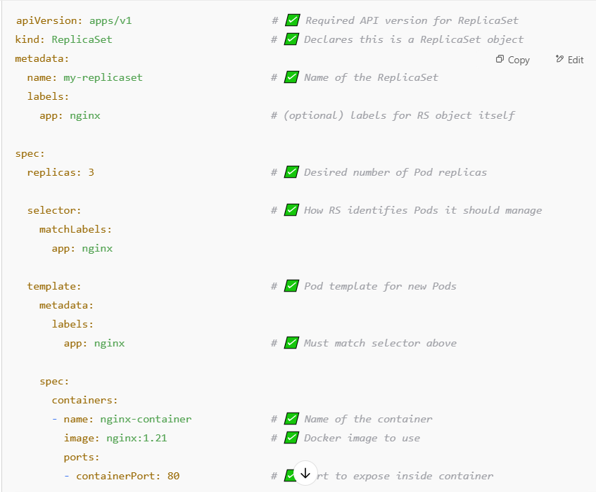
Section | Explanation
spec.selector.matchLabels | Critical – tells RS which Pods to manage (based on label match)
spec.template | Blueprint for Pods to be created if not enough replicas exist
template.metadata.labels | Must match matchLabels in the selector
spec.template.spec.containers | Defines containers inside the Pod – name, image, port, etc.
- Note:- RS is mostly used indirectly by Deployments, but you can use it standalone for learning.

11.3 Deployment
- Most commonly used controller.
- Manages ReplicaSets and handles:
  - Rolling updates
  - Rollbacks
  - Scaling
- Declarative updates to applications.
✅ Deployment – Definition
A Deployment in Kubernetes is a controller that ensures the desired number of identical Pods are running and available. It manages:
- Creation of ReplicaSets
- Rolling updates
- Rollbacks
- Pod scaling
Key Benefits:
- Self-healing (replaces failed Pods)
- Declarative syntax
- Version control (history of changes)
- Zero-downtime updates
🔁 Rolling Updates – Definition
Rolling Update is the default strategy in Deployments to update Pods gradually with new ones, avoiding downtime.
📌 How it works:
- Old Pods are terminated one by one
- New Pods are created simultaneously
- Service remains available throughout
🛠️ Command:
kubectl set image deployment/nginx-deployment nginx-container=nginx:1.22
🧠 Deployment YAML setting:
strategy:
type: RollingUpdate
rollingUpdate:
maxUnavailable: 1 # How many old Pods can be killed at once
maxSurge: 1 # How many extra Pods can be created

🔙 Rollbacks – Definition
Rollback is the process of reverting to a previous Deployment version if something goes wrong during an update.
🛠️ Commands:
kubectl rollout undo deployment/nginx-deployment
kubectl rollout history deployment/nginx-deployment
🧠 Use Case: App crashes after an image update → Rollback to stable version.

📈 Scaling – Definition
Scaling refers to increasing or decreasing the number of Pods in a Deployment as per demand.
🛠️ Command (CLI scaling):
kubectl scale deployment/nginx-deployment --replicas=5
🧠 YAML method:
spec:
replicas: 5 # Update to desired count
✅ Auto-scaling is possible via Horizontal Pod Autoscaler (HPA).

Deployment Strategies: -
✅ 1. Rolling Update (डिफ़ॉल्ट स्ट्रेटेजी)
🔹 क्या होता है:
पुराने Pods को एक-एक करके हटाया जाता है और उनकी जगह नए Pods लाए जाते हैं। ये सब धीरे-धीरे होता है ताकि एप्लिकेशन कभी डाउन न हो।
🔹 फायदे:
- बिना डाउनटाइम के अपडेट होता है
- ऑटोमैटिक और सुरक्षित तरीका
🔹 नुकसान:
- अगर नया वर्जन खराब है, तो कुछ यूजर्स को दिक्कत हो सकती है
🔹 YAML में कैसे सेट करें:
type: RollingUpdate
rollingUpdate:
maxUnavailable: 1 # एक बार में कितने पुराने Pod हटेंगे
maxSurge: 1 # एक बार में कितने नए Pod बन सकते हैं
Naya Pod pehle banta hai (up to maxSurge), tabhi purana Pod delete hota hai (up to maxUnavailable).
❓1. क्या rollingUpdate YAML में पहले से define होता है?
✅ हाँ — होता है (by default)!
जब आप एक Deployment बनाते हैं, Kubernetes उस पर Rolling Update Strategy को default रूप से apply करता है।
👉 यानी आपको define करने की ज़रूरत नहीं भी हो, तब भी rolling update ही होगा।
strategy:
type: RollingUpdate
rollingUpdate:
maxUnavailable: 25%
maxSurge: 25%
🔹 ये default values हैं।

❓2. क्या upgrade के समय ही define करते हैं?
❌ नहीं। Upgrade के समय strategy define नहीं की जाती —
strategy को आप Deployment YAML में पहले से ही define करते हैं ताकि future में कोई भी update हो, वो उसी strategy के हिसाब से हो।

🔧 Use Case:
आपका app चल रहा है AKS पर, अब आप v1 → v2 image में upgrade करना चाहते हैं:
kubectl set image deployment/frontend frontend=nginx:1.21
Kubernetes automatically पुराने pods को धीरे-धीरे terminate करेगा
और नए version के pods को rollout करेगा — rollingUpdate strategy के हिसाब से

✅ Strategy Types Summary:
Strategy | Behavior
RollingUpdate (default) | पुराने pods धीरे-धीरे हटते हैं, नए आते हैं (zero downtime possible)
Recreate | पहले सभी pods delete होते हैं, फिर नए create होते हैं (downtime possible)

🎯 Example Deployment YAML with RollingUpdate explicitly defined:
apiVersion: apps/v1
kind: Deployment
metadata:
name: frontend
spec:
replicas: 3
strategy:
type: RollingUpdate
rollingUpdate:
maxUnavailable: 1
maxSurge: 1
selector:
matchLabels:
app: frontend
template:
metadata:
labels:
app: frontend
spec:
containers:
- name: frontend
image: nginx:1.21
ports:
- containerPort: 80

🧠 Final Answer:
Point | Answer
क्या rolling update YAML में पहले से होता है? | ✅ हाँ, by default होता है
क्या upgrade करते समय define करना पड़ता है? | ❌ नहीं, पहले से define होता है या default apply होता है
कब define करना चाहिए? | जब आप custom behavior चाहते हों (e.g. no downtime, faster rollout)

🔁 2. Recreate Strategy
🔹 क्या होता है:
सभी पुराने Pods पहले खत्म किए जाते हैं, फिर नए Pods बनाए जाते हैं। मतलब कुछ समय के लिए एप्लिकेशन बंद हो सकती है।
🔹 फायदे:
- सिंपल तरीका
- कुछ ऐप्स (जैसे Database) में ज़रूरी होता है
🔹 नुकसान:
- अपडेट के समय एप्लिकेशन कुछ देर के लिए बंद हो जाती है (Downtime)
🔹 YAML में:
strategy:
type: Recreate

🟦🟩 3. Blue-Green Deployment (K8s में डायरेक्ट नहीं, मैनुअल करना पड़ता है)
🔹 क्या होता है:
दो environment चलते हैं –
- Blue = पुराना वर्जन
- Green = नया वर्जन
जब Green पूरी तरह से टेस्ट हो जाए, तब ट्रैफिक Blue से Green में स्विच कर दिया जाता है।
🔹 फायदे:
- बिना रिस्क के रोलआउट
- जरूरत पड़ने पर तुरंत rollback
🔹 नुकसान:
- दो environment को एक साथ चलाना पड़ता है → resource ज्यादा लगता है
🔹 कैसे करें:
Service और Label के साथ ट्रैफिक स्विच करें (Ingress या LoadBalancer से)

🟡 4. Canary Deployment (Service mesh या External tools से)
🔹 क्या होता है:
नए वर्जन को थोड़े से यूज़र्स को दिया जाता है (जैसे 5%)। अगर सब कुछ ठीक चले, तो धीरे-धीरे सभी को नया वर्जन दिया जाता है।
🔹 फायदे:
- नया वर्जन सेफली टेस्ट हो जाता है
- यूजर एक्सपीरियंस खराब नहीं होता
🔹 नुकसान:
- थोड़ा complex setup
- Traffic split के लिए Istio/Linkerd जैसे tools चाहिए

📊 तुलना सारांश:
स्ट्रेटेजी | डाउनटाइम | बिल्ट-इन? | किसमें उपयोग करें?
Rolling Update | ❌ नहीं | ✅ हाँ | Default, सबसे Safe तरीका
Recreate | ✅ हाँ | ✅ हाँ | Simple, DB जैसे ऐप्स के लिए
Blue-Green | ❌ नहीं | ❌ नहीं | Quick rollback, zero downtime
Canary | ❌ नहीं | ❌ नहीं | Safe rollout, real user testing

11.4 StatefulSet
- Manages stateful applications.
- Each Pod has:
  - Stable network identity (DNS like pod-0, pod-1)
  - Stable storage using PVCs
- Useful for:
  - Databases (MySQL, MongoDB)
  - Kafka, Zookeeper
📌 Definition:
StatefulSet Kubernetes ka controller hai jo stateful applications (jinko stable identity & storage chahiye) ko manage karta hai. Isme har Pod ko ek unique and stable identity milti hai jaise pod-0, pod-1.

🔁 Use Case Examples:
- ✅ Databases – MySQL, PostgreSQL, MongoDB
- ✅ Distributed systems – Kafka, Zookeeper, Cassandra
- ✅ Applications jinko persistent identity & volume chahiye

🎯 Key Features:
Feature | Description
🆔 Stable Identity | Pods ko fixed hostname milta hai (<pod-name>-0, -1...)
📦 Stable Storage | Har pod ka dedicated PVC hota hai jo delete hone ke baad bhi persist karta hai
🔁 Ordered Deployment | Pods sequence mein create / delete / scale hote hain
🔄 Rolling Update | Updates bhi order-wise hote hain (pod-0, then pod-1, etc.)
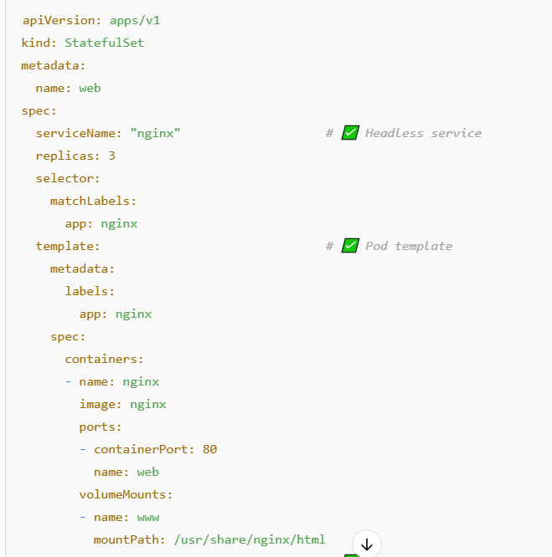
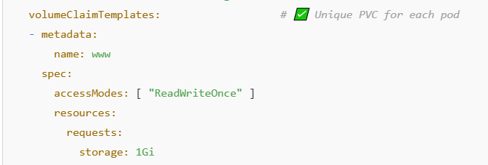
🔹 1. Scaling (✔ Supported)
kubectl scale statefulset my-app --replicas=3
👉 Behavior:
- Pods sequence me create/delete hote hain
- Order: pod-0 → pod-1 → pod-2
- Delete reverse order: pod-2 → pod-1 → pod-0

🔹 2. Rolling Update (✔ Supported)
👉 Default strategy: RollingUpdate
- Update one-by-one hota hai
- Order: highest ordinal se start
  - pod-2 → pod-1 → pod-0
✔ Ensures stability (DB apps ke liye important)

🔹 3. Rollback (✔ Supported but careful ⚠️)
kubectl rollout undo statefulset my-app
👉 Works similar to Deployment, but:
- Same ordered update follow karega
- Har pod sequential rollback hoga

🔹 Important Difference vs Deployment 🔥
Feature | Deployment | StatefulSet
Scaling | Parallel | Ordered
Update | Parallel/rolling | Strict ordered
Identity | Random | Fixed (pod-0, pod-1)
Storage | Ephemeral | Persistent

🔹 Special Note ⚠️
- Agar koi pod update me fail hua →
👉 poora rollout ruk jata hai
- Manual intervention needed ho sakta hai

🔹 Interview Line 💡
“Yes, StatefulSet supports scaling, rolling updates, and rollback, but all operations happen in a strict ordered and sequential manner to maintain stable identities and storage.”

____________________________________________________________________________________

11.5 DaemonSet
- Ensures one Pod per node (or more, if needed).
- Auto-adds/removes Pods as nodes join/leave cluster.
- Use cases:
  - Monitoring agents (Prometheus Node Exporter)
  - Log collectors (Fluentd)
  - CNI plugins
📌 Definition:
DaemonSet ek Kubernetes controller hai jo har node par ek pod (ya jitne chahiye) ensure karta hai. Jab nayi node cluster mein join karti hai, to DaemonSet automatically pod waha bhi create kar deta hai.

🎯 Use-Cases:
- Monitoring agents (e.g., Prometheus Node Exporter)
- Log collectors (e.g., Fluentd, Filebeat)
- CNI plugins (e.g., Calico, Weave)
- System-level daemons (e.g., storage or network agents)

✅ Features:
- Auto pod scheduling on new nodes
- Auto cleanup of pods when node is removed
- Doesn’t use ReplicaSet
- Suitable for node-wide background tasks
🧠 Extra Points (Interview Edge):
- DaemonSet pods can't be scaled via replicas: (not supported)
- Use tolerations and nodeSelector for targeting specific node groups
- Deleting DaemonSet = Deletes all its pods from nodes
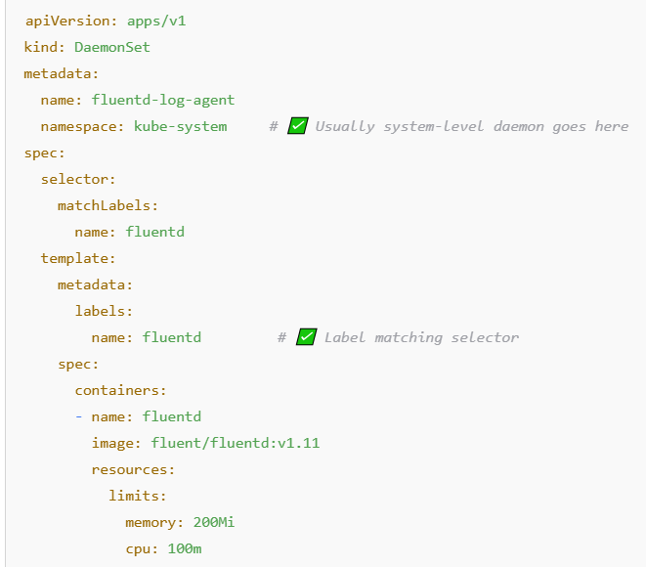
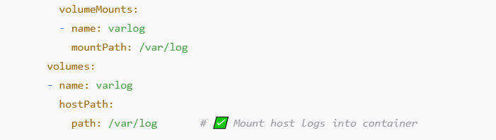
❓ आपका सवाल:
अगर एक DaemonSet एक Node पर सिर्फ एक Pod चलाता है,
तो क्या मैं एक Node पर 2 Pods DaemonSet के थ्रू चला सकता हूँ?

🧠 Answer: हाँ, बिल्कुल Possible है — But... अलग DaemonSet से
💡 Important rule:
1 DaemonSet = 1 Pod per eligible Node
लेकिन:
अगर आप 2 DaemonSet create करते हैं, तो हर एक DaemonSet अपने-अपने pod का एक copy हर Node पर चला सकता है।
🔁 यानी:
Node | DaemonSet-1 Pod | DaemonSet-2 Pod
node1 | ✅ | ✅
node2 | ✅ | ✅

🚫 लेकिन आप एक ही DaemonSet से एक Node पर 2 Pods नहीं चला सकते।
क्यों?
- क्योंकि DaemonSet का design है कि "per node per pod" चले
- अगर multiple चाहिए, तो multiple DaemonSet बनाइए (same image से भी कोई दिक्कत नहीं)

11.6 Job
- Runs a Pod or Pods once until completion.
- Handles short-lived tasks like:
  - Backup scripts
  - One-time batch processing
📌 Definition:
Job ek Kubernetes controller hai jo Pod ko ek baar chalata hai aur ensure karta hai ki task complete ho jaaye. Jaise hi task successful complete hota hai, Job terminate ho jaata hai.

🎯 Use-Cases:
- 🗂️ One-time batch processing
- 💾 Database backup script
- 🧪 Test jobs before deployment
- 📤 File migration or export
- ⏳ CronJob se periodically chalne wale tasks ke base

✅ Key Features:
- Runs until successful completion
- Agar pod fail ho jaaye, to retries hoti hain
- Multiple completions support karta hai (completions, parallelism)
- After success, pod remains in Completed state (until TTL is used)
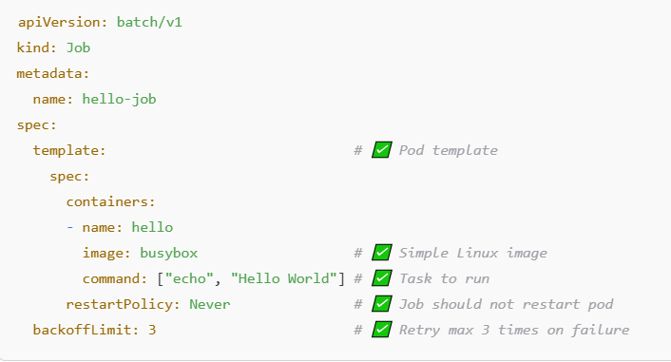

11.7. CronJob
- Schedules Jobs based on time/cron expressions.
- Repeats at regular intervals.
- Examples:
  - Daily reports
  - Scheduled backups
  - Regular cleanup tasks
📌 Definition:
CronJob ek Kubernetes resource hai jo aise jobs schedule karta hai jo bar-bar kisi specific time ya interval par run honi chahiye – jaise cron syntax (* * * * *) ke through.

Use Case | Description
📊 Daily Report Generator | Har raat 12 baje report generate karna
💾 Backup Scheduler | Rozana ya weekly app/data ka backup lena
🧹 Log Cleanup Job | Har 6 ghante mein old logs hataana

📑 Important Properties of CronJob
Field | Description
schedule | Cron expression (e.g. "0 * * * *" = hourly)
jobTemplate | Jo job chalani hai, uska template
startingDeadlineSeconds | Agar time se miss ho gaya to kitni der tak retry kare
concurrencyPolicy | Jobs parallel chalein ya ek ke baad ek
successfulJobsHistoryLimit | Kitni successful jobs ka record rakhe
failedJobsHistoryLimit | Kitni failed jobs ka record rakhe

⏱ Cron Format Summary:
sql
CopyEdit
* * * * *
| | | | |
| | | | └── Weekday (0-6, Sunday=0)
| | | └──── Month (1-12)
| | └────── Day of month (1-31)
| └──────── Hour (0-23)
└────────── Minute (0-59)
Example: "0 0 * * *" → Every day at midnight
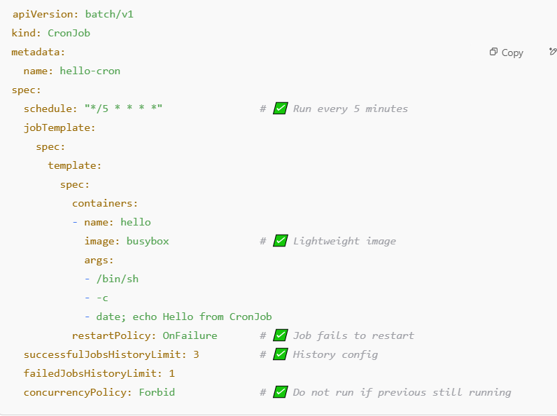

Summary Table:
Controller | Use Case
RC | Legacy replication
RS | Basic pod replication
Deployment | App rollout & management
StatefulSet | Stateful apps with identity & storage
DaemonSet | Node-level agents or services
Job | One-time tasks
CronJob | Scheduled recurring tasks

🔄 RC vs RS – Key Differences
Feature | ReplicationController (RC) | ReplicaSet (RS)
🔧 API Version | v1 | apps/v1
🧠 Label Selector | Basic equality-based selector only | Advanced: supports set-based selectors
📦 Used With | Old Deployments or Standalone | Used by Deployments (modern standard)
📆 Legacy vs Modern | Legacy controller (older Kubernetes versions) | Modern & preferred controller
📚 Recommended for use | ❌ No (deprecated-style) | ✅ Yes (industry standard now)

🔍 Deployment vs ReplicaSet – Key Differences
Feature | Deployment | ReplicaSet
🎯 Purpose | High-level controller for managing rollout | Low-level controller for maintaining pods
🔁 Manages | ReplicaSets + Rollouts + Rollbacks | Only manages replica Pods
🔄 Rolling Update | ✅ Supports (default strategy) | ❌ Not supported directly
🧵 Rollback Support | ✅ Yes, via kubectl rollout | ❌ No rollback support
📦 Use Case | App deployment, versioning, zero downtime | Internally used by Deployment
🧠 Abstraction Level | Higher (user-friendly) | Lower (not used directly usually)
📜 YAML Complexity | Slightly more (due to strategy etc.) | Simpler YAML

12. SERVICES :- (lb)
A k8s service is a resource we create to make a single, constant point of entry to a group of pods providing the same service.
Each service has an IP address and port that never change while the service exists.
K8s provide IP to pod by itself , and these ip are not persistent it can change if pod is deleted and recreated.
IMP”-Jaise backend pool hota hai LB mea wiase services mea ENDPOINT SLICE hota hai .
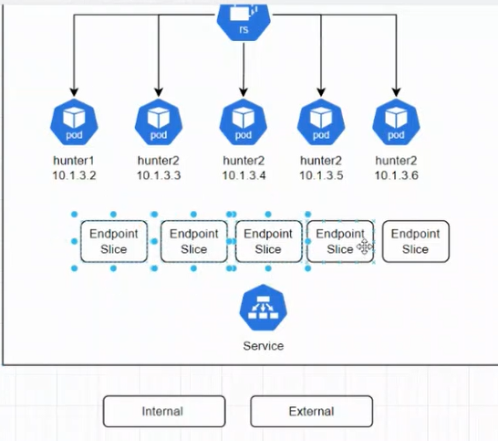
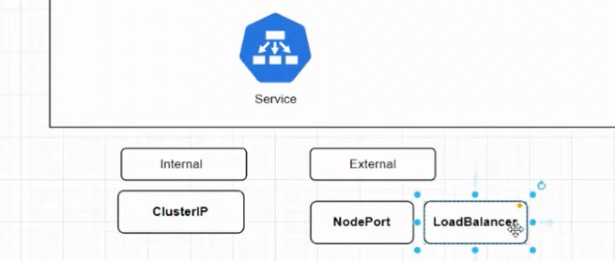
Service ek abstraction hai jo Kubernetes mein Pods ke stable network access ke liye use hoti hai. Pods ke IP dynamic hote hain, isliye Service unke upar ek stable endpoint provide karta hai (cluster-wide communication ke liye).

📦 Why Do We Need Services?
- Pods ka IP har bar change hota hai.
- Multiple replicas ke beech communication handle karna.
- Load Balancing.
- Internal/External network exposure.

🔥 Types of Services
Type | Use Case | Exposed To | IP Type
ClusterIP | Default, internal communication | Inside cluster only | ClusterIP
NodePort | Expose service on each Node IP + static port | Outside cluster | NodeIP:Port
LoadBalancer | Use cloud provider’s external Load Balancer | External | External LB
ExternalName | Maps service to DNS name (outside cluster) | External DNS | DNS Alias
Headless | No ClusterIP assigned, direct pod DNS needed | For StatefulSets | No IP (DNS)

12.1 ClusterIP
🔷 Definition:
ClusterIP ek aisa service type hai jo Kubernetes cluster ke andar hi communication allow karta hai. Ye default type hota hai agar aap type specify nahi karte ho.
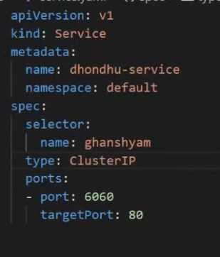

🎯 Use Case:
- Internal microservices ke beech communication.
- Example: Frontend Pod talks to Backend Pod via a Cluster IP service. (private ip )
- DNS se service ko access kiya jata hai (e.g., http://my-service).
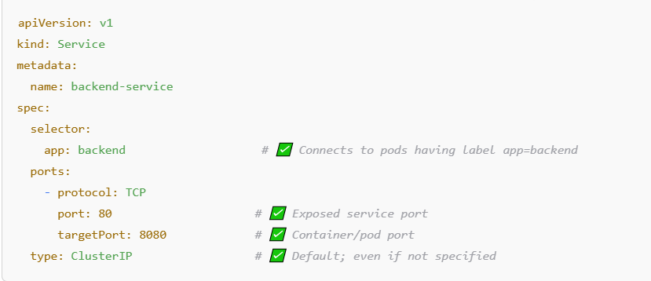
🧩 YAML Breakdown:
YAML Field | Description
kind | Defines the resource type as Service.
metadata.name | Name of the service (backend-service).
selector | Matches labels of pods to forward traffic (e.g., pods with app=backend).
port | Port on which service is accessible inside the cluster (like a virtual IP).
targetPort | Actual port on the pod/container where app is listening.
type | ClusterIP is default, makes the service internal.
🖥️ Real-World Example:
📌 You have:
- Backend pod running on port 8080
- Frontend pod wants to call http://backend-service:80
ClusterIP will resolve to the backend pods internally using DNS and balance the request if replicas exist.

12.2 NodePort
🔷 Definition:
NodePort ek aisa service type hai jo Kubernetes cluster ke bahar se access provide karta hai using any Node’s IP + a static port.
🎯 Use Case:
- Aap chahte ho ki app ko cluster ke bahar se bhi access kiya ja sake.
- Useful in bare-metal/on-prem clusters where LoadBalancer support nahi hota.
- Example: Browser se http://<NodeIP>:30080 par app chalana.
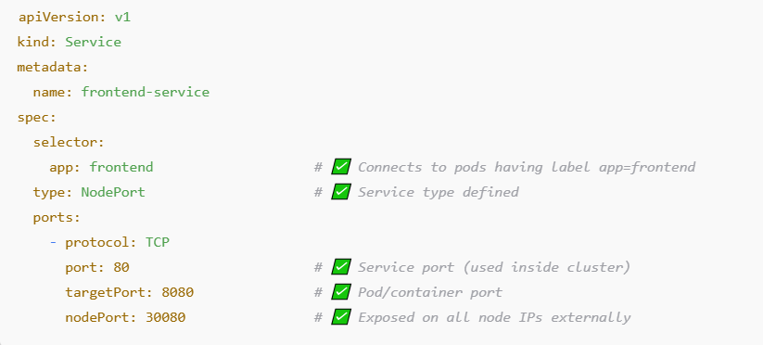

🧩 YAML Breakdown:
YAML Field | Description
type: NodePort | Enables access from outside the cluster using NodeIP and nodePort
port | Port inside the cluster (ClusterIP based access)
targetPort | Actual port inside the container
nodePort | External static port (range 30000–32767 by default)
🖥️ Real-World Example:
🧪 Use case: You have a frontend app running on a Pod (port 8080) and you want to test it from your browser.
- Access it via: http://<NodeIP>:30080
- Cluster will route traffic to the correct pod running the app.

🔐 Note:
- Port range: 30000–32767 (default)
- You can let Kubernetes assign a random port by omitting nodePort field.

12.3. LoadBalancer
🔷 Definition:
LoadBalancer type service externally expose karta hai application ko internet ke through using a cloud provider's external load balancer.

🎯 Use Case:
- Aapka app internet se accessible hona chahiye.
- Cloud clusters (AKS, EKS, GKE) mein mostly ye use hota hai.
- Example: Web app hosted on Azure AKS accessible at a public IP.
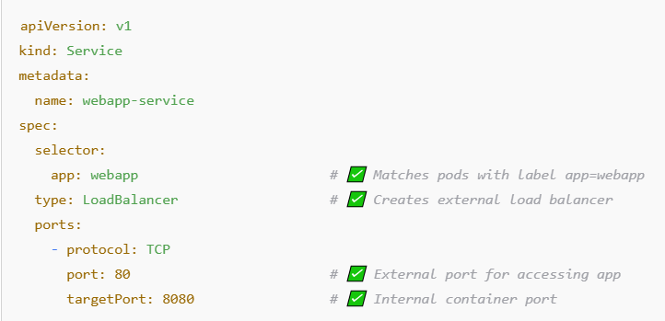
🧩 YAML Breakdown:
YAML Field | Description
type: LoadBalancer | Tells K8s to create an external cloud load balancer
selector | Finds matching pods to send traffic
port | Port on which service is exposed publicly
targetPort | Actual port where app runs inside the pod
status.loadBalancer.ingress.ip | IP given by cloud provider (automatically visible via kubectl get svc)

🖥️ Real-World Example:
📌 App running in Azure AKS:
- Pod → running app on port 8080
- LoadBalancer service exposes it on 80
- User accesses: http://<external-ip>:80

⚠️ Note:
- Works only on cloud-based Kubernetes clusters.
- Automatically provisions a public IP + Load Balancer.
- Internally uses ClusterIP + NodePort behind the scenes.

12.4 ExternalName
🔷 Definition:
ExternalName ek special service type hai jo DNS alias provide karta hai. Ye Kubernetes DNS ko use karke kisi external DNS name (jaise api.google.com) se redirect karta hai.

🎯 Use Case:
- Cluster ke andar se kisi external service ko access karna hai.
- Jaise: pod se http://external-service.default.svc.cluster.local likhne par vo http://real.external.com call kare.
- No port mapping, no selectors, no endpoints.
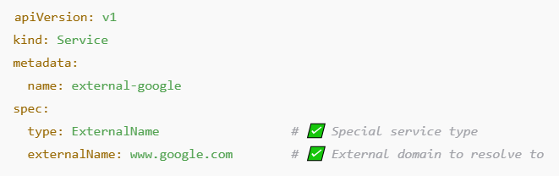
🧩 YAML Breakdown:
YAML Field | Description
type: ExternalName | Indicates a DNS-based service, not a regular K8s service
externalName | Actual external DNS name that the service points to
selector, ports | ❌ Not needed – No pod selection or port mapping

🖥️ Real-World Example:
📌 Pod inside cluster wants to call Google:
- Pod calls: http://external-google.default.svc.cluster.local
- DNS resolves it to: www.google.com

⚠️ Notes:
- No load balancing or port exposure.
- Just a DNS CNAME mapping from internal to external domain.
- Ideal for accessing legacy systems or 3rd-party APIs from pods.
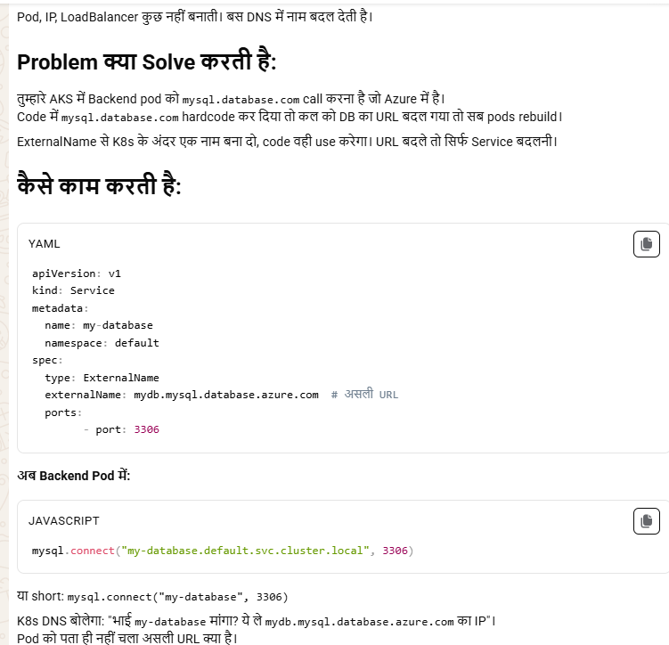

12.5 Headless Service
🔷 Definition:
Headless service is a ClusterIP service with no cluster IP assigned. Iska kaam DNS resolution per pod provide karna hai, load-balancing nahi karta.
Isme clusterIP: None hota hai.

🎯 Use Cases:
- Stateful apps like databases (Cassandra, Kafka, MongoDB) jahan har pod ka identity fix hota hai.
- Direct pod-to-pod communication.
- Service discovery within the cluster.
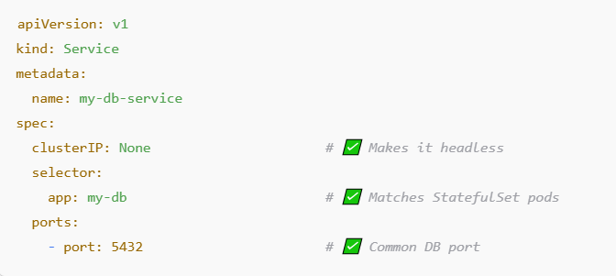

🧩 YAML Breakdown:
Field | Description
clusterIP: None | ✅ No virtual IP is created, makes service headless
selector | Pods matching app: my-db will be discovered
ports | Ports on which communication happens (but no load balancing)

🧠 How It Works:
- DNS returns A record for each pod (e.g., pod-0.my-db-service.default.svc.cluster.local)
- Every pod can be reached individually.
- Perfect for StatefulSets (which assign stable pod names).

🧪 Example DNS Entry:
bash
$ nslookup my-db-service.default.svc.cluster.local
Name: pod-0.my-db-service.default.svc.cluster.local
Name: pod-1.my-db-service.default.svc.cluster.local

Notes:
- No load balancing.
- Common with StatefulSets, not Deployments.
- Enables stable network identity per pod.
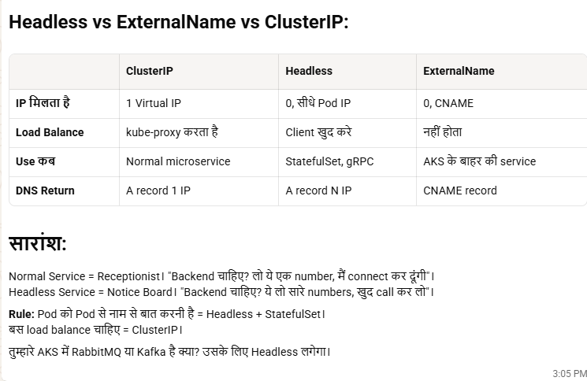

13. Ingress in Kubernetes
🔷 1. Definition:
Ingress ek Kubernetes API object hai jo define karta hai ki external users ka HTTP/HTTPS request cluster ke andar services tak kaise pahuchaana hai.
💡 Jaise ghar ka gate (Ingress) decide karta hai kis visitor ko kis kamre (service) mein bhejna hai.

🔷 2. Problem without Ingress:
Agar aapke paas multiple services hain (e.g., frontend, backend, auth), to:
- Har ek ke liye alag NodePort banana padta hai.
- Har ek port ko open karna padta hai – hard to manage.
ये Kubernetes का एक बहुत common doubt है — कि जब हमारे पास पहले से ही:
- ClusterIP
- NodePort
- और शायद LoadBalancer भी available है...
तो आखिर हमें Ingress Controller की ज़रूरत क्यों पड़ी?
चलिए step-by-step समझते हैं।

🚦 Kubernetes Service Types Recap:
Service Type | External Access? | Scope
ClusterIP | ❌ नहीं (internal only) | केवल cluster के अंदर
NodePort | ✅ हाँ (limited) | हर Node पर एक fixed port open
LoadBalancer | ✅ हाँ (cloud-managed) | External IP मिलती है
Ingress (Controller + Rules) | ✅ हाँ (smart + URL/path based routing) | Multiple services on single entrypoint

🧠 अब सवाल: जब NodePort और LoadBalancer हैं — तो Ingress Controller क्यों?
🚫 Limitations of NodePort / LoadBalancer:
Feature | NodePort / LoadBalancer | Problem
🎯 One app per port | NodePort exposes each app on a unique port (e.g., :30001, :30002) | आप port याद नहीं रख सकते, messy हो जाता है
💰 Cost | LoadBalancer per service = 1 Azure Load Balancer each | ज़्यादा खर्च
❌ No hostname/path routing | You can’t say /api → service A, /web → service B | Advanced routing impossible
🔒 SSL termination | Not native | Complex
📋 Central management | ❌ Not possible | Every service manages its own exposure

✅ Ingress Controller क्या देता है?
Ingress Controller = Smart traffic manager at Layer 7 (HTTP/HTTPS level)
🌟 फायदे:
Feature | Benefit
🔗 Single Entry Point | 1 IP/domain → multiple services
🧭 Path/Hostname-based routing | e.g. /api → service A, /app → service B
💸 Cost saving | 1 LoadBalancer for entire cluster
🔒 SSL termination | HTTPS handle करता है (with Let's Encrypt etc.)
⚙️ Rewrite, headers, rate-limiting | Advanced HTTP features
📊 Observability | Logs, metrics from single point

🔷 3. Solution: Ingress
- Ek single entry point (like a router)
- Based on:
  - Domain name (e.g., app.example.com)
  - Path (e.g., /login, /cart)
- Yeh traffic ko internally services tak route karta hai.

🔷 4. Ingress Architecture:
Client (Browser)
|
↓
Ingress Controller (NGINX / Traefik)
|
↓
Ingress Object (Rules)
|
↓
Kubernetes Service (ClusterIP / NodePort)
|
↓
Pod (Actual Application)

🔷 5. Ingress Object + Controller
Item | Description
Ingress Object | YAML file with routing rules
Ingress Controller | NGINX/Traefik – actual program that routes traffic
🛠 Without Ingress Controller, Ingress Object kaam nahi karta.
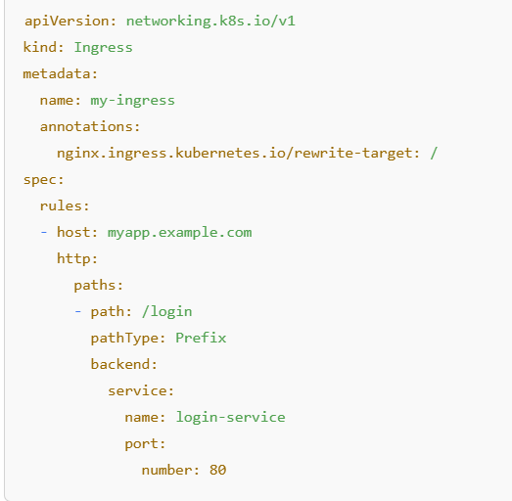
✅ YAML Breakdown:
Field | Description
kind: Ingress | Specifies Ingress resource
host: myapp.example.com | Domain name
path: /login | Incoming URL path
service.name: login-service | Service to forward traffic to
port.number: 80 | Port of the service
annotations | Extra settings (e.g., path rewrites)

🔷 7. Real Life Example:
🧑‍💻 Suppose you host a shopping app with:
- /login → Login Service
- /cart → Cart Service
- /admin → Admin Service
You can define ONE Ingress rule file with different paths going to different services. Public users only hit one domain: shop.example.com.

🔷 8. Benefits:
✅ Centralized routing
✅ Better TLS/SSL management
✅ Clean URLs
✅ Load balancing & path routing
✅ Avoid exposing every service via NodePort
Kubernetes Ingress bilkul Azure Application Gateway jaisa hi kaam karta hai — especially in terms of path-based aur host-based routing.

🔁 Comparison: Ingress vs Azure App Gateway
Feature | Kubernetes Ingress | Azure Application Gateway
Routing | Path-based / Host-based | Path-based / Host-based
SSL Termination | Yes (via TLS config in Ingress) | Yes
Load Balancing | Yes (via Service backend) | Yes
Web Application Firewall | Not built-in (NGINX plugins possible) | Yes (WAF included in SKU)
Controller Type | NGINX / Traefik / HAProxy | Microsoft-managed
K8s Native | Yes | No (but integrates via AGIC)

💡 Bonus:
Agar aap Azure Kubernetes Service (AKS) use kar rahe ho, to aap Azure Application Gateway Ingress Controller (AGIC) bhi use kar sakte ho — jisse App GW directly Ingress rules ko samajhne lagta hai.

**AKS NATIVE SUPPORT :-
1.APPLICATION ROUTING INGRESS CONTROLLER
To enable app routing ingress controller fire below cmd :-
#kubectl get ingressclass to chk controllers .
#kubectl get ingress
Deployment yaml , service yaml or rules yaml bna kr

2.APPLICATION GATEWAY INGRESS CONTROLLER (AGIC)
Azure Application Gateway Ingress Controller (AGIC)
✅ Overview:
AGIC is a cloud-native Kubernetes ingress controller that integrates with Azure Application Gateway (Layer 7 Load Balancer) to expose services in an AKS cluster.
It doesn’t use a reverse proxy like NGINX inside the cluster — instead, it programmatically configures the external Azure Application Gateway to route traffic to AKS services.

⚙️ Architecture:
- AGIC runs as a pod in AKS and watches Ingress resources.
- It updates Azure Application Gateway (App Gateway) config in near real-time.
- Traffic flows outside the cluster, directly via App Gateway (no in-cluster proxy).

🌟 Key Features:
- Managed SSL certificates using Azure Key Vault
- WAF (Web Application Firewall) support
- Auto-scaling, health probes
- Native Azure networking integration (NSGs, VNETs)
- Path-based routing, Host-based routing
- Integrated with Azure Front Door, Key Vault, and Monitor

🧰 Configuration:
- Uses standard Kubernetes Ingress resources.
- Can be configured via Helm, Azure CLI, or ARM/Bicep templates.
- Integrates with Azure-specific annotations.

🟢 Pros:
- Fully managed by Azure – no need to install and manage NGINX.
- Deep integration with Azure ecosystem (App Gateway, Key Vault, Monitor, etc.)
- Supports TLS termination, WAF policies, autoscaling
- External load balancer not running inside the cluster – reduces overhead.

🔴 Cons:
- Azure-only – not portable across clouds or on-prem.
- Slower to react to changes than in-cluster proxies (API latency).
- Limited flexibility/customization compared to NGINX.

✅ Best For:
- Organizations fully hosted on Azure (AKS).
- Teams wanting managed ingress + enterprise-grade WAF & SSL with minimal ops.
- Regulated industries needing compliance-ready ingress (PCI, HIPAA).

🔁 Comparison Summary:
Feature | NGINX Ingress Controller | Azure AGIC (App Gateway Ingress)
Hosting | In-cluster | Azure-managed (outside cluster)
TLS Termination | Supported | Supported via Azure Key Vault
WAF Support | Via third-party or NGINX Plus | Native Azure WAF
Custom Configurations | Highly customizable | Limited to Azure features
Performance | Depends on cluster resources | Scalable and managed by Azure
Platform | Cloud-agnostic | Azure-only
Setup Complexity | Requires installation | Easy via Azure integration
Certificate Management | Manual or cert-manager | Integrated with Azure Key Vault

🧠 Which One Should You Use?
- Choose NGINX if:
  - You need full control and flexibility
  - You're on a hybrid or multi-cloud setup
  - You want an open-source and customizable solution
- Choose Azure AGIC if:
  - You're fully invested in Azure
  - You want a zero-maintenance, secure, and scalable ingress solution
  - You need Azure WAF, Key Vault, and NSG integration

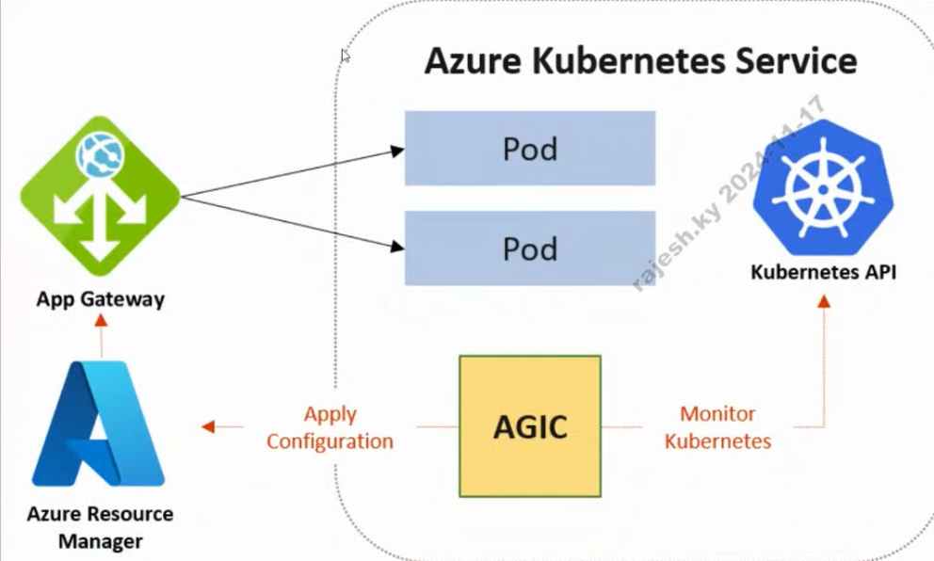
Need to enable AGIC via cmd ,search on google.
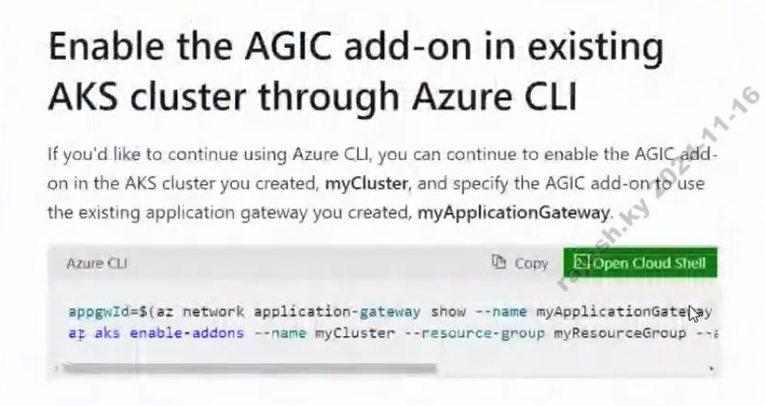
OPENSOURCES INGRESS CONTROLLER IS ALSO AVAILABLE :-
1. INGRESS-NGINX (Mostly used )—it is kind of app , cluster mea eklauta
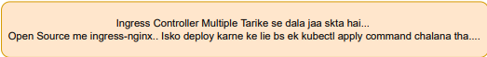
To install ingress-controller copy command from nginx github starthub page and fire in cluster .
create a deployment (nginx & Netflix)
create default service yaml (nginx & Netflix)
create two ingress rule yaml for both application (nginx & Netflix)
Chae to sath mea rule rakh skte hai , but not a best practice .
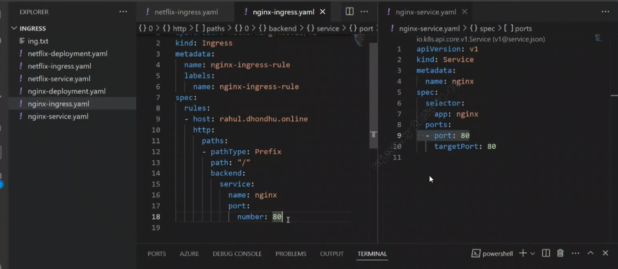
Suppose humre ek cluster mea ek se jada ingress controller ho to rule kis controller k liye chalega esko define krne k liye ingressclassname hum spec k andar rule mea dalenge taki rule us particular ingress controller pr jak r chipak jaye .
404 -not found error – Jab nginx controller k paas rule nai hoga backend tab
5xx- Jab entry ho hi nai dns k paas .domain jab exist hi nak re . site not found .
Manual startup of AGIC :-
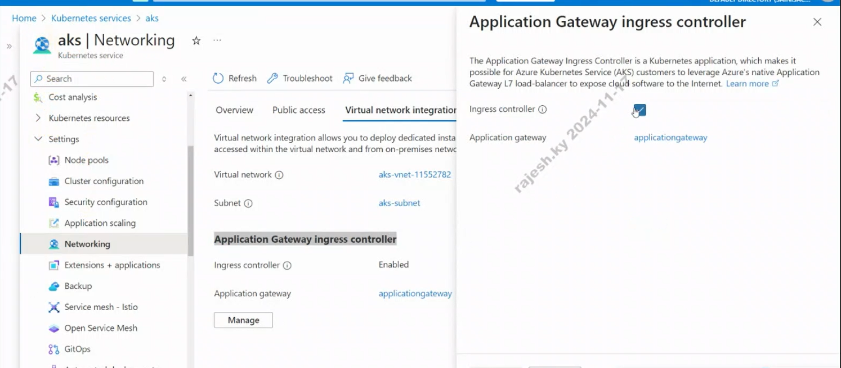

Microservice APP -using KS :-

1.BUILD IMAGES USEING MULTISTAGE DOCKER FILE
2.LOGIN ACR -
Az acr login — name
Registery name

FRONTEND -REACT
BACKEND- PYTHON /JAVA -POM
DB- SQL / AZURES MONGODB

14. Pushing of custom Image in Docker Registry/ACR /ECR :-

In interview we need to tell that we are using ACR to upload our custom Images .To create ACR:-
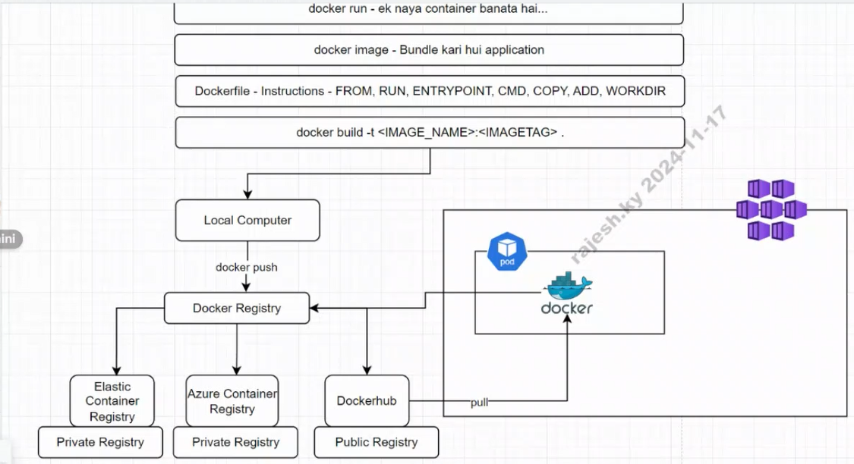
  - Go to portal search for container registry & fill the form.
  - Build the docker image using build -t .
  - Now login the registry . (docker login )
  - Then do tag .need to prepare tag with login server + current custom image name.
- Suppose the custom image we created name is calculater:latest
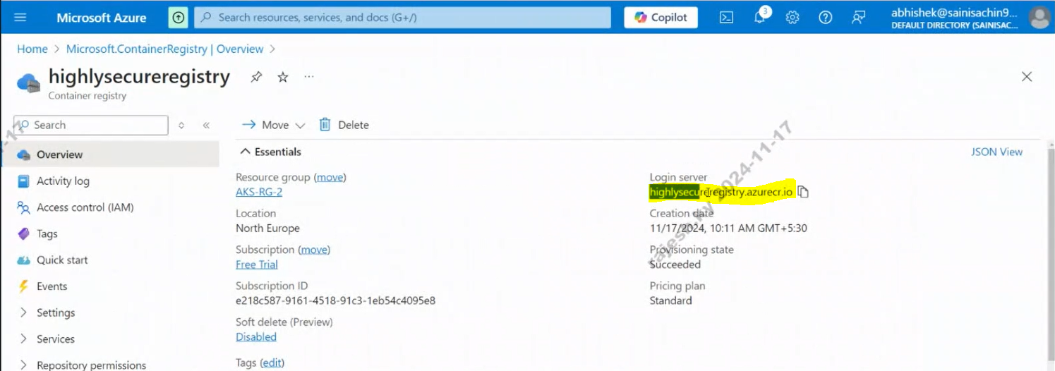
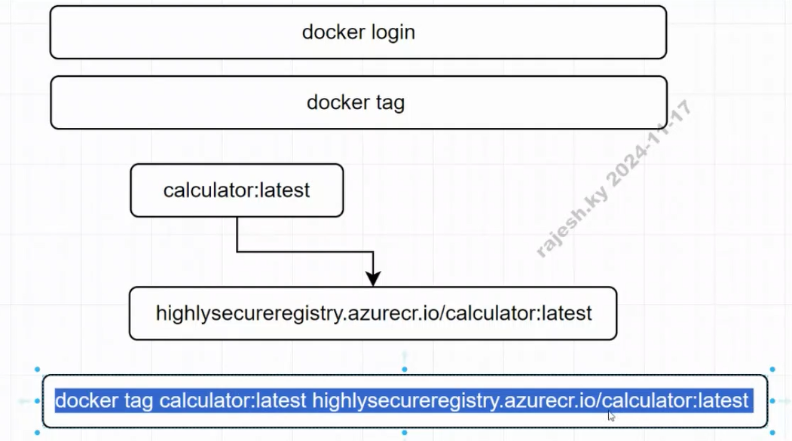

Need to rename the image with docker tag cmd.
Now login with az login .
Then do az acr login –name acrname
Then do docker push imagename.
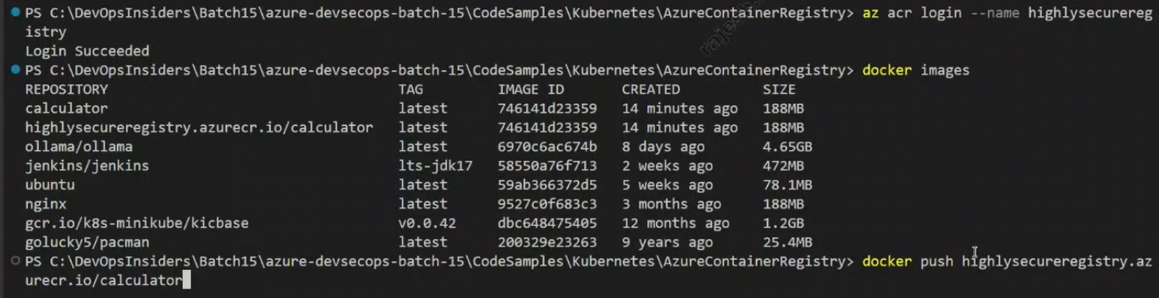

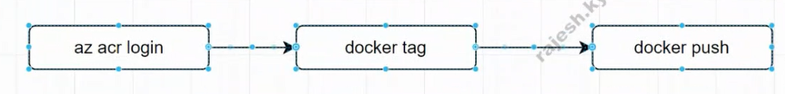
To check uploaded images :-
Go to ACR SERVICES Repositories .
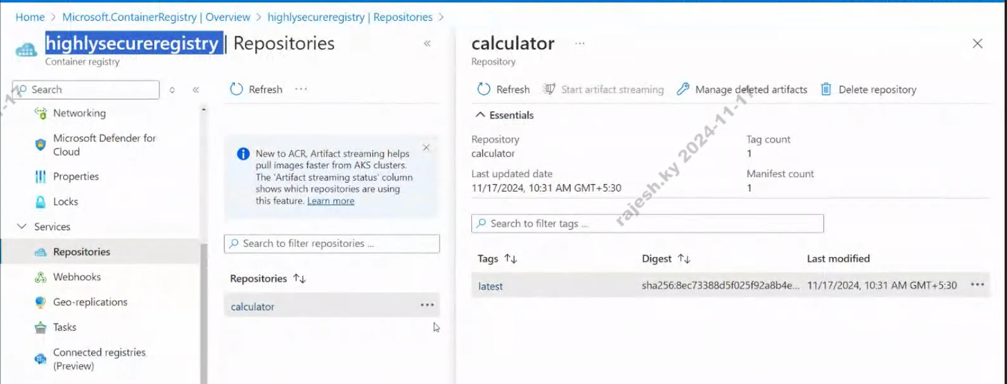
To chk from cli :- az acr reposiotiry list –name registoryname
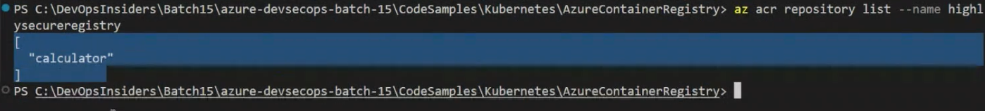

Project summary :-
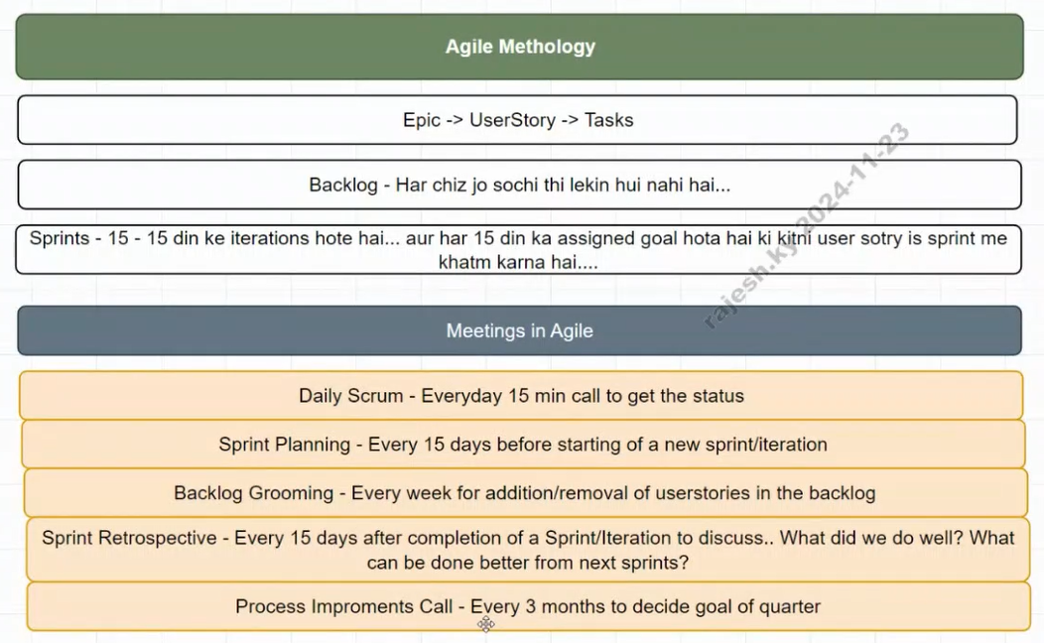
HLD DIAGRAM:-
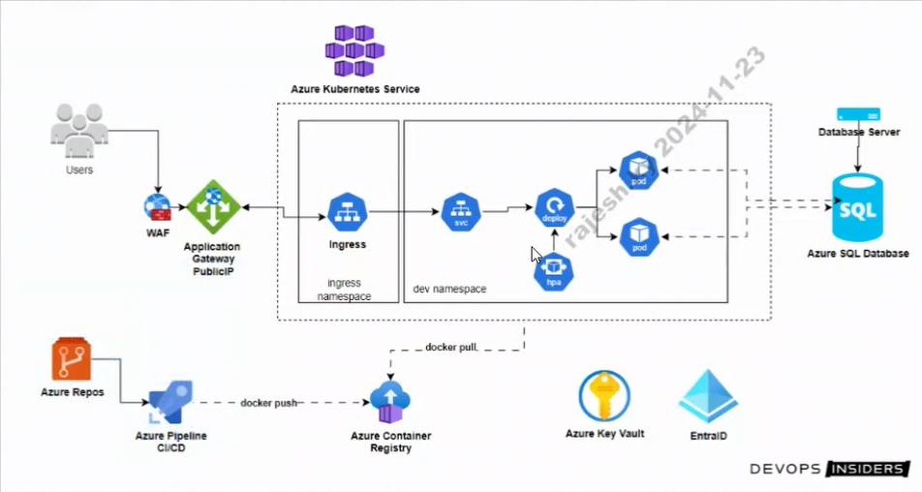

15 Fleet Manager :-
☸️ What is “Create a Kubernetes Fleet Manager” in AKS?
In the context of Azure Kubernetes Service (AKS), the Kubernetes Fleet Manager is a relatively new Azure resource designed to manage multiple AKS clusters at scale — as a fleet.
Think of it as a centralized control plane to:
- Group multiple AKS clusters (possibly across regions)
- Apply policies, configurations, and deployments uniformly
- Simplify multi-cluster management

🔧 Why do we use Kubernetes Fleet Manager?
✅ Use Case | 🔍 Purpose
Multi-cluster management | Manage multiple AKS clusters from one place
Centralized deployment | Deploy apps or configs to all clusters in the fleet
Consistent governance | Apply the same RBAC, network, or security rules
Cross-region scalability | Distribute clusters across geographies and manage them uniformly
Fleet workload deployment | Deploy apps across clusters using fleet-specific tools

🧠 When is it Useful?
- You're running AKS clusters in multiple regions (for HA or compliance)
- You want dev/test/prod clusters managed consistently
- You need central governance and policy enforcement across clusters
- You’re using hub-and-spoke architecture in Azure

🔨 How does it work? (High-level overview)
- Create a Fleet Manager:
A new Azure resource in your subscription, often located in a central hub region.
- Add AKS Clusters to the Fleet:
You can add clusters from different regions to this fleet.
- Define Fleet Membership Policies:
Control what each member cluster can do, and how workloads should behave.
- Use Fleet Workload Deployment:
Deploy the same workload to multiple clusters at once (like app v1 to test & prod).

📦 Example Scenario:
You have:
- aks-eastus (Production)
- aks-westus (Disaster Recovery)
- aks-europe (for EU customers)
➡️ Instead of managing each cluster separately, you:
- Create one Fleet Manager
- Add all three AKS clusters as fleet members
- Deploy your app using fleet workload deployment, which runs on all three clusters

🚀 Summary
Feature | Benefit
Multi-cluster control | Manage AKS clusters as a group
Centralized deployments | One deployment, multiple clusters
Policy & governance | Enforce consistent rules everywhere
Regional scalability | Operate across multiple geographies

16. COREDNS: -(kubedns)
AKS Cluster में DNS क्या होता है?
DNS = Domain Name System
Kubernetes cluster (including AKS) के अंदर DNS का काम है कि वो services, pods, और endpoints के names को IPs में translate करे — ताकि communication हो सके।
🔹 आप service का नाम लिखते हो → DNS backend उसे IP में बदलता है → network communication possible होता है।

🔧 AKS में कौन-सा DNS चलता है?
AKS में DNS की functionality CoreDNS (पहले kube-dns) नाम के pod से मिलती है:
bash
CopyEdit
kubectl get pods -n kube-system -l k8s-app=kube-dns
CoreDNS ही AKS cluster के अंदर internal DNS server की तरह काम करता है।

📍 DNS क्यों जरूरी है Kubernetes (AKS) में?
कारण | विवरण
🔁 Pod और Service discovery | Cluster के अंदर pods/services dynamic होते हैं — हर बार IP बदल सकती है
🔍 Name-based access | Service का नाम (mysql, backend, etc.) use करना आसान है IP की तुलना में
🛠️ Automation | DNS system automatically नए services और pods का नाम resolve करता है
🔐 Internal communication | Microservices आपस में नाम से बात करते हैं (http://auth-service)

🧠 Example: Internal DNS कैसे काम करता है?
मान लीजिए आपकी cluster में एक service है:
metadata:
name: my-backend
namespace: dev
अब उसका DNS name क्या बनेगा?
my-backend.dev.svc.cluster.local
DNS Part | Meaning
my-backend | Service का नाम
dev | Namespace
svc | Kubernetes service
cluster.local | Cluster DNS domain suffix (default)

🎯 आप कैसे use करते हो?
Pod से ping/test:
curl http://my-backend.dev.svc.cluster.local
या
curl http://my-backend
(अगर same namespace में हो)

🔄 Cluster DNS कैसे काम करता है?
- आप Pod से एक service का नाम call करते हैं (e.g., my-db)
- CoreDNS उस नाम को resolve करता है
- आपको उस service का ClusterIP मिल जाता है
- Networking उस IP पर request भेजती है

🔧 DNS Resolution कैसे configure होता है?
Cluster के Pods में /etc/resolv.conf file automatically update होती है, जिसमें DNS server के रूप में CoreDNS pod का IP होता है।

📦 CoreDNS YAML कहां होता है?
Namespace kube-system में एक ConfigMap होती है:
kubectl -n kube-system get configmap coredns -o yaml
यहाँ से आप DNS के behaviors (e.g., caching, forwarding) customize कर सकते हैं।

✅ Summary: AKS Cluster में DNS
Component | काम
CoreDNS | Internal DNS service
cluster.local | Default DNS suffix
Service discovery | Name → ClusterIP
Auto-registration | नए services का name auto-resolve होता है
Internal comm | Microservices एक-दूसरे से name से connect करते हैं

🔥 Bonus: External DNS?
अगर आप चाहते हो कि Kubernetes के services public DNS (like Azure DNS or Route53) में भी map हों, तो उसके लिए आप:
- External-DNS controller use कर सकते हैं
- जो Kubernetes resources को external DNS records से sync करता है

अगर आप चाहो तो मैं CoreDNS को customize करने का example भी दे सकता हूँ — जैसे TTL, forwarding external DNS, आदि। Ready हो तो बताओ!
WORKING: -
बहुत बढ़िया! आपने एक दम सही पकड़ा — जब हम Pod या Service बनाते हैं, तो CoreDNS अपने आप configure हो जाता है ताकि वो उनके नाम resolve कर सके।
अब चलिए इसके internal workings को गहराई से समझते हैं:

⚙️ CoreDNS कैसे काम करता है (Internal Working in AKS / K8s):
💡 Step-by-step Workflow:

🔹 1. Service या Pod बनाते हैं
जब आप कोई Service या Pod create करते हैं:
kubectl create deployment my-app --image=nginx
kubectl expose deployment my-app --port=80 --target-port=80
- Kubernetes अपने internal API server में एक Service object register करता है
- उस service को एक ClusterIP assign होता है

🔹 2. Kubelet और Kube-Controller उसे etcd में स्टोर करते हैं
- etcd = Kubernetes का key-value database
- etcd में ये service और pod की सारी details store होती हैं

🔹 3. CoreDNS watches the Kubernetes API
- CoreDNS एक Kubernetes plugin के जरिए continuously API server को watch करता है
- जैसे ही कोई नया Service या Endpoint add होता है, CoreDNS अपनी DNS table update कर लेता है
👀 CoreDNS की config file (plugin chain):
kubectl -n kube-system get configmap coredns -o yaml
.:53 {
errors
health
kubernetes cluster.local in-addr.arpa ip6.arpa {
pods insecure
fallthrough in-addr.arpa ip6.arpa
}
forward . /etc/resolv.conf
cache 30
loop
reload
}
🔍 kubernetes cluster.local
👉 इसका मतलब है: CoreDNS, cluster.local domain के अंदर Kubernetes services को resolve करेगा।

🔹 4. Pod से DNS Query जाती है
Pod में /etc/resolv.conf कुछ ऐसा दिखता है:
nameserver 10.0.0.10 # CoreDNS Service IP
search default.svc.cluster.local svc.cluster.local cluster.local
जब आप Pod से यह command चलाते हैं:
curl http://my-app
- DNS request my-app.default.svc.cluster.local के लिए जाएगी
- CoreDNS इस name को देखेगा
- और API server से उस service का ClusterIP निकालेगा

🔹 5. Response मिलता है – और Communication होता है
- CoreDNS उस domain को resolve करता है → IP देता है
- फिर आपका Pod उस IP पर connection establish करता है

🧪 Bonus: Logs देखना है कि CoreDNS ने क्या resolve किया?
kubectl -n kube-system logs -l k8s-app=kube-dns
आपको वहां DNS queries दिखेंगी जैसे:
[INFO] 10.244.1.5:50284 - 4496 "A IN my-app.default.svc.cluster.local." 0 NXDOMAIN 0 0.000062448s

🔐 Security Note:
- CoreDNS केवल cluster-internal DNS names resolve करता है
- External names (e.g., google.com) के लिए वो /etc/resolv.conf के हिसाब से Azure DNS या upstream DNS को forward करता है

🔹 CoreDNS kahan run hota hai?
👉 Worker nodes par pod ke form me run hota hai
✔ Namespace: kube-system
✔ Type: Deployment (pods)

🔹 Kya ye master ka part hai?
❌ Nahi (direct control plane component nahi hai)
✔ But logically cluster DNS service hai (control plane ko support karta hai)

✅ Summary of Internal Mechanics:
Step | Action
1️⃣ | Pod/Service create → API server में register
2️⃣ | etcd में store
3️⃣ | CoreDNS API server को watch करता है
4️⃣ | DNS request आती है → CoreDNS resolve करता है
5️⃣ | IP मिलता है → traffic route होता है

17. AutoScaling

💡 Kubernetes में Autoscaling के 3 Types होते हैं:
Type | काम
1. HPA (Horizontal Pod Autoscaler) | Pods की संख्या को बढ़ाता/घटाता है
2. VPA (Vertical Pod Autoscaler) | Pod के अंदर resource (CPU/Memory) limits को adjust करता है
3. Cluster Autoscaler | ज़रूरत पड़ने पर Node की संख्या बढ़ाता/घटाता है (AKS-level)

✅ सबसे ज़्यादा इस्तेमाल होता है — HPA (Horizontal Pod Autoscaler)
Example: अगर आपके pods 80% CPU consume कर रहे हैं, तो Kubernetes और pods launch कर देगा।

🧪 Step-by-Step: HPA Setup in AKS
✅ Prerequisites:
- Metrics Server installed होना चाहिए
🔹 Step 1: Metrics Server install करें (अगर नहीं है)
kubectl apply -f https://github.com/kubernetes-sigs/metrics-server/releases/latest/download/components.yaml

🔹 Step 2: Sample Deployment (e.g., NGINX)
apiVersion: apps/v1
kind: Deployment
metadata:
name: nginx-deploy
spec:
replicas: 2
selector:
matchLabels:
app: nginx
template:
metadata:
labels:
app: nginx
spec:
containers:
- name: nginx
image: nginx
resources:
requests:
cpu: "100m"
limits:
cpu: "500m"
ports:
- containerPort: 80

🔹 Step 3: Apply HPA (Horizontal Pod Autoscaler)
kubectl autoscale deployment nginx-deploy \
--cpu-percent=50 \
--min=2 \
--max=10
👉 ये बोलेगा:
अगर CPU 50% से ज़्यादा हो गया, तो pods को 2 से 10 तक scale करो।

🔹 Step 4: देखो HPA status
kubectl get hpa
Example Output:
bash
CopyEdit
NAME REFERENCE TARGETS MINPODS MAXPODS REPLICAS AGE
nginx-deploy Deployment/nginx-deploy 60%/50% 2 10 3 2m

💥 Cluster Autoscaler (Node Scaling) कैसे Enable करें? (AKS Specific)
🎯 Azure CLI से:
az aks update \
--resource-group <your-rg> \
--name <your-cluster-name> \
--enable-cluster-autoscaler \
--min-count 1 \
--max-count 5
🧠 इसका फायदा ये कि अगर pods को run करने के लिए nodes की कमी हो गई, तो new VM/node automatically add हो जाता है!

⚠️ Important Tips:
Tip | Why Important
resources.requests/limits देना ज़रूरी है | HPA तभी काम करेगा जब resource defined हों
Metrics server ज़रूरी है | HPA को CPU/memory usage दिखे तभी decision ले सकेगा
Cluster Autoscaler + HPA साथ काम करते हैं | पहले pods scale होंगे, फिर जरूरत पड़ी तो node

✅ Summary:
Autoscaler | काम | Enable कैसे करें
HPA | Pods को scale करता है | kubectl autoscale या YAML
VPA | CPU/Memory adjust करता है | YAML से setup
Cluster Autoscaler | Nodes को scale करता है | az aks update --enable-cluster-autoscaler
“HPA and Cluster Autoscaler can work independently, but together they provide full elasticity—HPA scales pods based on load, and Cluster Autoscaler scales nodes when capacity is insufficient.”

18. Troubleshooting: -

Interview के लिए Kubernetes Troubleshooting:
✅ Focus करो इन 3 Levels पर:
Layer | Examples | Tools
1️⃣ Pods & Containers | Pod crash, image pull fail, readiness fail | kubectl describe, kubectl logs
2️⃣ Networking & Services | Pod-to-pod communication, DNS fail, service not reachable | nslookup, curl, kubectl port-forward
3️⃣ Cluster Level Issues | Node not ready, PVC pending, scheduler fail | kubectl get nodes, events, describe

🔧 1. Pod & Container Troubleshooting
🔸 Check Pod status:
kubectl get pods
Look for statuses like:
- CrashLoopBackOff
- ImagePullBackOff
- Pending

🔸 Describe Pod for more info:
kubectl describe pod <pod-name>
Check:
- Events section
- Readiness/Liveness probe failures
- Image issues

🔸 Logs देखना:
kubectl logs <pod-name>
# अगर multi-container pod है:
kubectl logs <pod-name> -c <container-name>

🔧 2. Service & Network Troubleshooting
🔸 Check Service:
kubectl get svc
kubectl describe svc <svc-name>
- सही port है?
- selector सही pod को point कर रहा है?

🔸 Inside Cluster Network Test:
kubectl exec -it <pod> -- /bin/sh
# फिर अंदर से curl करो
curl http://<service-name>:<port>

🔸 DNS Test (CoreDNS):
kubectl exec -it <pod> -- nslookup <service-name>
- अगर DNS fail हो रहा है तो CoreDNS pod और config map check करें

🔧 3. Node, PVC, Scheduling Issues
🔸 Node Health:
kubectl get nodes
kubectl describe node <node-name>
Check for:
- Disk pressure
- Memory pressure
- Kubelet errors

🔸 PVC / Storage Issue:
kubectl get pvc
kubectl describe pvc <pvc-name>
- Check storage class
- PV status
- Mount errors

🔸 Scheduler Failures:
kubectl describe pod <pod-name>
If it's Pending:
- Resource नहीं मिल रहा
- Taint/toleration mismatch
- NodeSelector या affinity mismatch

💥 Bonus: Common Real-World Errors & Fixes
Problem | Reason | Fix
CrashLoopBackOff | App crash on startup | Logs देखो, health probe fix करो
ImagePullBackOff | Wrong image/tag | Image name सही करो, secret check करो
Pod Pending | No node fits | Resource limits ठीक करो, taints देखो
Service not reachable | Selector गलत या pod नहीं चल रहा | Labels match करो
DNS Fail | CoreDNS down/config error | CoreDNS logs देखो, configmap check करो
PVC Pending | No available PV | StorageClass सही दो या PV बनाओ

🎯 Interview Tips:
- Practical सोचो: सिर्फ answer मत दो, command भी बताओ!
- Example दो: "अगर pod CrashLoop में हो तो मैं logs देखूंगा, फिर describe करके event section check करूंगा…"
- Real cases बताओ: "एक बार मेरी PVC Pending में थी क्योंकि wrong storage class दी गई थी…"

📄 Kubernetes Troubleshooting Cheat Sheet (Interview Friendly)

✅ Section 1: Pod Related Issues
Problem | Symptom | Root Cause | Command | Fix
🔁 CrashLoopBackOff | Pod बार-बार restart हो रहा है | App crash कर रही है | kubectl logs <pod>  kubectl describe pod <pod> | Logs check करो, probes सही करो
⛔ ImagePullBackOff | Pod नहीं बन रहा | Wrong image name/tag  DockerHub limit | kubectl describe pod <pod> | Image name fix करो, या secret दो
🕒 Pending Pod | Pod schedule नहीं हो रहा | Resource ना मिलना / Taints / NodeSelector | kubectl describe pod <pod> | Limits कम करो या node config बदलो

✅ Section 2: Service & Networking Issues
Problem | Symptom | Root Cause | Command | Fix
❌ Service not reachable | Curl नहीं हो रहा / 503 error | Wrong selector / pod नहीं चला | kubectl describe svc <svc>  kubectl get ep <svc> | Labels verify करो
🧭 DNS Resolution fail | Service name resolve नहीं हो रहा | CoreDNS down या config error | kubectl exec -it <pod> -- nslookup <svc> | CoreDNS pod और configmap check करो
🔄 Inter-pod network fail | Curl fail inside cluster | Network policy block | kubectl exec -it <pod> -- curl <svc> | NetworkPolicy allow करो

✅ Section 3: Node & Cluster Issues
Problem | Symptom | Root Cause | Command | Fix
🟥 Node Not Ready | Node NotReady दिख रहा है | Disk/memory pressure, kubelet fail | kubectl describe node <node> | Logs देखो, resource बढ़ाओ
📦 PVC Pending | Volume attach नहीं हो रहा | No matching PV or wrong storage class | kubectl get pvc  kubectl describe pvc <pvc> | PV बनाओ या सही SC दो
❌ Scheduling Fail | Pod pending with “no node” error | Taints, affinity, resource mismatch | kubectl describe pod | Toleration या affinity fix करो

✅ Section 4: Tools & Commands Reference
🔍 Pod
kubectl get pods
kubectl describe pod <pod>
kubectl logs <pod> [-c container]
🌐 Network
kubectl get svc
kubectl describe svc <svc>
kubectl get ep <svc>
kubectl exec -it <pod> -- curl http://<svc>:<port>
kubectl exec -it <pod> -- nslookup <svc>
🧱 Node & PVC
kubectl get nodes
kubectl describe node <node>
kubectl get pvc
kubectl describe pvc <pvc>

🎯 Bonus: Interview में ऐसे बोल सकते हो
“अगर pod CrashLoop में है, तो सबसे पहले मैं kubectl logs से logs check करूंगा, फिर kubectl describe करके events section देखूंगा कि क्या probe fail हो रही है या resource कम है।”
“PVC pending error आ रहा हो, तो मैं check करूंगा कि storage class match हो रही है या नहीं, और अगर auto provisioner नहीं है तो PV manually create करूंगा।”

Scenario: आपके AKS cluster में एक pod continuously CrashLoopBackOff में जा रहा है और frontend से 503 error आ रही है।
आप क्या-क्या check करोगे और कैसे fix करोगे?"

✅ Answer Script (for interview)
"First, I’ll start by checking the pod status using:
kubectl get pods
If the pod is in CrashLoopBackOff, the next step is to look at logs:
kubectl logs <pod-name>
I’ll analyze whether the application is crashing due to missing env variables, wrong configuration, DB connectivity, or internal code exceptions.

Then, I’ll describe the pod to check the events section at the bottom:
kubectl describe pod <pod-name>
This will tell me if it's failing due to liveness or readiness probes, image issues, or resource constraints.

If it's a probe failure, I’ll check the probe definition in the deployment YAML — whether the path or port is incorrect, or the app is taking longer to boot.
Also, I’ll check the resource requests and limits — sometimes pods crash if memory or CPU is too constrained.

Since the frontend is giving 503, I’ll verify the service:
kubectl get svc && kubectl describe svc <svc-name>
I’ll make sure the selector matches the pod labels, and the target port is correctly set.

Then, I’ll check whether the service has healthy endpoints:
kubectl get ep <svc-name>
If it’s empty, that means either the pod is not running or it’s failing the readiness probe — so the service is not routing to it.

For further testing, I can do an internal curl from another running pod:
kubectl exec -it <another-pod> -- curl http://<svc-name>:<port>
This confirms if the service is reachable from inside the cluster.

Based on the root cause:
- If it's config-related, I’ll fix the config/env vars
- If it's probe issue, I’ll adjust the readiness/liveness parameters
- If service selectors are mismatched, I’ll fix the labels
Once pod is healthy and ready, the 503 from frontend should also go away.

🎯 End the answer confidently:
"So in short, I use logs, describe, get ep, and basic network tools like curl to trace the flow and fix the exact point of failure — whether it's at pod, service, or app level."

Scenario.2.
✅ Issue:
AKS cluster में से एक node गायब हो गया या NotReady में चला गया।

🔍 Step-by-Step Troubleshooting

🔹 Step 1: Nodes की स्थिति चेक करो
kubectl get nodes
देखो कौन सा node NotReady, Unknown या list में missing है?

🔹 Step 2: Node Describe करो
kubectl describe node <node-name>
नीचे जाओ और Events section देखो:
- Disk pressure?
- Memory pressure?
- Kubelet unreachable?
- Network issues?

🔹 Step 3: Pods जो उस node पर थे — चेक करो
kubectl get pods -o wide
देखो कौन से pods उस node पर थे?
अगर node चला गया तो pods को नए node पर schedule हुआ या नहीं?

🔹 Step 4: Azure Portal / CLI से Node Status Verify करो
az aks nodepool list \
--resource-group <RG> \
--cluster-name <CLUSTER>
देखो node healthy है या deallocated, stopped, या unreachable है?

🔹 Step 5: VM की health देखो (Portal से)
- क्या VM accidentally deallocate हो गई?
- क्या auto-scaling ने हटाया?
- क्या कोई scale down event हुआ?

🔹 Step 6: Cluster Autoscaler Logs (optional)
kubectl -n kube-system logs deployment/cluster-autoscaler
Check करो autoscaler ने intentionally node delete किया था क्या?

🛠️ Possible Root Causes & Fixes
Root Cause | Fix
🧯 Kubelet crashed | VM restart करो या node cordon करके recreate करो
💾 DiskPressure / MemoryPressure | Unused logs/volumes cleanup करो
🌐 Network Failures | NSG rules, subnet health check करो
⚙️ Node pool autoscaling issue | Scale manually + check autoscaler logs
❌ Node accidentally deleted | Azure से new node add करो
🔐 AKS control plane unreachable | Azure service health check करो

🔁 Node वापस लाना (manually rejoin):
bash
CopyEdit
az aks scale \
--resource-group <RG> \
--name <CLUSTER> \
--node-count <count>
या अगर node unhealthy है, उसे cordon ,drain & delete करो:
kubectl drain <node-name> --ignore-daemonsets --delete-emptydir-data
kubectl delete node <node-name>

🎯 Interview में ऐसे बोल सकते हो:
"अगर कोई node AKS cluster से गायब हो जाता है या NotReady हो जाता है, तो मैं सबसे पहले kubectl get nodes और describe से उसकी health check करता हूँ।
अगर वो Azure में भी missing है, तो मैं CLI या Portal से देखता हूँ कि VM accidentally delete हुई है या autoscaler ने हटाया है।
साथ ही, मैं check करता हूँ कि उस पर चल रहे pods successfully reschedule हुए हैं या नहीं।
अगर issue Kubelet या networking का है, तो मैं node drain करके recreate कर देता हूँ।
Overall, मैं cluster logs, autoscaler behavior और Azure activity logs तीनों check करता हूँ root cause समझने के लिए।"

🚨 DiskPressure & MemoryPressure in Kubernetes Nodes
जब कोई Kubernetes node resource limitation की वजह से proper तरीके से pod चला पाने की स्थिति में नहीं होती, तो Kubernetes taint लगा देता है उस node पर:
Type | Meaning | Effect
DiskPressure | Disk space कम है | नए pods schedule नहीं होंगे
MemoryPressure | Available RAM कम है | नए pods reject होंगे या evict हो सकते हैं

🔍 कैसे Check करें कि Node को Pressure है या नहीं?
kubectl describe node <node-name>
👇 Output में यह दिखेगा:
Conditions:
Type Status Reason Message
---- ------ ------ -------
MemoryPressure True KubeletHasInsufficientMemory
DiskPressure True KubeletHasDiskPressure
PIDPressure False KubeletHasSufficientPID
✅ अगर MemoryPressure = True या DiskPressure = True है → तो ये problem है।

🔧 Pressure आने के Common कारण:
✅ DiskPressure:
- Log files बहुत बन रहे हैं (container logs)
- Crashlooping pods
- emptyDir volumes में space भर जाना
- Container image cache बहुत बड़ी हो गई
✅ MemoryPressure:
- किसी pod ने ज्यादा memory ले ली (memory leak)
- Resource limits गलत दिए हैं
- बहुत ज़्यादा pod एक ही node पर चल रहे हैं

🧹 Fix कैसे करें?
🔹 DiskPressure Fix:
# SSH into node (VM scale set or standalone VM)
sudo du -sh /var/lib/docker/containers/* 2>/dev/null | sort -hr | head -n 10
sudo journalctl --disk-usage

# Clean up unused containers, images
docker system prune -a
या AKS में direct node delete करके recreate कर सकते हो:
kubectl drain <node-name> --ignore-daemonsets --delete-emptydir-data
kubectl delete node <node-name>
# Autoscaler या manually new node add हो जाएगा

🔹 MemoryPressure Fix:
- उस node पर चल रहे pods में से किसी pod को limit set करो:
resources:
requests:
memory: "256Mi"
limits:
memory: "512Mi"
- ज्यादा memory वाले pod को अलग node pool में भेज दो
- या उस node को manually restart करो

🧠 Interview में ऐसे बोलो:
"अगर node पर DiskPressure या MemoryPressure आता है, तो Kubelet उस node को unschedulable बना देता है और pods को दूसरी healthy node पर भेज देता है।
मैं kubectl describe node से देखता हूँ कौन सी pressure है, फिर logs, container data और resource usage check करके cleanup करता हूँ।
AKS में अक्सर image cache और emptyDir की वजह से disk भरती है।
MemoryPressure में मैं pods के resource limits tune करता हूँ या heavy pods को अलग node pool में भेजता हूँ।"
Scenario.3.
- Pod is in high utilization?
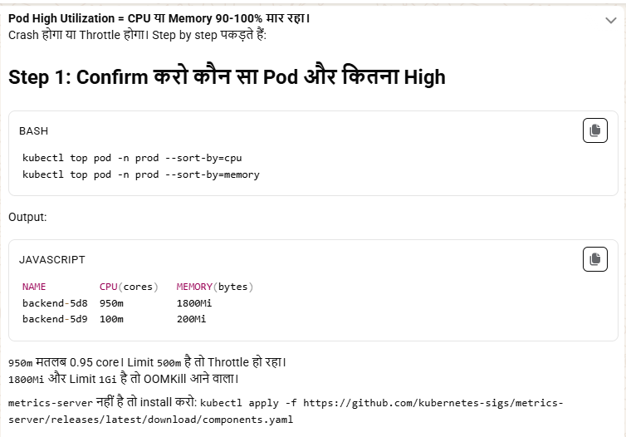
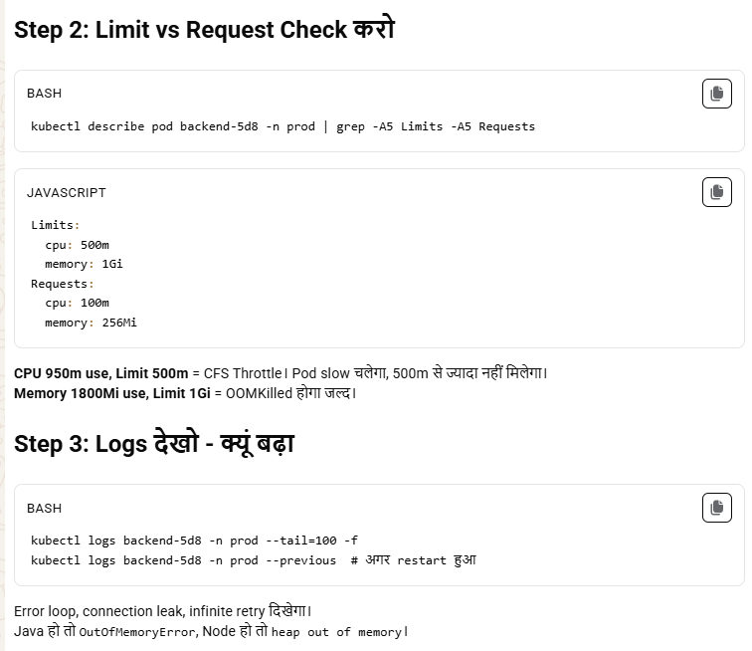
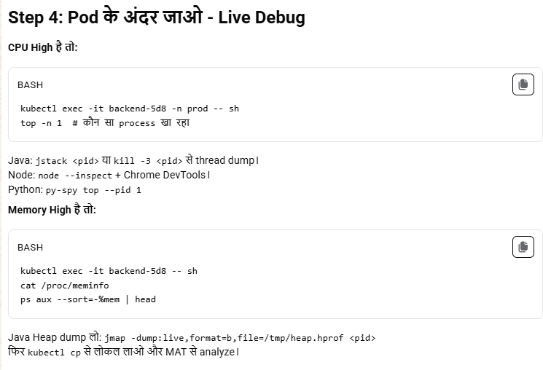
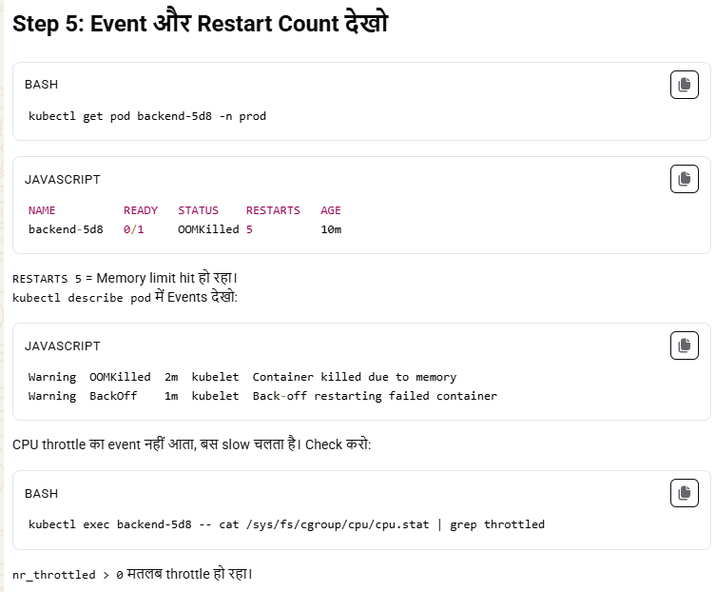
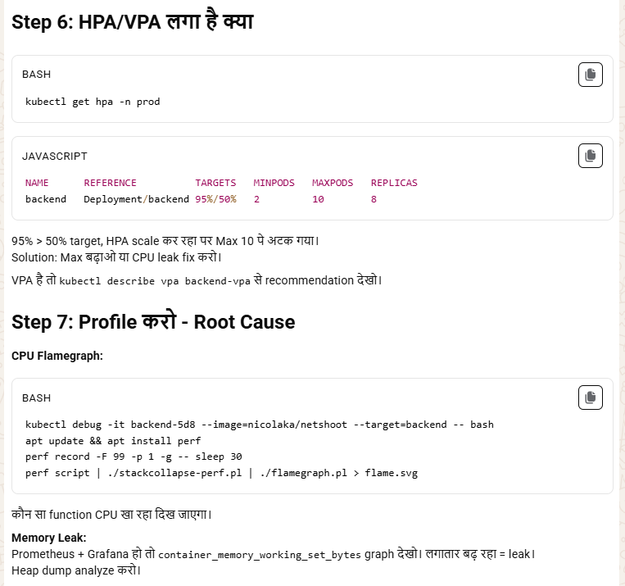
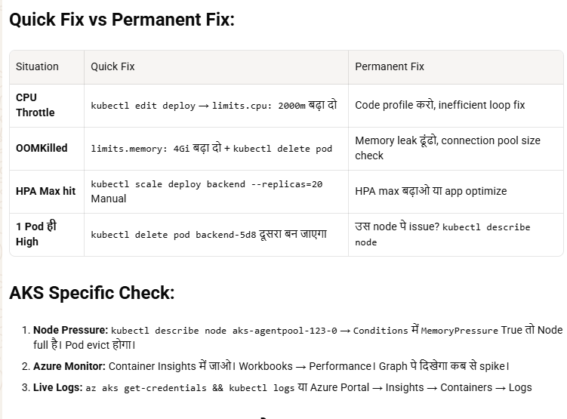
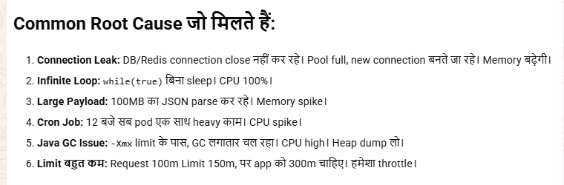
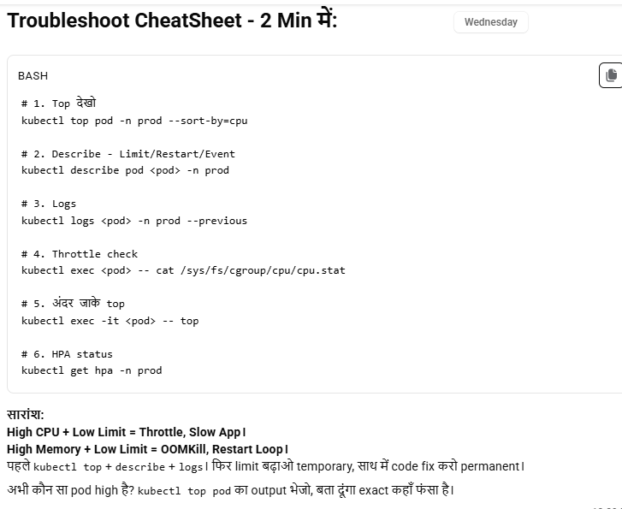
“In a connection leak scenario, I first identify increasing DB connections and errors, then fix application code to properly close connections, implement connection pooling, and configure timeouts to prevent resource exhaustion.”

“In an infinite loop scenario, I identify it via high CPU and repetitive logs, then fix the application logic by adding proper exit conditions, retry limits, and backoff mechanisms. As a temporary fix, I can restart the pod and enforce resource limits.”

“High utilization can be caused by traffic spikes, inefficient application logic, improper resource limits, dependency latency, lack of scaling, or background jobs. Troubleshooting involves identifying whether the issue is load-driven, application-related, or infrastructure-related.”

19. Cluster set up:-
Aapko customer ke own infrastructure par ek production-grade Kubernetes cluster set up karna hai. Niche main aapko complete step-by-step roadmap de raha hoon jo aapko guide karega cluster setup ke liye. Infrastructure aapke customer ka hai, isliye aapko unke environment ke hisaab se kuch configurations adjust karni hongi. Main steps vendor-neutral (VMs/bare-metal) base par de raha hoon:

✅ High-Level Checklist:
- Infra Requirements Finalize Karna
- Networking Setup
- Linux VM/Node Preparation
- Kubernetes Cluster Setup (Kubeadm based)
- Networking Plugin Install(calico)
- Storage Integration
- Monitoring, Logging, and Security Hardening
- Ingress Controller
- Backup & Disaster Recovery
- Testing & Handover

📌 1. Infra Requirements Finalize Karna
- Master Nodes: Min 1 (Production ke liye 3 HA recommended)
- Worker Nodes: 2+ (depending on app load)
- VM specs:
  - Master: 2-4 vCPU, 8-16 GB RAM
  - Worker: 4-8 vCPU, 16-32 GB RAM
- OS: Ubuntu 22.04 / CentOS 7 or 8 / RHEL
- Firewall Rules:
  - Ports like 6443, 10250, 2379-2380, etc. open internally
- SSH Access: Required for automation/setup
- Internet Access (Optional): For downloading packages. Otherwise use air-gapped mirror registry.

📌 2. Networking Setup
- Private IPs for nodes
- Static IP preferred
- DNS resolution
- Hostnames set properly
- No port conflicts
- Firewall config as per K8s port requirements

📌 3. Node Preparation (All Nodes)
bash
CopyEdit
# Disable swap
sudo swapoff -a
sudo sed -i '/ swap / s/^/#/' /etc/fstab

# Kernel modules
sudo modprobe overlay
sudo modprobe br_netfilter

# Apply sysctl
cat <<EOF | sudo tee /etc/sysctl.d/k8s.conf
net.bridge.bridge-nf-call-ip6tables = 1
net.bridge.bridge-nf-call-iptables = 1
net.ipv4.ip_forward = 1
EOF

sudo sysctl --system

# Install container runtime (containerd preferred)
sudo apt update && sudo apt install -y containerd
sudo mkdir -p /etc/containerd
containerd config default | sudo tee /etc/containerd/config.toml
sudo systemctl restart containerd
sudo systemctl enable containerd

📌 4. Kubernetes Install (All Nodes)
bash
CopyEdit
# Add Kubernetes apt repo
sudo apt-get update && sudo apt-get install -y apt-transport-https curl
sudo curl -fsSLo /usr/share/keyrings/kubernetes-archive-keyring.gpg https://packages.cloud.google.com/apt/doc/apt-key.gpg

echo "deb [signed-by=/usr/share/keyrings/kubernetes-archive-keyring.gpg] \
https://apt.kubernetes.io/ kubernetes-xenial main" | \
sudo tee /etc/apt/sources.list.d/kubernetes.list

sudo apt-get update
sudo apt-get install -y kubelet kubeadm kubectl
sudo apt-mark hold kubelet kubeadm kubectl

📌 5. Initialize Kubernetes Cluster (Master Node)
bash
CopyEdit
sudo kubeadm init --pod-network-cidr=192.168.0.0/16
Note: Use a --control-plane-endpoint and load balancer in HA setup.
Post Init:
bash
CopyEdit
# Configure kubectl for current user
mkdir -p $HOME/.kube
sudo cp -i /etc/kubernetes/admin.conf $HOME/.kube/config
sudo chown $(id -u):$(id -g) $HOME/.kube/config

📌 6. Join Worker Nodes
Use the kubeadm join command from the output of kubeadm init, or generate again:
bash
CopyEdit
kubeadm token create --print-join-command
Run this on all worker nodes.

📌 7. Install Networking Plugin (like Calico)
bash
CopyEdit
kubectl apply -f https://raw.githubusercontent.com/projectcalico/calico/v3.26.1/manifests/calico.yaml
OR use Flannel, Cilium, etc., as per use case.

📌 8. Setup Storage Integration
- Use dynamic storage class based on:
  - NFS
  - Ceph
  - OpenEBS
  - Cloud provider block storage
- Example for hostpath (Dev only): kubectl apply -f https://k8s.io/examples/pods/storage/hostpath.yaml

📌 9. Ingress Controller Setup
Example: NGINX Ingress
bash
CopyEdit
kubectl apply -f https://raw.githubusercontent.com/kubernetes/ingress-nginx/controller-v1.10.0/deploy/static/provider/cloud/deploy.yaml

📌 10. Monitoring & Logging
- Prometheus + Grafana
- EFK / Loki for logs
- Kube-state-metrics
- Optional: Use tools like Lens or Rancher for visibility.

📌 11. Security Hardening
- Use kube-bench, kube-hunter
- Network policies (via Calico, Cilium)
- RBAC rules strictly applied
- API server limited access

📌 12. Backup & Recovery
- Use tools like:
  - Velero for etcd & PV backups
  - Snapshots for etcd

📌 13. Testing
- Deploy sample apps
- Validate node failover
- Storage PVC provisioning
- Ingress routing
- RBAC access

- pod agar pending state mea atak gya hai to kya kubectl get pods krne pr wo pod dijhega ?
ChatGPT said:
Haan, kubectl get pods command se agar koi Pod "Pending" state mein hai, toh wo list mein dikhai dega, lekin uska STATUS field "Pending" show karega.
🔍 Example:
bash
CopyEdit
$ kubectl get pods
NAME READY STATUS RESTARTS AGE
nginx-6db489d4b7-xk5xz 0/1 Pending 0 5m

✅ Pending Pod ka matlab:
- Pod create ho gaya hai lekin abhi kisi Node pe schedule nahi ho paaya.
- Iska reason aap kubectl describe pod <pod-name> se dekh sakte ho.

📌 Common Reasons for Pending State:
Reason | Solution
🛑 No available nodes | Check if nodes are Ready using kubectl get nodes
🚫 Resource limits (CPU/RAM) | Pod ki resource request zyada hai – tune down or add capacity
📦 No matching NodeSelector/Taints | Check Node affinity, taints/tolerations
🔒 PVC not available (for volume) | Check if storage is correctly bound

🔧 Check Detail:
bash
CopyEdit
kubectl describe pod <pod-name>
Look under the Events section at the bottom, for example:
sql
CopyEdit
Events:
Type Reason Age From Message
---- ------ ---- ---- -------
Warning FailedScheduling 10s default-scheduler 0/3 nodes are available: 3 Insufficient memory.

20 HELM:-
Helm Kubernetes ka package manager hai, jise hum Kubernetes clusters ke liye application ko easily install, upgrade, delete aur manage karne ke liye use karte hain.
Helm is a package manager for Kubernetes that helps to manage Kubernetes applications using Helm charts. Helm charts are pre-configured Kubernetes resources that can be easily deployed, updated, and rolled back.

🔰 Helm Kya Hai?
- Helm ek CLI tool hai jo Kubernetes applications ko charts ke form mein manage karta hai.
- Jaise apt (Ubuntu) ya yum (RHEL) OS ke liye package manager hote hain, waise hi Helm Kubernetes ke liye hota hai.
Why Helm:- Suppose humko todo app bana hai to uske liye deployment +ingress+service manifest bnana parega .wo bhi alag alag .even jab delete krna ho to separately sabko delete krna parega .
Now, if you want to rollback, it is not an easy task; you have to delete the deployment, then the services, and all one by one. So it time taking and complex.
So, we have Helm.
- Helm creates a new package,called a chart, and using this chart, we deploy our application.
- Chart is nothing , it is a folder which contains templates, value.yaml and chart.yaml etc
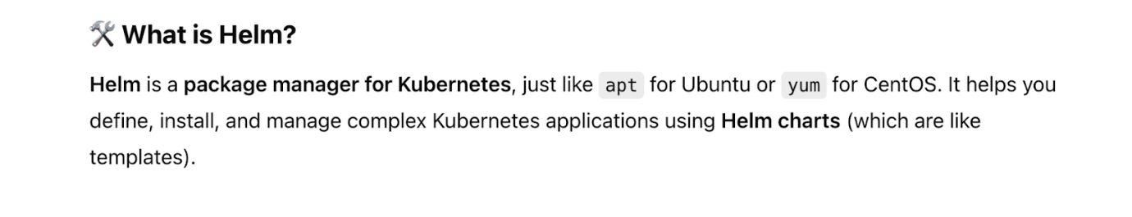

- Helm is a package manager for k8s which helps us to build and deploy application as well as manage the application very easly.
- Features:
- easily rollback
- Multi-environment deployment is very easy. Just create a separate value.yaml for each environment and modify it whenever is required. Rest file like chart.yaml and template folder will be common for all environments.
-version control
-dependencies management

How to use HELM: -
Step 1: Install Helm on your local pc. commands below are for a Linux pc.
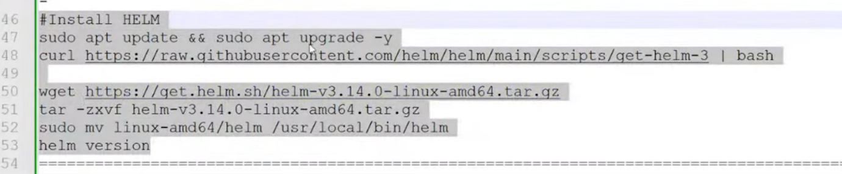
Window pc:-
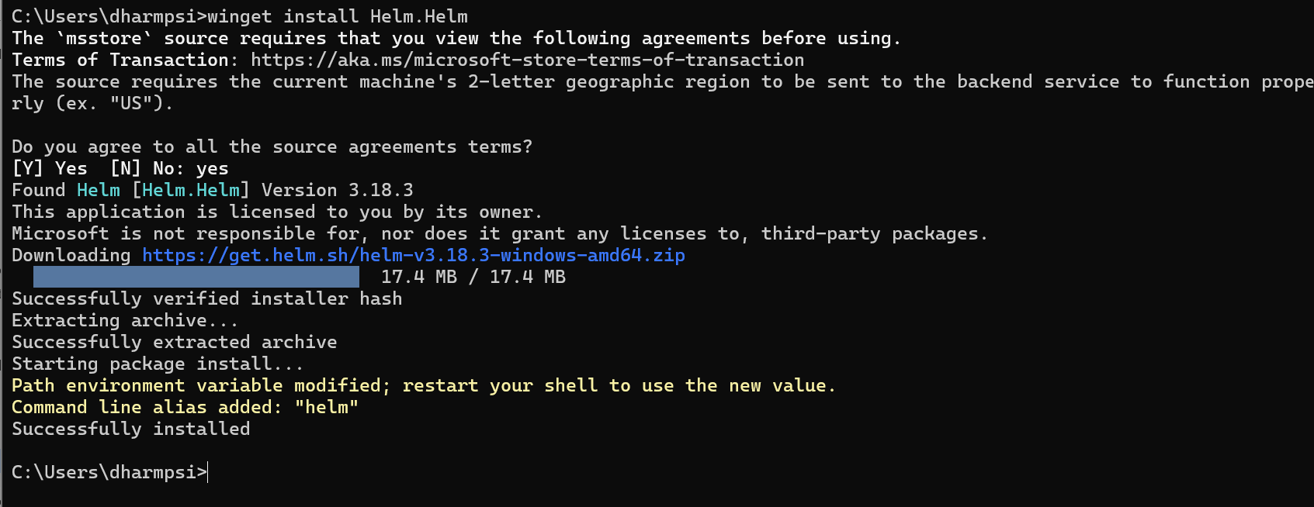
Step 2: create a chart [this command will create a folder that contains a chart, a template, a chart.yam,l and a value.yaml]
- helm create my-nginx
- cd my-nginx
- tree
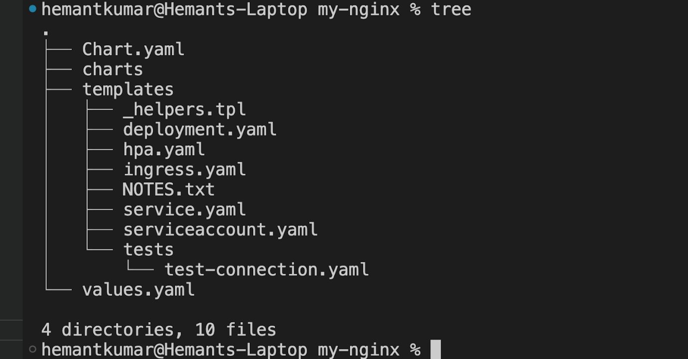

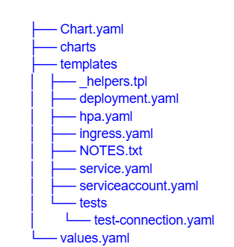
Chart Structure: A typical Helm chart structure includes:
Chart.yaml: Contains metadata about the chart, such as the name, version, and description.
values.yaml: Default configuration values for the chart. Users can override these values during deployment.
templates/: Contains Kubernetes manifests (like deployment.yaml, service.yaml, etc.) with Helm templating to make them dynamic.
charts/: Contains any dependent charts if the application has dependencies.
README.md: Optional file for documentation.

- chart.yaml: a metadata file. Info about your project, like description of project
- Charts: This is a folder that contains information about the dependency.
- Templates: a folder…that contains files as shown above..
Inside this folder,
Deployment.yaml/service.yaml etc will be defined as a template, menas actual value will be not defined here…actual value will be defined in value.yaml and chart.yaml etc.. and from there only it will use the actual value.
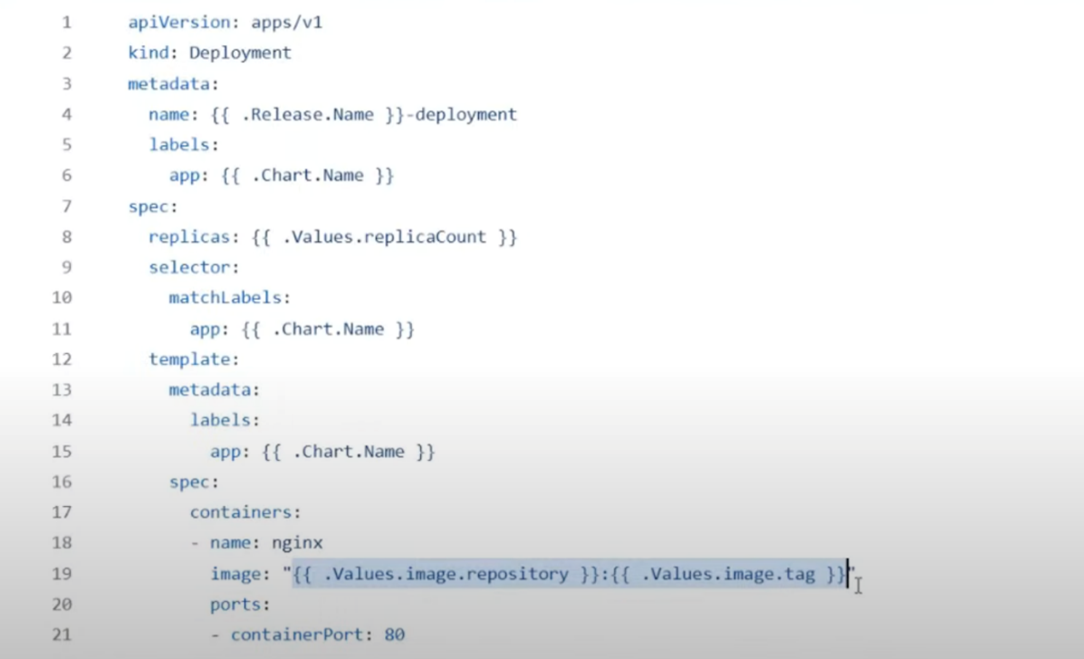
For example, these things will be defined as variable
Name
Image
Port
Replicas

There are three types of variables are defined here in deployment. yaml or service.yaml
Release: application release name
Chart: this variable value will be defined in chart.yaml
Value: values will be defined in value.yaml
- Notes.txt : some instructions which is to be followed after the deployment are done.
For example : how to get application URL
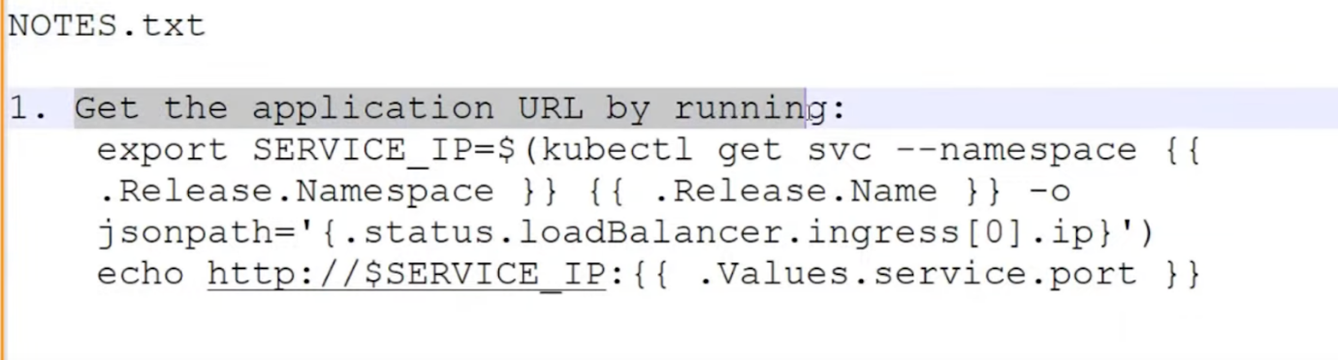
- _helpers.tpl: reusable functions ko define krte hain ham yahan par.
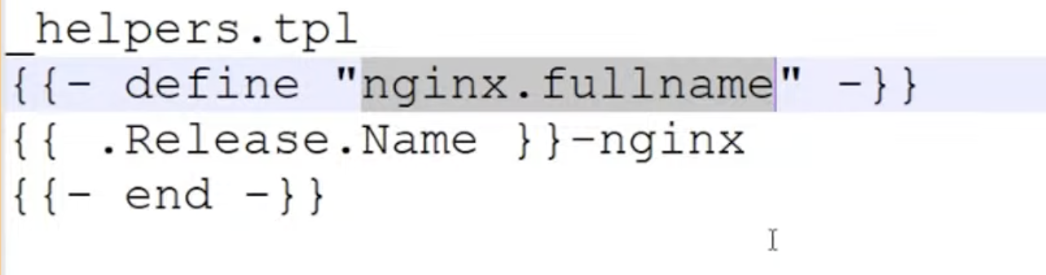

- Test folder : inside this folder we have separate kinds of yaml for testing purpose.

Just for now, basic learning purpose, we will remove charts folder, notes.txt and helpers.tpl

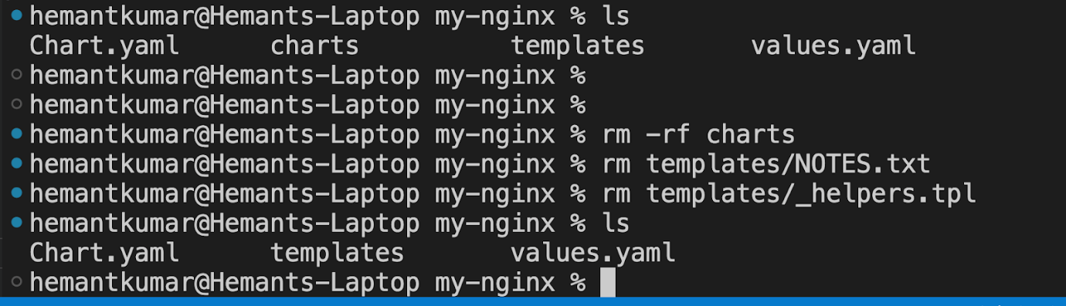

Also delete the all 4 yaml and test folder from template folder

rm deployment.yaml service.yaml serviceaccount.yaml ingress.yaml hpa.yaml
rm -rf tests
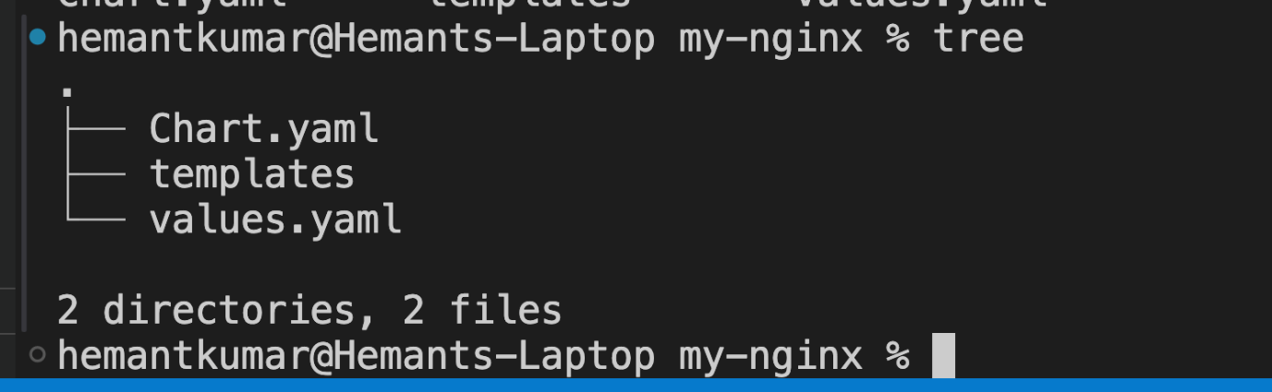
Now,

Create a deployment.yaml and service.yaml inside the template folder and define the value in value.yaml, chart.yaml and release

apiVersion: apps/v1
kind: Deployment
metadata:
name: {{ .Release.Name }}-deployment
labels:
app: {{ .Chart.Name }}
spec:
replicas: {{ .Values.replicasCount }}
selector:
matchLabels:
app: {{ .Chart.Name }}
template:
metadata:
labels:
app: {{ .Chart.Name }}
spec:
containers:
- name: nginx
image: {{ .Values.image.repository }}:{{ .Values.image.tag }}
ports:
- containerPort: 80
resources:
requests:
memory: {{ .Values.resources.requests.memory }}
cpu: {{ .Values.resources.requests.cpu }}
limits:
memory: {{ .Values.resources.limits.memory }}
cpu: {{ .Values.resources.limits.cpu }}

Service.yaml
apiVersion: v1
kind: Service
metadata:
name: {{ .Release.Name }}-service
spec:
selector:
app: {{ .Chart.Name }}
ports:
- protocol: TCP
port: 80
targetPort: 80
type: LoadBalancer

Value.yaml [Rules: indentation actual yaml file k jaise hona chahiye.]
replicaCount: 2

image:
repository: nginx
tag: stable
pullPolicy: IfNotPresent

resources:
limits:
cpu: 100m
memory: 128Mi
requests:
cpu: 100m
memory: 128Mi

service:
enabled: true
name: nginx
type: LoadBalancer
port: 80
targetPort: 80

hemantkumar@Hemants-Laptop helm_day1 % cd my-nginx
hemantkumar@Hemants-Laptop my-nginx %
hemantkumar@Hemants-Laptop my-nginx % helm install abc-release . -n dev-ns
NAME: abc-release
LAST DEPLOYED: Wed May 7 23:02:05 2025
NAMESPACE: dev-ns
STATUS: deployed
REVISION: 1
TEST SUITE: None
hemantkumar@Hemants-Laptop my-nginx %

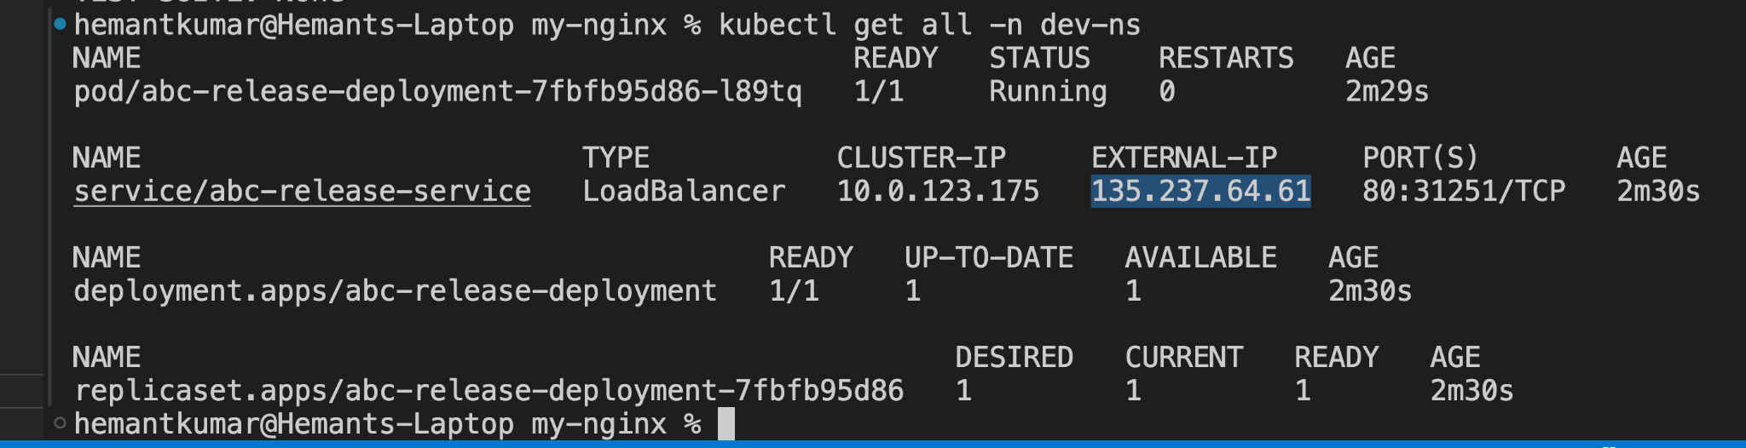

Now open NGINX in browser using external IP:port.
Helm upgrade
- Increase the replica count in value.yaml and then run the below command
hemantkumar@Hemants-Laptop my-nginx % helm upgrade abc-release . -n dev-ns
Release "abc-release" has been upgraded. Happy Helming!
NAME: abc-release
LAST DEPLOYED: Wed May 7 23:09:49 2025
NAMESPACE: dev-ns
STATUS: deployed
REVISION: 2
TEST SUITE: None
hemantkumar@Hemants-Laptop my-nginx %

👉 Single Helm command (install + upgrade) 👇
helm upgrade --install <release-name> <chart-name> -n <namespace>

Helm history[all revision of release.]
Helm rollback
hemantkumar@Hemants-Laptop my-nginx % helm rollback abc-release 1 -n dev-ns
Rollback was a success! Happy Helming!
hemantkumar@Hemants-Laptop my-nginx % kubectl get all -n dev-ns
NAME READY STATUS RESTARTS AGE
pod/abc-release-deployment-7fbfb95d86-m8nw6 1/1 Running 0 92s

NAME TYPE CLUSTER-IP EXTERNAL-IP PORT(S) AGE
service/abc-release-service LoadBalancer 10.0.123.175 135.237.64.61 80:31251/TCP 17m

NAME READY UP-TO-DATE AVAILABLE AGE
deployment.apps/abc-release-deployment 1/1 1 1 17m

NAME DESIRED CURRENT READY AGE
replicaset.apps/abc-release-deployment-7fbfb95d86 1 1 1 17m
hemantkumar@Hemants-Laptop my-nginx %

Now without updating the value.yaml still you can give the value at run time.

hemantkumar@Hemants-Laptop my-nginx % helm upgrade abc-release . --set replicasCount=4 -n dev-ns
Release "abc-release" has been upgraded. Happy Helming!
NAME: abc-release
LAST DEPLOYED: Wed May 7 23:31:34 2025
NAMESPACE: dev-ns
STATUS: deployed
REVISION: 12
TEST SUITE: None
hemantkumar@Hemants-Laptop my-nginx % kubectl get all -n dev-ns
NAME READY STATUS RESTARTS AGE
pod/abc-release-deployment-7fbfb95d86-2mqdj 1/1 Running 0 114s
pod/abc-release-deployment-7fbfb95d86-lfv5c 1/1 Running 0 114s
pod/abc-release-deployment-7fbfb95d86-m8nw6 1/1 Running 0 13m
pod/abc-release-deployment-7fbfb95d86-mdxmd 1/1 Running 0 5s
NAME TYPE CLUSTER-IP EXTERNAL-IP PORT(S) AGE
service/abc-release-service LoadBalancer 10.0.123.175 135.237.64.61 80:31251/TCP 29m

NAME READY UP-TO-DATE AVAILABLE AGE
deployment.apps/abc-release-deployment 4/4 4 4 29m

NAME DESIRED CURRENT READY AGE
replicaset.apps/abc-release-deployment-7fbfb95d86 4 4 4 29m
hemantkumar@Hemants-Laptop my-nginx %

Helm uninstall

emantkumar@Hemants-Laptop my-nginx % helm uninstall abc-release -n dev-ns
release "abc-release" uninstalled
hemantkumar@Hemants-Laptop my-nginx %

Now suppose we have 3 environments, dev, qa and prod.

So create 3 values.yaml for each environment, like dev-value.yaml, qu-value.yaml, prod-value.yaml

Then create 3 namespaces, dev-ns, qa-ns, and prod-ns.

Then deploy the application.
Suppose you want to deploy in dev-ns

helm install <chart name> . -f dev-value.yaml -n dev-ns

To deploy in QA
helm install <chart name> . -f qa-value.yaml -n qa-ns
Value.yaml
Or
--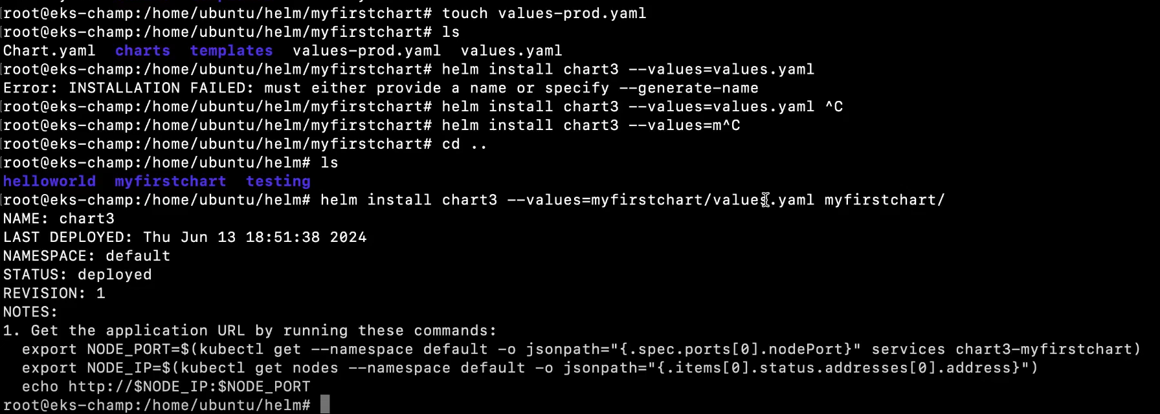

21. Prometheus integration with AKS.

📋 Summary: AKS me Prometheus + Node Exporter Manual Setup (Without Helm)
🔢 Step | 🔧 Task | 📄 Resource
1️⃣ | Namespace banayein | kubectl create namespace monitoring
2️⃣ | Prometheus config define karein (scrape config, targets) | prometheus-config.yaml (ConfigMap)
3️⃣ | Prometheus ko deploy karein | prometheus-deployment.yaml (Deployment with config volume)
4️⃣ | Prometheus ke liye Service banao (internal access ke liye) | prometheus-service.yaml
5️⃣ | Node Exporter ko har node pe deploy karein | node-exporter-daemonset.yaml (DaemonSet)
6️⃣ | Node Exporter ke liye headless Service banao | node-exporter-service.yaml (clusterIP: None)
7️⃣ | Prometheus UI access karo | kubectl port-forward -n monitoring svc/prometheus 9090
8️⃣ | Verify karo Prometheus UI me /targets pe jaake | Metrics from Prometheus & Node Exporters

🧱 Output Aapko Milega:
Component | Description
Prometheus UI | http://localhost:9090 (via port-forward)
Scrape Targets | Node Exporters (1 per node) visible in Prometheus
Metrics | CPU, memory, disk, load average etc. per node

📋 Summary: Prometheus + Node Exporter Setup via Helm in AKS
🔢 Step | 🔧 Task | 🧾 Command / File
1️⃣ | Namespace create karo (optional) | kubectl create namespace monitoring
2️⃣ | Helm repo add karo (prometheus-community) | helm repo add prometheus-community https://prometheus-community.github.io/helm-charts  helm repo update
3️⃣ | Install Prometheus + Node Exporter + Grafana (optional) | helm install prometheus prometheus-community/kube-prometheus-stack -n monitoring
4️⃣ | Prometheus access karo (UI) | kubectl port-forward -n monitoring svc/prometheus-kube-prometheus-prometheus 9090  Visit: http://localhost:9090
5️⃣ | Grafana access karo (optional) | kubectl port-forward -n monitoring svc/prometheus-grafana 3000:80  Visit: http://localhost:3000
6️⃣ | Grafana login credentials check karo | Username: admin  Password:  `kubectl get secret -n monitoring prometheus-grafana -o jsonpath="{.data.admin-password}"
7️⃣ | Verify targets in Prometheus UI | Navigate to Status > Targets tab

✅ Helm install se kya-kya milta hai?
Component | Description
✅ Prometheus | Metrics collector
✅ Node Exporter | Metrics from each node (via DaemonSet)
✅ Kube-state-metrics | Cluster resource level metrics
✅ Alertmanager | Alerts configuration
✅ Grafana | Visualization dashboard
✅ ServiceMonitor / PodMonitor | Auto-discovery of services

🧼 Cleanup (if needed):
helm uninstall prometheus -n monitoring
kubectl delete namespace monitoring

🎯 Summary Table (Manual vs Helm)
Feature | Manual YAML Setup | Helm Setup
Speed | Slow (many YAMLs) | Fast (1 command)
Node Exporter | Manually via DaemonSet | Auto-installed
Grafana | Separate setup | Auto-included
Service Discovery | Manual scrape config | Auto via ServiceMonitor
Ideal For | Learning, lightweight setup | Production, scaling

✅ Summary
Step | Task
1️⃣ | Check prerequisites (AKS, Azure CLI, login)
2️⃣ | Run az aks monitor enable-prometheus
3️⃣ | Validate Prometheus is enabled
4️⃣ | View metrics in Azure Portal
5️⃣ | (Optional) Connect to Azure Managed Grafana

22 ADVANCE TOPICS

22.1 KEDA :- ( Kubernetes Event-driven Autoscaler)

1. KEDA kya hai?
- KEDA ek Kubernetes-based event-driven autoscaler hai
- Ye pods ko external events ke basis par scale karta hai (sirf CPU/Memory nahi)
- Works with Kubernetes + HPA (Horizontal Pod Autoscaler)
👉 Simple:
Queue me message aaya → Pods auto scale up
Queue empty → Pods scale down (even to 0)

🔹 2. KEDA kyu use hota hai?
Default Kubernetes:
- Sirf CPU/Memory pe scaling
KEDA:
- Queue length (Azure Service Bus, Kafka)
- Events (Prometheus metrics, HTTP requests)
- Custom triggers
👉 Use case:
- Event-driven apps
- Serverless pattern on Kubernetes
- Cost optimization (scale to zero)

🔹 3. KEDA ka architecture
Main components:
- Operator
  - ScaledObject monitor karta hai
- Metrics Server
  - External metrics ko HPA ko deta hai
- Scaler
  - External source se data fetch karta hai
Flow:
Event Source (Queue / Kafka / etc)
↓
KEDA Scaler
↓
Metrics Server
↓
HPA
↓
Pods scale

🔹 4. KEDA kaise kaam karta hai?
Step-by-step:
- Keda install ,fir Tum ScaledObject define karte ho
- KEDA external system monitor karta hai
- Threshold cross → HPA trigger
- Pods scale up/down
👉 Special feature:
- Scale to zero (0 pods)
- Jab event nahi hai → cost save
👉 KEDA
- Ye poora system / tool / framework hai (opensource )
- Cluster me install hota hai (operator + scaler + metrics)
👉 ScaledObject
- Ye ek Kubernetes resource (CRD) hai (Custom Resource Definition- Kubernetes ko naya resource type sikhane ka tareeka)
- Jo tum define karte ho scaling ke liye

🔹 Simple analogy
- KEDA = Engine 🚗
- ScaledObject = Driving instruction (kahan jana hai)
🔹 Relation kaise hai
- Tum KEDA install karte ho
- Tum ScaledObject YAML likhte ho
- KEDA usko read karta hai
- Aur HPA create karke scaling karwata hai

🔹 Ek line me yaad rakhna
👉
“KEDA ek autoscaling framework hai aur ScaledObject uska configuration resource hai jo batata hai kis deployment ko kaise scale karna hai.”

🔹 Bonus (interview trap)
👉 Ek aur term hota hai:
- ScaledJob → batch jobs ke liye (Deployment nahi)

🔹 5. Important Concepts
✅ ScaledObject
- Deployment ko scale karta hai
- Trigger define hota hai
✅ Scaler
- External system se connect karta hai
Examples:
- Azure Service Bus
- Kafka
- Prometheus
✅ Trigger
- Condition define karta hai (jaise queue length > 10)

🔹 6. Supported Triggers
- Azure Service Bus
- Kafka
- RabbitMQ
- Prometheus
- HTTP
- Redis
- AWS SQS

🔹 7. Actual Flow
Step 1: KEDA install
kubectl apply -f https://github.com/kedacore/keda/releases
👉 Is time:
- KEDA operator install hota hai
- ❌ Koi HPA create nahi hota
✅ Step 2: ScaledObject apply
kind: ScaledObject
👉 YAHI main trigger point hai
➡️ Jaise hi tum ScaledObject apply karte ho:
- KEDA turant ek Horizontal Pod Autoscaler create karta hai
- Ye HPA automatically manage hota hai
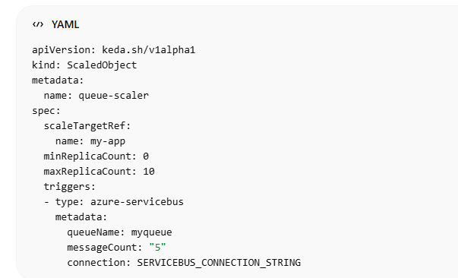
🔹 Final Answer
👉 KEDA apply ke time → HPA create nahi hota
👉 ScaledObject apply ke time → HPA create hota hai

🔹 Visualization
KEDA Install ❌ No HPA
ScaledObject Apply ✅ HPA Created
↓
Event Monitoring
↓
HPA Scaling Pods

🔹 Ek line me yaad rakhna
👉
“KEDA installation sirf operator deploy karta hai, actual HPA tab create hota hai jab hum ScaledObject define karte hain.”

👉 Meaning:
- Queue me 5+ messages → scale up
- Queue empty → scale to 0

🔹 8. KEDA vs HPA
Feature | HPA | KEDA
CPU/Memory scaling | ✅ | ✅
External metrics | ❌ | ✅
Scale to zero | ❌ | ✅
Event-driven | ❌ | ✅

🔹 9. Real-world Azure DevOps Use Case
- Azure Service Bus queue based processing
- CI/CD pipeline me background jobs
- Microservices async processing
👉 Example:
- Queue me job aayi → pod create
- Job complete → pod terminate

🔹 10. Installation (short notes)
kubectl apply -f https://github.com/kedacore/keda/releases

🔹 11. Interview Questions
Q1: KEDA kya karta hai?
👉 Event-based autoscaling in Kubernetes
Q2: HPA se better kyu?
👉 External triggers + scale to zero
Q3: Scale to zero ka benefit?
👉 Cost saving
Q4: Real use case?
👉 Queue-based processing (Kafka / Service Bus)

🔹 12. Key Points (Revise fast)
- Event-driven autoscaling
- Works with HPA
- External triggers support
- Scale to zero
- YAML based config
- No external metrics server is required .
👉 KEDA khud apna metrics server lekar aata hai
- KEDA install karte hi:
  - keda-operator
  - keda-metrics-apiserver (yehi external metrics server hai)

🔹 Kaise kaam karta hai
- KEDA external source (queue, kafka) se data leta hai
- Usko metric me convert karta hai
- Ye metric expose hota hai via external metrics API
- Horizontal Pod Autoscaler (HPA) usko use karta hai

🔹 Important Point
👉 Normally (without KEDA):
- External metrics ke liye alag setup chahiye (Prometheus adapter etc.)
👉 With KEDA:
- Built-in external metrics provider mil jata hai
Integration: -
“KEDA integrates with RabbitMQ by polling the queue length using configured triggers in a ScaledObject. Based on the message count, it drives scaling via HPA.”
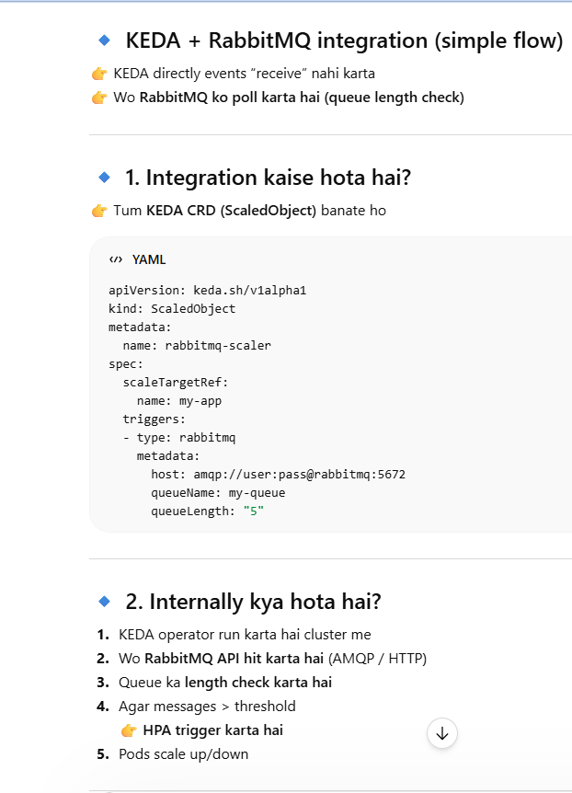

🔹 One-line (interview)
👉
“KEDA apna built-in metrics server provide karta hai, isliye external metrics server alag se install karne ki zarurat nahi hoti.”

22.2 Messages broker: -

👉 Message Broker = ek beech ka system jo 2 applications ke beech message exchange karwata hai
Flow:
Producer → Message Broker → Consumer
👉 Simple:
- App A directly App B ko call nahi karega
- Beech me broker use karega

🔹 2. Kyu use hota hai?
- Loose coupling
- Async communication
- Reliability (message store hota hai)
- Retry / buffering

🔹 3. Message Broker ke Types
✅ 1. Queue-based (Point-to-Point)
👉 1 producer → 1 consumer
- Ek message → ek hi service consume karegi
👉 Example:
- Order processing

✅ 2. Pub/Sub (Publish–Subscribe)
👉 1 producer → multiple consumers
- Ek message → multiple services ko jata hai
👉 Example:
- Notification system (Email + SMS + Analytics)
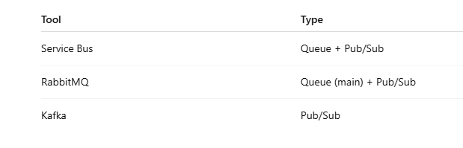

🔹 4. Popular Message Brokers
☁️ Cloud Based
👉 Azure Service Bus
- Enterprise-grade
- Queue + Topic support
- Features: DLQ, retry, ordering

🔓 Open Source
👉 Apache Kafka
- High throughput
- Event streaming platform
- Real-time data pipelines
👉 Use:
- Logs, analytics, streaming

👉 RabbitMQ
- Lightweight
- Easy to use
- Queue-based messaging
👉 Use:
- Background jobs
- Microservices communication

🔹 5. Comparison (Interview ke liye important)
Feature | Service Bus | Kafka | RabbitMQ
Type | Broker | Event Streaming | Broker
Throughput | Medium | Very High | Medium
Use case | Enterprise apps | Big data, streaming | Simple queues
Ordering | ✅ | Partition based | Limited
Complexity | Medium | High | Low

🔹 6. Kab kya use kare?
👉 Azure Service Bus
- Enterprise + Azure ecosystem
- Reliable messaging
👉 Kafka
- Real-time streaming
- Big data / logs
👉 RabbitMQ
- Simple messaging
- Lightweight apps

🔹 7. Real AKS Example
👉 Tumhare 5 backend services:
Option 1 (Direct)
- Service A → Service B (API call)
Option 2 (Broker use karke)
Service A → Broker → Service B
👉 Better:
- Failure safe
- Async processing

🔹 8. One-line Summary (notes ke liye)
👉
“Message broker ek middleware hai jo applications ke beech asynchronous aur reliable communication enable karta hai.”

🔹 9. Interview Quick Points
- Queue vs Pub/Sub difference
- Kafka vs RabbitMQ
- Async vs Sync communication
- DLQ kya hota hai
xxxxxxxxxxxxxxxxxxxxxxxxxxxxxxxxxxxxxxxxxxxxxxxxxxxxxxxxxxxxxxxxxxxxxxxxxxxxxxxxxxxxxxxxxx

22.2.1 Azure Service Bus
👉 Ye ek fully managed message broker (PaaS) hai
👉 Applications ke beech asynchronous communication enable karta hai
👉 Simple:
App A → message bhejta hai → queue/topic → App B later consume karta hai

🔹 2. Kyu use hota hai?
- Loose coupling between services
- Reliable messaging (guaranteed delivery)
- Async processing (real-time dependency remove)
👉 Microservices architecture me heavily use hota hai

🔹 3. Core Components
✅ Queue
- 1 producer → 1 consumer
- FIFO (mostly)
✅ Topic + Subscription
- 1 producer → multiple consumers
- Pub/Sub model

🔹 4. Architecture Flow
Producer (App)
↓
Azure Service Bus (Queue / Topic)
↓
Consumer (App)

🔹 5. Kaise kaam karta hai?
Step-by-step:
- Producer message send karta hai
- Message queue/topic me store hota hai
- Consumer poll/receive karta hai
- Process hone ke baad message delete

🔹 6. Important Features
✅ Message Durability
- Disk pe store hota hai (lost nahi hota)
✅ Dead Letter Queue (DLQ)
- Failed messages yaha store hote hain
✅ Message Locking
- Ek time pe ek consumer process kare
✅ Retry mechanism
- Failure me retry possible
✅ Scheduling
- Future me message send kar sakte ho

🔹 7. Delivery Modes
🔸 Peek-Lock (default)
- Message lock hota hai
- Process ke baad delete
🔸 Receive-and-Delete
- Direct delete (risk hai)

🔹 8. Use Cases
👉 Real-world:
- Order processing system
- Payment queue
- Email/SMS background jobs
- Microservices communication
- Event-driven architecture

🔹 9. Azure DevOps + KEDA Use Case
👉 Queue me message aaya →
👉 **KEDA detect karega →
👉 Pods auto scale ho jayenge

🔹 10. Service Bus vs Storage Queue
Feature | Service Bus | Storage Queue
Advanced features | ✅ | ❌
Ordering | ✅ | Limited
Transactions | ✅ | ❌
DLQ | ✅ | ❌
Cost | High | Low

🔹 11. Alternatives
👉 Cloud:
- AWS SQS
- Google Pub/Sub
👉 Open source:
- Kafka
- RabbitMQ

🔹 12. Kab use kare?
👉 Use Service Bus when:
- Enterprise messaging chahiye
- Reliability + ordering important
- Complex workflows hain
👉 Use NOT when:
- Simple queue chahiye → Storage Queue better

🔹 13. Advantages
- Fully managed (no infra)
- High reliability
- Scalable
- Secure (RBAC, SAS)
- Supports async architecture

🔹 14. Disadvantages
- Cost high
- Slight latency (queue based)
- Complex compared to simple queues

🔹 15. Interview Questions
Q1: Service Bus kya hai?
👉 Managed message broker
Q2: Queue vs Topic?
👉 Queue = 1 consumer, Topic = multiple
Q3: DLQ kya hota hai?
👉 Failed messages store hone ki jagah
Q4: Peek-lock kya hai?
👉 Safe processing mechanism

🔹 16. One-line summary
👉
“Azure Service Bus ek enterprise-grade message broker hai jo applications ke beech reliable, asynchronous communication provide karta hai.”

- EXAMPLE:- IN AKS , I have frontend and backend in backend I have 5 services . communication cluster ip se bhi to ho skta hai .
👉 Tumhare AKS cluster me:
- Frontend (UI)
- Backend (5 microservices)
❓ Kya ye services aapas me baat karti hain?
👉 Haan karti hain

🔹 Kaise karti hain (Normal way)
👉 Kubernetes me:
- Har service ka ClusterIP / DNS hota hai
Example:
frontend → http://orders-service
orders-service → http://payment-service
👉 Ye synchronous communication hai
(matlab direct API call, response ka wait)

🔹 Problem kya hai is approach me?
Socho:
- Order service → Payment service ko call karta hai
- Agar payment down hai ❌
👉 To:
- Order fail ho jayega
- System tightly coupled ho gaya

🔹 Yaha entry hoti hai Service Bus ki 🚀
👉 Azure Service Bus use karte hain

🔹 Same example (with Service Bus)
Scenario: Order place hua
Step 1:
Frontend → Order Service
Step 2:
Order Service:
❌ Direct Payment ko call nahi karega
✅ Message queue me daal dega
Order Service → Service Bus Queue → Payment Service
Step 3:
Payment Service:
- Queue se message uthayega
- Payment process karega

🔹 Difference samjho
🔸 Without Service Bus (Direct call)
Order → Payment (direct API call)
- Tight coupling ❌
- Failure = system fail ❌

🔸 With Service Bus
Order → Queue → Payment
- Loose coupling ✅
- Retry possible ✅
- Failure tolerant ✅

🔹 Kyu use karte hain?
👉 3 main reasons:
1. Loose Coupling
- Services independent ho jati hain
2. Reliability
- Message queue me store hota hai
- Service down ho to bhi data lost nahi
3. Scalability
- Multiple consumers ek hi queue process kar sakte hain

🔹 Important point (interview)
👉
ClusterIP se services baat karti hain → synchronous
👉
Service Bus use hota hai → asynchronous communication ke liye

🔹 Real-life analogy
👉 Direct call:
- Phone call 📞 → agar banda busy → kaam ruk gaya
👉 Service Bus:
- WhatsApp message 💬 → banda baad me reply karega

🔹 Final clarity
👉 Tumhare backend ki 5 services:
- Direct API se bhi baat kar sakti hain (ClusterIP) ✅
- Service Bus se bhi baat kar sakti hain (better for async) ✅

🔹 One-line yaad rakhna
👉
“ClusterIP synchronous communication ke liye use hota hai, jabki Service Bus asynchronous, reliable aur loosely coupled communication ke liye use hota hai.”
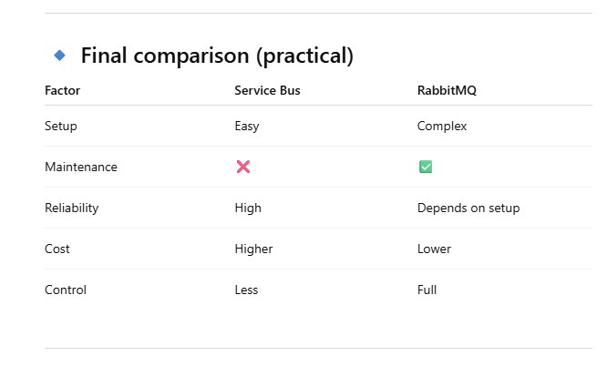
Integration: -
Azure Service Bus AKS me kaise run hota hai?
👉 Azure Service Bus AKS ke andar run nahi hota
❌ Koi pod nahi hota
❌ Tum kubectl se deploy nahi karte
👉 Ye Azure ka managed PaaS service hai (cloud me run hota hai)

🔹 To phir integration kaise hota hai?
👉 Flow samjho:
AKS Pod (your app)
↓
Internet / Azure Network
↓
Azure Service Bus (cloud service)
👉 Matlab:
- Tumhari AKS app (pod) → Service Bus ko client ki tarah call karti hai
- Bilkul jaise DB connect karte ho

🔹 Kaise connect karte hain?
✅ Option 1: Connection String
- Azure Portal se Service Bus create karo
- Queue/Topic banao
- Connection string lo
- App me use karo

✅ Option 2: Managed Identity (Best)
- AKS pod → identity use karta hai
- Direct Azure Service Bus access karta hai

🔹 Important clarity
👉 Tum 2 alag cheez mix kar rahe the:
Cheez | Kaha run hoti hai
AKS Pods | Kubernetes cluster
Service Bus | Azure cloud (managed service)

🔹 Real Example
👉 Tumhari AKS app:
Order Service (Pod)
↓
Send message
↓
Azure Service Bus Queue
↓
Payment Service (Pod)
👉 Dono services AKS me hain
👉 Beech me Service Bus Azure me hai

🔹 Ekdum simple line
👉
“Azure Service Bus AKS ke andar deploy nahi hota, balki Azure portal se create hota hai aur AKS ke pods usko external service ki tarah use karte hain.”

22.2.2 RabbitMQ
👉 Open-source message broker
👉 Applications ke beech asynchronous messaging enable karta hai
👉 Simple:
Producer → RabbitMQ → Consumer

🔹 2. Kyu use hota hai?
- Loose coupling
- Background processing
- Retry mechanism
- Load leveling

🔹 3. Core Components (Very Important 🔥)
✅ Producer
- Message bhejta hai
✅ Consumer
- Message receive karta hai
✅ Queue
- Message store hota hai
✅ Exchange ⭐ (Most Important)
- Decide karta hai message kis queue me jayega
✅ Binding
- Exchange aur Queue ka connection

🔹 4. Architecture Flow
Producer → Exchange → Queue → Consumer
👉 Direct queue me nahi jata
👉 Pehle Exchange decide karta hai

🔹 5. Exchange Types (Interview Gold 🔥)
🔸 Direct Exchange
- Exact match routing
👉 routing key match hona chahiye

🔸 Fanout Exchange
- Broadcast
👉 sab queues ko message

🔸 Topic Exchange
- Pattern based
👉 flexible routing (order.*)

🔸 Headers Exchange
- Header values ke basis pe routing

🔹 6. Kaise kaam karta hai?
- Producer message bhejta hai
- Exchange receive karta hai
- Routing rule apply hota hai
- Queue me store hota hai
- Consumer read karta hai

🔹 7. Message Acknowledgement
👉 Consumer process ke baad:
- ACK → success
- NACK → retry / requeue

🔹 8. Features
- Reliable delivery
- Flexible routing
- Retry support
- Dead Letter Queue
- Lightweight

🔹 9. Use Cases
- Background jobs
- Email processing
- Order system
- Microservices communication

🔹 10. RabbitMQ vs Service Bus
Feature | RabbitMQ | Service Bus
Type | Open-source | Managed
Hosting | Self-hosted | Azure
Control | Full | Limited
Maintenance | Required | Not needed

🔹 11. AKS me RabbitMQ kaise use hota hai?
👉 Tum RabbitMQ ko AKS me deploy karte ho (pod ke form me)
AKS:
RabbitMQ Pod
App Pods
👉 Apps internally connect karti hain

🔹 12. Advantages
- Free (open-source)
- Flexible routing
- Lightweight
- Easy to start

🔹 13. Disadvantages
- Maintenance required
- Scaling manually manage karna hota hai
- HA setup complex

🔹 14. Interview Questions
Q1: Exchange kya hota hai?
👉 Routing component
Q2: Direct vs Fanout?
👉 Direct = specific, Fanout = broadcast
Q3: ACK kya hai?
👉 Message processing confirmation
“RabbitMQ me ACK bolte hain, Service Bus me Complete() — concept same hai: reliable message processing.”
RabbitMQ vs Service Bus (ACK concept)
👉 RabbitMQ
- Explicit ACK / NACK
- Tum manually bolte ho:
  - ACK → message processed
  - NACK → retry / requeue

👉 Azure Service Bus
👉 Same concept hai but different terms:
🔸 Peek-Lock mode (default)
- Message lock ho jata hai
- Consumer process karta hai
- Phir:
  - Complete() → (ACK jaisa) ✅
  - Abandon() → (retry jaisa) 🔁
  - DeadLetter() → DLQ

🔹 15. One-line Summary
👉
“RabbitMQ ek open-source message broker hai jo exchange-based routing ke through reliable asynchronous communication enable karta hai.”

22.2.3 Kafka
👉 Distributed event streaming platform
👉 High-throughput, real-time data processing ke liye use hota hai
👉 Simple:
Producer → Topic → Consumer

🔹 2. Core Components (Important 🔥)
✅ Producer
- Message (event) send karta hai
✅ Consumer
- Message read karta hai
✅ Topic
- Logical stream (queue jaisa but advanced)
✅ Partition ⭐
- Topic ke andar multiple parts
- Parallel processing ke liye
✅ Broker
- Kafka server (cluster me multiple hote hain)
🔹 3. Architecture Flow
Producer → Topic (Partitions) → Consumer Group

🔹 4. Kaise kaam karta hai?
- Producer message bhejta hai
- Message topic ke partition me store hota hai
- Consumer group read karta hai
- Offset maintain hota hai (kaha tak read hua)

22.3 Service Mesh
जब K8s में 50-100 microservices आपस में बात करती हैं तो 4 दिक्कतें आती हैं:
1. Security: हर service को encrypt करके बात करनी चाहिए
2. Reliability: Timeout, Retry, Circuit breaker हर service में लिखना पड़ता है
3. Observability: कौन सी service slow है, trace करना मुश्किल
4. Traffic Control: नए version पर 5% traffic भेजना हो तो कैसे?
Service Mesh ये सब solve करता है - बिना application code छुए।

### *कैसे काम करता है:*
Service Mesh हर Pod के साथ एक छोटा proxy डाल देता है। इसे `sidecar` बोलते हैं।
बिना Service Mesh:
Pod A --------call--------> Pod B

Service Mesh के साथ:
Pod A --> Envoy Proxy A --> Envoy Proxy B --> Pod B

सारा traffic इन Proxy से होकर जाता है। Proxy को एक Control Plane manage करता है।
Data Plane: सारे Envoy proxies = असली traffic handle करते हैं
Control Plane: Istiod/Linkerd = सारे proxy को config भेजता है

### *Service Mesh क्या-क्या देता है:*
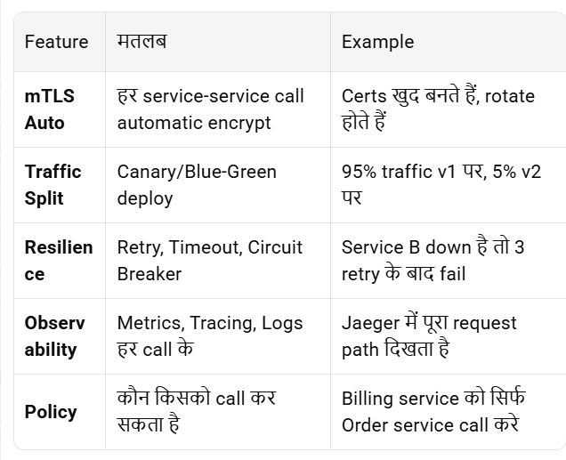
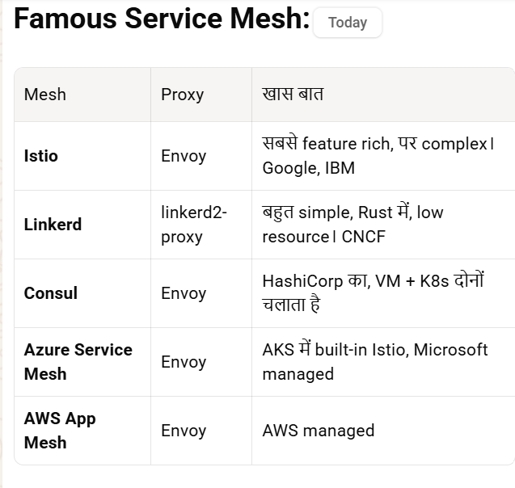
Key Features
- Traffic Management → routing, load balancing, canary
- Security → mTLS (service-to-service encryption)
- Observability → logs, metrics, tracing
- Resilience → retry, circuit breaker, timeout

### *AKS में Example - Canary बिना code change:*

मान लो `checkout` service का v2 deploy किया। अब 10% users पर test करना है:
apiVersion: networking.istio.io/v1beta1
kind: VirtualService
metadata:
name: checkout
spec:
hosts:
- checkout
http:
- route:
- destination:
host: checkout
subset: v1
weight: 90
- destination:
host: checkout
subset: v2
weight: 10
बस ये YAML apply करो। 10% traffic v2 पर चला जाएगा। K8s Service छूनी ही नहीं पड़ी।

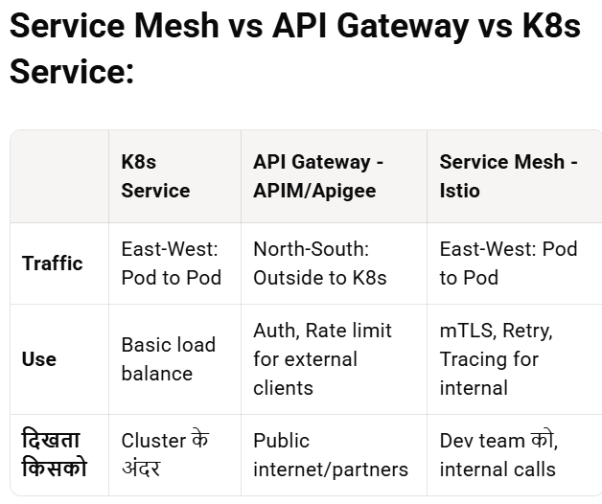
APIM = घर का Main Gate। Service Mesh = घर के अंदर हर कमरे के बीच का दरबान।

### *कब Use करें:*
1. 20+ microservices हैं
2. mTLS compliance चाहिए
3. Canary deployment रोज करते हो
4. "कौन सी service slow है" debug करना है

### *कब मत Use करो:*
1. 3-4 services हैं तो overkill है
2. टीम छोटी है - Istio सीखना/debug करना भारी पड़ता है
3. हर pod में sidecar = 50-100MB RAM extra + 2-3ms latency

*सारांश:* Service Mesh = Microservices के लिए dedicated networking layer। Security, Traffic control, Monitoring proxy के through करता है। Istio सबसे famous है, AKS में Azure Service Mesh addon से मिल जाता है।
🔹 Working (Simple Flow)
Frontend → Backend call:
- Request directly service pe nahi jata
- Pehle sidecar proxy pe jata hai
- Proxy:
  - TLS apply karega
  - Routing rules follow karega
  - Metrics/logs collect karega
- Phir next service ke proxy ko forward
INTEGRATIONS: -
*AKS में Frontend + Backend services के साथ Service Mesh कैसे use करें:*

मान लो तुम्हारा AKS cluster है:
Frontend Pod --> Backend-API-1, Backend-API-2, Backend-API-3 ... Backend-API-20
अभी ये सब K8s Service से बात कर रहे हैं। Service Mesh लगाते ही बीच में proxy आ जाएगा।

### *Step 1: Service Mesh Install करो AKS पर*

AKS के लिए 2 आसान तरीके हैं:

*Option A: Azure Service Mesh Addon - Managed Istio*
az aks update -g myRG -n myAKS --enable-azure-service-mesh
ये Microsoft खुद Istio install + manage करेगा। Best for beginners.

*Option B: Istio खुद install करो*
curl -L https://istio.io/downloadIstio | sh -
cd istio-*
./bin/istioctl install --set profile=demo -y
`demo` profile में सब कुछ मिल जाता है testing के लिए। Prod के लिए `default` use करो।

### *Step 2: Namespace को Mesh में Enroll करो*

Istio को बताना पड़ता है कि किस namespace के pods में sidecar डालना है।
kubectl label namespace default istio-injection=enabled
अब इस namespace में जो भी नया pod बनेगा, Istio खुद `envoy` sidecar inject कर देगा।

पुराने pods restart करो:
kubectl rollout restart deployment/frontend
kubectl rollout restart deployment/backend-api-1
kubectl rollout restart deployment/backend-api-2
Restart के बाद `kubectl get pods` करोगे तो `2/2` दिखेगा - 1 app container + 1 envoy sidecar।

### *Step 3: अब Service Mesh Features Use करो*

Sidecar लग गया तो अब मज़ा शुरू। Code change zero.

*1. mTLS Auto - सारे backend calls encrypt:*
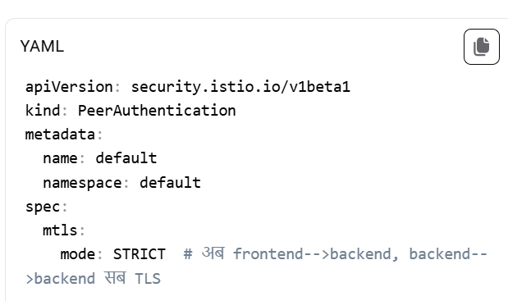
Apply करते ही सारे pod-to-pod calls automatic encrypt। Certs Istio खुद manage करेगा।

*2. Canary Deployment - Backend-API-2 का नया version test करो:*
apiVersion: networking.istio.io/v1beta1
kind: VirtualService
metadata:
name: backend-api-2
spec:
hosts:
- backend-api-2
http:
- route:
- destination:
host: backend-api-2
subset: v1
weight: 90
- destination:
host: backend-api-2
subset: v2
weight: 10
---
apiVersion: networking.istio.io/v1beta1
kind: DestinationRule
metadata:
name: backend-api-2
spec:
host: backend-api-2
subsets:
- name: v1
labels:
version: v1
- name: v2
labels:
version: v2
अब frontend से 10% request नए v2 पर जाएंगी, 90% पुराने v1 पर।

*3. Retry + Timeout - Backend slow है तो frontend hang न हो:*
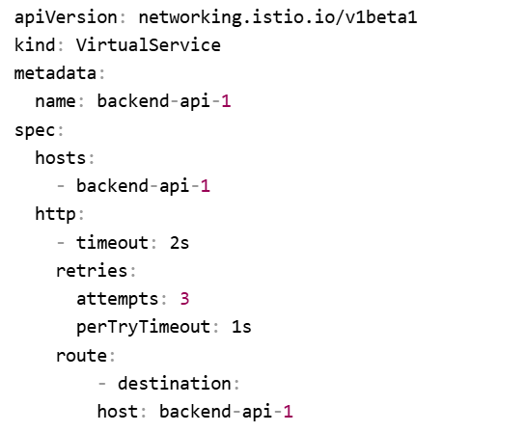
Backend 1s में जवाब नहीं दे तो 3 बार retry करेगा, फिर fail।

*4. Observability - कौन slow है देखो:*
Install होते ही Kiali, Grafana, Jaeger addons enable कर दो:
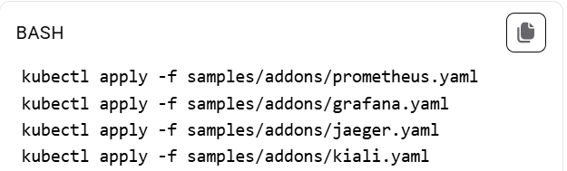
`istioctl dashboard kiali` चलाओ। Graph में दिखेगा: Frontend --> API1 = 50ms, API1 --> API3 = 500ms। तुरंत पता चल गया API3 slow है।

### *Frontend का क्या होगा:*

Frontend को कुछ नहीं करना। वो अभी भी `http://backend-api-1` ही call करेगा। बस अब वो call पहले Envoy proxy के पास जाएगी, फिर असली backend पर। Frontend code same रहेगा।

Ingress के लिए: Frontend को बाहर expose करना है तो Istio Gateway use करो, या APIM/Ingress-Nginx चलता रहने दो। Service Mesh सिर्फ cluster के अंदर का traffic handle करता है।
User --> APIM/Ingress --> Frontend Pod + Envoy --> Backend Pod + Envoy
North-South traffic | East-West traffic - Service Mesh संभालता है
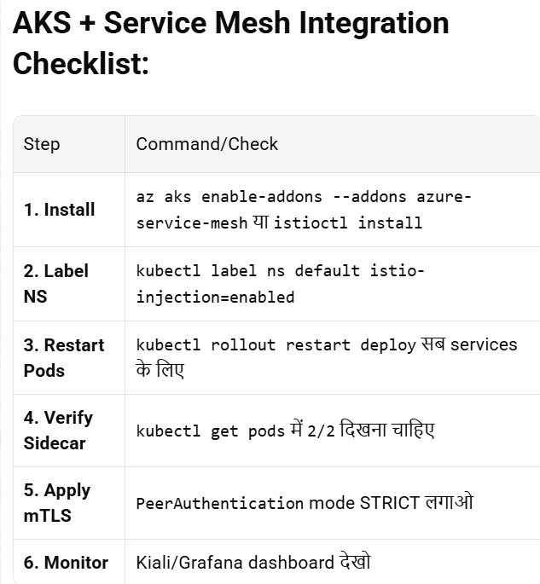
IF want can use for frontend pods :-
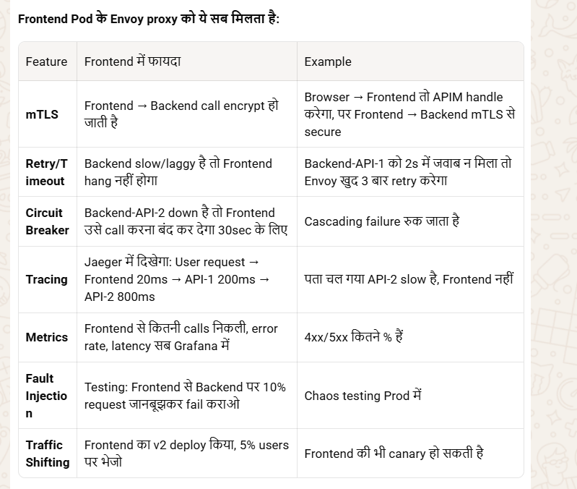
### *ध्यान रखने की बातें:*
1. *Resource:* हर pod ∼50-100MB RAM extra लेगा sidecar के लिए। 20 services = 1-2GB extra।
2. *Latency:* ∼2-5ms extra hop की वजह से। High frequency trading में मत लगाओ।
3. *Ingress:* APIM/NGINX हटाना नहीं है। Service Mesh सिर्फ internal calls के लिए है।

*सारांश:* AKS में Istio addon enable करो → namespace label करो → pods restart करो → VirtualService/DestinationRule से traffic control करो। Frontend-Backend code change zero। APIM बाहर रहेगा, Istio अंदर।

Difference between Service mesh and Message broker :-
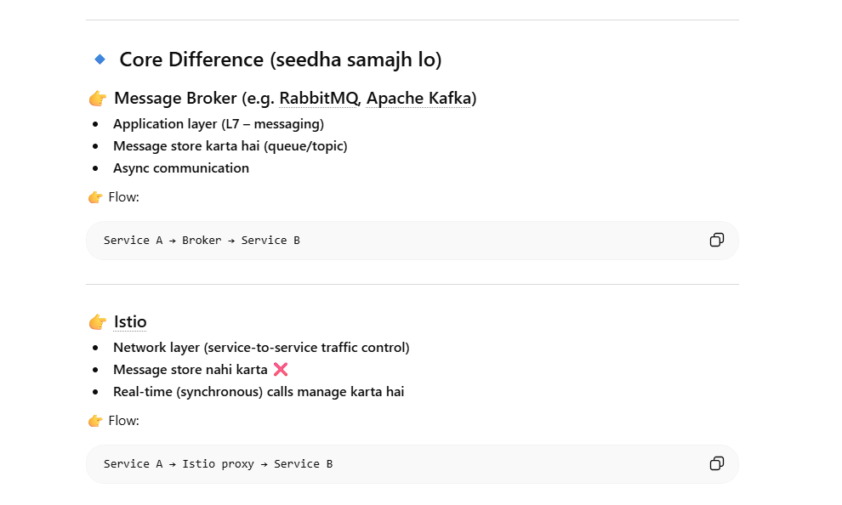
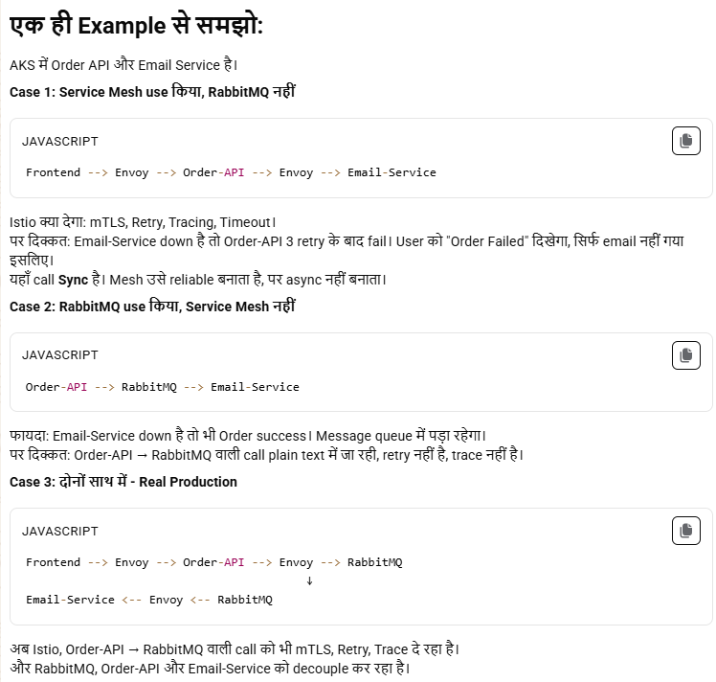
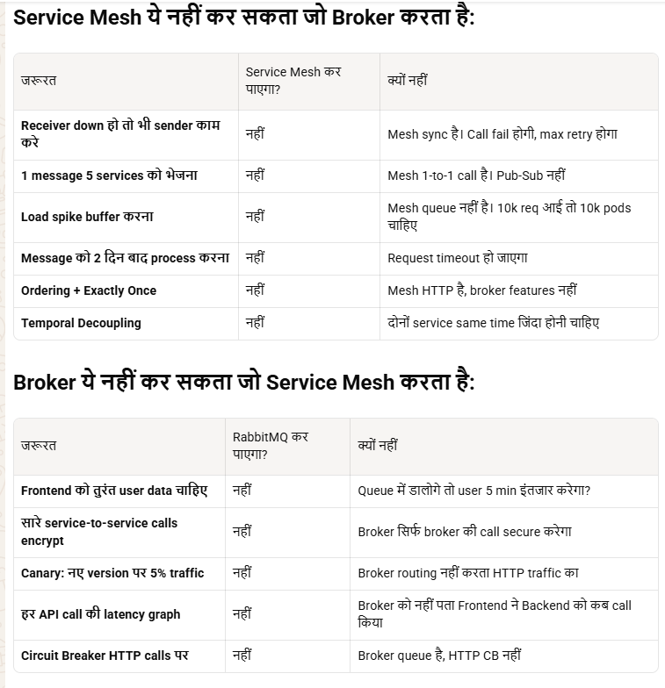

22.3.1 Istio :-
*Istio = Service Mesh का सबसे Famous Product। Google + IBM ने बनाया।*
👉 Ye ek Service Mesh tool hai jo services ke beech communication ko control karta hai without changing code

K8s में microservices की networking का बाप है। Code छुए बिना security, traffic, monitoring दे देता है।

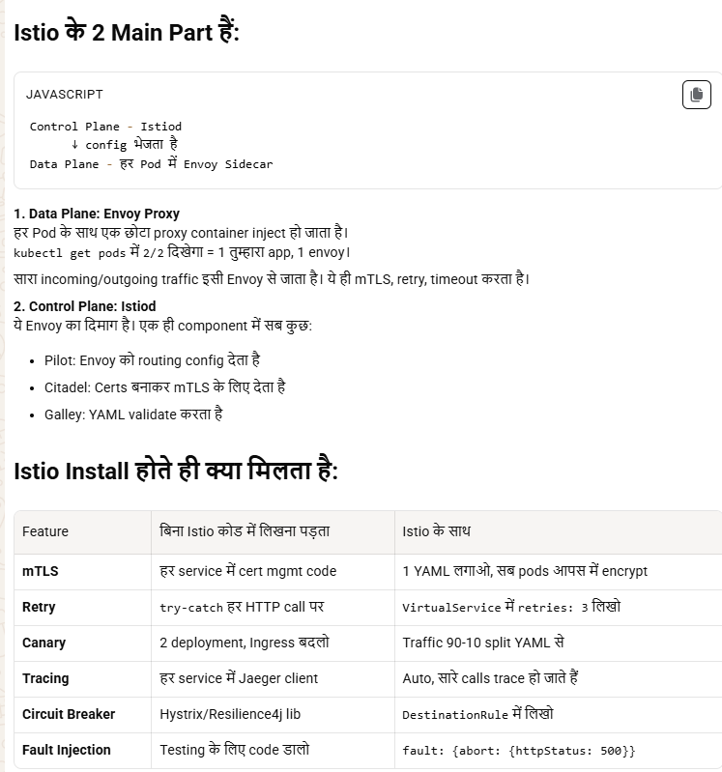
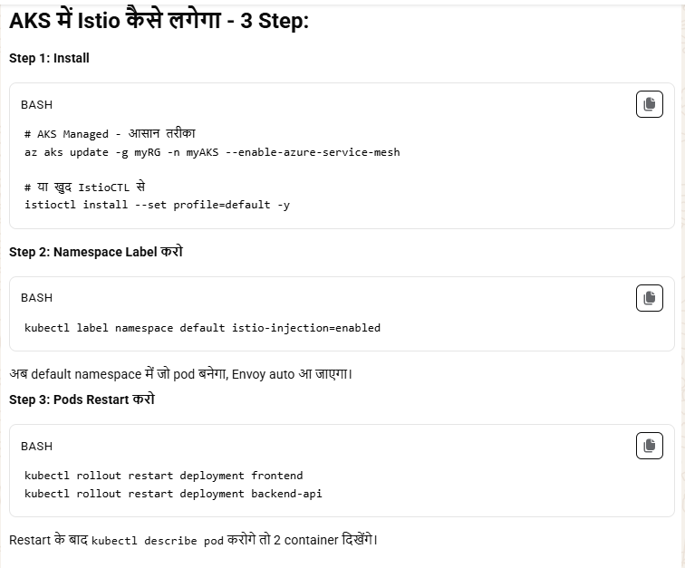
Note: CRD = Custom Resource Definition। K8s में अपने खुद के Resource type बनाना।
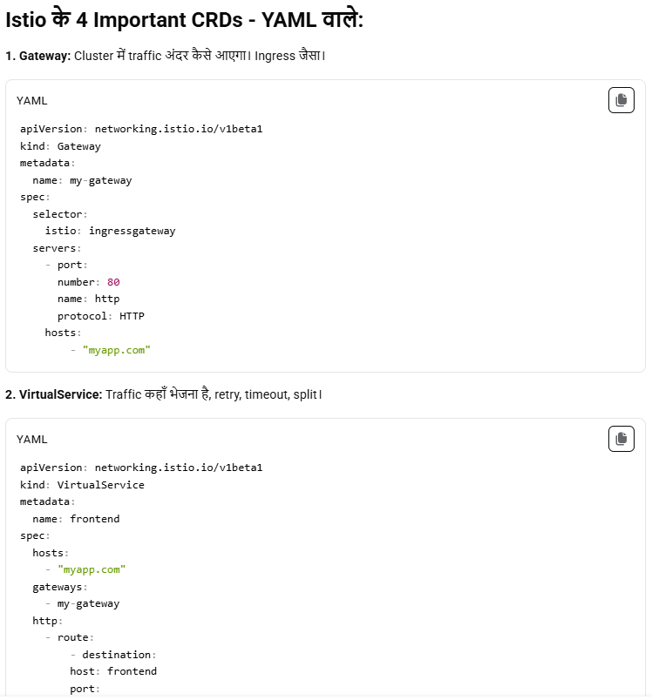
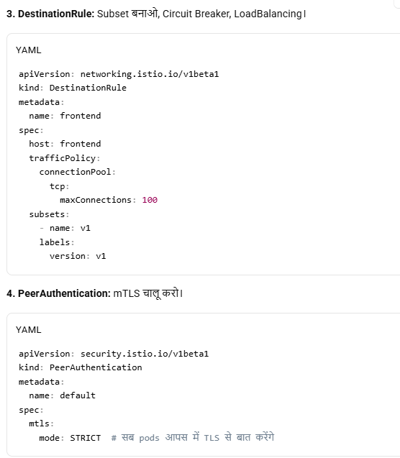
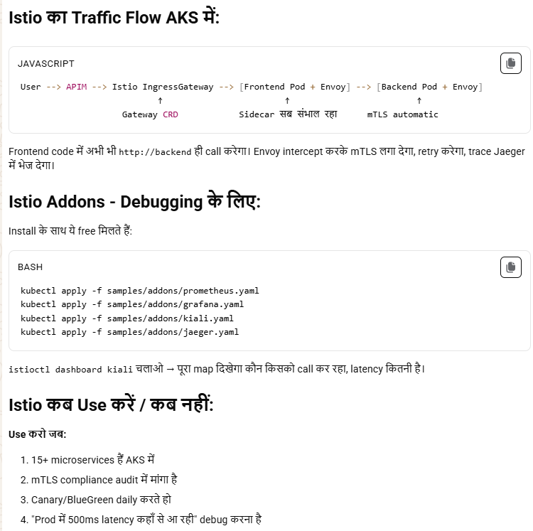
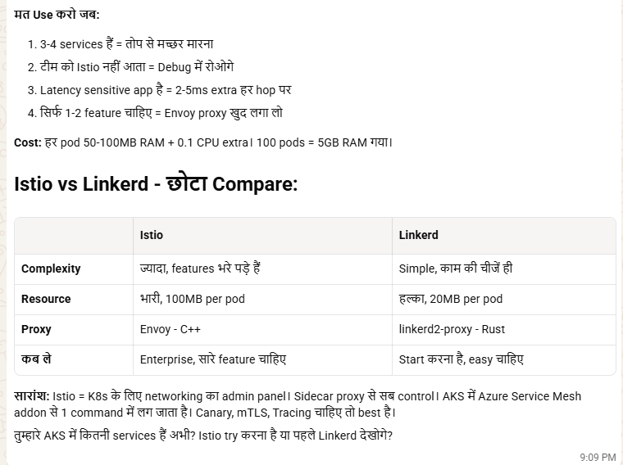

22.4 APIM :-
Azure API Management (APIM) = ek API Gateway + Management platform hai jo tumhare backend APIs ko secure, manage, monitor aur expose karta hai.
APIM =“API Gateway service used to secure, publish, manage and monitor APIs with features like authentication, rate limiting and transformation.”
Ques:- api & service are same ?
🔹 1. Service kya hoti hai?
👉 Backend logic / business functionality
Examples:
- User service
- Payment service
- Order service
➡️ Ye actual kaam karti hai (DB hit, processing, etc.)

🔹 2. API kya hota hai?
👉 Service ka interface / entry point
➡️ API define karta hai:
- URL (/users, /orders)
- Methods (GET, POST)
- Input/output

🔹 3. Relation
👉 Simple:
- Service = engine
- API = steering wheel
➡️ API ke through hi service access hoti hai

🔹 4. API Gateway / APIM ka role
👉 Jaise Azure API Management
✔ Sab APIs ko ek jagah expose karta hai
✔ Features:
- Auth (JWT, OAuth)
- Rate limiting
- Logging
- Routing

🔹 Flow
Client → APIM → API → Service → DB

🔹 5. Important Interview Point 💡
- Ek service ke multiple APIs ho sakte hain
- Ek API multiple services ko call kar sakta hai

“APIs and services are not the same—services implement business logic, while APIs are interfaces to access those services. API gateways like APIM sit in front to manage, secure, and route API calls.”
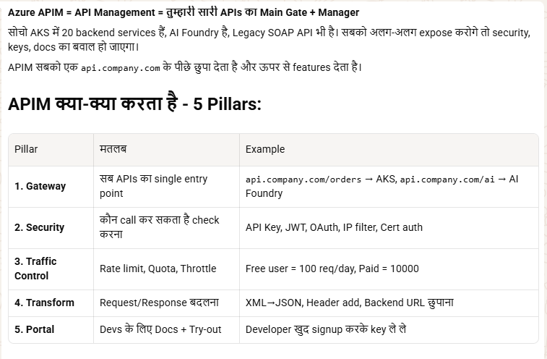
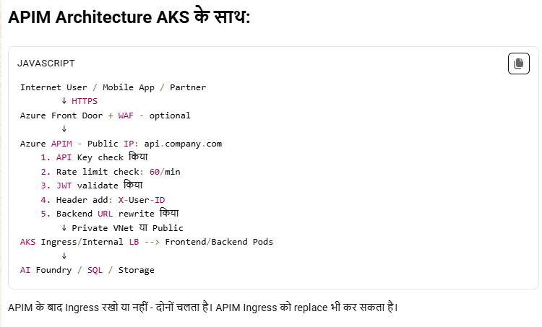
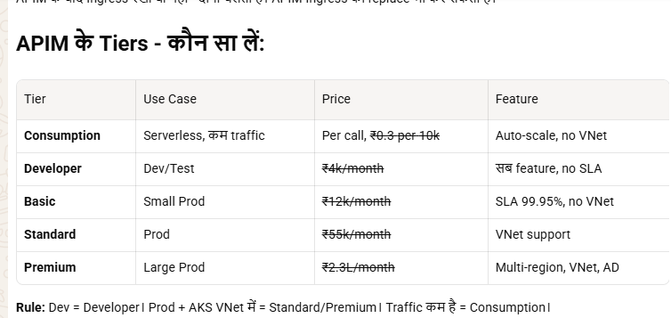
Key Features 🔥
🔐 Security
- OAuth2, JWT validation
- IP filtering
- Subscription keys
🚦 Rate Limiting
- e.g. 100 req/min per user
🔄 Transformation
- Request/Response modify (JSON/XML)
🔁 Versioning & Revision
- v1, v2 APIs manage
📊 Monitoring
- Logs, metrics (via Azure Monitor)
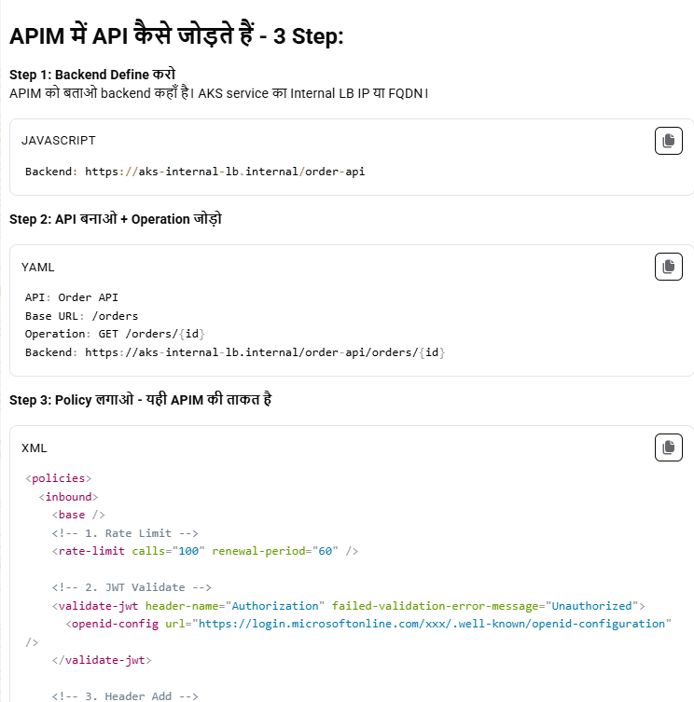
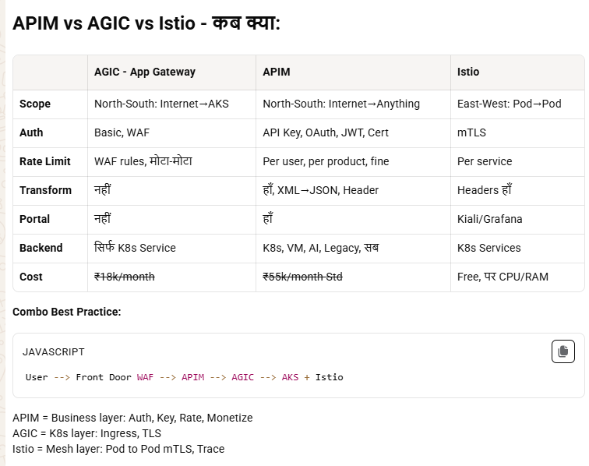
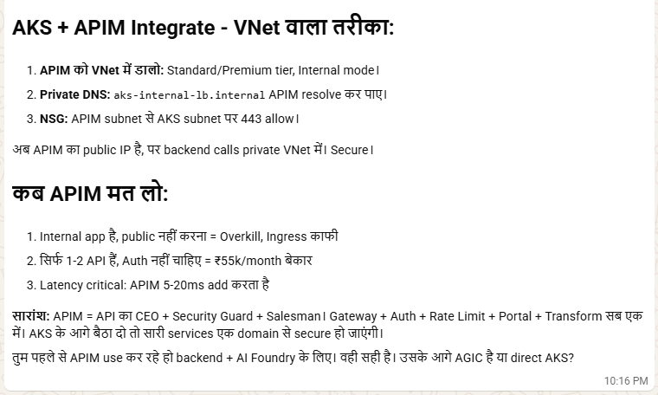
Use Cases
- 🔹 Microservices expose (AKS, App Service)
- 🔹 Backend hide karna (security)
- 🔹 Third-party API expose karna
- 🔹 API monetization
- 🔹 Internal APIs ko standardize karna
Where to use
- AKS (microservices)
- App Service APIs
- Functions (serverless APIs)
- Legacy apps (wrap APIs)
APIM vs Load Balancer ❌
- Load balancer → traffic distribute
- APIM → API level control (auth, rate limit, transform)
APIM vs Service Mesh (Istio) 🔥
- APIM → external traffic (north-south)
- Istio → internal service communication (east-west)
👉 Dono ek saath use hote:
- Internet → APIM → AKS → Istio → services
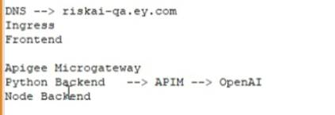
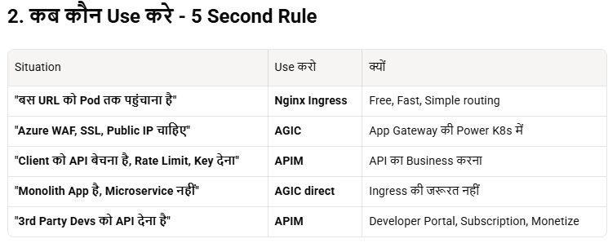

22.5 APIGEE:-
Apigee = Google ka API Management platform (APIM jaisa hi concept).
APIM = Microsoft Azure का। काम दोनों का same है - API का Gateway + Manager। पर मालिक अलग, features में थोड़ा फर्क।
Simple samajh
👉 Client → Apigee → Backend APIs
- API gateway + security + analytics
- Same role as Azure API Management

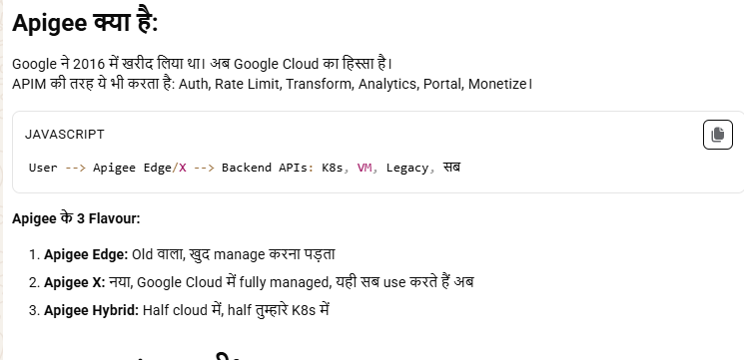
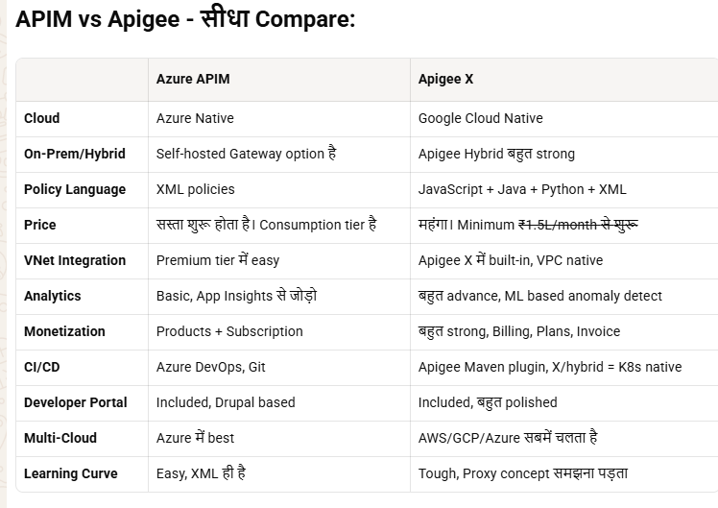
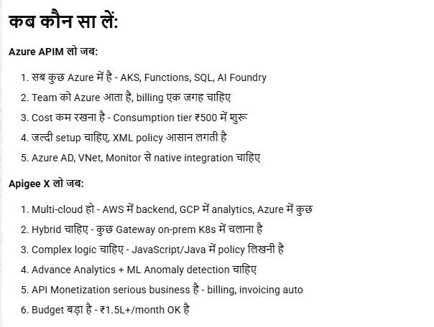

22.6 POD EVICITION
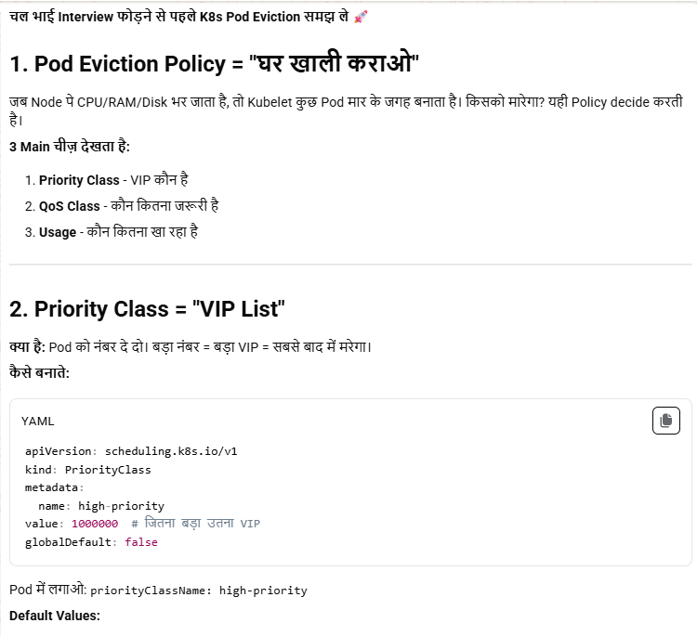
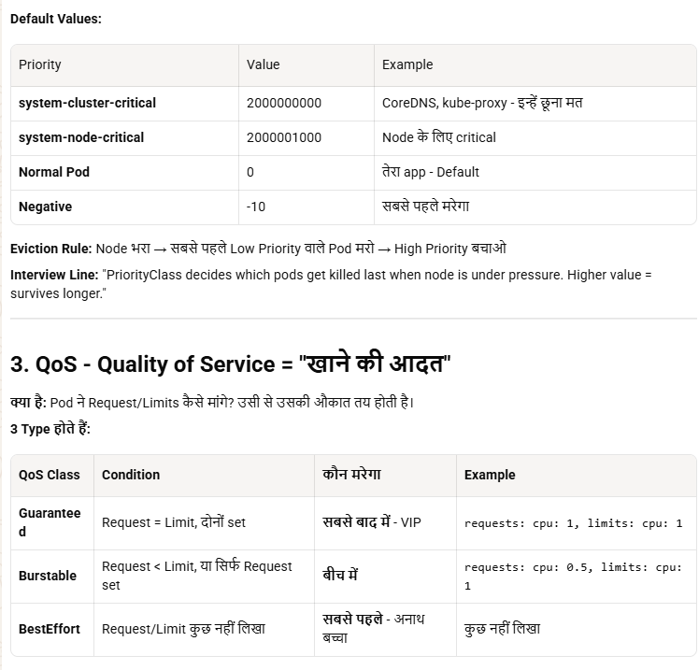
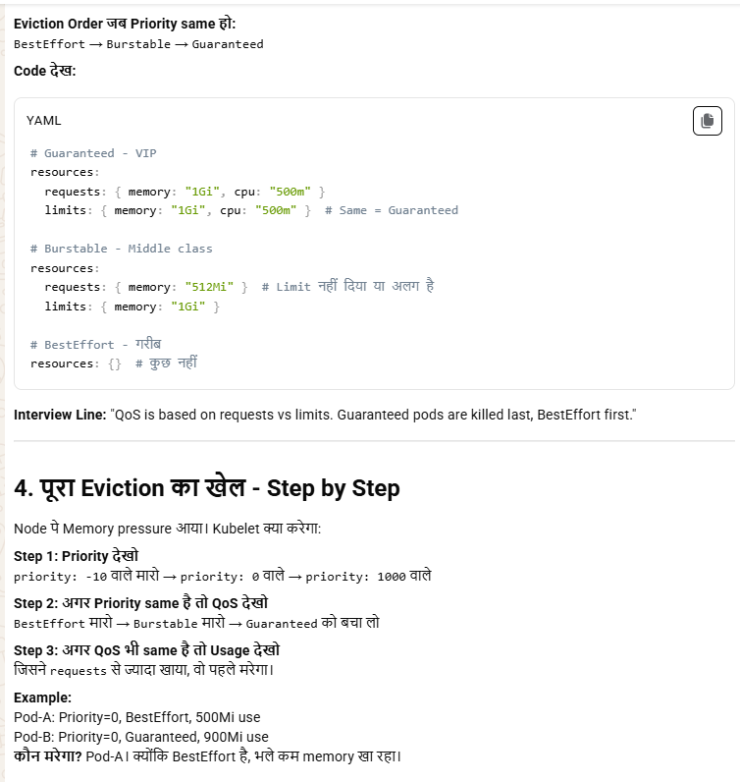
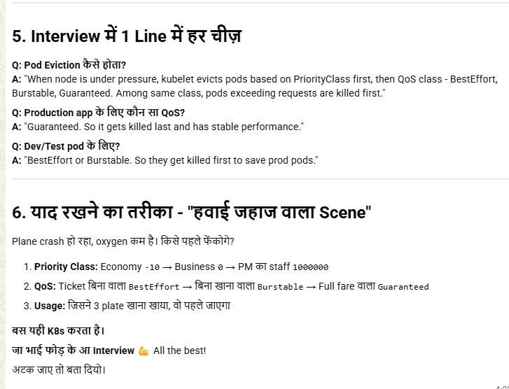

22.7 PDB:- (PodDisruptionBudget)
PodDisruptionBudget ensures a minimum number of pods remain available during voluntary disruptions like node drain or cluster upgrade. It prevents K8s from evicting pods if it would violate minAvailable count."

🔹 PDB (Pod Disruption Budget) kya hai?
👉 PDB = limit lagata hai ki ek time par kitne pods disrupt (down) ho sakte hain
➡️ Mainly used during:
- Node upgrade
- Drain
- Maintenance

🔹 Simple language
👉 “Mere app ke minimum itne pods hamesha running rehne chahiye”
“PDB ensures high availability by limiting how many pods can be disrupted during voluntary events like upgrades or node drains.”
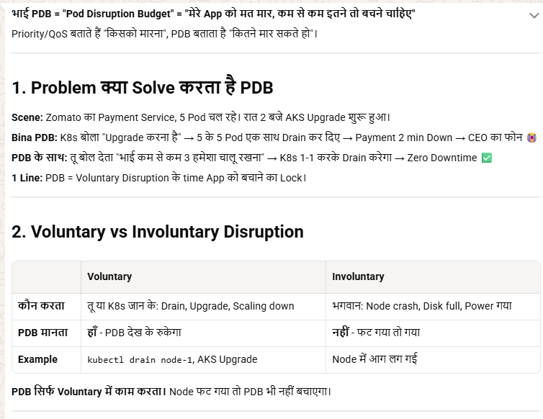
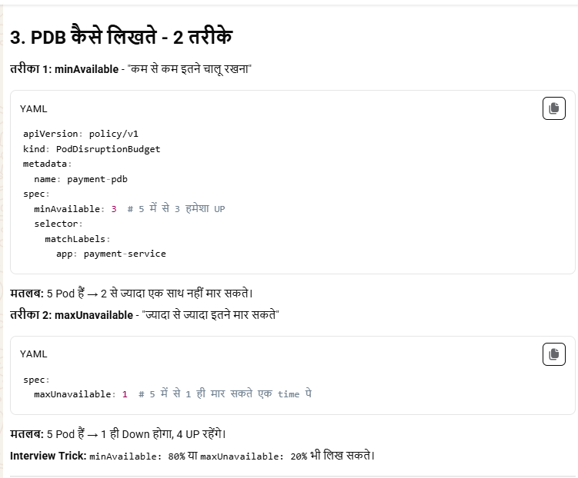
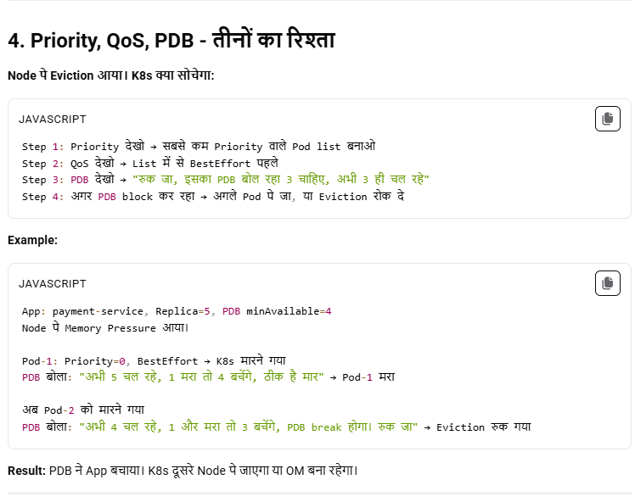
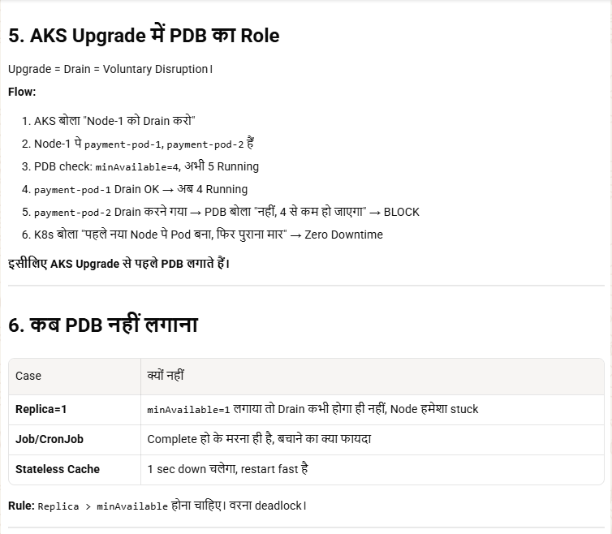
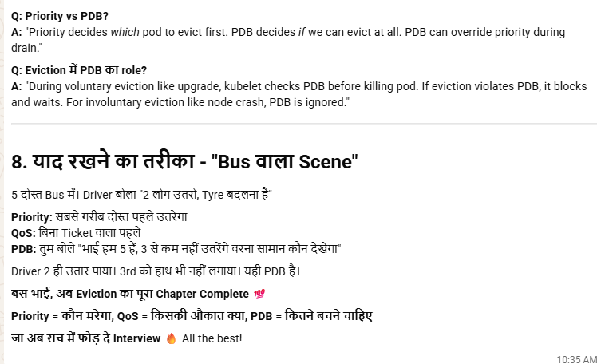

22.8 UPGRADE: -

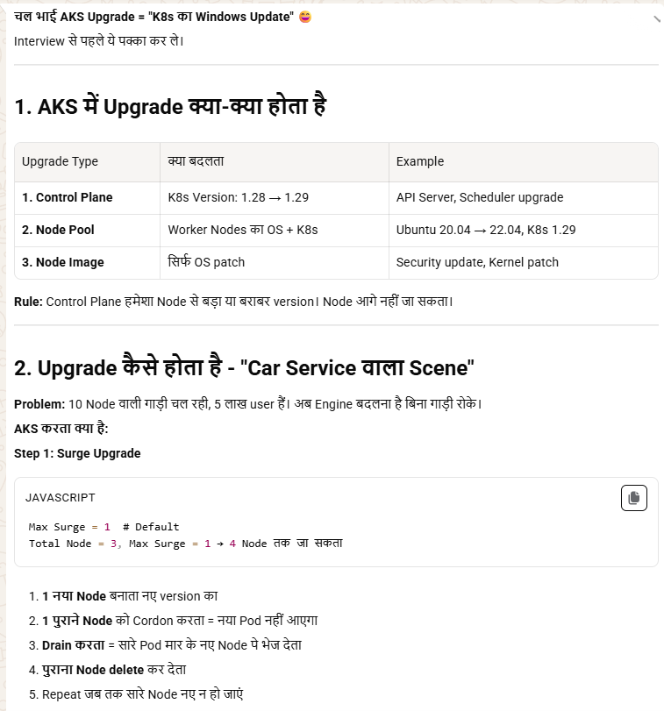

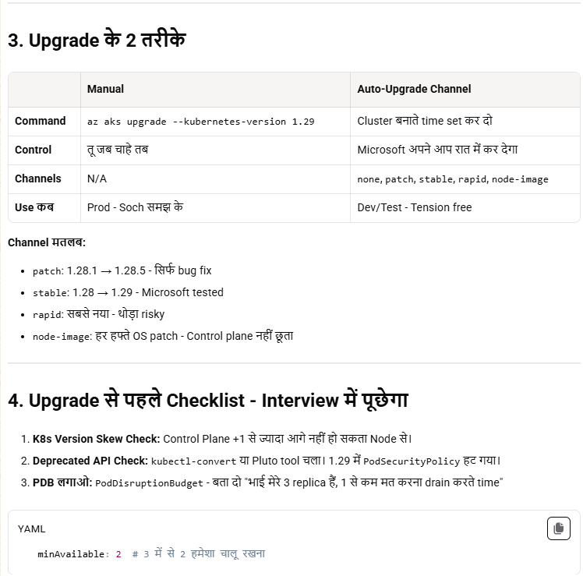

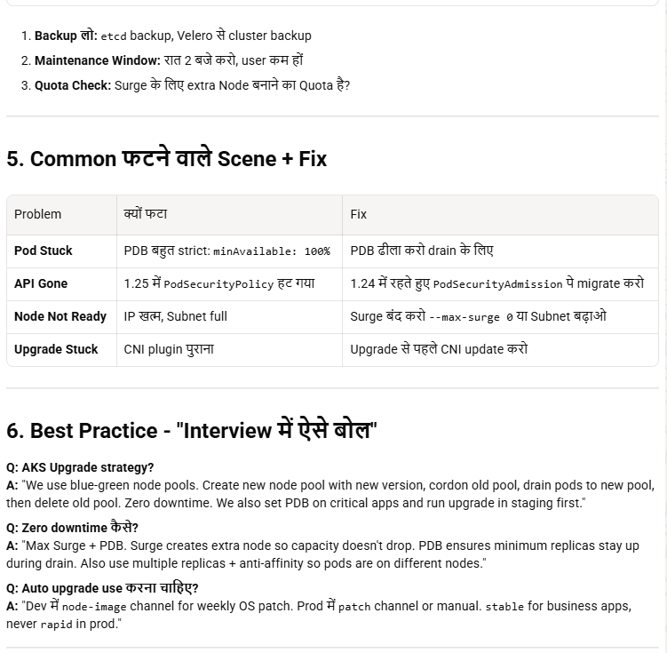
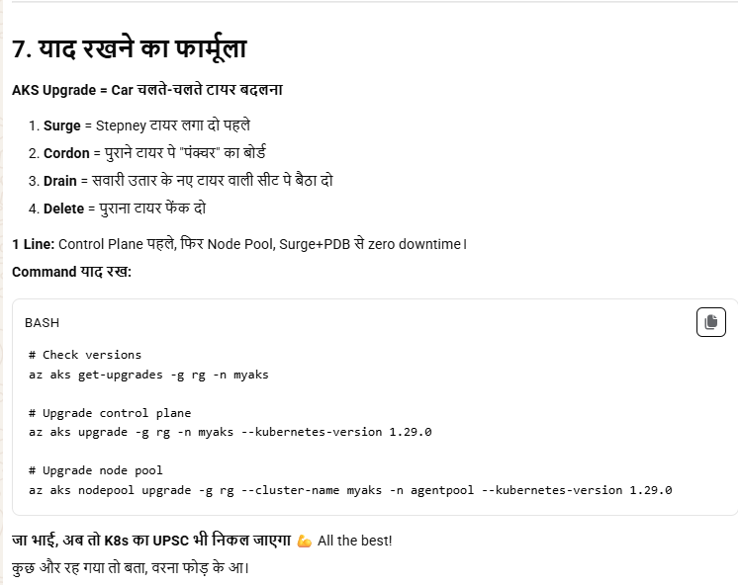
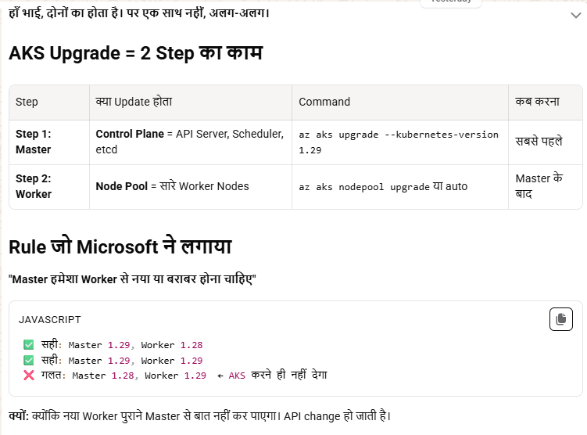
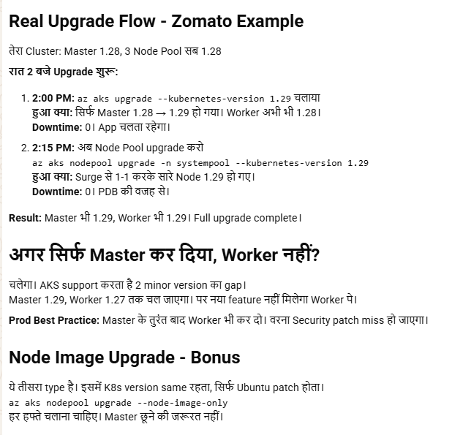
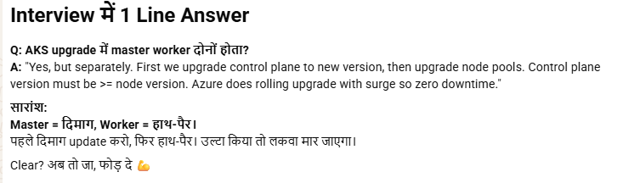
🔹 1. Actual Internal Flow (Node Upgrade – Deep)
👉 जब node pool upgrade होता है:
✔ Step 1: New node create होता है
- New VM spin होता है
- Latest Kubernetes version + OS image के साथ
- Cluster में join करता है

✔ Step 2: Old node → cordon
kubectl cordon <node>
- New pods schedule नहीं होंगे

✔ Step 3: Old node → drain
kubectl drain <node> --ignore-daemonsets
- Existing pods gracefully हटते हैं
- Scheduler उन्हें new node पर shift करता है

✔ Step 4: Traffic shift
- Service / kube-proxy automatically new pods पर route करता है
- कोई manual traffic shift नहीं

✔ Step 5: Old node delete
- VM delete
- Node cluster से हट जाता है

👉 ⚡ Important correction:
पहले new node आता है → फिर old node drain होता है (NOT reverse)

🔹 2. Upgrade में क्या-क्या update होता है
✔ 1. Kubernetes Version
- Control Plane (API server, scheduler, controller manager)
- Node components:
  - kubelet
  - kube-proxy

✔ 2. Node OS Image
- Ubuntu / Azure Linux image updated
- Security patches + kernel updates
👉 Example:
Old: Ubuntu 18.04
New: Ubuntu 22.04

✔ 3. Container Runtime
- containerd version update होता है

✔ 4. AKS System Components
- CoreDNS
- kube-proxy
- metrics-server
- (कुछ cases में auto upgrade होते हैं)

✔ 5. Networking Components
- Azure CNI / Kubenet plugins
- Sometimes updated silently

🔹 3. Control Plane Upgrade Internals
जब तुम ये चलाते हो:
az aks upgrade
👉 Internally:
- New control plane instance ready होता है
- API server upgraded
- etcd migration handled by Azure
- No downtime (managed by Azure)

🔹 4. Zero Downtime कब possible है?
✔ अगर:
- Multiple replicas (Deployment ≥2 pods)
- Proper PDB
- Readiness probes configured
❌ अगर:
- Single pod app
- Strict PDB (minAvailable=100%)

🔹 5. Important Hidden Concept (Interview Gold 🔥)
👉 Max Surge
- AKS extra nodes create करता है during upgrade
- Example:
  - 3 nodes cluster
  - maxSurge = 1 → 1 extra node add होगा

🔹 Final Short Answer (Interview)
“During AKS upgrade, a new node with updated Kubernetes version and OS is created, then old node is cordoned and drained, pods are rescheduled to new node, and finally old node is deleted. Upgrade includes control plane, kubelet, OS image, container runtime, and system components.”

MAX surge :-
🔹 Default hota hai ya manually?
✔ By default set hota hai
- Default: 1 node (or ~33%)
- Tum manually change kar sakte ho

🔹 Kab set karte hai?
👉 2 options:
- Cluster / node pool creation ke time
- Baad me update bhi kar sakte ho

22.9 AKS architecture
(control plane vs data plane).
🔹 AKS Architecture (Control Plane vs Data Plane)
🔸 Control Plane (Managed by Azure)
- Azure Kubernetes Service me Azure manage karta hai (user access nahi)
- Components:
  - API Server → cluster entry point
  - Scheduler → pods ko node assign karta hai
  - Controller Manager → desired state maintain karta hai
  - etcd → cluster state store karta hai
- Highly available + auto-managed

🔸 Data Plane (Worker Nodes)
- Ye tum manage karte ho (VM/VMSS)
- Components:
  - Kubelet → pod run/manage karta hai
  - kube-proxy → networking handle karta hai
  - Container runtime (containerd)
- Yahi pe actual application pods run hote hain

🔥 Key Difference (Interview)
- Control Plane → decision making (brain)
- Data Plane → execution (actual workload run)
- Control plane Azure manage karta hai, data plane user

🔗 Flow
kubectl → API Server → Scheduler → Node → Pod run

👉 Final:
Control plane decides “kya aur kaha run hoga”, data plane actually “run karta hai” 🚀
Ques:- data plane mea bhi system nodepool and user node pool hota hai kya ?
Haan 👍 Data plane me hi System node pool aur User node pool dono hote hain

🔹 Data Plane (AKS)
- Azure Kubernetes Service ke worker nodes (VM/VMSS) = data plane
- Isi me node pools bante hain

🔹 System Node Pool
- Default pool (mandatory)
- System pods run hote hain
  - CoreDNS, kube-proxy, etc.
- Usually small size, stable workload

🔹 User Node Pool
- Tum create karte ho (custom workloads ke liye)
- Application pods run hote hain
- Scale up/down, different VM size use kar sakte ho

🔥 Interview Point
- “Both system and user node pools are part of data plane; system pool runs Kubernetes core components, user pool runs application workloads.”

🔗 Example
- System pool → cluster services
- User pool → microservices / apps

👉 Final:
Yes, dono node pools data plane ka part hain — difference sirf workload type ka hai 🚀

