- CAF (CLOUD ADOPTION FRAMEWORK ):-
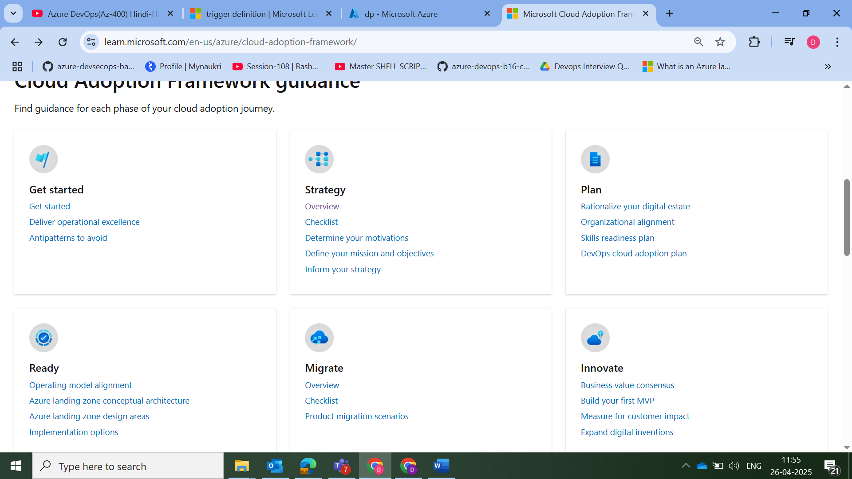

🔷 On-Prem to Azure Migration में CAF Landing Zone कैसे मदद करता है?
1. Cloud Adoption Strategy
- Business goals को define करता है (क्यों cloud पर जाना है: cost, scalability, security?)
- Prioritize करता है कौनसे workloads पहले जाएंगे।
2. Plan Phase (CAF Plan)
- Existing environment का assessment करता है (using Azure Migrate tools)
- TCO (Total Cost of Ownership) calculator से cost estimation
- Org structure के हिसाब से Management Groups, Subscriptions, Policies define होते हैं।
3. Ready Phase (Landing Zone Deployment)
- एक secure & governed Azure environment create किया जाता है।
- यहीं पर Landing Zone setup होता है with networking, identity, monitoring, security।
4. Migrate Phase
- Azure Migrate tool से on-prem VMs, databases, apps को Azure में lift-and-shift या rehost किया जाता है।
- Required workloads को Landing Zone में deploy किया जाता है।
5. Govern & Manage Phase
- Policies, monitoring, cost controls, tagging strategy लागू किए जाते हैं
- Azure Monitor, Security Center, Defender जैसे tools active होते हैं।

Strategy :- A cloud adoption strategy is a comprehensive plan that outlines your organization's approach when you adopt and integrate cloud technologies.
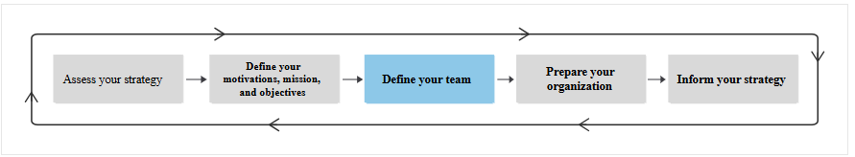
Plan :- Cloud rationalization is the process of evaluating assets to determine the best approach to hosting them in the cloud.

Ready :-
MIGRATE:-
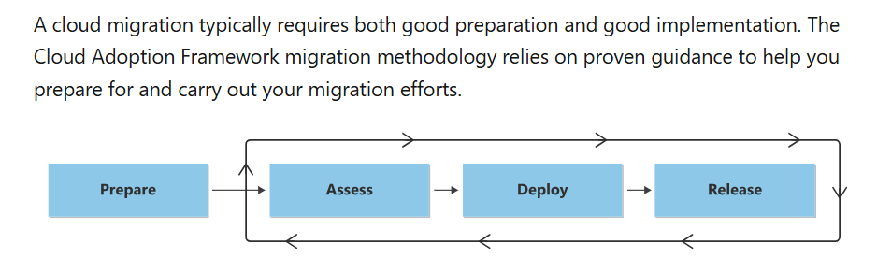Migration Strategies (6R Framework)
Azure MEA migration usually 6R strategy par based hoti hai:
Strategy | Description
1. Rehost (Lift-and-Shift) | Existing VMs/applications ko without modification Azure par shift karo.  Fastest method.
2. Refactor (Repackage) | Application mein thodi modification karke PaaS (e.g. Azure App Service) use karo.
3. Rearchitect | Application ko redesign karo for cloud scalability and performance (e.g. use of Azure Kubernetes).
4. Rebuild | Application ko Azure-native technologies (like .NET on Azure Functions) se dobara develop karo.
5. Replace | Existing application ko SaaS offering se replace karo (e.g. Salesforce, Microsoft 365).
6. Retire | Jo workloads kaam ke nahi hain, unhe retire kar do.

1. Rehost (Lift-and-Shift)
📌 Kya hota hai?
- Existing servers, applications ya VMs ko bina koi code change kiye as-is Azure par migrate karna.
- Sabse fast aur low-risk approach.
📦 Kab Use Karte Hain?
- Jab time kam ho aur jaldi cloud par move karna ho.
- Legacy apps jinke code ko modify karna risky ho.
- Disaster Recovery scenarios mein.
🧰 Tools:
- Azure Migrate
- Azure Site Recovery
✅ Pros:
- Fast deployment
- Minimal testing required
- Simple and cost-effective for short term
❌ Cons:
- Cloud-native benefits (like auto-scaling, cost efficiency) ka use nahi hota
- Long-term mein inefficient ho sakta hai
📘 Example:
Aapka ek Windows Server 2012 VM hai jisme SQL Server chal raha hai. Aap use Azure VM mein move karte ho using Azure Migrate. Koi code change nahi kiya gaya.

♻️ 2. Refactor (Repackage)
📌 Kya hota hai?
- Application code mein minor changes karke use Platform-as-a-Service (PaaS) par run karwana.
- Jise "lift-tinker-and-shift" bhi kehte hain.
📦 Kab Use Karte Hain?
- Jab app thoda flexible ho aur thoda modify karna feasible ho.
- Cost efficiency aur performance improve karni ho.
🧰 Tools:
- Azure App Services
- Azure Database for MySQL/PostgreSQL/SQL
✅ Pros:
- Better scalability and performance
- Lower infra management overhead
- Cloud benefits ka use hota hai
❌ Cons:
- Code changes required
- Thoda development/testing effort lagta hai
📘 Example:
Aapke paas ek Node.js app hai jo on-premise chal rahi hai. Aap usko Azure App Service pe deploy karte ho aur SQL Database ko Azure PaaS mein migrate kar dete ho.

🏗️ 3. Rearchitect
📌 Kya hota hai?
- Application ko significantly redesign karna taaki wo cloud-native ban jaye.
- Monolithic architecture ko microservices mein convert karna etc.
📦 Kab Use Karte Hain?
- Jab aapki app performance, scale, or agility mein bottleneck ho.
- Long-term vision ho fully cloud-native solution ka.
🧰 Tools:
- Azure Kubernetes Service (AKS)
- Azure Functions
- Azure API Management
✅ Pros:
- Maximum cloud utilization
- High scalability and flexibility
- DevOps and CI/CD integration ka best support
❌ Cons:
- High effort, time, aur skilled team chahiye
- Costly in short term
📘 Example:
Ek legacy monolith .NET application ko microservices mein tod diya gaya, AKS pe deploy kiya gaya, aur APIs ko API Gateway ke zariye expose kiya gaya.

🔨 4. Rebuild
📌 Kya hota hai?
- Poora application scratch se dubara develop karna, using Azure-native stack.
- Legacy systems ko puri tarah modernize karna.
📦 Kab Use Karte Hain?
- Jab old system outdated ho aur new features add karne mein problem ho.
- Jab koi on-premise system bilkul obsolete ho gaya ho.
🧰 Tools:
- Azure Functions
- Azure Logic Apps
- Cosmos DB
- .NET Core / Java / Python on Azure
✅ Pros:
- Maximum flexibility and modern architecture
- Serverless architecture = cost-efficient & scalable
❌ Cons:
- Sabse zyada time, cost aur skilled manpower lagta hai
- Business downtime ho sakta hai during rebuild
📘 Example:
Ek 15 saal purani Java-based app ko completely Azure serverless pe re-create kiya gaya, jisme Azure Functions + Cosmos DB + Azure Front Door use hua.

🔁 5. Replace
📌 Kya hota hai?
- Existing system ko kisi readymade SaaS (Software-as-a-Service) product se replace kar dena.
- Custom dev se chutkaara milta hai.
📦 Kab Use Karte Hain?
- Jab market mein better solution already available ho.
- App business critical na ho aur replace karna easy ho.
🧰 Tools:
- Microsoft 365
- Dynamics 365
- Salesforce, ServiceNow, etc.
✅ Pros:
- No infrastructure management
- Fast deployment
- Maintenance handled by SaaS provider
❌ Cons:
- Limited customization
- Data migration aur user adoption ka issue ho sakta hai
📘 Example:
Ek internal ticketing system ko retire karke Microsoft Dynamics 365 Customer Service tool ko implement karna.

🗑️ 6. Retire
📌 Kya hota hai?
- Aisi workloads ya apps ko identify karna jo ab kaam ki nahi hain aur unko sunset (band) karna.
📦 Kab Use Karte Hain?
- Jab old systems redundant ho gaye ho.
- Business ya compliance need nahi rahi ho.
🧰 Tools:
- Azure Migrate (Dependency analysis)
- Application Discovery Tools
✅ Pros:
- Cost savings
- Cleaner architecture
- Better manageability
❌ Cons:
- Data archival required ho sakta hai
- Users ka resistance ho sakta hai
📘 Example:
Ek purani inventory management system jiska use nahi ho raha, usko retire kar diya gaya aur uska data archive kar diya Azure Storage mein.

Azure Migrate :-
Azure Migrate Microsoft ka ek centralized hub hai jo on-premise se Azure par migration plan karne, assess karne aur perform karne mein madad karta hai.
Yeh tool aapko VMs, servers, databases, web apps, aur data ko Azure cloud mein securely aur efficiently migrate karne ka ek end-to-end solution provide karta hai.

Azure Migrate Use Karne Ka Step-by-Step Process
STEP 1: Azure Migrate Project Create Karna
- Azure Portal open karo.
- Search bar mein “Azure Migrate” likho aur select karo.
- "+ New Project" par click karo.
- Subscription, resource group, region aur project name select karo.
- Create par click karo.

STEP 2: Discovery aur Assessment
Option 1: VMware ya Hyper-V VMs ke liye
- Azure Migrate Appliance download karo (OVA for VMware / VHD for Hyper-V).
- Usse on-prem hypervisor par deploy karo.
- Configuration wizard se connect karo.
- Azure Migrate project ke saath register karo.
- Discovery start karo (automatic inventory banega).
Option 2: Physical Servers ke liye
- Microsoft Dependency Agent aur Azure Migrate agent install karo.
- Server ko Azure Migrate portal se link karo.
📝 Assessment Output:
- Azure readiness report
- Sizing recommendation (VM size in Azure)
- Cost estimation
- Dependency map (kin systems se connected hai)

STEP 3: Migration Execution
💻 VM Migration
- Azure Migrate: Server Migration Tool use karo.
- Migration batches create karo.
- Test migration karo (non-disruptive testing in Azure).
- Final migration schedule karo (downtime ke sath ya without downtime).
🗃️ Database Migration
- Azure Database Migration Service (DMS) enable karo.
- Source SQL Server connect karo.
- Azure SQL Database ya Managed Instance target select karo.
- Schema migration ➤ Data migration ➤ Cutover
🌐 Web App Migration
- App Service Migration Assistant use karo.
- ASP.NET app ka analysis karo.
- Azure App Service pe deploy karo.

6R Strategy | Use-case / Situation | Microsoft Tools to Use | Description
🟢 Rehost | "Lift & Shift" VM as-is to Azure | ✅ Azure Migrate: Server Migration  ✅ Azure Site Recovery (ASR) | Fastest, safest for legacy systems
🔵 Refactor | Minor code/config change; move to PaaS | ✅ App Service Migration Assistant  ✅ Azure Migrate: App Containerization (Preview)  ✅ VS Publish / DevOps Pipelines | For IIS/.NET/Node apps that can run on Azure App Service or containerized
🟠 Rearchitect | App ko microservices, AKS, or Functions pe le jana | 🛠 Azure Kubernetes Service (AKS)  🛠 Azure Functions  🛠 Visual Studio + GitHub + DevOps  🔗 Azure App Configuration | Code rewrite & cloud-native shift
🔴 Rebuild | App ko scratch se naya likhna | ❌ Azure Migrate not used  ✅ Azure Dev Tools + GitHub Codespaces + PaaS services | Complete redesign, modern stack
🟣 Replace | Use SaaS alternative (e.g. CRM → Dynamics 365) | ❌ No Azure Migrate Tool  ✅ Microsoft SaaS Apps (Power Platform, Dynamics, O365) | Buy, not build or migrate
⚫ Retire | App no longer needed | ✅ Azure Migrate: Assessment → Identify idle servers | Reduce cost, simplify infra

