🔐 Azure Network Security Best Practices
1. Use Network Security Groups (NSGs)
- Control traffic at subnet and NIC level.
- Allow only required ports (e.g., 80/443) and block all others by default.
2. Use Azure Firewall / Application Gateway (WAF)
- Use Azure Firewall for centralized traffic control.
- Use Application Gateway with WAF to protect web apps from OWASP attacks.
3. Private Endpoints
- Connect to Azure services (e.g., SQL, Storage) over a private IP inside your VNet.
- Prevents data exfiltration.
4. Implement VNet Peering with Route Filtering
- Securely connect VNets with VNet Peering.
- Use UDRs and Route Tables to control traffic flow.
5. Disable Public IPs Where Not Needed
- Avoid using public IPs on VMs and PaaS services.
- Use Jumpbox/Bastion for admin access.
6. DDoS Protection
- Enable Azure DDoS Protection Standard for critical workloads.
7. Monitor with NSG Flow Logs and Azure Monitor
- Track traffic patterns and detect anomalies.
8. Zero Trust Architecture
- Enforce least privilege access, use Azure AD Conditional Access, and Just-In-Time VM access.

💡 Smart & Cost-Effective Azure Network Security Tips
1. Use NSGs First (Free)
- NSGs are free and effective.
- Block unwanted ports/IPs at subnet level — zero extra cost.
2. Use Azure Bastion Instead of Public IPs
- Costly but eliminates risk of exposed RDP/SSH ports.
- Use only in production; for dev/test use JIT (Just-In-Time) Access (via Azure Security Center).
3. Private Endpoints Only for Sensitive Resources
- Use Private Endpoint only for DBs or Storage with sensitive data.
- Don’t overuse — they charge per endpoint.
4. App Gateway with WAF – Only at Entry Point
- Use one central Application Gateway with WAF for all apps.
- Avoid deploying multiple gateways.
5. Azure Firewall – Only for Enterprise Scale
- Costly, use only if multiple spokes/subscriptions need filtering.
- Otherwise, use NSGs + UDRs as cheaper alternative.
6. DDoS Protection – Only for Public Facing Apps
- Enable DDoS Standard only for critical/external workloads.
7. Monitor selectively
- Enable diagnostic logs only for critical resources.
- Use sampling in Log Analytics to control data volume (and cost).

🧠 Tip: Use Azure Cost Management to analyze security service costs and optimize.

💸 Azure Cost Optimization Best Practices
1. Right-size Resources
- Use Azure Advisor recommendations.
- Avoid over-provisioning VMs; choose right SKU (B-series for dev/test).
- Use Auto-scaling where possible.
2. Use Reserved Instances (RI)
- For long-running workloads (1–3 years), buy Reserved VM Instances — up to 72% cheaper.
3. Use Azure Spot VMs for non-critical workloads
- Ideal for batch jobs, test environments — up to 90% cheaper.
4. Turn Off Idle Resources
- Schedule shutdown of dev/test VMs with Azure Automation / Logic Apps.
- Delete unused disks, IPs, NICs, and orphaned resources.
5. Use Azure Hybrid Benefit
- Use your existing on-prem Windows Server or SQL Server licenses to save cost in Azure.
6. Use Cost Alerts and Budgets
- Setup Azure Cost Management budgets and alerts to track overages.
7. Use Tags for Cost Tracking
- Tag resources by department, environment, or owner to track and chargeback usage.
8. Choose Cost-Efficient Services
- Use App Service Plans (shared) instead of full VMs.
- For small apps/APIs, use Azure Functions (consumption plan) — pay per execution.
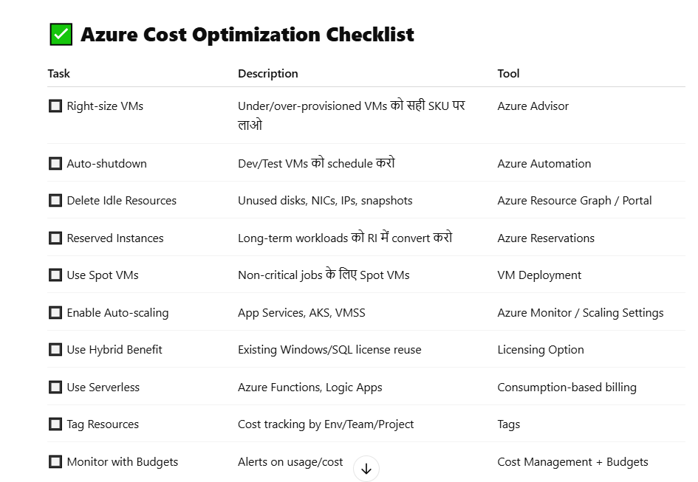
Azure Spot VM ek special type ka Virtual Machine hota hai jo aapko badi cost savings deta hai — lekin thoda unpredictable behavior ke saath.

💡 Definition — What is an Azure Spot VM?
Azure Spot VMs are virtual machines that let you take advantage of unused Azure compute capacity at deeply discounted prices, with the risk of eviction when Azure needs the capacity back.

📉 Key Characteristics
Feature | Description
💸 Low Cost | Spot VMs can be up to 90% cheaper than regular VMs
⚠️ Eviction Risk | Azure can evict (delete) the VM at any time, usually when demand increases
🕐 Short-Lived Workloads | Best for non-critical or interruptible tasks
🛑 No SLA | No uptime guarantee or support SLA
🔁 No automatic redeploy | Once evicted, VM is gone unless you handle retry logic

🛠️ Use Cases
- Batch processing (e.g., video rendering, simulations)
- CI/CD pipelines (test environments)
- Machine learning training
- Massive parallel workloads
- Dev/Test environments

⚙️ Eviction Policies
When Azure needs the compute back, it evicts the Spot VM using one of two policies:
Eviction Policy | Description
Stop/Deallocate | VM is stopped and can be restarted later (if capacity available)
Delete | VM is fully removed
You can choose which policy suits your workload.

💲 Pricing Models
You can set:
- Max price you're willing to pay per hour
OR
- Let Azure use the current market price (default)
If the market price exceeds your max price or capacity is no longer available, your VM is evicted.

📦 How to Create a Spot VM (via Portal)
- Go to Azure Portal → Virtual Machines → Create
- Choose VM type (e.g., Ubuntu, Windows)
- In "Instance details", set:
  - Eviction type = Stop or Delete
  - Eviction policy = based on workload
  - Spot instance = Yes

🧠 Quick Analogy
Spot VM is like booking a hotel room for a huge discount, but the hotel might ask you to leave if they get a full-price booking.

✅ Best Practices
- Always use Spot VMs with autoscaling groups / scale sets
- Store critical data on separate persistent disks
- Design apps to be resilient to eviction
- Monitor Eviction rate using Azure metrics

Reserved Instances (RI ) kya hota hai?
💡 Reserved Instances (RI) in Azure kya hota hai?
Azure Reserved Instances (RI) ek pricing option hai jisme aap 1 ya 3 saal ke liye VM capacity reserve karte ho — aur iske badle aapko significant cost savings milte hain compared to pay-as-you-go pricing.

🔍 Simple Definition:
Reserved Instances allow you to pre-commit to using specific virtual machines for 1 or 3 years, and in return, Microsoft gives you up to 72% discount over regular VM prices.

📉 Key Features
Feature | Description
💰 Huge Discount | Up to 72% cheaper than pay-as-you-go
🕒 Long-Term Commitment | You commit for 1 or 3 years
📦 Applies to Specific VM Sizes | You reserve a specific VM size/region
🔄 Not a VM Type | It's just a billing model, not a special VM like Spot
🔁 Can Exchange/Cancel | You can exchange or cancel under certain conditions

📌 How It Works
When you buy an RI:
- Azure matches your VM usage (in the same region, size, and OS) to your reservation
- That usage is billed at the reserved rate
- If you're not using a matching VM, reservation is wasted
🔸 RI = You’re paying in advance (or monthly) to get a discounted rate on a specific VM usage.

💳 Payment Options
Option | Description
Upfront | Pay full 1 or 3-year cost immediately
Monthly | Pay monthly with no extra cost

🔄 Flexibility Options
- Scope: You can apply RI to a single resource group, entire subscription, or shared across multiple subscriptions.
- Instance Size Flexibility: Some RI types allow size changes within the same VM family.
- Exchange: You can exchange unused RIs for others of equal or greater value.
- Cancel: Allowed with a cancellation fee (typically 12%).

✅ When to Use Reserved Instances?
Use RIs when:
- Workload is predictable (e.g., production VMs)
- You plan to run VMs 24/7 for the next 1-3 years
- You want to optimize cost and are okay with less flexibility

🔄 RI vs Spot VM vs Pay-as-you-go
Feature | Reserved Instance | Spot VM | Pay-as-you-Go
Pricing | 💰 Cheapest (after upfront) | 💸 Very cheap (but unpredictable) | 💵 Most expensive
Availability | ✅ Guaranteed | ❌ Not guaranteed | ✅ Always available
Eviction Risk | ❌ None | ✅ Yes | ❌ None
Flexibility | ⚠️ Low | ✅ High | ✅ High
Use Case | Steady, long-term | Short, batch, testing | Dynamic workloads

🎯 Example Use Case
You have a production web app that runs 24/7 on 3 D2s_v3 VMs in East US.
You buy 3 RIs for D2s_v3 in East US for 3 years.
Now you save ~60% on your compute bill, without changing your infrastructure.

