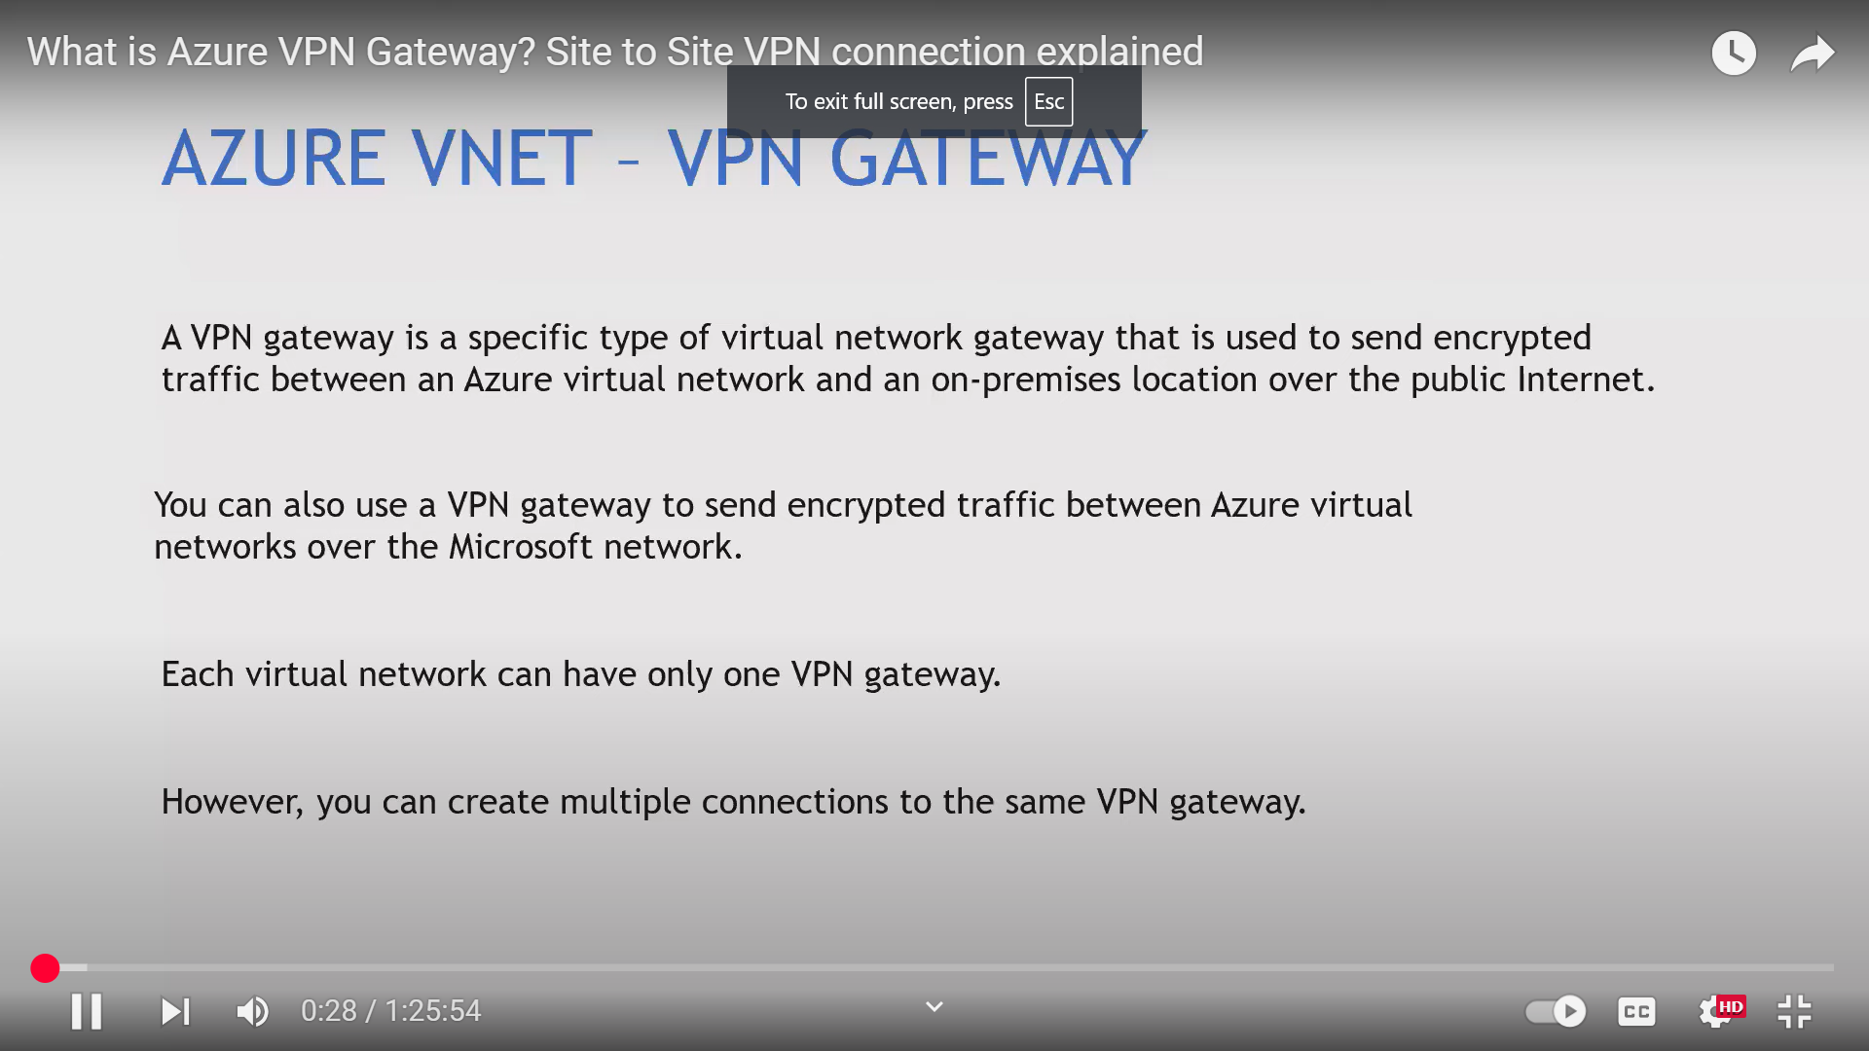

📘 Azure VPN –
🔹 1. Introduction
Azure VPN Gateway ek service hai jo secure connection provide karti hai between:
- On-premises network ↔ Azure VNet
- Azure VNet ↔ Azure VNet
- Client ↔ Azure VNet
👉 Public internet use hota hai but connection encrypted (IPSec/IKE) hota hai

🔹 2. Types of Azure VPN
🔹 1. Site-to-Site (S2S) VPN
- On-premises network ko Azure VNet se connect karta hai
- Router/VPN device required
👉 Use case: company datacenter connect to Azure

🔹 2. Point-to-Site (P2S) VPN
- Individual client (laptop/user) connect karta hai Azure se
👉 Use case: remote employees access

🔹 3. VNet-to-VNet VPN
- Do Azure VNets ko connect karta hai
👉 Use case: multi-region architecture

🔹 3. Key Components
- Virtual Network (VNet)
- Subnet (GatewaySubnet)
- VPN Gateway
- Local Network Gateway (on-prem representation)
- Public IP

🔹 4. VPN Gateway SKUs
- Basic
- VpnGw1, VpnGw2, VpnGw3
👉 Difference: throughput, tunnels, performance

🔹 5. Protocols Used
- IPSec
- IKEv1 / IKEv2
- SSL (P2S case)
👉 Encryption + secure tunneling

🔹 6. Authentication Methods
🔐 P2S Authentication
- Azure AD
- Certificate-based
- RADIUS
🔐 S2S Authentication
- Pre-shared key (PSK)

🔹 7. How it Works (Flow)
On-prem/User → Internet → Encrypted Tunnel → VPN Gateway → Azure VNet
👉 Data secure rehta hai end-to-end

🔹 8. High Availability
- Active-Active VPN Gateway
- Zone-redundant gateways
👉 No single point of failure

🔹 9. Security Features
- Encrypted tunnel (IPSec)
- Authentication (PSK / Cert / Azure AD)
- Traffic isolation

🔹 10. Use Cases
- Hybrid cloud setup
- Remote access
- Multi-region connectivity
- Disaster recovery

🔹 11. VPN vs ExpressRoute
👉 Azure ExpressRoute
Feature | VPN | ExpressRoute
Network | Public internet | Private network
Security | Encrypted | Private + secure
Cost | Low | High
Speed | Medium | High
👉 Interview line:
“VPN is cost-effective, ExpressRoute is high performance.”

🔹 12. Important Interview Points
- GatewaySubnet mandatory hota hai
- Public IP required for VPN Gateway
- NSG GatewaySubnet pe apply nahi hota
- SLA available based on SKU
- Max tunnels depend on SKU

🔹 13. Real-Time Scenario
👉 Company ka on-prem DC hai
- S2S VPN setup
- Secure communication Azure resources ke sath
👉 Remote employee
- P2S VPN use karega

🔹 14. Common Interview Questions
- S2S vs P2S difference
- VPN vs ExpressRoute
- GatewaySubnet kya hota hai
- VPN Gateway ka role kya hai
- Authentication methods kya hain

🔥 Final Interview Answer
👉 “Azure VPN Gateway is used to securely connect on-premises networks, remote users, or other VNets to Azure using encrypted tunnels over the public internet.”

Types of Azure VPN:
VPN Type | Purpose | Use Case
Site-to-Site VPN (S2S) | Connect On-Premises Network to Azure VNet | Datacenter to Azure secure connection
Point-to-Site VPN (P2S) | Connect individual users (Laptop/Mobile) to Azure VNet | Remote users secure access to Azure resources
VNet-to-VNet VPN | Connect two or more Azure VNets securely | Multi-region VNet communication

Use Case Examples:
- Extend On-Premises network to Azure securely
- Provide secure access to remote employees
- Connect multiple VNets across regions

Interview Line:
"Azure VPN provides secure, encrypted connectivity between on-premises networks, remote users, and Azure VNets over the internet using Site-to-Site, Point-to-Site, and VNet-to-VNet VPN types."

What is Azure ExpressRoute?
Definition:
Azure ExpressRoute ek private connection service hai jo aapke on-premises datacenter ko Azure ke network se directly connect karta hai — bina public internet ke.

Key Features:
- Private Dedicated Connection
- High Speed (50 Mbps to 100 Gbps)
- Low Latency
- More Secure than VPN
- SLA-based Availability

Use Case:
- Banking, Healthcare, Financial sectors (Data Security Required)
- Large Data Transfer (Backup, DR, Migration)
- Hybrid Cloud Setup

Interview Line:
"Azure ExpressRoute provides a private and dedicated network connection between on-premises infrastructure and Azure, offering higher security, reliability, and faster speeds compared to VPN over the internet."

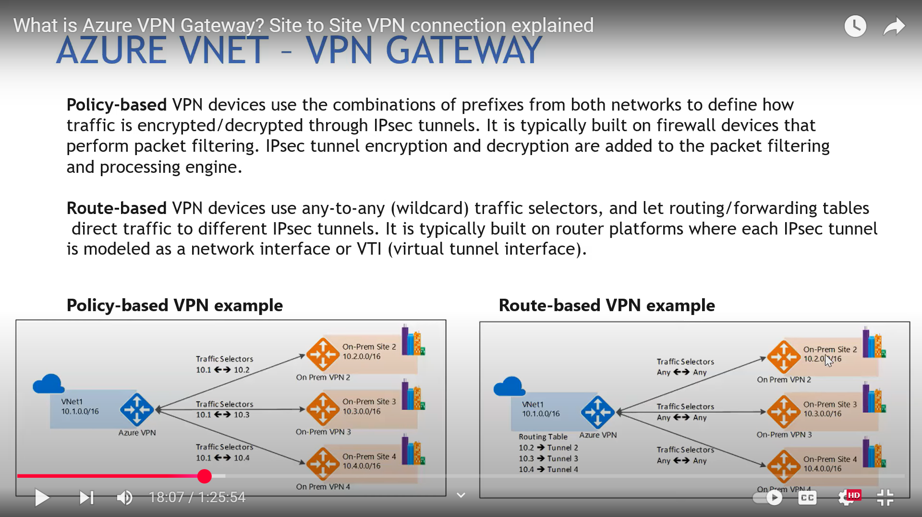

CONFIGURATION IN VNG (SITE TO SITE )
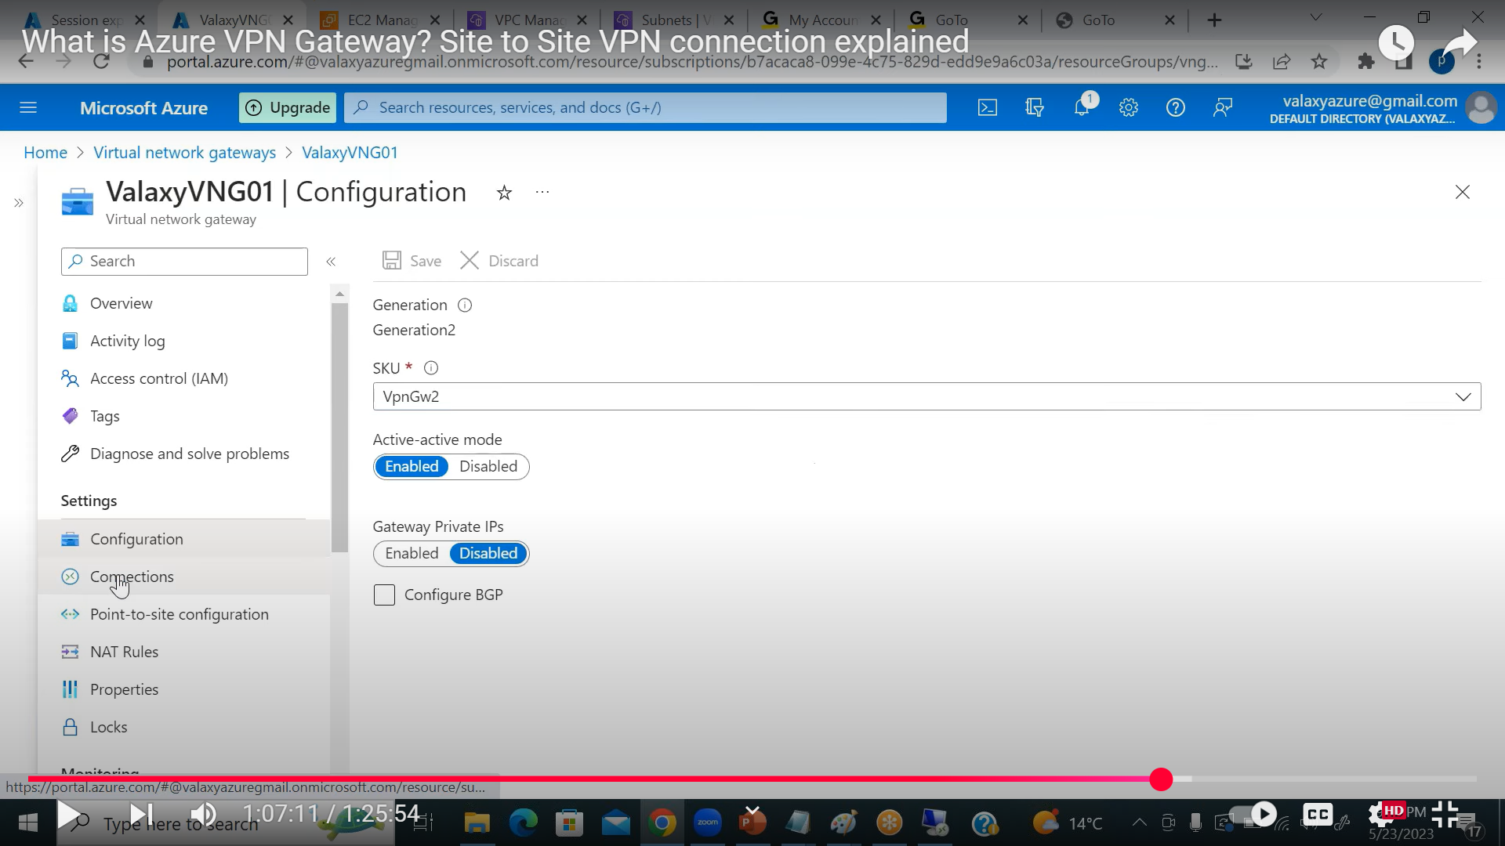

GO TO CONNECTION ADD LOCAL AREA CONNECTION (DESTINATION DEFINE )CREATE
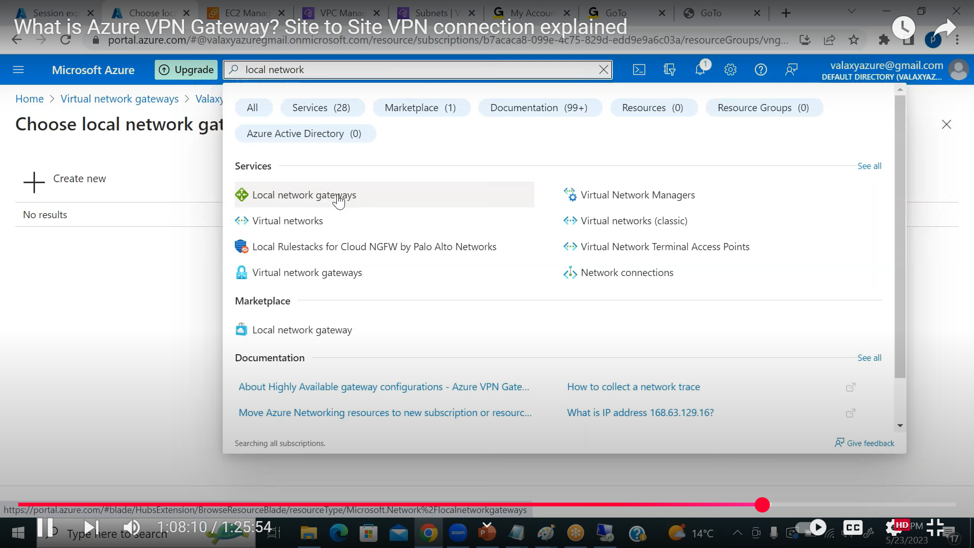

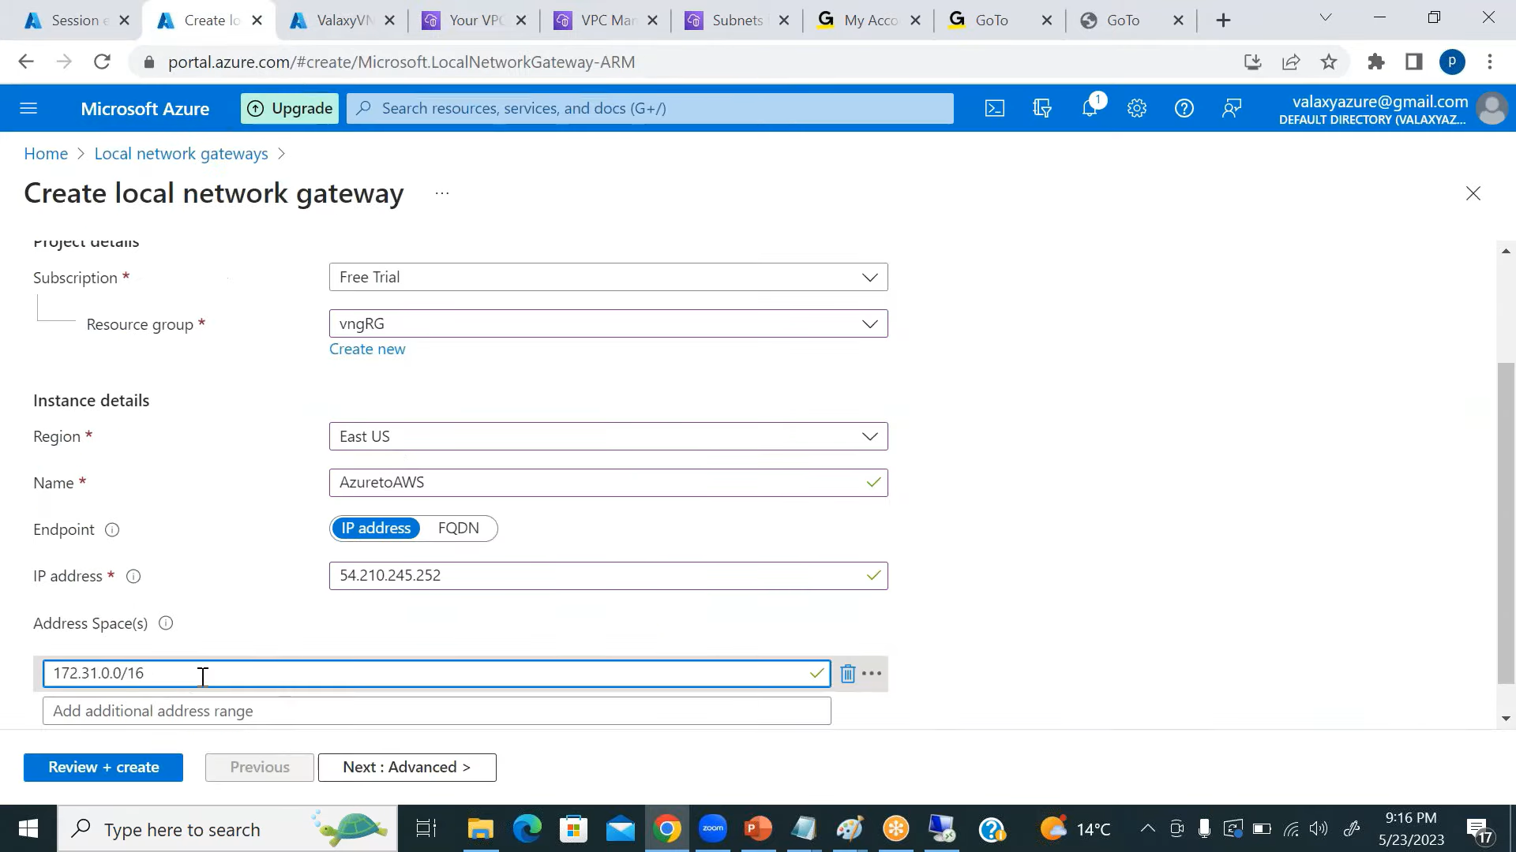
IN IP ADDRESS PUBLIC IP ONPREM (RAS IN OUR CASE)

POINT TO SITE VPN :-
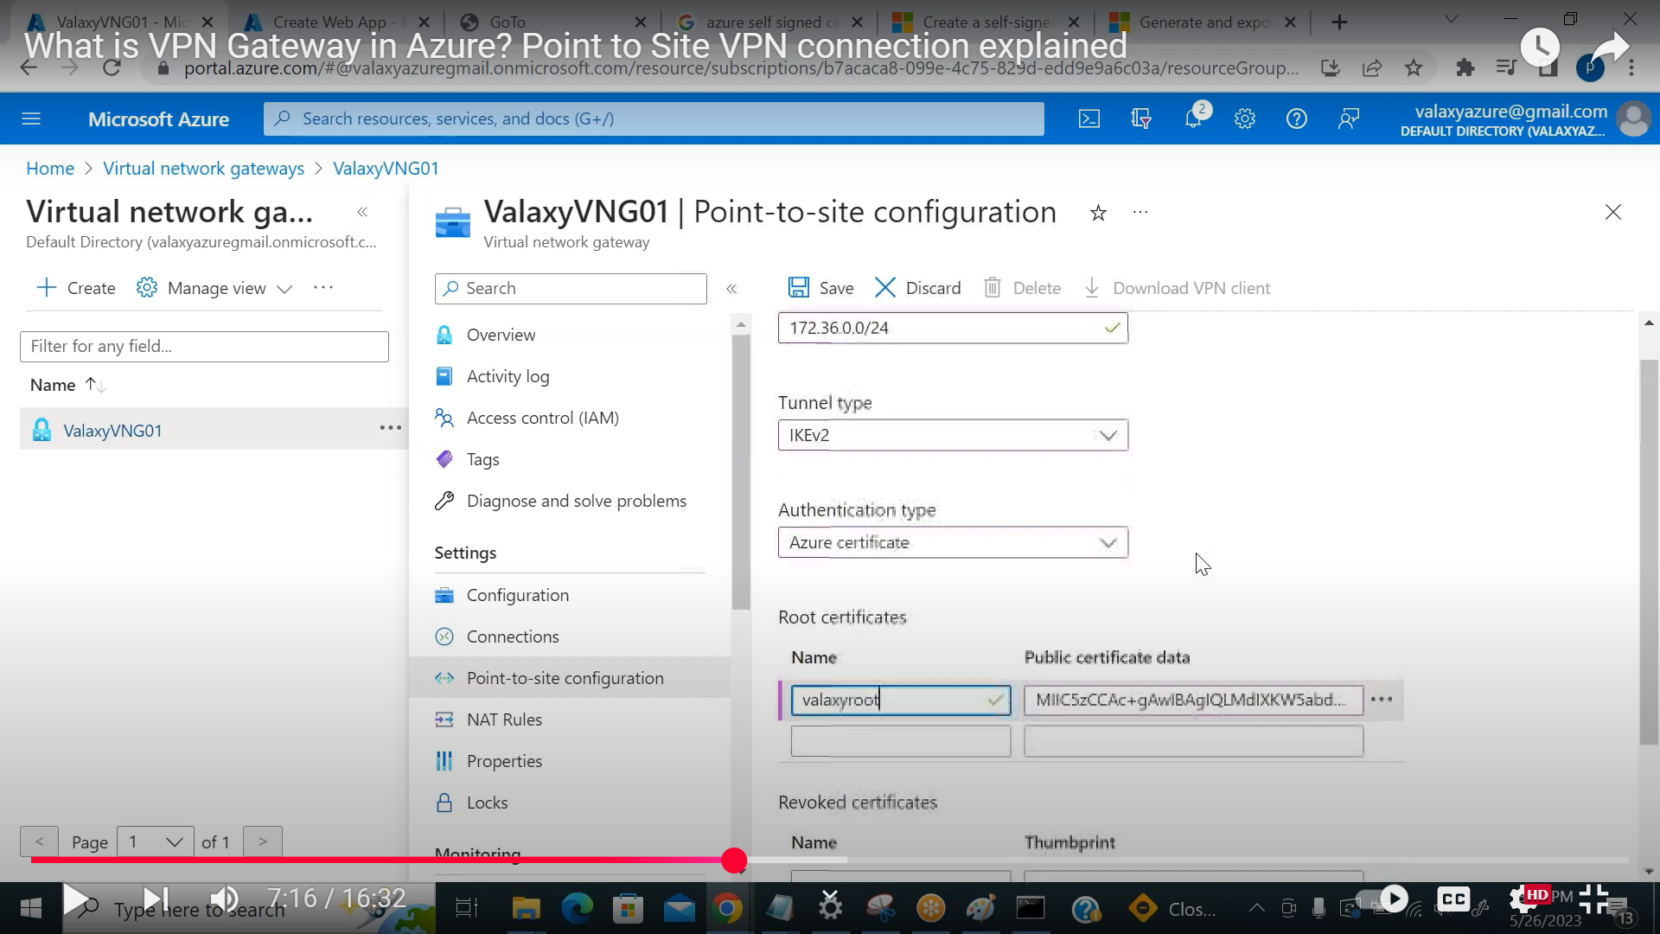
IN IP -PROVIDE IP WHICH WE WANTED TO GIVE TO LAPTOP WHO WILL CONNECT TO VPN .
PROVIDE CERTIFICATE.

On-Prem
|
[ VPN/ExpressRoute ]
|
[ HUB VNet ]
|
[ Azure Firewall ]
|
→ App Gateway → Web Tier (Spoke 1)
→ App Tier (Spoke 2 via ILB)
→ DB Tier (Spoke 3)

