AZURE MONITOR

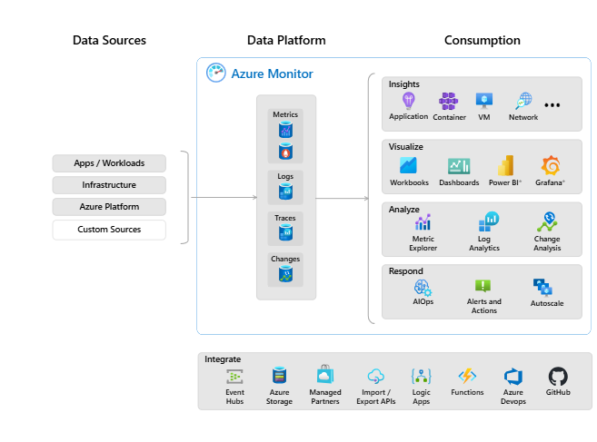

Azure Monitor:
Azure Monitor is Microsoft’s comprehensive observability and monitoring platform for collecting, analyzing, and acting on telemetry across your entire environment—including Azure, on-premises, and multi-cloud resources.Microsoft LearnMicrosoft Azure

1. Purpose & Scope
- End-to-end observability: Monitors applications, infrastructure, network, and more in a unified way.Microsoft Azure
- Automatic telemetry: Activity logs and basic platform metrics start being collected immediately upon subscription creation.Microsoft AzureFAUN.dev — Developer Community
- Unified interface: Combines what used to be separate services—Azure Monitor, Log Analytics, and Application Insights—into one holistic system.Microsoft AzureTECHCOMMUNITY.MICROSOFT.COM

2. Key Components
Data Collection & Agents
- Azure Monitor Agent (AMA): Collects metrics and logs from VMs, containers, and on-prem systems.Microsoft LearnScaler
- Application Insights SDK: Embedded in apps to collect detailed telemetry like requests, exceptions, and user behavior.Microsoft LearnGo Cloud EasilyRajnish Kumar Jha
- Log Ingestion API: For sending custom logs or telemetry via REST or client libraries.Microsoft Learn
Storage & Data Platforms
- Metrics Store: Platform metrics stored per resource, viewable via Metrics Explorer.Microsoft Learn
- Log Analytics Workspace: Centralized repository for logs, diagnostic data, and traces. Supports Kusto Query Language (KQL).Microsoft LearnGo Cloud EasilyHovermind
- Azure Monitor Workspace: Specialized for Prometheus metrics (such as from Kubernetes clusters).Microsoft Learn
Insights
- Application Insights: APM tool for live applications—captures performance, anomalies, dependencies, user behavior, and distributed tracing.Microsoft LearnGo Cloud EasilyRajnish Kumar Jha
- Resource-Specific Insights:
  - VM Insights: Deep diagnostics for VMs, including guest OS and dependencies.
  - Container Insights: Monitors AKS and container health.
  - SQL Insights, Network Insights, etc.Rajnish Kumar Jha+1

3. Analysis & Visualization Tools
- Kusto Query Language (KQL): Powerful language for querying and analyzing logs.Go Cloud EasilyScaler
- Workbooks: Interactive, highly customizable dashboards and reports—great for storytelling with data.Microsoft LearnRajnish Kumar Jha
- Azure Portal Dashboards: Pin metrics, charts, and visualizations for quick insights.Rajnish Kumar Jha
- Azure Managed Grafana: For users familiar with Grafana, fully integrated and managed.Microsoft Learn

4. Alerts, Automation, & Response
- Alert Types:
  - Metric-based (e.g., CPU > 80%)
  - Log-based (e.g., specific error messages detected)
  - Availability alerts and anomaly detectionRajnish Kumar Jha+1
- Actions & Notifications:
  - Send alerts via email, SMS, Teams, or even ITSM tools.
  - Trigger Logic Apps, Azure Functions, or Automation Runbooks for automated responses.Rajnish Kumar Jha
- AutoScale: Automatically scale resources based on performance metrics.Rajnish Kumar Jha+1

5. Ecosystem & Integrations
- Hybrid Monitoring: Monitor non-Azure environments via Azure Arc and the same telemetry pipelines.Microsoft Learn
- Security & SIEM Integration:
  - Microsoft Sentinel uses Azure Monitor infrastructure for security event ingestion.
  - Microsoft Defender XDR also leverages this shared workspace.Microsoft Learn
- ITSM & Automation Integration: Alerts can create tickets in systems like ServiceNow via connectors.Microsoft Learn
- Power BI Export: Feed logs or metrics into Power BI for advanced analytics.Rajnish Kumar Jha

6. Architectural Workflow
- Telemetry Generated: Applications, resources, VMs, containers produce metrics & logs.
- Data Ingestion: Data flows into Metrics store and Log Analytics (or Azure Monitor) workspaces.
- Storage & Enrichment: Data is retained, possibly enriched with insights and analytics.
- Visualization: Dashboards, Workbooks, or Grafana visualize the data.
- Alerts & Automation: Threshold breaches trigger alerts or automated workflows.
- Integration: Tours into SIEM, security tools, or external analytics platforms.Rajnish Kumar JhaMicrosoft Learn

7. Summary Table
Component | Description
Data Collection | Via agents (AMA), SDKs, APIs
Storage | Logs in Log Analytics, metrics in Metrics store or Monitor workspaces
Insights & APM | Application, VM, Container, SQL, etc.
Query & Analysis | KQL via Logs page
Visualization | Dashboards, Workbooks, Grafana
Alerts & Automation | Metric & log-based alerts, auto-actions, scaling
Integrations | Sentinel, Defender, ITSM, Power BI, Logic Apps
Hybrid & Multi-Cloud | Support via Azure Arc

Pro Tips for Interviews
- Start with a clear definition: Azure Monitor = unified platform for telemetry across infra & apps.
- Talk about key components (data collection, storage, insights, alerts, visualization).
- Wrap up with use case examples like auto-scaling, real-time incident response, hybrid monitoring, or DevOps integration.

App Insight
Application Insights aur Azure Monitor dono Azure ki monitoring tools hain, lekin unka scope aur use-case thoda alag hai. Interview ya real-world usage ke liye yeh distinction clear hona chahiye.

✅ Application Insights vs Azure Monitor – Difference Explained
Feature | Application Insights | Azure Monitor
Purpose | App-level monitoring | Platform-wide monitoring
Scope | Monitors performance, availability, usage, and errors of your application code | Monitors infrastructure, network, VMs, containers, and even App Insights data
Use Case | Debugging, performance tracking, request traces, dependency tracking, etc. | Centralized logging, metrics, and alerting for all Azure resources
Data Type | Telemetry data from apps (requests, exceptions, dependencies, custom events) | Metrics, logs, alerts from VMs, App Services, AKS, Storage, etc.
Integrated With | SDKs for .NET, Java, Node.js, Python, etc. | Azure resources like VMs, AKS, App Service, Log Analytics, etc.
Log Storage | Application Insights stores telemetry in its own workspace or Log Analytics | Uses Log Analytics Workspace for centralized logs
Can Create Alerts? | Yes | Yes (more advanced and broader scope)
Part of Azure Monitor? | ✅ Yes | ✅ Yes (Azure Monitor is the umbrella service)

🔍 Short Summary for Interview:
"Application Insights is used for application-level monitoring (e.g., performance, exceptions, requests), while Azure Monitor is a broader platform that monitors infrastructure, applications, and networks. In fact, Application Insights is a feature under Azure Monitor."**

🧠 Example to Make It Clear:
Suppose you're running a .NET web app on Azure App Service:
- Application Insights: Tells you that a specific HTTP request is failing or taking 5 seconds because of a slow SQL query.
- Azure Monitor: Tells you that your App Service CPU usage is 90%, memory is spiking, or your VM in the backend is down.

