Azure App Service (PAAS) is a fully managed platform provided by Microsoft Azure that lets you build, host, and scale web applications, RESTful APIs, and mobile backends easily. It supports multiple programming languages and frameworks like .NET, Java, Node.js, Python, PHP, and Ruby.
🔹 Key Features of Azure App Service:
- Fully managed hosting: Microsoft handles infrastructure, patching, scaling, and maintenance, so you can focus on your app.
- Multiple languages: Supports .NET, .NET Core, Java, Node.js, PHP, Python, etc.
- Auto-scaling: Automatically adjusts the number of compute resources based on demand.
- High availability: Built-in load balancing and redundancy.
- CI/CD integration: Works seamlessly with GitHub, Azure DevOps, Bitbucket for automated deployments.
- Custom domains & SSL: Easily map custom domains and add free or paid SSL certificates.
- Authentication/Authorization: Built-in support for Azure AD, Facebook, Google, Twitter, and Microsoft accounts.
- Dev/Test/Prod environments: You can set up deployment slots to stage changes before pushing to production.
🔸 Common Use Cases:
- Hosting websites (from small blogs to enterprise-level portals)
- Running REST APIs
- Backend for mobile apps
- Web jobs and background services
🛠️ How It's Different from Azure Functions or VMs:
- App Service: Focused on web apps and APIs with full control of app environment.
- Azure Functions: Serverless, pay-per-use model for event-driven apps.
- Azure VMs: Gives you full control over the OS and environment but requires more maintenance.
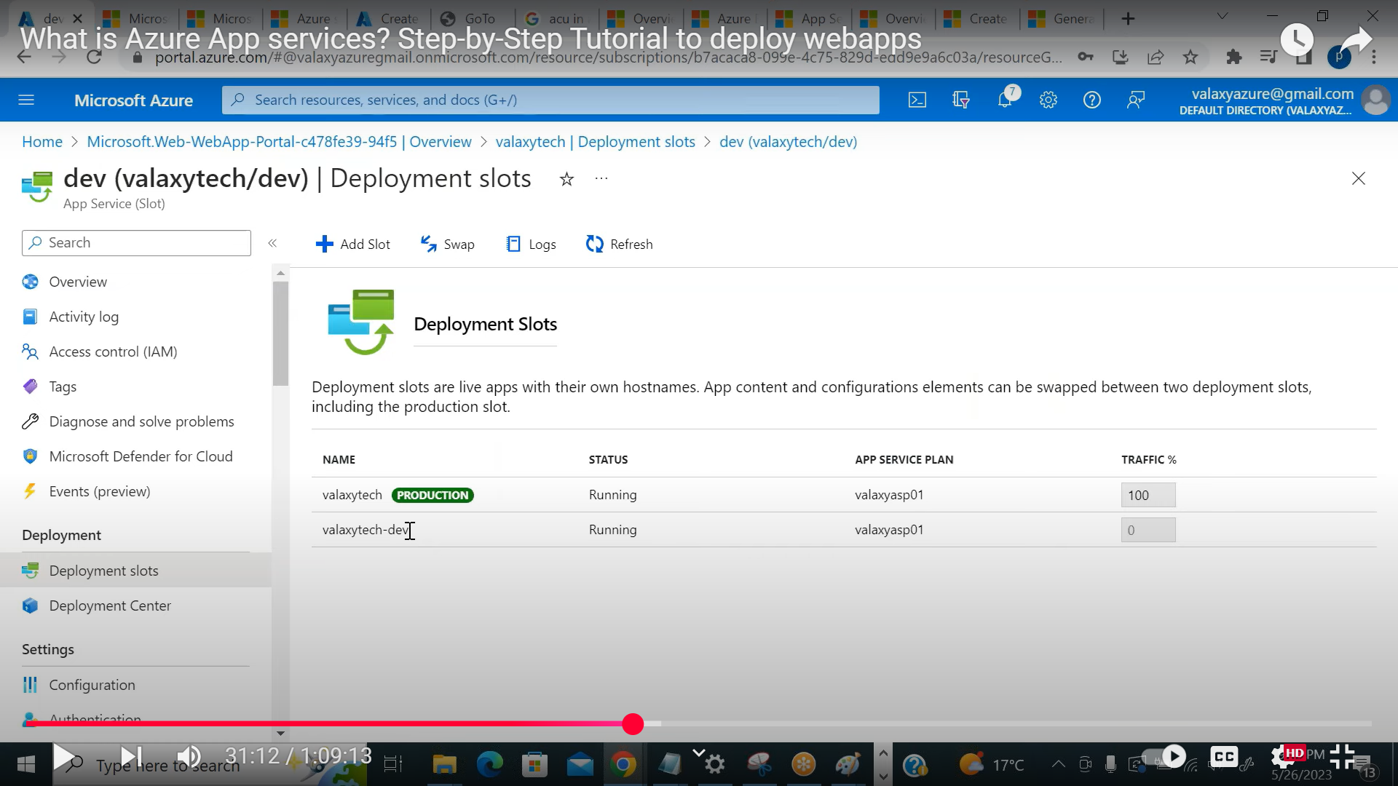
Based on plan we can have slots available. it is like environment like dev prod test.
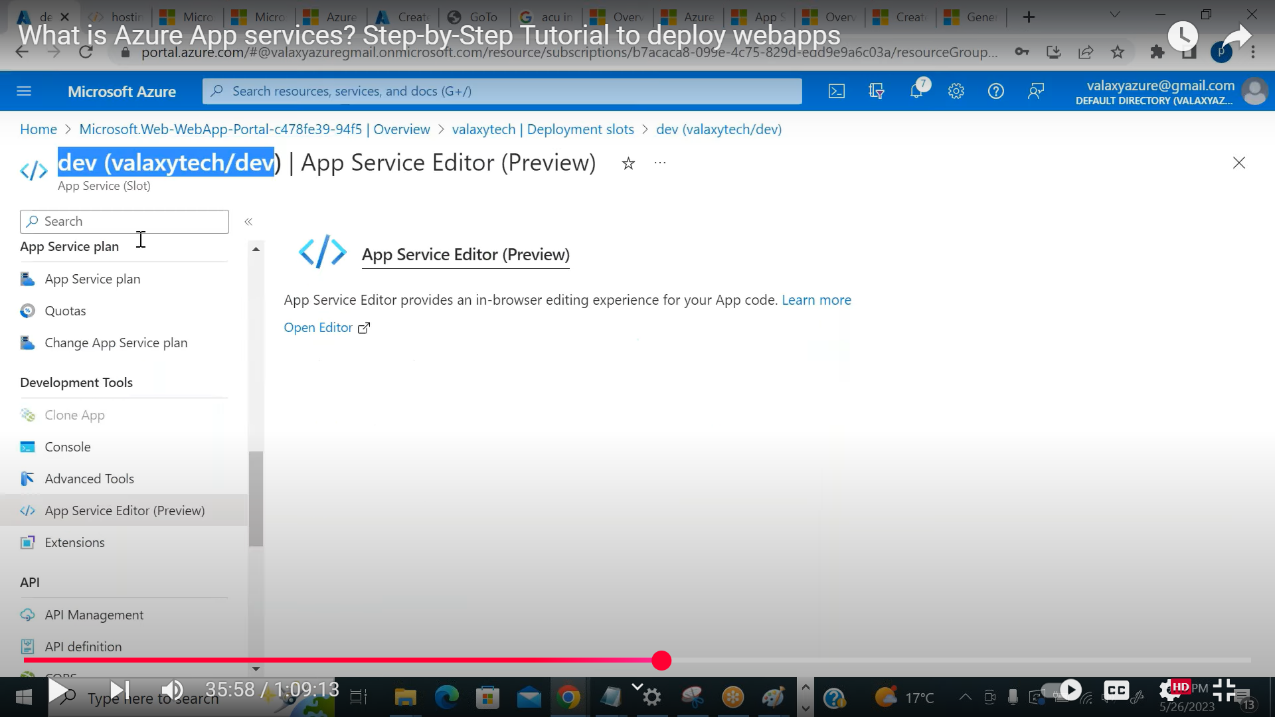
We can edit the code via online editor same like vs code.
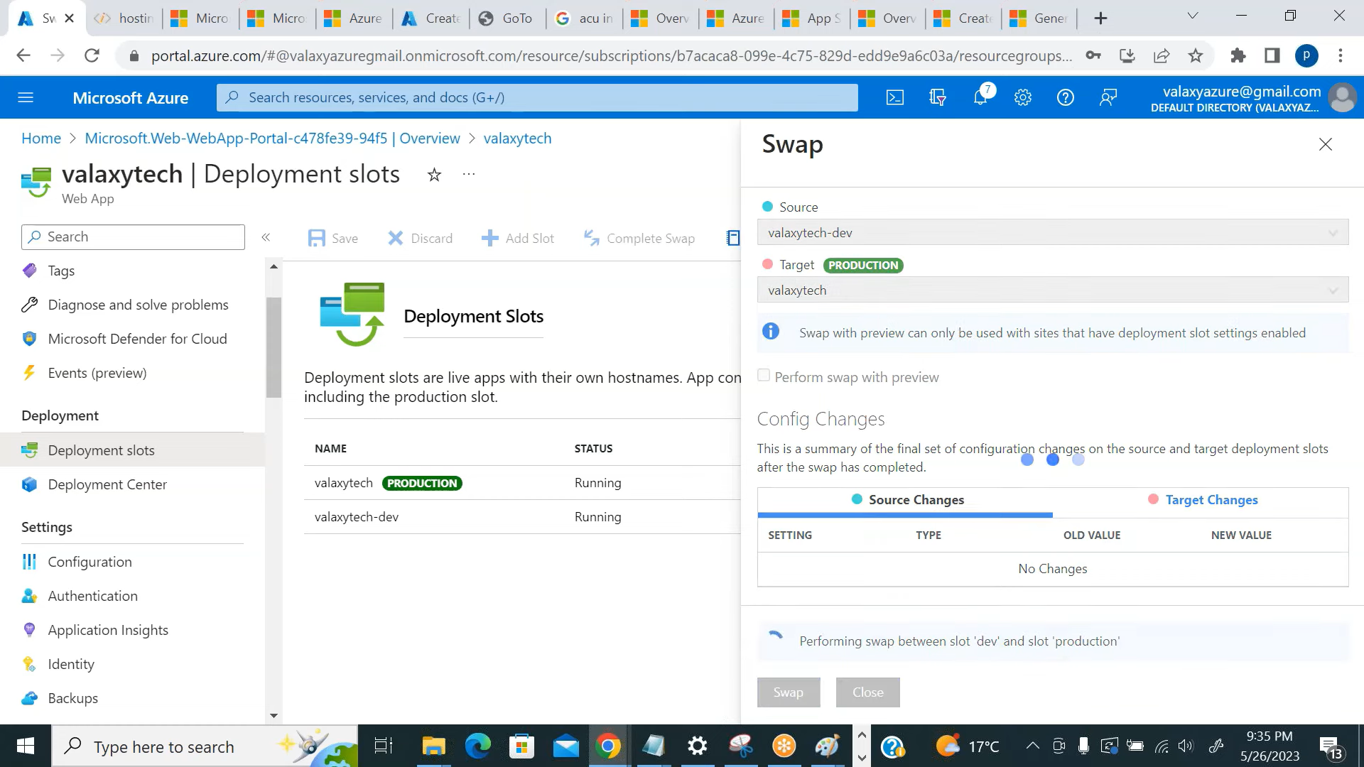
Can swap between two environment .vice-versa.(no downtime )

CI/CD Flow for Azure App Service (Code in Azure Repos)
CI – Continuous Integration
- Code Commit: Developer pushes code to Azure Repos (Git).
- Pipeline Trigger: Azure Pipelines is triggered (YAML or Classic).
- Build Stage:
  - Restore dependencies.
  - Run tests (unit, linting, etc.).
  - Build the code/artifact.
  - Publish build artifacts (e.g., zip, DLLs).
- Store Artifacts: Artifacts are saved in Azure DevOps pipeline.

CD – Continuous Deployment (MEA)
- Release Pipeline Triggered:
  - Can be automatic (post-build) or manual approval.
- Environment-Specific Stages:
  - Dev → QA → UAT → Prod
  - Each stage has:
    - Slot-specific or app-specific configuration (App Settings, Connection Strings).
    - Approval gates (manual/automated).
- Deploy to Azure App Service:
  - Uses Azure App Service Deploy task.
  - Targets correct App Service based on environment.
  - Can use deployment slots (e.g., staging → swap to prod).
- Post-Deployment Steps:
  - Health check.
  - Slot swap if used.
  - Notifications (Teams/Email).

✅ Bonus Tips
- Use Variable Groups or Key Vault for secrets.
- Use ARM Templates or Bicep for infra as code.
- Enable rollback using deployment history.
✅ Azure App Service – Interview Questions and Answers

🔹 Basic Concepts
1. What is Azure App Service?
Azure App Service is a fully managed platform for building, deploying, and scaling web apps, RESTful APIs, and mobile backends in any programming language.
2. What are the different types of App Services in Azure?
- Web Apps
- API Apps
- Mobile Apps
- WebJobs (background jobs)
3. What is the difference between App Service and App Service Environment (ASE)?
App Service is a multi-tenant platform; ASE is a fully isolated and dedicated environment for high-security and network-isolated apps.
4. What are deployment slots in Azure App Service?
Slots are live environments (like staging, QA) where you can deploy your app and swap it with production with no downtime.
5. What languages are supported by Azure App Service?
Supports .NET, Java, Python, Node.js, PHP, Ruby, and custom containers.
6. What is the difference between Azure App Service and Azure Function?
App Service is for hosting web apps and APIs with persistent runtime. Azure Functions is a serverless compute platform for event-driven code.

🔹 Deployment & CI/CD
7. How do you deploy code to Azure App Service?
- Azure DevOps Pipelines
- GitHub Actions
- FTP
- Zip deployment
- Local Git
- Azure CLI
8. What are the different deployment options supported by App Service?
- CI/CD (DevOps, GitHub)
- FTP/SFTP
- Web Deploy
- Local Git
- Docker containers
9. How do you configure CI/CD with Azure Repos for App Service?
Use Azure Pipelines with a YAML file or classic pipeline that triggers on commits to Azure Repos, builds the app, and deploys to App Service using a deployment task.
10. What is the purpose of deployment slots? How do you use them?
They allow testing in a staging environment without affecting production. Once tested, you can swap the slot with production.
11. What is slot swapping, and how does it work?
It exchanges the content and configuration of two deployment slots, enabling zero-downtime deployment.
12. How do you roll back a bad deployment in Azure App Service?
Use slot swap to revert to the previous slot or redeploy an earlier artifact from Azure DevOps.
13. Can you explain Blue-Green deployment with Azure App Service?
Yes, deploy the new version to a slot (Green), test it, then swap with production (Blue) when ready.
14. How do you handle multiple environment deployments (Dev, QA, Prod) using App Services?
Use different App Services or slots for each environment. Separate pipelines or stages in Azure DevOps manage each environment.

🔹 Configuration & Settings
15. How do you manage app settings and connection strings in Azure App Service?
Through the Configuration blade in the Azure portal. These settings override values in your code.
16. What is the difference between App Settings and Environment Variables?
App Settings are key-value pairs set in Azure that become environment variables in the app runtime.
17. How do you use Azure Key Vault with App Service?
Reference Key Vault secrets in App Settings using @Microsoft.KeyVault(...) syntax or use managed identity to access secrets from code.
18. What is "Application Configuration" in Azure, and how is it used with App Services?
It refers to App Settings, Connection Strings, and Feature Flags configured in Azure to separate config from code.

🔹 Scaling & Performance
19. How does scaling work in Azure App Service (manual vs autoscaling)?
- Manual scaling: Manually set instance count.
- Autoscaling: Scale based on metrics (CPU, memory, HTTP queue length) via rules in the App Service Plan.
20. What is the difference between vertical and horizontal scaling in App Service?
- Vertical: Upgrade to a higher pricing tier (more CPU/RAM).
- Horizontal: Increase the number of instances.
21. What is an App Service Plan?
It defines the region, number of instances, and pricing tier that your app runs on.
22. How do you choose the right pricing tier for an App Service Plan?
Based on performance needs, scaling, traffic, SLA, and feature requirements (e.g., VNet integration).
23. Can a single App Service Plan host multiple apps?
Yes. Multiple apps can share the same App Service Plan to save costs, but they also share resources.

🔹 Security
24. How do you secure an Azure App Service?
- HTTPS only
- Authentication/Authorization (AAD, Facebook, etc.)
- Access restrictions (IP filtering)
- Managed Identity for secure resource access
25. How do you configure custom domain and SSL certificate for App Service?
Map a custom domain via DNS and bind an SSL certificate (either uploaded or from App Service Managed Certificate).
26. What is Authentication/Authorization in App Service?
Also called "Easy Auth", it provides built-in authentication with identity providers like Azure AD, Google, Facebook, without writing code.
27. How can you restrict IP addresses or use access restrictions for App Services?
Configure access restrictions (IP rules, virtual network rules) under the “Networking” blade.
28. What is Managed Identity in App Service and how is it used?
Provides an automatically managed identity in Azure AD to access other Azure resources securely (like Key Vault, Storage).

🔹 Monitoring & Troubleshooting
29. How do you monitor Azure App Service health and performance?
Use Azure Monitor, Application Insights, and the App Service diagnostics panel.
30. What tools do you use to troubleshoot issues in App Service?
- Kudu
- Log stream
- Application Insights
- Diagnostic logs
- Azure Monitor
31. What are App Insights and how are they integrated with App Service?
App Insights is a monitoring tool that collects telemetry data from your app (performance, exceptions, requests) for troubleshooting and analysis.
32. How do you capture logs from Azure App Service?
Enable Diagnostic Logs:
- Application logs
- Web server logs
- Failed request tracing
Also stream logs in real-time via Azure CLI or portal.
33. What is Kudu? How is it used?
Kudu is the advanced tool behind App Service. Access it at https://<appname>.scm.azurewebsites.net for log streaming, process explorer, console, etc.

🔹 Advanced / Real-world Scenarios
34. What is the difference between an App Service in Consumption Plan and Standard Plan?
- Consumption: Used for serverless (like Azure Functions), auto-scales, billed per execution.
- Standard: Fixed cost, used for Web Apps, supports scaling and deployment slots.
35. How would you migrate an on-prem app to Azure App Service?
- Assess app compatibility
- Package and publish app
- Use Azure Migrate or manually deploy
- Configure networking and dependencies
- Validate and monitor post-migration
36. How do you manage zero downtime deployments in Azure App Service?
Use deployment slots, test in staging, then swap. Monitor health during and after swap.
37. How do you handle secrets and sensitive data in App Services?
Store them in Azure Key Vault and reference in App Settings or use Managed Identity to access them securely.
38. How do you use ARM templates or Bicep for App Service provisioning?
Define infrastructure (App Service, Plan, Settings) in code (JSON or Bicep) and deploy using Azure CLI or DevOps pipelines.
39. Can App Service connect to on-prem resources? If yes, how?
Yes, via:
- VNet Integration (VPN/ExpressRoute)
- Hybrid Connections
- Private Endpoints (for App Service Environment)
40. How does Hybrid Connection or VNet Integration work with App Services?
Hybrid Connections allow apps to access on-prem services using Relay.
VNet Integration allows outbound access to private resources via a virtual network.

