Azure Backup is a cloud-based backup solution from Microsoft that helps you protect your data and workloads—whether they’re in the cloud or on-premises. It’s a part of the Azure Recovery Services and is fully managed, secure, scalable, and cost-effective.

🔹 Key Features of Azure Backup:
✅ Backup for Various Workloads:
- Azure VMs (Windows & Linux)
- On-premises servers via Azure Backup Agent or Azure Backup Server
- SQL Server, SharePoint, Exchange running in Azure VMs
- Azure Files & Azure Blob Storage (snapshot-based)
✅ No Infrastructure Management:
- You don’t need to set up or maintain any backup servers or storage.
- Microsoft handles scaling, availability, and security.
✅ Built-in Security:
- Encryption (data encrypted at rest and in transit)
- Soft delete to protect against accidental or malicious deletions
- Multi-user authorization (MUA) for critical operations
✅ Long-Term Retention:
- Store data for days, weeks, months, or years, depending on your compliance or business needs.
✅ Policy-Based Management:
- Create backup policies that automate the backup schedule and retention rules.
✅ Restore Options:
- Restore entire VMs, specific files/folders, or application-level data like SQL databases.

🔸 Common Use Cases:
- Protect against data loss from ransomware, accidental deletions, or hardware failures.
- Ensure disaster recovery readiness.
- Meet regulatory compliance by retaining data for long periods.

🛠️ How It Works (Simplified Flow):
- Set up a Recovery Services Vault in Azure.
- Register your resources (VMs, files, apps) with the vault.
- Define a backup policy (frequency, retention).
- Backups run automatically based on the schedule.
- Restore when needed from the backup vault.

Tool used in traditional datacenter for backup:-
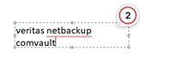
Type of backup:-
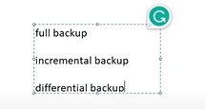
Azure-Based Resources (In-Cloud)
1. Azure Virtual Machines (VMs)
- Full VM backup (system state + data)
- Linux and Windows VMs
- Application-aware backups (e.g., SQL Server in Azure VMs)
2. Azure Files
- Backup for Azure File shares
- Snapshot-based; supports multiple versions and long retention
3. Azure Blob Storage (Preview)
- Point-in-time restore for block blobs
- Useful for data lakes and object storage protection
4. SQL Server on Azure VMs
- Full and differential backups
- Log backups for point-in-time recovery
- Application-consistent backups
5. SAP HANA on Azure VMs
- Backup support with native integration
- Application-consistent and certified by SAP

🖥️ On-Premises Resources
You can use the Microsoft Azure Recovery Services (MARS) Agent or Azure Backup Server (MABS) to back up:
1. On-prem Windows Servers and Clients
- Files and folders
- System State
- Bare-metal recovery (via Azure Backup Server)
2. Application Workloads (via Azure Backup Server or System Center DPM)
- Microsoft SQL Server
- Microsoft Exchange
- SharePoint
- Hyper-V VMs
- VMware VMs (via Azure Backup Server integration)

🧰 Other Backup Scenarios
- Azure Stack VMs
- Azure Kubernetes Service (AKS) (via Azure Backup center and partner integrations)
- Azure Disks (via Azure Backup Center using snapshot-based backups)

🛡️ TL;DR: You can back up...
Backup Item | In Azure | On-Prem
Virtual Machines | ✅ | ✅ (via MABS)
Files & Folders | ✅ (Azure Files) | ✅
SQL Server Databases | ✅ | ✅
System State | ❌ | ✅
SAP HANA | ✅ | ❌
SharePoint/Exchange | ❌ | ✅
Azure Blobs | ✅ (Preview) | ❌

Let me know what you're trying to protect—like VMs, databases, or file shares—and I can guide you on exactly how to set it up!
You said:
suppose we have zrs available with vm then why should i use backup ?
ChatGPT said:
Awesome question! It's a common one—“If my Azure VM uses ZRS (Zone-Redundant Storage), do I still need to back it up?” The short answer is: YES, and here’s why 👇

🔄 ZRS ≠ Backup
ZRS (Zone-Redundant Storage) gives you high availability, but not protection from data loss or corruption.
Let’s break it down:

🛠️ What ZRS Actually Does:
- Replicates your data synchronously across 3 Availability Zones in a region.
- Protects against hardware failures, zone outages, and data center-level disasters.
- Ensures durability and uptime, not historical recovery.
✅ Great for high availability
❌ Not designed for data recovery, accidental deletion, or corruption

💾 What Azure Backup Provides:
- Creates point-in-time backups (snapshots + stored securely in Recovery Services Vault).
- Supports long-term retention (daily, weekly, monthly, yearly).
- Lets you restore entire VMs, specific files/folders, or even SQL databases.
- Protects against:
  - ❌ Accidental deletion
  - ❌ Ransomware/malware attacks
  - ❌ Corruption or misconfiguration
  - ❌ Human errors
  - ❌ Application failures

🔁 Example Scenario:
Let’s say:
- You accidentally delete a file on a VM.
- Or a patch/update corrupts the OS.
- Or someone deletes the VM by mistake.
🧠 ZRS won't help — because it just replicates that change (or deletion) across zones. It won’t let you "go back in time."
💡 Azure Backup will help — you can restore the VM or files from a backup taken before the issue happened.

✅ TL;DR:
Feature | ZRS | Azure Backup
Data Redundancy/Availability | ✅ Yes | ❌ No
Protection from Deletion | ❌ No | ✅ Yes
Protection from Corruption | ❌ No | ✅ Yes
Point-in-Time Recovery | ❌ No | ✅ Yes
Long-Term Retention | ❌ No | ✅ Yes

So yeah, ZRS is awesome for uptime, but Azure Backup is what saves you from disasters 💥
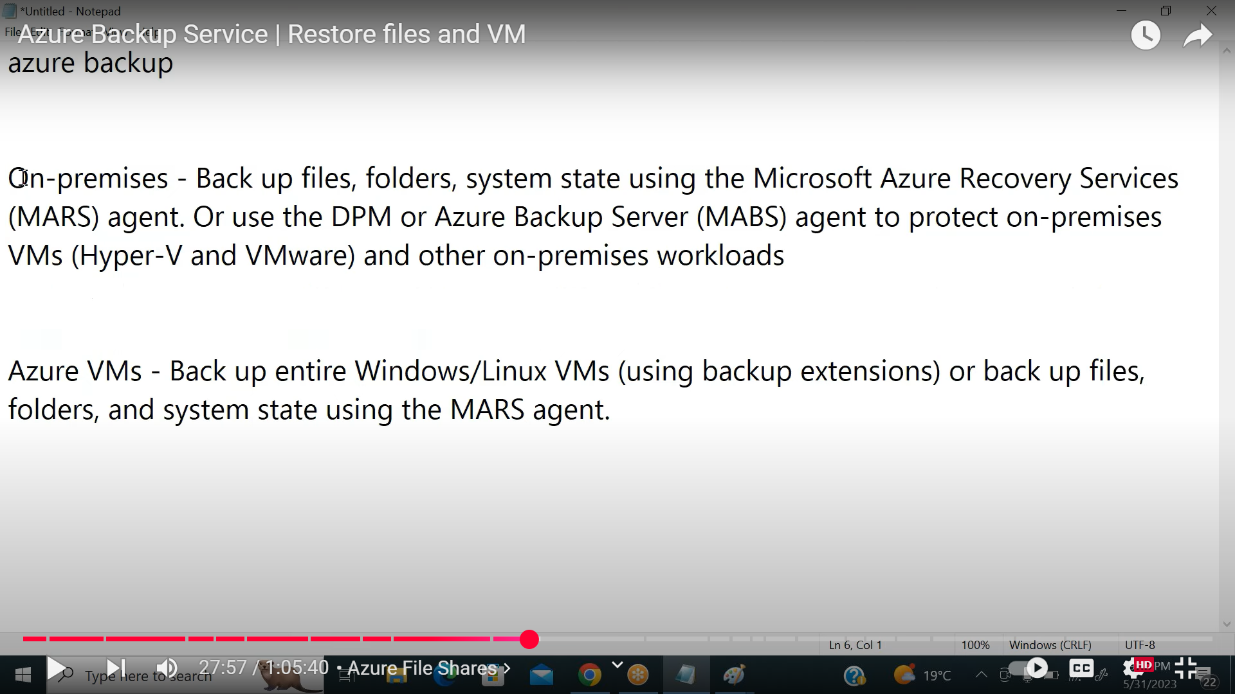

Create a recover service vault for backup.
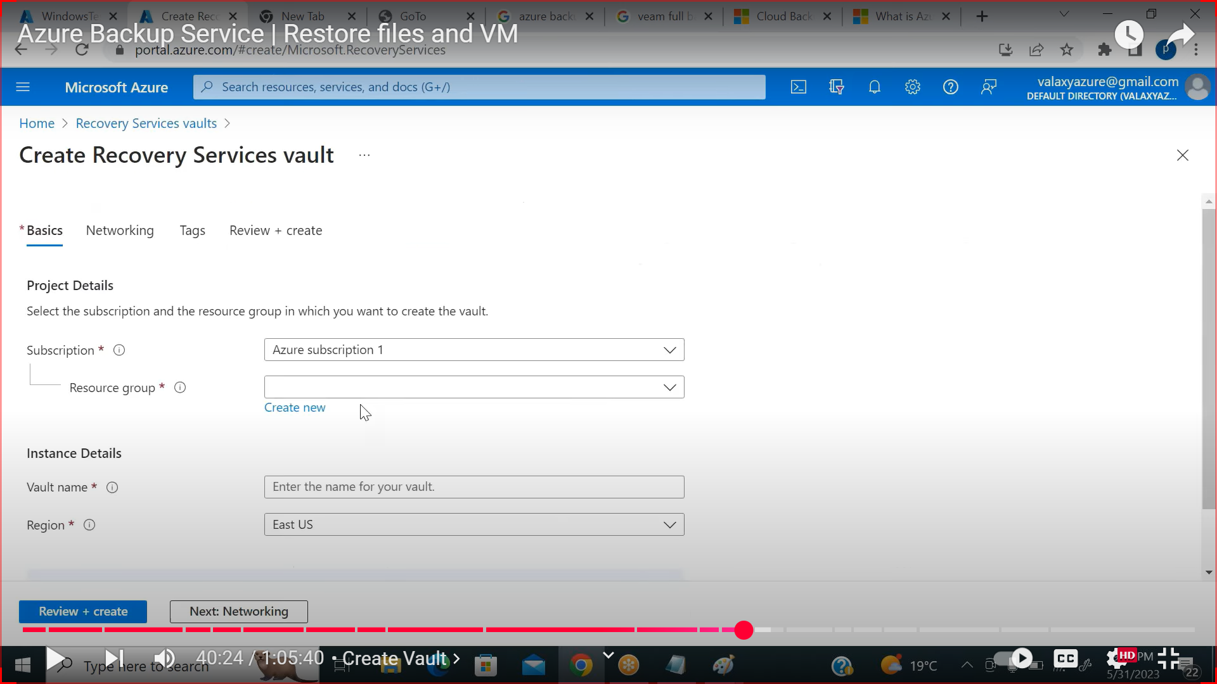
Create backup policy under vault .click on ADD
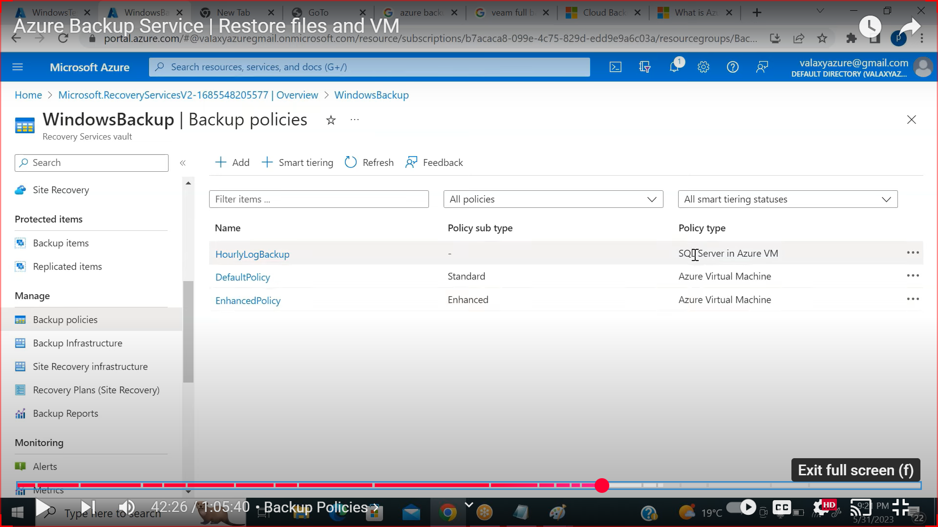
SELECT FOR WHAT RESOURCE YOU WANT TO CREATE BACKUP POLICY .AND CREATE POLICY.
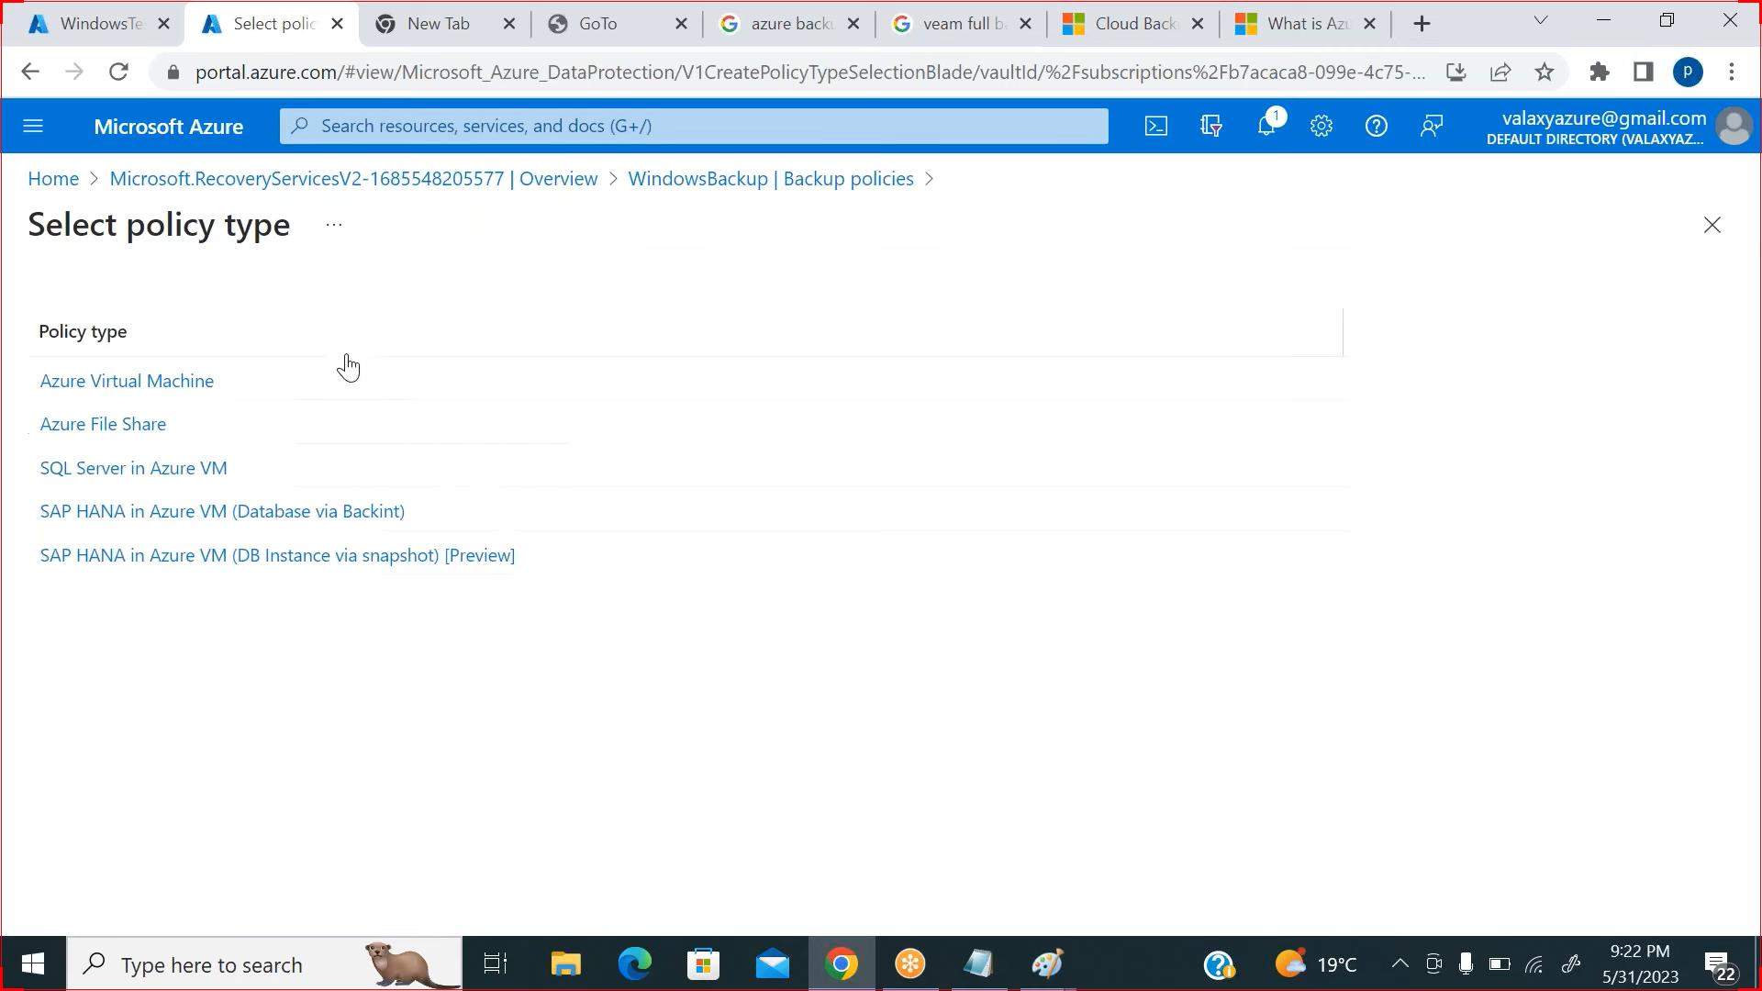
SUPPOSE YOU CREATED A VM THEN GO TO OPERATION IN BACKUP AND CAN SELECT THE BACKUP POLICY WE CREATED .

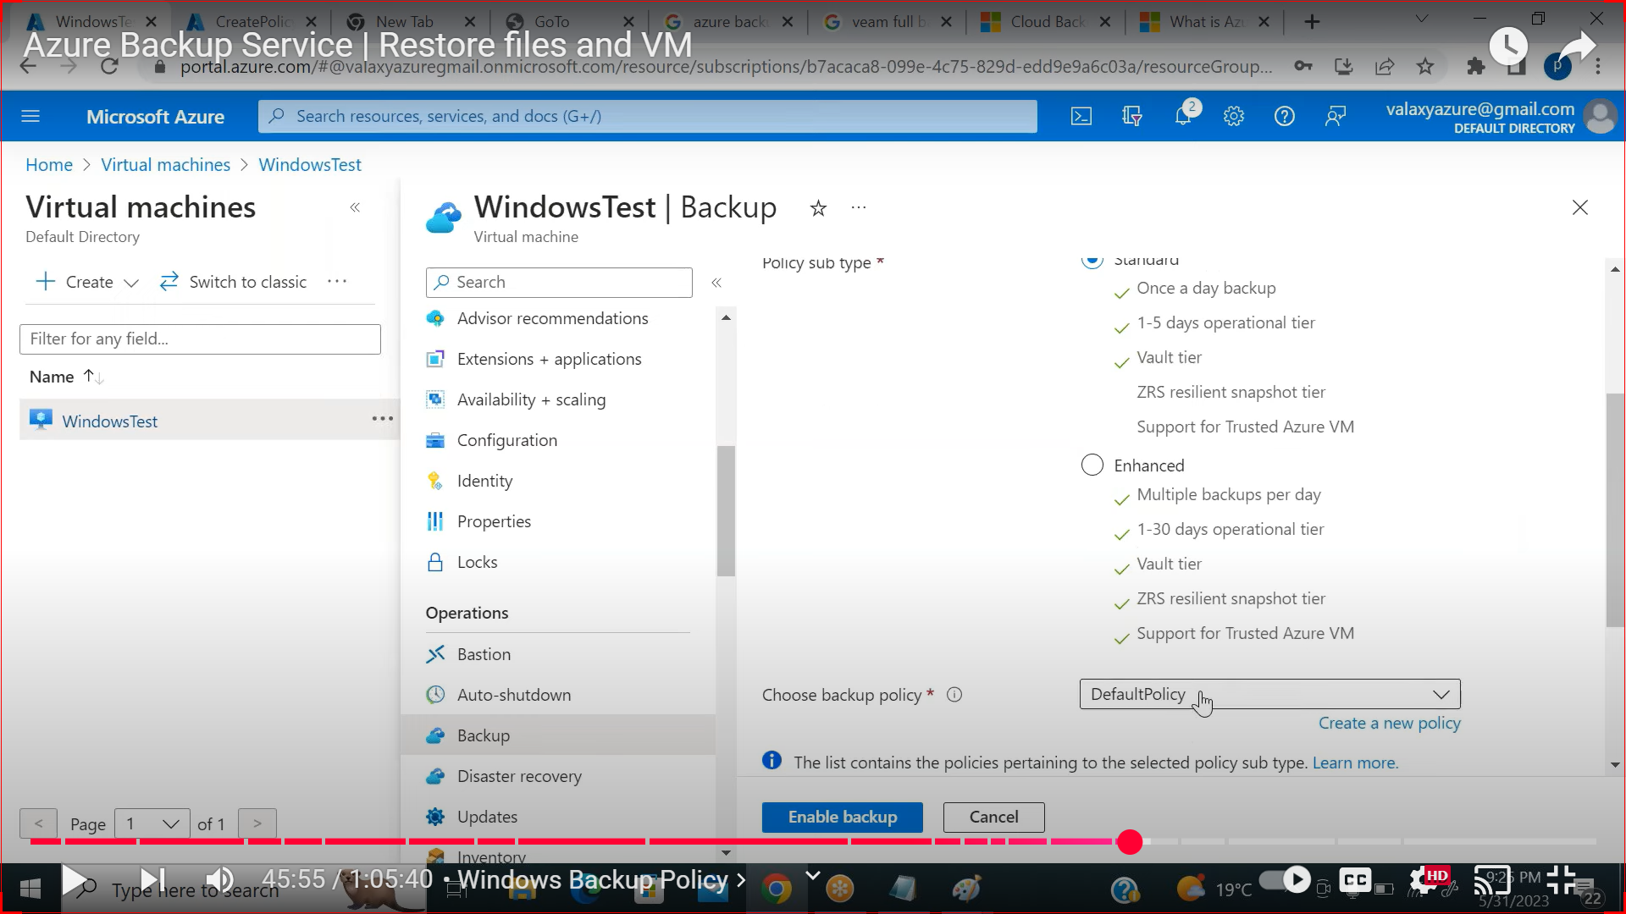

IN BACKUP VAULT UNDER MONITORING IN BACKUP JOBS WE CAN SEE HOW MANY NUMBER OF BACKUP CREATED .
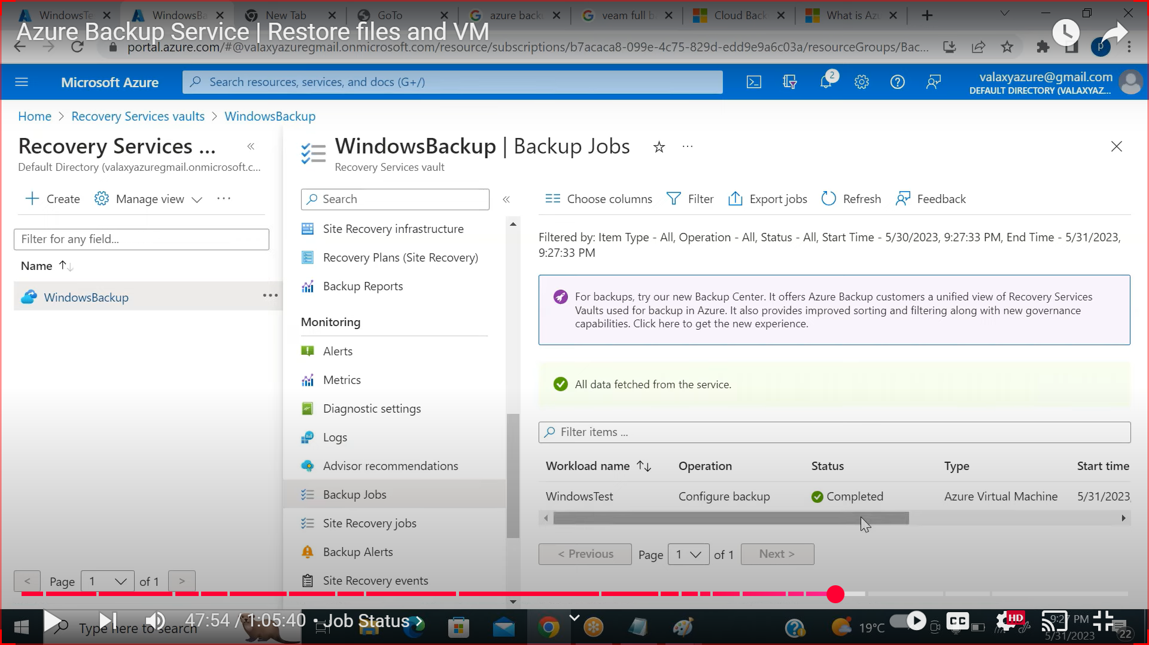
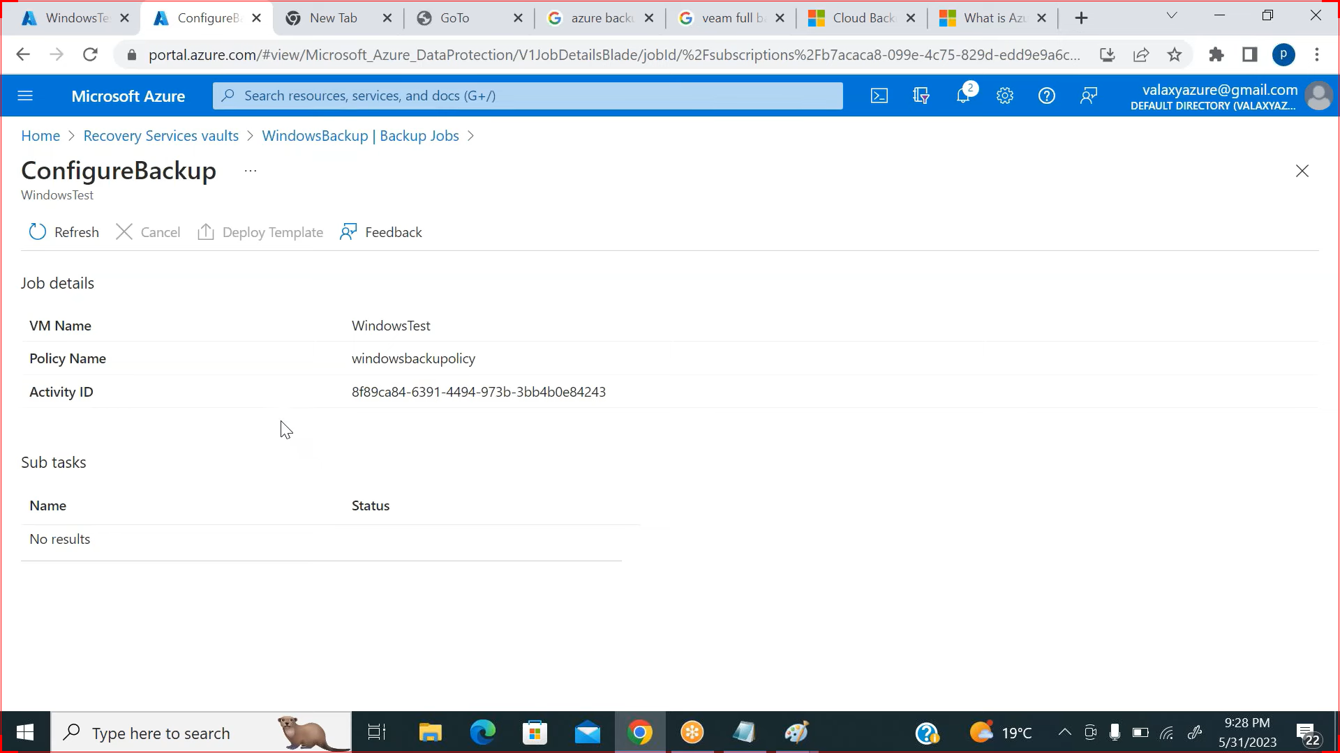
HOW TO TAKE PARTICULAR FILE OR FOLDER BACKUP USING MARS .
-DOWNLOAD MARS IN SYSTEM
-OPEN MARS CLICK ON REGISTER & PROVIDE PWD .
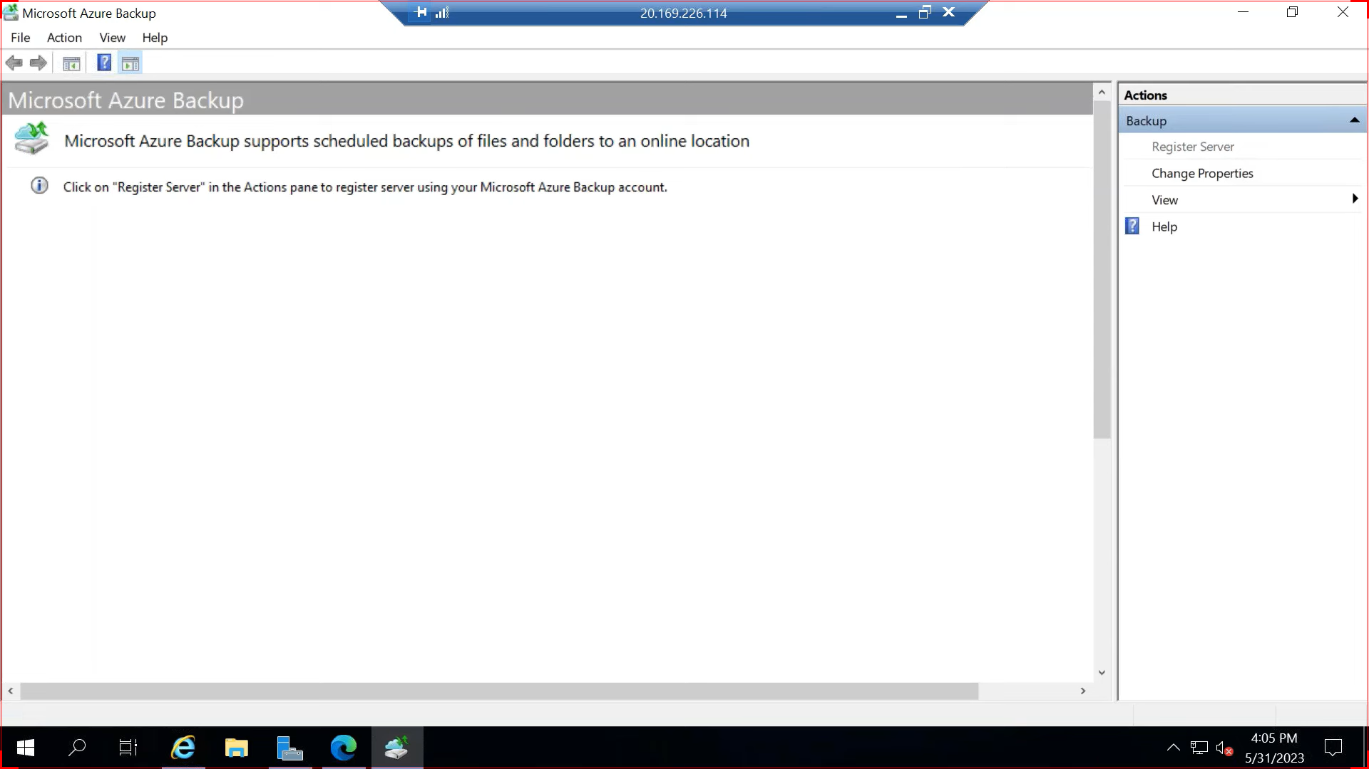
GO TO VAULT:- CLICK BACKUP SELECT RESOURCE TYPE.
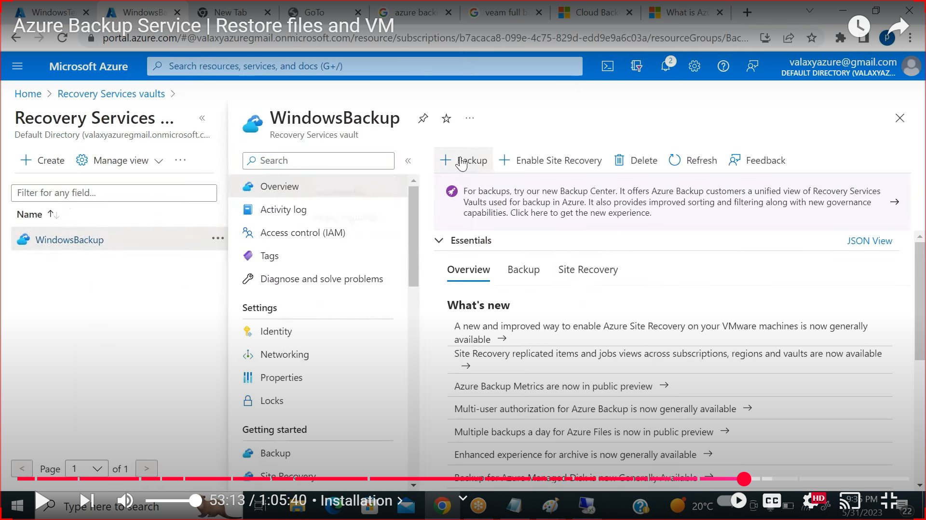
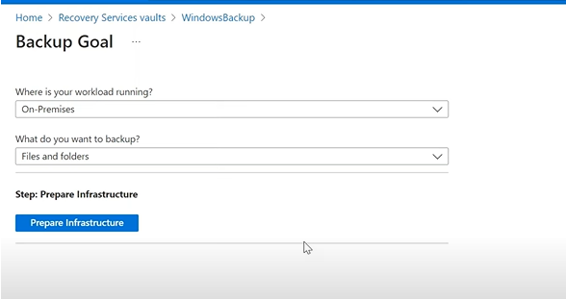
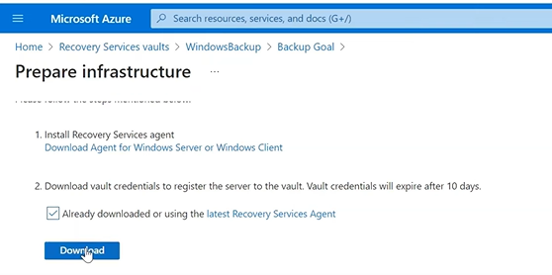
DOWNLOAD PWD COPY IN TARGET VM ,AND USE IT.
GO TO TARGET VM AND UPLOAD CREDENTIALS.
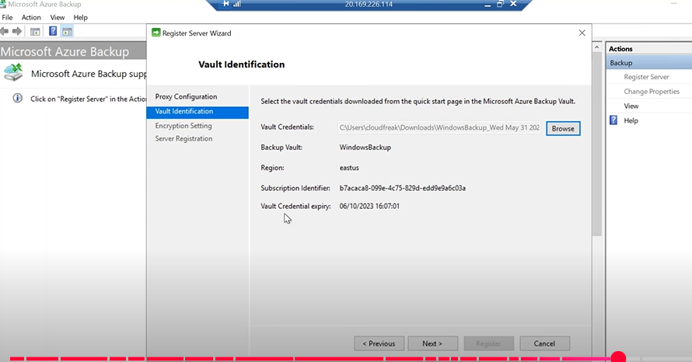

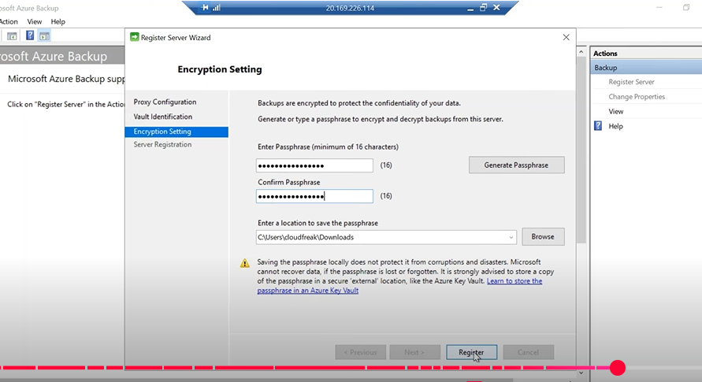
NOW OPEN MARS AND SCHEDULE BACKUP.
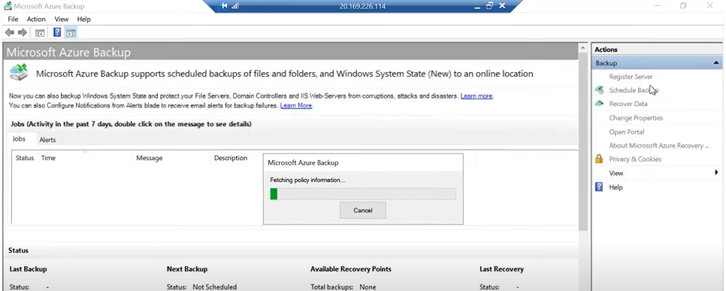
SELECT SPECIFIC FILE OR BACKUP WHILE CREATING BACKUP.
