📘 Azure Storage Account –
1. Introduction
Azure Storage Account ek centralized storage platform hai jahan hum different types ka data store kar sakte hain.
Yeh highly available, scalable, durable aur secure service hai.
👉 Ek storage account = ek namespace jisme multiple services hoti hain.

2. Storage Services (Core Components)
🔹 1. Blob Storage
- Unstructured data store karta hai (image, video, logs, backup)
- Types:
  - Block Blob → files & media
  - Append Blob → logs
  - Page Blob → VM disks
👉 Use case: backup, media storage, data lake

🔹 2. File Storage
- SMB/NFS protocol support
- File share jaise kaam karta hai
- Lift & shift apps ke liye best
👉 Example: on-prem file server ko cloud me move karna

🔹 3. Queue Storage
- Message-based communication
- Async processing ke liye use hota hai
👉 Example: order system → queue → background processing

🔹 4. Table Storage
- NoSQL key-value store
- Schema-less data
👉 Example: large-scale structured but flexible data

3. Storage Account Types
🔹 General Purpose v2 (GPv2)
- Most recommended
- All services support karta hai
- Lifecycle management available
🔹 General Purpose v1
- Old version (limited features)
🔹 Blob Storage Account
- Only blob ke liye optimized
🔹 Premium Storage
- SSD based (low latency, high IOPS)

4. Performance Tier
- Standard → HDD based, cost-effective
- Premium → SSD based, high performance
👉 Premium use: databases, high TPS apps

5. Replication (VERY IMPORTANT 🔥)
🔹 LRS (Locally Redundant Storage)
- Same data center me 3 copies
🔹 ZRS (Zone Redundant Storage)
- Multiple availability zones me data
🔹 GRS (Geo Redundant Storage)
- Secondary region me replication
🔹 RA-GRS
- Secondary region se read access bhi
👉 Interview line:
“Replication ensures high availability + durability even during region failure.”

6. Access Tiers (Blob Storage)
🔹 Hot
- Frequently accessed data
- High storage cost, low access cost
🔹 Cool
- Less frequent access
- Lower storage cost
🔹 Archive
- Rarely accessed
- Very cheap but retrieval slow

7. Security Features 🔐
- RBAC (IAM roles)
- Storage Account Keys
- SAS Token → temporary limited access
- Private Endpoint → secure private access
- Firewall + VNet restriction
👉 Encryption:
- Default: Microsoft-managed keys
- Optional: Customer-managed keys (CMK)

8. Data Access Methods
- REST API (HTTP/HTTPS)
- Azure CLI / PowerShell
- SDKs (Java, Python, .NET)
- Azure Portal

9. Lifecycle Management
- Data ko automatically move kar sakte ho:
Hot → Cool → Archive
- Old data auto-delete
👉 Cost optimization ke liye important

10. Integration
- Azure Data Lake Storage Gen2 → big data analytics
- Azure Kubernetes Service → volumes & logs
- Azure CDN → faster content delivery

11. Important Interview Points
- Storage account name globally unique hota hai
- Region selection impacts latency & cost
- Highly durable (11 9’s durability)
- Public & private access dono support
- Static website hosting possible

12. Real-Time Use Cases
- Backup & Disaster Recovery
- Application logs storage
- Media streaming
- Data lake architecture
- DevOps pipelines (artifact storage)

📘 Azure Storage Account – Section Wise Q&A
🔹 1. Basic Q&A
Q1. Azure Storage Account kya hai?
👉 Azure Storage Account ek scalable, durable aur secure storage service hai jisme hum Blob, File, Queue aur Table data store karte hain.
Q2. Isme kaun-kaun se storage types hote hain?
👉 Blob (unstructured), File (SMB/NFS), Queue (messaging), Table (NoSQL).
Q3. Real use case kya hai?
👉 Backup, logs, media storage, application data store.

🔹 2. Intermediate Q&A
Q4. Blob vs File Storage?
👉 Blob internet-based object storage hai, jabki File SMB/NFS based file share provide karta hai.
Q5. Hot vs Cool vs Archive?
👉 Hot → frequent access, Cool → less access, Archive → rarely access (low cost, slow retrieval).
Q6. GPv2 kyu use karte hain?
👉 Kyunki yeh latest hai, lifecycle management + all features support karta hai.

🔹 3. Replication (🔥 Important)
Q7. LRS kya hai?
👉 Same data center me 3 copies store karta hai.
Q8. GRS kya hai?
👉 Secondary region me data replicate hota hai (DR purpose).
Q9. ZRS kya hai?
👉 Different availability zones me data store hota hai.
Q10. Best kaunsa hai?
👉 Critical data ke liye GRS/RA-GRS best hai.

🔹 4. Security Q&A
Q11. Storage secure kaise karte ho?
👉 RBAC, SAS Token, Private Endpoint, Firewall.
Q12. SAS Token kya hai?
👉 Temporary limited access provide karta hai specific resource ke liye.
Q13. SAS vs Access Key?
👉 Access key full access deta hai, SAS limited aur time-bound hota hai.

🔹 5. Scenario-Based Q&A
Q14. Highly critical data hai – kya use karoge?
👉 RA-GRS use karunga taki DR + read access dono mile.
Q15. Cost optimize karna hai?
👉 Lifecycle management use karke Hot → Cool → Archive shift karunga.
Q16. App private network me hai?
👉 Private Endpoint use karunga, public access disable kar dunga.
Q17. Rarely accessed data?
👉 Archive tier best hai.

🔹 6. Troubleshooting Q&A
Q18. Access denied error?
👉 Check RBAC role, SAS expiry, firewall/VNet restriction.
Q19. Slow performance issue?
👉 Check tier (Standard vs Premium), network latency, region mismatch.
Q20. Data loss avoid kaise karte ho?
👉 Replication enable + soft delete + versioning use karta hoon.

🔹 7. DevOps / Real-Time Q&A
Q21. Terraform se kaise create karte ho?
👉 azurerm_storage_account resource use karte hain with replication & tier config.
Q22. AKS me use kaise hota hai?
👉 Azure Kubernetes Service me persistent volumes aur logs store karne ke liye.
Q23. CI/CD me use?
👉 Artifacts, logs aur backup store karne ke liye use hota hai.

🔹 8. Rapid Fire 🔥
Q24. Storage account name kaisa hota hai?
👉 Globally unique + lowercase.
Q25. Encryption default hoti hai?
👉 Haan, Microsoft-managed keys se.
Q26. Blob vs Data Lake?
👉 Data Lake optimized hai analytics ke liye (hierarchical namespace).
Q27. Lifecycle management kya karta hai?
👉 Data ko auto move/delete karta hai based on rules.

Azure Storage Account – Authentication Methods (Detailed)
🔹 Overview
Azure Storage Account ko access karne ke liye 3 main authentication methods hote hain:
- Access Keys
- SAS Token
- Azure AD (RBAC)

🔐 1. Access Keys (Account Keys)
👉 Kya hota hai?
- Storage account ke 2 keys hote hain (key1, key2)
- Full access provide karte hain (admin level)
👉 Kaise use hota hai?
- Connection string me use hota hai
- Apps directly use kar sakti hain
👉 Example
DefaultEndpointsProtocol=https;
AccountName=xyz;
AccountKey=abcd1234;
👉 Pros
- Simple aur easy
- Quick setup
👉 Cons ❌
- Full access (least secure)
- Agar leak ho gaya → pura storage compromise
👉 Interview Line
👉 “Access keys provide full control, so they should be rotated regularly and avoided in production apps.”

🔐 2. SAS Token (Shared Access Signature)
👉 Kya hota hai?
- Time-bound + permission-based access
- Specific resource ke liye limited access
👉 Types
- Service SAS → specific service (Blob/File)
- Account SAS → multiple services
- User Delegation SAS → Azure AD based (more secure)
👉 Example
https://storage.blob.core.windows.net/container/file.txt?sv=2023&st=...&se=...
👉 Permissions
- Read / Write / Delete / List
👉 Pros
- Secure (limited access)
- Expiry time set kar sakte ho
- Least privilege principle follow karta hai
👉 Cons ❌
- Manage karna complex ho sakta hai
- Expiry track karna padta hai
👉 Interview Line
👉 “SAS token is used to delegate limited and temporary access without exposing account keys.”

🔐 3. Azure AD Authentication (RBAC) ✅ BEST
👉 Kya hota hai?
- Identity-based authentication using Azure AD
- Role-based access control (RBAC)
👉 Kaise kaam karta hai?
- User / Service Principal ko role assign karte hain
- Example roles:
  - Storage Blob Data Reader
  - Storage Blob Data Contributor
👉 Flow
User → Azure AD → Token → Storage access
👉 Pros
- Most secure 🔥
- No keys required
- Centralized access control
👉 Cons ❌
- Setup thoda complex
- Initial learning curve
👉 Interview Line
👉 “Azure AD with RBAC is the recommended approach as it provides secure, identity-based access with least privilege.”

🔥 Comparison Table (Interview Favorite)
Feature | Access Key | SAS Token | Azure AD
Access Level | Full | Limited | Role-based
Security | Low | Medium | High ✅
Expiry | No | Yes | Token-based
Use Case | Testing | Sharing | Production

🔹 Real-Time Scenarios
👉 Scenario 1
App publicly file download kar raha hai
✔ Use → SAS Token
👉 Scenario 2
Internal secure app hai
✔ Use → Azure AD (RBAC)
👉 Scenario 3
Quick testing / script
✔ Use → Access Key

🔥 Final Interview Answer (Perfect बोलने वाला)
👉 “Azure Storage supports three authentication methods: Access Keys for full access, SAS tokens for limited and time-bound access, and Azure AD with RBAC for secure, identity-based access. In production, Azure AD is preferred due to better security and least privilege control.”

📘 Securely Access Azure Storage Account
🔹 1. Identity-Based Access (Most Important)
👉 Azure Storage Account ko Azure AD (RBAC) se access karo
- User / App ko role assign karo
- Example: Storage Blob Data Reader / Contributor
- No keys expose karne ki zarurat
👉 ✅ Most secure method

🔹 2. Disable Public Access 🚫
- “Allow Blob Public Access” = Disabled
- Taaki koi bhi internet se direct access na kar sake

🔹 3. Private Endpoint (Network Security) 🔐
👉 Storage ko Private Endpoint se VNet ke andar expose karo
- Public internet bypass ho jata hai
- Private IP se access hota hai
👉 Interview line:
“Traffic flows over Microsoft backbone, not public internet.”

🔹 4. Firewall & VNet Restriction
- Sirf trusted IPs allow karo
- Ya specific VNet/Subnet allow karo
👉 Extra security layer

🔹 5. SAS Token (Controlled Sharing)
- Limited permission + expiry ke sath use karo
- Example: sirf read access for 1 hour
👉 Never share access keys

🔹 6. Encryption 🔐
- Default: Microsoft-managed keys
- Advanced: Customer Managed Keys (CMK)
👉 Data at rest always encrypted

🔹 7. Secure Data in Transit
- HTTPS only enable karo
- HTTP disable
👉 Prevents data sniffing

🔹 8. Monitoring & Logging
- Storage analytics logs enable karo
- Azure Monitor / Log Analytics use karo
👉 Unauthorized access detect karne ke liye

🔥 End-to-End Secure Architecture (Interview Answer)
👉 “To securely access Azure Storage Account, I use Azure AD RBAC for identity-based authentication, disable public access, enable private endpoints to restrict traffic within VNet, apply firewall rules, use SAS tokens for limited external access, and ensure encryption with HTTPS and at-rest keys.”

📘 Azure Storage Account – Advanced Q&A
🔹 1. Private Endpoint vs Service Endpoint?
Q: Difference between Private Endpoint and Service Endpoint?
👉
- Service Endpoint: public IP use karta hai but restricted via VNet
- Private Endpoint: private IP assign hota hai (fully private access)
👉 Best: Private Endpoint (zero public exposure)

🔹 2. How do you design secure storage architecture?
Q: Secure architecture kaise design karoge for Azure Storage Account?
👉
- Azure AD (RBAC) use karunga
- Public access disable
- Private Endpoint enable
- Firewall restrict
- SAS for temporary access

🔹 3. How to handle key rotation?
Q: Access key rotation kaise karte ho without downtime?
👉
- 2 keys (key1, key2) use hote hain
- App me ek key use ho rahi → dusri regenerate karo
- Phir switch karo → first key regenerate
👉 Zero downtime rotation

🔹 4. How to optimize cost?
Q: Cost optimization strategy kya hai?
👉
- Lifecycle policies (Hot → Cool → Archive)
- Right replication choose (LRS vs GRS)
- Unused data delete
- Reserved capacity

🔹 5. How to improve performance?
Q: Storage performance kaise improve karte ho?
👉
- Premium tier use karo (SSD)
- Data ko same region me rakho
- CDN integrate karo
- Parallel uploads use karo

🔹 6. Data protection strategies?
Q: Data loss avoid kaise karte ho?
👉
- Soft delete enable
- Versioning enable
- GRS/RA-GRS use
- Backup strategy implement

🔹 7. Difference: Blob vs Data Lake?
Q: Blob vs Azure Data Lake Storage Gen2?
👉
- Blob → general storage
- Data Lake → hierarchical namespace + analytics optimized
👉 Big data workloads → Data Lake

🔹 8. Multi-region architecture?
Q: Global users ke liye design kaise karoge?
👉
- GRS/RA-GRS enable
- Azure CDN use karo
- Geo-distribution improve karo

🔹 9. How to restrict public access completely?
Q: Internet se access kaise block karte ho?
👉
- Public access disable
- Private Endpoint enable
- Firewall → deny all

🔹 10. Monitoring & auditing?
Q: Monitoring kaise karte ho?
👉
- Azure Monitor logs
- Diagnostic settings enable
- Alerts configure

🔹 11. Handling large data migration?
Q: TBs data migrate kaise karoge?
👉
- AzCopy tool
- Azure Data Box (offline transfer)
- Parallel upload strategy

🔹 12. Storage in AKS?
Q: Azure Kubernetes Service me storage kaise use hota hai?
👉
- Persistent Volume (PV)
- Azure Disk / Azure File
- Logs store in Blob

🔹 13. Throttling issue?
Q: Storage throttling kaise handle karte ho?
👉
- Retry mechanism (exponential backoff)
- Partitioning data
- Premium tier switch

🔹 14. SAS misuse prevention?
Q: SAS token misuse kaise prevent karte ho?
👉
- Short expiry
- IP restriction
- Minimum permissions
- HTTPS enforce

🔹 15. Real DevOps Scenario 🔥
Q: CI/CD pipeline me storage ka use kaise karoge?
👉
- Artifacts store in blob
- Logs store
- SAS token se temporary access
- Secure via RBAC + Private Endpoint

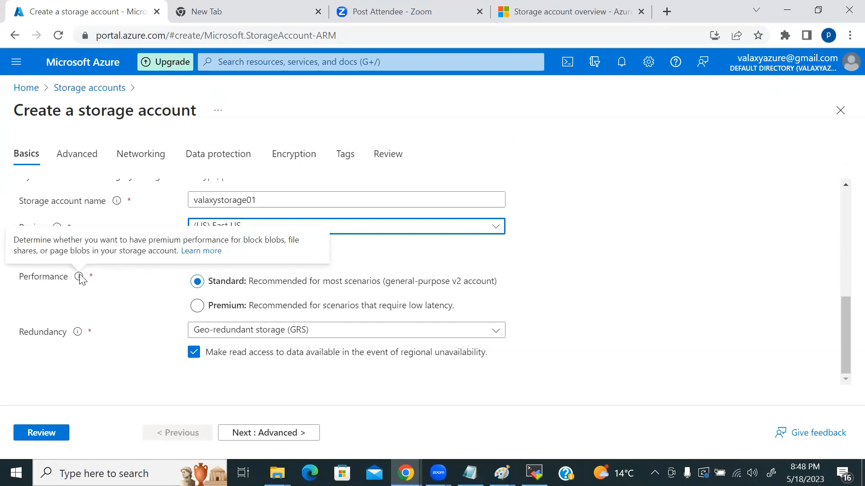

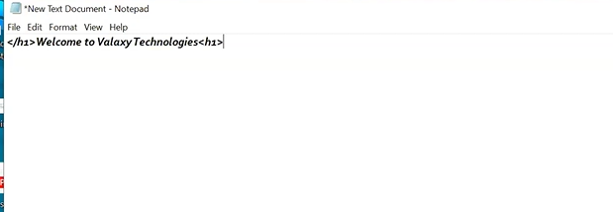
Static web bna kr us l container mea ek index.html bna kr daal do .
