1. Objective:

* Digital read thru arduino using a temperature / humidity digital sensor (DHT22)
* Arduino library install(?)

1. Hardware

2.1 DHT22: digital output temperature / humidity sensor

+ download DHT specification

++ Pin diagram

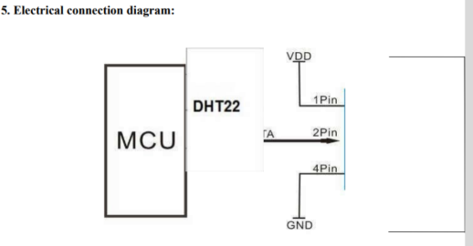

++ communication protocol

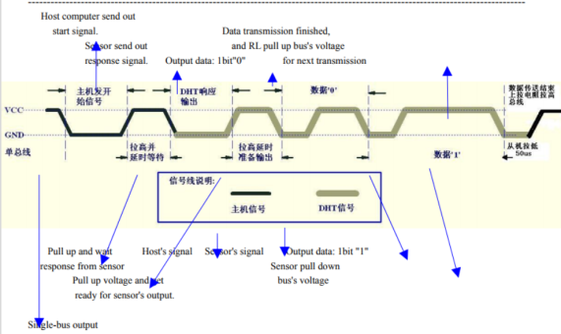

1. Build a circuit

<https://gustmees.wordpress.com/2018/03/25/first-steps-with-the-arduino-nano-dht22-temperature-humidity-with-meter-maker-makered-coding/>

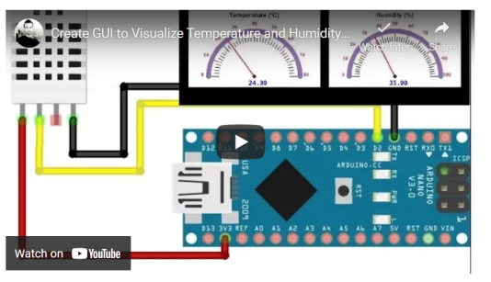

1. **DHT library download**

* <https://www.electroschematics.com/arduino-dht22-am2302-tutorial-library/>
* Unzip the download
* The generated folder as ‘DHTtester’ has a subfolder including the auduino source file ‘DHTtester’
* Copy and paste the source file ‘DHTtester’ into the folder DHTtester

1. Open “DHTtest.ino” and upload
2. If the compiling and upload is finished, it will be run
3. To see the serial output,

In arduino : **tool>serial monitor**

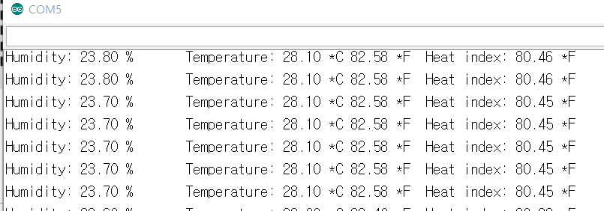

%%%%%% read analog output %%%%%%

1. Objective:

* Analog read thru Arduino using a variable potentiometer
* Using matlab to draw the resistor in real time

1. 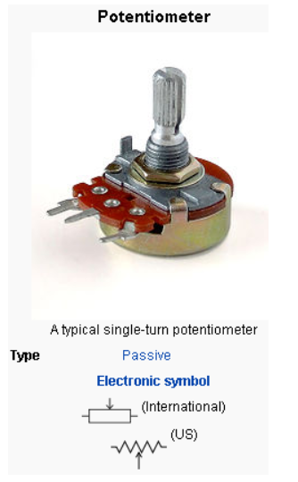Hardware

* Variable resistor

1. Down load “matlab support package Build a circuit

* Find the directory “SupprotPackages” under Matlab. It may be under the main matlab folder or independent folder
* Download all the files under Ashbirr

1. Build a circuit

* One of Arduino analog pin will be connected to the pin2 of the potentiometer

1. Connect the B/D to PC
2. Run the matlab code “VariablePotentiometer.m”

See the output graph changing the resistance.

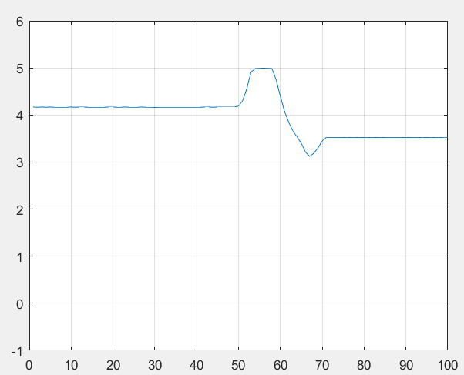

Home Assignment:

* Report to read digital output using DHT22
* Report to read analog output using multiple resistors.