HILS_1 03/17_Arduino

1. Objective : run an arduino code to blink control a led connected thru Arduino.
2. Set up the arduino environment
   1. download Arduino IDE 1.8.13 : <https://www.arduino.cc/en/software>
   2. “Getting started with arduino Nano” : <https://www.arduino.cc/en/Guide>
   3. Check the “arduino icon” in the desktop
3. 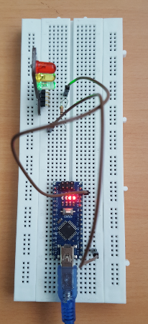Build a circuit in a bread B/D
   1. With PC power supply
   2. Independent power supply

<https://www.instructables.com/LED-BLINKING-USING-ARDUINO-NANO/#:~:text=To%20connect%20LED's%20positive%20end,and%20negative%20to%20the%20ground>.

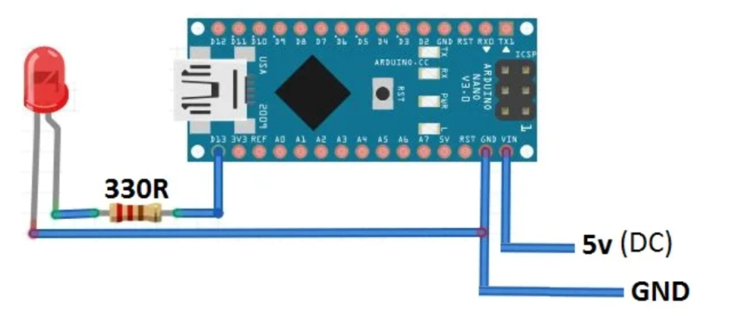

%%% Kim’s comment : why $330 Ω$? Since the resistance of LED is very small, even if the supplied voltage is small, the current may be large to destroy the LED. Hence to prevent the excessive current, a resistor is needed as $100\sim 1000Ω$%%%

%%% Kim’s comment

Check the schematic diagram of arduino nano

<https://www.circuitstoday.com/arduino-nano-tutorial-pinout-schematics>

In the circuit, the output pin is connected to D13 (real pin number is 16)

1. Connect to Pc thru USB

* Connect USB to PC

1. H/W environment Check

* Confirm the COMPORT number 🡪 COM5

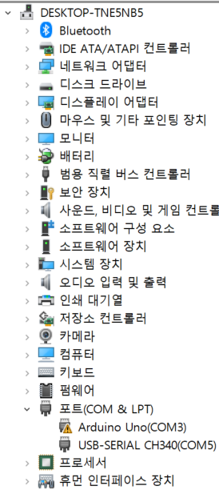

1. Open Arduino code

* Click “Arduino” icon
* Open ‘sketch_0308’

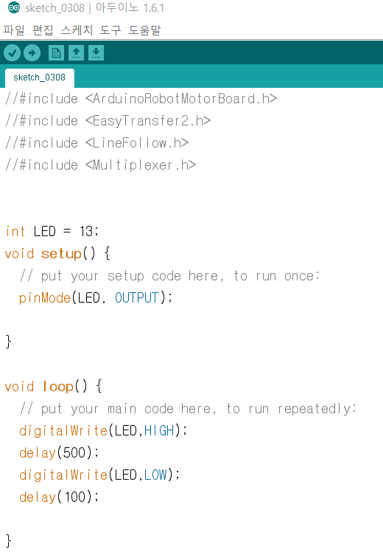

1. Arduino environment setup

In the upper bar

1. B/D setting: Tool>Board>Arduino …
2. Processor setting: Tool>process>Atmel328
3. Port setting : Tool >port >COM5 (as in step 5)
4. Upload

In the upper bar click “Upload”

* If compile is incorrect then upload code into m/c

1. Automatically execute your code.

Team announcement

* 3 students:

+ programmer : program a code in lap-top / keep the code

+ simulator : hardware designer / keep the harware

+ manager: write a report (including H/W specifications) /

03/17 Objective

+ Blink a led

++ write a technical spec

++ simulation environment

++ circuit diagram /code / simulation ..

++ results