1. HW 1.5

Prove $R_{xx}\left(0\right)=\frac{W}{2a}$ not using (1)’

$R_{xx}\left(τ\right)=E\left[x\left(t\right)x\left(t+τ\right)\right]=\frac{1}{2π}\int_{-∞}^{∞}{G_{xx}\left(ω\right)e^{jωτ}dω}=\frac{W}{2a} e^{-a\left|τ\right|} --(1)'$

Hence $R_{xx}\left(0\right)=\frac{W}{2a} e^{-a\left|τ\right|}|_{τ=0}=\frac{W}{2a}$

* Or

$$R_{xx}\left(τ=0\right)=\frac{1}{2π}\int_{-∞}^{∞}{G_{xx}\left(ω\right)e^{jωτ}dω|_{τ=0}=\frac{1}{2π}\int_{-∞}^{∞}{\frac{W}{ω^{2}+a^{2}}dω}}$$

Since

$$\int{\frac{1}{1+x^{2}}dx=\tan^{-1}{x}+C}$$

We will use this formula,

$$\int_{-∞}^{∞}{\frac{W}{ω^{2}+a^{2}}dω}=\int_{-∞}^{∞}{\frac{W/a^{2}}{{\left(\frac{ω}{a}\right)}^{2}+1 }dω}=\frac{W}{a^{2}}\int_{-∞}^{∞}{\frac{1}{{\left(\frac{ω}{a}\right)}^{2}+1 }ad(\frac{ω}{a})}$$

$$=\frac{W}{a}\tan^{-1}{\frac{ω}{a}|_{-∞}^{∞}}=\frac{W}{a}\left(\frac{π}{2}-\left(-\frac{π}{2}\right)\right)=\frac{Wπ}{a}$$

Hence

$$R_{xx}\left(τ=0\right)=\frac{1}{2π}\int_{-∞}^{∞}{\frac{W}{ω^{2}+a^{2}}dω}=\frac{1}{2π}\left(\frac{Wπ}{a}\right)=\frac{W}{2a}$$

1. HW 1.6
   1. prove the ex.6.13 : See the text book
   2. Plot $G_{yy}\left(ω\right) , 0<ω<1000, ω_{d}=2πf_{d} , f_{d}=50, ζ=0.1 , ω_{n}=2πf_{n}, f_{n}=5$

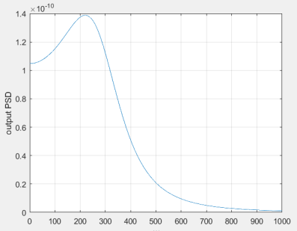 : Some mistakes. $ω_{d} ≡ω_{n}\sqrt{1-ξ^{2}}$

1. HW.2.1 : Prove the PSD of discrete system
2. HW.2.2: the non-causal filter example
   1. Write a code in the comments, run your code to check the result as in (2’)
   2. Non-causal filter is not a real time filter, It is batch – type filter. In the case of a real time filter, it is difficult to construct a constant phase filter(Really!), which means even if you may construct a Kalman filter, in the steady state, so that you may have a transfer function, but it is not a constant phase!!

%%%

1. HW. 2.3
   1. How about the other stationary points?

From (2’),

$$\frac{dx}{dt}= f\left(x\right)= -x\left(1-x^{2}\right)=0$$

The others stationary points are

* 1. Draw the phase portraits

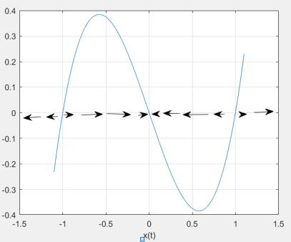

* 1. At the initial point $x\left(t=0\right)=0.5 ,$ draw the trajectory.

And 5.4



