* The Unscented Kalman Filter
* 1960’: Kalman introduced his famous Optimal Controller(LQR, LGQG)
* 1970’; Jazwinski introduced EKF
* 1990’: Julier, Uhlmann introduced “Unscented Kalman” – non-linear filter

based on Kalman filter.

* Present: modifications on Unscented Kalman for the applications to non-linear estimation problems.

1. Introduction for non-linear filter

Given a non-linear system, to estimate the states, with the assumption of small perturbation on the stationary point(or let say attractor), EKF is based on the **Taylor series.**

The other approach was based on approximation for **probability characteristics**, , mean and variance of the trajectory. To get the mean and variance of the random variables (or process), the analytic methods are impossible in general.

To get a mean and variance, the simple method but huge number of realizations of the model will be helpful, so called **Monte Carlo simulation**.

1. Simple example- one dimensional case

Consider a random variable $y$ which is a non-linear transform of a gaussian R.V. $x \sim N(\overline{x}, σ_{x}^{2})$

$y=x^{2}$

Find the mean and variance of

* 1. Find the PDF

Let $x \sim N\left(\overline{x}, σ_{x}^{2}\right)=N({0,1}^{2})$

Then using the definition of the probability distribution,

<https://stats.stackexchange.com/questions/192807/pdf-of-the-square-of-a-standard-normal-random-variable>

Then **we may find the mean and the variance of y**

* 1. Monte Carlo simulation

We may realize (or simulate) to solve it as many as possible using COMPUTER. Let a simulation in matlab code

clear all; clc

std=1;

n = 10000; % the number of simulations , as Monte Carlo

x = std.*randn(n,1); % mean=0,

figure(1)

plot(x,'.')

figure(2)

histogram(x,50)

y = x.^2;

figure(3)

plot(y,'.')

figure(4)

histogram(y,50)

fprintf(' mean and variance of r %4.2f and %4.2f using Monte Carlo \n',mean(x), var(x))

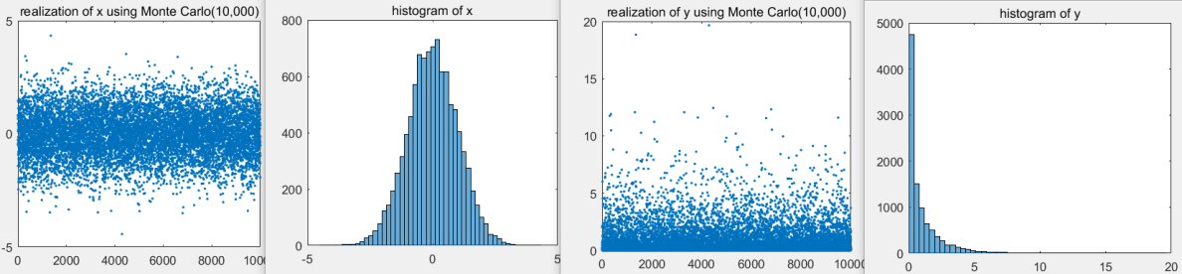fprintf(' mean and variance of r^2 %4.2f and %4.2f \n',mean(y), var(y))

>> mean and variance of x 0.00 and 1.00 using Monte Carlo

mean and variance of x^2 1.00 and 2.04

Hence by realization(or simulation) the mean and the variance of $y$ are **1.00 and 2.04.**

We may call “A realization” as “A sigma point”.

* 1. Analytic way without PDF

Let $x$ as

$$x= \overline{x}+δx$$

Then $δx \sim N(0, σ_{x}^{2})$

The non-linear transform is

$$y=x^{2}={\left(\overline{x}+δx\right)}^{2}= {\overline{x}}^{2}+2\overline{x}δx+{\left(δx\right)}^{2}$$

Therefore taking expectations

$$\overline{y}= E\left[y\right]=E\left[x^{2}\right]={\overline{x}}^{2}+E\left[{\left(δx\right)}^{2}\right]= {\overline{x}}^{2}+σ_{x}^{2}$$

For the variance of $y$

$${\left(y- \overline{y}\right)}^{2}={ (\left(\overline{x}+δx\right)}^{2}-({\overline{x}}^{2}+σ_{x}^{2}))^{2} \\ ={\left(2\overline{x}δx+δx^{2}-σ_{x}^{2}\right)}^{2} \\ ={\left(δx\right)}^{4}+4\overline{x}{\left(δx\right)}^{3}+\left(4{\overline{x}}^{2}-2σ_{x}^{2}\right){\left(δx\right)}^{2}-4σ_{x}^{2}\overline{x}δx+σ_{x}^{4}$$

Taking expectations

$$σ_{y}^{2}=E\left[{\left(δx\right)}^{4}\right]+4{\overline{x}}^{2} σ_{x}^{2}-σ_{x}^{4}$$

Since

$$E\left[{\left(δx\right)}^{4}\right]=3σ_{x}^{4} (2)$$

The variance of $y, σ_{y}^{2},$ is

$$σ_{y}^{2}={2σ}_{x}^{4}+4{\overline{x}}^{2} σ_{x}^{2}$$

Now if then

* 1. Linearize method

Since

$$y=x^{2}={\left(\overline{x}+δx\right)}^{2}= {\overline{x}}^{2}+2\overline{x}δx+{\left(δx\right)}^{2}$$

If we take the first order term as linearization procedure in general, $$y_{LIN}\sim {\overline{x}}^{2}+2\overline{x}δx$$

Taking expectations

$$E\left[y_{LIN}\right]= {\overline{x}}^{2}, ∵E\left[δx\right]=0$$

For the variance

$${σ_{y}^{2}}_{LIN}=4{\overline{x}}^{2} σ_{x}^{2}$$

Now if then

* 1. Summarize

|  |  |  |  |
| --- | --- | --- | --- |
|  | Mean $\overline{y}$ | Variance $σ_{y}^{2}$ |  |
| PDF | 1 | 2 | difficult |
| Monte Carlo | 1 | 2.04 | Simple but costly and not realtime |
| Without PDF | 1 | 2 | Comparatively easy |
| Linearized | 0 | 0 | Too large of error |

%%% **HW.3.1**

3.1 prove pdf of $y$ as (1) and find the mean and the variance if $x \sim N(0, 1^{2})$

%% Hint : to get the mean and variance, using symbolic math in matlab

3.2 To get the mean and the variance of y, use Monte Carlo with different number of simulation to see the result, i.e., n = 1000,5000, 50000.

3.3 Prove (2), $E\left[{\left(δx\right)}^{4}\right]=3σ_{x}^{4}$

%%%

1. The Unscented transformation

%%% Kim’s comment

The anther method, which is a brilliant idea, is developed in the statistics, where the Monte Carlo method is popular to get probabilistic characters. One of the deficiency of Monte Carlo simulation is that the cost is very high and it is difficult to be realtime. See [3] %%

3.1 Unscented Transform

Let’s non-linear transformed function $y=f\left(x\right), x :a guassian random variable$

To implement a Kalman filter, it is needed to get the mean and variance of $y$.

In the previous examples, to get PDF, Monte Carlo , or without PDF, still it is difficult. Now we may introduce “Unscented Transform” to solve(or get approximate) to this problem.

* Error using linearization : Example in multivariable case [1]

Consider two gaussian random variables $\left(x_{1},x_{2}\right)$ as

$$μ=E\left[ \begin{matrix}x_{1} \\ x_{2}\end{matrix}\right]= \left[\begin{matrix}0 \\ 0\end{matrix}\right] , Σ= \left[\begin{matrix}32 & 15 \\ 15 & 40\end{matrix}\right]$$

And its non-linear transformed system as

$$y_{1}=x_{1}+x_{2} \\ y_{2}=0.1 x_{1}^{2}+x_{2}^{2}$$

Then Monte Carlo simulation 10,000 times,

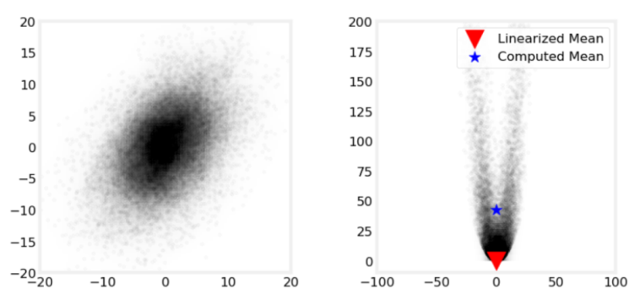

In this figure, the errors between the Monte and the linearized mean are

$$errors=(-0.055,42.895)$$

Again in the multivariable case, the errors is bigger than that of Mote Carlo simulation. We may believe that Monte Carlo simulation is more correct to estimate the mean and the variance. However the deficiency to use Monte Carlo is the computational cost is high( 10,000 sigma points are needed!) and due to this fact it may not be applied to real time simulation.

* Unscented Transform[2]

To get the mean and the variance of a non-linear transformed random variable, In contrast to Monte Carlo method which is to select sigma points randomly and huge number of sigma points, The unscented transform is

* To select the sigma points to be deterministic.
* The number of sigma points are very small.

1. Problem : given the following non-linear system

$y=f\left(x\right), x \sim N\left(\overline{x}, P_{xx}\right) , x∈R^{n}$

Find the mean $\overline{y}$ and the covariance $P_{yy}$ of $y,$

1. Define sigma points $χ$ with weighting function $W_{i}$

$$χ_{0}= \overline{x} , W_{0}=λ/(n+λ) \\ χ_{i}= \overline{x}+ {\left[\sqrt{\left(n+λ\right)P_{xx}} \right]}_{i}, W_{i}=\frac{1}{2}\left(n+λ\right), i=1,…,n \\ χ_{i+n }= \overline{x}- {\left[\sqrt{\left(n+λ\right)P_{xx}} \right]}_{i}, W_{i+n }=\frac{1}{2}\left(n+λ\right), i=1,…,n$$

where

$${\left[\sqrt{\left(n+λ\right)P_{xx}} \right]}_{i}=i_{th} column or row of P_{xx}$$

%%% the weighting factor has a constraint as

$$\sum_{i=0}^{2n}{W_{i}=1}$$

%%%

%%% what is $\sqrt{P_{xx}}$, the square root of a symmetric square matrix?

It is defined as

Let $M=M^{T},$ then there exists N such that

$$M={NN}^{T}$$

Then

$$\sqrt{M}= N$$

It is unique. Be careful as $$M=NN$$

Which may not be unique. %%%

1. Instantiate (projection) each points as
$$Υ_{i}=f\left(χ_{i}\right), i=0,1,…, 2n$$

2. The mean $\overline{y}$ of $y$
$$\overline{y}= \sum_{i=0}^{2n}{W_{i}Υ_{i}}$$

3. The covariance $P_{yy}$ of $y$

$$P_{yy}=\sum_{i=0}^{2n}{W_{i}\left\{Υ_{i}-\overline{y}\right\}{\left\{Υ_{i}- \overline{y}\right\}}^{T}}$$

In this procedure, $λ$ is a “tuning parameter”, in general, $x$ is a Gaussian, then

$$n+λ=3, n=dim⁡(x)$$

%%% Kim’s comment

* The number of sigma points = $2n+1 , n=the dimension of x$, which is small

compared to Monte Carlo.

* Sad
* Example of UT in $y=x^{2}$

Consider a non-linear system $y$

$$y=x^{2}, x \sim N(\overline{x},σ_{x}^{2})$$

1. Define sigma points

Since n=1,

$$\left\{χ_{0}, χ_{1}, χ_{2}\right\}= \left\{\overline{x}, \overline{x}+σ, \overline{x}-σ\right\}$$

Where $σ= \sqrt{\left(1+λ\right)σ_{x}^{2}}$

1. Projection these points thru $y=x^{2}$
$$\left\{Υ_{0}, Υ_{1}, Υ_{2}\right\}= \left\{{\overline{x}}^{2}, {\overline{x}}^{2}+2\overline{x}σ+σ^{2}, {\overline{x}}^{2}-2\overline{x}σ+σ^{2}\right\}$$

2. Calculating to get $\overline{y}$

$$\overline{y}= \sum_{i=0}^{2n}{W_{i}Υ_{i}}$$

$$=\frac{1}{2\left(1+λ\right)}\left(2λ{\overline{x}}^{2}+2{\overline{x}}^{2}+2\left(1+λ\right)σ_{x}^{2}\right) \\ ={\overline{x}}^{2}+σ_{x}^{2}$$

which is independent of the tuning parameter , $λ$, which is the same of ““TRUE mean of y in 2.1 and 2.3”.

1. Calculating the variance of $y, σ_{yy}$

$$σ_{y}^{2}=\frac{1}{2\left(1+λ\right)} \left(\sum_{i=1}^{2n}{{\left\{Υ_{i}- \overline{y}\right\}}^{2}+2λσ_{x}^{4}}\right) \\ =λσ_{x}^{4}+4{\overline{x}}^{2}σ_{x}^{2}$$

Which is the same of “TRUE variance of y in 2.1 and 2.3” if $λ=2$

* Example of UT in multivariable case [1]

In the previous example of “error in linearization”, if UT is applied, then

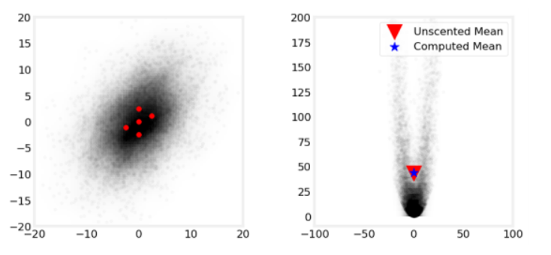

The mean errors compared to Monte Carlo, are

$$errors=\left(0.097,0.549\right)$$

which is much small to linearization method,

$$errors=(-0.055,42.895)$$

%%% Kim’s comment:

If the states are random, and a non linear function of the states is analyzed using UT not Linearized method! There are several reasons to select UT. %%%

Reference

[1]” Kalman and Bayesian Filters in Python”, ch.10

[2]” A New Extension of the Kalman Filter to Non-linear System”

[3] “A General Method for Approximating Nonlinear Nonlinear Transformations of Probability Distributions