1. Problem : estimation of distance, velocity and altitude of an airplane using surveillance radar
   1. Radar

* Surveillance radar

+ measurement: the slant range from the radar to the airplane

* Tracking radar

+measurement: the slant range and the angle of elevation

%%% Kim’s comment

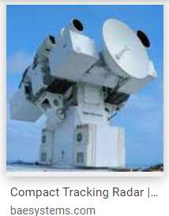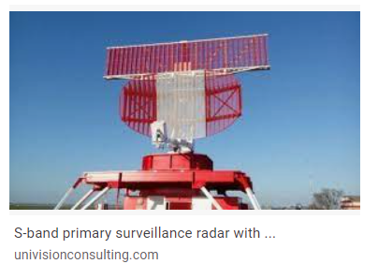

* Difference between surveillance and tracking radars

|  |  |  |  |
| --- | --- | --- | --- |
|  | surveillance | tracking | remark |
| Rotation | 360 degree | Tracking a target |  |
| Radar beam | Fan beam | Pencil beam |  |
| Range measurement | Slant range | Slant range |  |
| angle | Azimuth angle | Azimuth elevation angle |  |

If we do know the elevation angle, then the distance and altitude will be easily determined. %%%%%%%%%%

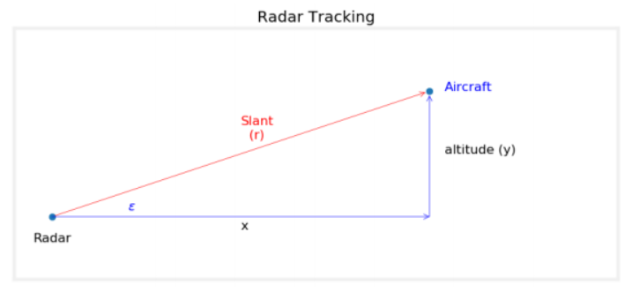

1. Plant Model : GetRadar.m

-Airplant

$$pos\left(t\right)=pos_{int}+vel*t, \\ alt\left(t\right)=alt_int$$

-radar measurement

$$r\left(t\right)= \sqrt{{(pos)}^{2}+{(alt)}^{2}}+v \\ v:0.05*rand, noise$$

1. Filter Design
   1. Real Plant in State space model

$$\left[\begin{matrix}pos \\ vel \\ alt\end{matrix}\right]≡\left[\begin{matrix}x \\ v \\ z\end{matrix}\right], {\left[\begin{matrix}pos \\ vel \\ alt\end{matrix}\right]}_{in}=\left[\begin{matrix}2000 \\ -100 \\ 1000\end{matrix}\right]$$

Then

$$\left[\begin{matrix}\dot{x} \\ \dot{v} \\ \dot{z}\end{matrix}\right]=\left[\begin{matrix}0 & 1 & 0 \\ 0 & 0 & 0 \\ 0 & 0 & 1\end{matrix}\right]\left[\begin{matrix}x \\ v \\ z\end{matrix}\right], r\left(t\right)={\left(x^{2}+v^{2}\right)}^{1/2}+v,$$

To discretization,

$$X_{k+1}=\left[\begin{matrix}x_{k+1} \\ v_{k+1} \\ z_{k+1}\end{matrix}\right]=\left[\begin{matrix}1 & dt & 0 \\ 0 & 1 & 0 \\ 0 & 0 & 1\end{matrix}\right]\left[\begin{matrix}x_{k} \\ v_{k} \\ z_{k}\end{matrix}\right]=AX_{k}, r_{k}={\left(x_{k}^{2}+v_{k}^{2}\right)}^{\frac{1}{2}}+v=h\left(X_{k}\right)+v$$

$$v=0.05\left(x_{k}\right)*w, w\sim N(0,1)$$

1. Plant model in Computer
$$X_{k+1}=\left[\begin{matrix}x_{k+1} \\ v_{k+1} \\ z_{k+1}\end{matrix}\right]=\left[\begin{matrix}1 & dt & 0 \\ 0 & 1 & 0 \\ 0 & 0 & 1\end{matrix}\right]\left[\begin{matrix}x_{k} \\ v_{k} \\ z_{k}\end{matrix}\right]+w_{k}=AX_{k}+w_{k},$$

$$E\left[\begin{matrix}x_{0} \\ v_{0} \\ z_{0}\end{matrix}\right]=\left[\begin{matrix}2000 \\ -90 \\ 1100\end{matrix}\right] ,M_{0}=100\left[\begin{matrix}1 & 0 & 0 \\ 0 & 1 & 0 \\ 0 & 0 & 1\end{matrix}\right]=P_{0}$$

$${E[w}_{k}w_{k}^{T}]=Q= \left[\begin{matrix}0.01 & 0 & 0 \\ 0 & 0.01 & 0 \\ 0 & 0 & 0.01\end{matrix}\right]$$

$$r_{k}={\left(x_{k}^{2}+v_{k}^{2}\right)}^{\frac{1}{2}}+v_{k}=h\left(X_{k}\right)+v_{k}$$

$$E\left[v_{k}v_{k}^{T}\right]=R=100$$

2. EKF design: RadarEKF.m
   1. Find jacobian

$$H=Hjacob\left({\hat{X}}_{k}\right);$$

where $H$ is the Jacobian of

* 1. Prediction

$${\overline{X}}_{k+1}=A{\hat{X}}_{k} \\ M=APA^{T}+W$$ 5.3 The Kalman gain $K_{k}$

$$K_{k}=MH^{T}{\left(HMH^{T}+V\right)}^{-1},$$

5.4 Correction

$${\hat{X}}_{k}= {\overline{X}}_{k}+K_{k}(r_{k}-h\left({\overline{X}}_{k}\right))$$

$$P=\left(I-K_{K}H\right)M$$

Using this correction states go to top to calculate the “H” matrix.

%%Kim’s comment

1. If $X_{k+1}=f(X_{k})$, then $A=\frac{∂f}{∂X}$
2. Compared to linear system, the measurement matrix $H$ is varying whereas in the linear system is constant
3. The model of real and computer may be different, in this case, the noise is added in the plant model. Of course you may model the noise will be zero. %%%
4. UKF design: RadarUKF.m
   1. Calculate the Sigma points and weighting : $\left[χ_{i} W\right]=SigmaPoints\left({\overline{x}}_{k}, P, 0\right)$

In this case, tuning parameter .

* 1. Find the mean and the variance of ${\overline{X}}_{k+1} , M$ using the unscented transform

$$\left[{\overline{X}}_{k+1}, M\right]=UT(f(χ_{i}),W,Q)$$

where

$f\left(x\right)=Ax , f\left(x\right)∈R^{3}$ (in this case)

%% Kim’s comment

You should define what is %%%

* 1. Find the mean and the variance of measurement using the unscented transform

$$\left[{\overline{r}}_{k}, P_{r_{k}}\right]=UT(h({f(χ}_{i}),W,R)$$

where

$h\left(f\left(χ_{i}\right)\right)=\sqrt{f\left({χ_{i}}_{x}^{2}\right)+f\left({χ_{i}}_{z}^{2}\right)} ,h(f\left(χ_{i}\right))∈R$ (in this case)

* 1. Find the cross covariance of $P_{\overline{x}\overline{r}}$
  2. Find the Kalman gain $K_{k}$
  3. Estimate (correction) of the states

$${\hat{X}}_{k}= {\overline{X}}_{k}+K_{k}(r_{k}-{\overline{r}}_{k})$$

$$P=M-KP_{\overline{x}\overline{r}}K^{T}$$

Using this mean and variance of estimate of $X_{k}$, go to top to calculate next sigma points

1. Simulation results

* It is a very popular problem to estimate the distance, velocity and altitude with

the measurement of the slant range

* The results of EKF and UKF are quite similar,

1. The estimate of velocity: within 15 sec,

${vel}_{est}=vel_{real}±10\%$, ${alt}_{est}=alt_{real}±15sec$

1. These are one of the specification on the airplane flight regulations and radar performances.

* however, if you change the models then they are a little different. Reasons for their similarities are due to

1. The plant is a linear system but the measurement is non-linear
2. The dynamics is also linear w.r.t the time
3. Probably this is one reason(it is not proved yet, I did not see the proof), in common sense, the non-linearity has no stationary point. If in the case of multiple stationary points, it may be quite different(See the papers about the UKF)

%%% HW week_4

Watch the following video and summarize its contents

<https://www.youtube.com/watch?v=DWDzmweTKsQ> %%%