Review the last lecture(week_3_Unscented Transform)

Given a non-linear transform

$$y=f\left(x\right), x\sim N(\overline{x}, σ_{x}^{2})$$

Fine the mean of $y, \overline{y}=E\left[y\right], and σ_{y}^{2}=E[{\left(y-\overline{y}\right)}^{2}]$

1. Find the pdf of $y$
2. Monte Carlo simulation
3. Linearizing the non-linear transform
4. Without PDF, apply a small perturbation to get 🡪 The unscented transform

Once more the Unscented Transform is

* Unscented Transform[2]

1. Problem : given the following non-linear system

$y=f\left(x\right), x \sim N\left(\overline{x}, P_{xx}\right) , x∈R^{n}$

Find the mean $\overline{y}$ and the covariance $P_{yy}$ of $y,$

1. Define sigma points $χ$ with weighting function $W_{i}$

$$χ_{0}= \overline{x} , W_{0}=λ/(n+λ) \\ χ_{i}= \overline{x}+ {\left[\sqrt{\left(n+λ\right)P_{xx}} \right]}_{i}, W_{i}=\frac{1}{2}\left(n+λ\right), i=1,…,n \\ χ_{i+n }= \overline{x}- {\left[\sqrt{\left(n+λ\right)P_{xx}} \right]}_{i}, W_{i+n }=\frac{1}{2}\left(n+λ\right), i=1,…,n$$

where

$${\left[\sqrt{\left(n+λ\right)P_{xx}} \right]}_{i}=i_{th} column or row of P_{xx}$$

1. Instantiate (projection) each points as
$$Υ_{i}=f\left(χ_{i}\right), i=0,1,…, 2n$$

2. **The mean $\overline{y}$ of $y$**
$$\overline{y}= \sum_{i=0}^{2n}{W_{i}Υ_{i}}$$

3. **The covariance $P_{yy}$ of $y$**

$$P_{yy}=\sum_{i=0}^{2n}{W_{i}\left\{Υ_{i}-\overline{y}\right\}{\left\{Υ_{i}- \overline{y}\right\}}^{T} } a)$$

%%% Kim’s comment

* The number of sigma points = $2n+1 , n=the dimension of x$, which is small, compared to Monte Carlo.
* In order to get the mean $\overline{y}=E\left[f\left(x\right)\right] , x \sim N(\overline{x}, P_{xx})$ in 4), **it does not need the Probability Density function of y.** For the covariance of $y, E\left[\left(y- \overline{y}\right){\left(y- \overline{y}\right)}^{T}\right]$**it does not need either! See 4), and 5) !!** In general to get the pdf of a non-linear transform is difficult so that the linearization may be used.
* The deficiency of linearization is it is necessary to calculate the Jacobian , so that some system it is difficult and it may not be linearized,.i.e.,
$$y=x^{2} -→ y_{Lin}=0 for x=0 !$$

* **Why does not UT need PDF to get the mean and variance? see [3]**
* Example of UT in $y=x^{2}$

Consider a non-linear system $y$

$$y=x^{2}, x \sim N(\overline{x},σ_{x}^{2})$$

1. Define sigma points

Since n=1,

$$\left\{χ_{0}, χ_{1}, χ_{2}\right\}= \left\{\overline{x}, \overline{x}+σ, \overline{x}-σ\right\}$$

Where $σ= \sqrt{\left(1+λ\right)σ_{x}^{2}}$

1. Projection these points thru $y=x^{2}$
$$\left\{Υ_{0}, Υ_{1}, Υ_{2}\right\}= \left\{{\overline{x}}^{2}, {\overline{x}}^{2}+2\overline{x}σ+σ^{2}, {\overline{x}}^{2}-2\overline{x}σ+σ^{2}\right\}$$

$$\left\{W_{0}, W_{1}, W_{2}\right\}=\{\frac{λ}{1+λ},\frac{1}{2\left(1+λ\right)},\frac{1}{2\left(1+λ\right)}\}$$

2. Calculating to get $\overline{y}$

$$\overline{y}= \sum_{i=0}^{2n}{W_{i}Υ_{i}}$$

$$=\frac{1}{2\left(1+λ\right)}\left(2λ{\overline{x}}^{2}+2{\overline{x}}^{2}+2\left(1+λ\right)σ_{x}^{2}\right) \\ ={\overline{x}}^{2}+σ_{x}^{2}$$

which is independent of the tuning parameter , $λ$, which is the same of ““TRUE mean of y in 2.1 and 2.3 inWeek_3_Nonlinear filter”.

1. Calculating the variance of $y, σ_{yy}$

$$σ_{y}^{2}=\frac{1}{2\left(1+λ\right)} \left(\sum_{i=1}^{2n}{{\left\{Υ_{i}- \overline{y}\right\}}^{2}+2λσ_{x}^{4}}\right) \\ =λσ_{x}^{4}+4{\overline{x}}^{2}σ_{x}^{2}$$

Which is the same of “TRUE variance of y in 2.1 and 2.3 in Week_3_Nonlinear filter ” if $λ=2$.

* Example of UT in multivariable case [1]

In the previous example of “error in linearization”, if UT is applied, then

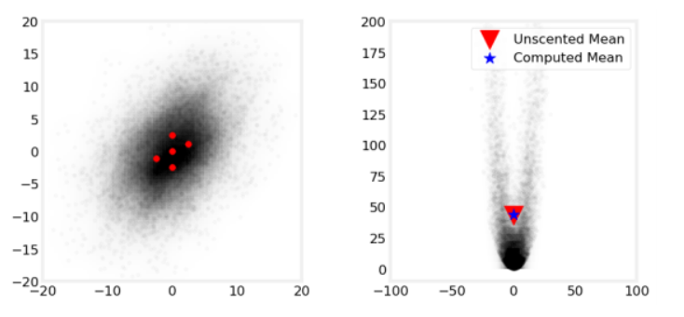

The mean errors compared to Monte Carlo, are

$$errors=\left(0.097,0.549\right)$$

which is much small to linearization method,

$$errors=(-0.055,42.895)$$

%%% Kim’s comment:

If the states are random, and a non linear function of the states is analyzed using UT not Linearized method! There are several reasons to select UT. %%%

* Basic Ideas of Unscented Kalman Filter

1. Recall the linear system

$$x_{k+1}=Fx_{k}+w, w\sim N(0,Q) \\ z_{k}=Hx_{k}+v , v \sim N(0,R)$$

Then The Kalman filter is

$${\overline{x}}_{k+1 }=F{\hat{x}}_{k} \\ {\hat{x}}_{k}= {\overline{x}}_{k}+K_{k}(z_{k}-{\overline{x}}_{k})$$

where

$${\overline{x}}_{k}=E\left[x_{k} | Z_{k-1}\right], {\hat{x}}_{k}=E[x_{k}|Z_{k}]$$

are the conditional mean(expectation)

Now Consider the non-linear system

$$x_{k+1}=f\left(x_{k}\right)+w, z_{k}=h\left(x_{k}\right)+v$$

In this case we need the mean of $x_{k}$. If we know the pdf of $f(x_{k})$,

$$E\left[x_{k+1}\right]=f\left(E\left[x_{k}\right]\right)= \int{f\left(x_{k}\right) df_{x_{k}}}$$

Or if we define sigma points $χ_{i}$ to get unscented transform $Υ_{i}=f\left(χ_{i}\right)$,

$$E\left[x_{k+1}\right]={\overline{x}}_{k+1}= \sum_{i=0}^{2n}{W_{i}Υ_{i}}$$

With a properly chosen weighting function $W_{i}$. In this way, we may get the mean of $z_{k}$ using sigma points $Z_{i}$ unscented transform $Z_{i}=h(Υ_{i})$

**In summary**

|  |  |  |
| --- | --- | --- |
| Linear | Non-linear | Remarks |
| $$x_{k+1}=Fx_{k}+w$$ $$z_{k}=Hx_{k}+v$$ | $$x_{k+1}=f(x_{k})+w$$ $$z_{k}=h(x_{k})+v$$ |  |
| Prediction $${\overline{x}}_{k+1 }=F{\hat{x}}_{k}$$ | $$Υ_{i}=f(χ_{i})$$ $${\overline{x}}_{k+1}= \sum_{i=0}^{2n}{W_{i}}Υ_{i}$$ | Find sigma points of ${\hat{x}}_{k}$ Find the mean of $f\left({\hat{x}}_{k}\right), {\overline{x}}_{k+1}$ |
| Correction $${\hat{x}}_{k}= {\overline{x}}_{k}+K_{k}(z_{k}-H{\overline{x}}_{k})$$ | $$Ζ_{i}=h(Υ_{i})$$ $$μ_{z}=\sum_{i=0}^{2n}{W_{i}}Z_{i}$$ $${\hat{x}}_{k}= {\overline{x}}_{k}+K_{k}(z_{k}-μ_{z})$$ | Find the mean of $h({\overline{x}}_{k})$ |

1. A new algorithm for $K_{k}$: cross covariance

In the linear or extended KF, the Kalman gain is

$$K={PH}^{T}{\left(HPH+V\right)}^{-1},$$

Hence to get Kalman Gain , we need the measurement matrix, $H$. Since the measurement is non-linear $h(x)$, to get “H” matrix we may linearize $h(x)$ or using the cross covariance between the states and the measurement as

The Kalman gain is equivalent to

$$K=P_{xz}P_{z}^{-1}, P_{xz}=E\left[\left(x-\overline{x}\right){\left(z-\overline{z}\right)}^{T}\right], P_{z}=E\left[\left(z-\overline{z}\right){\left(z-\overline{z}\right)}^{T}\right] [4]$$

Here to get $P_{xz}$, we may use

$$P_{z}=\sum{W_{i}\left(Z_{i}-{\overline{z}}_{k}\right){\left(Z_{i}-{\overline{z}}_{k}\right)}^{T}}+R$$

$$K=\sum{W_{i}(Υ_{i}-}{\overline{x}}_{k})\left(Z_{i}-{\overline{z}}_{k}\right)P_{z}^{-1}$$

* The UKF [1]

First to find the sigma points of ${\hat{x}}_{k}$, $χ_{i}$. then

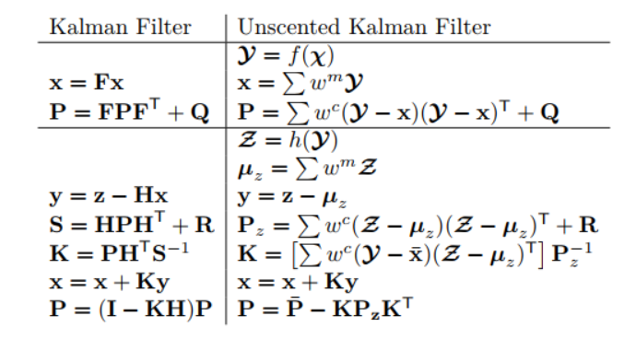

%%% Kim’s comment

In the recursive procedure, for notation simplicity we may use as

$${\hat{x}}_{k+1}=F{\overline{x}}_{k}$$

$${\overline{x}}_{k}=H{\hat{x}}_{k}$$

* Without the subscription in the matlab programming

For i= 1:N

X = F*X;

X =H*X

End

%%%%

Reference

[1]” Kalman and Bayesian Filters in Python”, ch.10

[2]” A New Extension of the Kalman Filter to Non-linear System”

[3] “A General Method for Approximating Nonlinear Transformations of Probability Distributions”

[4] <https://www.youtube.com/watch?v=LkHBR7efKQw>