* Optimal and adaptive control
* Linear control system

+Linear quadratic regulator(LQR): continuous system, discrete system,

+Linear quadratic Gaussian (LQG)

* non-linear optimal control
* model predictive control
* Contents: Parameter optimization problems

-“Applied Optimal Control: Optimization, Estimation and Control”, E.Bryson,1975.

-“Linear Optimal control system”,Sivan, Kwakernaak, 1972

-“Data-Driven Science and Engineering, Machine Learning, Dynamic Systems and Control”,S.Bruton, 2019.

%%%%%%%%-----------------

1. Parameter optimization problems
   1. Problems without constraints

-decision vector as

$$u= \left[\begin{matrix}u_{1} \\ ⋮ \\ u_{m}\end{matrix}\right]$$

-the performance index

$$L(u)$$

-problem

Find $u^{*}$ s.t. $L\left(u^{*}\right)=\min{L(u)}$

-**The stationary points**: the necessary conditions for the optimality

$$\frac{∂L}{∂u}=0$$

* Exam.1 $$L\left(u\right)=u^{2}+2u+5 , L\left(x\right)=x^{2}+x+1$$
* Exam.2
$$L\left(u_{1},u_{2}\right)={\left(u_{1}-1\right)}^{2}+{\left(u_{2}-2\right)}^{2}+5$$

* Exam.3: A positive definite matrix
$$L\left(u_{1},u_{2}\right)={2u}_{1}^{2}+2u_{1}u_{2}+4u_{2}^{2}+1 \\ =\left[u_{1} u_{2}\right]\left[\begin{matrix}2 & 1 \\ 1 & 4\end{matrix}\right]\left[\begin{matrix}u_{1} \\ u_{2}\end{matrix}\right]+1$$

* Exam.4: not positive definite matrix

-------------%%%%%%%%%%%%

* 1. Problems with constraints
* Decision vector $u$
* State vector $x={\left[x_{1},x_{2},…, x_{n}\right]}^{T}$
* Constraint vector $f={\left[f_{1},f_{2},…,f_{n}\right]}^{T}, f(x,u)=0$
* Performance Index $L(x,u)$
* Problem:

Find $u^{*}$ s.t. $L\left(u^{*},x^{*}\right)=\min{L(u,x)}$ with the constraints $f\left(x,u\right)=0$

* Exam.5
$$L\left(x,u\right)=x^{2}+u^{2}, x+u=1$$

* **Lagrange Multiplier: $λ$**

Define $H \left(x,u,λ\right)$ is to “adjoin” the constraints to the index as

$$H\left(x,u, λ\right)=L\left(x,u\right)+λf(x,u)$$

* Necessary conditions:

1. Constraints:
$$\frac{∂H}{∂λ}=f\left(x,u\right)=0$$

2. Stationary points: differential changes in $H(x,u,λ)$

$$dH=\frac{∂H}{∂x}dx+\frac{∂H}{∂u}du$$

$$\frac{∂H}{∂x}=0,\frac{∂H}{∂u}=0$$

* Exam.1

$$L=\frac{1}{2}\left(\frac{x^{2}}{a^{2}}+\frac{u^{2}}{b^{2}}\right), f\left(x,u\right)=x+mu-c=0$$

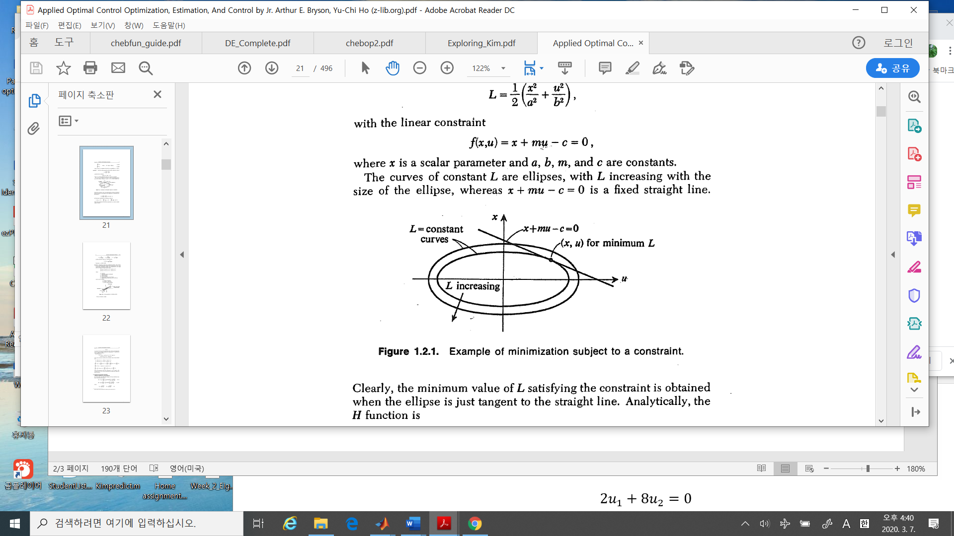

* Procedure to Solution:

1. Define adjoined index $$H\left(x,u,λ\right)=\frac{1}{2}\left(\frac{x^{2}}{a^{2}}+\frac{u^{2}}{b^{2}}\right)+λ(x+mu-c)$$
2. Necessary conditions)
3. $x+mu-c=0$: the constraint condition
4. $0=\frac{∂H}{∂x}=\frac{x}{a^{2}}+λ$: the stationary condition w.r.t $x$
5. $0=\frac{∂H}{∂u}=\frac{u}{b^{2}}+λm$: the stationary condition w.r.t $u$
6. Find solutions satisfying a), b) and c)
 $$u^{*}=\frac{b^{2}mc}{a^{2}+m^{2}b^{2}}, x^{*}=\frac{a^{2}c}{a^{2}+m^{2}b^{2}}, λ^{*}= -\frac{c}{a^{2}+m^{2}b^{2}}$$

  1. (skip) Problems with equality constraints: sufficient conditions
7. Together with the necessary conditions
8. The second derivatives

$${\left(\frac{∂^{2}L}{∂u^{2}}\right)}_{f=0}=H_{uu}-H_{ux}f_{x}^{-1}f_{u}-f_{u}^{T}{\left(f_{x}^{T}\right)}^{-1}H_{xu}+f_{u}^{T}{\left(f_{X}^{T}\right)}^{-1}H_{xx}f_{x}^{-1}f_{u}$$

* **Ex.4 (prob.4. page 12)**

$$\min_{u}{L\left(x,u\right)=\min_{u} }\left({\frac{1}{2}x}^{T}Qx+ {\frac{1}{2}u}^{T}Ru\right)$$

with constraints

$$f\left(x,u\right)=x+Gu+c=0$$

Sol:

1. Define $H$ as
$$H=L+λf$$

2. Find the necessary conditions:
3. Constraints($\frac{∂H}{∂λ}=0)$
$$f\left(x,u\right)=x+Gu+c=0$$

$x= -Gu-c$

4. The stationary points
$$\frac{∂H}{∂x}=\frac{∂}{∂x}\left({\frac{1}{2}x}^{T}Qx+ {\frac{1}{2}u}^{T}Ru+ λ(x+Gu+c)\right)=Qx+λ=0$$

$$λ=-Qx$$

$$\frac{∂H}{∂u}=\frac{∂}{∂x}\left({\frac{1}{2}x}^{T}Qx+ {\frac{1}{2}u}^{T}Ru+ λ(x+Gu+c)\right)=Ru+G^{T}λ=0$$

$$Ru={-G}^{T}Q\left(-Gu-c\right)$$

5. Find the optimal $u^{*}$
$$u^{*}=-{\left(R+G^{T}QG\right)}^{-1}G^{T}Qc$$

6. The others, you may substitute $u^{*}$ into equations.
7. Calculus of Variations
   1. Problem Concept

$$\min_{u}{J}=h\left(x\left(t_{f}\right)\right)+ \int_{t_{0}}^{t_{f}}{g\left(x\left(t\right), u\left(t\right),t\right) dt}$$

Subject to $$\dot{x}=f\left(x,u,t\right)$$

$x\left(t_{0}\right), x\left(t_{f}\right):fixed$

* $J(x,u,t_{0},t_{f})$: a functional.

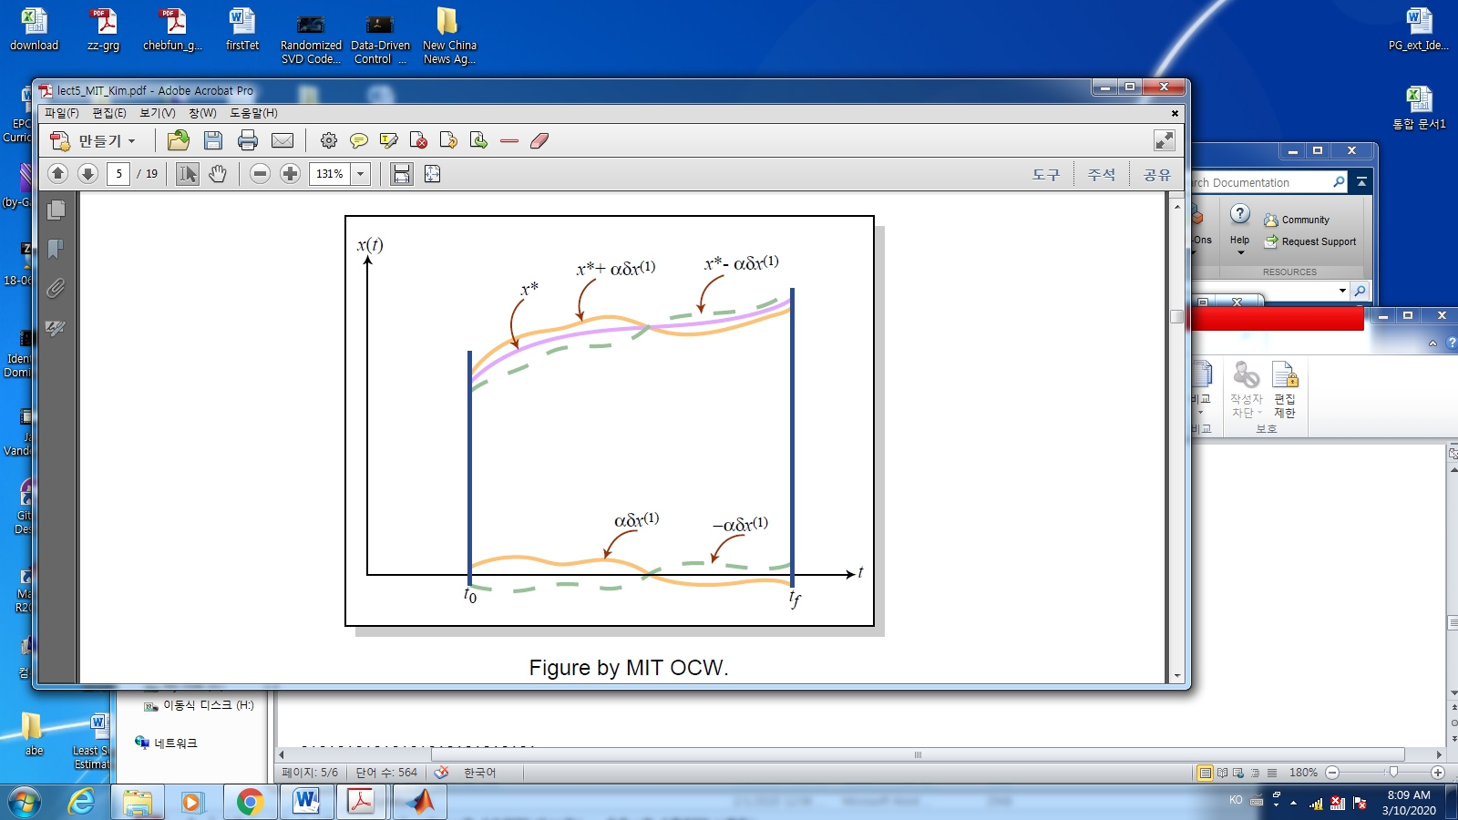

%%%%Kim’s comment: Functional

* Functional: it is a function but it’s value is a scalar.
* Example

-------------------------%%%%%%%%%

* 1. Some definitions and facts
* Maximum and minimum: functional

A functional $J\left(x\left(t\right)\right)$ has a local minimum at $x^{*}$ if

$$J\left(x\right)≥J(x^{*})$$

For all admissible $x$ in $\left\|x-x^{*}\right\|≤ϵ$

* Minimum can occur at (i) stationary point, (ii) at boundary..
* An increment of a functional:
$$∆J(x,δx\left(t)\right)=J\left(x\left(t\right)+δx\left(t\right)\right)-J(x\left(t\right) )$$

* A **variation of the functional** is a linear approximation of the increment
$$∆J(x,δx\left(t)\right)=δJ\left(x,δx\right)+H.O.T$$

* Fundamental theorem of the calculus of variations

If $x^{*}$ is an extremal function, then the variation of $J$ must vanish on $x^{*}$ for all admissible ,

* 1. **Euler Equation**: Without path constraints , scalar case
* The cost is

$$J\left(x(t)\right)= \int_{t_{0}}^{t_{f}}{g(x, \dot{x}}, t) dt, t_{0}, t_{f} fixed$$

Find

$$\min_{x}{J}=\int_{t_{0}}^{t_{f}}{g\left(x\left(t\right), \dot{x}\left(t\right),t\right) dt}$$

* **By the fundamental theorem of the calculus of variations, the necessary condition for an extreme is**

$$\frac{∂g\left(x,\dot{x},t\right)}{∂x}-\frac{d}{dt} \left(\frac{∂g\left(x,\dot{x},t\right)}{∂\dot{x}}\right)=0$$

%%%%Kim’s comment

Why the integrand has $\frac{d}{dt} ( )$? If $g\left(x,y,t\right), x and y$ are independent, then Euler equation is

$$\frac{∂g}{∂x }+\frac{∂g}{∂y}=0.$$

In our case $g\left(x,\dot{x},t\right),$ looks like..

$$\frac{∂g}{∂x }+\frac{∂g}{∂\dot{x}}$$

But $x, \dot{x}$ are not independent. Hence the $\frac{d}{dt} ( )$ term is appeared.

%%%%%

* Ex. Find the curve that gives the shortest distance between 2 points in a plane $(x_{0},y_{0})$ and $(x_{f}, y_{f})$
* Solution:

$$J=\int_{x_{0}}^{x_{f}}{ds}=\int_{x_{0}}^{x_{f}}{\sqrt{{\left(dx\right)}^{2}+{\left(dy\right)}^{2}}} \\ =\int_{x_{0}}^{x_{f}}{\sqrt{1+ {\left(\frac{dy}{dx}\right)}^{2}}dx} \\ =\int_{x_{0}}^{x_{f}}{\sqrt{1+{\left(\dot{y}\right)}^{2}}dx} ≡\int_{x_{0}}^{x_{f}}{g(\dot{y})dx}$$

Using Euler’s condition,

$$\frac{∂g\left(x,\dot{x},t\right)}{∂x}-\frac{d}{dt} \left(\frac{∂g(x,\dot{x},t)}{∂\dot{x}}\right)=0$$

Since $x$ is independent variable, substitute $t-→x, x-→y$, then $\frac{∂g\left(\dot{y}\right)}{∂y}=0$

1. The first term
$$\frac{∂g\left(y,\dot{y},x\right)}{∂x}=\frac{∂}{∂x}\left(\sqrt{1+{\left(\dot{y}\right)}^{2}}\right)=0$$

2. The second term

$$\frac{d}{dx} \left(\frac{∂g\left(\dot{y}\right)}{∂\dot{y}}\right)=\frac{d}{d\dot{y}}\left(\frac{∂g}{∂\dot{y}}\right)\frac{d\dot{y}}{dx}=\frac{d}{d\dot{y}}\left(\frac{\dot{y}}{{\left(1+\dot{y^{2}}\right)}^{1/2}}\right)\ddot{y}=\frac{\ddot{y}}{{\left(1+ {\dot{y}}^{2}\right)}^{3/2} }=0$$

$\ddot{y}=0$

$y=c_{1}x+c_{2}$

* if $x_{0}=0, y\left(x_{0}\right)=0$ and 🡪
  1. Vector case:

$$J\left(X\left(t\right)\right)= \int_{t_{0}}^{t_{f}}{g\left(X\left(t\right), \dot{X}\left(t\right),t\right)dt}, t_{0}, t_{f}, X\left(t_{0}\right)fixed$$

Then Euler condition is

* 1. boundary conditions
* There are several constraints about boundaries. It may be free or fixed.

$$t_{0}, t_{f}, x\left(t_{0}\right), x\left(t_{f}\right)$$

At each boundary condition, there are necessary conditions for the extreme.

If you are interested in these conditions, which is called as “**transversality condition** “

* Hamiltonian Jacobi Bellman condition: with path constraints

$$\min{J=h\left(x\left(t_{f}\right),t_{f}\right)+ \int_{t_{0}}^{t_{f}}{g\left(x\left(t\right),u\left(t\right),t\right)dt}}$$

Subject to

* 1. Hamiltonian

Define

* 1. Hamiltonian
 $$H \left(x,u,J_{x}^{*},t\right)=g\left(x,u,t\right)+J_{x}^{*}\left(x,t\right)a(x,u,t)$$

 2. Hamiltonian-Jacobi-Bellman condition: necessary and sufficient condition for optimality

$$-J_{t}^{*}\left(x,t\right)= \min_{u∈U }{H(x,u,J_{x}^{*},t)}$$

1. Example of HJB : Continuous LQR [1]
   1. problem
 $$\dot{x}=Ax+Bu$$

 $$J=\frac{1}{2}x{\left(t_{f}\right)}^{T}Hx\left(t_{f}\right)+\frac{1}{2}\int_{t_{0}}^{t_{f}}{\left\{x^{T}Qx+u^{T}Ru\right\}dt}, t_{f}:fixed$$

 2. Hamiltonian
 $$H\left(x,u,J_{x}^{*},t\right)=\frac{1}{2}\left(x^{T}Qx+u^{T}Ru\right)+J_{x}^{*}(Ax+Bu)$$

  3. For optimal control

$$\frac{∂H}{∂u}=u^{T}R+J_{x}^{*}\left(x,t\right)B=0$$

$u^{*}= -R^{-1}B^{T}{J_{x}^{*}}^{T}$

* Since 🡪 a global minimum
  1. Solve for $J_{x}^{*}$

Assume $J^{*}=\frac{1}{2}x^{T}Px, P=P^{T}$,

Then $$\frac{∂J^{*}}{∂x}=x^{T}P, \frac{∂J^{*}}{∂t}=\frac{1}{2}x^{T}\dot{P}x$$

The HJB is

$$-J_{t}^{*}\left(x,t\right)= \min_{u∈U }{H(x,u,J_{x}^{*},t)}$$

Substituting these into HJB:

$$-\frac{1}{2}x^{T}\dot{P}x=\frac{1}{2}x^{T}\left(Q+PA+A^{T}P-PBR^{-1}B^{T}P\right)x , ∀x,$$

$$-\dot{P}=Q+PA+A^{T}P-PBR^{-1}B^{T}P,$$

* With terminal condition as $P\left(t_{f}\right)=H$
  1. Riccati equation
 $$-\dot{P}=Q+PA+A^{T}P-PBR^{-1}B^{T}P, P\left(t_{f}\right)=H$$

 2. The optimal control
$$u^{*}= -R^{-1}B^{T}Px$$

* A linear state feedback!!

[1] “MIT OpenCourseWare, Principles of Optimal Control, Lecture 4”.