Week_7 Linear Quadratic Gaussian(LQG)

1. Re-visit LQR problem in steady state

Consider steady state LQR problem as the path constraint,

$$\dot{x}=Ax+Bu, J=\frac{1}{2}\int_{t_{0}}^{∞}{\left\{x^{T}Qx+u^{T}Ru\right\}dt},$$

Then

$$u^{*}=-R^{-1}B^{T}Px = -K_{r}x$$

where

$$0 =PA+A^{T}P-PBR^{-1}B^{T}P +Q$$

* To implement the optimal control law, we need the full state – feedback, i.e., we need the number of sensors = the dimension of $x∈R^{n}$
* We implement $n$ sensors 🡪 it is bulky and sometimes it is not possible to measure some state in physically.
* We may design optimal estimators for unmeasured states.

1. Controllability / Observability [1]
   1. Controllability

Given $\dot{x}=Ax+Bu$, it is controllable if for any state $ξ∈R^{n}$ is reachable in a finite time with some $u(t)$

1. Controllability matrix test

$\left[B AB A^{2}B,…, A^{n-1}B\right]$ is a full column rank $n$

1. Popov-Belevitch—Hautus test: $\left[\begin{matrix}A-λI & B\end{matrix}\right]$ must have column rank n for all $λ$
2. Gramian test : $∃W_{C} >0, AW_{C}+W_{C}A+BB^{T} =0,$
   1. Observability

* Fact: Observability

Let the measurement states as

$$y=Cx+w_{v}$$ If A system is observable if it is possible to estimate any state from a time-history of the measurement $y(t)$

* Test for the Observability

1. The observability matrix: $\left[C CA {CA}^{2},…,CA^{n-1}\right]$ is a full row rank
2. Popov-Belevitch—Hautus test: $\left[\begin{matrix}(A-λI) \\ C\end{matrix}\right]$ must have row rank n for all $λ$
3. Gramian test : $∃W_{0}>0, A^{T}W_{o}+W_{o}A+C^{T}C =0,$
4. Kalman Filter(Estimator) : Full-State Estimation
   1. Problem

$$\frac{dx}{dt}=Ax+Bu+w_{d}$$

$$y=Cx+Du+w_{n}$$

$$E\left[w_{d}\left(t\right)w_{d}{\left(τ\right)}^{T}\right]=V_{d}δ\left(t-τ\right)$$

$$E\left[w_{n}\left(t\right)w_{n}^{T}\left(τ\right)\right]=V_{n}δ(t-τ)$$

Find the estimator $\hat{x}=E[x|y]$

$$\frac{d\hat{x}}{dt}=A\hat{x}+Bu+K_{f}\left(y- \hat{y}\right) (1) \\ \hat{y}=C\hat{x}+Du$$

%%% Kim’s comment

$E\left[x | z\right]$ is the minimum mean square error estimator for

%%%%

* 1. Kalman Gain

where

* 1. Block Diagram

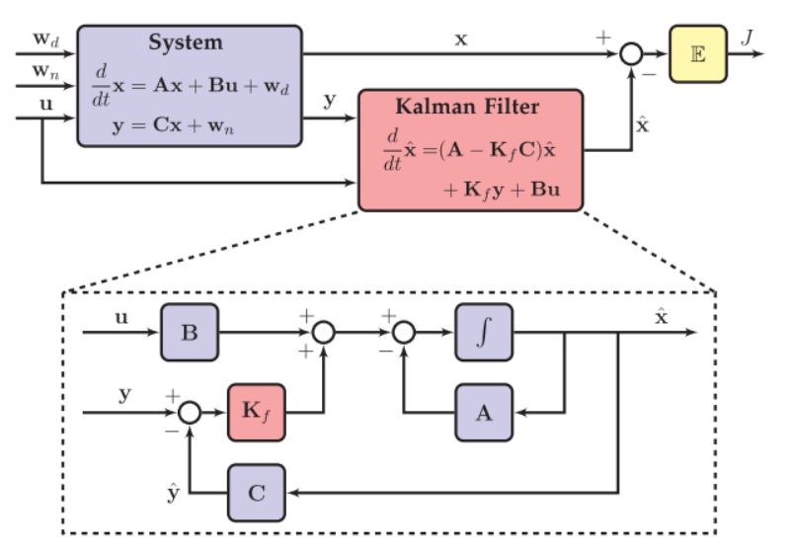

1. The closed kalman system

From (1) and (2)

$$\frac{d}{dt}\hat{x}=\left(A-K_{f}C\right)\hat{x}+K_{f}y+\left(B-K_{f}D\right)u \\ =\left(A-K_{f}C\right)\hat{x}+\left[\begin{matrix}K_{f} & (B-K_{f}D)\end{matrix}\right]\left[\begin{matrix}y \\ u\end{matrix}\right]$$

Now the estimation error $ϵ=x- \hat{x}:$

$$\frac{d}{dt}ϵ=\frac{d}{dt}x-\frac{d}{dt}\hat{x} \\ =\left[Ax+Bu+w_{d}\right]-\left[\left(A-K_{f}C\right)\hat{x}+K_{f}y+\left(B-K_{f}D\right)u\right] \\ =\left(A-K_{f}C\right)ϵ+w_{d}-K_{f}w_{n}$$

Therefore if $(A-K_{f}C)$ is asymptotically stable, $\hat{x}-→x as t-→∞$

%%% Kim’s comment

$$\frac{d}{dt}\hat{x}=\left(A-K_{f}C\right)\hat{x}+K_{f}y+\left(B-K_{f}D\right)u \\ =\left(A-K_{f}C\right)\hat{x}+\left[\begin{matrix}K_{f} & (B-K_{f}D)\end{matrix}\right]\left[\begin{matrix}y \\ -K_{r}\hat{x}\end{matrix}\right] \\ =\left(A-K_{f}C-\left(B-K_{f}D\right)K_{r}\right)\hat{x}+K_{f}y \\ =\left(A-K_{f}C-BK_{r}\right)\hat{x}+K_{f}y assume D=0$$

As you may see, the e-values of the estimator may be bigger negative than that of the controller. %%%%

1. Optimal Sensor-based Control(output): Linear Quadratic Gaussian(LQG)[1]

Given the system

$$\frac{d}{dt}x=Ax+Bu+w_{d}$$

$$y=Cx+w_{n}$$

Find the optimal controller to minimize

* 1. Solution

The optimal output feedback controller is

$$u= -K_{r}\hat{x}$$

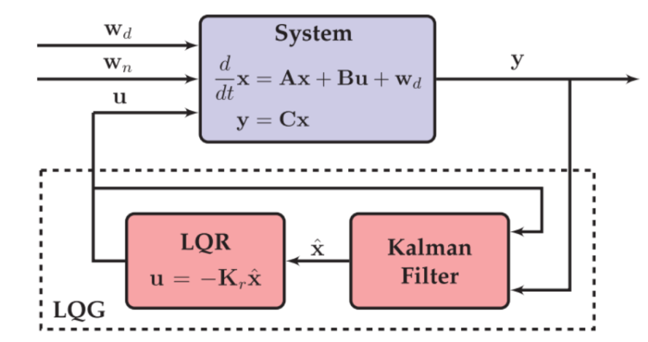

%%% Kim’s comment

The full state optimal feedback for LQR is

$$u_{r}=-K_{r}x$$

Since only output are avaialble, we may design the optimal estimater as

$$u_{f}={-K}_{f}y$$

So that

%%%

* 1. Separation Principle[2]

As before the estimatrion error $ϵ=x- \hat{x}$, then the augumented stste equation may be

$$\frac{d}{dt}\left[\begin{matrix}x \\ ϵ\end{matrix}\right]=\left[\begin{matrix}A-BK_{r} & BK_{r} \\ 0 & A-K_{f}C \end{matrix}\right]\left[\begin{matrix}x \\ ϵ\end{matrix}\right]+\left[\begin{matrix}I & 0 \\ I & -K_{f}\end{matrix}\right]\left[\begin{matrix}w_{d} \\ w_{n}\end{matrix}\right]$$

The eigenvalues of

$$\left[\begin{matrix}A-BK_{r} & BK_{r} \\ 0 & A-K_{f}C \end{matrix}\right]$$

are decomposed into two parts as

$$eig (A-{BK}_{r}), eig(A-K_{f}C)$$ wich implies

the regulator and estimator can be designed separatedly.

1. Example : inverted pendulum
   1. Physical model [1], [2],[3]

Purpose: design the controller to stabilize the inverted pendulm.

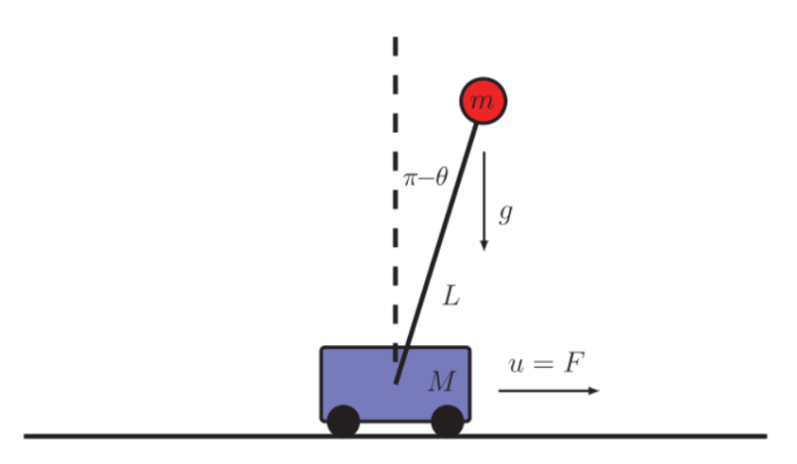

There are several modelings and different control strategies.In [1], [2], and [3].

At least in simulation they succeeded to stablize the unstable inverted pendulum( In [3] it was realized to show the control performance). However they are a little bit different as followd.

1. Deterministic model[3] / Stochastic model[1], [2]
2. The number of output measurement [1], [2]
3. In [3], it was realized to show the control performance!
4. In [1], the simualtion is performed the system model as non-linear dynamic system to be simulated in C program

So which one is correct or better than others? I think it depends on system environment(noise in there?) and system specifications, and so on..So far in real system is not so simple in the text book. And the optimal controlled, which is grobally optimal, is not optimal in real situation. It should be closely checked.

* 1. The simulation will be done in the laboratory[1]

1. Modern Control- Robust Control [4]

7.1 SISO

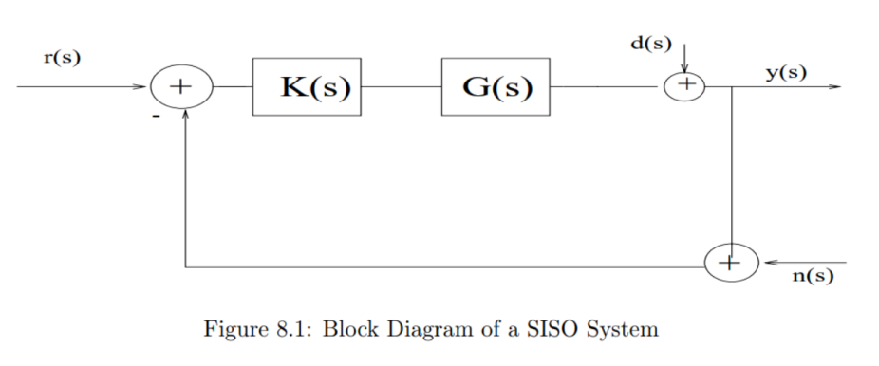

* Notation:

$r\left(s\right):$ The input of command

$K\left(s\right):$ The Compensator $G\left(s\right):$ The plant

$u\left(s\right):$ the control command

$y\left(s\right):$ The output

$d\left(s\right):$ The disturbance

$n\left(s\right):$ The sensor noise

$e\left(s\right):$ the error signal

* 1. Single input Single output
$$y\left(s\right)=\frac{G\left(s\right)K\left(s\right)}{1+G\left(s\right)K\left(s\right)}\left[r\left(s\right)-n\left(s\right)\right]+\frac{1}{1+G\left(s\right)K\left(s\right)}d(s)$$

* Definition

$1+G\left(s\right)K\left(s\right):$ Return Difference Transfer Function

$S\left(s\right)=\frac{1}{1+G\left(s\right)K\left(s\right)}:$ Sensitivity T.F

$T\left(s\right)=\frac{G\left(s\right)K\left(s\right)}{1+G\left(s\right)K\left(s\right)}:$ Complememtary Sensitivity T.F

$G\left(s\right)K\left(s\right):$ Feedforwardloop gain

* Fact:
 $$∀ ω, S\left(s\right)+T\left(s\right)=1$$

 1. Control Objective : in SISO case [4]

Sensitivity to Model Uncertainty, Command Following, Disturbance Rejection, Noise Progagation, Stability and Robust

1. Sensitivity to Model Error

Assume : $G\left(s\right)=G{\left(s\right)}^{*}+δG(s)$

1. Open loop case

$$y\left(s\right)=G\left(s\right)r\left(s\right)=\left(G^{*}+δG\right)r=y^{*}+δy$$

Hence sensitivity due to model uncertainty is

$${Sen}_{open}=\frac{δy}{y}=\frac{δG}{G^{*}}$$

1. Closed loop

$$y=\frac{GK}{1+GK}r= \frac{\left(G^{*}+δG\right)K}{1+\left(G^{*}+δG\right)K}r=y^{*}+δy$$

Then

$$\frac{δy}{y^{*}}=\frac{δG}{G^{*}}\frac{1}{1+GK} \left(HW-1\right)$$

* It is **better $GK$ is large**

1. Command Following

$$y=\frac{GK}{1+GK}r$$

* It is **better $GK$ is large**

1. Disturbance rejection

If $r=n=0$, then

$$y=\frac{d}{1+GK}$$

* It is **better $GK$ is large**. One Comment should be put in here. In general the disturances are in the low frequencies

1. Noise reduction

If $r=d=0$, then

$$y=-\frac{GK}{1+GK}n$$

* **It is better $GK$ is small.** . One Comment should be put in here. In general the noises are in the high frequencies

1. **Stability and Robust**

* The nominal Plant should be stable. i.e., $G^{*}(s)$ is stable
* Let the real plant be modelled as

$$G\left(s\right)=G{\left(s\right)}^{*}\left[1+\frac{δG\left(s\right)}{G{\left(s\right)}^{*}}\right]=G^{*}\left(s\right)[1+L\left(s\right)]$$

$L\left(s\right):$ multiplicative uncertainty

* Assumptions  
  A.1) # of unstable poles of $G(s)$ = those of $G^{*}(s)$

A.2) $∃ a upper bound s.t. \left|L(jω)\right|≤l(ω)$

A.3) The controller $K\left(s\right)$ is chosen so that the nominal closed loop is stable.

%%% kim’s Comment [5]

For the sensitivity / robust there is a **good tool of Nyquist plot**. %%%

* Fact to stability / robust problem using Nyquist plot

The closed loop systme is stable if

The encirclements of plots of $G\left(jω\right)K\left(jω\right)$ around (-1,0) point is not changed for all allowable $L(jω)$ from the nominal system $G^{*}\left(jω\right)K(jω)$.

* Check the robust in scaler case
$$1+KG =1+KG^{*}+KG^{*}L ≠0$$

* It will be satisfied if

$$\left|LG^{*}K\right|≤ \left|1+G^{*}K\right|$$

Hence

$$\left|L(jω)\right|≤l\left(ω\right)≤ \frac{\left|1+G^{*}(jω)K(jω)\right|}{\left|G^{*}\left(jω\right)K(jω)\right|}$$

or

$$\frac{\left|G^{*}\left(jω\right)K(jω)\right|}{\left|1+G^{*}(jω)K(jω)\right|}≤\frac{1}{l(ω)}$$

* Implications

In general $\left|l\left(ω\right)\right|=\left\{\begin{aligned}small if ω is small \\ large if is large \end{aligned}\right.$

* For robust due to model uncertainty, it is better

$$G^{*}K=\left\{\begin{aligned}large if ω is small \\ small if ω is large \end{aligned}\right.$$

1. **In summary**

Now since the sensitivity f.t. $S\left(s\right)=\frac{1}{1+GK }$ and the complementary t.f. $T\left(s\right)=\frac{GK}{1+GK}$

Hence

+ is small 🡪 is large $T\left(s\right)$ is small

+ is large 🡪 is small $T\left(s\right)$ is large

+ For all frequenccies, $T\left(jω\right)+S\left(jω\right)=1$

$$ω$$

$$S(jω)$$

Mag.

$$T(jω)$$

**To satisfy the control objective the controller $K$ may be designed as**

1. In small frequencies range, to select $K$ to S(s) is small for compensating

* Model error
* Command following
* Disturbance rejection
* For robust

1. In large frequencies range, to select $K$ to T(s) is small for compensating

* Noise reduction
* For robust

1. **Roughly speaking the LQR optimal controller satisfies these condition. However, LQG controller may not satisfy these.**
   1. Control objective: in MIMO case

In MIMO case, things are complicate so that in modern control after Kalman was introduced. First

$$K\left(s\right)G\left(s\right) ≠G\left(s\right)K\left(s\right)$$

You may notice that (output) = T(s) (input) , hence even if in the scaler case it is more logical to write as

$output = G\left(s\right)K\left(s\right) Input ,$

Second, in MIMO the transfer function is not scaler but matrix which is function of frequency. It is difficult to apply Nyquist plot in MIMO. For example, i.e.,

$$G\left(jω\right)= \left|\begin{matrix}G_{11}(jω) & G_{12}(jω) \\ G_{21}(jω) & G_{22}(jω)\end{matrix}\right|$$

Then is is not directly applicable Fact introduce in scaler case. What tool is to measure of $G\left(jω\right)= \left|\begin{matrix}G_{11}(jω) & G_{12}(jω) \\ G_{21}(jω) & G_{22}(jω)\end{matrix}\right|$? One of the popular tools is singular value decompostion.

HW_Week_7 [5]

1. In Section 7, derive HW-1
2. Following systems find stability and gain margin

$G\left(s\right)= \frac{1}{s+1}$

$G\left(s\right)=\frac{s+1}{s^{2}+3s+2}$

$G\left(s\right)=(s-1)/(s^{2}+3s+2)$

$G\left(s\right)=(s^{2}+10s+24)/(s^{2}-8s+15)$

$G\left(s\right)=(50)/(s^{3}+9s^{2}+30s+40)$

Reference:

[1] “Data-Driven Science and Engineering, Machine learning and Dynamic Systems and Control”, Steven L.Bruton, 2019

[2] “Linear Optimal Control system”, Sivan & Kwaternaak, page 391

[3] <https://www.youtube.com/watch?v=D3bblng-Kcc>, “Lecture 26, Feedback Example: The inverted Pendulum |MIT RES.6.007 Signals and Systems, Spring 2011

[4] <http://mae2.eng.uci.edu/~fjabbari//me270b/chap8.pdf>

[5] <https://ctms.engin.umich.edu/CTMS/index.php?example=Introduction&section=ControlFrequency#26>