

**Dire Dawa University**

Institute of Technology

Department of Electrical and Computer Engineering

**Project Title: Dire Dawa University Student Union Vote System (DDU-SU Integrated Vote System)**

Group Members

1. Samuel Nega
2. Bereketabe Ayenachew
3. Neway Gorfu

Advisor Mr. Zemenfes

Submission date Monday, June 12, 2018

Dire Dawa Ethiopia

Declaration

We hereby declare that the research paper entitled **“Dire Dawa University Student Union Vote System (DDU-SU Integrated Vote System)”.** The project submitted herewith is a result of our own efforts in totality and in every aspects of the project works. All information that has been obtained from other sources had been fully acknowledged. We understand that any plagiarism, cheating or collusion or any sorts constitutes a breach of College rules and regulations and would be subjected to disciplinary actions.

Name Signature Date

1. Samuel Nega
2. Bereketabe Ayenachew
3. Neway Gorfu

This final thesis document declaration made by the candidates is verified and acknowledge by

Advisor Name Signature Date

1. Mr. Zemenfes

Department head Signature Date

Abstract

Dire Dawa university student union voting system in short DDU Vote is specially designed for dire dawa university student union for keeps track their daily operation basically regarding with election systems. The main purpose of doing this project is in partial fulfillment of the requirement for Bachelor of Science. Beside that we will get to know in detail regarding how to complete a project in the real working environment by following the standard methodology during development of the system such as prepare documentation, system development and system testing. DDU voting system is an online system that used by the student union staffs, normal students and by all who are concerned like school management staffs. The system covers all the basic module including student voting module, student visit module, candidate president voting module and current president information release and report module.

This project is following different phases including the planning analyze, design, testing and implementation. During this development phase, the document that required by each phase are proposal of the system, system requirement specification, system development diagram (such as use case diagram, sequence diagram and etc.), test plan and etc.

DDU voting system helps the union to store their confidential data especially former, current and candidate presidents and students data in a very secure way and easy to keep track when they want to use it. Furthermore, only certain authority user can access to the confidential data in order to protect the privacy. As a result, it helps the union as well as the university to conduct free and transparent voting system in a very easy manner within a very short period of time and with a mitigated burden of all concerned body.

Acknowledgment

We wish to express our sincere gratitude to our project advisor Mr. Zemenfes For his guidance constant support and encouragement throughout the completion of this final year project. We would like to say we are thankful and lucky to be in this group we are grateful with each other for sharing of knowledge’s and skills.

A warm thank is extended for our classmates for kindly sharing out their resources, opinion, knowledge, experience and skills in programming and development methodology with us, so generously. Beside that we would also want to express our thankfulness to our fellow friends from other department in our university who always there to provide us the best solution to struggle against the problem before we can complete this final year project.

Last but not least, we wish to acknowledge the un wavering support shown by our family members who always there for us to give us endless support when we need them.

Table of Contents

1. Introduction 1

1.1. Introduction 1

1.2. Background of Dire Dawa university Student Union 1

Mission 2

Vision 2

Objectives of Dire Dawa University Student Union 2

1.3. Literature Review 3

1.4. Statement of the problem 3

1.5. Objectives 3

1.5.1. General Objective 3

1.5.2. Specific Objective 3

1.6. Scope of the project 4

1.7. Significance of the project 5

1.8. Limitation 6

1.9. Methodology 6

1.10. Requirement Analysis 8

1.10.1. Hardware Requirements 8

1.10.2. Software Requirements 8

1.11. Data Collection Methodology 8

1.12. Feasibility of the project 8

1.12.1. Economic Feasible 8

1.12.2. Technical Feasible 9

1.12.3. Operational Feasible 10

1.12.4. Schedule Feasible 10

1.13. Project plan activities 10

2. SOFTWARE REQUIERMENT SPECIFICATION (SRS) 12

2.1. Introduction 12

2.2. Purpose 12

2.3. Overall description 13

2.3.1. Description of the current system 13

2.3.2 players in the existing system 13

2.4. Proposed Systems 14

2.4.1. Overview of the proposed system 14

2.5. Functional requirements 14

2.6. Non-Functional Requirement 15

2.6.1. Usability Requirements: - 15

2.6.2. Reliability Requirements: - 15

2.6.3. Performance Requirements: - 16

2.6.4. Security Requirements: - 16

2.6.5. Safety Requirements: 16

2.7. Hardware/Software Requirement 16

2.7.1. Software Requirements 16

2.7.2. Hardware Requirement 16

2.8. Security and Safety Procedure 17

2.9. Use Case Diagram and Use Case Description 17

2.9.1. Use Case Description 18

2.9.2. Activity Diagram 21

2.10. Class Diagram 25

3. Database Design 26

3.1. Database Design 26

3.2. User Interface 29

3.3. Sequence Diagram 30

3.4. User Interface Design 33

3.4.1. User Interface Description 33

4. Programming 37

4.1. Coding 37

5. Testing Technique 40

5.1. Unit Testing 40

5.2. Validation Testing 40

5.3. User Acceptance Testing 40

5.4. Test Plan 41

6. Evaluation against Project 45

6.1. Project Strength 45

6.2. Project Weaknesses 46

6.3. Group Reflection 46

Bibliography 47

List of Figure

Figure 1Agile methodology 7

Figure 2Use case diagram of the system 17

Figure 3Activity diagram of current president/admin 21

Figure 4Activity diagram of current president/admin 22

Figure 5Activity diagram of candidate president 23

Figure 6Activity diagram of student 24

Figure 7 class diagram of the system 25

Figure 8 sequence diagram for vote 30

Figure 9 sequence diagram for edit profile 30

Figure 10 sequence diagram for generate result, report, notification, news and for registering. 31

Figure 11 sequence diagram for view editing profile, post propagandas initiated by the candidate president 32

Figure 12 sequence diagram for view result initiated by the candidate president 32

Figure 13 User Interface 33

Figure 14 Home Page 34

Figure 15Login page 34

Figure 16 Cast Vote page 35

Figure 17 Result display page 36

Figure 18 Registering new user 37

Figure 19 News and notification display 38

Figure 20 Display Rating code 39

Figure 21 Casting vote code 39

List of Table

Table 1cost estimation table 9

Table 2 work plan projection 10

Table 3 User table 26

Table 4 post table 27

Table 5 Ratings table 27

Table 6 password_reset table 27

Table 7 migration table 28

Table 8 user role table 28

Table 9 user_role_list table 29

Table 10 Test Case 41

Table 11Candidate president table 43

Table 12 student information test table 44

Chapter One

1. Introduction
   1. **Introduction**

The project is to create an Online Voting system for Dire Dawa University student union mainly for the students of Dire Dawa university. The system should be able to the students to vote for their student council president and their student council parliament member for the current academic year. In Dire Dawa university this voting process will occur every year to fulfill the parliament members and to select the new president. In this Online Voting system helps the authenticated students, to view some information’s about the student union, to directly participate through the election process, keep track of changes, and be accessed only by the authorized personnel. This design document presents the designs used or intended to be used in implementing the project. The designs described, follow the requirements specified in the Software Requirements Specifications document prepared for the project.

* 1. Background of Dire Dawa university Student Union

The union is an autonomous nonpolitical and fully secular union which is formed and governed by the students. The primary objective of the union is to work for the academic and social rights of Dire Dawa University. Students who enrolled in the university’s undergraduates and post-graduate studies in the regular program.

The Union is run by students for students. All students are automatically members of the Union. Its key objective is to represent its students' academic and welfare interests. It complements the University's provision in terms of support and welfare services.

The Students' Union Advice and Information Center has literature on a wide range of issues and is staffed by professional advisers and specially trained student officers. The student officers are well-trained and have general expertise in welfare and academic matters and, in particular, the needs of mature and women students.

### ****Mission****

To observe and secure that the best interest of students in the academic, and services, are realized with the required quality.

* Having close observance on every feeling and activities of the students.
* Searching for the solution to the possible causes of student’s problems.
* Addressing the unresolved matter to the concerned body for remedial purpose.

### ****Vision****

* To see the elimination of factors deteriorating the strength of unity within diversity.
* Observing students adopting culture of peace, love and unity regardless of their differences.
* Finding Everlasting solution to the deeply rooted problem of the country.
* To see civilized nations competing with developed nations.

### ****Objectives of Dire Dawa University Student Union****

* Solving the academic social, economic problems of the students
* Check the service of students, whether it is with its best quality.
* Maintain the teaching learning process always in harmony
* Serve as a bridge, with the university management.
* Raising student’s issues as priority Agenda wherever, whenever.
* Claim student’s involvement, in decisions passed by the management
* Create an environment in which student’s unity becomes stronger and stronger.
* Create an environment in one understands the other, deeply. To see the effect of our historical unjust relationship and bring it in to of just relationship.
* Organize different student events.
  1. Literature Review
  2. Statement of the problem

The method used in the Dire Dawa university for voting of student committee is old fashion and very tedious and, on many occasions, it creates difficulty for the ongoing result to be known. As well as the candidates have less platform (medium) to motivate students. Voters have difficult time voting that comes with waiting in line to vote. Resources are wasted for voting purposes like paper, voters and workers time.

Since in Dire Dawa University the voters assign the nominees to the committee as well as the vote the committee from those nominated students for the student committee, the voting process takes time and some students don’t even know the appointed persons and what they agenda have.

Some of the problems are listed below:

* There is no transparent way of cabinet election
* The students don’t have direct participation to the voting process
* The students of dire Dawa university did not have enough participation through the election
* Student union don’t have a well-organized medium to pass information to the students.
* There is leakage of information between the students and the union members
  1. Objectives
     1. General Objective

Develop web-based voting system which contains various function starting from voter registration to vote result publication inside the university area.

* + 1. Specific Objective

Give the students of the Dire Dawa university students easy accessible web-based application that is very secure to vote student committee members and also see the ongoing progress while they vote. And for the candidates give a platform that they can post their own news and idea that promotes their agenda so as to be voted. To develop a web-based application that helps voters to register and vote online where ever they are inside the university area. To help give a better platform for candidates to motivate voters to vote for them.

In general, the specific objectives for the project are listed bellow

* Identifying the problem in existing vote system
* Selecting the appropriate development tools for the system
* Designing friendly user interface
* Designing database to the system that can hold all the information’s
* Implementing standard security algorithms that can keep the confidentiality of the data.
* Testing the system
* Integrating the whole system
  1. Scope of the project

Dire Dawa university student union has different departments which are working together to accomplish the organization goal. From these departments our project will focus only in the compound of the union that uses the student union president, Parliament members and students and online system.

The scope of the project is that every voter will use User name and password in the login page and can check the eligibility in main security of the voting system. So, every voter who has user name and password can vote. This project targets to do web-based voting system. The system contains modules that can handle voters’ and candidates’ registration system, including vote counting module etc.

The scope of the project is that it will use the ID and password created by user to register him/her in the voting site, through this all the details of voter are saved in database. And it will act as the main security to the votes system. Advanced technology: It is an advanced technology used now a day. It increases the internet knowledge of the users which is very necessary for current generation.

When the system starts its operation the first time it will provide the following functionalities: -

* Users can create their account and setup their profile.
* The system authenticates the user by matching the Id number, username and the password.
* Student can vote their president through this system
* Students will be able to appoint their parliament members
* Students will be able to know about the candidate’s propaganda
* Candidates will be able to post their propaganda
* The current student union president will be able to transmit information and new update
* Information transmission between the student and the council members will be easy
* The university community will be able to see the progress and the final result of the vote
* Implement network security moreover it has to incorporate the restricted access to unauthorized person.
  1. Significance of the project

Availability of the voting system where ever the voter is helps and motivates students to vote since the voting system will be easy for them Easy useable interface because the easy the interface more students can understand and use it without any misconceptions and also the voting flow will go smoothly and quickly Fast and reliable voting system, each students vote will be accounted for and one vote equals one for the candidate and no additional things are done to it to maintain the reliability also the online voting system stays without any breaking down or glitches.

Seeing progress as the voting goes on, one thing voting system must have is the transparent flow of the occurrence for that matter as the voting system is going on one can see the progress and, on the end, the final value (result) can be viewed right there.

Highly secure database system for voting, election is a high risky event as such high security must be there to avoid the influence of cyber-attack to change the outcome of the election

Gives free platform for candidates to address voters, in election process the candidates must tell the voters why they are the best and why they deserve to be elected so for this a platform that connect all students is needed and this provides that give students (voters) the chance to know who they are they voting for relevant information about each candidate that influences the outcome of the election to maintain the transparent flow the system maintaining the security we must assure voters that the system is true to their votes

The benefits of the new computer-based system are: -

* Provides free fair and transparent way of election
* Gives direct participation of voting for the students
* Reduce the amount of resources that are wasted.
* Keeping information safely.
* Reduce the number of workers that are required to do the task.
* Used for decision making purpose using the reports those are generated from the system.
* Accessing information’s in fast way.
* Increased accuracy and availability.
* Increased the speed to perform activities.
  1. Limitation

Limitation of the project defines what the newly proposed system is not going to perform and not cover.

* Our system **can’t provide** with other languages for nation nationality individually (i.e. our system will be developed by **English language** only for all).
* Our system cannot help any **blind voter** those wants to vote their representatives by sound synthesizer.
  1. Methodology

We have chosen the agile methodology for the purpose of aligning the project with the need of the voting strategy that is already used by the university, since what we want to do is improve the way it’s done not replace the whole strategy. Instead of a single-pass development of 6 to 18 months where all the requirements and risks are predicted upfront, Agile adopts a process of frequent feedback where a workable product is delivered after 1 to 4-week iteration. [1]

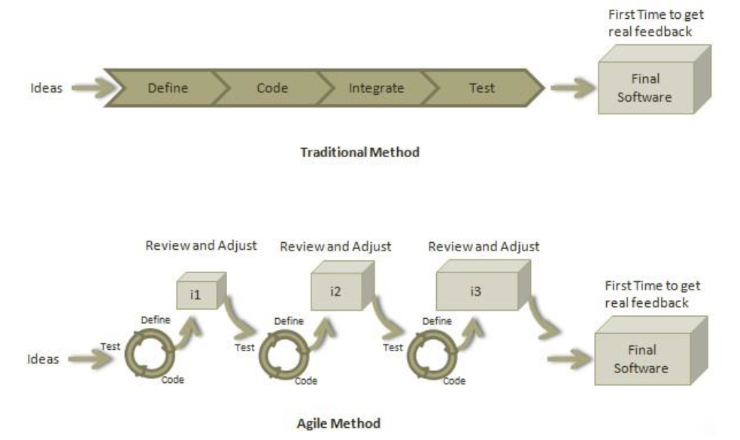

Figure 1Agile methodology

Ideas

The main idea of this project is to eradicate the problems on the voting system that are listed above

Define

Here the main architectural flow will be defined database as well as the whole system architecture

Code

Here the coding is done, where the ideas are changed to a practical system

Test

Here the code written will be tested that it does what was meant to do as well as the security of the system will be tested

* 1. Requirement Analysis
     1. Hardware Requirements
* A working internet (LAN or WAN)
* Mobile phone or laptop to access the web application
  + 1. Software Requirements
* Xampp server 7.1.1 application for the database and server
* Laravel framework for making the web based application
* GitHub for integrating the work flow and sharing work with the group members
* Atom, Sublime Text platforms for writing the code
* Fire Fox, Opera, IE, Chrome and Spark for browsing
* Laravel testing plugin for testing the code
  1. Data Collection Methodology
* **Document (supplementary method)**

Collecting information from different references, projects and web sites.

* **By discussing and analyzing** the problems with project team.
* **Interview (supplementary method)**

The additional data would be gathered through the technique of interview, through this technique we get different information’s from the current workers of the organization.

* 1. Feasibility of the project

A feasibility study may be conducted for a project with an emphasis a financial viability, environmental integrity, cultural acceptability or political feasibility. It is the determination as to the likelihood of success and adscription of how that determination was achieved.

* + 1. Economic Feasible

The purpose of assessing economic feasibility is to identify the financial benefit and cost association with the development project, economic feasibility is referred to us cost benefit analysis.

* + - 1. Costs

Table 1cost estimation table

|  |  |  |  |
| --- | --- | --- | --- |
| Items | Quantity | Unit price(birr) | Total price(birr) |
| Computer | 3(for development and deployment purpose) | 9000 | 27000 |
| Printers | 1 | 9000 | 9000 |
| Laravel | 1 | 50 | 50 |
| Sublime text editor | 1 | 50 | 50 |
| MS office | 1 | 50 | 50 |
| Xampp server | 1 | 50 | 50 |
| Total | | | 36,200 |

* + - 1. Benefits

The benefits of the project are listed below

* Cost reduction
* Error reduction
* Increased the speed of activity
* Reduction in material usage
* Faster decision making
* Increased accuracy and availability.

So, cost=36,200 birr, since the **benefits** are **larger** than the **cost** that spend to do the project, our team is conclude that this project is **Economically feasible**.

* + 1. Technical Feasible

Technical feasibility can be defined in two ways:

* Do we have skilled man power to develop the project?
* Do we have enough technology?

In designing the project, we already have qualified individuals and enough technologies so, this project is **Technically feasible**.

* + 1. Operational Feasible

The purpose of Operational feasibility can ask, Is the system solve the problem after the proposed system is implemented for the **user**? **YES,** Because, the system is allowed for the voters to get the access of the computer and internet by allocating different **voting stations** rather than manual system to vote. so, this project is **Operationally feasible**.

* + 1. Schedule Feasible
* Involves checking if the project team can develop the proposed system with the time allocated.
* Meeting project deadline may depend on the size the project team and the availability of the key members of the user group.
  1. Project plan activities

To develop the system our team has followed project plan precisely in order to make the concerned body get the system simple.

Table 2 work plan projection

|  |  |  |
| --- | --- | --- |
| Tasks | Responsible person | Deliverables |
| PROJECT INITIATION AND PLANNING | | |
| Explanation of the existing system | Samuel | Existing system documentation |
| Major functions of existing system | Neway and Bereketabe |
| PROJECT ANALYSIS | | |
| Use case modeling | Neway and Bereketabe | Use case diagram and description |
| Sequence diagramming | Neway | Sequence diagram |
| Activity diagramming | Bereketabe | Activity diagram |
| Functional & non-Functional Requirement | All members | User Requirement documentation |
| PROJECT DESIGN | | |
| State chart modeling | Neway and Bereketabe | State chart diagram |
| Design class diagramming | Neway and Samuel | Class diagram |
| Collaboration diagramming | Bereketabe and Samuel | Collaboration diagram |
| Component diagramming | Neway | Component diagram |
| User interface diagramming | All members | User interface flow diagram |
| PROJECT IMPLEMENTATION | | |
| Coding | All group members | Project code |
| Testing | All group members | Checked the code and tested the system |

CHAPTER TWO

1. SOFTWARE REQUIERMENT SPECIFICATION (SRS)
   1. Introduction

A Software Requirements Specification (**SRS)** is a document that lays out the description of the software that is to be developed as well as the intention of the software under development. Software requirements specification shows **what** the software is supposed to do as well as **how** it is supposed to perform. It is written down before the actual software development work starts. [2]

The software requirements specification document lists sufficient and necessary requirements for the project development. [2] To derive the requirements, the developer needs to have clear and thorough understanding of the products under development. This is achieved through detailed and continuous communications with the project team and customer throughout the software development process[3].

* 1. Purpose

Software Requirements Specification(SRS) is important for developers because it minimizes the amount of time and effort developers have to expend to achieve desired software goals. It thus reduces development cost. This also benefits the client company because the lesser the development cost, the lesser the developers will charge from the client. And, if composed properly, an SRS ensures that there is less possibility of future redesigns as there is less chance of mistake on the part of developers as they have a clear idea on the functionalities and externalities of the software. It also helps clear any communication problems between the client and the developer. Furthermore, an SRS serves to form a foundation of mutual agreement between the client and the developer (supplier). It also serves as the document to verify the testing processes.

* 1. **Overall description**
     1. Description of the current system

Current system is the manual system that needs intensive human labor, resource, consume time, less security. First of all, in these manual systems voters have requested to select their department representatives by hand.

* Voters must be physically presented at the time of representative vote
* Vote coordinators must be assigned by the union
* Coordinators must count properly
* Coordinators are accountable for any problems
* Coordinators are high risk takers

voters’ vote the candidates when the coordinator selected by the student union and the coordinator will have a direct contact with the students to be present in the class ant the coordinator’s must ask the students which student will represent them in the parliament and they will take out candidates of 6 student 3 male and 3 female students, then the students will vote from the candidates by hand and the coordinators will the result of the count from each of this 1 male and 1 female student will represent the department in the parliament. Counting the voice of each voter and reporting the winner will be performed by coordinators, perhaps if the counting error is occurred that manual system cannot report. Fraud occurring during election time was protected by law only.

2.3.2 players in the existing system

There are different players in the existing system: -

1. **Voters (students): -**

* They should at the voting place
* they should vote their candidates.
* view the result.

1. **Election offices (current president):-**

* register the candidates.
* coordinates and manages the workers and co-workers.
* count the votes.
* report the result.

1. **Parliament cabinets: -**

* Compete to the vote.

1. **Candidates: -**

* candidates registered by Election offices.
  1. Proposed Systems
     1. Overview of the proposed system

The main aim of our project is to automate the current manual system and it will solve the problems that are in the manual system. This system saves resources by doing all things used in election system and counts the result for each candidate correctly and report with exact value electronically. The new system does not pass over without reporting the occurred errors during the counting result. Also, in security side our system is secured because, it needs User name and Password. Before the Election Day the system will be used for viewing candidates’ profiles. Our system will be in election mode, for the purpose of vote polling only on the Election Day.

* 1. Functional requirements

A functional requirement, in software and systems engineering, is a declaration of the intended function of a system and its components [4].Based on functional requirements, an engineer determines the behavior (output) that a device or software is expected to exhibit in the case of a certain input.

Functional requirements describe the interactions between the system and its environment independent of its implementation. [5] The environment includes the user and any other external system with which the system interacts.

The following points list down the functional requirements of our system: -

* This system should provide registration of new students to the system
* The system should provide login page with proper authentication methods and security rules
* The system should have a password recovery method for lost passwords
* The system should verify the user is authorized person
* It should display the home page with the student union organization hierarchy
* The home page should also display the notifications and other relevant data
* The system should provide the user to change profile
* The system should have user or student privilege
* The system should contain admin or current in charge person or president
* The system should provide candidates privilege
* The system should provide the admin to post news
* The system should provide the admin to give privilege for candidate
* This system should provide for the admin to setup voting start date and end date
* This system must take care of the voting process
* Must display the candidate profile
* The system should provide the candidates to post their propaganda according to the schedule
* After voting is accomplished the system should revert the candidate privilege to the normal privilege or to user mode
  1. Non-Functional Requirement

Non-functional requirements (also known as **quality requirements**), which impose constraints on the design or implementation (such as performance requirements, security, or reliability). [6]

* + 1. Usability Requirements: -

It is expected that the user(voters) should be able to vote easily online. User(voters) should complete voting in a few minutes. Provide an online help and a quick guide for users(voters).

* + 1. Reliability Requirements: -

The system should be reliable. Security is a major concern in an online voting system. Process used in this system should be secure enough to be able to meet the requirements mentioned for online voting. It requires database connections and network connections. Changes can be done in the databases to store the votes. All changes need to be confirmed and if the transfer is complete the confirmation should be displayed. The changes should be monitored.

* + 1. Performance Requirements: -

There might be many users accessing to the web server simultaneously. As an online voting tool performance shouldn’t be affected much and response time for submitted page should be less than a minute.

* + 1. Security Requirements: -

The system should provide basic security features like password authentication. All the passwords generated and communicated to the users should be stored in the server only in an encrypted form for login management to prevent misuse.

* + 1. Safety Requirements:

In order to prevent data loss in case of system failure, the result of votes that were polled till then have to be saved in the database, for the system to resume the counting process on reboot. The current president should set up his system time appropriately for the election process to start at the correct time. The system should be capable of gracefully recovering from earlier crashes and continuing the voting process.

* 1. Hardware/Software Requirement
     1. Software Requirements
* Edraw Max for drawing the diagram such as use case diagram, sequence diagram Activity Diagram and etc.
* Sublime text editor
* Laravel 5.6 MVC framework
* Xampp 7.1.1 server
  + 1. Hardware Requirement

Toshiba laptop for developing the system and view the output of the system. The following is our laptop specification:

* Processor – Intel® Core™2 Duo CPU T6400@2.00GHz
* Memory(RAM) – 4.00GB
* With windows 10 installed
* System type – 32-bit Operating System
  1. Security and Safety Procedure

The new proposed system provides security to prevent unauthorized modification of records, the new database must have a solid security system to control the activities that can be performed by the users and determine which information can be viewed and modified and also the security system encores the protection of data regardless of new users gain access to the database.

In general, the system: -

* Prevented from unauthorized users by requesting valid user name and password.
* Permits access privilege for each user in the system.
* Permits the restriction of specific functions to specific users.
* Generate warning messages for every invalid input.
* Permits the administrator to perform all tasks.
* Secure every document in order to be used in the future.
  1. Use Case Diagram and Use Case Description

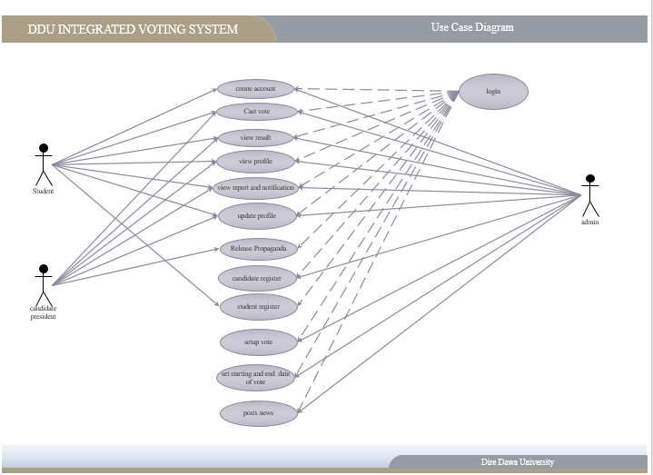

Figure 2Use case diagram of the system

* + 1. Use Case Description

1. **Use case name: Login**

Description: this use case allows to login into the system

Actors: Current President, student, candidate president.

Precondition: The actors should activate the system.

Basic course of action:

1. the actor instantiates login page
2. Login page will be activated
3. actor enter user name and password and clicks login button
4. system checks the validity of the provided information
5. if the user ID and password are valid, the actors will be logged on to the system
6. Confirmation message will be. displayed
7. Workers home form displayed.

Post condition: the actor should log on successfully.

Alternative course of action:

* actor enter user name and password and clicks login button
* system checks the validity of the provided information
* If the user ID and password are invalid.
* The system displays “error message”.
* The system asked to re-enter user name and password.

1. **Use case name: Cast Vote**

Actor: Student

Description**:** This use case is initiated by the student. This use case will enable the student to cast vote. It provides the capability to the system to process the voter’s ballot.

Pre-condition: The voter must have valid user id.

Basic course of Action: -

* This use case begins when the voters select cast vote from main page.
* The system shall display the well come page.
* The voter will insert his/her id number and encrypted code.
* The system shall check the id number and encrypted code with the existing id number and encrypted code.
* The system will open.

Post-condition**:** The voter can use rating to vote.

1. **Use case name: View Result**

Actor: Students, Candidate president, Current president.

Description: This use case is initiated by the Students, Candidate president, Current president. It provides the capability to the system to perform the counting of ballots polled for each candidate and announces the election results.

Pre-condition: Ballot information should be secured before the counting.

Basic course of Action: -The Use Case begins when the Students, Candidate president, Current president sends request to view the result.

Post-condition: Must report the result to the Students, Candidate president, Current president.

1. **Use case name: Candidate Register**

Actor**:** Current president

Description: this use case is initiated by the Current president. It provides to register candidates.

Pre-condition: The Current president must log on the system.

Basic course of Action: -

* the Current president must activate the system.
* The Current president user name and password on the login page.
* The system shall check the user name and password with the existing user name and password.
* The system will open the register page.
* The Current president will be register the voter.
* The Current president click the save button.

Post-condition**:** The Current president register the candidates.

1. **Use case name: Generate Result, Report and Notification**

Actor: Current president

Description: this use case is initiated by the Current president. It provides to generate result.

Pre-condition: The Election Current president log on the system.

Basic course of Action: -

* The Current president must activate the system.
* The Current president select result form from Report menu
* Result from menu interface displayed.
* The Current president can Generate the result from the page.

Post-condition: The Current president generate result.

1. **Use case name: View Profile**

Actor: Students, Candidate president, Current president.

Description: This use case is initiated by the Students, Candidate president, Current president. It provides the capability to the system to View each candidate.

Pre-condition: The Actors must activate the system.

Basic course of Action: -

* The Use Case begins when the Students, Candidate president, Current president sends request to view the Profile.

Post-condition: Must report the Profile to the Students, Candidate president, Current president.

* + 1. Activity Diagram

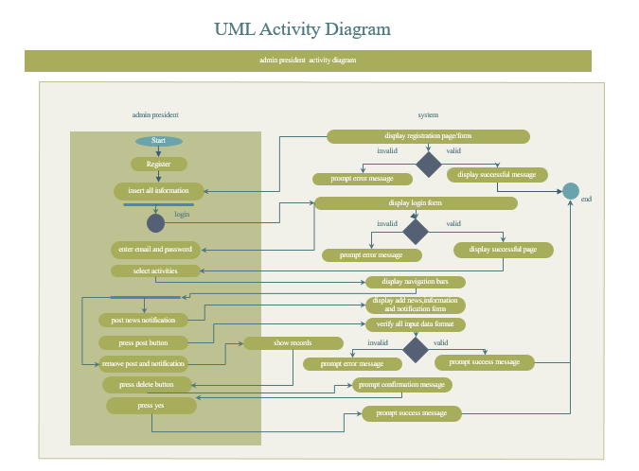

Figure 3Activity diagram of current president/admin

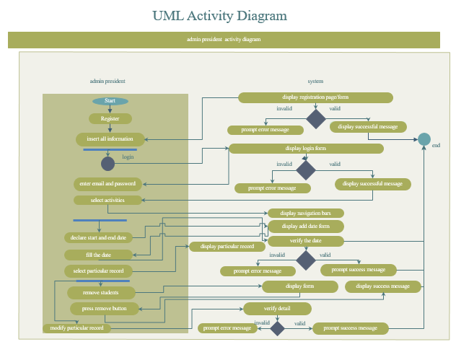

Figure 4Activity diagram of current president/admin

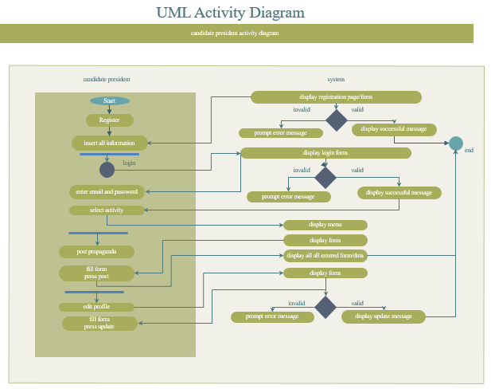

Figure 5Activity diagram of candidate president

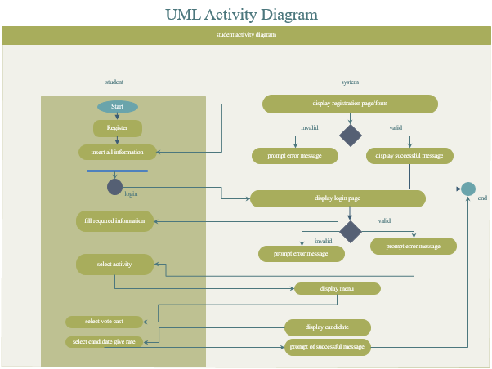

Figure 6Activity diagram of student

* 1. Class Diagram

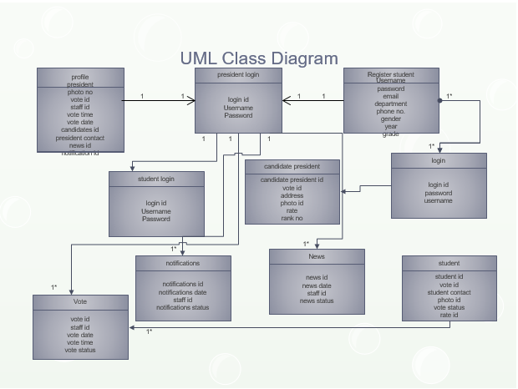

Figure 7 class diagram of the system

CHAPTER THREE

1. Database Design
   1. Database Design

Table 3 User table

|  |  |  |  |  |
| --- | --- | --- | --- | --- |
| Field Name | Data Type | Length | Key | Default Value |
| Id | Int | 10 | Primery | None |
| User_id | Varchar | 191 | forign | None |
| Fname | Varchar | 191 |  | None |
| Lname | Varchar | 191 |  | None |
| Gender | Varchar | 191 |  | None |
| Department | Varchar | 191 |  | None |
| Batch | Int | 11 |  | None |
| Pimage | Varchar | 191 |  | Defult.jpg |
| Email | Varchar | 191 |  | None |
| password | Varchar | 191 |  | None |
| Role | Int | 11 |  | 0 |
| Status | Varchar | 191 |  | New |
| Remember_token | Varchar | 100 |  | None |
| Created_at | Timestamp |  |  |  |
| Updated_at | Timestamp |  |  |  |

Table 4 post table

|  |  |  |  |  |
| --- | --- | --- | --- | --- |
| Field Name | Data Type | Length | key | Default Value |
| Id | Int | 10 | primery | None |
| Title | Varchar | 191 |  | None |
| Body | Text |  |  | None |
| Created_at | Timestamp |  |  | None |
| Updated_at | Timestamp |  |  | None |

Table 5 Ratings table

|  |  |  |  |  |
| --- | --- | --- | --- | --- |
| Field Name | Data Type | Length | Key | Default Value |
| Id | Int | 10 | primary | None |
| Created_at | Timestamp |  |  | None |
| Updated_at | Timestamp |  |  | None |
| Rating | Int | 11 |  | None |
| Rateable_type | Varchar | 191 |  | None |
| Rateable_id | Bigint | 20 | Foreign | None |
| User_id | Int | 10 | Foreign | None |

Table 6 password_reset table

|  |  |  |  |  |
| --- | --- | --- | --- | --- |
| Field Name | Data Type | Length | Key | Default Value |
| Email | Varchar | 191 | primary | None |
| Token | Varchar | 191 |  | None |
| Created_at | Timestamp |  |  | None |

Table 7 migration table

|  |  |  |  |  |
| --- | --- | --- | --- | --- |
| Field Name | Data Type | Length | Key | Default Value |
| Id | Int | 10 | Primery | None |
| Migration | Varchar | 191 |  | None |
| Batch | Int | 11 | Forign | None |

Table 8 user role table

|  |  |  |  |  |
| --- | --- | --- | --- | --- |
| Field Name | Data Type | Length | Key | Default Value |
| Id | Int | 10 | Primery | None |
| Role_id | Varchar | 191 |  | None |
| Student_id | Varchar | 191 |  | None |
| Created_at | Timestamp |  |  | None |

Table 9 user_role_list table

|  |  |  |  |  |
| --- | --- | --- | --- | --- |
| Field Name | Data Type | Length | Key | Default Value |
| Role_id | Int | 10 | primary | None |
| Role_name | Varchar | 191 |  | None |
| Created_at | Timestamp |  |  | None |

* 1. User Interface

The Proposed system has several user interfaces to communicate easily with the User.

We attempt to illustrate this interface in general as follows: -

**Specification**

* The system user interface should be consistent with all other program.
* All of the icons used in the program should be consistent throughout the program and unambiguous.
* The user interface should follow Microsoft standards because of its familiarity.
* The caption and the test of user interface should be self-descriptive and clear to understand.
* The user interface should be easy to understand.
* The user interface should be customized.
* The user interface should be designed in the way that they can be extended easily to support localization.
  1. Sequence Diagram

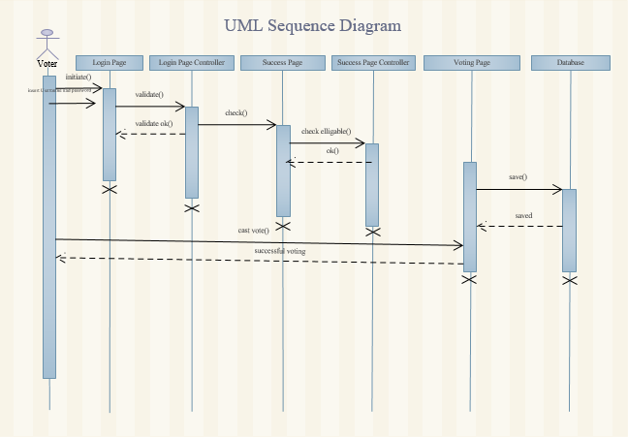

Figure 8 sequence diagram for vote

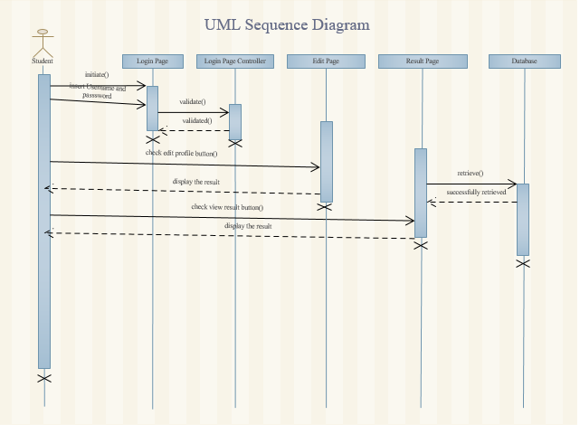

Figure 9 sequence diagram for edit profile

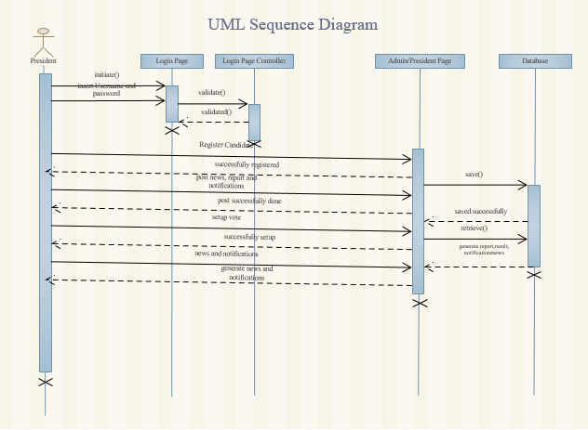

Figure 10 sequence diagram for generate result, report, notification, news and for registering.

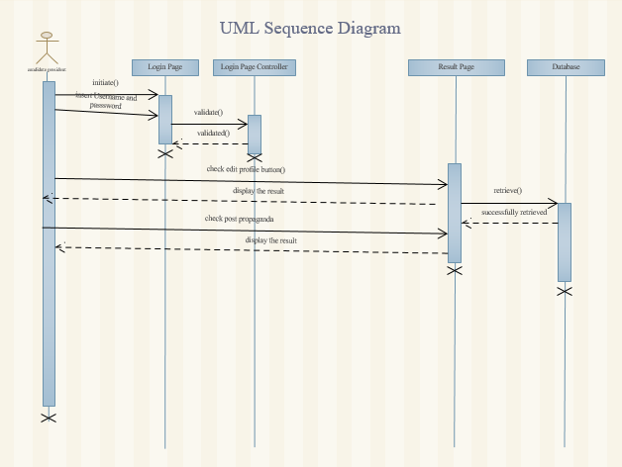

Figure 11 sequence diagram for view editing profile, post propagandas initiated by the candidate president

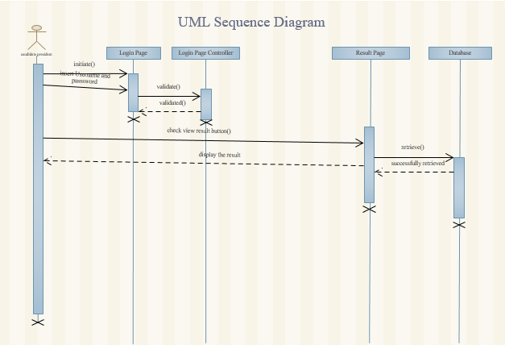

Figure 12 sequence diagram for view result initiated by the candidate president

* 1. User Interface Design

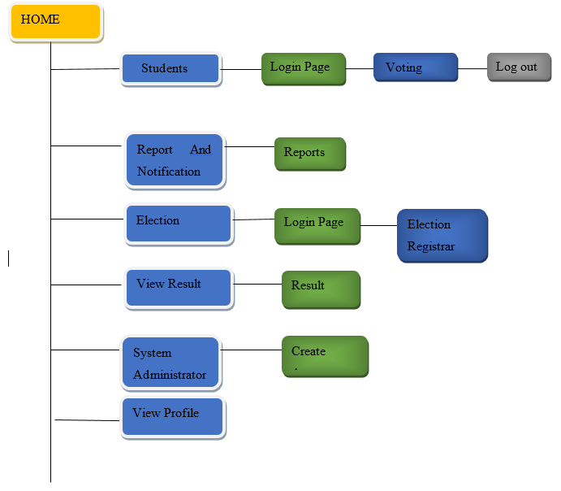

Figure 13 User Interface

* + 1. User Interface Description

1. **Home Page**

Description: -This user interface is a place where Online Voting are viewed and links for related topics (websites) are also mentioned in this user interface.

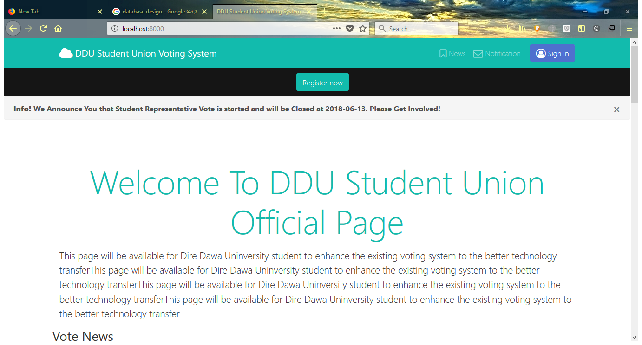

Figure 14 Home Page

1. **Login Page**

Description: -This page is the most important and key user interface to the system. It is a place where the system users (students, candidate presidents, Election parliament cabinets, current president) get access to the system by entering their user name and password. A user must provide a valid user id and password to access the next user interfaces.

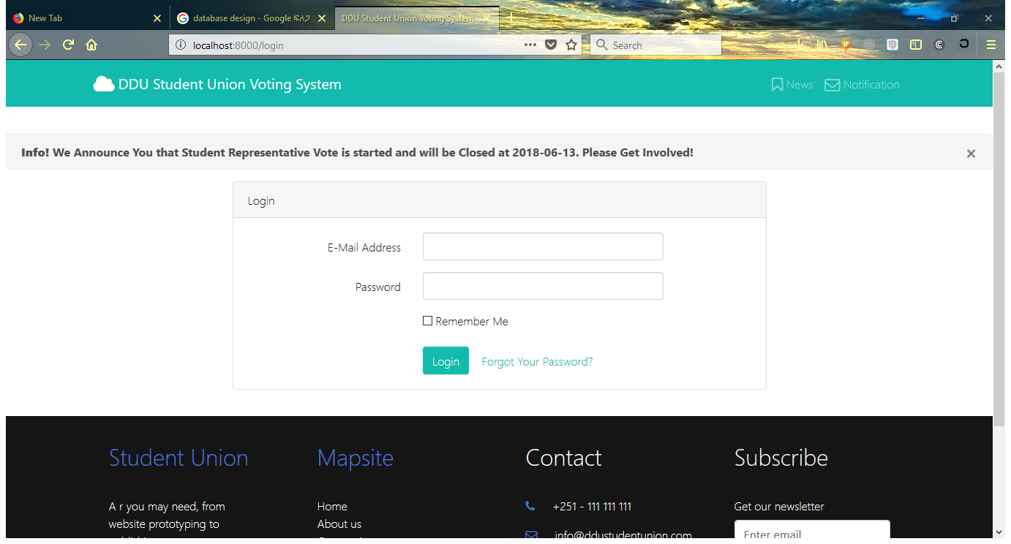

Figure 15Login page

1. **Voter (students)**

Description: -This User interface is used to vote the candidates by using his encrypted code and user name.

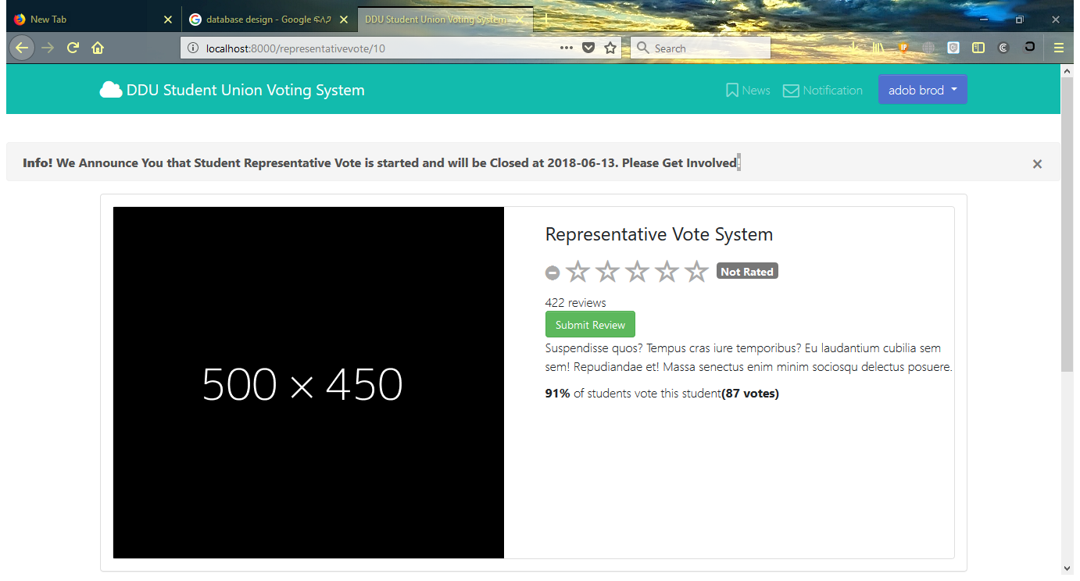

Figure 16 Cast Vote page

1. **Current President**

Description: - This User interface is used for the Current President can login to the system and register the candidates. And also posts news and notifications, setup voting and administering election process. It also used for Administrator only to Add, delete, and change data and user account.

1. **View Result**

Description: -This User interface is used to view the result that can generate by the Current president.

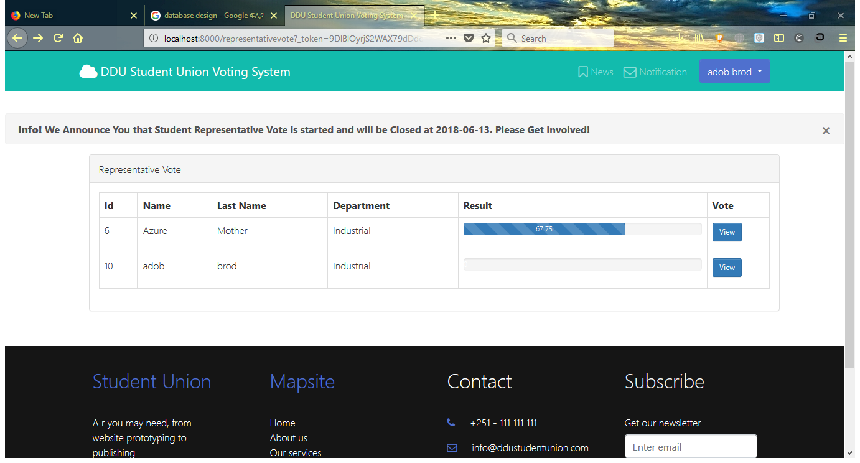

Figure 17 Result display page

1. **View Report and Notifications**

Description: -This User interface is used to view the reports and notifications that can generate by the Current president.

1. **View Profile**

Description: - This interface used for the voter that can view the profile of the candidates.

CHAPTER FOUR

1. Programming
   1. Coding

Here is some sample code used in the system: -

**Register New User Coding**

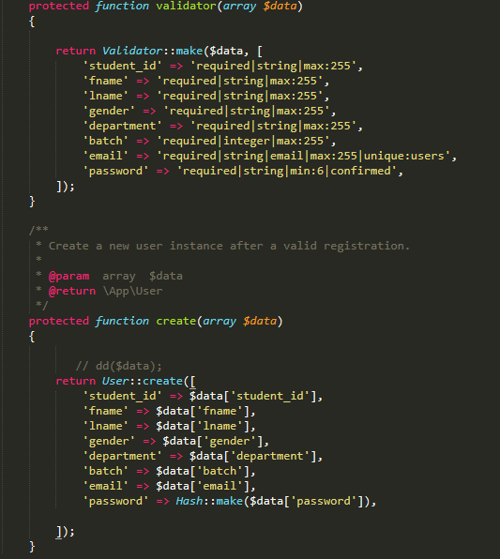

Figure 18 Registering new user

**Display News and Notification Code**

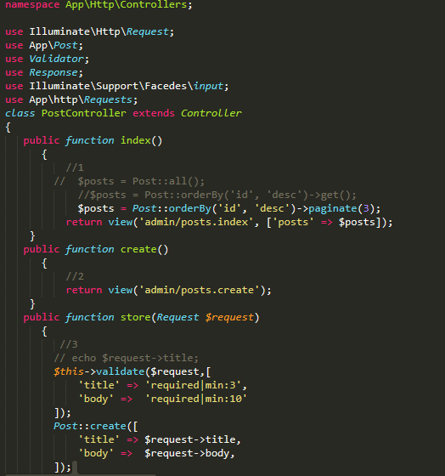

Figure 19 News and notification display

**Display Rating code**

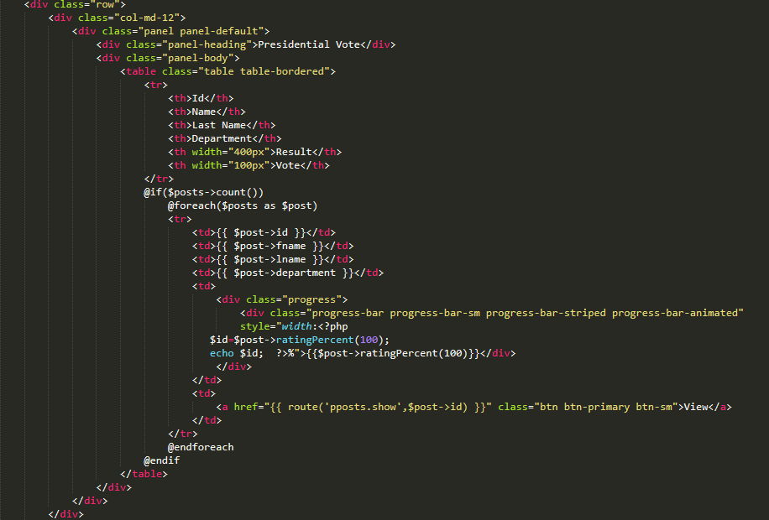

Figure 20 Display Rating code

**Casting vote code**

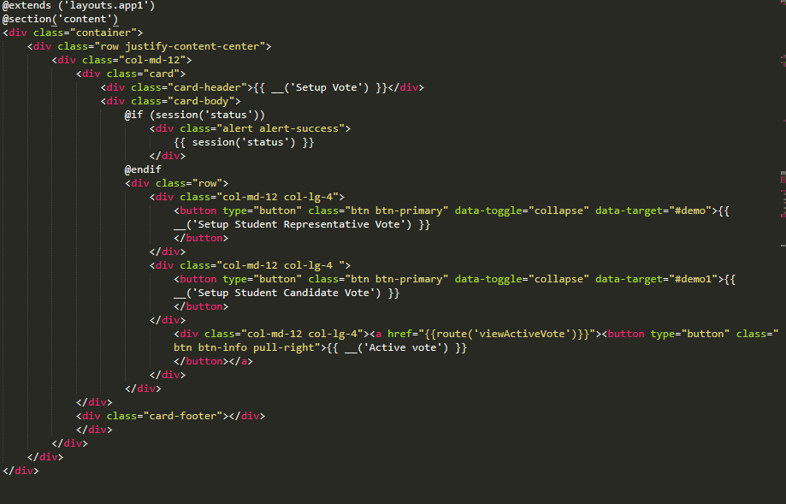

Figure 21 Casting vote code

CHAPTER FIVE

Software Testing

1. Testing Technique
   1. Unit Testing

Unit Testing is to make sure the module that been develop can run smoothly and executable without any bugs or system error. Unit testing basically will test on the particular part or unit such as function, procedures, or modules. It is to ensure that the particular function that has been developed can fulfil the requirement of the user and without any error. Unit testing is normally test by the programmer who writes the code. Every time after they had finish writing the code, they will run the debugger and test whether the function of source code can run smoothly or not. If there are bugs or system errors occur, the developer will try to solve it and then run the debugger again. If the function can run smoothly without error and can meet the required function, the developer will test the whole module all over again.

* 1. Validation Testing

Validation testing is one kind of testing which will test on whether the system is able to handle the wrong data that entered by the user or not. It also use to ensure that the data entered by the user is relevant and in the correct format or correct data types. For this testing, we will test whether the system can handle the data that entered by the user. For example, if the user is required to enter the numeric data but they are enter the string data, will the system able to track the data entered by user and prompt error message to inform the user to enter the correct one. This testing is very important because the wrong data entered may cause the system error or accidentally insert the wrong data into the database and misleading the system.

* 1. User Acceptance Testing

User Acceptance Testing is a testing to determine whether the system that had been developed is satisfied and accepted by the user or not. It will carry out after all testing are done and will test by the user who will use the system. In this testing, the user also can decide whether the acceptance level to the system or perhaps the user can provide some feedback to the programmer so that the programmer can make enhancement on the system.

* 1. Test Plan

Table 10 Test Case

|  |  |  |  |  |
| --- | --- | --- | --- | --- |
| Module Name: President Information Maintenance | | | | |
| Task Name | Test Objective | Expected Result | Actual Result | Remark |
| Validation | To check whether the validation will be executed if the required fields are blank or wrong  data type. | Prompt out error message to inform the user that the blank fields or incorrect data types are entered. | Prompt out the error message. | Pass |
| Add user | Check whether the new user can be added into the database. | Successful added the user into the database. | Successful update the particular user  details in the database. | Pass |
| Edit user | Check whether the existing user can be successful edit. | Successful update the user details into database. | Successful update the particular user  details in the database. | Pass |
| Search user | Check whether the system can search the correct information that request by user. | Display the correct information based on the search criteria. | Display the correct information. | Pass |
| List all user | Check whether the system can list out all the user record on data grid view. | Display all user record that retrieved from the database. | Display all user record. | Pass |
| Delete user | Check whether the user record can be deleting. | Successful delete the user record. | Successful removed particular user record from database. | Pass |
| Edit Profile Info | Check whether the president profile information can  be successful edit. | Successful update the president profile information details into database. | Successful updated the president profile  information in the database. | Pass |
| Set Time | Check weather the starting and ending dates of voting can be successful set | Successful set the time constraints into database. | Successful sat the time constraints in the database. | Pass |
| Post News and Notifications | Check whether the news and notifications can  be successful post. | Successful post the news and notifications into database. | Successful post the news and notifications information’s into database. | Pass |

Table 11Candidate president table

|  |  |  |  |  |
| --- | --- | --- | --- | --- |
| Module Name: Candidate president information Maintenance | | | | |
| Task Name | Test Objective | Expected Result | Actual Result | Remark |
| Validation | To check whether the validation will be executed if the required fields are blank or wrong data type. | Prompt out error message to inform the user that the blank fields or incorrect data types are entered. | Prompt out the error message. | Pass |
| Edit Profile Info | Check whether the candidate president profile information can be successful edit. | Successful update the candidate president profile information details into database. | Successful updated the candidate president profile information in the database. | Pass |
| Post Propaganda | Check whether Propaganda can be successful post. | Successful post the Propaganda into database. | Successful post the Propaganda into database. | Pass |
| Edit Propaganda | Check whether the Propaganda can be successful edit. | Successful update the Propaganda details into database. | Successful updated the Propaganda in the database. | Pass |

Table 12 student information test table

|  |  |  |  |  |
| --- | --- | --- | --- | --- |
| Module Name: Student information Maintenance | | | | |
| Task Name | Test Objective | Expected Result | Actual Result | Remark |
| Validation | To check whether the validation will be executed if the required fields are blank or wrong  data type. | Prompt out error message to inform the user that the blank fields or incorrect data types are entered. | Prompt out the error message. | Pass |
| Edit Profile Info | Check whether the student profile information can  be successful edit. | Successful update the student profile information details into database. | Successful updated the student profile  information in the database. | Pass |
| Give Rating | Check whether the student rating orders can be successful performed. | Successful record the student rating order into database. | Successful recorded the student rating order into database. | Pass |

CHAPTER SIX

CONCLUSION

1. Evaluation against Project
   1. Project Strength

* Faster response time toward student

Due to all information are already store in the database, so the student can retrieve data for example president, candidate president and parliament cabinets details through the system in a fastest way instead of searching their record from a bunch of messy document on the cabinet. This DDU student union voting System is to achieve the university satisfaction on shorter waiting time and transparent, free and fair election provided to and from the student. With this system, the DDU student union can save up a lot of response time to handle the voting. So, the union can provide better voting service to more students within an operation time.

* Easy to maintain union data

Everything is digitalize including all the data that belongs to the student union will store in a well-organized database. Staff is easy to maintain such well-organized data as it is easy when they want to modified some detail from particular records, searching for data, add in some new data or delete some data with the help of the system. They can perform all the activity that I mentioned in an efficient way.

* Secure database

The user of the system is allowed to access to those data that authority to his/her level. For example, the president private information is restricted to access only by current president level user at the union.

* Reduce number of worker needed

With the help of the system, the union does not need to hire for so many workers to cope with bunch of students because the operation of the union is digitalized. Most of the things could do by the system effectively and efficiency, thus the number of worker can be reduced.

* 1. Project Weaknesses
* Do not entirely perform all DDU student union tasks

This system only performs sorts of tasks from student union. For example, voting and tasks associated with the voting process.

* 1. Group Reflection

Through the developing of this project, we gain a lot of extra knowledge. We had learned additional knowledge for LARAVEL which is the programming language that We used to develop our project. Besides that, we got to know how to debug the system to find the error in an efficient way instead of go through the code one by one.

It is not easy to successful create a project because there is no perfect system as we only can try our best to make the system fulfil the user needs. User will have endlessly expectation towards the system since the day they start interact with the system. As a programmer, we must try to come out with solution to fulfil their requirement as long as the requirement is logical.

We had faced kind of coding problems, logical problem as well as system flow problem when we developing this project. Fortunately, we can able to solve all these problems with the aid of help from our supervisor, our friends and of course the solutions from Google search. Besides that, our supervisor does provide us with precious suggestion and advice on enhancing our system to a better one. With the advice and suggestion that he gave, it brought a lot of benefits to us.

Although this project is the toughest task ever to us we believe that it could really help us a lot when we come out to working. Last but not least, we know the effort that we’d pay and the time that contributed to this project is worth the knowledge and experience that we gain. We would like to use this opportunity to show our gratefulness to everyone that kindly given out their helping hand to us when we needed them. Thanks again.

# Bibliography

|  |  |
| --- | --- |
| [1] | "https://www.guru99.com/," june 2017. [Online]. Available: https://www.guru99.com/learn-software-requirements-analysis-with-case-study.html. |
| [2] | A. p. methodology, "www.tutorialspoint.com," Tutorialspoint, 2018. [Online]. Available: https://www.tutorialspoint.com/agile/index.htm. |
| [3] | U. S. G. U. A. 2. ISBN, " Supplement 4-A, A Procedure for Requirements Analysis"," 18 March 2016. [Online]. Available: https://en.wikipedia.org/wiki/Functional_requirement. [Accessed 23 may 2018]. |
| [4] | T. McGraw-Hill, "Software maintenance: effective practices," in *Software maintenance for software engineers*, Gopalaswamy Ramesh; Ramesh Bhattiprolu (2006). |
| [5] | Tutorialspoint, "www.tutorialspoint.com," 12 april 2018. [Online]. Available: https://www.tutorialspoint.com/laravel/index.htm. [Accessed 20 june 2018]. |
| [6] | D. Leffingwell, "https://www.scaledagileframework.com/," Agile Software Requirements: Lean Requirements Practices for Teams, Programs, and the Enterprise. Addison-Wesley,, 19 April 2018. [Online]. Available: https://www.scaledagileframework.com/nonfunctional-requirements/. |