**例子程序**

* U8glib库的使用

打开**文件**->**示例**->**U8glib**->**U8gLogo**，如下图所示：

[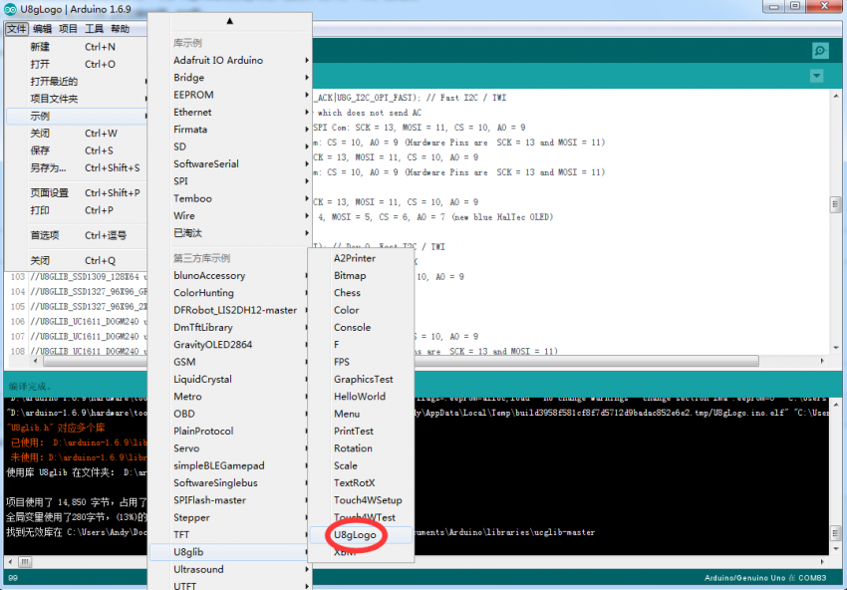](http://wiki.dfrobot.com.cn/index.php?title=%E6%96%87%E4%BB%B6:U8glib%E7%A4%BA%E4%BE%8B.png)

[http://wiki.dfrobot.com.cn/skins/common/images/magnify-clip.png](http://wiki.dfrobot.com.cn/index.php?title=%E6%96%87%E4%BB%B6:U8glib%E7%A4%BA%E4%BE%8B.png)

U8glib示例目录

选择 **U8GLIB_SSD1306_128X64 u8g(U8G_I2C_OPT_NONE | U8G_I2C_OPT_DEV_0); // I2C / TWI**，取消注释，如下图所示：

[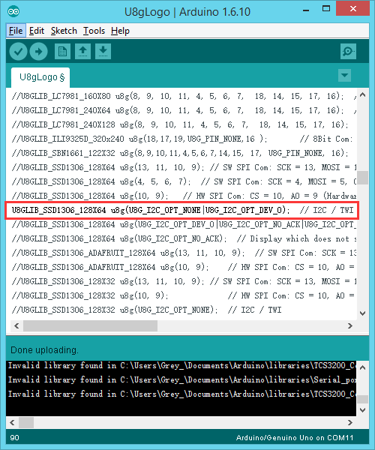](http://wiki.dfrobot.com.cn/index.php?title=%E6%96%87%E4%BB%B6:U8glib%E7%A4%BA%E4%BE%8B%E4%BB%A3%E7%A0%81.png)

[http://wiki.dfrobot.com.cn/skins/common/images/magnify-clip.png](http://wiki.dfrobot.com.cn/index.php?title=%E6%96%87%E4%BB%B6:U8glib%E7%A4%BA%E4%BE%8B%E4%BB%A3%E7%A0%81.png)

U8glib代码修改部分

源码如下：

/*

U8gLogo.pde

Put the U8GLIB logo on the display.

>>> Before compiling: Please remove comment from the constructor of the

>>> connected graphics display (see below).

Universal 8bit Graphics Library, https://github.com/olikraus/u8glib/

Copyright (c) 2012, olikraus@gmail.com

All rights reserved.

Redistribution and use in source and binary forms, with or without modification,

are permitted provided that the following conditions are met:

Redistributions of source code must retain the above copyright notice, this list

of conditions and the following disclaimer.

Redistributions in binary form must reproduce the above copyright notice, this

list of conditions and the following disclaimer in the documentation and/or other

materials provided with the distribution.

THIS SOFTWARE IS PROVIDED BY THE COPYRIGHT HOLDERS AND

CONTRIBUTORS "AS IS" AND ANY EXPRESS OR IMPLIED WARRANTIES,

INCLUDING, BUT NOT LIMITED TO, THE IMPLIED WARRANTIES OF

MERCHANTABILITY AND FITNESS FOR A PARTICULAR PURPOSE ARE

DISCLAIMED. IN NO EVENT SHALL THE COPYRIGHT HOLDER OR

CONTRIBUTORS BE LIABLE FOR ANY DIRECT, INDIRECT, INCIDENTAL,

SPECIAL, EXEMPLARY, OR CONSEQUENTIAL DAMAGES (INCLUDING, BUT

NOT LIMITED TO, PROCUREMENT OF SUBSTITUTE GOODS OR SERVICES;

LOSS OF USE, DATA, OR PROFITS; OR BUSINESS INTERRUPTION) HOWEVER

CAUSED AND ON ANY THEORY OF LIABILITY, WHETHER IN CONTRACT,

STRICT LIABILITY, OR TORT (INCLUDING NEGLIGENCE OR OTHERWISE)

ARISING IN ANY WAY OUT OF THE USE OF THIS SOFTWARE, EVEN IF

ADVISED OF THE POSSIBILITY OF SUCH DAMAGE.

*/

#include "U8glib.h"

U8GLIB_SSD1306_128X64 u8g(U8G_I2C_OPT_NONE | U8G_I2C_OPT_DEV_0); // I2C / TWI

//#define MINI_LOGO

void drawColorBox(void)

{

u8g_uint_t w, h;

u8g_uint_t r, g, b;

w = u8g.getWidth() / 32;

h = u8g.getHeight() / 8;

for ( b = 0; b < 4; b++ )

for ( g = 0; g < 8; g++ )

for ( r = 0; r < 8; r++ )

{

u8g.setColorIndex((r << 5) | (g << 2) | b );

u8g.drawBox(g * w + b * w * 8, r * h, w, h);

}

}

void drawLogo(uint8_t d)

{

#ifdef MINI_LOGO

u8g.setFont(u8g_font_gdr17r);

u8g.drawStr(0 + d, 22 + d, "U");

u8g.setFont(u8g_font_gdr20n);

u8g.drawStr90(17 + d, 8 + d, "8");

u8g.setFont(u8g_font_gdr17r);

u8g.drawStr(39 + d, 22 + d, "g");

u8g.drawHLine(2 + d, 25 + d, 34);

u8g.drawVLine(32 + d, 22 + d, 12);

#else

u8g.setFont(u8g_font_gdr25r);

u8g.drawStr(0 + d, 30 + d, "U");

u8g.setFont(u8g_font_gdr30n);

u8g.drawStr90(23 + d, 10 + d, "8");

u8g.setFont(u8g_font_gdr25r);

u8g.drawStr(53 + d, 30 + d, "g");

u8g.drawHLine(2 + d, 35 + d, 47);

u8g.drawVLine(45 + d, 32 + d, 12);

#endif

}

void drawURL(void)

{

#ifndef MINI_LOGO

u8g.setFont(u8g_font_4x6);

if ( u8g.getHeight() < 59 )

{

u8g.drawStr(53, 9, "code.google.com");

u8g.drawStr(77, 18, "/p/u8glib");

}

else

{

u8g.drawStr(1, 54, "code.google.com/p/u8glib");

}

#endif

}

void draw(void) {

if ( u8g.getMode() == U8G_MODE_R3G3B2 ) {

drawColorBox();

}

u8g.setColorIndex(1);

if ( U8G_MODE_GET_BITS_PER_PIXEL(u8g.getMode()) > 1 ) {

drawLogo(2);

u8g.setColorIndex(2);

drawLogo(1);

u8g.setColorIndex(3);

}

drawLogo(0);

drawURL();

}

void setup(void) {

// flip screen, if required

//u8g.setRot180();

}

void loop(void) {

// picture loop

u8g.firstPage();

do {

draw();

u8g.setColorIndex(1);

} while ( u8g.nextPage() );

// rebuild the picture after some delay

delay(200);

}