**Python fundamentals:**

**Data Types:**

* ‘Hello world’: str,
* None: NoneType,
* 15: int,
* 20.14: float,
* function,
* (1, ‘b’, 3, 5): tuple

/* immutable, can contain mixed data types, written between parentheses () */

* [1, ‘b’, 3, 5]: list

/* mutable (add by append() function), can contain mixed data types, written between square brackets [] */

* {‘name’: ‘Asmaa’, ‘surname’: ‘Mirkhan’}: dictionary

/* labeled list, no order, similar to JSON */

**Classes:**

Note: Objects do not have private or protected members

Constructor: (Syntax: __init__) it is not necessary

**Map Function:**

Function signature: map(function, iterable , …)

Note: Useful for analysis

**BASIC DATA PROCESSING WITH PANDAS:**

/* loc and iloc for row based querying and square brackets [] for column based querying */

**Series in pandas:**

Between list and dictionary, sorted but has keys(labeled), labels are indices starting from 0 and the last key is dtype key (data type)

**Data Frames in pandas:**

Briefly, it is a two-dimensional series

/* like SQL database tables*/

**Boolean Masking:**

Useful for removing unwanted data

e.g

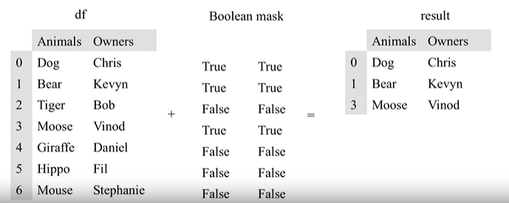

Data frames offer functions like SQL queries such as join, groupby,…

**Scales in pandas:**

* **Ratio Scale**
  + Units are equally spaced
  + Math. ops. are valid
  + Ex: height, weight
* **Interval Scale**
  + Units are equally spaced
  + No true zero
  + Ex: temperature scale
* **Ordinal Scale**
  + Order is important
  + Not evenly spaced
  + Common in machine learning
  + Ex: letter grades (AA, BA, ..)
* **Nominal Scale**
  + Like categories, order is not important
  + Ex: Teams of sports