PAMBAYANG DALUBHASAAN NG MARILAO

WEBAKE: WEB-BASED SALES AND INVENTORY SYSTEM FOR
CRUMBS N’ ROLL BAKERY

A Project
Presented to the Faculty of the
College of Computer Studies
Pambayang Dalubhasaan ng Marilao

In Partial Fulfillment
of the Requirements for the Degree of
Bachelor of Science in Information Technology in
System Analysis and Design Case Study

by
JOHN CLIVEN B. AMADEO
WENDEL T. SILVA
JUSTIN KEN S. TEJADA
GERALD R. VELASCO

OCTOBER 2026
TABLE OF CONTENTS

PRELIMINARIES
Title Page
Table of Contents
CHAPTER 1 - INTRODUCTION
Project Context
Objectives of the Study
Purpose and Description
Scope and Delimitation of the Study
CHAPTER 2 - TECHNICAL BACKGROUND OF THE STUDY
Project Analysis
Project Structure

1. INTRODUCTION
This chapter contains the project context, general and specific objectives of the study, purpose and description and scope and delimitation of the study.
1.1 Project Context
WeBake is a web-based inventory and sales system designed for Crumbs N' Roll Bakery. The proposed system aims to help and improve the current method of managing inventory and recording sales through a computerized process instead of using manual logbooks. With WeBake, the Crumbs N' Roll Bakery can easily track its products, monitor stock levels, and keep accurate records of every transaction. This will save time, reduce effort, and lessen the chances of errors that come with manual recording, making the bakery's daily operations more organized and efficient.
Crumbs N’ Roll Bakery is a wholesale bakery owned by Angelita B. Amadeo and established in 2010. It is located at 1356 Cordero Street, Lambakin, Marilao, Bulacan. The Crumbs N’ Roll Bakery was founded to provide quality and affordable bread products, supply partner bakeries, and provide a stable source of income for the owner’s family. Crumbs N’ Roll Bakery mainly serves wholesale customers, but it also serves walk-in customers when products are available. It currently has eight staff members who are responsible for production, packaging, and delivery operations. The bakery produces different kinds of bread products, like Butter Toast, Mamon, Otap, Eggnog, and other baked products, with the production depending on customer demand. Those products are distributed to different areas such as Caloocan, Ilocos, and Malolos. The partner bakeries commonly place orders ranging from 400 to 500 bundles, making the Crumbs N’ Roll Bakery primarily focused on wholesale distribution, maintaining their daily production and delivery operations.
Crumbs N’ Roll Bakery contains several processes, including inventory management, bread production, packaging, order placement, delivery, payment, and sales recording. The Crumbs N’ Roll Bakery manages its inventory by reviewing customer orders before production to determine the required quantity of each bread product. Orders are received through phone calls, text messages, or Facebook Messenger. After receiving the orders, the Crumbs N’ Roll Bakery prepares the products through ingredient preparation, mixing, shaping, proofing, baking, cooling, and packaging. The packed products are then loaded into the bakery’s L300 delivery vehicle and delivered to partner bakeries. Upon delivery, customers check the products and confirm the order before making the full payment. After the payment is completed, Crumbs N’ Roll Bakery records the transaction in a notebook or written log. The sales records include the customer, products delivered, quantity sold, and payment received. These records are used to keep track of its inventory, orders, deliveries, payments, and daily sales transactions.
Currently, Crumbs N’ Roll Bakery uses a manual process for recording its sales and inventory. It also uses a logbook to record and monitor its inventory, while completed transactions and sales are also recorded. Because this process is done manually, it takes a lot of time and requires a lot of effort. Since the records are maintained manually, there is also a high possibility of human error. As a result, monitoring inventory and sales records becomes less efficient. The main problem of Crumbs N’ Roll Bakery is the lack of a computerized system and organized or clean way of listing the transactions that can help to manage its inventory and sales records more efficiently.
1.2 Objectives of the study
1.2.1 General Objective
The general objective of this study is to develop a Web-Based Sales and Inventory System that will be used to manage the sales records and inventory of Crumbs N’ Roll Bakery more efficiently.
1.2.2 Specific Objectives
1. To design a user friendly online ordering system that allows the customers to browse available products, and place orders.
2. To create a system that helps the owner to handle their sales report and product stocks in a much faster and efficient way.
3. To develop an inventory management module that allows the bakery owner to monitor product stocks, track inventory levels, and receive notifications when stocks are low.
4. To provide a centralized web-based system that integrates sales and inventory records, helping the bakery owner manage business transactions, product availability, and records more accurately and efficiently.

1.3 Purpose and Description
This study aims to develop a Web-Based Sales and Inventory system for Crumbs N’ Roll Bakery. The proposed system is meant to benefit the following:

1.3.1 Owner of Crumbs N’ Roll Bakery
The proposed system aims to reduce the workload for the owner by simplifying stock monitoring, sales recording, and inventory management. The system will also help the owner to manage customers' orders, and generate reports to monitor business performance that will support decision-making.
1.3.2 Customers
The proposed system will allow the customers a convenient way to view available products and place orders online without needing to contact the bakery through phone calls or messages.
1.3.3 Proponents
The study allows the proponents to enhance their creativity, problem-solving, and programming skills through developing a web-based system, and to apply the knowledge gained in their course to a real-world business problem.
1.3.4 Future Researchers
The study can serve as a reference for future researchers who wish to develop similar web-based sales and inventory systems.This study may provide useful information about development of a system that supports online ordering, inventory monitoring, and sales recording.
1.4 Scope and Delimitation of the Study
This study focuses on the design and development of a web-based sales and inventory system for Crumbs N' Roll Bakery. The system aims to assist the owner in managing inventory, processing customer orders, and monitoring sales. It also provides customers with an online platform for browsing and purchasing products.
The system has two types of users: The Admin and the Customer. The Customer may freely access the Home, Products, About Us pages, and track orders without logging in. Registration and login are optional for customers. The Admin, who is responsible for managing the functions of the system, is required to have an account and to log in in order to access the WeBake administrative module.
The Customer Module allows customers to browse products, add products to their cart, and place orders through the WeBake system. Customers may choose to proceed as either a Guest or a Member of WeBake when placing an order.
A Guest may browse products, add products to the cart, place an order without creating or logging into an account. However, the Guest must provide the required information for each transaction. For orders, the Guest must provide their name, delivery address, contact number, and email address, and select a preferred payment method, such as Paymaya or GCash. The submitted email address must be verified through a One-Time Password (OTP) sent to the provided email address before the order can be completed. Email verification may also be required to validate the email address submitted with the inquiry.
A Member of WeBake is a registered customer with an account in the system. Members may place orders while having access to account-based features. The system allows Members to save their ordering information, including their name, delivery address, contact number, and email address, so that they do not need to repeatedly enter the same information during checkout. Members may also view their order history, and add products to their shopping cart. The saved information is used to simplify the checkout process and provide Members with easier access to their previous order transaction. Members are still subject to the system's email verification requirements when applicable.
The Admin module enables the Admin to review customer orders and either accept or reject them. The Admin may also monitor and update the product inventory (adding, deleting, and updating product stock) and generate sales reports (daily, weekly, monthly).

The study is limited to the features and functions described in the scope. Orders are accepted only for delivery locations within Bulacan and Metro Manila. For customers located outside these areas, Crumbs N' Roll Bakery may arrange a halfway meeting point, which is arranged outside the system.
The Customer is required to pay 50% down payment when placing an order through the system. The initial payment is recorded through the system while the remaining 50% of the payment is manually inputted by the admin to the admin side website system after the transaction is completed or the product is already delivered to the assigned customer. The system does not support barcode scanning or the bulk importing of product data, and product information must be entered manually by the Admin through the inventory form.

2. TECHNICAL BACKGROUND OF THE STUDY
2.1 Project Analysis
2.1.1 Data Flow Diagram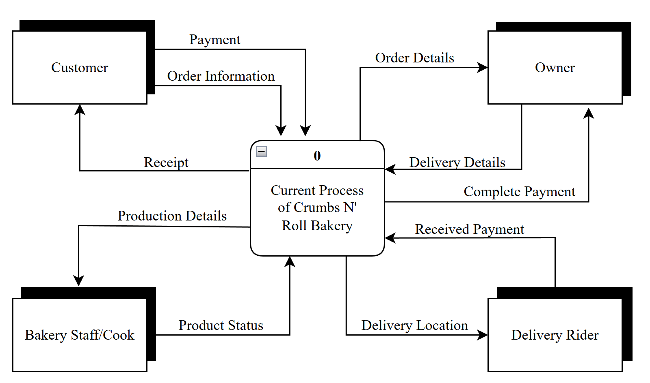
FIGURE 1. Context Diagram of the Existing System
In figure 2, this diagram shows the context diagram of Crumbs N’ Roll Bakery. There are four (4) entities which are customer, owner, bakery staff/cook, and delivery rider. The customer gives the order information. The owner receives the customer order and gives it to the bakery staff/cook as production details. The bakery staff//cook sends the product status. The owner gives the delivery details to the delivery rider. The delivery rider delivers the product to the customer. The customer gives the payment and will receive a receipt from the delivery rider. The delivery rider gives the received payment to the owner.
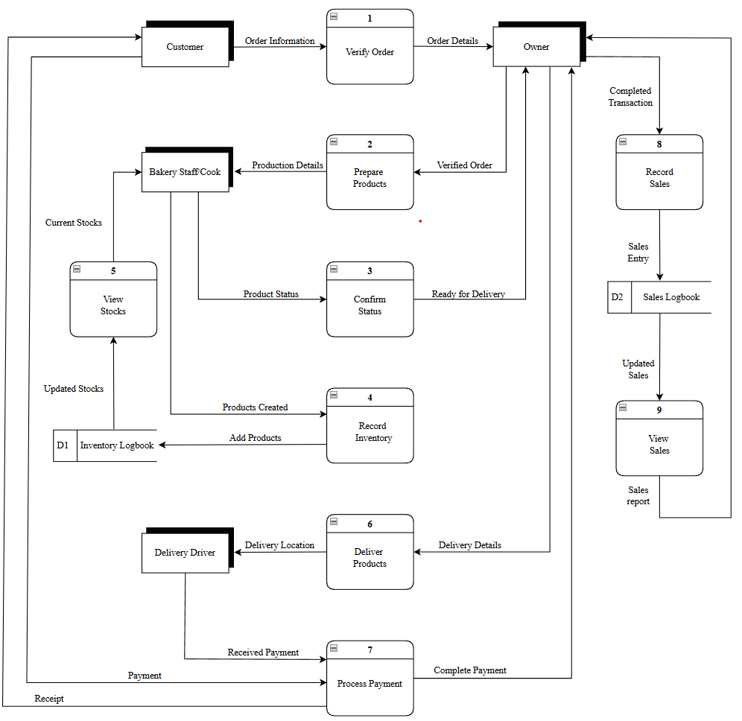
FIGURE 2. Diagram 0 of the Existing System
In figure 3, this diagram shows the existing process of Crumbs N’ Roll Bakery. The diagram has four (4) entities which are customer, owner, bakery staff/cook, and delivery driver. There are seven (7) processes. The first process is Verify Order where the owner will verify the order sent by the customer. The second process is Prepare Products where the admin gives the verified order as production details that the bakery staff/cook will prepare. The third process is Confirm Status where the bakery staff/cook sends an update whether the product is ready for delivery. The fourth process is Record Inventory where the bakery staff/cook records so they can keep track of the created products so far. The fifth process is View Stocks where the bakery staff/cook checks the current stocks of the products. The sixth process Deliver Products where the owner gives the delivery details to the delivery rider. The seventh process is Process Payment where the delivery rider collects the payment from the customer then gives receipt to the customer and the delivery rider gives the collected payment to the owner. The eighth process is Record Sales where the owner records the completed transaction. The ninth process is View Sales where the admin views the recorded sales in the logbook.
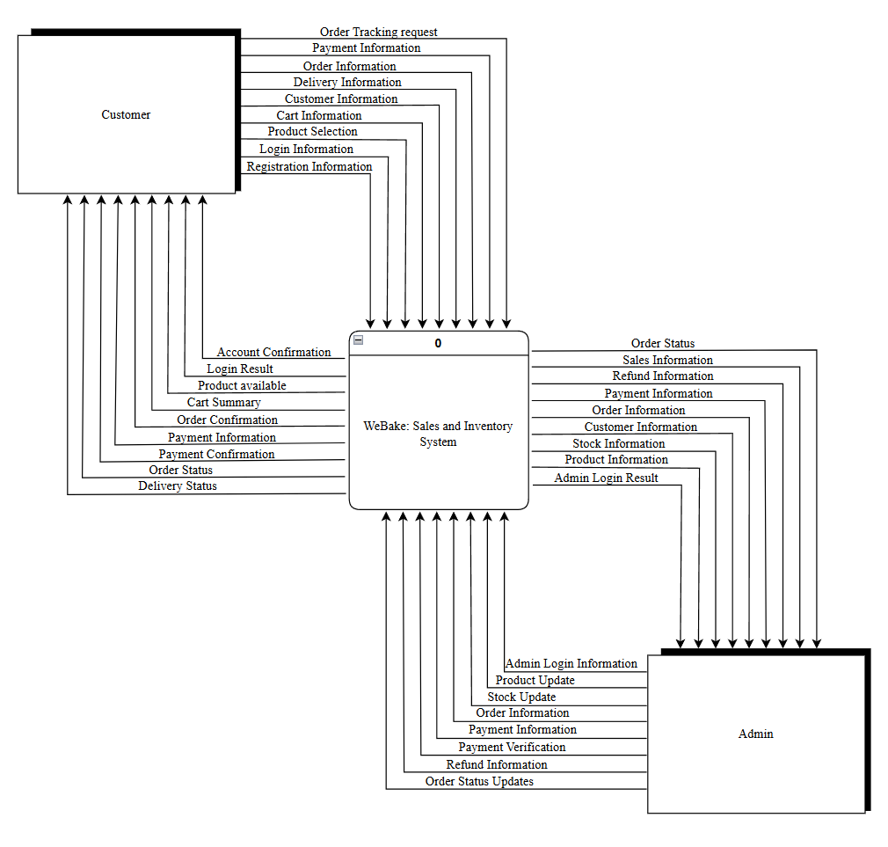
FIGURE 3. Context Diagram of the WeBake System

In figure 4, shows the context diagram of the WeBake System. There are two (2) entities, the customer, and the administrator. The customer inputs registration and login information resulting in account confirmation and login result. The customer sends product selection and cart information for ordering. The customer gives customer information, delivery information, order information, and payment information. Finally the customer sends an order tracking request. The system sends products available, cart summaries, order confirmations, payment confirmations, order status, and delivery status. The admin inputs admin login information to access the system. The admin can send product and stock updates to the system. The admin manages the payment information, payment verification, refund information, and order status updates. The system provides the admin with product, stock, customer, order, payment, refund, and sales information.
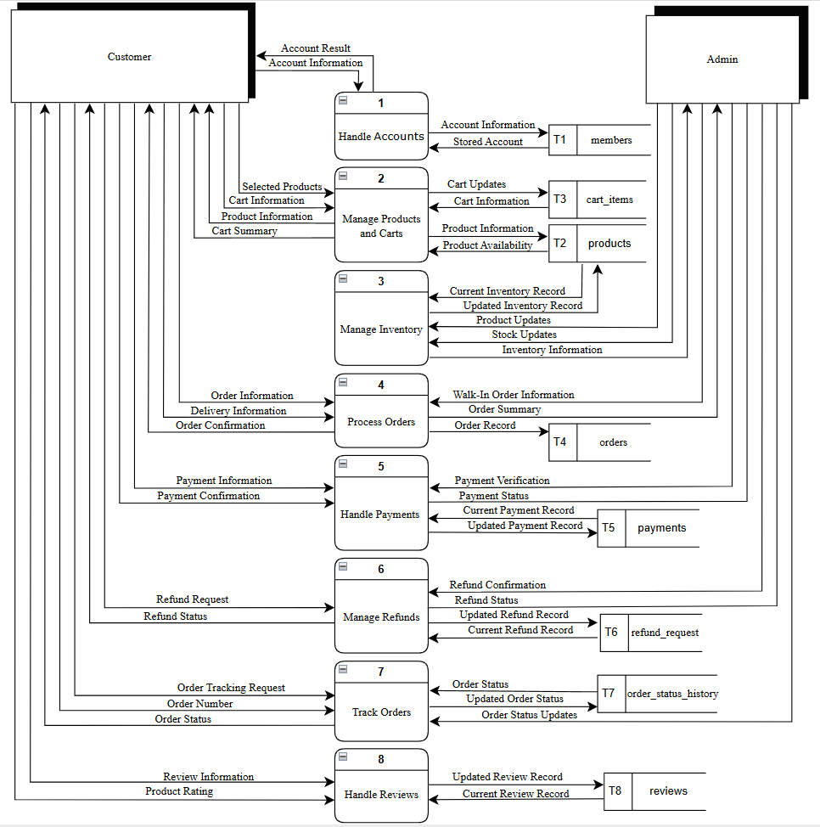
FIGURE 4. Diagram 0 of the WeBake System

In figure 5, shows the diagram 0 of the WeBake System. There are two (2) entities, the customer, and the administrator. There are eight (8) processes. The first process is Handle Accounts where the system handles the customers account information and saves it to the database. The second process is Manage Products and Carts where the customer selects products that will be added to the cart, the system will check the product database and send product information to the customer, then cart information will be added to the cart database and send a cart summary to the customer. The third process is Manage Inventory where the system deducts the current stocks when an order is processed and sends an update to the admin, the admin can send stock and product updates to the system. The fourth process is Process Orders where the customer sends order and delivery information to the system, the system then sends an order confirmation to the customer and records it to the order database, the admin sends walk in order information and the system sends order summary to the admin. The fifth process is Handle Payments where the customer sends payment information and confirms it, the admin verifies the payment and the system records the payment to the database. The sixth process Manage Refunds where the customer sends a refund request to the system and the admin confirms the request the system will record it to the database and send a refund status to both customer and admin. The seventh process is Track order where the customer sends a tracking request and the system sends back an order status, while the admin updates the order status to the system, the system records the order status to the database. The eighth process is Hande Reviews where the customer can leave a review after an order is completed, the system records the customer review to the database and shows it to the website page.
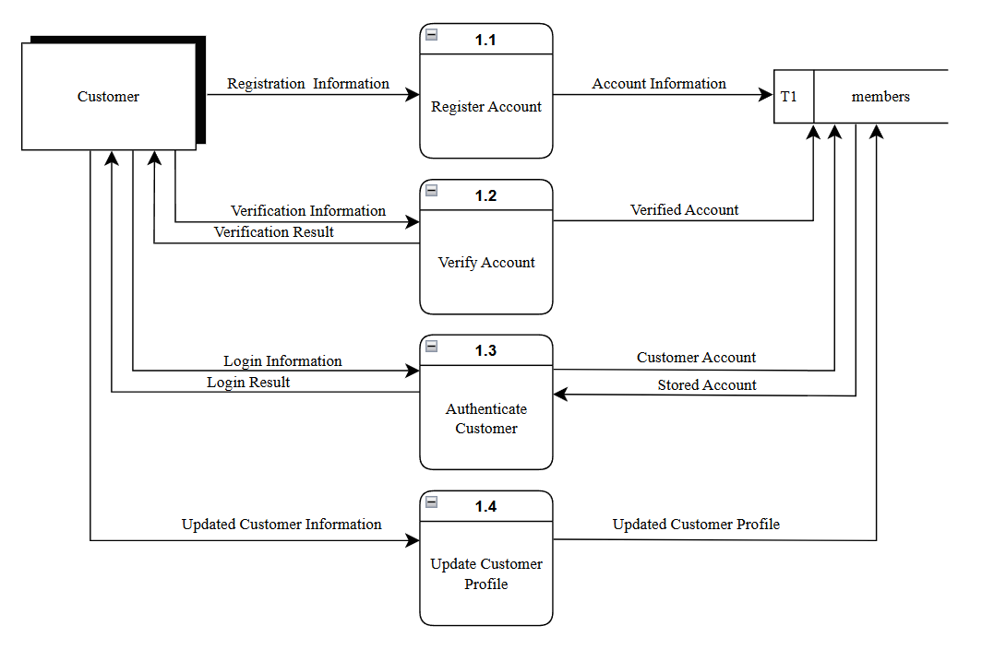
FIGURE 5. Diagram 1 of the WeBake System
In figure 6, shows the data flow diagram 1 process 1 of WeBake System. The Customer is the only entity and there are four (4) processes. The first process is Register Account where the customer registers an account in the system and will be recorded to the database. The second process is Verify Account where the customer sends the verification information to verify the account. The third process is Authenticate Customer where the customer logs in and the system will check if the account exists in the database and send a login result to the customer. The fourth process is Update Customer Profile where the customer can update its profile and the changes made will be saved to the database.
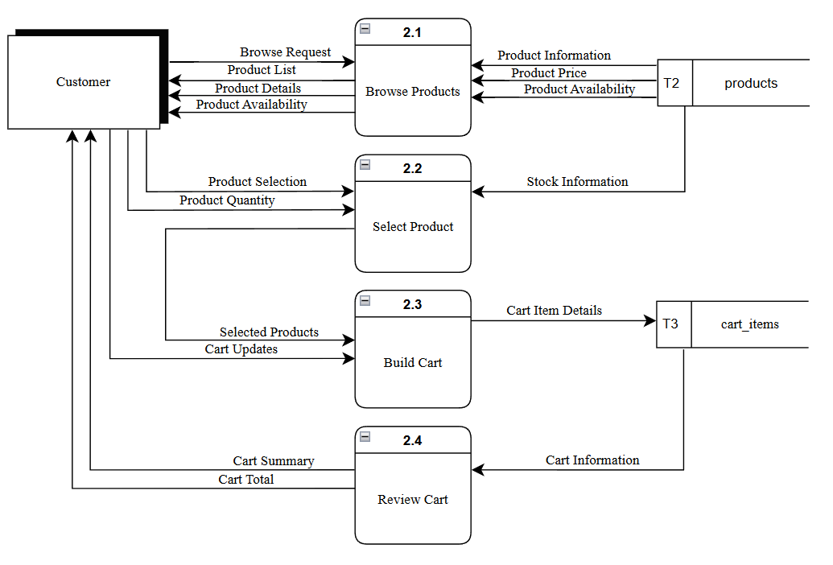
FIGURE 6. Diagram 1 of the WeBake System
In figure 7, shows the data flow diagram 1 process 2 of WeBake System. The Customer is the only entity and there are four (4) processes. The first process is Browse Products where the customer can view the available products on the website. The second process is Select Product where the customer selects the chosen products along with its quantity. The third process is Build Cart where the selected products from the second process will be received to the third process and will be recorded in the cart database. The system sends to customers the current items on the cart. The fourth process is Review Cart where the system gets the cart information from the database and sends it to the customer as a cart summary along with its total.
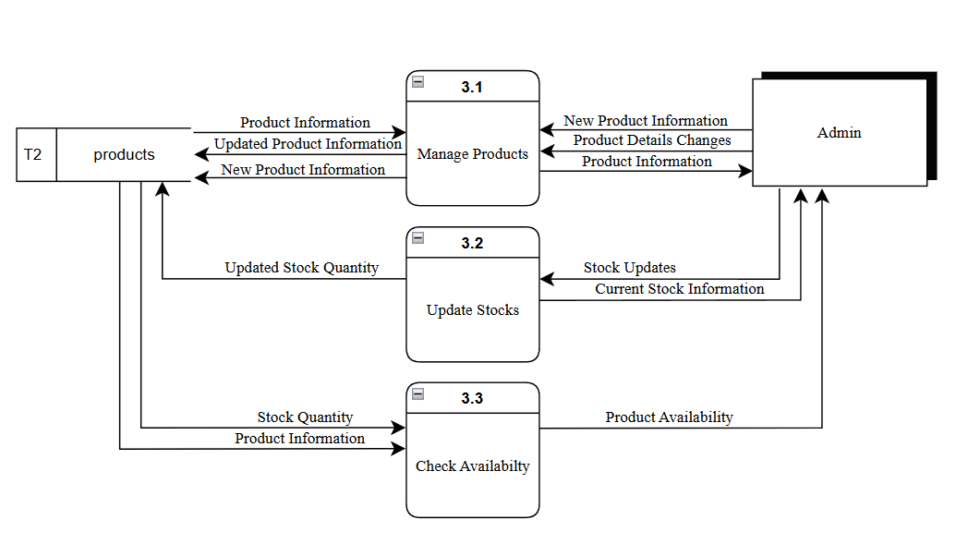
FIGURE 7. Diagram 1 of the WeBake System
In figure 8, shows the data flow diagram 1 process 3 of WeBake System. The Admin is the only entity and there are three (3) processes. The first process is Manage Products where the admin can send new product information and changes to the system, then those changes will be applied to the products database. The second process is Update Stocks where the admin sends Stock updates to the system and will be applied to the database. The third process is Check Availability where the system will get the current records and information in the database and send it to the admin.

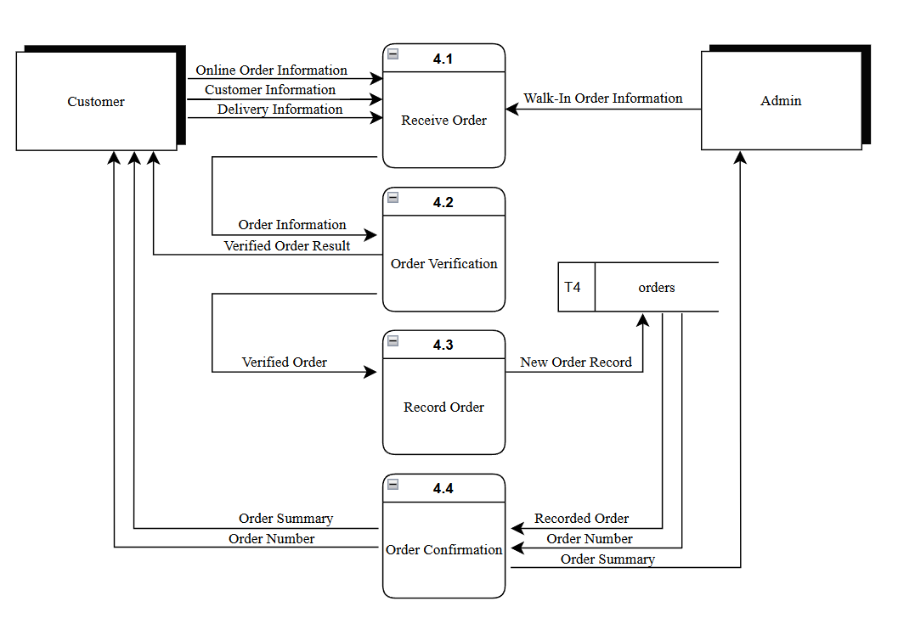
FIGURE 8. Diagram 1 of the WeBake System
In figure 9, shows the data flow diagram 1 process 4 of the WeBake System. There are two (2) entities, the customer, and the administrator. There are eight (4) processes. The first process is Receive Order where the customer sends the order, customer, and delivery information to the system, while the admin sends the order information of the walk-in customer. The second process is Order Verification where the received order will be sent back for the customer to verify their order. The third process is Record Order where the verified order will be recorded to the database. The fourth process is Order Confirmation where the system gets the record from the database and send a summary to both customer and admin.

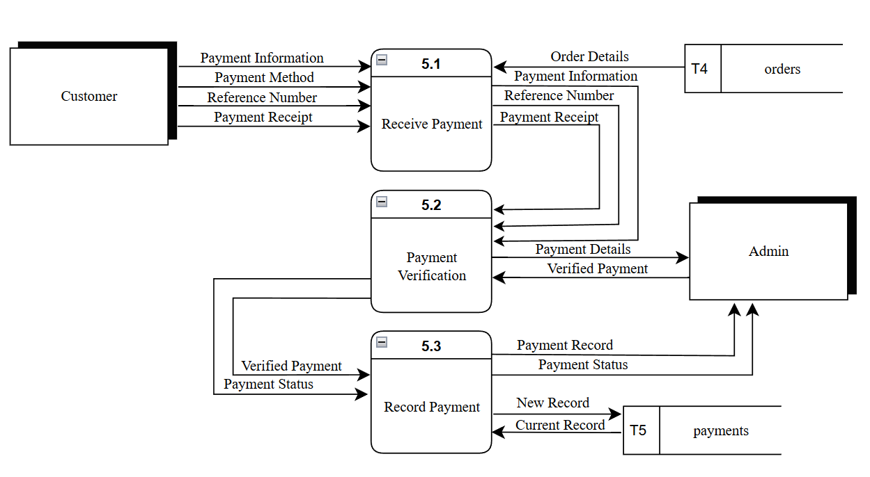
FIGURE 9. Diagram 1 of the WeBake System
In figure 10, shows the data flow diagram 1 process 5 of the WeBake System. There are two (2) entities, the customer, and the administrator. There are eight (3) processes. The first process is Receive Payment where the customer sends payment information, payment method, reference number, and payment receipt to the system, that’ll go for verification. The second process is Payment Verification where the admin verifies the payment. The third process is Record Payment where the system records the verified payment to the database and sends a record and status to the admin.

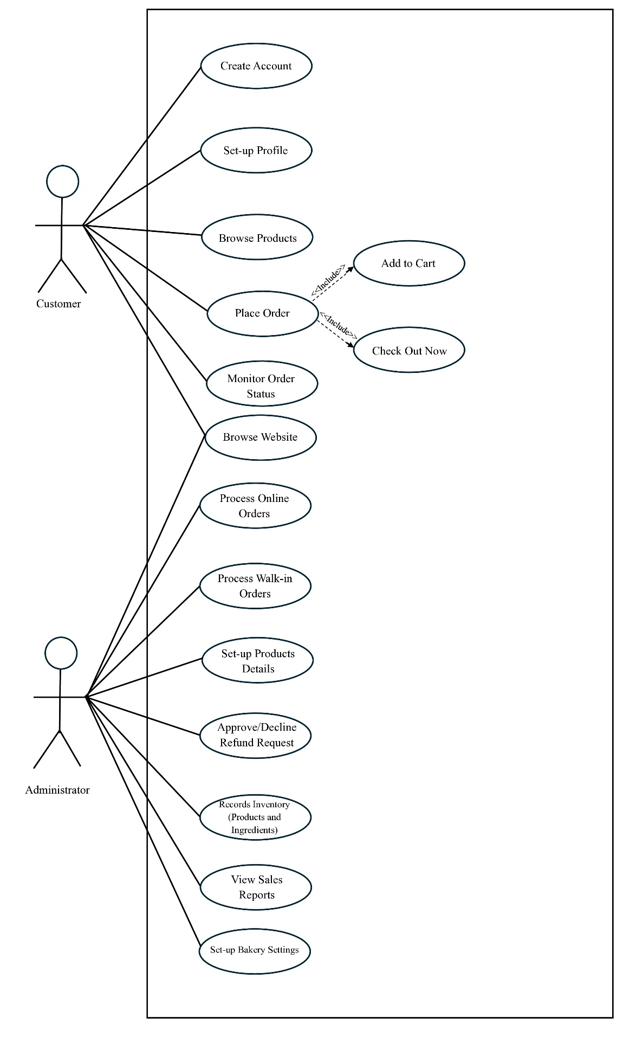
2.1.2 Use Case Diagram

FIGURE 10. Use Case Diagram
The figure shows the use case diagram of the WeBake system, which has two actors: the Customer and the Administrator. The Customer can Create Account and Set-up Profile for account-related activities. The Customer can also Browse Product and Place Order, either with an account or as a guest. The Place Order use case includes Add to Cart and Check Out. Additionally, the Customer can Monitor Order Status to check the progress of an order. Both Customer and Administrator can browse pages to the WeBake Website. The Administrator handles the business side of the system by performing Process Online Order and Process Walk-in Order, Set-up Product Details, Approve/Decline Refund Request, View Sales Reports, Record Inventory for Products and Ingredients, and Set-up Settings. Together, the functions of the Customer and the Administrator support the bakery’s online ordering, sales recording, and inventory monitoring through the WeBake system.

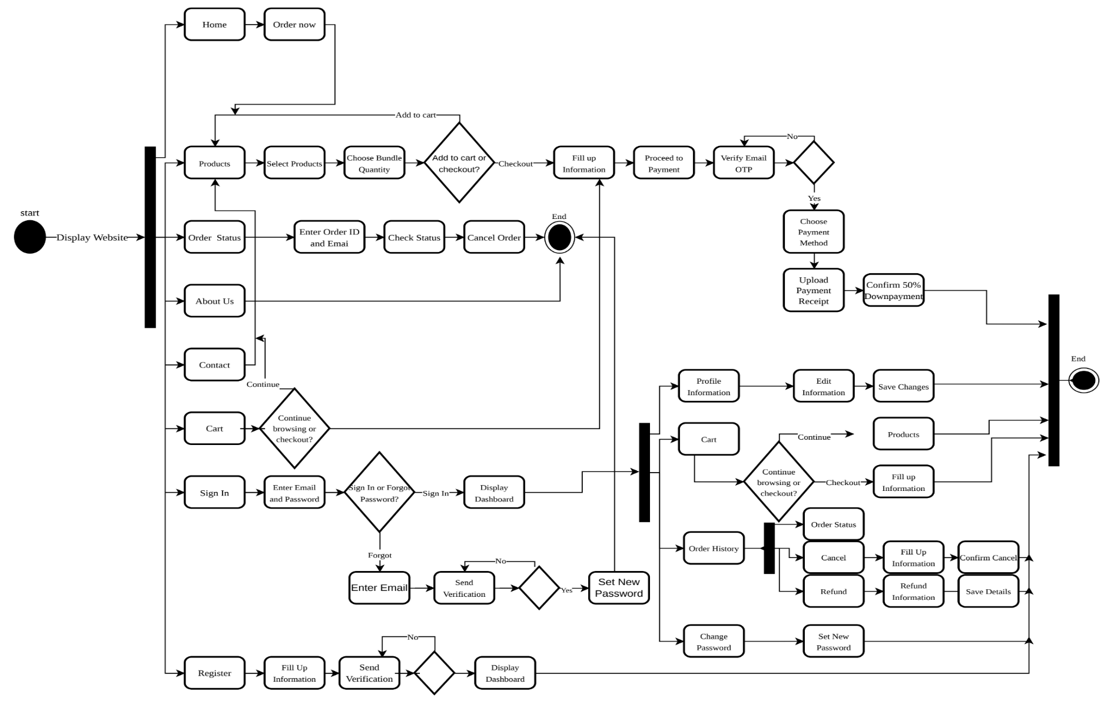
2.1.3 Activity Diagram
FIGURE 11. Activity Diagram
The activity diagram illustrates the flow of activities in the WeBake system, starting when a customer accesses the website. Customers can browse products, select bakery items and bundle quantities, add products to their cart, and proceed to checkout. During checkout, they provide their information, verify their email through an OTP, choose a payment method, upload their payment receipt, and confirm the 50% downpayment. Customers can also check their order status, access the About Us and Contact pages, and use account features such as registration, sign-in, profile updates, password recovery, order history, order cancellation, and refund requests. The process ends when the selected activity is completed.

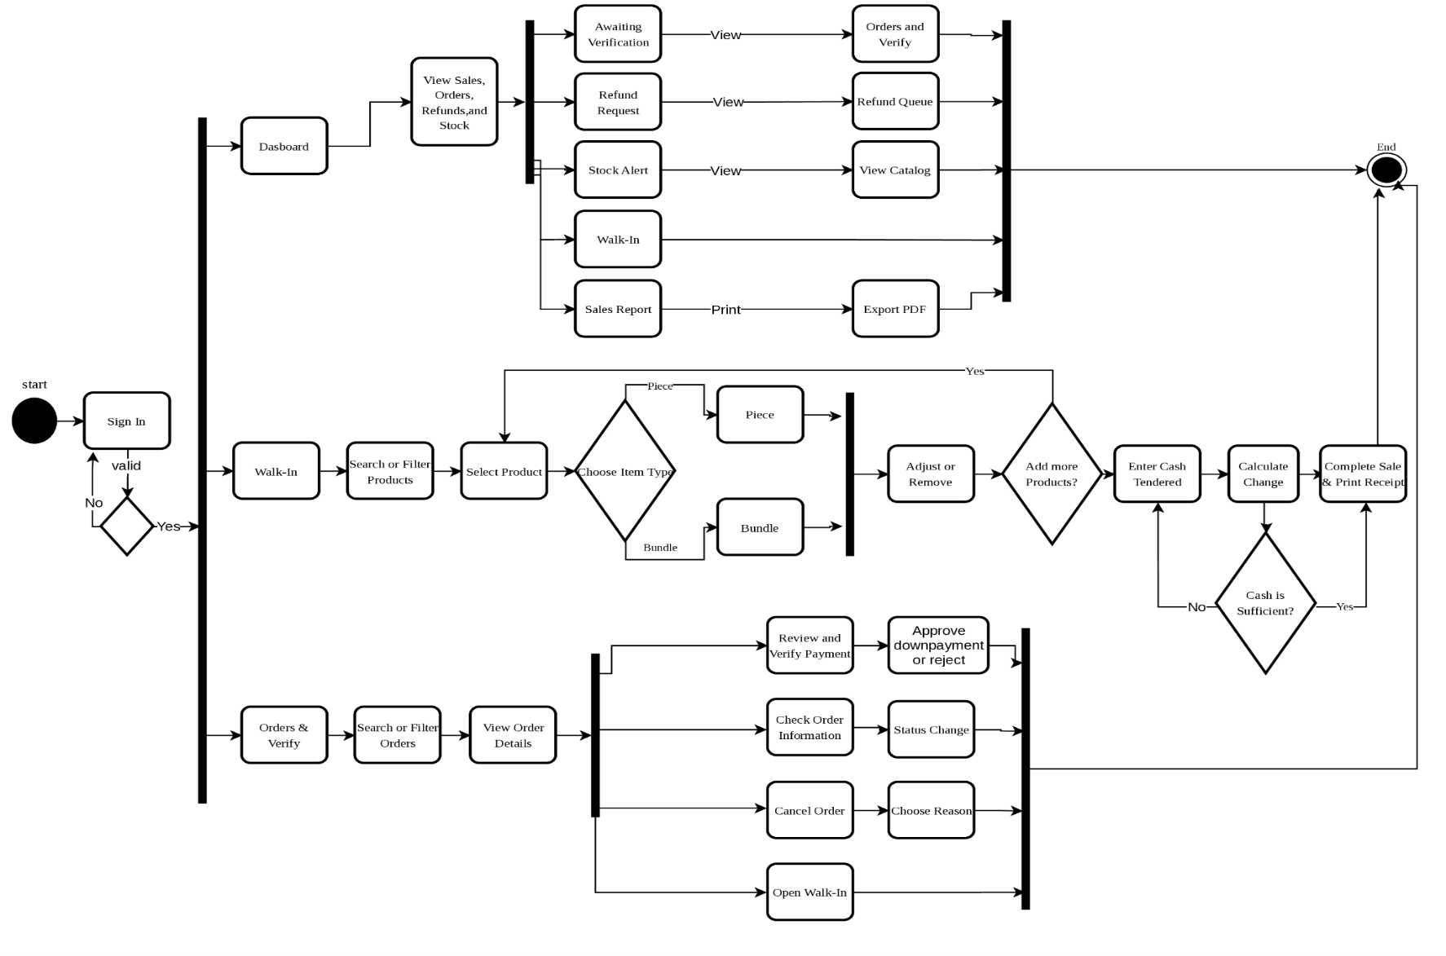
FIGURE 12. Activity Diagram

The Admin Activity Diagram Part 1 illustrates the activities performed by the admin after signing in to the system. The admin must enter valid login credentials to access the system. Once authenticated, the admin can manage refund requests, view sales reports, manage product inventory, manage ingredient inventory, and update bakery settings. These activities allow the admin to monitor sales, process refunds, maintain product and ingredient records, and configure bakery information. After completing the selected activity. the process proceeds to the end node.

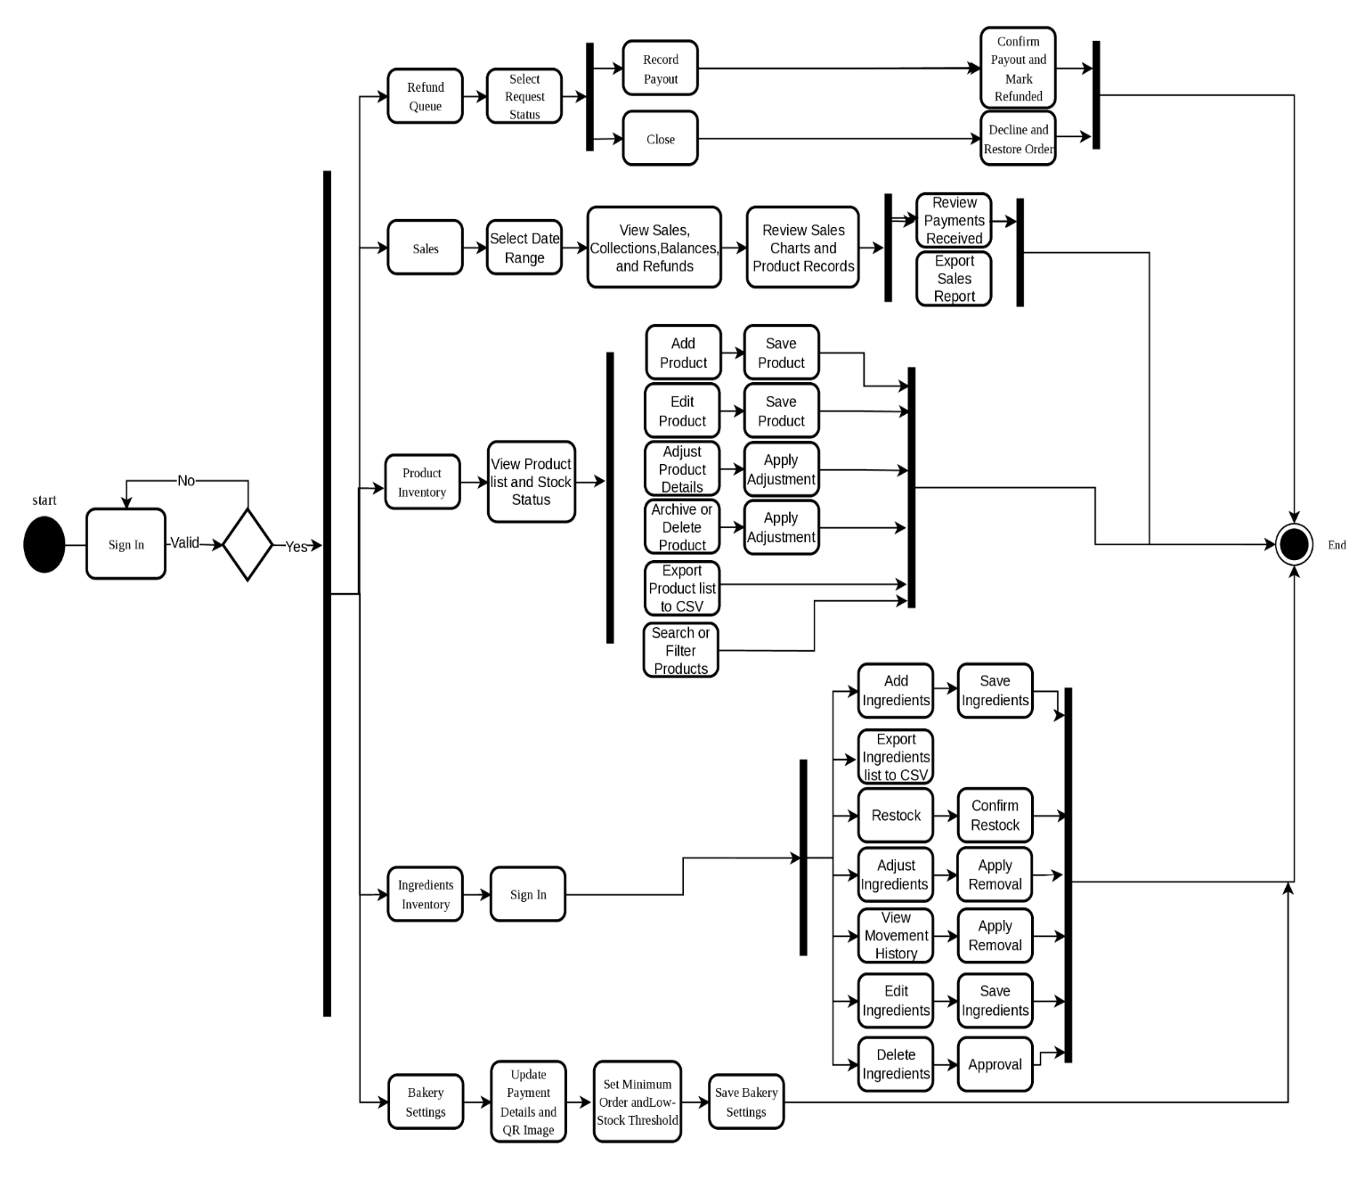
ss
FIGURE 13. Activity Diagram
The Admin Activity Diagram Part 2 illustrates the admin's activities in managing refunds, sales reports, product inventory, ingredient inventory, and bakery settings. The admin can process refund requests, review sales and payment records, add or edit products, adjust stock, and manage ingredients. The admin can also update bakery payment details, QR images, minimum order requirements, and low-stock thresholds. These activities help maintain accurate inventory records, monitor business transactions, and manage bakery setting

2.3 Project Structure
2.3.1 Screen Layouts

2.3.2 Entity Relationship Diagram

2.3.3 Data Dictionary
Field | Data Type | Required | Key | Description
id | BIGINT | Yes | Primary Key | Unique identifier for the administrator account
email | VARCHAR(255) | Yes | Unique | Administrator’s email address used for system login
password_hash | VARCHAR(255) | Yes |  | Securely hashed administrator password
reset_token_hash | VARCHAR(255) | No |  | Hashed password-reset token
reset_expires_at | DATETIME | No |  | Expiration date and time of the reset token
created_at | DATETIME | Yes |  | Date and time the account was created
updated_at | DATETIME | Yes |  | Date and time the account was last updated
Table 1. Admins
Table 2. Members
Field | Data Type | Required | Key | Description
id | BIGINT | Yes | Primary Key | Unique identifier for the customer member account
full_name | VARCHAR(255) | Yes | — | Full name of the customer
email | VARCHAR(255) | Yes | Unique | Customer’s email address used for authentication
email_verified_at | DATETIME | No | — | Date and time when the customer verified their email via OTP
contact | VARCHAR(50) | Yes | — | Customer’s mobile or telephone contact number
address | TEXT | Yes | — | Default delivery address of the customer
password_hash | VARCHAR(255) | Yes | — | Securely hashed customer password for account login
created_at | DATETIME | Yes | — | Date and time the customer registered their account
updated_at | DATETIME | Yes | — | Date and time the account profile was last updated
Table 3. Carts
Field | Data Type | Required | Key | Description
member_id | BIGINT | Yes | Primary Key, Foreign Key | References members(id) representing the member owning the cart
updated_at | DATETIME | Yes | — | Date and time the shopping cart was last modified
Table 4. Cart_Items
Field | Data Type | Required | Key | Description
member_id | BIGINT | Yes | Composite Primary Key, Foreign Key | References carts(member_id) identifying the active cart
product_id | BIGINT | Yes | Composite Primary Key, Foreign Key | References products(id) identifying the selected bread item
bundles | INT | Yes | — | Number of wholesale bundles added to the cart
Table 5. Products
Field | Data Type | Required | Key | Description
id | BIGINT | Yes | Primary Key | Unique identifier for the bakery product
name | VARCHAR(255) | Yes | Unique | Official product name (e.g., Mamon, Otap, Butter Toast)
description | TEXT | Yes | — | Detailed description, texture, and product characteristics
price_bundle_centavos | INT | Yes | — | Wholesale price per bundle in centavos (e.g., 10500 = ₱105.00)
pieces_per_bundle | INT | Yes | — | Number of individual bread pieces contained in one bundle
piece_price_centavos | INT | Yes | — | Retail price per individual piece in centavos (e.g., 500 = ₱5.00)
stock_pieces | INT | Yes | — | Current stock available counted in individual pieces
low_stock_threshold_pieces | INT | Yes | — | Minimum piece threshold triggering a low-stock alert
image_url | TEXT | Yes | — | Relative path or URL to the official product packaging photo
is_archived | BOOLEAN | Yes | — | Flag indicating if product is hidden from public storefront
created_at | DATETIME | Yes | — | Date and time the product record was added to catalog
updated_at | DATETIME | Yes | — | Date and time the product information was last updated
Table 6. Orders
Field | Data Type | Required | Key | Description
id | BIGINT | Yes | Primary Key | Unique identifier for the wholesale order
order_code | VARCHAR(50) | Yes | Unique | Tracking reference code of the order (e.g., WB-XXXX)
member_id | BIGINT | No | Foreign Key | References members(id); null for guest checkouts
customer_name | VARCHAR(255) | Yes | — | Customer full name entered during checkout
customer_email | VARCHAR(255) | Yes | — | Customer email address for order notifications
customer_contact | VARCHAR(50) | Yes | — | Contact phone number for delivery dispatch
delivery_address | TEXT | Yes | — | Complete destination address for bread delivery
subtotal_centavos | INT | Yes | — | Total price of all ordered line items in integer centavos
total_centavos | INT | Yes | — | Final total payable order amount in integer centavos
downpayment_centavos | INT | Yes | — | Required 50% deposit amount in integer centavos
downpayment_paid_centavos | INT | Yes | — | Verified downpayment amount received in integer centavos
balance_due_centavos | INT | Yes | — | Remaining unpaid balance amount in integer centavos
payment_method | VARCHAR(20) | Yes | — | Payment method selected (GCASH or MAYA)
status | VARCHAR(50) | Yes | — | Current lifecycle state of the order
rejection_reason | TEXT | Yes | — | Stated explanation if payment verification was rejected
resubmit_count | INT | Yes | — | Number of times customer resubmitted proof of payment
idempotency_key | VARCHAR(255) | No | Unique | Cryptographic token preventing duplicate checkout orders
created_at | DATETIME | Yes | — | Date and time the order was initially placed
updated_at | DATETIME | Yes | — | Date and time the order was last updated
Table 7. Order_Items
Field | Data Type | Required | Key | Description
id | BIGINT | Yes | Primary Key | Unique identifier for the order line item
order_id | BIGINT | Yes | Foreign Key | References orders(id) indicating parent order
product_id | BIGINT | No | Foreign Key | References products(id) indicating purchased product
product_name | VARCHAR(255) | Yes | — | Historical snapshot of product name at purchase time
pieces_per_bundle | INT | Yes | — | Historical snapshot of packaging size at purchase time
bundles | INT | Yes | — | Number of wholesale bundles ordered
unit_price_centavos | INT | Yes | — | Historical snapshot of bundle price in centavos
line_total_centavos | INT | Yes | — | Total calculated price for this line item in centavos
Table 8. Payments
Field | Data Type | Required | Key | Description
id | BIGINT | Yes | Primary Key | Unique identifier for the payment transaction
order_id | BIGINT | Yes | Foreign Key | References orders(id) linking payment to order
stage | VARCHAR(20) | Yes | — | Payment phase (DOWNPAYMENT or BALANCE)
channel | VARCHAR(20) | Yes | — | Remittance platform (GCASH, MAYA, or CASH)
amount_centavos | INT | Yes | — | Remitted monetary amount in integer centavos
reference_number | VARCHAR(100) | Yes | — | Financial transaction reference number from receipt
proof_storage_path | TEXT | Yes | — | Secure storage path to the uploaded receipt screenshot
verification_status | VARCHAR(20) | Yes | — | Verification status (PENDING, VERIFIED, or REJECTED)
verified_at | DATETIME | No | — | Date and time the receipt was verified by administrator
created_at | DATETIME | Yes | — | Date and time the payment proof was uploaded
Table 9. Refund_Requests
Field | Data Type | Required | Key | Description
id | BIGINT | Yes | Primary Key | Unique identifier for the refund request
order_id | BIGINT | Yes | Unique, Foreign Key | References orders(id) enforcing 1-to-1 refund relation
reason | TEXT | Yes | — | Reason explanation for requesting the refund
reason_source | VARCHAR(20) | Yes | — | Origin of request (CUSTOMER or ADMIN_REJECTION)
wallet_type | VARCHAR(20) | No | — | Recipient e-wallet provider (GCASH or PAYMAYA)
account_number | VARCHAR(50) | Yes | — | Recipient mobile account number receiving refund
account_name | VARCHAR(255) | Yes | — | Account holder name on the recipient e-wallet
refund_amount_centavos | INT | Yes | — | Amount to be returned to customer in integer centavos
status | VARCHAR(30) | Yes | — | Lifecycle status of the refund request
requested_at | DATETIME | Yes | — | Date and time the refund was submitted
processed_at | DATETIME | No | — | Date and time the refund payout was finalized
admin_reference_number | VARCHAR(100) | Yes | — | Transaction reference number for the completed payout
admin_note | TEXT | Yes | — | Internal remarks recorded by the administrator
Table 10. Order_Status_History
Field | Data Type | Required | Key | Description
id | BIGINT | Yes | Primary Key | Unique identifier for the status audit record
order_id | BIGINT | Yes | Foreign Key | References orders(id) tracking progression
old_status | VARCHAR(50) | No | — | Previous status state prior to change
new_status | VARCHAR(50) | Yes | — | Updated new status state
changed_by | VARCHAR(20) | Yes | — | Actor who initiated change (CUSTOMER, ADMIN, or SYSTEM)
changed_at | DATETIME | Yes | — | Date and time the status transition occurred
note | TEXT | Yes | — | Additional context or remarks regarding the transition
Table 11. Stock_Movements
Field | Data Type | Required | Key | Description
id | BIGINT | Yes | Primary Key | Unique identifier for the product stock movement
product_id | BIGINT | Yes | Foreign Key | References products(id) indicating affected bread item
change_pieces | INT | Yes | — | Signed quantity in pieces (negative for sales, positive for restocks)
reason | VARCHAR(50) | Yes | — | Movement cause (APPROVAL_DEDUCTION, POS_SALE, RESTOCK, etc.)
order_id | BIGINT | No | Foreign Key | References orders(id) if triggered by an online order
note | TEXT | Yes | — | Audit trail note or reference memo
created_by | VARCHAR(100) | Yes | — | Staff username or process executing the stock change
created_at | DATETIME | Yes | — | Exact date and time the movement was logged
Table 12. Walkin_Sales
Field | Data Type | Required | Key | Description
id | BIGINT | Yes | Primary Key | Unique identifier for the counter walk-in sale
sale_code | VARCHAR(50) | Yes | Unique | Tracking reference number of POS receipt (e.g. POS-XXXX)
total_centavos | INT | Yes | — | Total sale charge in integer centavos
cash_received_centavos | INT | Yes | — | Cash handed by walk-in customer in integer centavos
change_centavos | INT | Yes | — | Change amount returned to customer in integer centavos
created_by | VARCHAR(100) | Yes | — | Cashier username or staff who processed transaction
created_at | DATETIME | Yes | — | Date and time the transaction occurred
Table 13. Walkin_Sale_Items
Field | Data Type | Required | Key | Description
id | BIGINT | Yes | Primary Key | Unique identifier for the walk-in sale item
sale_id | BIGINT | Yes | Foreign Key | References walkin_sales(id) indicating parent sale
product_id | BIGINT | No | Foreign Key | References products(id) indicating product sold
product_name | VARCHAR(255) | Yes | — | Historical snapshot of product name at transaction time
pieces_per_bundle | INT | Yes | — | Packaging ratio snapshot at transaction time
unit | VARCHAR(10) | Yes | — | Unit sold (BUNDLE or PIECE)
qty | INT | Yes | — | Quantity of units purchased
unit_price_centavos | INT | Yes | — | Price per unit charged in integer centavos
line_total_centavos | INT | Yes | — | Total price for this line item in integer centavos
Table 14. Ingredients
Field | Data Type | Required | Key | Description
id | BIGINT | Yes | Primary Key | Unique identifier for the raw bakery ingredient
name | VARCHAR(255) | Yes | Unique | Official ingredient name (e.g. All-Purpose Flour, White Sugar)
stock_quantity | DECIMAL(12,3) | Yes | — | Current inventory volume on hand
unit | VARCHAR(20) | Yes | — | Unit of measurement (e.g., kg, pcs, sacks)
reorder_level | DECIMAL(12,3) | Yes | — | Minimum stock threshold triggering a restock alert
cost_per_unit | DECIMAL(12,2) | No | — | Estimated purchase cost per unit in Philippine Pesos
expiry_date | DATE | No | — | Expiration date of the current ingredient batch
stock_updated_at | DATETIME | No | — | Date and time stock level was last updated
created_at | DATETIME | Yes | — | Date and time ingredient was added to inventory
updated_at | DATETIME | Yes | — | Date and time ingredient details were last modified
Table 15. Inventory_Movements
Field | Data Type | Required | Key | Description
id | BIGINT | Yes | Primary Key | Unique identifier for the ingredient movement record
ingredient_id | BIGINT | Yes | Foreign Key | References ingredients(id) indicating ingredient adjusted
movement_type | VARCHAR(20) | Yes | — | Movement category (restock, usage, adjustment, waste)
quantity_change | DECIMAL(12,3) | Yes | — | Signed volume change amount added or deducted
quantity_before | DECIMAL(12,3) | Yes | — | Stock volume immediately before transaction
quantity_after | DECIMAL(12,3) | Yes | — | Resulting stock volume immediately after transaction
unit_cost | DECIMAL(12,2) | No | — | Purchase unit cost associated with this stock entry
reason | TEXT | No | — | Audit explanation, delivery receipt, or baking batch memo
created_by | VARCHAR(100) | Yes | — | Staff username or baker who performed the adjustment
created_at | DATETIME | Yes | — | Date and time the inventory movement was logged
Table 16. Reviews
Field | Data Type | Required | Key | Description
id | BIGINT | Yes | Primary Key | Unique identifier for the customer review
order_id | BIGINT | No | Foreign Key | References orders(id) linking feedback to an order
product_id | BIGINT | No | Foreign Key | References products(id) indicating reviewed item
member_id | BIGINT | No | Foreign Key | References members(id) identifying reviewer account
display_name | VARCHAR(255) | Yes | — | Display screen name shown on public testimonial
rating | SMALLINT | Yes | — | Customer rating score ranging from 1 to 5 stars
text_en | TEXT | Yes | — | Written review commentary and feedback text
is_seed | BOOLEAN | Yes | — | Flag identifying initial template reviews from live orders
created_at | DATETIME | Yes | — | Date and time the review was submitted
Table 17. Otp_Codes
Field | Data Type | Required | Key | Description
id | BIGINT | Yes | Primary Key | Unique identifier for the verification code record
email | VARCHAR(255) | Yes | — | Recipient email address the OTP was sent to
code_hash | VARCHAR(255) | Yes | — | Secure cryptographic hash of the 6-digit one-time code
purpose | VARCHAR(20) | Yes | — | Action scenario (REGISTER, CHECKOUT, or RESET)
expires_at | DATETIME | Yes | — | Expiration date and time of the OTP (typically 5–10 min)
attempts | INT | Yes | — | Count of failed verification attempts to block brute-force
verified_at | DATETIME | No | — | Date and time the code was successfully validated
consumed_at | DATETIME | No | — | Date and time the validated code was consumed by the action
created_at | DATETIME | Yes | — | Date and time the verification code was generated
Table 18. Settings
Field | Data Type | Required | Key | Description
key | VARCHAR(100) | Yes | Primary Key | Unique configuration key identifier (e.g., gcash_qr)
value | TEXT | Yes | — | Stored configuration setting value or QR image URI
updated_at | DATETIME | Yes | — | Date and time the configuration setting was last updated

