Life Expectancies

Denis Ryan

12 January 2018

## Introduction

We are going to present some results for the Life Expectancies and GDP of various nations.

### Life Expectancy by Continent

We examined life expectancy by continent and nation.

g <- ggplot(data=gapminder, aes(x=year, y=lifeExp, colour=continent, group=country))  
g + geom_line() + scale_y_log10() + facet_wrap(~continent)

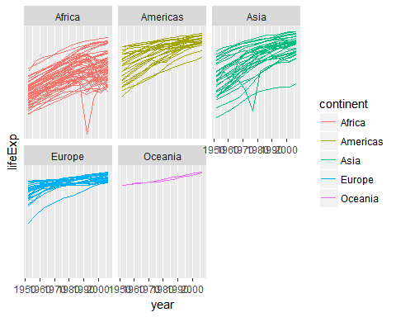

### GDP by Continent

We examined GDP by continent and nation.

g <- ggplot(data=gapminder, aes(x=year, y=gdpPercap, colour=continent, group=country))  
g + geom_line() + scale_y_log10() + facet_wrap(~continent)

