User Guide: CANDO Stimulation Box

Initial Setup:

Hardware:
- Connect the laptop to the box using a USB cable.
- Connect the DC shift box to the mains and to the intan output (into input one of the DC shift box)
- Output 1 of the DC shift box then connects to the ADC
- DAC port (to the left of the ADC) goes to the LED

Software:
- Double click on the CANDO user interface (UI) icon if you are using a compiled version
- If using the mlapp code, open a Matlab instance and then navigate to the folder containing the mlapp file. Double click on the file in the file explorer tab, or alternatively type CANDO_control_GUI in the command window and press enter.
- Once the UI has loaded it should look like the image in figure 1.

Setting up an experiment using the Stimulation Box:
- Select the port which your serial device is connected to in the Port Select dropdown. (This will auto-populate with viable ports).

Press Start Button
get popup - select save directory
Starts recording at this point, no stimulation. Should see trace in LFP graph.

TTL: define on/ off time, click enable.

Click radio button to select the algorithm
Define parameters, inc. selecting sequential or random phase. Auto runs original algorithm unless set intensity is selected.

Press configure to start the stimulation

To stop it, press start then close.

NB: need to unplug and replug box after each run, and reload the gui after each run.

Loading pre-recorded data to test the algorithm output:

Using a test signal from a local machine:

Additional Features:

Analysis notes:

The results are saved as...

* Run ‘runscript’ in each folder
* Collect results into structures
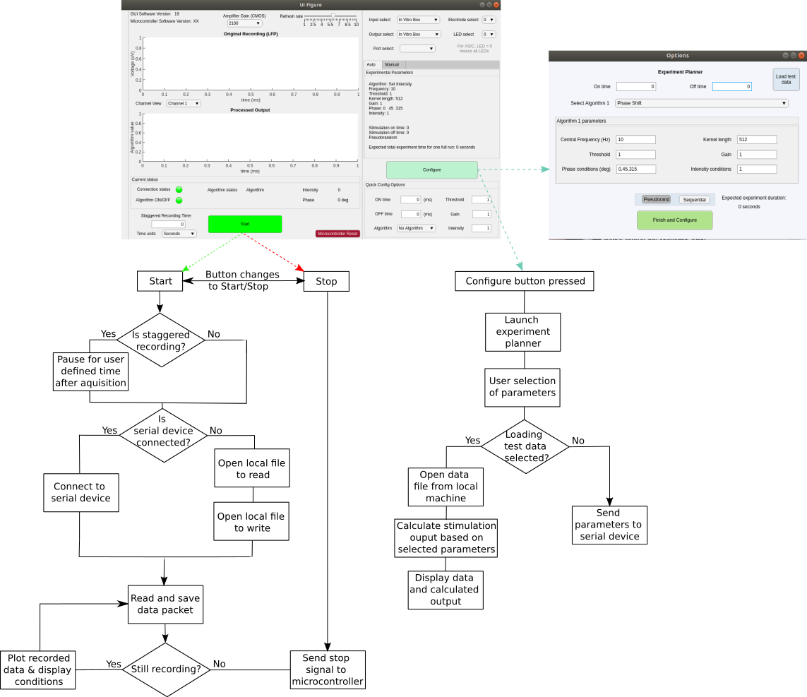
* run Junbox_stimcomparison

