Relational Databases with MySQL Week 6 Coding Assignment
Points possible: 70
Category | Criteria | % of Grade
Functionality | Does the code work? | 25
Organization | Is the code clean and organized? Proper use of white space, syntax, and consistency are utilized. Names and comments are concise and clear. | 25
Creativity | Student solved the problems presented in the assignment using creativity and out of the box thinking. | 25
Completeness | All requirements of the assignment are complete. | 25

Instructions: In Eclipse, or an IDE of your choice, write the code that accomplishes the objectives listed below. Ensure that the code compiles and runs as directed. Take screenshots of the code and of the running program (make sure to get screenshots of all required functionality) and paste them in this document where instructed below. Create a new repository on GitHub for this week’s assignments and push this document to the repository. Additionally, push your Java project code to the same repository. Add the URL for this week’s repository to this document where instructed and submit this document to your instructor when complete.
Coding Steps:
- Create a new Maven project. In Eclipse…
  - Right-click in Project Explorer, select "New / Project". Expand "Maven". Select "Maven Project". Click "Next".
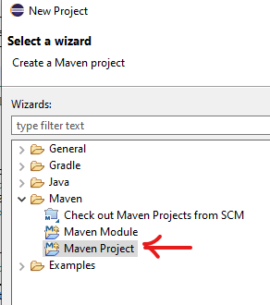
  - Check "Create a simple project (skip archetype selection)". Click "Next".
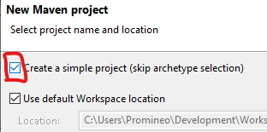
  - Enter the Group Id: "my.unit.test". Enter the Artifact Id: "unit-test-assignment". Click "Finish".
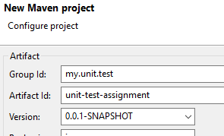
  - The project "unit-test-assignment" should appear in the Package Explorer. Click the down arrow next to "unit-test-assignment" to expand it. Double-click on "pom.xml" to open it in the editor.
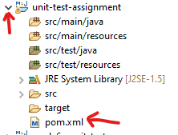
  - Put a couple of blank lines between <version>0.0.1-SNAPSHOT</version> and </project>.
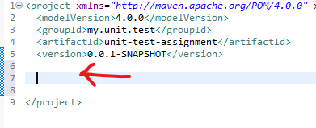
  - Copy and paste the following code into the blank area you just created.
<properties>
<java.version>11</java.version>
<project.build.sourceEncoding>utf-8</project.build.sourceEncoding>
</properties>

<dependencies>
<dependency>
<groupId>com.google.guava</groupId>
<artifactId>guava</artifactId>
<version>30.1.1-jre</version>
</dependency>

<dependency>
<groupId>org.junit.jupiter</groupId>
<artifactId>junit-jupiter</artifactId>
<version>5.7.2</version>
<scope>test</scope>
</dependency>

<dependency>
<groupId>org.assertj</groupId>
<artifactId>assertj-core</artifactId>
<version>3.20.2</version>
<scope>test</scope>
</dependency>

<dependency>
<groupId>org.mockito</groupId>
<artifactId>mockito-junit-jupiter</artifactId>
<version>3.11.2</version>
<scope>test</scope>
</dependency>
</dependencies>

<build>
<plugins>
<plugin>
<groupId>org.apache.maven.plugins</groupId>
<artifactId>maven-compiler-plugin</artifactId>
<version>3.8.1</version>
<configuration>
<source>${java.version}</source>
<target>${java.version}</target>
</configuration>
</plugin>
</plugins>
</build>
  - Save the file.
  - For Eclipse only: right-click on "unit-test-assignment" in the Project Explorer. Click on "Properties". Click "Java Compiler". Make sure "Enable project specific settings" is checked. Uncheck "Use compliance from execution environment 'J2SE-1.5' on the 'Java Build Path'. Set "Compiler compliance level" to 11. Click "Apply and Close".
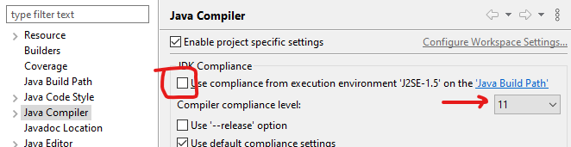
  - If asked to rebuild the project, click "Yes".
- Create a class named "TestDemo" under src/main/java in the default package. (In Package Explorer, expand "unit-test-assignment". Right-click on "src/main/java" and select "New / Class". Enter "TestDemo" in the "Name" field and click "Finish".)
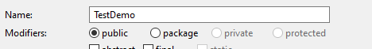
  - Create an instance method (not static) named addPositive. It should take two int parameters and return an int.
public int addPositive(int a, int b) {}
  - If both parameters are positive (greater than zero) return the sum of the parameters. If either parameter is zero or negative, throw an IllegalArgumentException with the message "Both parameters must be positive!". IllegalArgumentException is in the java.lang package so you won't need an import statement.
  - Save the file.
- In Package Explorer, find "src/test/java" and right-click on it. Select "New / JUnit Test Case". In the "Name" field, enter "TestDemoTest". Make sure that "New JUnit Jupiter test" is selected. Make sure that "@BeforeEach setUp()" is checked. Click "Finish".
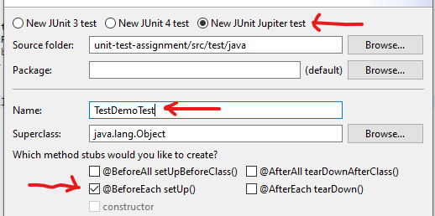
- In TestDemoTest.java, add a private instance variable of type TestDemo named testDemo.
  - In the setUp method, create the TestDemo object. This will ensure that a new TestDemo object is created before each test.
  - Change "@Test" to "@ParameterizedTest". Add the import statement for org.junit.jupiter.params.ParameterizedTest.
  - Change the name of method "test" to "assertThatTwoPositiveNumbersAreAddedCorrectly".
  - Add four parameters to assertThatTwoPositiveNumbersAreAddedCorrectly as shown:
Type | Name
int | a
int | b
int | expected
Boolean | expectException

  - Write the test. Remove the "fail" line. Test the value of expectException. If it is false, assert that when TestDemo.addPositive is called with values a and b, that the result is the same as the parameter expected. The assertion should look like this:
if(!expectException) {
assertThat(testDemo.addPositive(a, b)).isEqualTo(expected);
}
  - Add the test for the thrown exception in an else clause. Use assertThatThrownBy for this. Add the static import org.assertj.core.api.Assertions.assertThatThrownBy;
  - As a parameter to assertThatThrownBy, add a Lambda expression with no parameters. The Lambda body should be the method call to testDemo.addPositive.
  - Use the assertion isInstanceOf(IllegalArgumentException.class) to ensure that the correct exception is thrown.
  - If this is too confusing, you can "cheat" and copy this:
assertThatThrownBy(() ->
testDemo.addPositive(a, b))
.isInstanceOf(IllegalArgumentException.class);
  - Add the parameter source method.
    - Create a static method named argumentsForAddPositive. It should not have any parameters and it should return a Stream of Arguments. The imports are: java.util.stream.Stream and org.junit.jupiter.params.provider.Arguments.
    - The method should return a Stream as in Stream.of();
    - Each parameter set should be wrapped in an arguments() method call. Add the static import for arguments: org.junit.jupiter.params.provider.Arguments.arguments.
    - So, if you are adding 2 and 4 to get the value of 6 and are not expecting an exception, you need to do:
arguments(2, 4, 6, false)
    - Add as many arguments lines as needed to test the addPositive method thoroughly. Make sure to add some zero or negative arguments.
  - Just below the @ParameterizedTest annotation, add the annotation @MethodSource. Pass a single parameter to @MethodSource. It must be the fully-qualified (includes package) class name of the test followed by a # sign followed by the name of the method that supplies the parameters. Since the test is in the default package, there is no package in the fully-qualified class name. So,
@MethodSource("TestDemoTest#argumentsForAddPositive")
- In TestDemo.java, add another method named randomNumberSquared. This method obtains a random int between 1 and 10 and then returns the square of the number.
  - randomNumberSquared should return an int and not take any parameters.
  - It should call another method in the same class named getRandomInt. This method takes no parameters and must be package visibility so that the test can see it. getRandomInt should look like this:
int getRandomInt() {
Random random = new Random();
return random.nextInt(10) + 1;
}
The Random class is in the java.util package.
  - randomNumberSquared should return the value obtained from getRandomInt multiplied by itself.
- Write a test for randomNumberSquared in TestDemoTest.java. Since you don't know what getRandomInt will return (that's the point of random, after all), you will need to mock it out and supply a known value.
  - Create a method annotated with @Test named assertThatNumberSquaredIsCorrect. The method must have package visibility (not public!) or JUnit won't find it. The annotation @Test is in the org.junit.jupiter.api package.
  - To mock the TestDemo class, use Mockito.spy. The spy method can be imported with a static import of org.mockito.Mockito.spy.
TestDemo mockDemo = spy(testDemo);
  - Program the mocked TestDemo object to return 5 when the getRandomInt method is called. Remember to use the form: doReturn(aValue).when(mockedObject).methodCall(). You can use a static import for doReturn: import static org.mockito.Mockito.doReturn;
doReturn(5).when(mockDemo).getRandomInt();
  - Call the method randomNumberSquared on the mocked TestDemo object. This will call the stubbed out (mocked) method getRandomInt, which now should return the value 5.
int fiveSquared = mockDemo.randomNumberSquared();
  - Use assertThat to test that the value returned from randomNumberSquared is equal to 5 squared.
assertThat(fiveSquared).isEqualTo(25);
  - You don't need to verify the mocked method call – you know it was called since the return value is correct.

Screenshots of Code:
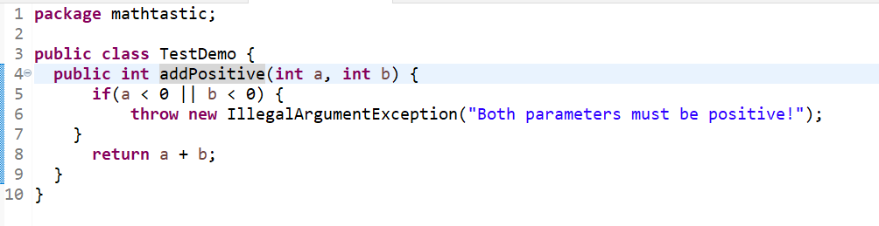
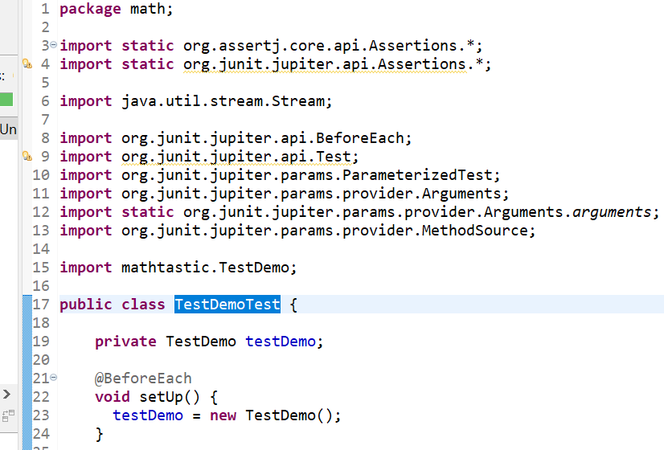

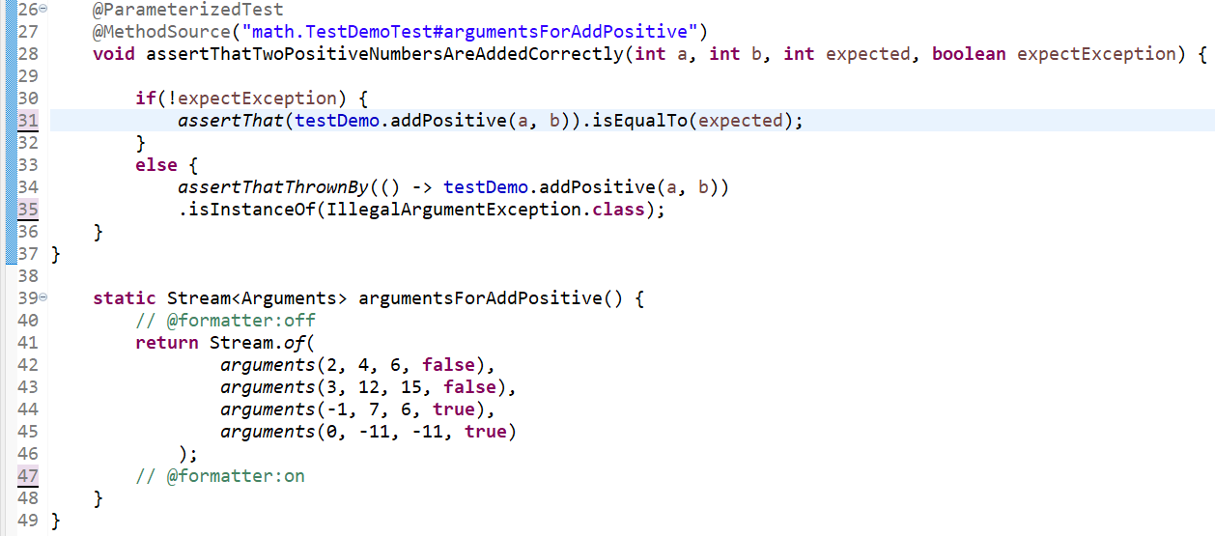

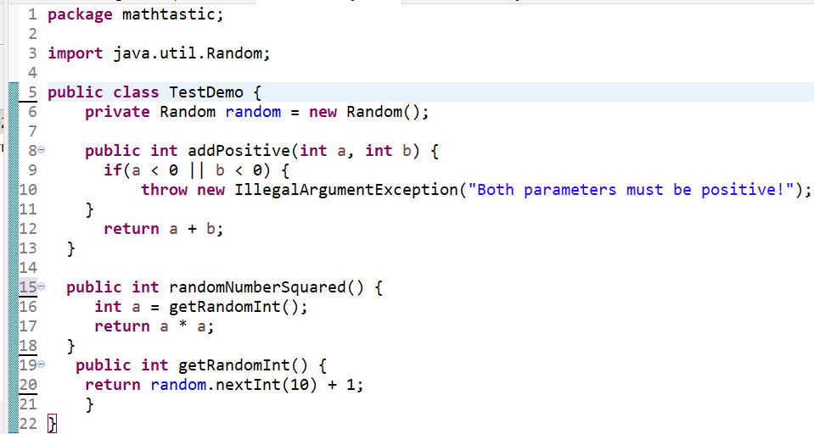

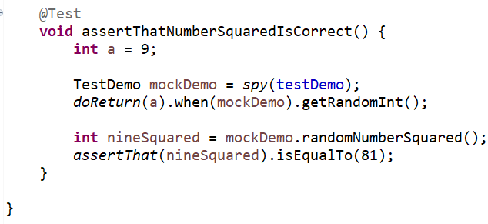
Screenshots of Running Application:
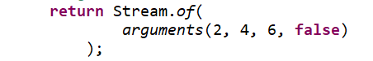
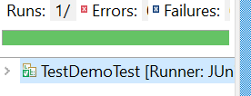
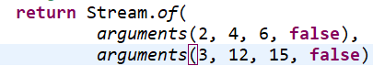
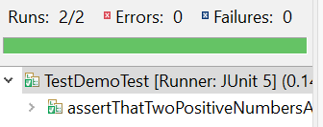

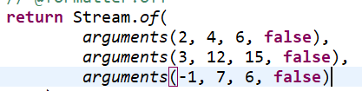
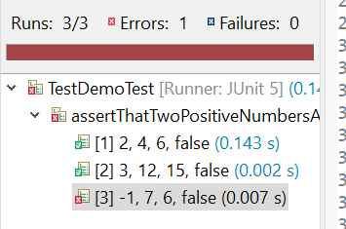

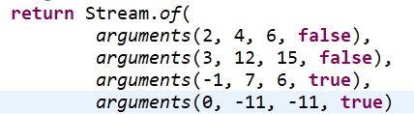

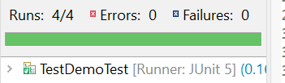

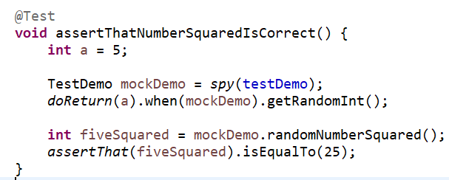
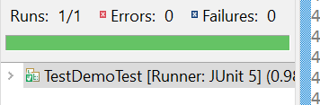

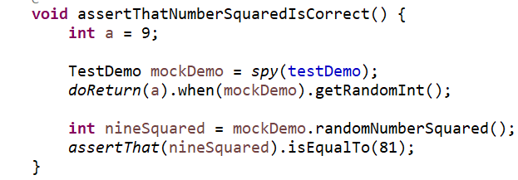
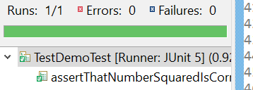
URL to GitHub Repository:
https://github.com/Newdevelopment10/MySQL-Week-6-Final-Project-

