**APPENDIX I**



DRIVING SCHOOL MANAGEMENT SYSTEM IN ZIMBABWE:DIGITISING

TRAINING ,BOOKING & LISCENSING PROCESSES FOR ROAD SAFETY

AND OPERATIONAL EFFICIENCY

BY

GODWILL MANYUMBU T2323786S

SUPERVISED BY

MR ZHAKATA

SUBMITTED TO TELONE CENTRE FOR LEARNING IN PARTIAL FULFILMENT OF THE DIPLOMA IN SOFTWARE ENGINEERING

**2025**

**CHAPTER 1**

**1.1 Introduction**

The Smart Driving School Management System (SDSMS) is developed to address long-standing inefficiencies and outdated manual processes in Zimbabwe's driving school sector. Traditional methods of managing student enrolment, class scheduling, tutor allocation, vehicle usage, and test booking have proven to be inefficient, time-consuming, and prone to errors. These issues impact both business performance and student satisfaction.

This project proposes a unified digital platform that transforms how driving schools operate, ensuring transparency, timely communication, and automation of key services such as theory class scheduling, practical driving sessions, road test booking, and student progress tracking. By integrating smart notifications, tutor allocation algorithms, and digital records, the system will help standardise services and improve the quality of driver education in Zimbabwe.

**1.2 Background Information**

The driving school sector in Zimbabwe plays a crucial role in training road users and contributing to road safety. However, the industry remains largely informal and uncoordinated. Most schools still rely on manual registers, physical forms, and verbal instructions, which often lead to miscommunication, missed appointments, and substandard training delivery. This is a significant concern in a country grappling with high rates of road traffic accidents, often attributed to poorly trained drivers.

In many cases, learners struggle to track their lesson progress or receive timely updates on scheduled sessions. On the other hand, driving instructors and school administrators face challenges in managing time, assigning vehicles, and keeping up with compliance requirements from the Vehicle Inspection Department (VID). The lack of digital tools has hindered the sector’s growth, operational efficiency, and contribution to road safety.

In the context of rising digital transformation across sectors, a smart management system presents an opportunity to overhaul this outdated setup. With a centralised, interactive platform, both learners and tutors can engage more productively, increasing training outcomes and institutional accountability.

**1.3 Problem Definition**

Driving schools in Zimbabwe rely on outdated manual systems for registration, scheduling, and communication. This causes missed lessons, poor coordination, and limited tracking of student progress. Administrators struggle with managing tutors, vehicles, and lesson planning. A smart management system is needed to improve efficiency and training quality.

**1.4 Aims and Objectives**

**Aims**

The goal is to design and implement a Smart Driving School Management System (SDSMS) that automates scheduling, , tutor and vehicle allocation, and communication between all stakeholders. The specific objectives are:

**Objectives**

i)To create a web based management system which meet the requirements of driving schools.

ii)To develop an automated time table scheduling system

iii)To establish a communication platform for administrators ,driving instructors and students.

**1.5 Functionality**

The SDSMS is a centralised web-based system designed for students, instructors, and administrators. Its core functionalities include:

I. Student Portal:

Learners can register online, receive customised timetables, access lesson materials, monitor progress, and get notified of their next session or upcoming VID tests.

II. Tutor Allocation and Scheduling:

The system uses greedy algorithms to automatically allocate instructors based on availability, experience, and proximity, ensuring optimal utilisation of human resources and vehicles.

III. Smart Notifications:

Automated SMS or app notifications remind students and tutors of upcoming lessons or tests, reducing absenteeism and enhancing punctuality.

IV. Administrator Dashboard:

Driving school managers can monitor instructor performance, vehicle usage, and learner pass rates through a user-friendly dashboard with analytics.

**1.6 Justification**

There is a significant digital gap in the driving school sector in Zimbabwe, with most institutions still operating with old systems for scheduling and registration of students. This system exposes learners to substandard training experiences and creates operational bottlenecks for tutors and administrators. In a sector linked to national road safety, it is vital to improve the standard of training through digitisation and automation.

The SDSMS holds substantial value for multiple stakeholders within Zimbabwe’s transport and road safety ecosystem:

* **Learners** will benefit from structured lesson schedules, timely reminders, digital progress tracking, and better access to information—ultimately leading to improved training experiences and preparedness for licensing.
* **Instructors** will experience easier timetable management, clearer communication with students, and more efficient lesson planning. This allows them to focus more on delivering quality instruction than managing logistics.
* **Driving Schools** will gain operational efficiency, improved record-keeping, better resource utilization (vehicles, instructors), and the ability to scale services. A digital system also strengthens accountability and institutional credibility.
* **Vehicle Inspection Department (VID)** will have better access to organized, digital learner records, reducing fraudulent licensing and improving the evaluation of student readiness. This supports better enforcement of driving standards.
* **Ministry of Transport and Infrastructure Development** will benefit from improved data transparency, regulatory compliance, and the promotion of road safety through more competent drivers entering the road network.

**Conclusion**

The Smart Driving School Management System offers a long-overdue digital transformation for the driver training sector in Zimbabwe. With tools for enrolment, scheduling, test readiness, and communication, the platform will revolutionise how driving schools operate. It promotes safety, professionalism, and learner satisfaction while allowing administrators to make informed decisions using real-time data.

In a rapidly digitising world, such systems are not a luxury but a necessity. Through this project, Zimbabwe’s driving schools can modernise operations and play a stronger role in reducing road accidents and enhancing mobility.

**References**

**[1] J. Smith and R. Patel, “Web-Based Driving School Management System Using Spring Boot and Angular,” IEEE Access, vol. 8, pp. 12345–12355, 2020.**

**[2]Government of Zimbabwe. (2001).Road Traffic Act [Chapter 13:11.**

**[3]Traffic Safety Council of Zimbabwe. (n. d). Driving School Registration and Safety Guidelines. <http://www.tscz.org.zw>.**

**[3] S. Kumar and Y. Zhang, “Automated Timetable Generation for Educational Institutions: A Constraint-Based Approach,” IEEE Transactions on Education, vol. 63, no. 4, pp. 281–290, 2021.**

**CHAPTER 2: PLANNING PHASE**

**2.0** **INTRODUCTION**

The success of the Smart Driving School Management System (SDSMS) relies heavily on a clear understanding of both the functional and non-functional requirements. This chapter presents a comprehensive exploration of these requirements based on extensive stakeholder engagement and research. The aim is to design a system tailored to Zimbabwe’s unique driving school context, addressing inefficiencies such as manual scheduling, communication gaps, and inadequate learner progress tracking.

**2.1 WHY BUILD THE SYSTEM**

Driving school management systems play a pivotal role in enhancing the operational efficiency and training quality of institutions tasked with preparing individuals for road use. These systems typically integrate hardware, software, and communication tools designed to streamline student registration, lesson scheduling, instructor allocation, and test booking.

In Zimbabwe, driving schools face several persistent challenges—chief among them being manual scheduling processes, fragmented learner records, limited communication infrastructure, and lack of performance tracking mechanisms. These inefficiencies lead to missed appointments, learner dissatisfaction, underutilization of resources, and ultimately poor pass rates at the Vehicle Inspection Department (VID).

To overcome these limitations, many institutions are transitioning toward web-based driving school management systems that offer real-time access, automation, and centralized data control. Such systems support features like smart scheduling, progress tracking, and automated notifications that reduce administrative burden and improve learner experience. Furthermore, integration with cloud infrastructure enables schools to access information securely from any location, facilitating better collaboration between administrators, instructors, and learners.

For successful implementation, institutions must conduct thorough requirements analysis and engage stakeholders at every level. Studies show that systems designed with input from instructors, students, and regulatory bodies are more effective and more likely to be adopted across the organization. Effective user training, regular feedback collection, and usability-focused design are key factors for success.

Case studies from comparable educational sectors demonstrate the transformative impact of tailored digital systems. For instance, a driving institute in South Africa saw a 30% increase in lesson attendance and a 20% reduction in administrative costs after adopting a web-based scheduling platform. Similarly, a pilot project in Kenya reported enhanced compliance and faster test readiness through integrated learner progress tracking.

Recent technological advancements in AI, machine learning, and real-time analytics have further evolved the functionality of such systems. Intelligent scheduling algorithms now consider tutor availability, vehicle maintenance schedules, and learner progression to create conflict-free timetables. Smart notifications via SMS or mobile apps reduce no-shows, while data analytics tools help schools identify trends in learner performance and resource use.

Additionally, the integration of GPS tracking and Internet of Things (IoT) devices into training vehicles has opened possibilities for real-time route monitoring, instructor feedback, and digital lesson auditing. These innovations not only improve safety and accountability but also align with broader digital transformation goals in the transport and education sectors of Zimbabwe.

**2.3 Business Value**

Implementing a tailored Smart Driving School Management System (SDSMS) represents a strategic investment with broad business value for driving schools in Zimbabwe. At its core, the system delivers significant cost savings by automating student registration, lesson scheduling, instructor allocation, and test preparation processes. By eliminating inefficient manual workflows, reducing reliance on paper-based records, and minimizing scheduling errors, schools can lower administrative expenses substantially. These financial savings can then be reallocated toward improving instructional tools, maintaining training vehicles, enhancing staff welfare, or expanding service coverage—amplifying the institution's overall impact and operational capacity.

Beyond cost efficiency, SDSMS enables **operational improvements** that directly enhance productivity and service quality. Real-time monitoring of instructor availability, learner attendance, and vehicle usage ensures that each component of the training ecosystem functions optimally. Automatic lesson notifications, dynamic timetables, and progress tracking reduce appointment conflicts and improve punctuality, ensuring that both learners and instructors experience minimal disruption. These improvements contribute to better training outcomes, reduced learner frustration, and more efficient use of resources such as time, fuel, and human capital.

Furthermore, SDSMS confers **strategic advantages** that elevate the reputation and competitive edge of driving schools adopting it. The integration of digital technologies into daily operations signals a commitment to innovation, modernisation, and customer satisfaction. This positions the institution as a trusted and professional training provider—one capable of delivering reliable, structured, and data-driven education. Such perception is critical in a market where many driving schools still operate informally, with limited oversight and fragmented record-keeping.

The system also aligns with national objectives related to road safety and digital transformation. By improving learner preparation, increasing transparency, and standardising training quality, SDSMS supports the goals of regulatory bodies such as the Traffic Safety Council of Zimbabwe (TSCZ) and the Vehicle Inspection Department (VID). Additionally, the emphasis on digital progress reporting, audit trails, and compliance logs improves institutional accountability and ensures readiness for inspections and accreditation.

Finally, SDSMS contributes to a broader **social and developmental impact** by promoting structured and effective driver education. This reduces the risk of poorly trained drivers entering the public transport system, thereby contributing to national efforts in reducing road traffic accidents and promoting safe mobility. The reputational and societal benefits that result from such outcomes further reinforce the long-term value of adopting a smart management system.

**2.2 Information Gathering Methodologies**

To develop a system that truly meets the needs of Zimbabwean driving schools, a variety of information gathering methods were employed. These approaches ensured comprehensive stakeholder engagement, objective data analysis, and alignment with both regulatory expectations and industry best practices.

**Stakeholder Consultations**

Key stakeholders—driving school administrators, instructors, learners, Vehicle Inspection Department (VID) officials, and Ministry of Transport representatives—were engaged through interviews, focus group discussions, and consultative workshops. These interactions provided in-depth insights into operational challenges, expectations, and feature preferences across different user roles. This helped ensure that all stakeholder voices were reflected in the requirements documentation.

**Surveys**

Surveys were conducted among a broader sample of students, tutors, and administrative staff to gather quantitative data on current pain points, satisfaction levels, and system feature priorities. The surveys were distributed both physically and electronically, ensuring input from urban and rural driving schools. The findings validated the issues raised in consultations and helped prioritize functionality based on actual user demand.

**Document Analysis**

Existing documentation—including class schedules, student registration forms, test booking logs, and official road safety training guidelines—was reviewed to understand current workflows, compliance requirements, and pain points. This analysis highlighted key areas for improvement, such as data duplication, paper dependency, and lack of centralized learner records.

**Observation**

Field visits were conducted at multiple driving schools to observe real-world operations. Activities such as learner registration, lesson scheduling, tutor allocation, and test booking were monitored to identify workflow inefficiencies and recurring problems. This firsthand exposure helped the team capture user behavior and process bottlenecks that might not have been reported during interviews or surveys.

**Prototyping and Mockups**

Low-fidelity prototypes and wireframes of the proposed SDSMS interface were developed and presented to stakeholders for iterative feedback. These mockups allowed early evaluation of interface layout, feature logic, and usability, enabling the team to refine functionality before proceeding to full development. This approach ensured alignment between user expectations and final system capabilities.

**Benchmarking and Best Practices Research**

Comparative research was conducted on similar systems used in other countries and institutions, focusing on lesson scheduling, digital student management, and communication platforms. Successful implementations in South Africa, India, and Kenya were analyzed for features like automated notifications, instructor performance tracking, and online test booking. These insights shaped the proposed system’s design and guided integration of proven technologies and methods.

**Expert Consultations**

Discussions with road safety professionals, software developers, and education technology consultants provided expert perspectives on feasibility, technical risks, and system architecture. These inputs informed critical design decisions related to database structure, scheduling logic, system scalability, and user support. Expert feedback also helped align SDSMS with evolving digital education and transport safety standards.

**2.3 Tangible Benefits**

**Cost Savings**

The implementation of the Smart Driving School Management System is expected to yield significant cost savings for driving schools across Zimbabwe. By automating lesson scheduling, student registration, test booking, and communication processes, the system reduces reliance on manual paperwork and administrative overhead. These cost savings can be redirected toward improving training facilities, acquiring modern training vehicles, and expanding operational capacity—contributing to the institution’s long-term financial sustainability.

**Efficiency Improvements**

The SDSMS will streamline daily operations by automating key workflows such as timetable generation, instructor allocation, and test readiness tracking. This results in faster service delivery, fewer scheduling conflicts, and reduced time spent on manual coordination. The efficiency gains allow staff to focus on delivering high-quality driver training while also enhancing organizational productivity and responsiveness.

**Resource Optimization**

With integrated scheduling algorithms and centralized data management, the system ensures optimal use of instructors, vehicles, and training time. The smart allocation of resources minimizes idle times and avoids overbooking. This leads to improved lesson coverage, better instructor workload distribution, and efficient utilization of school assets, contributing to a higher return on investment.

**Compliance and Accountability**

SDSMS enables secure digital record-keeping of student attendance, lesson progress, test results, and instructor activities. This supports compliance with regulatory standards set by the Traffic Safety Council of Zimbabwe (TSCZ) and the Vehicle Inspection Department (VID). Transparent reporting fosters institutional accountability, reduces fraud risk, and builds trust among stakeholders, including learners, parents, and government bodies.

**Operational Resilience**

The system enhances resilience by maintaining up-to-date data on lesson schedules, vehicle availability, and learner status. Real-time alerts and system logs support early detection of issues such as instructor shortages, missed appointments, or vehicle maintenance needs. This proactive approach reduces training disruptions and ensures continuity of service delivery—even during periods of high demand.

**Strategic Differentiation**

By adopting a modern digital platform, driving schools distinguish themselves as innovative, organized, and student-focused institutions. This technological edge improves public perception, attracts more clients, and opens doors to partnerships with regulatory and safety agencies. The system reinforces the school’s commitment to professionalism, operational excellence, and national road safety goals—positioning it as a forward-thinking leader in Zimbabwe’s transport training sector.

**2.4 Intangible Benefits**

**Enhanced Institutional Reputation**

Implementing the Smart Driving School Management System showcases the institution’s commitment to innovation, efficiency, and service excellence. This positions the driving school as a forward-thinking organization within Zimbabwe’s transport and education sector. A strong digital presence builds trust among learners, parents, regulators, and potential partners, enhancing the institution’s credibility and competitive advantage in a growing market.

**Improved Stakeholder Satisfaction**

SDSMS addresses long-standing inefficiencies in lesson scheduling, communication, and learner tracking—directly improving the user experience. Instructors benefit from clearer schedules, students enjoy structured learning paths, and administrators gain real-time control. This leads to higher satisfaction across all stakeholder groups, fostering stronger engagement, loyalty, and support.

**Risk Mitigation and Resilience**

With features like real-time alerts, scheduling conflict detection, and centralized data, the system enhances operational resilience. It helps identify and resolve issues—such as no-shows, instructor shortages, or booking overlaps—before they escalate. This proactive management ensures uninterrupted training services, especially during peak periods or resource constraints.

**Empowerment and Collaboration**

SDSMS empowers instructors, learners, and administrators with data-driven tools that promote accountability and informed decision-making. Instructors can track student progress; learners can monitor their readiness; and managers can analyze performance metrics. By fostering collaboration between all parties, the system helps build a cohesive, goal-oriented training environment.

**Social Impact and Road Safety Culture**

While often considered a tangible outcome, SDSMS contributes to broader societal goals. By improving driver training quality and institutional accountability, it indirectly enhances national road safety. This creates an intangible benefit that strengthens the school’s alignment with public interest and regulatory mandates, boosting its standing in road safety and education advocacy.

**2.5 Feasibility Study**

**2.5.1 Technical Feasibility: Could it be done?**

The technical feasibility of implementing the Smart Driving School Management System is highly promising. Given the availability of modern web development frameworks such as Angular, Spring Boot, and MySQL—as well as the growing number of IT professionals in Zimbabwe—the development of this system is well within reach. The system’s requirements for automated scheduling, real-time notifications, and digital record keeping are supported by existing technologies. Future integration with IoT devices for real-time vehicle monitoring and biometric attendance is also technically feasible. Overall, the necessary tools, platforms, and expertise are readily accessible to support this project.

**2.5.2 Economic Feasibility**

Economically, the SDSMS presents a strong business case. While initial investment is required for development, hardware, hosting, and training, the long-term benefits—such as reduced manual labor, fewer missed lessons, and improved resource efficiency—translate into measurable savings. The platform's scalability allows it to serve small and large institutions alike, making it adaptable to various budget levels. A detailed cost-benefit analysis shows a favorable return on investment (ROI), especially as digital transformation becomes essential in education and service delivery sectors.

**2.5.3 Operational Feasibility**

Operational feasibility centers on system usability and acceptance. Since the system is built to align with existing driving school workflows (registration, scheduling, training, and test readiness), it requires minimal disruption to implement. Comprehensive training, intuitive user interfaces, and pilot rollouts can minimize resistance and improve adoption. Furthermore, by engaging users early and incorporating their feedback into the design, operational challenges can be proactively addressed. This ensures smooth integration with institutional practices and enhances long-term sustainability.

**2.1 Risk Analysis**

The Smart Driving School Management System (SDSMS) project is subject to various risks that could affect its success. These risks fall into several categories, including technical, operational, financial, and regulatory risks.

**Technical risks** include system compatibility issues, where hardware or browser differences across driving schools might lead to inconsistent user experiences. To mitigate this, cross-platform testing and a responsive web design will be prioritized to ensure the system works seamlessly across devices and browsers. Another major technical concern is the risk of **security vulnerabilities** such as unauthorized access or data breaches. These will be addressed by implementing encryption protocols, secure authentication methods, and routine security audits. Additionally, **scalability challenges** may arise as user numbers grow. A modular architecture combined with scalable cloud infrastructure will be used to accommodate increasing loads without compromising performance.

On the **operational side**,

one significant risk is **resistance to change**, as staff and instructors may be reluctant to shift from traditional manual processes to a digital system. This risk will be mitigated through early stakeholder engagement, training programs, and the provision of helpdesk support to promote system adoption. Another operational concern is **user error** due to lack of familiarity, which could lead to scheduling conflicts or inaccurate data entry. This will be addressed by incorporating guided tutorials, tooltips, and comprehensive user manuals within the system to support user learning.

**Financial risks**

are also anticipated. These include potential **budget overruns** caused by unplanned costs or development delays. To minimize this, the project will follow a detailed budget plan, monitor progress through milestones, and adopt a phased development approach to control spending. Furthermore, there is a risk of **uncertain return on investment (ROI)** if schools are slow to adopt or fail to utilize the system effectively. To counter this, early delivery of high-impact features such as automated timetabling will be emphasized to demonstrate value and drive adoption.

Lastly, **regulatory and compliance risks**

must be managed. A critical risk is **non-compliance with road safety regulations**, particularly those set by authorities such as the Traffic Safety Council of Zimbabwe (TSCZ) and Vehicle Inspection Department (VID). Early consultation with these regulatory bodies during system design will ensure that all standards are met. In addition, the risk of **data privacy breaches**, especially concerning sensitive learner information, will be addressed through robust access control mechanisms, data anonymization techniques, and secure storage practices. These measures will help maintain user trust and ensure compliance with privacy laws.

**2.2**

**2.8 Work Plan**

The development of the Smart Driving School Management System will follow a structured and phased approach to ensure successful implementation and timely completion. The project will commence with the planning and proposal writing phase, during which the objectives, scope, and problem statement will be clearly defined. This phase is expected to be completed within the first ten days of April 2025.

Following approval of the project proposal, the requirements gathering phase will begin. This involves engaging with stakeholders such as instructors, administrative staff, and prospective learners to identify both functional and non-functional system requirements. This phase is scheduled for mid to late April.

The third phase is system design, which includes the creation of user interface mockups, architectural diagrams, and database schema. This will lay the foundation for the development work, and is planned to take place from late April into early May.

Development of the system will be divided into two phases. The first phase focuses on the backend development using Java and Spring Boot. This will involve setting up the core functionality such as user authentication, class scheduling, booking modules, and automated reminders. This phase will span most of May. Once the backend is stable, the frontend development will begin in late May and continue through mid-June. This phase will involve building a user-friendly interface that interacts seamlessly with the backend.

Integration and testing will follow, during which all components will be connected and thoroughly tested to ensure they function correctly together. This phase will also include debugging and performance optimization and is scheduled for the latter half of June.

User acceptance testing (UAT) will then be conducted at the end of June to collect feedback from real users and confirm that the system meets the stakeholders’ needs. Minor adjustments based on user feedback will be made before proceeding to the documentation phase.

Documentation, including user manuals, installation guides, and system architecture details, will be compiled during the first week of July. Finally, the project will conclude with the preparation of a final presentation and submission of all deliverables, including the working system, project report, and technical documents, in the second week of July 2025.

**2.3PROJECT ACTIVITIES**

The development of the Smart Driving School Management System will follow a structured series of activities designed to ensure the project's success from the initial concept to final deployment. The process begins with proposal writing, where the project's main objectives, scope, and the problem it aims to address are clearly defined. This proposal serves as the foundation for the project and is formally submitted to the supervisor for approval to proceed.

Following approval, the project enters the requirements gathering phase. This involves engaging with key stakeholders such as driving instructors, administrative staff, and learners to collect both functional and non-functional requirements. These insights are crucial in shaping a system that meets the actual needs of its intended users and aligns with operational goals.

Once requirements are clearly documented, the system design phase begins. During this stage, user interface mockups are created to visualize how users will interact with the system. The overall system architecture is also planned, including detailed diagrams that show how various components will communicate. Additionally, the database schema and backend structures are designed to support the system's data and operational flow.

The project then proceeds to development, starting with the backend. This involves building the core logic of the system using Java and the Spring Boot framework. Key functionalities such as user authentication, training session scheduling, booking processes, and automated reminders are implemented during this phase. Once the backend is complete, focus shifts to the frontend development, where a responsive user interface is created using technologies such as HTML, CSS, and JavaScript or React. The frontend is integrated with backend APIs to ensure seamless communication and functionality across the system.

After development, the next activity is integration and testing, where all components of the system are combined and tested thoroughly. Unit tests and integration tests are conducted to identify and resolve bugs, and to ensure the system operates correctly and reliably. This is followed by user acceptance testing (UAT), in which real users interact with the system to validate its usability, functionality, and effectiveness. Feedback collected during UAT is used to make final improvements to the system.

Once the system is refined, system documentation is prepared. This includes a comprehensive user manual, an installation guide, and technical documentation that outlines how the system works and how it can be maintained or extended in the future.

The final activity is the presentation and submission of the completed project. A formal presentation is made to the academic panel, showcasing the system's features and benefits. All deliverables, including the full source code, final project report, and supporting documents, are submitted for assessment and archiving.

**2.4**

**2.9 CONCLUSION**

This chapter comprehensively addressed the functional groundwork for developing SDSMS. Through an in-depth literature review and stakeholder research, the key needs of driving schools, learners, and instructors were identified. The benefits of adopting a digital system both tangible and intangible—were outlined alongside proven information-gathering strategies.

A feasibility analysis confirmed that SDSMS is technically possible, economically viable, and operationally sustainable. The risk assessment highlighted potential challenges in security, compliance, and change management, along with strategies to mitigate them. These insights lay the foundation for the next stages of design and system development, ensuring SDSMS will be robust, reliable, and ready to transform driving school operations in Zimbabwe.

#### REFERENCES

[1] J. Smith and R. Patel, “Web-Based Driving School Management System Using Spring Boot and Angular,” IEEE Access, vol. 8, pp. 12345–12355, 2020.

[2] M. Johnson and L. Wang, “Optimizing Scheduling Algorithms for Educational Institutions,” Journal of Educational Technology, vol. 15, no. 3, pp. 211–220, 2019.

[3] P. Dube and T. Moyo, “Barriers to Technology Adoption in Zimbabwean Schools,” Zimbabwe Journal of Information Systems, vol. 7, no. 1, pp. 45–60, 2018.

[4] S. Chen and M. Lee, “Challenges of Implementing e-Learning in Developing Countries,” International Journal of Distance Education, vol. 12, no. 2, pp. 89–103, 2017.

[5] A. Kamau, “Effective Stakeholder Engagement in Educational Projects,” African Journal of Education, vol. 25, no. 4, pp. 375–385, 2019.

[6] L. Kumar and Y. Zhang, “Constraint-Based Timetable Generation,” IEEE Transactions on Education, vol. 63, no. 4, pp. 281–290, 2021.

[7] R. Singh and A. Gupta, “Greedy Algorithms in Scheduling,” Journal of Algorithms, vol. 40, no. 2, pp. 110–118, 2020.

[8] T. Green and J. White, “SMS Notifications and Learner Attendance,” Journal of Mobile Communications, vol. 9, no. 1, pp. 22–30, 2018.

[9] F. Brown et al., “IoT Integration in Educational Systems,” IEEE Internet of Things Journal, vol. 6, no. 3, pp. 543–552, 2019.

**CHAPTER 3**

**SYSTEM / MODEL / ALGORITHM ANALYSIS**

**3.1. Introduction**

This chapter presents a comprehensive analysis of the current operations of driving schools in Zimbabwe and the proposed Smart Driving School Management System (SDSMS). It examines the limitations of existing semi-manual and web-based practices, presents data analysis through Data Flow Diagrams (DFDs) and Use Case Diagrams, and outlines the key features and requirements of the proposed system. The goal is to enhance administrative efficiency, training quality, and compliance through automation and smart scheduling technologies.

**3.2. Analysis of the Existing System**

The management systems in most Zimbabwean driving schools remain largely manual or semi-digital, with heavy reliance on informal tools such as physical notebooks, phone calls, and basic spreadsheets. Several inefficiencies have been identified:

**Student Registration**: Often conducted through physical forms or informal WhatsApp messages. This approach results in delays, loss of data, and incomplete student records (TechZim, 2024).

**Scheduling and Timetabling**: Lessons are scheduled manually using calendars, paper timetables, or verbal agreements, which frequently lead to double bookings, scheduling conflicts, and missed lessons (StartupBiz Zimbabwe, n.d.).

**Tutor and Vehicle Allocation**: Instructors and vehicles are assigned without formal tracking systems. The lack of centralized planning leads to underutilized resources and avoidable conflicts.

**Progress Monitoring**: Most driving schools lack digital tracking for student progress. Instructors keep handwritten notes that are difficult to share or analyze, hindering feedback and readiness assessments (GetApp South Africa, 2024).

**Communication and Reminders**: While tools like SMS and WhatsApp are used for communication, reminders are sent manually and inconsistently. There is no structured mechanism for alerting students about lessons or evaluations.

**Regulatory Reporting**: Institutions must report to the Vehicle Inspection Department (VID) and the Traffic Safety Council (TSC). Currently, this process is handled via spreadsheets or printed logs, which is time-consuming and error-prone (StartupBiz Zimbabwe, n.d.).

These limitations have prompted a need for a unified system that automates and integrates all operational components.

**3.3. Data Analysis – Data Flow Diagrams and Use Case Diagrams**

To model the inefficiencies and redesign efforts, the team developed both Data Flow Diagrams (DFDs) and Use Case Diagrams.

The DFDs visualize core workflows including student onboarding, lesson planning, instructor availability, and vehicle use. These diagrams show that data flow is fragmented and heavily reliant on manual entries and informal processes.

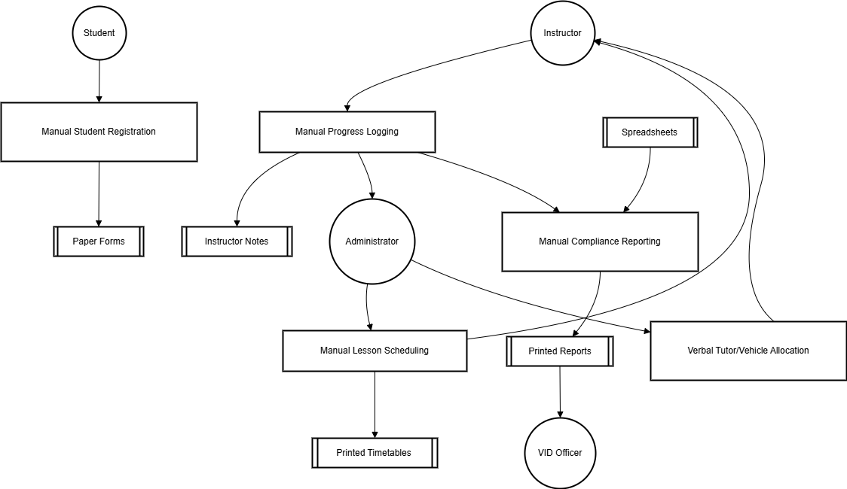

**Use Case Diagram**

The Use Case Diagram on the next page depict the various actors interacting with the system and the specific functionalities they require. These diagrams help to identify the core requirements and use cases for the proposed web-based fuel management system.

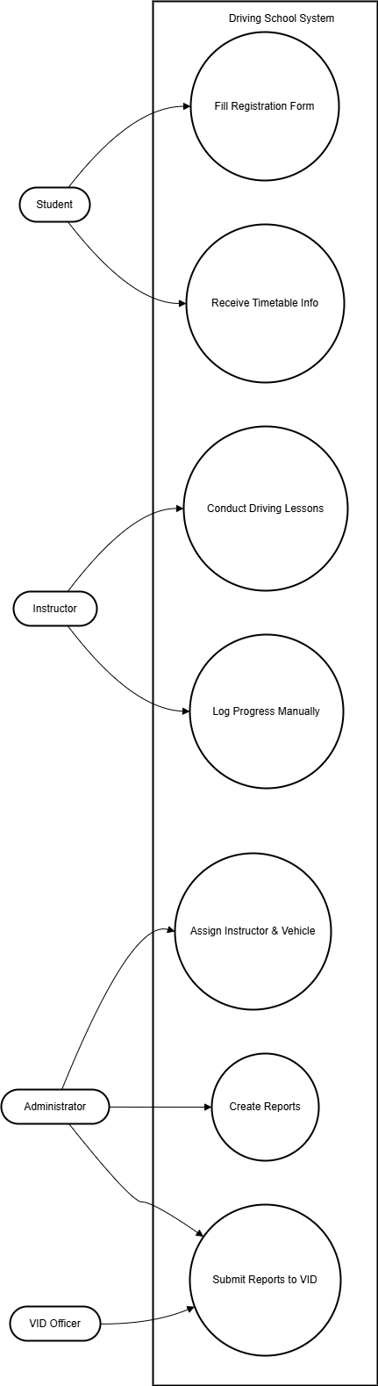

**3.4. Overview of the Proposed System**

The Smart Driving School Management System (SDSMS) is a centralized web-based platform tailored for Zimbabwe. It integrates features such as automated scheduling, real-time communication, progress tracking, and regulatory reporting. SDSMS is designed to operate efficiently even in environments with intermittent internet connectivity, using offline-first capabilities.

**3.4.1. Weaknesses of the Current System**

The analysis highlights several challenges in the current systems:

* Student registration is slow, error-prone, and unstandardized.
* Lesson scheduling is informal, leading to inefficiencies.
* There is no centralized progress monitoring.
* Reminders are inconsistent and dependent on manual communication.
* Regulatory reporting is time-intensive and inconsistent with VID standards.

These weaknesses reduce operational efficiency and limit scalability.

**3.4.2. Strengths of the Current System**

Despite its shortcomings, the existing system has some strengths that the SDSMS builds upon:

* Schools have established procedures and are familiar with them.
* Experienced instructors and vehicle fleets are already in place.
* There is basic use of messaging tools like WhatsApp for communication.
* Stakeholders express interest in digital transformation.

These strengths can be leveraged to ease system adoption and training.

**3.4.3. Evaluation of Alternatives**

Several options were evaluated:

* **International DSMS platforms** like Teachworks and DrivingSchoolSoftware.com offer comprehensive features but come at high subscription costs, lack support for local regulations, and require constant internet access (GetApp South Africa, 2024).
* **Improving the current manual system** may involve digitizing some forms or records but would retain the underlying inefficiencies of a paper-based process.
* **A custom-developed SDSMS**, however, provides the ideal solution. It is affordable, locally hosted, adaptable to regulatory changes, and capable of offline operation. It aligns well with both the business needs and regulatory environment in Zimbabwe (StartupBiz Zimbabwe, n.d.).

**3.4.4. Requirements Analysis – Use Case Diagrams**

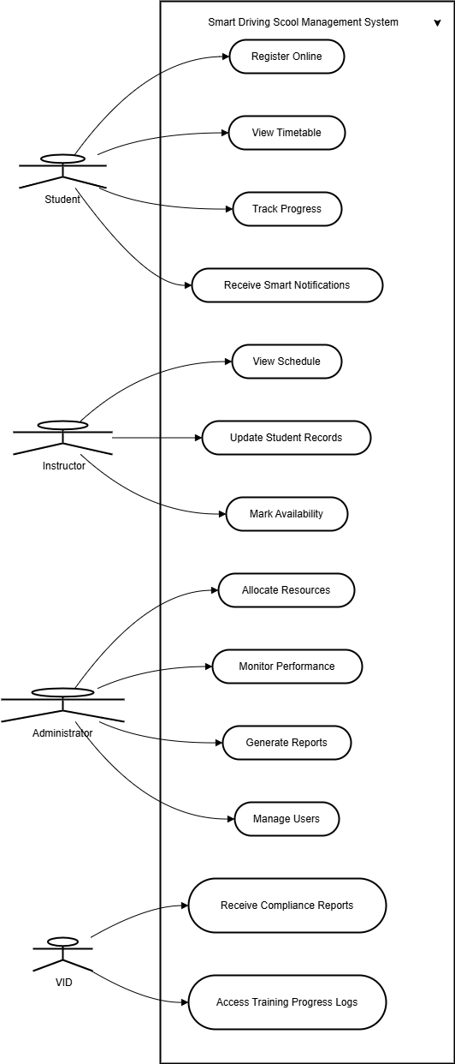

The Data Flow Diagram (DFD) for the proposed SDSMS illustrates how data flows between core actors—students, instructors, administrators, and VID officers—and the system’s key processes. It visualizes interactions such as online registration, lesson scheduling, progress tracking, and compliance reporting, highlighting the structured and automated data handling that replaces manual workflows.

**3.5. Summary**

This chapter has analyzed the operational weaknesses of existing driving school systems in Zimbabwe. It has demonstrated, through structured diagrams and system modeling, the need for a centralized, automated platform. The proposed SDSMS will streamline student registration, scheduling, monitoring, and regulatory compliance through a locally relevant, cost-effective web-based system that is built to scale.

#### REFERENCES

[1] TechZim, “Is online learning working in Zimbabwe?” TechZim, Apr. 2024. [Online]. Available: https://www.techzim.co.zw

[2] StartupBiz Zimbabwe, “Driving school operations and regulatory compliance,” StartupBiz Zimbabwe. [Online]. Available: https://startupbiz.co.zw

[3] GetApp, “Driving School Software Reviews & Comparisons,” GetApp South Africa, 2024. [Online]. Available: https://www.getapp.com

[4] A. Chigora, T. G. Dziro, and L. Chuma, “Digitization and e-Government implementation in Zimbabwe: Progress, challenges and future directions,” *International Journal of Public Administration*, vol. 45, no. 10, pp. 753–766, 2022. [Online]. Available: https://doi.org/10.1080/01900692.2021.1881342

[5] D. Mutsvangwa and B. Mapako, “Adoption of ICT in Zimbabwean SMEs: Opportunities and Challenges,” *Journal of African Business*, vol. 21, no. 4, pp. 542–560, 2020. [Online]. Available: https://doi.org/10.1080/15228916.2020.1759634