Classic Car Display
Published Date : April 25, 2019
Author : ng23055
Categories :
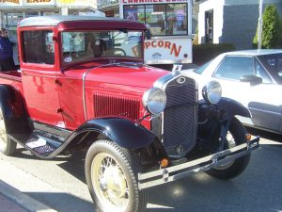 Come see some amazing classic cars that will be on display for everyone to enjoy! View the Facebook Event: https://www.facebook.com/events/2345058825772191/

Comments

