Helicopter Rides
Published Date : April 25, 2019
Author : ng23055
Categories :
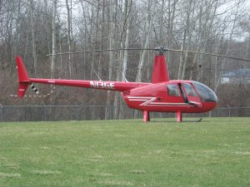 Helicopter Rides at the Shepherd Maple Syrup Festival! $20 per person for 2 minute ride $40 per person for 4 minute ride View Facebook Event: https://www.facebook.com/events/2145880362136784/

Comments

