Introduction to Database Systems

Pharmacy Management System

Design Phase – Schema Design

Team Members:

Name | Student ID
Habiba Mohammed | 202402213
Ahmed Mahmoud | 202401491
Mohamed Essam | 202401171
Ali Mahmoud | 202400666

Contact Email:
s-habiba.mohammed@zewailcity.edu.eg
Date: 30/11/2025

The final ER Diagrams:
https://drive.google.com/file/d/17Aukg_L_2ohn2BFnVxkxplM-NE20X0Pk/view?usp=sharing
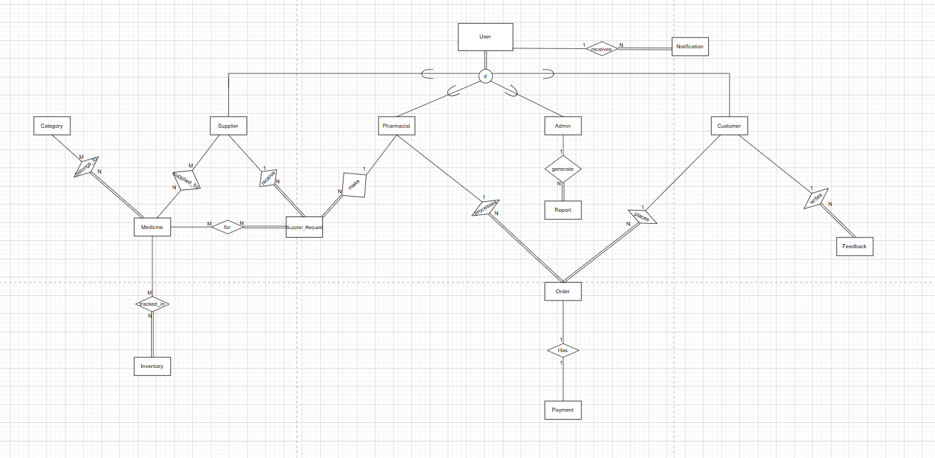

https://drive.google.com/file/d/1PspQpbWsdDC2Hm7zpUsRhaMGK502SPHE/view?usp=sharing
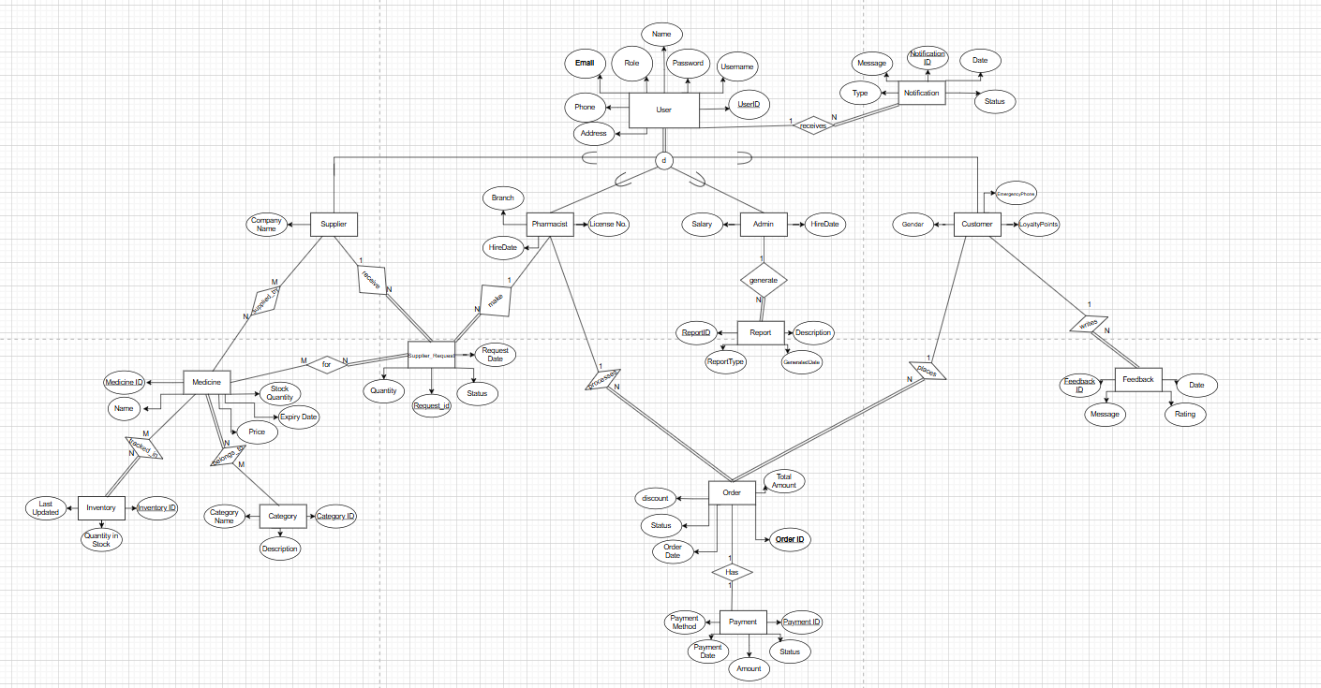

Mapping from ERD to Relations:

1. User and Specialization (Admin, Pharmacist, Supplier, Customer)
- Entity User
→ Relation:
Users(UserID, Username, Password, Name, Role, Email, Phone, Address)
  - UserID is the primary key.
- Subtype Admin of User
→ Relation:
Admins(UserID, Salary, HireDate)
  - UserID is PK and FK → Users(UserID).
- Subtype Pharmacist of User
→ Relation:
Pharmacists(UserID, Branch, LicenseNo, HireDate)
  - UserID is PK and FK → Users(UserID).
- Subtype Supplier of User
→ Relation:
Suppliers(UserID, CompanyName)
  - UserID is PK and FK → Users(UserID).
- Subtype Customer of User
→ Relation:
Customers(UserID, LoyaltyPoints, Gender, EmergencyPhone)
  - UserID is PK and FK → Users(UserID).

2. Category, Medicine and Inventory
- Entity Category
→ Relation:
Category(CategoryID, CategoryName, Description)
  - CategoryID is PK.
- Entity Medicine
→ Relation:
Medicine(MedicineID, Name, Price, ExpiryDate, StockQuantity)
  - MedicineID is PK.

- Entity Inventory
→ Relation:
Inventory(InventoryID, LastUpdated, QuantityInStock)
  - InventoryID is PK.
- Relationship belongs_to (Medicine – Category, M:N)
→ New relation (for M:N):
Medicine_Category(MedicineID, CategoryID)
  - MedicineID and CategoryID together form a composite PK.
  - Both are FKs referencing Medicine(MedicineID) and Category(CategoryID).
- Relationship located_in (Medicine – Inventory, M:N)
→ New relation:
Medicine_Inventory(MedicineID, InventoryID)
  - Composite PK: (MedicineID, InventoryID)
  - FKs → Medicine(MedicineID), Inventory(InventoryID).

3. Supplier and Supplier Requests
- Relationship supplies (Supplier – Medicine, M:N)
→ Relation:
Supplied_By(SupplierID, MedicineID)
  - Composite PK: (SupplierID, MedicineID)
  - FKs → Suppliers(UserID), Medicine(MedicineID).
- Entity Supplier_Request
(request created by a pharmacist and sent to a supplier)
→ Relation:
Supplier_Request(RequestID, RequestDate, Status, Quantity, SupplierID, PharmacistID)
  - RequestID is PK.
  - SupplierID is FK → Suppliers(UserID).
  - PharmacistID is FK → Pharmacists(UserID).
- Relationship for (Supplier_Request – Medicine, M:N)
→ Relation:
SupplierRequest_Medicines(RequestID, MedicineID)
  - Composite PK: (RequestID, MedicineID)
  - FKs → Supplier_Request(RequestID), Medicine(MedicineID).

4. Orders and Payments
- Entity Order
(placed by a customer and handled by a pharmacist)
→ Relation:
Orders(OrderID, Discount, Status, OrderDate, TotalAmount, CustomerID, PharmacistID)
  - OrderID is PK.
  - CustomerID is FK → Customers(UserID).
  - PharmacistID is FK → Pharmacists(UserID).
- Entity Payment (related 1:1 / 1:N with Order)
→ Relation:
Payment(PaymentID, PaymentMethod, PaymentDate, Amount, Status, OrderID)
  - PaymentID is PK.
  - OrderID is FK → Orders(OrderID).

5. Notifications, Reports and Feedback
- Entity Notification (received by User)
→ Relation:
Notification(NotificationID, Status, Date, Message, Type, UserID)
  - NotificationID is PK.
  - UserID is FK → Users(UserID).
- Entity Report (generated by Admin)
→ Relation:
Reports(ReportID, Description, GenerateDate, ReportType, AdminID)
  - ReportID is PK.
  - AdminID is FK → Admins(UserID).
- Entity Feedback (written by Customer)
→ Relation:
Feedback(FeedbackID, Date, Rating, Message, CustomerID)
  - FeedbackID is PK.
  - CustomerID is FK → Customers(UserID).

List of Tables with Primary Keys and Foreign Keys:
Users
- PK: UserID
- FK: —
Admins
- PK: UserID
- FK: UserID → Users(UserID)
Pharmacists
- PK: UserID
- FKs: UserID → Users(UserID)
Suppliers
- PK: UserID
- FK: UserID → Users(UserID)
Customers
- PK: UserID
- FK: UserID → Users(UserID)

Category
- PK: CategoryID
- FK: —
Medicine
- PK: MedicineID
- FK: —
Inventory
- PK: InventoryID
- FK: —

Medicine_Category
- Composite PK: (MedicineID, CategoryID)
- FKs:
  - MedicineID → Medicine(MedicineID)
  - CategoryID → Category(CategoryID)
Medicine_Inventory
- Composite PK: (MedicineID, InventoryID)
- FKs:
  - MedicineID → Medicine(MedicineID)
  - InventoryID → Inventory(InventoryID)

Supplier_Request
- PK: RequestID
- FKs:
  - SupplierID → Suppliers(UserID)
  - PharmacistID → Pharmacists(UserID)
SupplierRequest_Medicines
- Composite PK: (RequestID, MedicineID)
- FKs:
  - RequestID → Supplier_Request(RequestID)
  - MedicineID → Medicine(MedicineID)
Supplied_By
- Composite PK: (SupplierID, MedicineID)
- FKs:
  - SupplierID → Suppliers(UserID)
  - MedicineID → Medicine(MedicineID)

Orders
- PK: OrderID
- FKs:
  - CustomerID → Customers(UserID)
  - PharmacistID → Pharmacists(UserID)
Payment
- PK: PaymentID
- FK: OrderID → Orders(OrderID)

Notification
- PK: NotificationID
- FK: UserID → Users(UserID)
Reports
- PK: ReportID
- FK: AdminID → Admins(UserID)
Feedback
- PK: FeedbackID
- FK: CustomerID → Customers(UserID)

schema diagram:
https://drive.google.com/file/d/1s2xb5E0Ka9lG5hLzqllx8mma-CHD7yV7/view?usp=sharing

