**Maintaining Wireless Sensor Networks with a Swarm of UVs**

Aaron T. Becker[1], University of Houston

Wireless sensor networks (WSNs) are increasingly common, thank to new wireless sensor technologies. WSNs proliferate in many different ﬁelds including battleﬁeld surveillance, environmental sensing, and biomedical observation. Although advances in processing and computing designs have enabled sensors with a multitude of sensing (temperature, pressure, light, magnetometer, infrared, etc.), advances in battery technology have been more modest. Energy constraints on battery-powered sensors limits the sustainability of WSNs. In WSNs, the majority of energy is consumed by **(i) wireless transmission of perceived data, and (ii) long-distance multi hop transmissions from source sensors to the sink**. Radio transmission and listening, dominate power usage.

Clockwise from Top Left

Fig.1. Wireless Sensor Network with battery levels of each sensor node.

Fig.2. the Setup, UV is servicing a sensor network wirelessly.

Fig.3. the path UV follows with its footprints.

Blue Recharge Footprint

Red Data Footprint



*r*recharge



10101…

10101…

10101…

10101…

10101…

10101…

*r*data

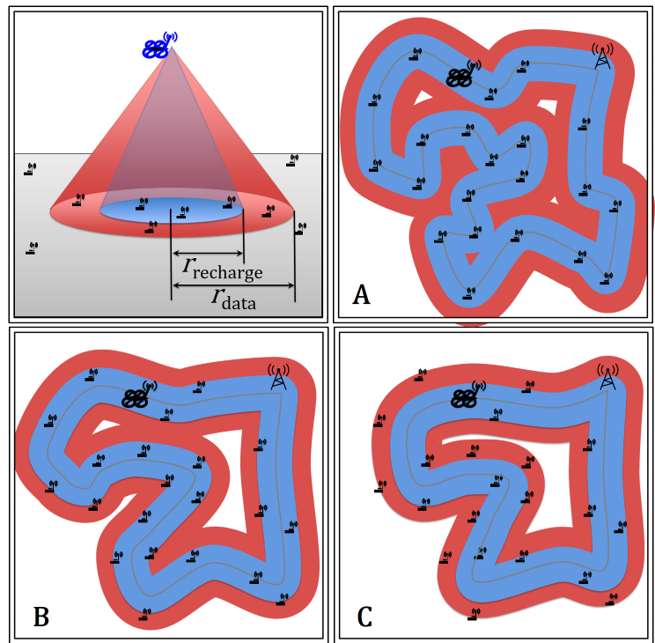

Research efforts to address WSN energy concerns have focused on energy conservation, and environmental energy harvesting. However, energy conservation schemes only *slow* energy consumption, not compensate energy depletion. Harvesting environmental energy is subject to availability, and is often uncontrollable. Fortunately, recent breakthroughs in the area of wireless power transfer technologies, including inductive coupling, magnetic resonant, and RF energy harvesting, provide promising alternatives for deploying such WSNs. Magnetic resonant wireless power transfer can wirelessly transfer electric power from the energy storage device to the receiving device efﬁciently within medium range (40% efﬁciency within 2 meters). It is also insensitive to the neighboring environment and does not require a line of sight between the charging and receiving devices. We propose mobile unmanned vehicles (UVs) carrying wireless chargers that can visit and service each sensor to sustain a WSN. Here *servicing* means recharging the sensor node and collect data (avoiding high energy costs due to long transmission) from sensor nodes, which in turn reduces the energy.

REFERENCES

[1] S. K. V. Sudarshan and A. T. Becker, ``Using Gradient Descent to Optimize Paths for Sustaining Wireless Sensor Networks,'' in IEEE Texas Symposium on RF and Microwave Circuits and Systems, Waco, TX, USA, April 24-25, 2015.

[2] S. K. V. Sudarshan and A. T. Becker, “Waypoint Control For Path Planning”, mathworks.com/matlabcentral/fileexchange/49863-waypointcontolforpathplanningtwmcs--.

[3] G. A. Pereira, M. B. Soares and M. M. Campos, "A potential field approach for collecting data from sensor networks using mobile robots," Proc. of Int. Conf. on Intelligent Robots and Syst., Sendal, Japan, Sep., 2004, pp. 3469-3474.

[4] Daniel E Soltero, Mac Schwager, and Daniela Rus. Decentralized path planning for coverage tasks using gradient descent adaptive control. The International Journal of Robotics Research, page 0278364913497241, 2013.

1. [atbecker@uh.edu](mailto:atbecker@uh.edu) , (217) 722-2058 (cell), (713) 743 6671 (office)