**WAYPOINT CONTROL FOR SERVICING WSNs WITH UVs**

Srikanth K. V. Sudarshan, Dr. Aaron T. Becker[1]

New wireless sensor technologies have enabled wireless sensor networks (WSNs) to proliferate in many different ﬁelds (e.g., battleﬁeld surveillance, environmental sensing, and biomedical observation). Although advances in processing and computing designs can endow sensors with a multitude of sensing modalities (temperature, pressure, light, magnetometer, infrared, etc.), advances in battery technology have been more modest. Energy constraints on battery-powered sensors limits the sustainability of WSNs. In WSNs, the majority of energy is consumed by **(i) wireless transmission of perceived data, and (ii) long-distance multi hop transmissions from source sensors to the sink**. Radio transmission and listening, dominate power usage. Research efforts to address WSN energy concerns have focused on **energy conservation, environmental energy harvesting and incremental sensor deployment**. However, energy conservation schemes only slow energy consumption, not compensate energy depletion. Harvesting environmental energy is subject to their availability, and is often uncontrollable. Incremental sensor deployment is neither sustainable nor environmentally friendly. Fortunately, recent breakthroughs in the area of wireless power transfer technologies (e.g. inductive coupling, magnetic resonant, and RF energy harvesting) provide promising alternatives for deploying such WSNs. Magnetic resonant wireless power transfer can wirelessly transfer electric power from the energy storage device to the receiving device efﬁciently within medium range (40% efﬁciency within 2 meters). It is also insensitive to the neighboring environment and does not require a line of sight between the charging and receiving devices. We propose a mobile unmanned vehicle (UV) carrying a wireless charging device, that could visit and service each sensor to sustain a WSN. Servicing means recharging the sensor node and collect data (high energy costs due to long transmission) from sensor nodes which in turn reduces the energy consumption there by improving efficiency.

Clockwise from Top Left

Fig.1. Wireless Sensor Network with battery levels of each sensor node.

Fig.2. the Setup, UV is servicing a sensor network wirelessly.

Fig.3. the path UV follows with its footprints.

Blue Recharge Footprint

Red Data Footprint

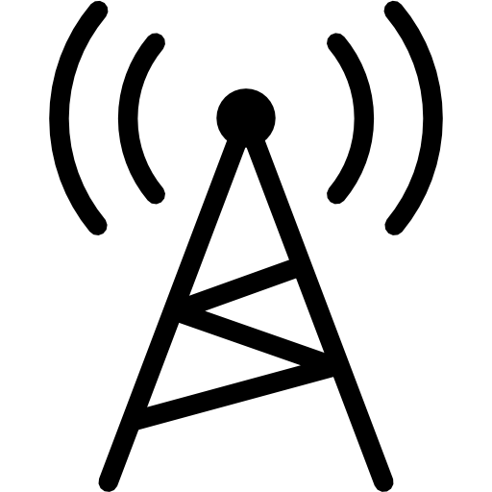

*r*recharge



10101…

10101…

10101…

10101…

10101…

10101…

*r*data

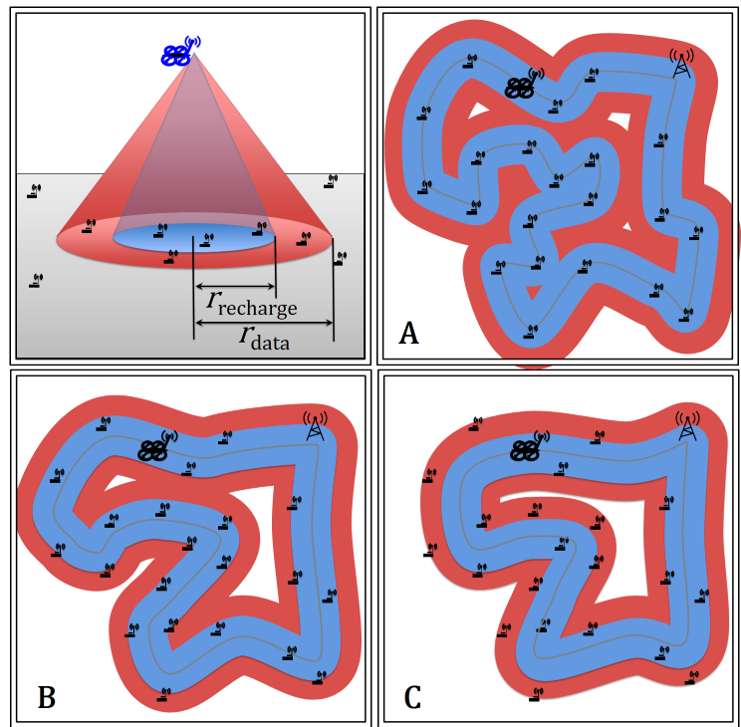

The base technique is a variant of **Lloyd’s algorithm**. Each path is represented by a ﬁnite number of waypoints, and these waypoints are both attracted to the centroid of all sensor nodes within their **Voronoi cell**, and attracted to their neighboring waypoints. To optimize the path we switch between a **gradient descent optimization** routine that ﬁnds the local minima and an **mTSP solver** (anytime algorithm) that rearranges the order of waypoints to improve the paths. The path constructed is adaptive to the sensor node locations. The simulations use a static WSN, but often sensor data transmission is dependent on transient phenomena. Finally, future work should extend our simulation to handle non-stationary sensor nodes, improve the convergence rate. We are in the process of implementing the algorithm with a set of quadcopters. Our MATLAB implementation is available at mathworks.com/matlabcentral/fileexchange/49863-waypointcontolforpathplanningtwmcs--.

REFERENCES

[1] G. A. Pereira, M. B. Soares and M. M. Campos, "A potential field approach for collecting data from sensor networks using mobile robots," Proc. of Int. Conf. on Intelligent Robots and Syst., Sendal, Japan, Sep., 2004, pp. 3469-3474.

[2] Daniel E Soltero, Mac Schwager, and Daniela Rus. Decentralized path planning for coverage tasks using gradient descent adaptive control. The International Journal of Robotics Research, page 0278364913497241, 2013.

1. [skvenkatasudarshan@uh.edu](mailto:skvenkatasudarshan@uh.edu), [atbecker@uh.edu](mailto:atbecker@uh.edu)