CSF-HYPE Input Data UpdateR

Purpose
The CSF-HYPE Input Data UpdateR is an R-based data processing pipeline written specifically for generating/updating all required inputs for the CSF-HYPE model. This document provides an overview of the pipeline, overview of the data processing methodology and detailed instruction on how to run the update process.

Overview
The CSFHYPE_Input_Data_updateR repository contains a resumable, auditable data update pipeline for generating CSF‑HYPE input datasets. The pipeline executes a fixed, ordered sequence of R scripts, validates required inputs, enforces explicit output declarations, records provenance metadata for every successful step and incorporates robust input validation and error handling.

Workflow summary
An update run is executed by opening the Rproject and sourcing the 00_Master_Runner_Input_Data_UpdateR.R script – for a standard update this requires no changes. Sourcing will execute each script in order (order is important as downstream scripts require inputs generated upstream):
run_pipeline()
├─ step 1 ── Scripts/1_Update_Forcing_data.R
├─ step 2 ── Scripts/2_Extract_Flow_data.R
├─ ...
└─ step 15 ── Scripts/15_Create_XObs_input.R
Each step:
- Validates required input files
- Executes the script in an isolated environment
- Verifies declared outputs exist
- Records a success marker containing:
  - output paths
  - input file hashes
  - runtime
  - R/session metadata
If a step has already succeeded and its inputs are unchanged, it is skipped.

Automatic execution
When 00_Master_Runner_Input_Data_UpdateR.R is sourced:
- Current pipeline status is printed
- The full pipeline is executed in order
- Execution stops immediately on any error

Manual execution
run_pipeline(start_from = 3, stop_at = 7)
Allows partial execution. Not intended for general use, but may be useful for troubleshooting etc.

CSFHYPE_Input_Data_updateR structure
├── CSFHYPE_Input_Data_updateR - top level (project root) main pipeline log file and documentation stored here

├── Scripts
R scripts that make up the pipeline
├── 00_Master_Runner_Input_Data_UpdateR.R – all downstream scripts are executed from here
├── 1_Update_Forcing_data.R
├── 2_Extract_Flow_data.R
├── 3_Extract_consents.R
├── 4_Extract&Update_observations.R
├── 5_Prepare_consents.R
├── 6_Collate_EDM_returns.R
├── 7_Create_Intermittents_monthly_series.R
├── 8_Create_Abstractions_monthly_series.R
└── 9_Create_CattleInStreams_monthly_series.R
├── 10_Make_PSData_master.R
├── 11_Prepare_STW_flow_data.R
├── 12_Create_Quantitative_monthly_series.R
├── 13_Make_Final_PointSource_inputs.R
├── 14_Create_QObs_Input.R
├── 15_Create_XObs_Input.R

├── ForcingData
Meteorological forcing data used to drive the model.
├── HadUKRaw
Raw HadUK gridded daily climate data.
├── Daily_rainfall – daily rainfall
├── Daily_tasmax – daily maximum temperature
├── Daily_tasmin – daily minimum temperature
├──Rainfall
Pobs.txt Final rainfall inputs derived/updated from raw HadUK data.
├── Temperature
Pobs.txt Final temperature inputs derived/updated from raw HadUK data.

├── GeoData
Geospatial inputs used for model setup and spatial analysis (sub-basin polygons).

├──PointSourceData
Point-source inputs, including abstractions and discharges.

├── Abstractions
Water abstraction data and associated processing outputs.
├── data_in
├──returns_data
Abstraction return datasets.
├──returns_data_backup
Archived copies of abstraction return datasets.
├──returns_details
Metadata for abstraction returns.
├── WRGIS_data
├── data_out
Processed abstraction datasets produced.

├── Discharges
Discharge and effluent data processing
├── api_cache
Houses the canonical data file of WQ monitoring data extracted & updated from the Water Quality Explorer API
├── data_in
Required inputs
├── CattleInStreams
├── EDM_returns
├──stw_flow_data
├──collated_data
├── new_exports
├── data_out
Final collated discharge datasets.
├── EDM_returns_collated

├── QObs
Observed flow (Q) datasets.
├── data_in
├── Flow_data
Raw observed flow data.
├── data_out
Processed observed flow datasets.

├── Status_tracking
Files used to track pipeline status and input data hashes to facilitate resumability (Should be empty when starting an update workflow)

├── XobsData
Cross-validation data output for CSF-HYPE (input data comes from the API cache).

Configuration
The pipeline is configured via the CONFIG list (master runner script):
Field | Description
status_dir | Directory storing success marker .rds files
log_file | Path to pipeline log file
force_rerun | If TRUE, ignores all success markers

Success Markers
After successful completion of a script, a success marker is written to:
status_tracking/<script_name>_SUCCESS.rds
Each marker contains:
- Script name
- Completion timestamp
- Runtime (seconds)
- Declared outputs
- Hashes of required input files
- R version
- Session hash
These markers determine whether a step can be safely skipped on subsequent runs.

Error Handling & Logging
- All execution is logged to pipeline_run.log
- On script failure:
  - The error message is logged
  - The full R traceback is logged
  - Pipeline execution stops immediately
This ensures failures are reproducible and diagnosable.

Performance Tracking
For each script, the pipeline records:
- Runtime (seconds)
- Completion timestamp
This enables identification of slow or unstable steps over time.

Notes
- Success markers are part of the pipeline state; do not move or rename them - they will be automatically cleared following successful completion of the full pipeline
- To force a clean run, either:
  - set CONFIG$force_rerun <- TRUE, or
  - delete relevant files in status_tracking/

Operator Instructions
This section is intended for users running the pipeline operationally to update all or part of the CSF-HYPE input data. It is intended that each subsequent update is run from the same project root as the previous, it is therefore strongly recommended that a copy of the whole project (CSFHYPE_Input_Data_UpdateR) is saved as a backup before and after each update. The project can, in theory, be run from any location the user has read and write access, but it is recommended to be run from a local drive for efficiency.

Prerequisites
In order to run the pipeline successfully the following is required:
- R version 4.5 or newer must be installed (it may work with older versions, but hasn’t been tested)
- RStudio is not strictly essential, but strongly recommended as the pipeline is designed to be run from it.
- A CEDA Archive account (https://archive.ceda.ac.uk/) is required for downloading the HadUK forcing data.
- A WISKI7 account (EA staff only) is required for downloading effluent flow data
- A NALD access in BOXI for downloading abstraction returns data (or data requested from the NALD team)
- Most recent WRGIS snapshot (abstraction licenses)
- CCM outputs for Cattle-in-Streams and Diffuse loadings
- Access ODBC drivers installed (https://www.microsoft.com/en-us/download/details.aspx?id=54920) - required for processing the consents extract
- An internet connection

HadUK CEDA access token generation
The first script in the pipeline (1_Update_Forcing_data.R) requires a CEDA access token to be entered when prompted in order to authenticate HadUK data download. To generate a token, log in to your CEDA account and under My Account > My Archive Access > Access Token > Create New Access Token
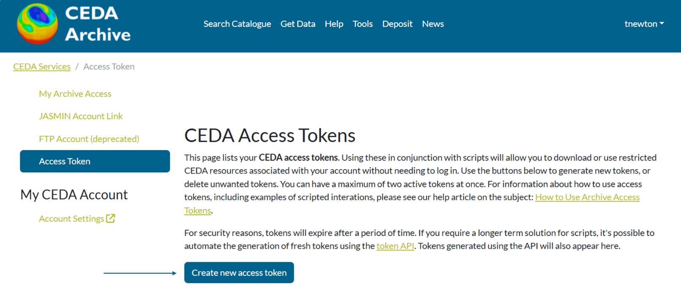
Copy the token and paste it into the R console window when prompted then press Enter.

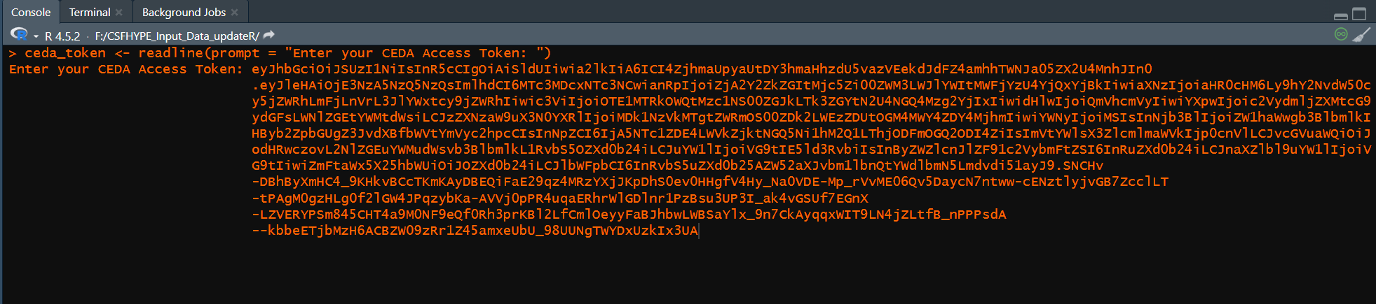

WISKI7 STW flow data export
Log-in and launch the WISKI7 application
Open the filter dialogue either by clicking on the filter button along the top menu ribbon or pressing F4:
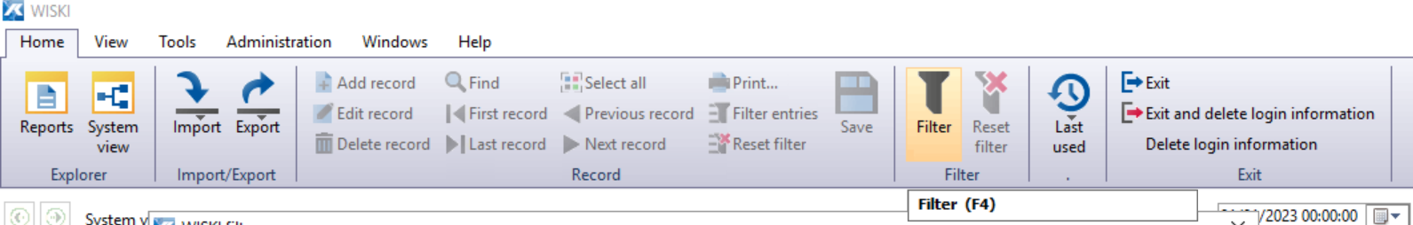
This is used to get to the timeseries export wizard so only one station needs to be added. But to list all Effluent sites enter EF* into the Station Number field:
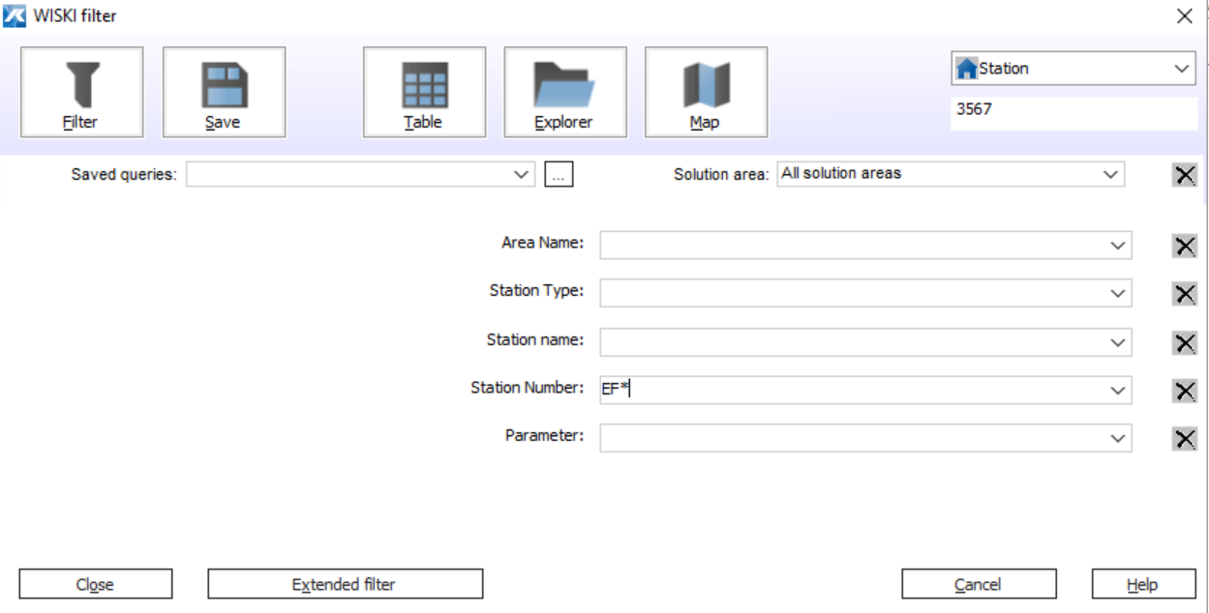
Then click the Explorer button (top of the WISKI filter window). Wait a moment for the ‘nodes’ to load. Then close the filter window. You should now see the stations returned by the filter query:
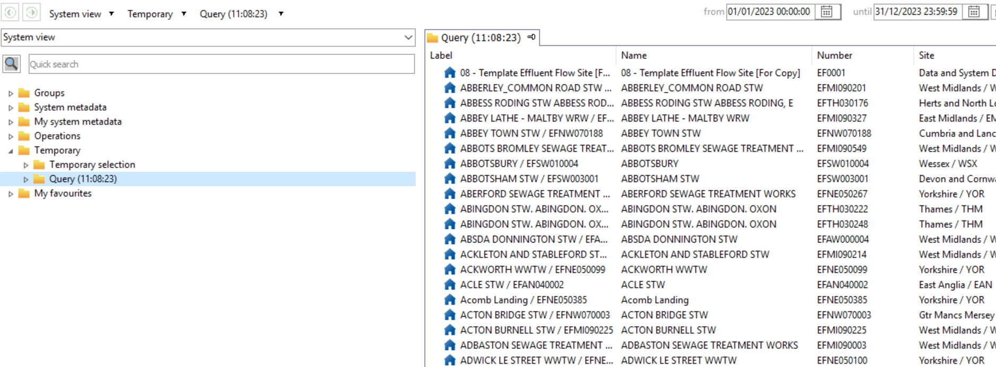
Right-click any station in the query and select Time series export… to open the timeseries export wizard.

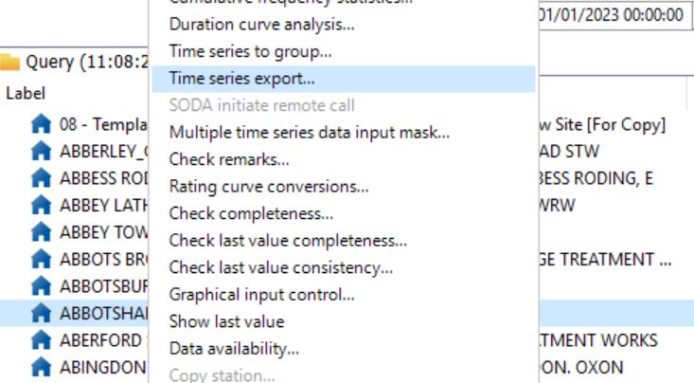
In the timeseries export wizard click the Multiple selection tab, then complete as follows:
Source data:
Source list: */EF*
Short name mask: */Day.Total.P
Analysis period:
Select Absolute and enter the time period required for export. To determine when to export data from (start date) check the log file (flow_data_log.csv) in ~CSFHYPE_Input_Data_updateR\PointSourceData\Discharges\data_in\stw_flow_data\
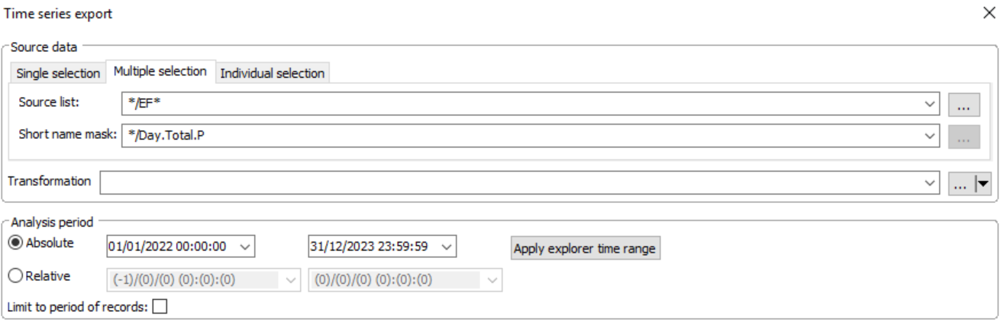
Configuration:
Uncheck the interactive box.
Under filename click the … button to the right. This will open a FileExplorer window.
Navigate to Network>Client to list directories on your laptop (outside the virtual machine WISKI runs in)
You may then be shown warning:
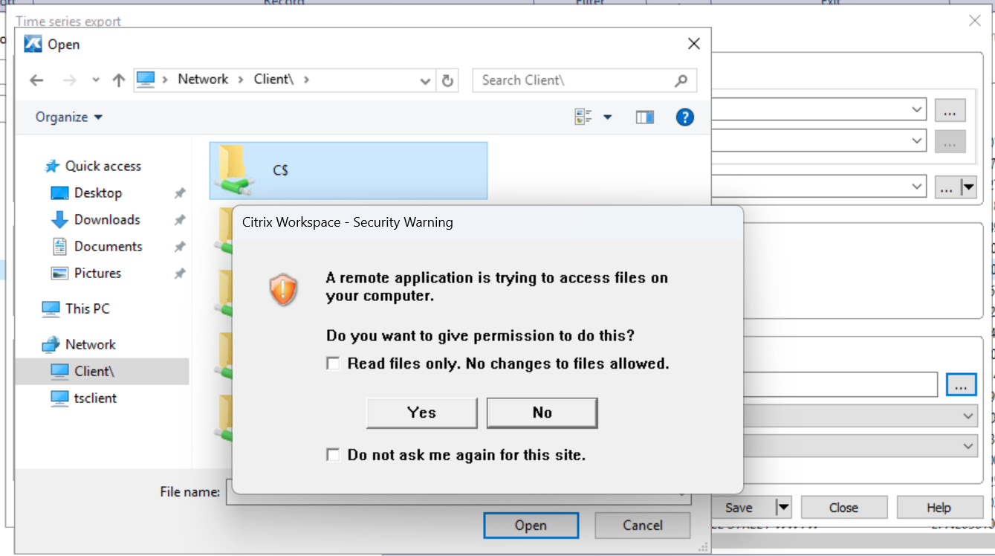
Ensure you give permission (Yes) and leave Read files only unchecked.
Pick a location you want to export the data to (e.g. the C drive) create a folder or open an existing folder. You then need to enter a name for the file ending in .csv in the File name: box and then click Open - this is where the export will be written to and the path should now appear in the File name: field of the export wizard.
From the Configuration dropdowns select:
Format group: Default
File format: Extended generic CSV for EA time series data (over KiIOSys [ALLGEXEA_E])
The completed Export wizard should then look like this:
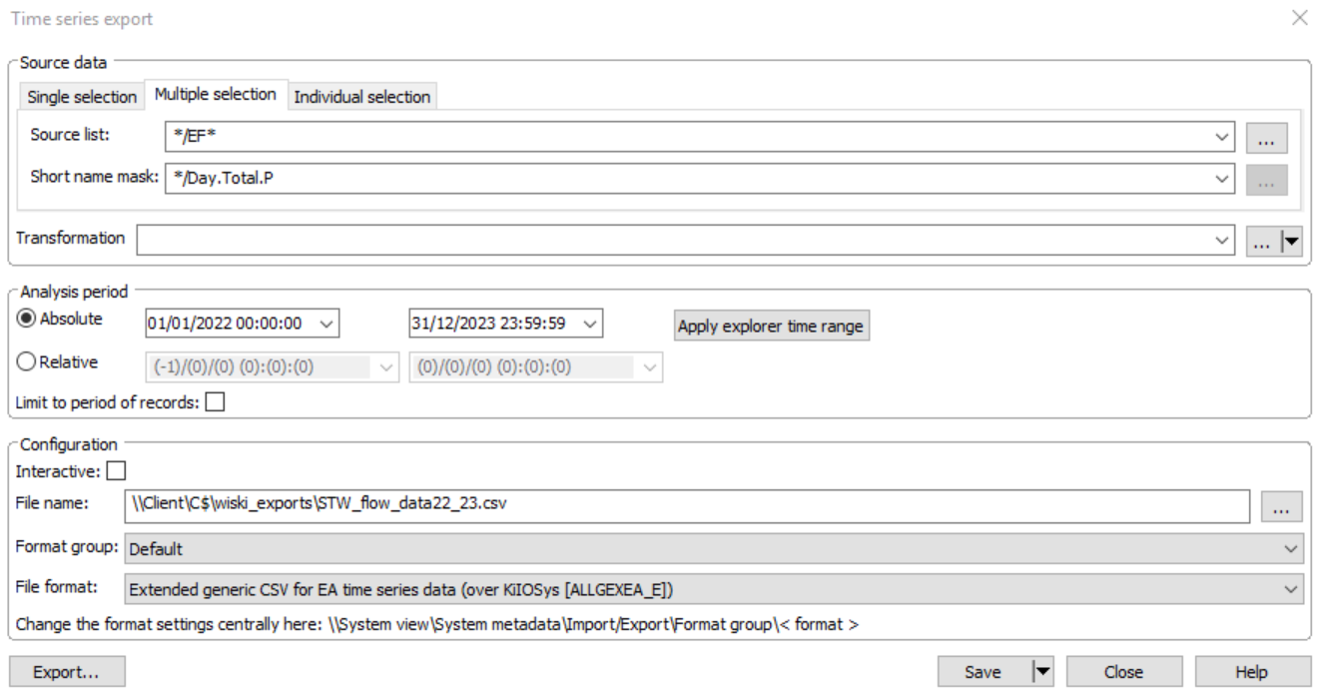
Click the Export… button to perform the export. The progress bar may quickly look to be completed but nothing seems to be happening. Don’t worry, the export should eventually complete:
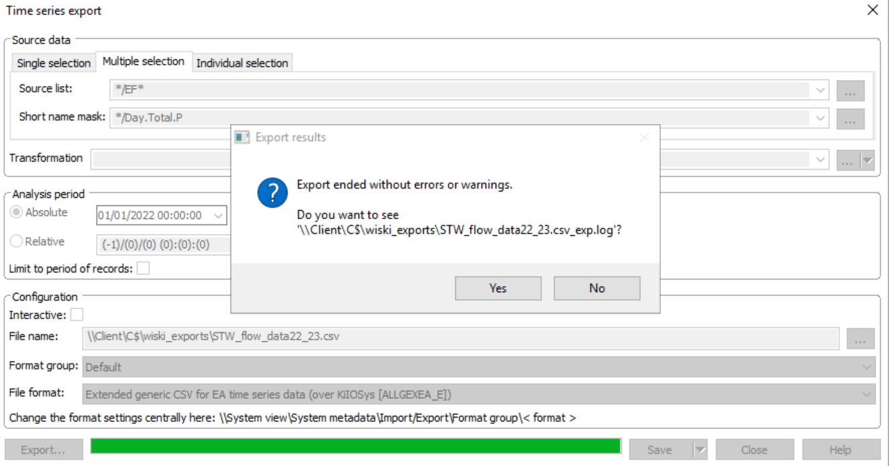
Finally, move the exported data file to the ‘new_exports’ folder of the R project:
~CSFHYPE_Input_Data_updateR\PointSourceData\Discharges\data_in\stw_flow_data\new_exports\

NALD abstraction data export

Running the Full Pipeline
To run the entire pipeline from start to finish:
  - Open the Rproject in RStudio (File > Open Project…)
  - source("00_Master_Runner_Input_Data_UpdateR.R")
  - Pay attention to messages in the console window – some steps require user interaction with the console.
This will:
- Print the current pipeline status
- Execute all pending steps in order
- Stop immediately if any step fails
Successful steps will be skipped on subsequent runs unless their inputs change.

Running a Subset of Steps
You can run only part of the pipeline using the start_from and stop_at arguments:
run_pipeline(start_from = 4, stop_at = 8)
Typical use cases:
- Restarting after a known failure
- Re-running only downstream processing
- Testing a subset of steps during development
Warning – this may not be successful or produce reliable output as many upstream scripts are dependent on downstream outputs.

Interpreting Pipeline Status Output
The print_pipeline_status() function displays the current state of each step:
- ✓ DONE — step completed successfully and inputs are unchanged
- ○ PENDING — step has not run or must be re-run
Each completed step shows its last completion timestamp.

Understanding Skipped Steps
A step is skipped only when:
- A success marker exists and
- All required input file hashes match the previous run
This is intended to allow resuming an update run if a step fails midflow, providing the issue has been resolved.
If inputs have changed, the step will automatically re-run even if it succeeded previously.

Forcing Re-runs
To force all steps to re-run regardless of success markers:
CONFIG$force_rerun <- TRUE
run_pipeline()
Alternatively, to force re-running specific steps, delete their success markers:
clear_success_markers("3_Extract_consents")

Handling Failures
If the pipeline fails at any point:
- Execution stops immediately at the failing step
- The error message and traceback are written to pipeline_run.log
- All previously completed steps remain marked as successful
To recover:
- Fix the underlying issue (missing input, code error, etc.)
- Re-run the pipeline
- Execution will resume from the failed step

Reading the Log File
The pipeline log (pipeline_run.log) records:
- Start and end of pipeline runs
- Execution of each script
- Skip decisions
- Error messages and tracebacks
The log is append-only and can be used as an audit trail.

Success Marker Files
Success markers are stored in:
status_tracking/
Each _SUCCESS.rds file represents one completed step and contains runtime and provenance information.
These files are pipeline state and should not be committed to version control.

Script summaries and methods

Script 1 – Update CSF-HYPE forcing data
File: 1_Update_Forcing_data.R
This script updates the CSF-HYPE forcing input files (Pobs.txt and Tobs.txt) with the latest daily rainfall and temperature data from HadUK-Grid (1 km resolution). It:
- Downloads new NetCDF files for rainfall (rainfall) and temperature (tasmin, tasmax) from CEDA.
- Aggregates gridded data to CSF-HYPE sub-basins using area-weighted means.
- Appends new daily data to the existing forcing files.
- Writes metadata describing the latest forcing date.
- Cleans up raw downloaded files to save disk space.
This is the first step in the CSF-HYPE pipeline and provides meteorological forcing for all downstream analyses.

Inputs
Required files: - ForcingData/Rainfall/Pobs.txt — existing precipitation forcing file - ForcingData/Temperature/Tobs.txt — existing temperature forcing file - GeoData/Eco_HYPE_SUBBASINS.gpkg — sub-basin geometries (SUBID field required)
External dependencies: - HadUK-Grid daily NetCDF files for rainfall and temperature - Valid CEDA access token (entered at runtime)
Required directories: - ForcingData/Rainfall/ - ForcingData/Temperature/ - Temporary download folder: ForcingData/HadUKRaw/

Outputs
Declared outputs: - ForcingData/Rainfall/Pobs.txt — updated precipitation forcing - ForcingData/Temperature/Tobs.txt — updated temperature forcing - ForcingData/_forcing_metadata.rds — metadata with latest forcing date and generation timestamp

Workflow

1. Determine update period
max DATE in Pobs.txt
▼
update_from = year(max DATE) + 1
▼
Set download years: update_from → current year

2. Download HadUK data
For each variable (rainfall, tasmin, tasmax):
Get latest folder URL from CEDA
Parse file listing in JSON
Filter files by year
Download missing files using curl + CEDA token
- Skips files already downloaded (resume safe)
- Validates downloads (file size, HTTP response)
- Logs success/failure for each file

3. Update Pobs (rainfall)
Downloaded NetCDFs → Raster
▼
Replace fill values with NA
▼
Exact area-weighted mean by sub-basin (using exactextractr)
▼
Format as wide table (DATE × SUBID)
▼
Append to existing Pobs.txt and remove duplicate dates

4. Update Tobs (temperature)
tasmin/tasmax NetCDFs → Raster
▼
Replace fill values with NA
▼
Exact area-weighted mean by sub-basin
▼
Compute daily mean: temp = (tasmin + tasmax)/2
▼
Format as wide table (DATE × SUBID)
▼
Append to existing Tobs.txt and remove duplicate dates

5. Metadata
- Writes _forcing_metadata.rds containing:
  - latest_forcing_date
  - latest_forcing_year
  - generated_at timestamp
  - script name

6. Cleanup
- Deletes raw NetCDF downloads in HadUKRaw/

Downstream Dependencies
- 4_Extract&Update_observations.R
- 7_Create_Intermittents_monthly_series.R
- 8_Create_Abstractions_monthly_series.R
- 9_Create_CattleInStreams_monthly_series.R
- 11_Prepare_STW_flow_data.R
- 12_Create_Quantitative_monthly_series.R
- X_Create_QObs.R
- X_Create_XObs.R

Failure Modes
- Missing input files or directories
- Invalid/expired CEDA token
- Network/download failures (after built-in retry attempts)
- NetCDF structure changes
All errors are logged and will stop pipeline execution.

Script 2: Download Flow Data for HYPE
File: 2_Extract_Flow_data.R

Purpose
This script automates the download of river flow data from the National River Flow Archive (NRFA) for selected gauging stations. The data are used downsteam to create the QObs.txt observed flow input to CSF-HYPE.

Inputs
- QObs/data_in/NRFA_IDs_SUBIDs_lookup.csv: A lookup table mapping NRFA station numbers to sub-basin IDs in the CSF-HYPE model.

Outputs
- QObs/data_in/NRFA_GDF_metadata.csv: Metadata for all stations successfully fetched.
- QObs/data_in/Flow_data/NRFA_GDF_<stationID>.csv: Individual flow time series per station.
- QObs/NRFA_failed_ids.csv (conditional): List of stations that failed to fetch.

Processing Steps
- Setup and Package Loading: Checks for and loads required packages (tidyverse, rnrfa, here, zoo).
- Input Validation: Verifies that the required lookup CSV exists.
- Station ID Corrections: Updates known changed station IDs (e.g., 26802 → 26016, 27858 → 27099).
- Data Fetching:
  - Loops over the list of NRFA station IDs.
  - Uses the rnrfa::gdf() function to fetch daily flow data and metadata.
  - Introduces a short sleep (0.5 sec) between API calls to avoid rate limiting.
  - Logs any failures and collects them for optional output.
- Output Directory Setup:
  - Creates QObs/data_in/Flow_data if it does not exist.
- Exporting Metadata and Flow Data:
  - Combines metadata from all successful stations into one CSV.
  - Writes individual station flow data as CSVs in the Flow_data folder.
- Conditional Outputs:
  - If any stations failed, writes their IDs to NRFA_failed_ids.csv.

Key Assumptions / Notes
- Some NRFA stations may no longer exist or may have changed ID; the script adjusts for known changes.
- Flow data may be returned as zoo objects or data frames; the script converts all to tibble format.
- Failed stations should be manually investigated if NRFA_failed_ids.csv is created.

Workflow
Start
|
▼
Load packages and validate required input CSV
|
▼
Correct known station IDs
|
▼
For each station ID:
├─ Fetch flow data and metadata using rnrfa::gdf()
├─ Handle errors (store failed IDs)
└─ Pause 0.5 sec to avoid API limits
|
▼
Combine metadata → NRFA_GDF_metadata.csv
|
▼
Export each station's flow data → Flow_data/NRFA_GDF_<station>.csv
|
▼
If any failures → NRFA_failed_ids.csv
|
▼
End

Downstream Dependencies
- X_Create_QObs.R

Failure Modes
- Missing or corrupted lookup CSV: script stops.
- API fetch fails: station is logged in NRFA_failed_ids.csv.
- Flow data format unexpected: script attempts conversion; may require manual inspection.

Script 3 – Consented Discharges Processing for HYPE
File: 3_Extract_consents.R

Purpose
This script extracts, cleans, harmonises, and spatially allocates consented point-source discharge data for use in created the point source monthly timeseries for CSF-HYPE. It combines:
- England: Environment Agency Consented Discharges (Access database)
- Wales: Natural Resources Wales (NRW) consents via WFS
The final outputs provide mean-consented flows and concentrations, linked to HYPE sub-basin IDs (SUBID).

Key Responsibilities
- Validate required inputs and environment
- Download and manage the latest EA Access database
- Extract and clean consent, effluent, and determinand tables
- Derive mean-equivalent values from regulatory limits
- Convert flow limits to consistent mean m³/s estimates
- Spatially assign consents to HYPE sub-basins
- Import and harmonise Welsh NRW consents
- Combine England and Wales datasets into a unified output

Inputs

Mandatory Files
File | Purpose
Consented Discharges to Controlled Waters with Conditions.accdb | EA consented discharge database
excluded_consent_types.csv | Industry types to exclude
Eco_HYPE_SUBBASINS.gpkg | HYPE sub-basin polygons

External Services
- EA data.gov.uk ZIP download (automatic, with manual fallback)
- NRW DataMap WFS service

System Dependencies
- Microsoft Access ODBC driver (for .accdb connection)

Outputs
File | Description
consent_discharges_used_HYPE_with_consented_means.rds | Final harmonised consent dataset (England + Wales)
effluent_monitoring_sites.csv | Lookup of effluent monitoring sites linked to consented discharges
All outputs are written to:
PointSourceData/Discharges/data_out/

Workflow
Validate inputs
▼
Download / verify EA Access DB
▼
Read consent, effluent, determinand tables
▼
Filter valid consents (dates, environments, industries)
▼
Derive mean-equivalent limits
▼
Convert flow limits → mean m³/s
▼
Spatial join to HYPE SUBID
▼
Load NRW consents
▼
Clean, convert, spatially join Welsh data
▼
Harmonise schemas
▼
Combine England + Wales
▼
Write final outputs

Processing methods

1. Determinand Handling
Only determinands of interest are retained. Consented value types are converted to mean-equivalent values using consistent rules:
Original type | Conversion
Mean | Use directly
95th percentile | ÷ 2
Maximum | ÷ 3
Minimum | × 3
This ensures consistent mean estimates across permits with different reporting styles. Where a permit has consented values for Mean and any other limit format (95th percentile, min or max) then the Mean is preferred.

2. Flow Standardisation
All consented flow types are converted to mean m³/s as follows:
Original type | Original units | Conversion applied | Rationale | Resulting units
Max volume | m³/day | / 86400 × 0.3333333 | Convert daily volume to rate in second by dividing by the number of seconds in a day then approximate mean as one third of the maximum daily value | m³/s
Max Rate | L/s | / 3 × 0.001 | Approximate mean as one third of the maximum daily rate, then convert litres to cubic metres (×0.001) | m³/s
DWF volume | m³/day | / 86400 × 1.25 | Convert dry weather flow to m³/s and apply uplift factor (×1.25) | m³/s
Mean volume | m³/day | / 86400 | Direct conversion of reported mean daily flow to m³/s | m³/s

The dry weather flow (DWF) uplift of 1.25 represents an approximation of mean discharge from DWF, based on the median observed ratio for permits that have consented limits for both DWF and mean (n = 7542).
The final Flow_m3s value preferentially selects actual consented mean values or otherwise conservatively takes the minimum available mean-equivalent flow .

3. Spatial Assignment
- Outlet grid references are parsed to XY coordinates
- Receiving environment type is filtered for only freshwater
- Spatial join assigns each discharge to the nearest CSF-HYPE sub-basin
- Consents without valid coordinates remain unassigned (SUBID = NA) and are logged.

4. Welsh Consents Integration
NRW consents are:
- Retrieved via WFS
- Transformed to match EA schema
- Converted using the same mean-derivation logic
- Spatially joined to CSF-HYPE sub-basins i.e. only keeping relevant ones for CSF-HYPE
This ensures full CSF-HYPE coverage with consistent assumptions.

5. Schema Harmonisation
Before combining datasets:
- Column names are aligned
- Column types are coerced consistently (character)
- Duplicate permits across time windows are collapsed

Assumptions & Caveats
- Regulatory limits are assumed to represent enforceable maxima, not observed means
- Mean conversions are conservative approximations for modelling
- Nearest-sub-basin matching is used where outlets fall outside polygons, QA suggests these are where the outlet point falls within the river and the sub-basin polygon is clipped to the riverbank.

Failure Modes
Issue | Behaviour
Missing inputs | Script halts with explicit error
Consents download failure | Manual intervention prompt
ODBC connection failure | Script stops
NRW WFS offline | Script stops with diagnostic message

Downstream Use
The primary RDS output is designed to feed directly into:
- Point-source load calculations
- HYPE parameterisation
- Effluent monitoring linkage and QA workflows

Script 4: Effluent Monitoring Incremental Update
File: 4_Extract&Update_observations.R

Purpose
This script performs a transactional, incremental update of effluent monitoring data associated with discharge consents. It retrieves water quality monitoring results from the Environment Agency Water Quality Explorer API, appending only new observations beyond an existing cached baseline.
The script is designed to be resume-safe, resilient to API failures, and aligned to the modelling timeframe, avoiding unnecessary re-fetching when the existing dataset already covers the latest forcing data period.

Key responsibilities
- Incremental updates: only data newer than the cached baseline are requested
- Transactional workflow: baseline is only replaced after a successful full update
- Timeframe-aware: fetching is skipped entirely if baseline already spans the forcing period
- API-safe: includes retry logic, backoff, and rate limiting
- Parallelised but controlled: uses parallel processing to retrieve data for multiple sites simultaneously with bounded memory and worker counts
- Checks and identifies site-det combinations suitable for quantitative analysis

Inputs
The script requires the following inputs to be present before execution:
Input | Description
effluent_monitoring_sites.csv | List of sampling point identifiers associated with effluent consents
HYPE_EFFLUENT_MONITORING_DATA_*.rds | Existing cached baseline effluent monitoring dataset
WISKI_to_WIMS_LUT.txt | Lookup table for determinand mapping (used downstream)
_forcing_metadata.rds | Metadata describing the latest forcing data year
If any required input is missing, execution halts immediately.

Outputs
Output | Description
HYPE_EFFLUENT_MONITORING_DATA_2000-<date>.rds | Updated effluent monitoring dataset
effluent_data_log.csv | Summary log of observation counts and date ranges per site/determinand
sites_for_quant_analysis.csv | List of effluent sampling sites/determinands suitable for quantitative use
All outputs are written to the PointSourceData/Discharges/api_cache/ directory.

Workflow
Start
▼
Validate required inputs
▼
Read baseline effluent monitoring dataset
▼
Extract baseline coverage year
▼
Read latest forcing year
▼
Is baseline year ≥ forcing year?
Yes
→ Skip API fetching
→ Load existing baseline dataset only
No
→ Incremental update required:
▼
Build site × determinand lookup
▼
Identify unknown or new sites
▼
Parallel API fetching (Water Quality Explorer)
▼
For each site:
• Loop over determinands
• Query observations using paging
• Apply retry logic and exponential backoff
• Flatten and clean JSON responses
• Save site-level results to temporary RDS
▼
Merge baseline and newly fetched observations
▼
Deduplicate by site, determinand and sample ID
End conditional branch
▼
Identify site-det combinations for quantitative analysis
▼
Write updated baseline effluent RDS
▼
Write effluent data summary log
▼
Clean up temporary update directory
▼
End

Processing methods

Baseline and Forcing Period Assessment
- The existing baseline file is identified from the API cache directory.
- The baseline year is extracted from the filename.
- The latest forcing year is read from _forcing_metadata.rds.
If baseline_year ≥ forcing_year, no API calls are made and the baseline is reused. - Otherwise, an incremental update is triggered.

Baseline Metadata Construction
When updating is required:
- The full baseline dataset is loaded.
- For each sampling point and determinand combination, the most recent sample date is identified.
- A list of known closed sites is checked
- A site–determinand lookup table is created, defining the earliest date from which new data must be fetched for open sites
This ensures that only potential new observations are requested from the API.

API Fetching Strategy
Data are retrieved using the Water Quality Explorer API with the following safeguards:
- Pagination via skip and limit
- Determinand-specific queries per site
- Exponential backoff with jitter for transient failures
- Automatic retry on HTTP 429 and 5xx responses
Each site’s fetched data are written to a temporary per-site cache file, enabling safe retries without duplication.

Parallel Execution
- Fetching is parallelised using future.apply::future_lapply()
- The number of workers is capped at a dynamically configured fraction of available cores
- Memory limits are enforced to prevent runaway futures
Parallel execution is reverted to sequential mode immediately after fetching to avoid side effects in downstream code.

Transactional Merge
After all site updates succeed:
- Newly fetched observations are combined with the baseline
- Records are deduplicated using:
  - Sampling point reference
  - Sample ID
  - Determinand code
The canonical baseline file is only replaced after the updated dataset has been successfully written.

Quantitative site-det determination
After the baseline is updated it is checked for sites that are listed in the discharge consents, their suitability for quantitative use in the CSF-HYPE PSMonthlySeries is assessed and if suitable flagged for downstream use (Script 12). The minimum requirement for a given site-determinand combination to be used for quantitative analysis is 12 observations over 2 years (not necessarily consecutive).

Logging and Cleanup
- A summary log is written containing:
  - Number of observations per site and determinand
  - Earliest and latest sample dates
- Temporary update files are deleted
- A completion message is emitted

Failure modes
- Missing inputs cause immediate termination
- API failures trigger retries with backoff
- Partial site failures do not corrupt the baseline
- If all retries fail, execution stops with an explicit error

User notes
- This script may take significant time on execution, depending on the number of sites and historical coverage
- The API cache directory should not be manually modified during execution

Script 5 – Prepare Discharge Consents for CSF-HYPE
File: 5_Prepare_consents.R

Purpose
This script transforms discharge consent data extracted in Script 3 into the quantitative and qualitative point‑source inputs required by CSF‑HYPE, producing:
- Numeric (monitoring data driven) point sources for quantitative analysis
- Descriptive (consent/default driven) point sources for PSMonthlySeries
- Supporting lookup tables linking PSIDs, SUBIDs, permits, and sampling points
The script harmonises consented values, applies industry‑based defaults where required, separates intermittent from constant discharges, and formats outputs to CSF-HYPE specifications.

Inputs
Input | Description
consent_discharges_used_HYPE_with_consented_means.rds | Core discharge consents selected for use in HYPE, including consented mean flows
default_concentrations_by_industry_type.csv | Default pollutant concentrations by industry type
Fix_wrong_SUBIDs_lut_eco.txt | Lookup correcting SUBID assignments for mis‑located outlets
sites_for_quant_analysis.csv | List of effluent sampling sites/determinands suitable for quantitative use
_forcing_metadata.rds | Metadata from Script 1
All inputs are validated at runtime; execution stops if any are missing.

Processing method
Summary
- Load and harmonise consent data
- Apply consented values, then industry defaults where required
- Derive HYPE determinands and flows
- Separate intermittent and constant discharges
- Identify quantitative vs descriptive point sources
- Build quantitative point‑source lookup
- Construct qualitative PSMonthlySeries time series
- Export HYPE‑ready outputs and lookup tables

Applying consented values and defaults
For each discharge:
- Consented determinands are prioritised where present and valid
- Defaults are applied when:
  - A determinand is not monitored for and has no consented limit
  - A consented value is zero or negative
- Derived determinands are calculated consistently:
  - IN = NH₃‑N + TN
  - ON = IN / 9
  - PP = TP − SP
Special handling rules include:
- Preference of Total Phosphorus determinand 0348 over legacy 0192 where both exist
- Capping extreme suspended solids consented limits (>250 mg/L) to 100 mg/L
- Default FIO concentrations applied universally as not consented
A lookup of default values by effluent sampling point is written for downstream use.

Separation of intermittent discharges
Discharges are classified as intermittent if they match:
- Known intermittent industry types (CSOs)
- Intermittent effluent or site type codes
These are exported separately (All_intermittent_consents.csv) and excluded from further constant‑discharge processing.

Identification of quantitative point sources
Using outputs from the effluent monitoring update workflow:
- Sampling point–determinant combinations suitable for quantitative modelling are identified
- Consented/default values for these determinants are set to NA to avoid double‑counting
- Point sources are flagged as:
  - Numeric (ps_type = 1) – driven by observed time series
  - Descriptive (ps_type = 2) – driven by consent/default values only

Quantitative point‑source preparation
For numeric point sources:
- One PSID is assigned per unique SUBID–sampling‑point combination
- Flow is averaged across permits where no flow time series exists
- Flow is set to NA where a quantitative flow series is available, flagging it to be replaced by quantitative flow data downstream
- SUBID corrections are applied using the supplied lookup for consents known to have inaccurate spatial information
The resulting lookup is written to:
HYPE_point_sources_for_quantitative_analysis.txt

Descriptive (qualitative) point‑source time series
For descriptive discharges:
- Consents are aggregated by permit and outlet
- Flows are split evenly across all outlets per permit
- Concentrations are averaged across active permits
- Effective and revocation dates are enforced
- Values outside consent validity periods are set to zero
A complete monthly time series (from Jan 2000 to present) is generated and aggregated to SUBID level, producing a HYPE‑formatted PSMonthlySeries.
Output:
Qualitative_PSMonthlySeries.rds

Lookup tables for HYPE integration
A master lookup combining numeric and descriptive point sources is produced, including:
- PSID
- SUBID
- Point‑source type
- Sampling point (if numeric)
- Permit reference
- Source of time series (Numeric / Descriptive)
Output:
WQ_PSData_lut.txt

Declared outputs
The script declares the following outputs for pipeline tracking:
- HYPE_point_sources_for_quantitative_analysis.txt
- All_intermittent_consents.csv
- Qualitative_PSMonthlySeries.rds
- WQ_PSData_lut.txt
- HYPE_EFF_SMPT-Default_lut.rds

Notes and assumptions
- Quantitative data always override consented/default values for the same determinand
- Defaults are industry‑specific and applied conservatively
- Flows for descriptive discharges represent permitted mean conditions

Script 6 – EDM Annual Returns Collation
File: 6_Collate_EDM_returns.R

Purpose
This script automatically collates Event Duration Monitoring (EDM) Storm Overflow Annual Returns for water and sewerage companies. It:
- Detects whether new EDM annual return data are available
- Automatically downloads newer official EA ZIP files where possible
- Reads all sheets from each EDM Excel return
- Flexibly matches required columns despite naming inconsistencies
- Appends new data to an existing collated dataset
- Outputs a single consolidated RDS file for downstream analysis
The script is designed to safe to re-run annually and is robust to minor, previously known, format changes in EDM returns with a fallback option to manually download the EDM returns if automated download fails.

Inputs
- PointSourceData/Discharges/data_in/EDM_returns/
  - Local EDM Excel files (optional)
  - Auto-downloaded ZIPs if newer data exist
- PointSourceData/Discharges/data_out/EDM_returns_collated/
  - Existing collated EDM returns (.rds), if present

Output
- EDM_returns_collated.rds
  - A unified table of EDM annual returns across all processed years

Workflow
Start Script 6
▼
Check required directories exist
▼
Load existing collated EDM returns
▼
Determine latest Return year already
collated
▼
Search for EDM Excel files locally
▼
Files found?
No / Newer data online
▼
Query EA dataset metadata (CSW API)
for available EDM Annual Return ZIPs
▼
Filter ZIPs to years > latest local
Return year i.e. new data to collate
▼
Download ZIP(s) and extract Excel
files
▼
Read every Excel file and every
worksheet
▼
Match required columns using
keyword-based logic
▼
Clean and standardise fields
▼
Append new years to existing EDM
dataset and de-duplicate
▼
Write updated EDM_returns_collated
▼
Clear EDM_returns input directory
(ready for next run)
▼
Declare outputs
▼
End

Processing method
Summary
- Validate required directory structure
- Load existing collated EDM dataset (if any)
- Determine latest return year already processed
- Locate new local EDM files or auto-download newer official ZIPs
- Read and clean all Excel sheets using keyword-based column matching
- Combine new returns with existing collated data
- Save updated consolidated dataset
- Clean input directory ready for next update

Column Matching Logic
Because EDM returns vary slightly between years and publishers, the script does not rely on fixed column names. Instead it:
- Uppercases and sanitises all column names
- Searches for required keywords:
  - WATER COMPANY NAME
  - SITE NAME
  - EA PERMIT REFERENCE
  - TOTAL DURATION
  - COUNTED SPILLS
  - EDM OPERATION
- Selects the first matching column per keyword
- Renames to a standard internal schema
If any required keyword cannot be matched, the script fails with a clear error indicating the file and worksheet.

Data Cleaning Rules
- Spills, Duration, PerReport converted to numeric
- PerReport values < 1 assumed to be fractions and converted to percentages
- Each row tagged with:
  - Reporting year (Return_yr)
  - Source file name
  - Source worksheet name

QA
- Existing collated data are preserved and extended, not overwritten
- Duplicate rows are removed after appending
- If no new years are available, the script exits cleanly using existing data only
- Input directory is reset at the end to prevent accidental reprocessing

Downstream Use
The output EDM_returns_collated.rds is designed to be:
- Joined to consent and site datasets
- Used in compliance reporting
- Used to inform intermittent discharge characterisation
- Re-run annually with no manual edits

Script 7 – Intermittent PSMonthlySeries creation
File: 7_Create_Intermittents_monthly_series.R

Purpose
This script converts Event Duration Monitoring (EDM) annual returns into a monthly time series of intermittent point‑source discharges formatted for use in the HYPE PSMonthlySeries input. It represents storm overflows and other intermittent discharges using reported spill frequencies combined with rainfall data to approximate timing.
The script always rebuilds the intermittent series from the current canonical EDM dataset, regardless of whether EDM data were updated in the current pipeline run.

Key responsibilities
- Load and validate collated EDM annual returns
- Match EDM records to consented intermittent discharges
- Estimate active spill days per year from EDM data
- Allocate spill activity to calendar days using rainfall ranking
- Aggregate daily activity to monthly HYPE format
- Generate PSID lookup entries for intermittent point sources

Inputs
Mandatory files - EDM_returns_collated.rds – Canonical collated EDM annual returns - All_intermittent_consents.csv – Intermittent discharge consents - Pobs.txt – Observed daily rainfall time series - WQ_PSData_lut.txt – Existing point‑source lookup (numeric & descriptive)
External assumptions - EDM coverage ≥90% (PerReport >= 90) is required for use - Since 2020, all significant storm overflows are assumed to be EDM‑monitored - One recorded spill ≈ one active day

Outputs
- EDM_data_used.txt – Record of EDM returns matched and used
- int_PSData_lut.txt – PSID lookup entries for intermittent discharges
- Intermittent_PSMonthlySeries.rds – HYPE‑formatted intermittent PSMonthlySeries

Workflow
Summary
- Load collated EDM returns and apply quality filtering
- Load intermittent consents and match to EDM records
- Aggregate permit versions and normalise durations
- Estimate average active days per year per site
- Allocate active days to rainfall‑ranked dates
- Aggregate daily activity to monthly values
- Generate HYPE‑formatted PSMonthlySeries and lookup tables
Start
▼
Load EDM_returns_collated
▼
Filter to valid permits & ≥90% coverage
▼
Load intermittent consents
▼
Match EDM ↔ consents (permit + region)
▼
Normalise durations & aggregate permit versions
▼
Summarise spills → average active days/year
▼
Load rainfall (Pobs)
▼
For each site‑year:
├─ Rank rainfall days
└─ Select top N days (N = spills)
▼
Aggregate daily → monthly
▼
Assign PSIDs & spatial references
▼
Build HYPE PSMonthlySeries
▼
Save outputs

Processing methods

EDM filtering and standardisation
- Water company names are normalised and mapped to EA regions
- Records without permit references are excluded
- Returns with insufficient monitoring (EDM operational for < 90% of reporting period) are dropped

Consent matching
- EDM records are matched to intermittent consents
- Multiple permit versions are collapsed where consented values are identical
- Extreme durations (> annual hours) are corrected using spill counts

Spill‑day estimation
- For each site‑year, the mean number of reported spills is used as the number of active days where 1 spill = 1 day active
- Where annual spill data are missing, long‑term averages are applied

Rainfall‑driven timing allocation
- Daily rainfall is ranked per site and year
- The highest‑rainfall days are selected to represent spill events
- This approach approximates storm‑driven overflow timing assuming spills are directly related to rainfall events

Aggregation to HYPE format
- Daily values are aggregated to monthly resolution
- Flow is summed per month; concentrations are averaged
- Values outside consent effective periods are set to zero
- Output is reshaped into HYPE two‑row PSMonthlySeries format

Assumptions & caveats
- Spill timing is approximated using rainfall as a proxy
- All spills are assumed to last one day
- Low‑significance non‑EDM sites are excluded (assumed to spill less than 1 day a year)
- Results represent average intermittent behaviour

Failure modes
- Missing EDM or rainfall inputs halt execution
- No matched EDM–consent records triggers a hard stop
- Inconsistent permit references may reduce matched coverage

Downstream use
The outputs are used by CSF‑HYPE to represent intermittent discharges as time‑varying point sources, complementing: - Numeric point sources (observations‑driven) - Descriptive point sources (consented/default values)
Intermittent PSIDs are integrated into the HYPE master point‑source lookup and simulation inputs.

Script 8 – Abstractions PSMonthlySeries creation#
File: 8_Create_Abstractions_monthly_series.R

Purpose
This script constructs monthly abstraction point-source time series for CSF-HYPE in the PSMonthlySeries format. It integrates measured abstraction returns data (preferred) with WRGIS abstraction data (used only where returns are unavailable), and outputs both:
- A HYPE-formatted Abstractions_PSMonthly_Series, and
- A corresponding PointSourceData lookup table describing abstraction PSIDs and metadata.
The script always rebuilds outputs from the current input datasets and does not rely on incremental updates.

Key principles
- Returns data take precedence over WRGIS data for the same abstraction licence.
- Abstraction quantities are converted to monthly mean flow rates (m³/s).
- Where abstraction returns start later than the model start year, seasonal patterns are extrapolated backwards.
- Returned fractions (e.g. irrigation return flows, groundwater transfers) are explicitly handled.

Inputs
Input | Description
Eco_HYPE_SUBBASINS.gpkg | HYPE sub-basin polygons
_forcing_metadata.rds | Used to identify latest forcing year
returns_data/*.xlsx | Abstraction returns workbooks
returns_details/*.xlsx | Spatial & licence metadata for returns
WRGIS_data/*.xlsx | WRGIS abstraction snapshots
use_code_ret_frac.csv | Return fractions by use code

Outputs
Output | Description
Abstractions_PSMonthly_Series.rds | HYPE-formatted abstraction PSMonthlySeries
Abstractions_PointSourceData.txt | PointSourceData lookup (PSID, type, source)

Processing Methods
- Load and validate inputs
Required datasets are checked and the latest forcing year is read to ensure abstraction coverage is sufficient.
- Read and collate abstraction returns
  - All Excel workbooks in returns_data are read (multiple sheets supported).
  - Returns are merged with spatial licence details and assigned to HYPE sub-basins.
- Adjust abstraction quantities
  - Returned fractions are applied using use_code_ret_frac.csv.
  - Where multiple abstraction points exist per licence/date and identical quantities are reported, abstraction is evenly distributed across points.
- Convert returns to monthly abstraction rates
  - Abstraction quantities are aggregated to month and converted to m³/s.
  - Groundwater returned flows are separately tracked for transfer representation and are routed as surface water flow inputs – assumed to be into the same sub-basin they are abstracted from
- Process WRGIS abstractions (fallback source)
  - WRGIS abstractions are spatially joined to sub-basins.
  - Monthly abstraction profiles are normalised and scaled to annual abstraction quantities.
  - WRGIS abstractions already represented in returns are excluded.
- Derive seasonal abstraction patterns
  - Mean monthly patterns are extracted from returns data.
  - These patterns are used to backfill abstraction series prior to the start of recorded returns (no returns data prior to 2006).
- Assign PSIDs and metadata
  - Unique PSIDs are generated separately for:
    - Returns-based abstractions
    - WRGIS-based abstractions
    - Groundwater return / transfer flows
  - PS type and source codes are assigned consistently with CSF-HYPE conventions.
- Build full abstraction PSMonthlySeries
  - Returns-based, WRGIS-based, and groundwater transfer series are combined.
  - Periods outside the licensed abstraction window are filled with zeros.
  - Output is formatted to the two-line HYPE PSMonthlySeries standard.
- Write outputs
  - Existing abstraction outputs are removed.
  - Updated PSMonthlySeries and PointSourceData files are written to data_out.

Workflow

Returns data (Excel) ──┐
├► Adjust quantities & apply return fractions
Returns details ───────┘
▼
Monthly abstraction rates
▼
WRGIS data ───────────────► Monthly profiles & scaling
▼
Merge returns + WRGIS abstractions
▼
Assign PSIDs & metadata
▼
HYPE Abstractions PSMonthlySeries

Assumptions & notes
- Identical abstraction quantities reported across multiple points are treated as totals, not independent abstractions.
- WRGIS abstractions are assumed static and are distributed using provided monthly profiles using the maximum abstraction quantity licensed.
- Returned fractions assumed to be returned locally and immediately (same month).
- Groundwater returns are explicitly modelled as transfer flows.

Downstream usage
The outputs of this script are consumed directly by the CSF-HYPE model as: - Abstraction point-source inflows/outflows, and - Supporting PointSourceData metadata for PSID interpretation.

Script 9 – Cattle‑In‑Streams PSMonthlySeries creation
File: 9_Create_CattleInStreams_monthly_series.R

Purpose
This script converts Cattle‑In‑Streams (CIS) outputs from the Catchment Change Matrix (CCM) into HYPE‑compatible PSMonthlySeries time series and associated PointSourceData lookup tables.
The CIS data represent diffuse livestock inputs routed directly to the river network and are treated in CSF-HYPE as point sources. Four alternative CIS model runs are processed independently to support scenario modelling (Baseline to CSF).
Only the following determinands are included: - Flow (m³/s) - T1 – faecal indicator organisms (cfu/ml) - PP – particulate phosphorus (mg/L) - ON – organic nitrogen (mg/L)

Key Characteristics
- Processes four CIS scenarios independently
- Uses CIS‑assigned PSIDs supplied by CCM outputs
- Always rebuilds outputs from current CIS inputs i.e. if changes are made to the CCM then the entire CIS series will reflect the changes

Required Inputs
Input | Description
Direct_T1NP_Conc_run1–4.txt | CIS model outputs for each run (monthly resolution)
PointSourceData_direct_*.txt | CIS PointSourceData lookup defining PSIDs and metadata
All files must be located in:
PointSourceData/Discharges/data_in/CattleInStreams/

Outputs
Output | Description
CattleInStreams_Run1_PSMonthlySeries.rds | HYPE PSMonthlySeries Baseline run
CattleInStreams_Run2_PSMonthlySeries.rds | HYPE PSMonthlySeries Regulation run
CattleInStreams_Run3_PSMonthlySeries.rds | HYPE PSMonthlySeries AES run
CattleInStreams_Run4_PSMonthlySeries.rds | HYPE PSMonthlySeries CSF run
CattleInStreams_PointSourceData.txt | PointSourceData lookup for CIS PSIDs
All outputs are written to:
PointSourceData/Discharges/data_out/

Workflow

1. Input validation
- Confirms all four CIS run files are present
- Confirms CIS PointSourceData lookup exists
- Stops execution if any required input is missing

2. Load CIS PointSourceData
- Reads CIS‑provided PSID lookup
- Removes unused metadata fields
- Retains PSID, SUBID and source identifiers

3. Build PSMonthlySeries (per run)
For each CIS run (1–4):
a. Read CIS outputs - Monthly time series at PSID level
b. Variable conversion - Flow taken directly from CIS (m3s) - PPconc: µg/L → mg/L - ONconc: µg/L → mg/L - T1conc: retained in cfu/ml
c. Monthly formatting - Dates converted to YYYYMM (HYPE format) - Data reshaped from long to wide
d. HYPE header construction - Two‑line HYPE PSMonthlySeries format: - Row 1: PSID - Row 2+: monthly values
e. NA handling - All missing values set to zero

4. Save outputs
- One PSMonthlySeries .rds file per CIS run
- Single PointSourceData lookup for all runs

CIS Outputs (Run 1–4)
▼
Read CIS monthly files
▼
Unit conversion
(Flow, PP, ON, T1)
▼
Monthly YYYYMM formatting
▼
Wide reshape by PSID
▼
Construct HYPE 2‑line headers
▼
PSMonthlySeries (.rds)

User Notes
- Ensure CIS inputs are refreshed before running the pipeline
- This script always rebuilds outputs regardless of pipeline state
- PSIDs are not regenerated – same for all four scenarios

Downstream Use

Script 10 – CSF‑HYPE Master PSData Lookup Builder
File: 10_Make_PSData_Master.R

Purpose
This script consolidates all upstream Point Source Data (PSData) lookup tables generated by the CSF‑HYPE input pipeline into a single master PSData lookup. This master table is the authoritative mapping between PSIDs, spatial identifiers, determinands, and source metadata used by HYPE when ingesting point‑source time series.

Required inputs
Input | Description
Discharge PSData lookup files (*PSData_lut*) | Constant and intermittent discharge PSData
Abstractions_PointSourceData.txt | Abstraction PSData lookup
CattleInStreams_PointSourceData.txt | CIS PSData lookup
WISKI_to_WIMS_LUT.txt | Mapping between WISKI and WIMS identifiers
Permits_to_omit_eco.csv | Flags permits excluded from ECO model runs
All required inputs are validated before processing; the script stops immediately if any are missing.

Outputs
Output | Description
PointSourceData_master.csv | Master PSData lookup
PointSourceData.txt | PointSourceData input for CSF-HYPE

Workflow
- Validate upstream outputs
Confirms that discharge, abstraction, and CIS PSData lookups exist.
- Read and combine discharge PSData lookups
  - Reads all discharge PSData files (constant and intermittent)
  - Preserves all unique columns across files
  - Orders records by PSID
- Standardise discharge metadata
  - Sets default ps_source = 3 (discharge)
  - Cleans and harmonises quantitative_dets, including:
    - Mapping numeric determinand codes to HYPE names (e.g. IN, ON, PP, TP, T1)
    - Removing invalid or duplicated entries
  - Cleans permit identifiers
- Append abstraction PSData
  - Reads abstraction PSData lookup
  - Joins WISKI–WIMS mapping
  - Applies ECO omission flags
  - Defaults missing ps_source values
- Append Cattle‑In‑Streams PSData
  - Reads CIS PSData lookup
  - Forces character typing for safe row‑binding
  - Sets ps_source = 3
- Write master PSData lookup
All PSData records are written to a single CSV file used by downstream HYPE runs.
Upstream discharge PSData (Scripts 4–7)
│
▼
Clean & standardise
│
├───────────────┐
│ │
▼ ▼
Abstractions PSData CIS PSData
(Script 8) (Script 9)
│ │
└───────┬───────┘
▼
Master PSData lookup
│
▼
PointSourceData_master.csv

User notes
- This script should be rerun whenever any upstream PSData‑generating script changes
- PSIDs flagged to be ‘switched off’ in Ecology evaluation runs are on by default, the flag is only there to ID points to be switched off when required
- The output CSV is to support auditing and manual inspection

Downstream use

Script 11 – Quantitative flow timeseries
File: 11_Prepare_STW_flow_data.R

Purpose
This script prepares sewage treatment works (STW) effluent flow data for use as quantitative point‑source input within CSF‑HYPE. It converts raw WISKI daily flow exports into a continuous, monthly timeseries for PSMonthlySeries input that reflects identified regime shifts (changepoints) in effluent flows.

Required inputs
Input | Description
PointSourceData_master.csv | Master PSID lookup
New WISKI STW data in new_exports folder | WISKI exports of new data to be collated
Existing collated data in collated_data folder | Previously collated data to be updated
_forcing_metadata.rds | Metadata from Script 1
All required inputs are validated before processing; the script stops immediately if any are missing.

Outputs
Output | Description
Quantitative_flows_monthly.rds | HYPE formatted timerseries of quantitative flow PSIDs
Missing_WISKI_sites.csv | Any sites listed in consents not present in WISKI data
read_issues_log.csv | Log of any issues when reading/parsing WISKI data
Flow_data_log.csv | Log of collated flow data period/ last update

Workflow
Start
▼
Read WISKI exports
▼
Split and collate by site
▼
Quality control filtering
▼
Convert daily flow to m³/s
▼
Aggregate to monthly means
▼
Detect changepoints (mean + variance)
▼
Construct continuous monthly series
▼
Prioritise observed data
▼
Write Quantitative_flows_monthly.rds
▼
End

Processing methods

Collation of WISKI exports
WISKI export files contain multiple stations. Files are parsed using header markers and split into station‑specific blocks. Duplicate timestamps or malformed headers trigger manual review outputs to prevent contamination of model inputs. Each station is written/appended to a dedicated file (with Statiuon Number) to facilitate the incremental update workflow and traceability.
Quality control filtering
Only records with QC_code = 'G' (Good) are retained. Negative values and implausibly large values (>5,000,000 m³/day) are removed (replaced with Nas). These checks enforce physical plausibility and avoid bias in monthly aggregation and regime detection.

Unit conversion
Daily discharge is converted to cubic metres per second:
$$Q_\{m^3/s\} = Q_\{m^3/day\} / 86400$$
This conversion ensures consistency with CSF‑HYPE internal units and enables comparison with other hydrological fluxes.

Monthly aggregation
Monthly flow is computed as the mean of valid daily values:

$$Q_m = (1/n) Σ Q_d$$
where n is the number of valid daily observations. Months with fewer than 10 valid days are set to missing to prevent under‑sampled bias.
If all monthly values for a station are missing, the CSF-HYPE STW default value of 0.002893519 m³/s is assigned to maintain structural continuity.

Changepoint detection
Structural changes in both mean and variance are detected using the PELT algorithm via cpt.meanvar(). The method minimises a penalised likelihood objective:
$$min Σ C(segment_i) + βk$$
where C is the cost function for each segment, β is a BIC‑style penalty (β = 2 log n), and k is the number of changepoints. A minimum segment length of 24 months (2 years) is enforced to ensure detected shifts represent persistent regime changes rather than short‑term variability (seasonality). Given this constraint, at least four years of data are required to detect a single changepoint i.e. with less than this the overall mean is extrapolated for the entire period.
If more than three changepoints are detected, only the three mean-variance shifts with the greatest effect size are retained. This maintains parsimony and prevents excessive segmentation inconsistent with infrastructure-scale change.

Construction of continuous series
A complete monthly sequence from January 2000 to the latest forcing date (determined by availability of HadUK data) is generated in two steps. First, explicitly derived monthly values from the aggregation step are applied to periods with adequate observations. Second, missing periods are filled using the contemporaneous mean flow of the detected regime segment.

Failure modes
Missing WISKI exports – script stops.
Malformed export structure – written to manual check log file.
No valid data for a site – default flow applied.
Parsing errors – logged and reported.

Downstream use

Script 12 – Quantitative PSMonthlySeries Construction
File: 12_Create_Quantitative_monthly_series.R

Purpose
This script generates the final quantitative PSMonthlySeries input for CSF-HYPE by combining effluent monitoring concentrations, quantitative flow time series (Script 11), permitted consent windows and converts Water Quality Explorer determinands to HYPE substances. It produces a continuous monthly time series of flow and concentrations for each quantitative point source in the HYPE PSMonthly format.

Required inputs
Input | Description
PointSourceData_master.csv | Master PSID lookup
HYPE_point_sources_for_quantitative_analysis.txt | Quantitative site-det list from Script 5
Canonical effluent monitoring data | API – extracted data from Script 4
Quantitative_flows_monthly.rds | Monthly STW flows timeseries from Script 11
_forcing_metadata.rds | Metadata from Script 1
The script checks that all required inputs exist before execution and stops if any are missing.

Outputs
Output | Description
Quantitative_PSMonthlySeries.rds | Final HYPE‑ready time series
missing_effluent_sites_after_quant_join.csv | Missing monitoring sites report

Workflow
Start
▼
Load monitoring data
▼
Filter to quantitative sites
▼
Aggregate to monthly means
▼
Detect changepoints (mean)
▼
Construct full monthly series
▼
Convert determinands → HYPE substances
▼
Apply consent windows
▼
Insert quantitative flows
▼
Format PSMonthlySeries
▼
Write output
▼
End

Processing methods

Input data
Effluent monitoring data are filtered to include only sites and determinands identified for quantitative analysis (Script 5). Measurements reported below detection limit are replaced by half the reported value (LOD/2).

Monthly aggregation
Observatios for each determined are aggregated to monthly average concentrations as the arithmetic means of valid daily values:
$$C_m = (1/n) Σ C_i$$
where n is the number of valid daily observations. Observation validity is assessed downstream in Script 5.

Changepoint detection
Structural changes in the aggregated means are detected using the PELT algorithm via cpt.mean (). The method minimises a penalised likelihood objective:
$$min Σ C(segment_i) + βk$$
where C is the cost function for each segment, β is a BIC‑style penalty (β = 2 log n), and k is the number of changepoints. A minimum segment length of 24 months (2 years) is enforced to ensure detected shifts represent persistent regime changes rather than short‑term variability (seasonality). Given this constraint, at least four years of data are required to detect a single changepoint i.e. with less than this the overall mean is extrapolated for the entire period.
If more than three changepoints are detected, only the three mean shifts with the greatest effect size are retained. This maintains parsimony and prevents excessive segmentation inconsistent with infrastructure-scale change.

Construction of continuous series
A complete monthly sequence from January 2000 to the latest forcing date (determined by availability of HadUK data). Where observations are unavailable, the mean of the detected regime segment is applied, with observed values taking precedence where available.

Determinand conversion
Monitoring determinands from the Water Quality Explorer are converted to HYPE substances as follows:
Nitrogen
- Inorganic nitrogen (HYPE substance = IN)
  - Preferred: 0111 + 0116
  - If 0116 unavailable: 0111 + 0117 + 0118
- Organic nitrogen (HYPE substance = ON)
  - ON = IN / 9
Phosphorus
- Soluble phosphorus (HYPE substance = SP)
  - 0180
- Total phosphorus (HYPE substance = TP)
  - Preferred: 0348
  - Fallback: 0192 if 0348 not available
SP–TP reconciliation
If only one of SP or TP is available:
- If only SP available:
  - PP = SP / 9
  - TP = SP + PP
- If only TP available:
  - SP = TP / 10
If both are available:
- If TP > SP: keep both
- If TP ≤ SP: recalculate SP from TP (SP = TP / 10)
- Particulate phosphorus (PP)
  - Calculated after SP and TP finalised:
  - PP = TP − SP
Suspended solids (HYPE substance = SS)
- 0135 = SS
All concentrations are already in mg/L, so no unit conversion is required.

Assigning flow
Monthly flow is taken from Script 11 outputs; where unavailable, a default STW flow of 0.002893519 m³ s⁻¹ is used.

Accommodating license periods
Consent windows are applied such that flows and concentrations are set to zero outside active consent periods (permitted Start and Revocation dates)

Failure modes
Missing required inputs – execution halted
Missing monitoring data – warning logged
Missing site after join – report written

Script 13 – Make final point-source input files
File: 13_Make_final_PointSource_Inputs.R

Script 14 – Create Qobs input
File: 14_Create_Qobs_input.R

Script 15 – Create Xobs input
File: 15_Create_Xobs_input.R

Final outputs required for CSF-HYPE

