

HYPERPARAMETER DATABASE

Progress Report

Newzy Sharma
Ashu Kapil
Bhagirathi Kundu

09th April 2019

Contents

Section |  | Heading | Page Number
Executive Summary |  |  | 4
 |  | Goal and Objectives
Project Actions |  | Key topics of what happened in the project | 5-6
Pending |  | Pending Tasks | X
Appendices | A | e.g. | X
Executive Summary

Goals and Objectives of our Project
The goal is to find the best possible value for the models. In machine learning, a hyperparameter is a parameter whose value is set before the learning process begins. By contrast, the values of other parameters are derived via training. Different model training algorithms require different hyperparameters and have a large effect on the predictive power of statistical models. Knowledge of the relative importance of a hyperparameter to an algorithm and its range of values is crucial to hyperparameter tuning and creating effective models. The hyperparameter database is a public resource with algorithms, tools, and data that allows users to visualize and understand how to choose hyperparameters that maximize the predictive power of their models.
Hyperparameter database is created by running millions of hyperparameter values, over thousands of public datasets and calculating the individual conditional expectation of every hyperparameter on the quality of the model. The hyperparameter database also uses these data to build models that can predict hyperparameters without search and for visualizing and teaching statistical concepts such as power and bias/variance tradeoff.
We analyze the effect of hyperparameters on algorithms such as
Distributed Random Forests(DRF)
Generalized Linear Model(GLM)
Gradient Boosting Machine(GBM)
Boosting(XGBoost)
Etc.
Consequently, the database attempts to provide a one-stop platform for data scientists to identify hyperparameters that have the most effect on their models in order to speed up the process of developing effective predictive models. Moreover, the database will also use these public datasets to build models that can predict hyperparameters without search and for visualizing and teaching concepts such as statistical power and bias/variance tradeoff. The raw data will also be publically available for the research community.

Project Actions / Tasks Achieved

For creating the database for hyperparameter, we have selected the dataset for a bike sharing app. It is a regression data where the target is to predict the count. The updates till now are:

- Selection of the dataset
- Data Cleaning
- Executed H2O AutoML on the dataset by deciding its TARGET variable
- Executed models 5 times with different runtimes – 500,1000,1350,1500,1850
- For each model parameters were generated to analyse the models.

- H2O has been initiated in the Jupyter Notebook.

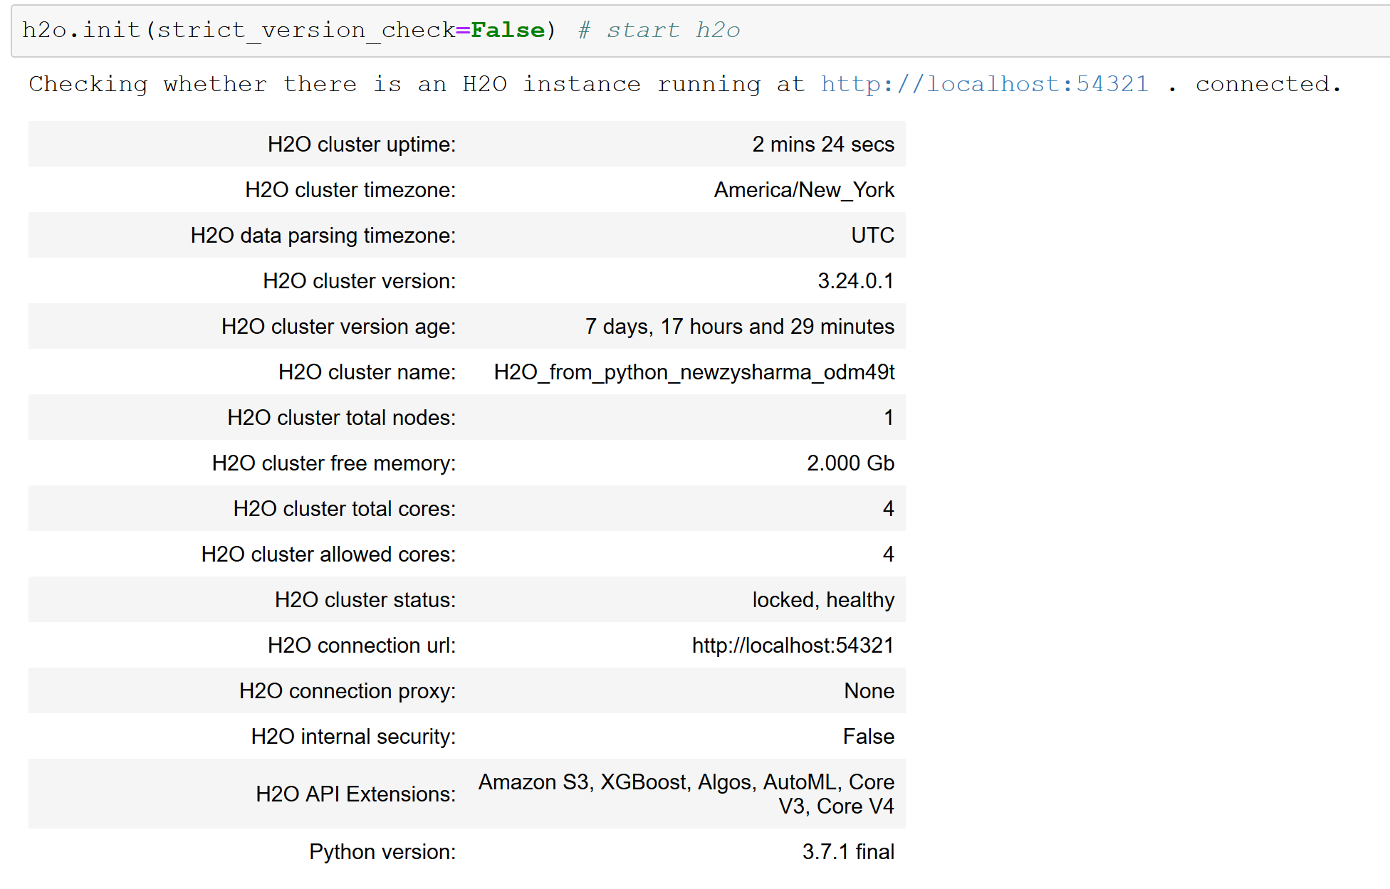

- Dataset has been imported and confirmed that it is clean and require no further cleaning

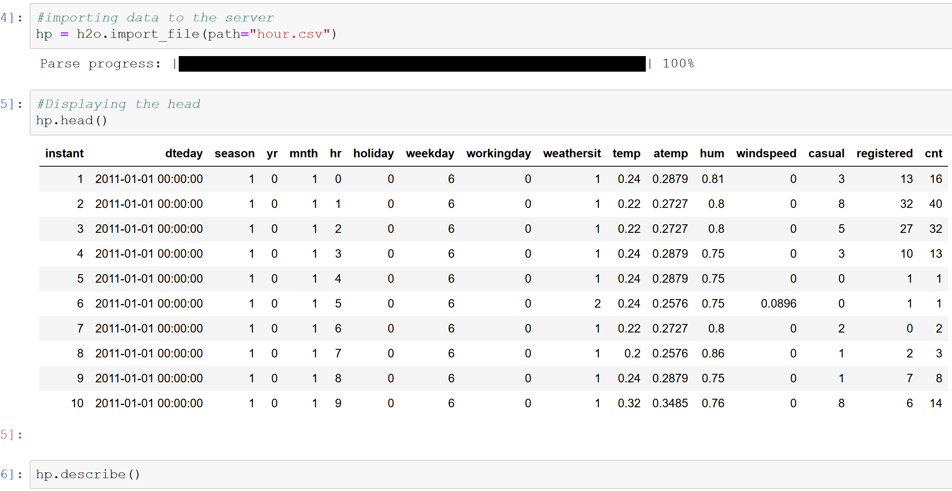

- Now the automl runs for runtime for 500 sec and builds stacked ensemble.

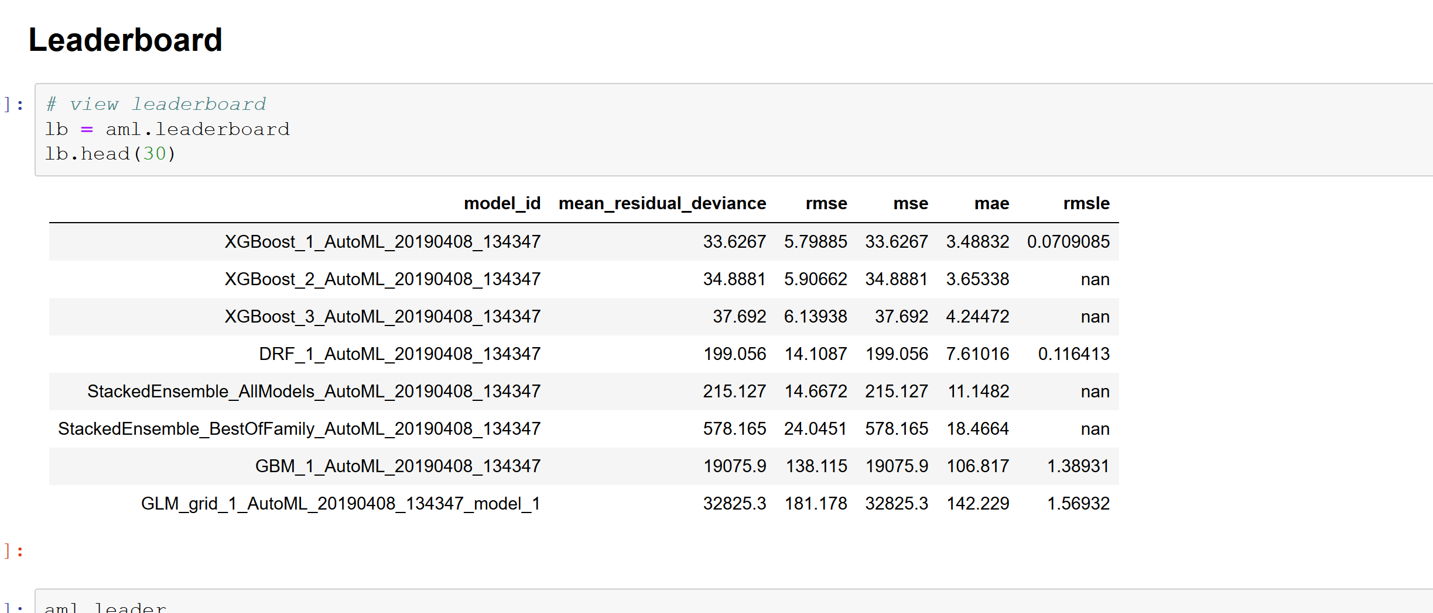

- All the models were evaluated on the basis of their RMSE and MSE value and their hyperparameters were identified

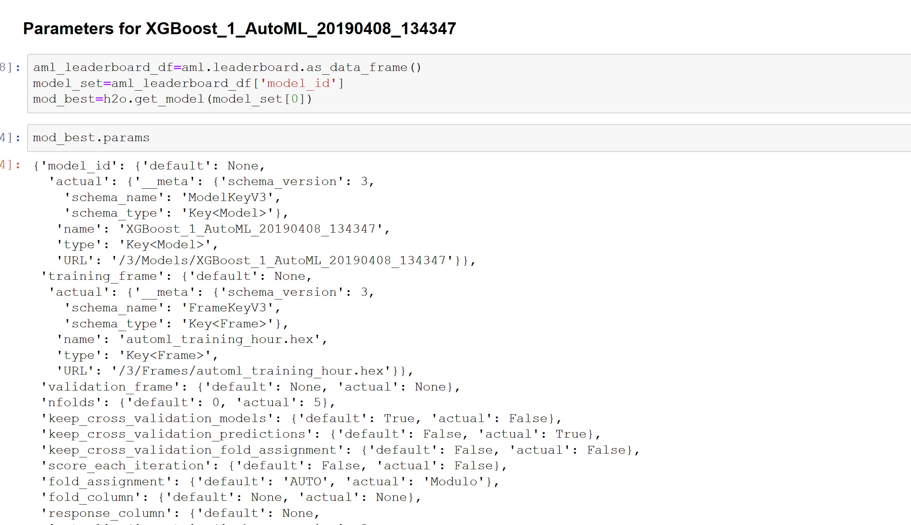

The same process was repeated for runtime of 1000, 1350, 1500 and 1850 and the models were evaluated.

Tasks to Be Completed Further

- Run each model of the same kind and fetch the best model out of them: We will achieve this by running a loop for each model and find it and select the best model out of it.

- Hyperparameter Fetching: Fetch the hyperparameters for the best model that will be generated from the above.

- Hyperparameter Extraction: Extract the Hyperparameter from each model for every run. And store them to JSON or CSV based on the flexibility. Confine the storing of Hyperparameters to JSON and CSV.

- Meta Data Creation: Create Meta_Data for every run with all details which has to be decided by us and save it in detailed manner.

- Pass the JSON and CSV files to DMDD students: Co-ordinate with DMDD team members if anything required for the database side, and add the relevant ask to your card in case of requirement with approval from the Project Manager.

CONCLUSION

Running time of model in Number of seconds | Number of Models generated
500 seconds | 7
1000 seconds | 13
1350 seconds | 33
1500 seconds | 56
1850 seconds | 84

