Name: Joaquin Celis
Course and section: BSIT-3A
Activity: Laboratory Activity - Visualizing Nested Forum Replies (PHP, MySQL and PDO)
Date submitted: 13/11/26
GitHub repository: https://github.com/NexAttxck/forums-lab-ipt.git

How a request moves through the app
Every request goes to public/index.php, which is the only entry point. Bramus Router matches the url, for example GET /discussions/1, and calls DiscussionController::show. The controller checks the id, then asks the model classes (Discussion and Comment, they use PDO with prepared statements) for the rows. It groups the comments by parent_id, works out the depth of each one and passes the nested array to the Mustache view, and the comment template calls itself for the replies. Libraries I used are Bramus Router and Mustache. I used plain PDO instead of Eloquent, so all the SQL stays inside app/Models.

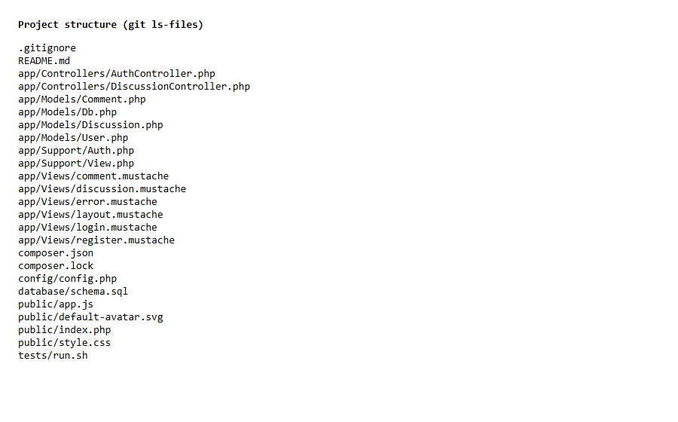
This is the project structure. public has the front controller, app has Controllers, Models, Views and Support, config and database hold the settings and schema.sql, and tests has the check script. Composer packages are in composer.json and vendor is not committed.

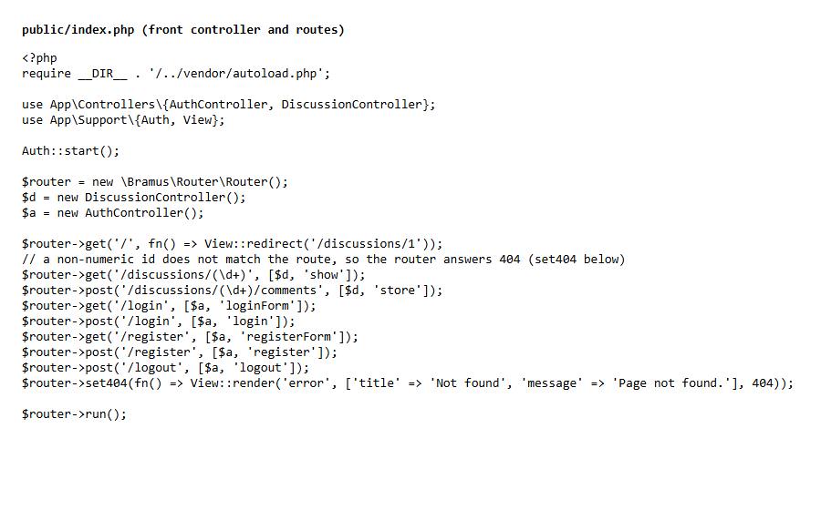
These are the routes in public/index.php. GET for the discussion, POST for comments, login, register and logout. The id only matches digits, so something like /discussions/abc never reaches the controller and the router gives a 404.

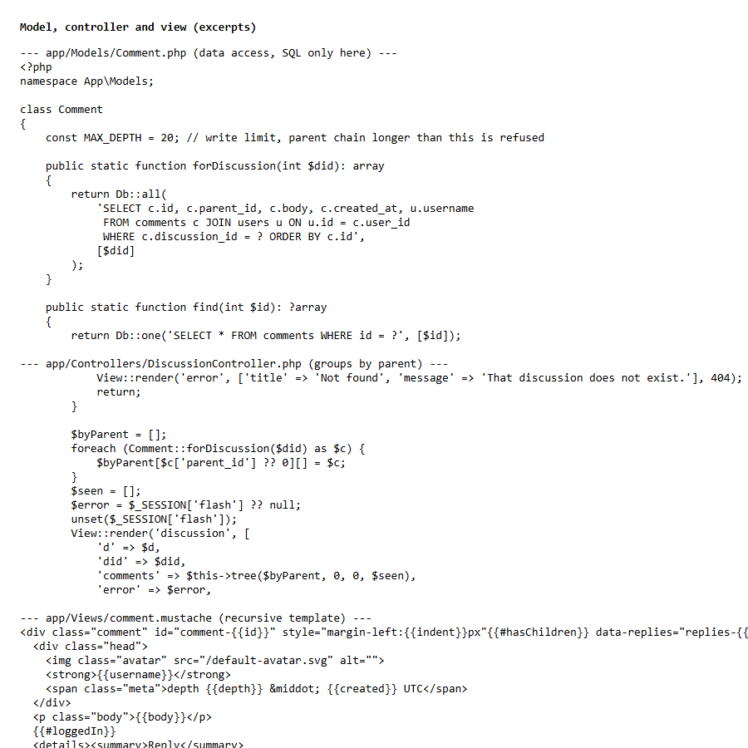
This shows the separation. The model does the SQL, the controller groups comments by parent and prepares the data, and the template only prints it. No SQL in the controller or the template.

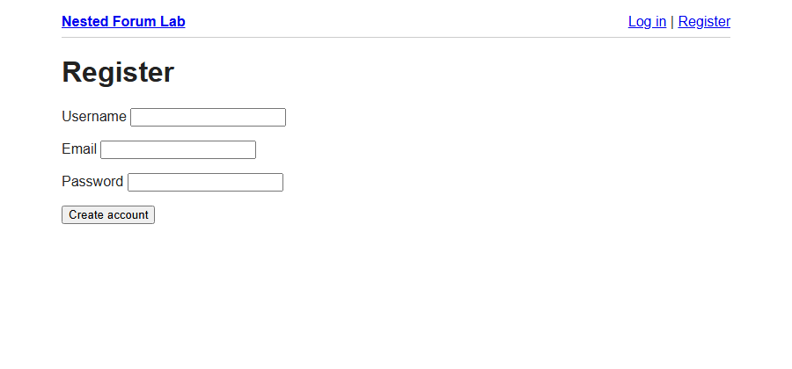
The registration page. It checks the username and email, needs a password of 8 characters or more, rejects duplicates and stores the password with password_hash. The form has a CSRF token.

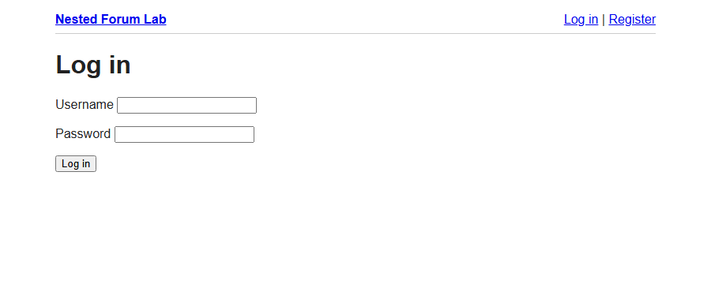
The login page. It uses password_verify, a user with a null hash can never log in, and the session id is regenerated after a successful login.

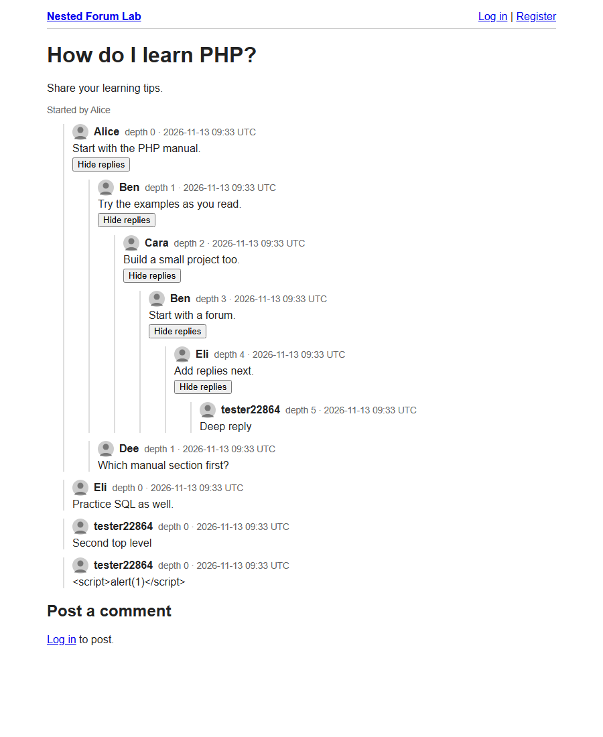
The nested thread. The seed data reaches depth 4 (Eli, Add replies next). After registering and logging in I posted a reply under it, which is the depth 5 reply, and a second top level comment. The authors and the depth labels are shown on each comment, and the Hide replies buttons are the optional challenge.


A guest sending a direct POST to the comment url with no session. The server answers 401 and the comment count in the database stays the same, so nothing was saved even though the form was never used.

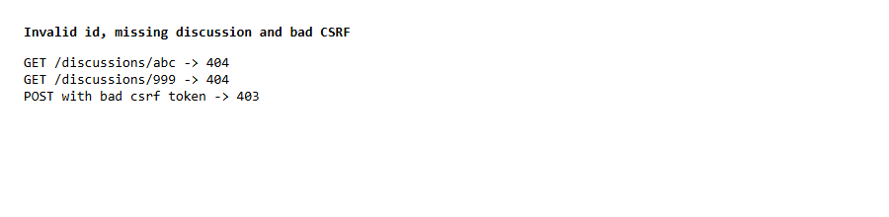
A non numeric id and a discussion that does not exist both return 404, and a POST with a bad CSRF token returns 403. The tests/run.sh script also checks a reply whose parent is in another discussion, and no row is created.


I posted a comment with a script tag as the text. In the page source it comes out as &lt;script&gt; so the browser shows it as text and does not run it, because Mustache escapes everything. You can also see it as plain text at the bottom of the thread screenshot.

Reflection
I built the database first with the composite foreign key, then the router and the read page, then registration and login, and last the reply handler and the tests. The tricky part was the nesting. I group the rows by parent_id and use a recursive Mustache partial, which also made the collapse buttons easy because each reply branch is its own div. One problem I had was making cycles impossible. Since the foreign key does not stop them I made parents never change and only allow a new comment to point to an older existing one, and I also cap the depth at 20 when writing and 50 when rendering. Limitations: it loads all comments of a discussion in memory, there is no pagination, no rate limiting or account recovery, and avatars and Gravatar are not done.

