Mathematical Modelling for Waste Reduction: Initial Ideas

The problem:
Unnecessary food waste due to fluctuations in demand

Aim of project:
To develop a mathematical model that is able to predict the demand in a given population. With better estimates for demand, overproduction can be prevented. Findings from the project can be used to make informed supply decisions which minimise food waste.

Data Collection
The Food Demand Forecasting dataset was used as a source of historical demand information. The dataset contains information about mela orders across multiple fulfilment centres over time.
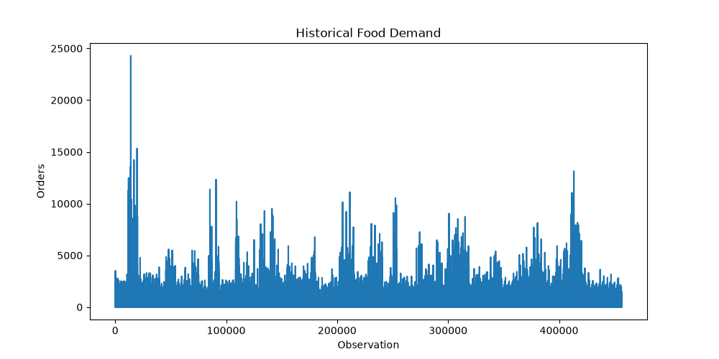
Variables used:
- meal_id
- center_id
- num_orders
To reduce external variation, the model was applied to a single meal type and fulfilment centre. This led to the assumption of a relatively stable demand environment.
Chosen example:
- meal_id = 2139
- centre_id = 55
For this set, n = 101 (observations)
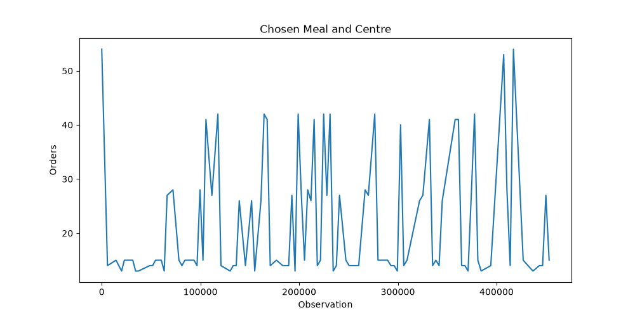

Initial Statistical Analysis
$$D=daily demand$$
Mean:
$$μ=\frac{1}{n}\sum_{i=1}^{n}{D_{i}}$$
The mean represents expected daily demand.
$$μ=21$$
Variance:
$$σ^{2}=\frac{1}{n-1}\sum{{\left(D_{i}-μ\right)}^{2}}$$
Variance measures how much demand fluctuates.
$$σ^{2}=125$$

Choice of Probability Distribution
Since food demand is measured as the number of orders, it is a discrete random variable. A Poisson distribution was initially considered.
Poisson property:
$$E\left(D\right)=Var(D)$$
However:
$$Var\left(D\right)=125$$
While:
$$E\left(D\right)=21$$
This means the data shows overdispersion. The variance is significantly larger than the mean which means a Poisson distribution would underestimate demand uncertainty. Therefore, a Negative Binomial distribution was selected.

Negative Binomial Model
Introduce:
$$D\sim NB(r,p)$$
Mean:
$$E\left(D\right)=\frac{r\left(1-p\right)}{p}$$
Variance:
$$Var\left(D\right)=\frac{r\left(1-p\right)}{p^{2}}$$
Parameter estimation:
$$r=\frac{μ^{2}}{σ^{2}-μ}$$
Substitute:
$$r=\frac{{21}^{2}}{125-21}=4.24$$
Then:
$$p=\frac{r}{r+μ}=0.168$$
Therefore:
$$D\sim NB(4.24, 0.168)$$

Simulation
Future demand cannot be predicted exactly, so the model generates many possible demand scenarios.
- Generate 10,000 random demand values from the Negative Binomial distribution
- Treat these as possible future demand outcomes
- Evaluate different supply decisions
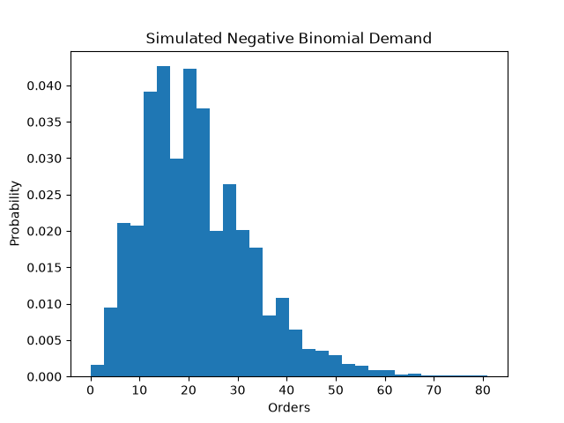
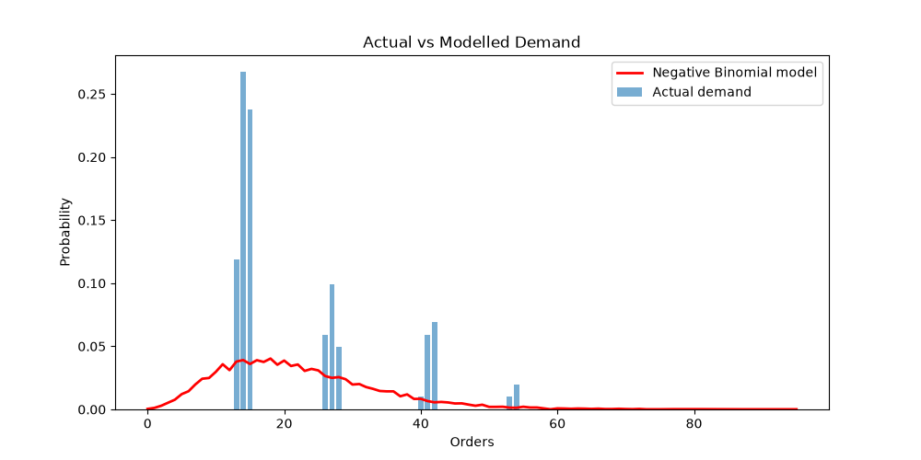
The model reproduced the general shape and variability of observed demand, suggesting it was suitable for simulation.

Supply Optimisation
Supply as $S$
Demand as $D$
Waste:
$$W=max⁡(S-D, 0)$$
Shortage:
$$L=max⁡(D-S,0)$$
Cost:
$$C=W+5L$$
The coefficient 5 represents the assumption that shortages are more costly than waste.
The optimisation process:
- Test many possible supply values
- Calculate expected cost
- Select the minimum
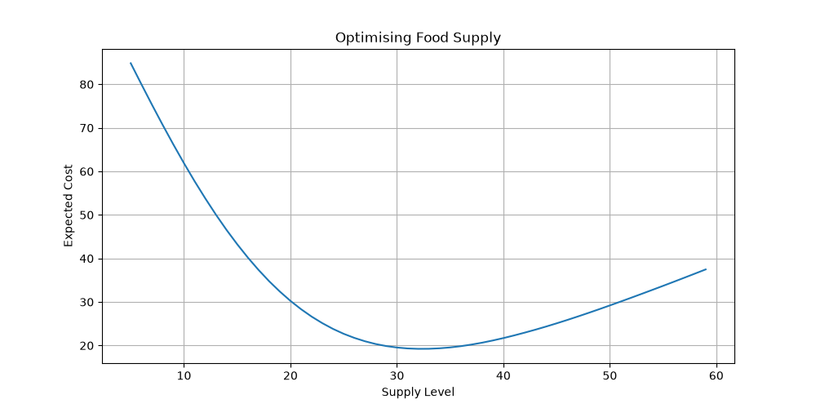

Evaluation:
Strengths:
- uses real demand data
- quantifies uncertainty mathematically
- allows comparison of supply strategies to help reduce waste
Limitations:
- assumes demand patterns remain similar
- does not account for the unpredictability of real-world demand
- extrapolated from historical data – it is impossible to truly predict
Improvements:
- include multiple meals simultaneously
- add seasonal effects
- include external factors such as weather
- use machine learning forecasting along with probability models
- allow users to adjust cost assumptions

