A
Autoware
Autoware is currently one of the most representative open-source autonomous driving software stacks, based on ROS, and its goal is a software system for autonomous vehicles. Both the official site and GitHub clearly position it as an open-source project for autonomous driving. The repository currently uses the Apache-2.0 license.

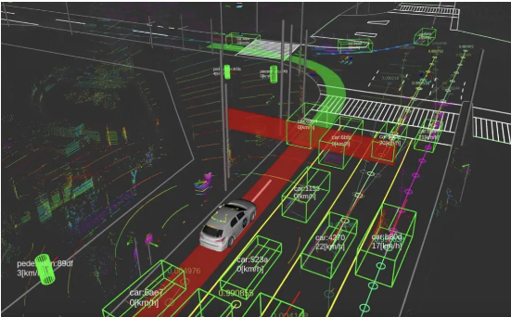
Advantages:
- The main autonomous driving link is complete and has the highest reference value.
- The community is mature, and the level of engineering is much higher than that of typical student projects.
- Suitable for your reference 'Where does vehicle status come from': Perception, Localization, Planning, Control
Disadvantage:
- Too big and too heavy, not suitable for you to use directly for Arduino beginners
- It leans more towards 'whether the car can drive,' rather than specifically addressing 'whether elderly or special groups can understand the car's intentions.'
Inspiration
Refer to its 'vehicle status interface' and then translate these statuses into concise, perceptible external signals
B
autonomous vehicle eHMI prototype
This GitHub project explicitly states that it is about external Human-Machine Interfaces (eHMIs) for autonomous vehicle-to-pedestrian communication, that is, 'external human-machine interfaces for communication between autonomous vehicles and pedestrians'
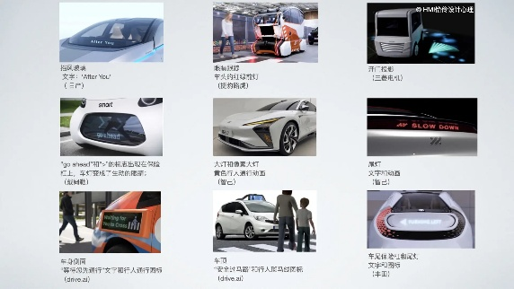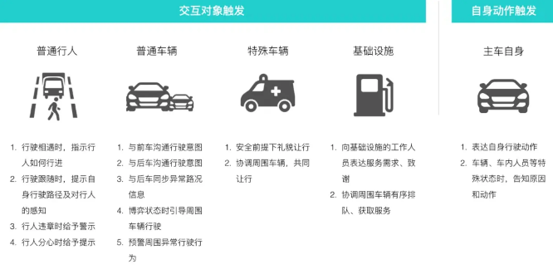
Advantages:
- Directly study 'how to express intentions outside the car'
- It is suitable to first conduct interface semantic verification, such as which is easier to understand: text, color, arrows, or animations.
Disadvantage:
- More like an interactive prototype or simulation, not a mature hardware system
- Multimodal adaptation for the elderly, visually impaired, and hearing-impaired groups is not obvious enough
Inspiration:
1.High-contrast large icons
2.Short text
3.Rhythmic lighting
4.Buzzer/voice
5.Close-range vibration ale

C
Harmoware-HMI
This project leans more towards 'human-computer interaction in autonomous driving,' including voice interaction, nod/shake confirmation, speed voice control, etc. It is focused on in-car scenarios, but it can give you strong inspiration for 'user-friendly interaction for special groups'.
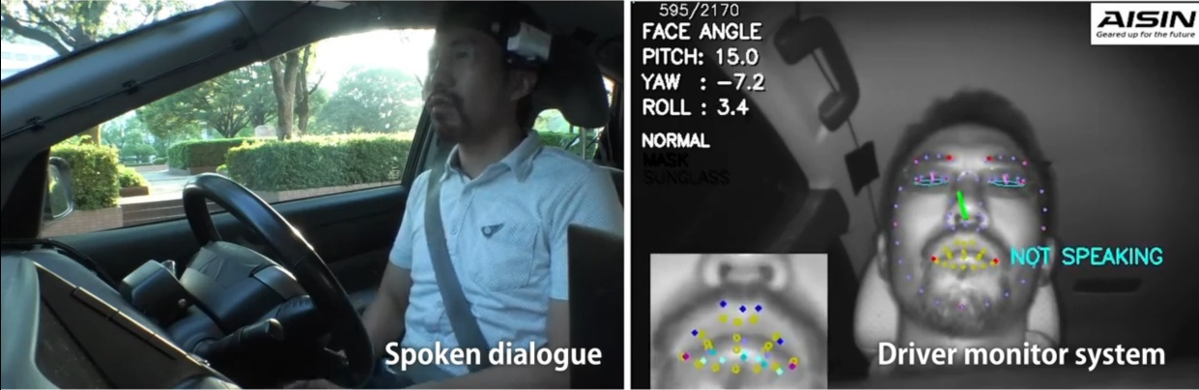
Advantages:
- Clearly emphasize human-computer interaction, not just algorithms
- Strong multimodal interaction ideas, suitable for reference in elderly scenarios
Disadvantage:
- Biased towards in-vehicle HMI, not the main scenario for communication between pedestrians and vehicles outside the car
- Design of external signal lights and external prompts provides limited help
Inspiration:
- You can learn 'do not rely on only one channel for a signal'; it's best to use both visual and auditory channels.
- For the elderly, redundant cues are usually more reliable than single cues.

D
Smart Cane
The Smart-cane project on GitHub is aimed at visually impaired and elderly users. Its core approach is to use multiple ultrasonic sensors and buzzers for real-time obstacle alerts. The project description explicitly states that its target users are visually impaired and elderly people, and it plans to further add features such as Bluetooth, GPS, and vibration feedback.
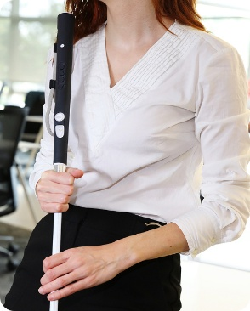
Advantages:
- Very close to 'special group assisted interaction'
- Low cost, easy to replicate
- It is suitable to first study 'whether the prompt method is clear and whether it is overloaded'
Disadvantage:
- It is mainly for single-person close-range obstacle avoidance, not vehicle-person interaction.
- The medium is somewhat single in type, mainly focused on sound
- Limited capability in noisy environments and complex road scenarios
Inspiration:
- You can refer to the 'multimodal alert' approach: sound, vibration, light
- You can refer to 'simplified interactions for elderly users': few and clear, do not give too many signals at the same time.

E
OpenHapticGlove
OpenHapticGlove is an open-source haptic glove designed for navigation for the visually impaired, using ToF distance sensing and vibration feedback. It is not an in-vehicle system, but it is well suited for your research on 'non-visual interaction.' This approach is valuable for the elderly, low-vision users, or users in bright light environments.
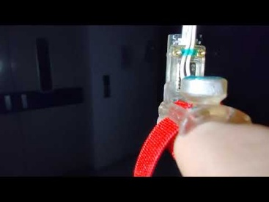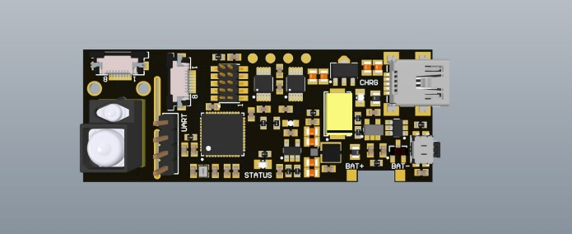
Advantages:
- Haptic feedback is naturally suitable for people who have difficulty looking at screens or lights.
- More private than a simple buzzer, and not easily drowned out by environmental noise
- Very suitable to complement visual signals outside the vehicle

Disadvantage:
- Users need to wear the device
- Cost, comfort, and range all need to be considered additionally
- May require training for first-time users
Inspiration:
- It doesn't necessarily have to only make the 'car send signal'; it can also design a 'human-end receiver'.
- It's best not to bet on a single channel for special group projects; tactile sense is worth preserving.

F
Smartpole-VR-AWSIM
This project combines AWSIM/Autoware/ROS 2/Unity/VR to simulate the impact of infrastructure eHMI (external human-machine interface) on pedestrians, aiming to assess the safety, clarity, and timing of signals. Its research path is very close to your 'autonomous driving interactive signaling system,' except that it is more oriented towards a simulation evaluation platform.
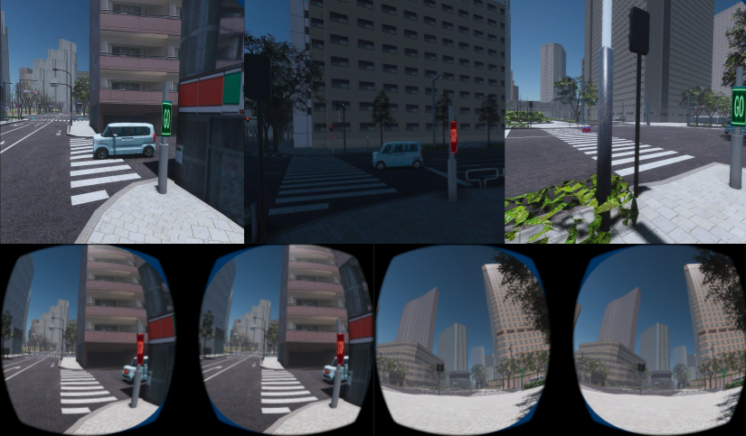
Advantages
- Very close to the autonomous driving interaction signal research scenario
- Able to quickly test different signal designs without actually being on the road
- Can conduct VR human factors experiments, suitable for comparing 'GO/STOP/path projection' and other schemes

Disadvantage:
- The tech stack is heavier, and the threshold is much higher than Arduino.
- More suitable for 'design verification' rather than 'rapid hardware prototyping'
- High requirements for the team's software/simulation capabilities

Inspiration:
It can be divided into two stages:
The first stage: Arduino for low-cost interactive prototyping;
The second stage: CARLA/AWSIM/Unity for human factor validation and scenario simulation

