**RESEARCH THE ROOT CAUSE**

**OF THE PROBLEM**

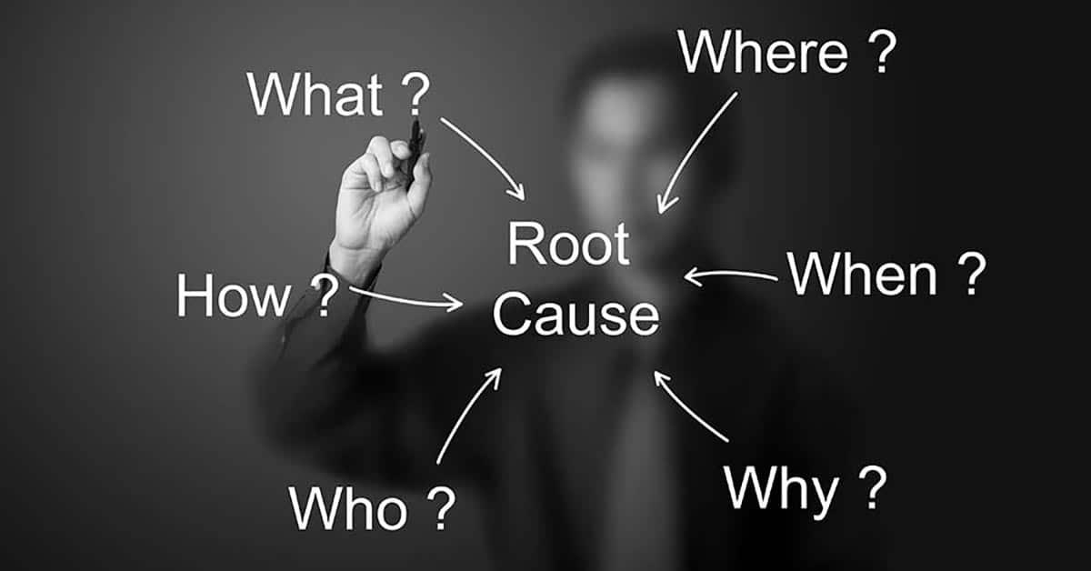

*The root cause explains why the prospect is experiencing the problem in the first place.*

*It reveals what’s truly happening beneath the surface — not just the symptoms, but the deeper trigger behind them.*

*By identifying the root cause, we’re able to show the prospect why other solutions haven’t worked — because they fail to address the real issue.*

*This not only builds trust (we understand exactly what’s causing their struggle), but also creates a clear path to a solution that actually works — one that targets the problem at its source.*

**Ai Prompt To Conduct This Research:  
  
1. Prompt: by deep research**

Hi, I want you to act as a **world-class direct response copywriter** for a $100M/year brand in the [NICHE].

Your job is to **research and explain the root cause** of a specific problem experienced by our ideal customer (the **[AVATAR]**). This is not surface-level — I want you to uncover what’s really happening underneath, based on **credible scientific and medical research**

Your task

#### **Deep Root Cause Research:**

1. Research the root cause of the following problem:  
    **"[INSERT PROBLEM HERE]"**
2. Find what is actually causing this issue.
3. Ensure your explanation is backed by logical, factual, and research-based information.

*Now after we get the results we go and copy them in a new document and call it ROOT CAUSE DRAFT and we go to use ChatGPT4o and past the second Prompt*

**2. Prompt:**Hi, I want you to act as a **world-class direct response copywriter** for a $100M/year brand in the [NICHE].

You are provided with a **document filled with research-based, science-backed explanations** of the root cause behind a specific problem experienced by our ideal customer.

This document may include clinical terms, biological processes, and logical reasoning — your job is to **translate that complexity into clear, emotional, easy-to-understand copy**.

Your task has 3 phases:

#### **Phase 1 – Deep Root Cause Understanding:**

1. Read the document provided:
2. Find what is actually causing this issue.
3. Ensure your explanation is backed by logical, factual, and research-based information.

**Phase 2 – Simplify & Visualize:**

1. **Summarize the root cause** in plain English — include all key facts, but no medical jargon.
2. Re-explain the root cause like you're talking to a **4th grader**. Simple, clean, and easy to understand.
3. Add **a clear real-life analogy or metaphor** that visually and emotionally connects the dots.

#### **Phase 3 – Copywriting Style Breakdown (For Advertorial Use):**

1. Now act as a **top-tier direct response copywriter**.  
   * Using everything above, write an **advertorial-ready section** that:

* Goes **straight into the root cause**
* **Does NOT start with a story**
* Uses short, punchy sentences
* Is easy to read and entertaining
* Includes a metaphor or analogy to make the cause visual

Think of it like a paragraph that could be dropped directly into the “Problem” or “Why it happens” section of an advertorial.

End result: a ready-to-use chunk of **copywriting gold** that makes the root cause easy to understand, emotionally compelling, and plug-and-play inside an advertorial.

*THEN PROCEED WITH THIS THIRD PROMPT* **3. Prompt:**

Hi, I want you to act as a **UGC-focused creative strategist** for a $100M/year brand in the [NICHE].

We’ve already done the deep, science-based research and simplification of the **root cause** behind the following problem:  
 **[INSERT PROBLEM HERE,]**

### **Your task:**

Using the information above, create a short, authentic UGC-style **clip segment** that explains the **root cause of the issue**. This is **not** a full UGC script — we are only focusing on the **part where the creator naturally explains what causes the problem** in her own voice.

### **Deliverables:**

#### **Part 1 — UGC-Style Root Cause Clip (Only)**

* Write a short, natural video monologue from the perspective of a real woman who personally struggles with the problem (e.g., hair loss from PCOS)
* The tone should feel authentic — like a girl talking to a friend on TikTok
* She should explain what she found out is *actually* causing the problem (based on the research above)
* Keep the language simple and casual — no jargon or heavy science terms
* If it fits naturally, include a visual metaphor or analogy to make it more memorable
* No story, no product, no intro or outro — just the **root cause explanation**

#### **Part 2 — Key Talking Points for Creators**

* List 7–10 short, natural **talking points** based on the clip that creators can use to guide their own delivery
* These should be easy to remember and speak freely on camera — not full sentences, just idea prompts

**Manuel research:**

PCOS HAIR LOSS CAUSED BY THREE THINGS:

* DHT androgen; because of pcos the body produce more androgens and one of them is DHT that is responsible for hair thinning we can look at DHT as some toxic chemical that if it put in the hair it cause the hair follicle to shrink

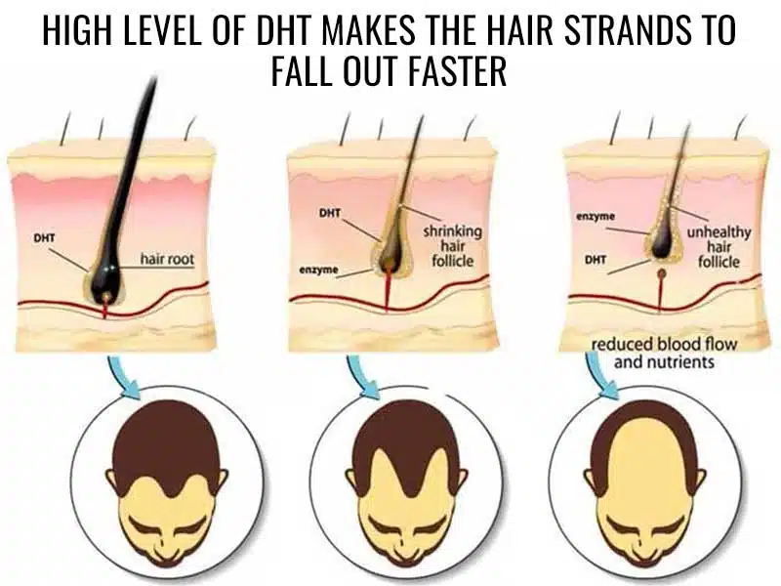  
  
  
Second is insulin resistant so instead of the body regulate the amount of androgenic hormones product because of insulin resistant its start produce more androgenic hormones means more DHT that lead to more hair thinning   
  
  
Insulin is a hormone that helps to regulate blood sugar levels. When the body is resistant to insulin, it can increase testosterone levels.  
  
**Inflammation:** Inflammation disrupts the hair growth cycle, pushing more hair into the resting phase (telogen), and causing increased shedding and hair thinning.  
  
  
And because now the insulin resitant cause more DHT aka more androgens means that your body **stimulate immune responses** and promote inflammation in tissues. So it like an not ending cycle you have dht it shrink your hair focil and now because of that you also have inflammation that make things worst and your body just keep producing more DHT because of the broken Insulin resitant