Text just above the image

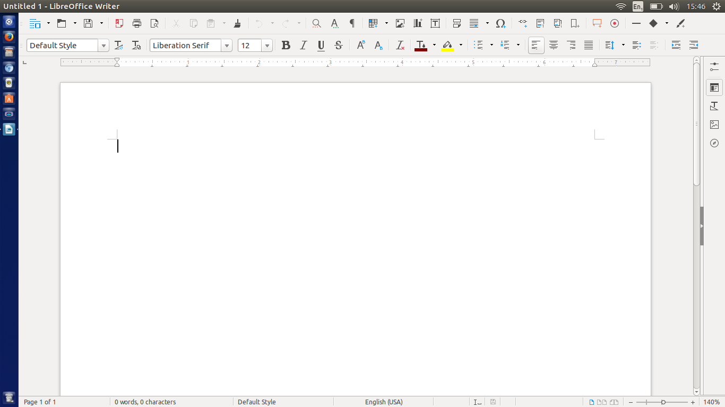Text just below the image

paragraph !