The method of handling inputs for now is primitive. The python codes that handles it all is in the LineGeneration script. This reads the data of all the elements and also the topology of the line, and then runs the simulation. In the Inputs folder the user can define general data, attributes for all the elements and the topology.
- General: In General.xls. Here we can define general values for the experiment such as total simulation time, number of replications etc.
- Attributes for the elements: Eg in the Machine.xls the rates, failures of the machines etc can be defined. In all the elements the last column must have the value END in the first row.
- Topology: Eg in Topology01.xls a special topology is defined. Running the LineGeneration script the user can choose the topology he wants to experiment with. (eg give “01” for Topology01). See below what the six topologies model. The print screens are from Plant Simulation which is used for verification of the SimPy code.

Topology01:
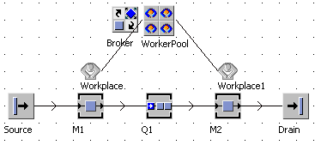

Topology02:
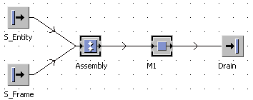

Topology03:

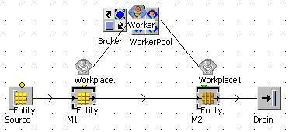

Topology04:

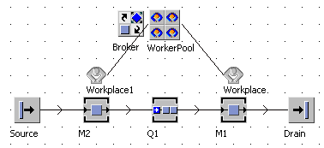

Topology05:

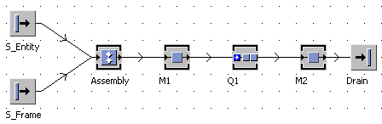

Topology06:

