Movie Player Example Application for Linux
Version 0.9.0

Version 0.8.0
Copyright © 2015 Nexell Co.,Ltd. All rights reserved.
Movie Player Example
Application for Linux
Nexell S/W Team 2
Release information
The following changes have been make to this document.
Change History
Date | Change
11 MAY 2015 | First release for v0.9.0

Proprietary Notice
Information in this document is provided solely to enable system and software implementers to use Nexell products. There are no express or implied copyright licenses granted hereunder to design or fabricate any integrated circuits or integrated circuits based on the information in this document.
Nexell reserves the right to make changes without further notice to any products herein.
Nexell makes no warranty, representation or guarantee regarding the suitability of its products for any particular purpose, nor does Nexell assume any liability arising out of the application or use of any product or circuit, and specifically disclaims any and all liability, including without limitation consequential or incidental damages. “Typical” parameters which may be provided in Nexell data sheets and/or specifications can and do vary in different applications and actual performance may vary over time. All operating parameters, including “Typicals” must be validated for each customer application by customer’s technical experts. Nexell does not convey any license under its patent rights nor the rights of others. Nexell products are not designed, intended, or authorized for use as components in systems intended for surgical implant into the body, or other applications intended to support or sustain life, or for any other application in which the failure of the Nexell product could create a situation where personal injury or death may occur. Should Buyer purchase or use Nexell products for any such unintended or unauthorized application, Buyer shall indemnify and hold Nexell and its officers, employees, subsidiaries, affiliates, and distributors harmless against all claims, costs, damages, and expenses, and reasonable attorney fees arising out of, directly or indirectly, any claim of personal injury or death associated with such unintended or unauthorized use, even if such claim alleges that Nexell was negligent regarding the design or manufacture of the part.

Copyrightⓒ 2009~2016 Nexell Co.,Ltd. All rights reserved.
No part of this publication may be reproduced, stored in a retrieval system, or transmitted in any form or by any means, electric or mechanical, by photocopying, recording, or otherwise, without the prior written consent of Nexell.

Contact us
[463-825] Bundang Yemizi Bldg. 1202, 6-5 Sunae-dong, Bundang-gu, Sungnam-city, Gyeonggi-do, Korea.
TEL: 82-31-698-7400
FAX:82-31-698-7455
http://www.nexell.co.kr
Contents
Chap 1. Overview 3
1.1 Overview 3
1.2 Environment 3
Chap 2. Environment Set 5
2.1 Overview 5
2.2 BuildRoot 5
2.3 Library make 5
2.4 Modules make(Linux) 5
2.5 Example Application 6
Chap 3. Example 7
3.1 Bolck Diagram 7
3.2 Shell Mode Diagram 9
3.3 Commands 10
Chap 4. Known Issues 11
4.1 To Do List 11
4.2 Known Issues 11

Overview

Overview
이 문서는 Linux 환경에서 Filter Library을 사용하여 각종 동영상 및 음악 파일을 재생하기 위한 Example Application의 설명한 문서이다.
Android Java(UI 포함) 와 관련된 Example 은 vendor/nexell/apps/src/NxPlayerBasedFilter 참고한다.
Codec 지원범위는 Movie Player API for Android Linux.doc 문서를 참고한다.

Environment

CPU
- S5P4418
- S5P6818

OS
- Lollipop
- Linux(Kernel Version 3.4.39)

External Depend
- FFmpeg library (2.1.4)
- Audio Decoder (FFmpeg)

Library
- FFmpeg library: libavutil.so, libavresampld.so, libavdevice.so,
libavcodec.so, libswscale.so, libswresample.so,
libavfilter.so, libavformat.so
- Filter library: libnxfilter.so, libnxfilterhelper.so, libnxmpmanager.so
- Video decoder module driver & library : nx_vpu.ko, libnxvpu.so
- Video memory allocator library : libnxvmem.so
- Theora parser library: libtheoraparser.so
- Additional library (Linux)
  - V4L2 library : libnxv4l2.so, libnxdsp.so
  - Fine scaler library : libnxscaler.so

- uevent library.
  - “libnxuevent.so”

Environment Set

Overview
이 부분은 player 를 실행하기 위한 환경설정에 관한 내용이다.

BuildRoot
BuildRoot System 은 br.2013.11.cortex_a9_glibc_tiny_rfs.config 를 사용해서 Build 한다.
자세한 내용은 NXP4330 Linux BSP User Manual VerXXX.docx 에 BuildRoot Build을 참고한다.

Library make
- /linux/platform/s5p4418/library/src/ 폴더로 이동해서 make 명령어을 실행하면, /linux/platform/s5p4418/library/lib폴더에 .a, .so 파일이 복사된다.
- /linux/platform/s5p4418/library/lib 폴더에libion.a , libnxdsp.so, libnxv4l2.so, libnxvip.so, libv4l2-nexell.so, libnxvpu.so, libnxuevent.so, libnxvmem.so, libnxscaler.so 파일을 root-file-system rootfs/usr/lib 폴더로 복사한다.
- /linux/platform/s5p4418/library/lib 폴더에libnxvidrc.so 파일을 root-file-system rootfs/usr/lib 폴더로 복사한다.
- /linux/platform/s5p4418/Solution/MediaPlayer/lib 폴더에 libnxfilter.so, libnxfilterhelper.so, libnxmpmanager.so 파일을 root-file-system rootfs/usr/lib 폴더로 복사한다.
- /linux/platform/s5p4418/Solution/MediaPlayer/lib/ffmpeg/linux 폴더에 모든 파일을 root-file-system rootfs/usr/lib 폴더로 복사한다.

Modules make(Linux)
- / linux/platform/s5p4418/modules/coda960 으로 이동해서 make ARCH=arm 을 실행하면 nx_vpu.ko 파일이 만들어진다.
- nx_vpu.ko 을 root-file-system rootfs/root/ 복사한다.
- 리눅스가 부팅되면 insmod nx_vpu.ko 명령어을 실행한다.

Example Application
- /linux/platform/s5p4418/Solution/MediaPlayer/path.env 파일에서 build.env 경로를 자신에 경로에 맞게 설정한다.
- /linux/platform/s5p4418/Solution/MediaPlayer/apps/NxPlayerConsole 폴더에서 make 명령어를 실행한다.
- 실행 파일을 root-file-system rootfs/root/ 폴더로 복사한다

Example

Bolck Diagram

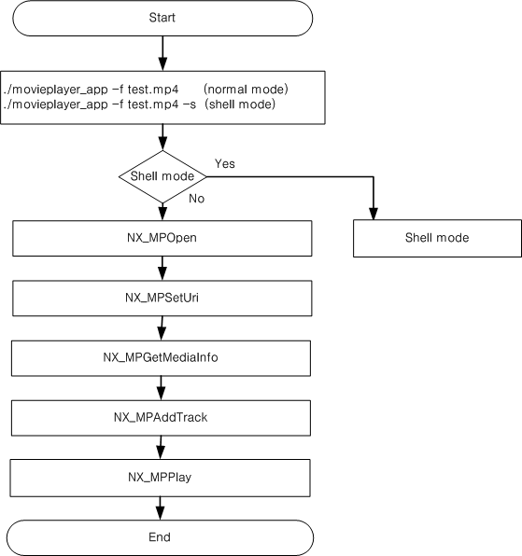그림1. Example Block Diagram
그림1은 example 에 대한 설명이다.
- NxPlayerConsole –f test.mp4 명령어를 실행하면 기본적인 플레이가 된다.
- NxPlayerConsole –f test.mp4 –s 명령어를 실행하면 Shell mode 가 실행되어 원하는 Commands 을 실행할수 있다.
- 기타 Scenario 는 Movie Player API for Android Linux.doc 문서를 참고한다.

Shell Mode Diagram
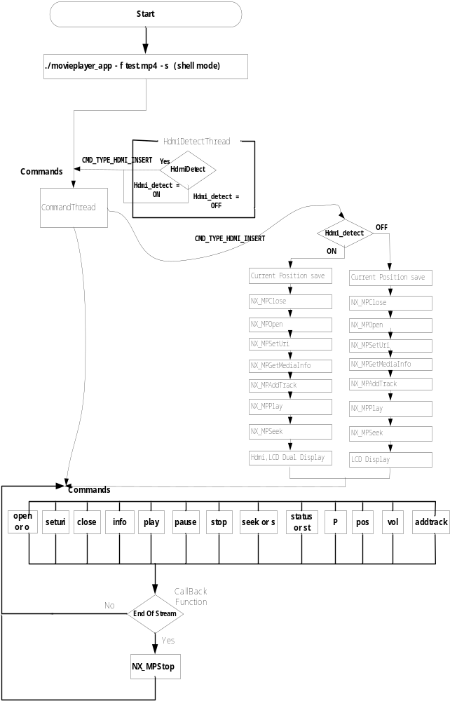

그림 2. Shell Mode Diagram 1
그림 2는 shell mode에 대한 설명이다.
- NxPlayerConsole –f test.mp4 –s 명령어 를 실행한다.
- Command(open or o) 를 실행한다.
- Command(seturi) 를 실행한다.
- Command(info) 를 실행한다.
- Command(addtrack) 를 실행한다.
  - MediaInfo 정보를 바탕으로 원하는 track 을 add 한다.
- Command(play) 를 실행한다.
- 원하는Command(close, info, pause,stop,seek,status,pos) 를 실행한다.
- file에서 더 이상 읽어올 데이터가 없으면 Callback function 을 통해 CALLBACK_MSG_EOS 를 발생시킨다.
- CALLBACK_MSG_EOS 발생하면 stop 을 실행한다.
- 원하는 Command 를 실행한다.

Commands

Commands | Function
open or o | open player for specific file
seturi | Set Uri
close | close player
info | show file informationc
play | Play
pause | Pause playing
stop | stop playing
seek or s | Seek (ex: s 50000)
status or st | Display current player status
p | Toggle play & pause
pos | Change play position (ex: pos 0 0 30 30 720 480)
vol | Change volume (ex: vol 50)
addtrack | Add Track(Audio or Video)

Known Issues

To Do List
- Audio File Thumbnail 지원.
- 자막지원.
- HEVC S/W Codec 지원.

Known Issues

1. | Theora Video Codec 에서 영상 재생이 원할 하지 않음(1920*1080)

