


www.chinesedumps.com Demo Design 1: 18-Sept-2023


FORTINET CERTIFIED EXPERT CYBERSECURITY

Fortinet Certified Expert Cybersecurity

(NSE8 – PRACTICAL LAB EXAM)

Lab Workbook Policy


- We highly discourage sharing of the workbook hence the workbooks are mapped to Laptop/Desktop MAC address. If one tries to open the workbook on other desktop or laptop than the registered MAC address; account will get locked and we will not unlock it for any reasons.

- The workbook does not have print access; kindly do not request to enable to print access. However, you will have perpetual access to the workbook which you have purchased.

- One will be provided with free updates up to 120 days from the date of purchase, post that one need to renew his/her account to access the latest update. However, one will continue to have access to their existing workbooks. If you pass the lab within 120 days, you are not eligible for further updates.

- If one wish to renew their subscription/account, you need to renew within 120 days or before the account gets expired. Post 120 days one can renew their account however the renewal will be considered has a new purchase. Hence, we encourage one to renew within 120 days of the purchase.

- The renewal cost is 999 USD if one pay within 180 days, if one fail to renew then the cost will be equivalent of a new purchase. (The renewal price can be changed at any time, without informing the client)

- Every workbook is uniquely identified for each user with hidden words. If one shares his/her workbooks with others, and if the system detects the share, the account will be banned and we will not entertain any explanation of any sort.

- For any queries regarding Questions/Solutions, you can contact us on email: support@chinesedumps.com or skype @ chinesexams@gmail.com. Response time to any of the queries is 24 hours.

- We do require NSE Id and Official email id for security purposes. We do not sell without these details. We do background verification of the details provided, so request to give us the correct ID and official email id.

- The workbooks are in secured pdc format and delivered via email within 24 hours after payment is received.

- License is provided for only one Device. And we don’t give license again if the device crashes or company security policies. Please install license on the device cautiously as the license will not be provided again.

- We do support devices running Windows OS, Mac OS, Android and Mac iOS only

- We do not provide Refund in any circumstances once the product is sold.


- This policy is in effect from 23 November 2016 and in immediate effect for new clients and new renewals. Old clients will continue with the old Policies until the accounts get expired.

- If there is any update, one will receive the update automatically on their registered email id.

- For any future update you can check our 'updates' page.

- Labs are always published in phases. For e.g. if there is a new lab we publish it as First, Second, Third ... till Final release.

- Client who have purchased our worbooks and services and wishes to attempt the lab, need to consult our experts before their CCIE Lab.

-Exam Start

You're working at a company providing consultancy services for security and networking infrastructure with a strong focus on Fortinet products. Today you're at one of your customers that requested your help.
They recently hired a contractor to implement several Fortinet products. The base configuration was completed and all devices are accessible and manageable from a management station. However, the configuration that was initially requested was never completed and several functionalities and objectives still need to be implemented.

It is now your job to complete the configuration. To help you get started, the customer has provided a list of tasks for you to complete.

Exam Instructions:
This GUI will provide you with all the information needed to complete your exam tasks.
• The topbar includes a number of tools to help you get the best personal experience during the exam and provide you with access to the lab credentials and RDP session:

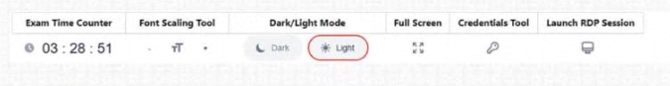

• The left menu lists the tasks (toggling is possible using the hamburger icon (=) at the top). When you've selected a task the task description will show and you can:
- Click on the Topology bar to show/hide the topology related to the task.
- Open the notes section using the hamburger menu (=) on the right to record your task notes.
- Mark tasks as 'completed' or 'needs review' using the check and flag buttons next to the topology bar.
The Out-Of-Band network (192.168.8.0/24) is only there to allow easy access to your devices.
Never use this network to establish any form of connectivity between VMs unless specifically mentioned in the task description!

In case you need IP addresses to establish communications, the IP block 172.254.0.0/16 is reserved for you as the test-taker to be used freely throughout the topology.

Note: Licensing inside this environment is setup using a closed network approach. The local FDS service runs on the OOB network on IPs 192.168.8.241-192.168.8.243. Don't change these settings to prevent license validation checks to fail during your session.

Important reminders:
• Console Access: When using the console bookmarks, press enter to receive the prompt.
• RDP Session Screen Resolution: Refresh the RDP session using the RDP top toolbar if the resolution is not full screen.
• FortiGate Revisions: To restore the initial configuration of a FortiGate use the following commands:

execute revision list config
execute restore config flash <revision_id>
Good luck on your exam and manage your time wisely!

- Multi – Tenant FGCP
Topology
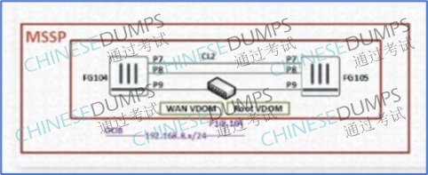

High Availability and Clustering

- Multi-Tenant FGCP

Your client has two FortiGate devices (FG104/FG105) that need to be configured for High Availability with FGCP, where large amounts of sessions are expected to be synchronized. Configure the cluster following the requirements below:

a. The data center switches used have a known conflict with FortiGate HA operation (cluster formation and config sync). Adjust the default configuration to handle this known conflict.

b. Cluster settings must match the values in the table:

Cluster name | CL2
Cluster password | Nse8pass
Cluster Heartbeat on interface | Port9

c. FG104 must always be primary even if FG105 has been up longer.

d. The cluster configuration must ensure that the virtual MAC address of each interface is unique and will not interfere with other Clusters that are configured in its default state.

e. Configure the cluster so that a large amount of session synchronization does not affect the heartbeat connection and provides redundancy.

f. If port1 or port2 goes down or if pings from port1 to 100.88.8.8 fails, the cluster must
failover to FG105.

g. Once CL2 is synchronized, you must prioritize the WAN VDOM on FG105

- BGP

Topology
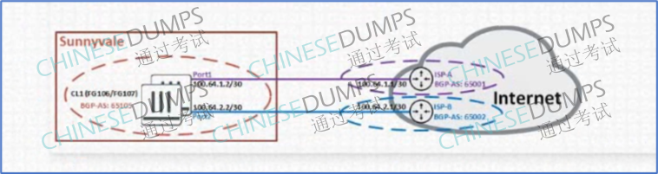

Dynamic Routing

- BGP

Your Client requires you to configure BGP on CL1 for IPv4 Internet traffic. The following requirements must be met:

a. IPv4 neighbors must handle the IPv4 address family only.

b. Only the IPv4 default route must be accepted from ISP-B and ISP-A.

c. The default route for both ISP-A and ISP-B must be simultaneously active in the routing table.

d. You must only advertise a single IPv4 summary route, 100.105.0.0/16, covering the
local interfaces (port4, loop1, and loop2). You are not permitted to use redistribute and route-map, or disable network-import-check in the BGP config to advertise the summary route.

WhatsApp : - https://wa.me/+19513764336

WhatsApp : - https://wa.me/+19513764336

Thank You for choosing www.chinesedumps.com Workbooks.

